Fiber coupled laser: <http://www.civillaser.com/fiber-coupled-laser-c-44.html>

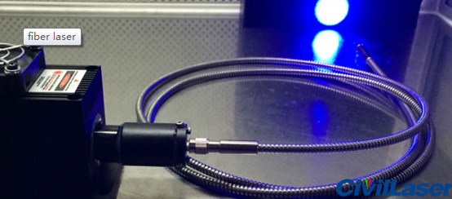

**[Important]**

The fiber cannot be folded, otherwise it will cause irreparable damage.