Assignments(PLSQL)

1. Write a procedure for the following.

a. To accept employee number , delete the record of the given

employee.

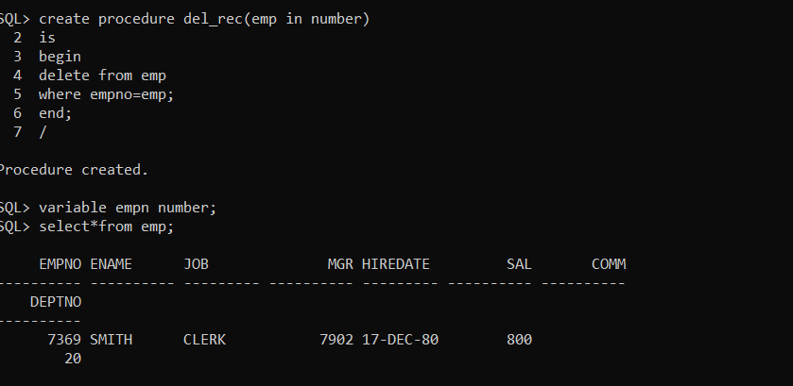

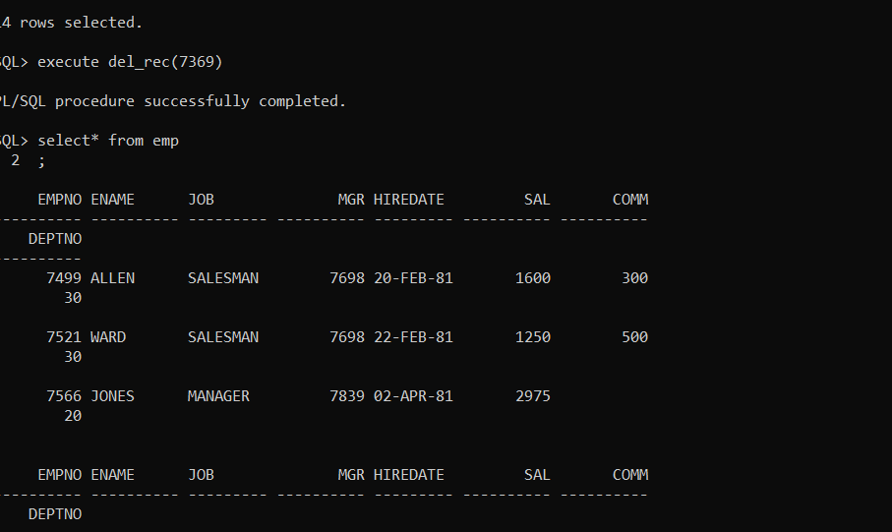

b. To accept grade,losal and hisal and insert a record into

salgrad table

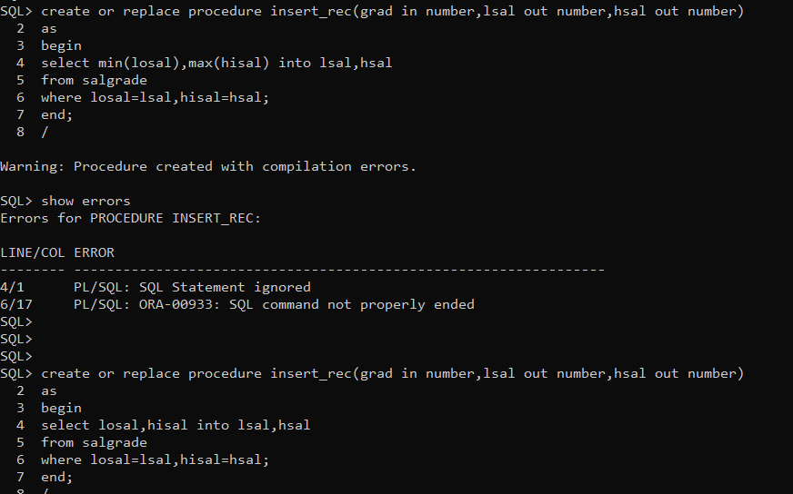

Q Procedure to find minsal,max sal,avsal

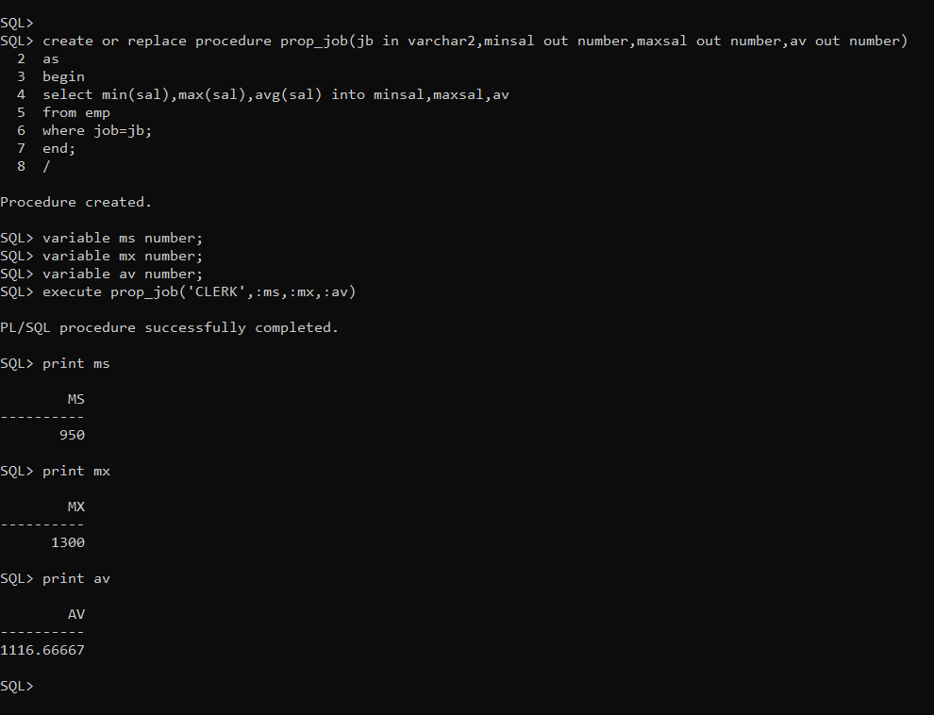

Q2

A

