Drinks in Melbourne

## Gary Simmons

## October 2020

# **Introduction**

* 1. **Background**

Melbourne, Australia, has been acknowledge consistently as one of the most liveable in the world to reside in (<https://www.telegraph.co.uk/travel/icons-of-the-sky/why-melbourne-is-the-best-city-to-live-in>). This is due to its very cosmopolitan make up of its population which has resulted in a melting pot of food, drinks and entertainment. Additionally the make up of the infrastructure and dispersal over a wide geographical area makes Melbourne quite a challenge to fully explore.

* 1. **Problem**

A visitor to Melbourne can be easily overwhelmed by the scale of the city and its many suburbs, when presented with the options in the locality they tend to stay local. This can be a shame as they will tend to miss out on many weird, wild and eclectic experiences in the huge variety of Bars, Clubs and Hotels (in Australia a Hotel is generally the same as a UK Pub !)

* 1. **Interested Parties**

This investigation is aimed towards a visitor to Melbourne who would like an indication on the concentration and variety of Drinking options based upon the Suburbs.

# **Data**

* 1. **Source**

An opensource of data will be used to generate the locality data that will be used to feed into the visual report. This is provided via (<https://www.matthewproctor.com/australian_postcodes>) and is valid to within the last 180days.

This will be used as the basis to query the Foursquare API(<https://api.foursquare.com>) to generate all venues within a PostCode as defined by its Latitude and Longitude.

* 1. **Hygiene**

The initial data will be ratified and cleansed to remove data points not specific to the generation of the projected results. This means that any data not relating to Delivery Areas and any *sa4name* (The Australian Bureau of Statistics label for a greater regional zone) that does not contain ‘Melbourne’. This will result in all locations outside of the State of Victoria being removed and any rural location within Victoria being removed also

As the foursquare API will be utilised via a free account there will be a limitation on the quantity of results generated. Thus this dataset is a demonstration of the capability and the results are indicative only

* 1. **Feature Selection**

The data will generate counts based on Venue Classifications that are deemed relative to Drinking Venues – for example (but not limited to) :

*'Cocktail Bar', 'Bar', 'Wine Bar', 'Pub', 'Hotel Bar', 'Sports Bar'*

This will relative to each PostCode. Therefore the output will be specific to Postal Zones – which to a large degree match Suburb designations

The following mapping demonstrates the targeted Postcodes for analysis

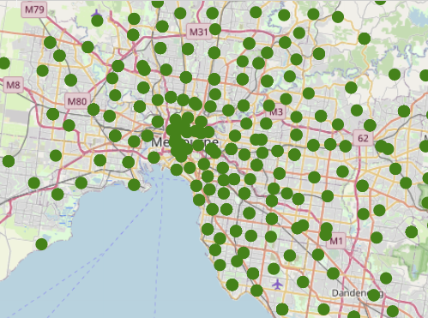

1. **Analysis**

Using a Clustering algorithm upon the classification of the data generated from Foursquare for each suburb it was possible to classify or rate the strength of availability of drinking establishments ion the Melbourne area.

The following output was generated and the common Violet - > Red colour model of strong to cold was applied.

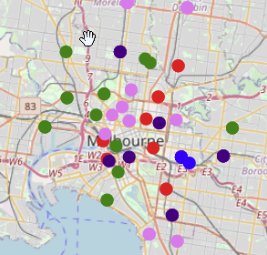

1. **Finding and Recommendations**

The generated output shows clearly that the central part of Melbourne (commonly known as the CBD) is not the most highly rated location to find drinking establishments of a varied range.

Indeed the most densely available areas are outside of the CBD and located in what are historically and locally recognised as the more cosmopolitan areas of Melbourne