Ряды | Размеры | 1 x 1 | 1 x 1.25 | 1x1.5 | 1 x 1.75 | 1 x 2 | 1x2.25 | 1x2.75 | 1x6.25 | 2 x 1
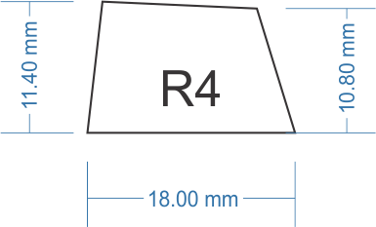 |  | Esc F1-F12 PrtScr ScrLck Break ~ - =  1 2 3 4 5 6 7 8 9 0  Insert Home PgUp  NumLock Num/  Num * Num- |  |  |  | Backspace
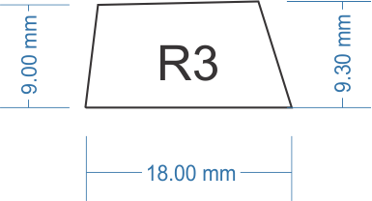 |  | Q W E R T Y  U I O P { }  Del End PgDn  Num7 Num8 Num9 |  | Tab  \ |  |  |  |  |  | Num+
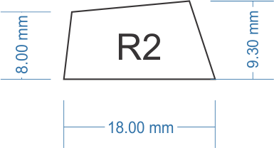 |  | A S D F G H  J K L ; '  Num4 Num5 Num6  Num. |  |  | CapsLock |  | Enter
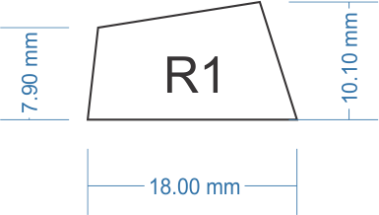 |  | Z X C V B N M , . /  Up Left Right Down  Num1 Num2 Num3 | Ctrl Win  Alt noWin  Fn |  |  | Num0 | LShift | RShift |  | Num_Enter
 |  |  |  |  |  |  |  |  | Space

(красный10 голубой1)

