实验名称 数据可视化实验

学号 2228324110 姓名 王浩强 专业 移动开发方向

【实验要求】
题目1: 现在有`奖牌.csv`这个数据集,要求根据这个数据集绘制分组柱形图:
具体要求: 图表字体规范:中文字体为宋体,英文字体为Times New Roman.
图表必须要有坐标轴名称,标题,图例,合理进行配色,下图为示例图表.可做参考.
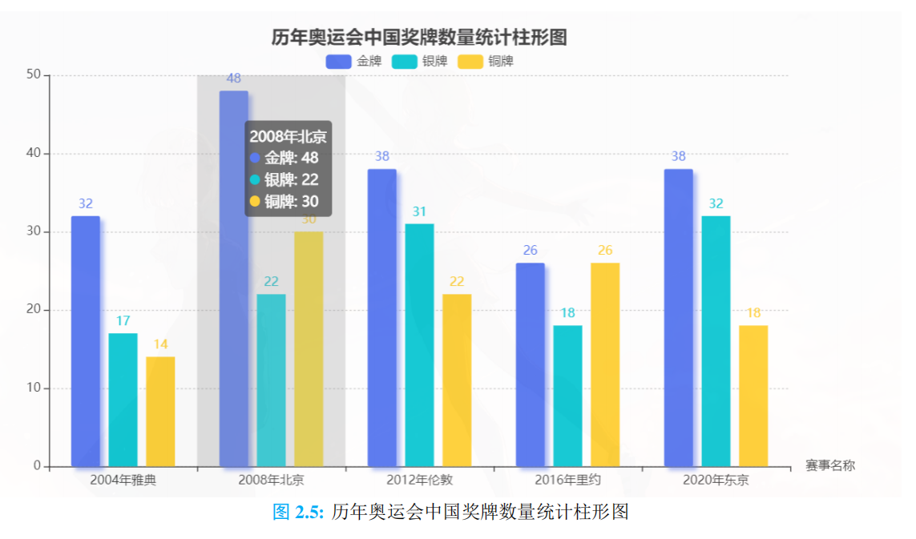
题目2: 现在有降雨量.csv这个数据集,要求根据所给数据集绘制降雨量变化折线图,
图表要求有坐标轴名称,标题,图例,合理进行图表的配色,和保存.下面是参考示例:
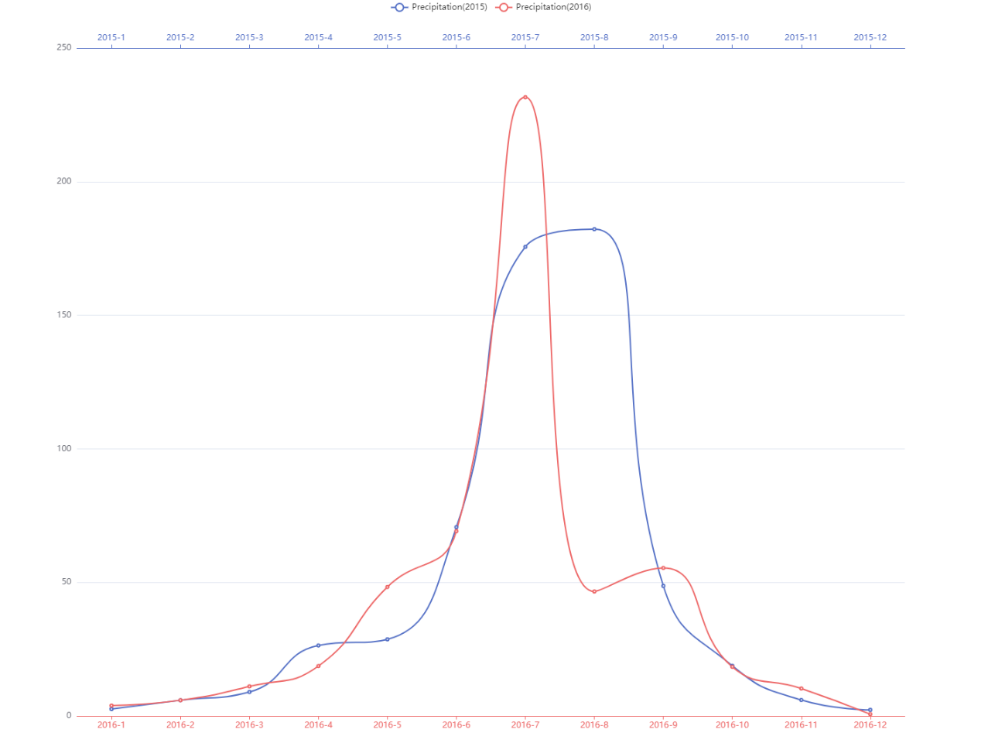

【实验结果】
核心代码 | #第一张图  with plt.style.context(matplotx.styles.pitaya_smoothie['light']):  plt.rcParams['font.sans-serif'] = ["Times New Roman"]  x = np.arange(data2.shape[0])  plt.figure(figsize=(16,12),dpi=100)  rects1 = plt.bar(x-.3,height=data2["金牌"],width=.25,fc="#5d7bee",label = "金牌")  rects2 = plt.bar(x,height=data2["银牌"],width=.25,fc="#13c4cf",label = "银牌")  rects3 = plt.bar(x+.3,height=data2["铜牌"],width=.25,fc="#f8cc39",label= "铜牌")  ax=plt.gca()  ax.yaxis.grid(True, linestyle='--', which='major')  ax.xaxis.grid(False)  for rect in zip(rects1,rects2,rects3):  rect[0].remove()  rect[1].remove()  rect[2].remove()  patch1 = get_round_rect(rect[0], fc="#5d7bee")  patch2 = get_round_rect(rect[1], fc="#13c4cf")  patch3 = get_round_rect(rect[2], fc="#f8cc39")  ax.add_patch(patch1)  ax.add_patch(patch2)  ax.add_patch(patch3)  plt.ylim(0,55)  lists = []  for i in range(data2.shape[0]):  lists.append(data2.iloc[i,0])  plt.legend(loc = "upper center",ncol = 3,  bbox_to_anchor=(0.5, 1.05),  prop= FontProperties(family='STsong'),  fancybox = False,  framealpha = 0)  plt.xticks(ticks=x,labels=lists,fontproperties='STsong',fontsize = 20)  for i in range(data2.shape[0]):  plt.text(x[i]-.3,data2["金牌"][i]+1,data2["金牌"][i],va = "bottom",ha = "center")  plt.text(x[i],data2["银牌"][i]+1,data2["银牌"][i],va = "bottom",ha = "center")  plt.text(x[i]+.3,data2["铜牌"][i]+1,data2["铜牌"][i],va = "bottom",ha = "center")  plt.xlabel("赛事名称",fontdict={"family":"STsong"},fontsize= 20,)  plt.ylabel("奖牌的数量",fontdict={"family":"STsong"},fontsize= 20)  ax.xaxis.set_label_coords(1.05 ,0)  plt.title("历年奥运会中国奖牌数量统计柱形图",fontdict={"family":"STsong"},size=20,y = 1.05)  plt.savefig("C:/Users/wang/Desktop/pyLearn/模块4-数据可视化/figure/作业_奖牌.png")  plt.show()  #第二张图  plt.rcParams['font.family'] = 'Times New Roman'  plt.rcParams['font.size'] = 14  fig, ax1 = plt.subplots(figsize=(14,8), dpi=100)  ax1.plot(data.loc[12:]["Date"],data.loc[12:]["Value_2016"], lw=1, color='#ef8484', label='Precipitation(2016)')  ax1.plot(data.loc[12:]["Date"],data.loc[12:]["Value_2016"], 'ro')  ax1.grid(axis='y', linestyle='--', which='major')  ax2 = ax1.twiny()  ax2.plot(data.loc[:12]["Date"],data.loc[:12]["Value_2015"], lw=1, color='#768bcf', label='Precipitation(2015)')  ax2.plot(data.loc[:12]["Date"],data.loc[:12]["Value_2015"], 'bo')  lines1, labels1 = ax1.get_legend_handles_labels()  lines2, labels2 = ax2.get_legend_handles_labels()  lines = lines1 + lines2  labels = labels1 + labels2  plt.legend(lines,labels,loc = "upper center",ncol = 2,  bbox_to_anchor=(0.5, 1.15),  fancybox = False,  framealpha = 0)  plt.savefig("C:/Users/wang/Desktop/pyLearn/模块4-数据可视化/figure/作业_降雨量.png")  plt.show()

