FitBuddy AI Fitness Plan Generator
Complete Project Report
FastAPI Gemini SQLite SQLAlchemy Jinja2
Field | Details
Project | FitBuddy AI Fitness Plan Generator
Category | AI Assisted Web Application
Submission | Complete Source Code and Phase Documentation
Prepared | October 2026

Academic project documentation

Abstract
FitBuddy is an AI-assisted fitness planning web application that generates a personalized seven-day workout schedule from a user's age, weight, goal, and preferred intensity. The application also provides a concise nutrition or recovery tip, accepts user feedback to revise the latest plan, stores original and revised plans in SQLite, and exposes an admin view plus JSON API endpoints.
The solution uses FastAPI, Pydantic, Jinja2, SQLAlchemy, SQLite, and the Google Gen AI Python SDK. A deterministic offline fallback ensures that required project flows remain demonstrable without a live key or during a temporary API failure. The verified build includes nine passing automated tests with 91 percent application-code coverage, phase-wise documents, screenshots, an editable report, a PDF, and a five-minute demonstration script.

Contents
1 Introduction 8 Testing and Results
2 Objectives and Scope 9 Security Safety and Limitations
3 Requirements Analysis 10 Installation and Operation
4 System Design 11 Demonstration and Submission
5 Database and API Design 12 Conclusion
6 Development and Implementation References
7 User Interface and Working Output Appendices

1 Introduction
Many beginners understand a fitness goal but struggle to convert it into a balanced weekly routine. Generic plans may not reflect age, weight, preferred intensity, recovery needs, or later feedback. FitBuddy provides a single interface that creates, saves, and revises a structured week.
The project demonstrates an end-to-end AI web application rather than a standalone model call. Validated data moves through a FastAPI route, an AI service, and a database service before a Jinja2 page displays the result. The same core services also support JSON endpoints.

1 1 Problem Statement
Users need a clear, accessible way to obtain a seven-day fitness schedule and refine it without manually rewriting the entire plan. Students also need a project that reliably demonstrates AI integration, persistence, testing, documentation, and user experience.

1 2 Proposed Solution
- Collect the minimum profile data required for a useful plan.
- Generate Day 1 through Day 7 with warm-up, main work, cooldown, and recovery.
- Create a goal-related nutrition and hydration tip.
- Use feedback to produce and store a revised version.
- Display users and plan status in a coach or evaluator view.
- Remain demonstrable through a transparent offline fallback.

2 Objectives and Scope

2 1 Objectives
- Build a complete FastAPI application with a responsive web interface.
- Use Gemini through the current Google Gen AI SDK with a configurable model.
- Persist users, original plans, nutrition tips, feedback, and revised plans.
- Expose both HTML workflows and validated JSON endpoints.
- Provide automated evidence for required functionality.
- Package source code, eight phases, report, screenshots, and demo guidance.

2 2 Scope
Included | Excluded
Plan generation and feedback revision | Medical diagnosis or treatment
Five supported fitness goals | Wearable device integration
Three intensity levels | Payments or subscriptions
SQLite storage and admin page | Public user authentication
Gemini and offline fallback modes | Cloud production deployment
Tests and formal documentation | Prescription nutrition plans

3 Requirements Analysis
Requirements were derived from the supplied project description and demonstration instructions. Each major functional requirement maps to an implemented route or test.
ID | Functional requirement | Acceptance condition
FR 01 | Collect user profile and preference | Six required inputs are validated
FR 02 | Generate weekly plan | Output contains Day 1 through Day 7
FR 03 | Generate nutrition tip | Tip is shown on result page
FR 04 | Persist user and original plan | SQLite records are created
FR 05 | Revise from feedback | Updated plan is stored and displayed
FR 06 | Display admin view | User and latest status are listed
FR 07 | Provide API endpoints | JSON creation and feedback succeed
FR 08 | Support demo mode | Full flow works without an API key

3 1 Nonfunctional Requirements
Area | Design response
Usability | Responsive form, clear labels, readable status and errors
Security | Environment-only key, ignored secret files, validated input
Reliability | Fallback mode and controlled error responses
Maintainability | Separated configuration, routes, AI, services, and database
Testability | Deterministic output and isolated test database
Safety | General guidance and explicit pain/health warning

4 System Design
FitBuddy follows a layered design. The browser interacts with HTML routes, Pydantic validates incoming data, the AI service generates content, service functions manage persistence, and SQLAlchemy maps data to SQLite.
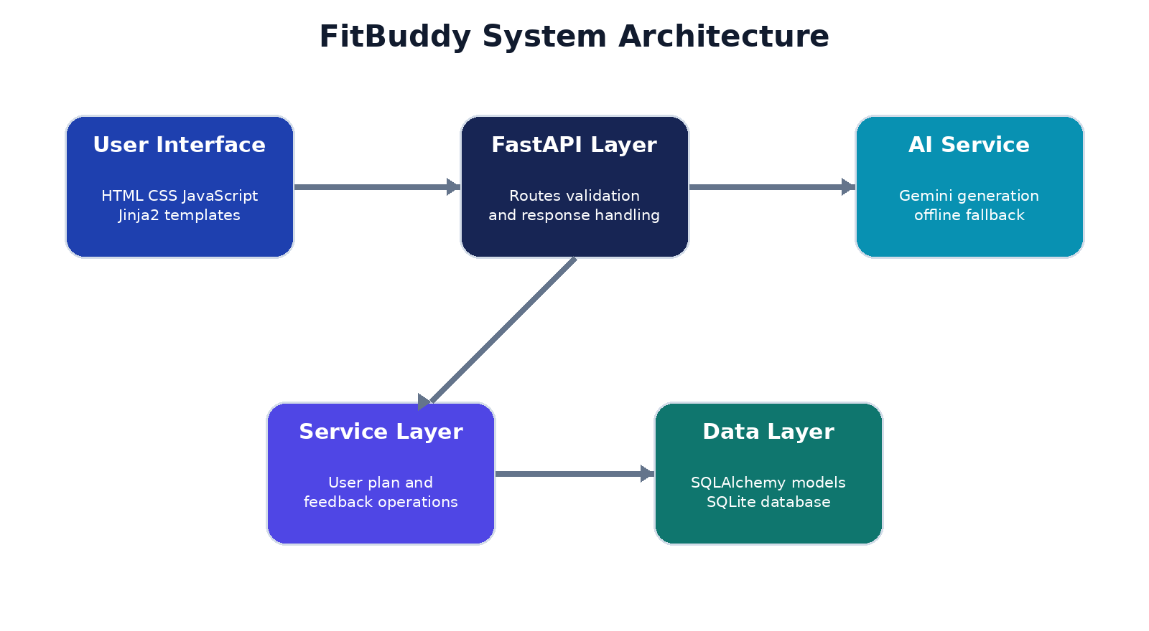
Figure 1 FitBuddy system architecture

4 1 Component Design
Module | Responsibility
config.py | Environment variables and AI mode
database.py | Engine sessions entities and table creation
schemas.py | Validated workout feedback and response models
ai_service.py | Gemini prompts and deterministic fallback
services.py | User plan feedback and list operations
routes.py | HTML pages and JSON endpoints
main.py | FastAPI application startup and static mounting

5 Database and API Design
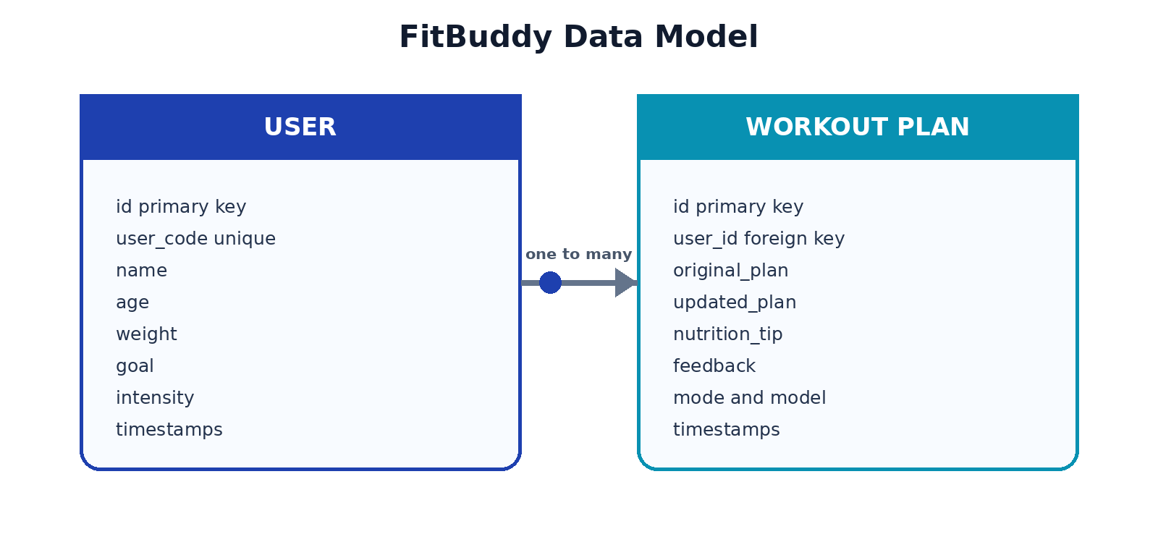
Figure 2 FitBuddy data model

5 1 Main Routes
Method | Path | Purpose
GET | / | Display plan form
POST | /generate-workout | Generate save and display plan
POST | /submit-feedback | Revise latest plan
GET | /view-all-users | Display coach dashboard
GET | /api/health | Return application and AI status
POST | /api/workouts | Create plan as JSON
POST | /api/feedback | Revise plan as JSON
GET | /docs | Open interactive API documentation

5 2 Input Validation
Field | Rule
Name | 2 to 80 characters
User ID | 2 to 40 characters
Age | 13 to 90
Weight | 25 to 300 kilograms
Goal | One of five supported values
Intensity | Low medium or high
Feedback | 5 to 500 characters

6 Development and Implementation
The project uses the current `google-genai` package. The model is read from `GEMINI_MODEL`, so the application can be updated without source changes. The default supplied configuration uses `gemini-3.8-flash`.

6 1 Application Startup
app = FastAPI(title=settings.app_name, version=settings.app_version, lifespan=lifespan)
app.mount('/static', StaticFiles(directory=STATIC_DIR), name='static')
app.include_router(router)

6 2 Gemini Request
with genai.Client(api_key=settings.gemini_api_key) as client:
response = client.models.generate_content(
model=settings.gemini_model,
contents=prompt,
)

6 3 Resilient Generation
If no key is configured, demo mode is enabled, or Gemini fails while fallback is allowed, the AI service returns a deterministic seven-day plan. Every stored plan records the model and generation mode, preventing the demonstration from presenting fallback output as a live Gemini response.

6 4 Security Controls
- `.env` is excluded from Git while `.env.example` shows safe configuration names.
- All form and API input passes through Pydantic.
- SQLAlchemy parameterizes database work.
- Jinja2 escapes inserted text by default.
- API keys never enter templates, logs, tests, screenshots, or saved records.

7 User Interface and Working Output
The interface uses a responsive navy, blue, cyan, and violet design system. The same application responses used during verification produced the screenshots below.
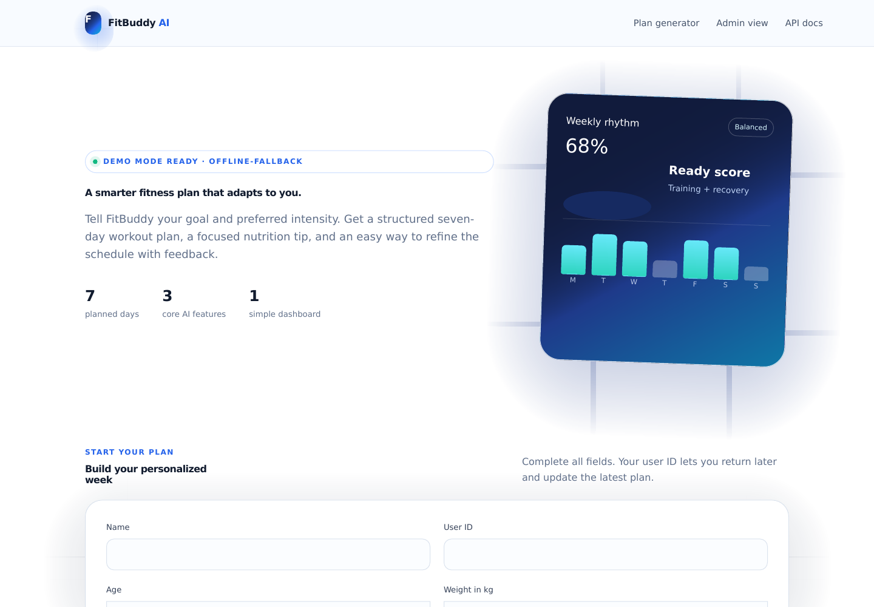
Figure 3 Plan generator home page
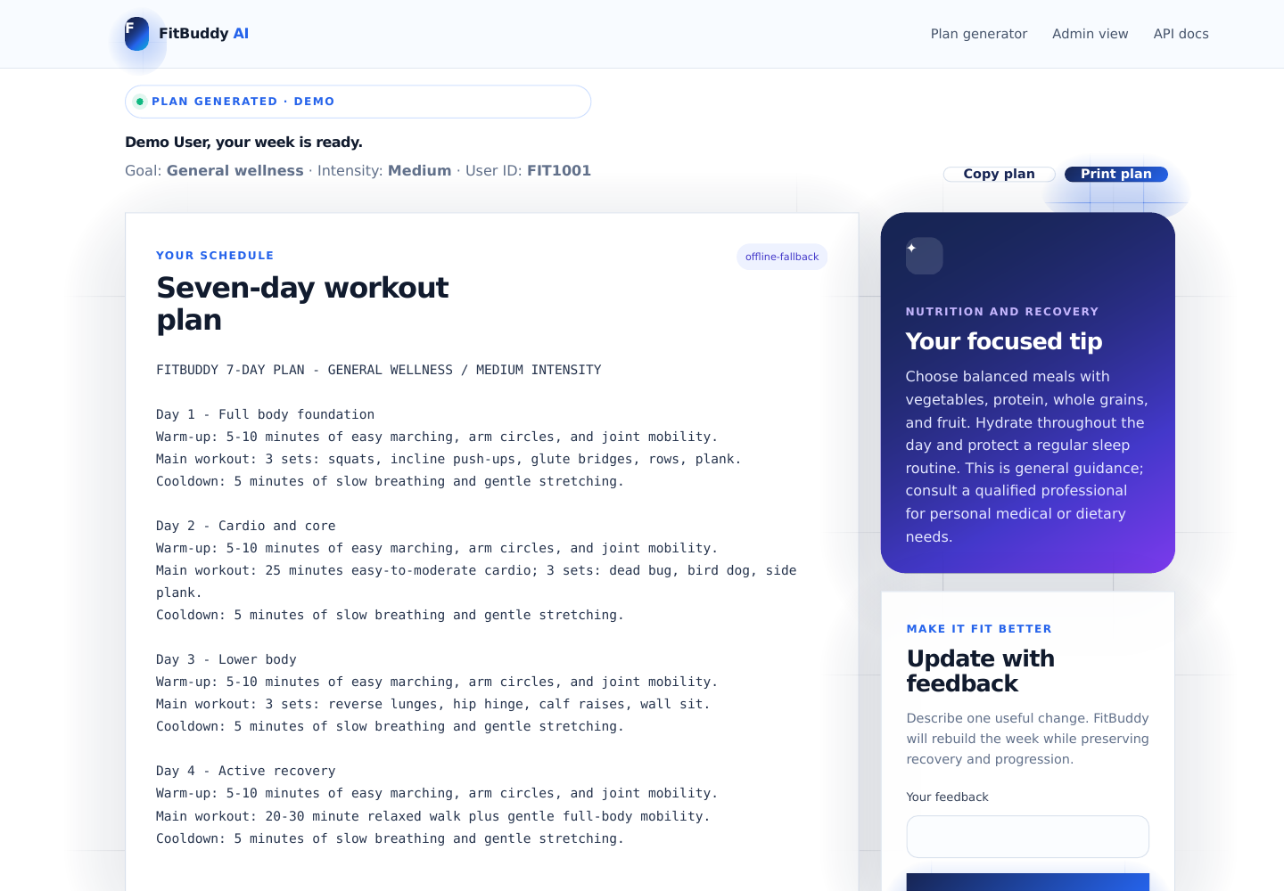
Figure 4 Generated plan and nutrition tip
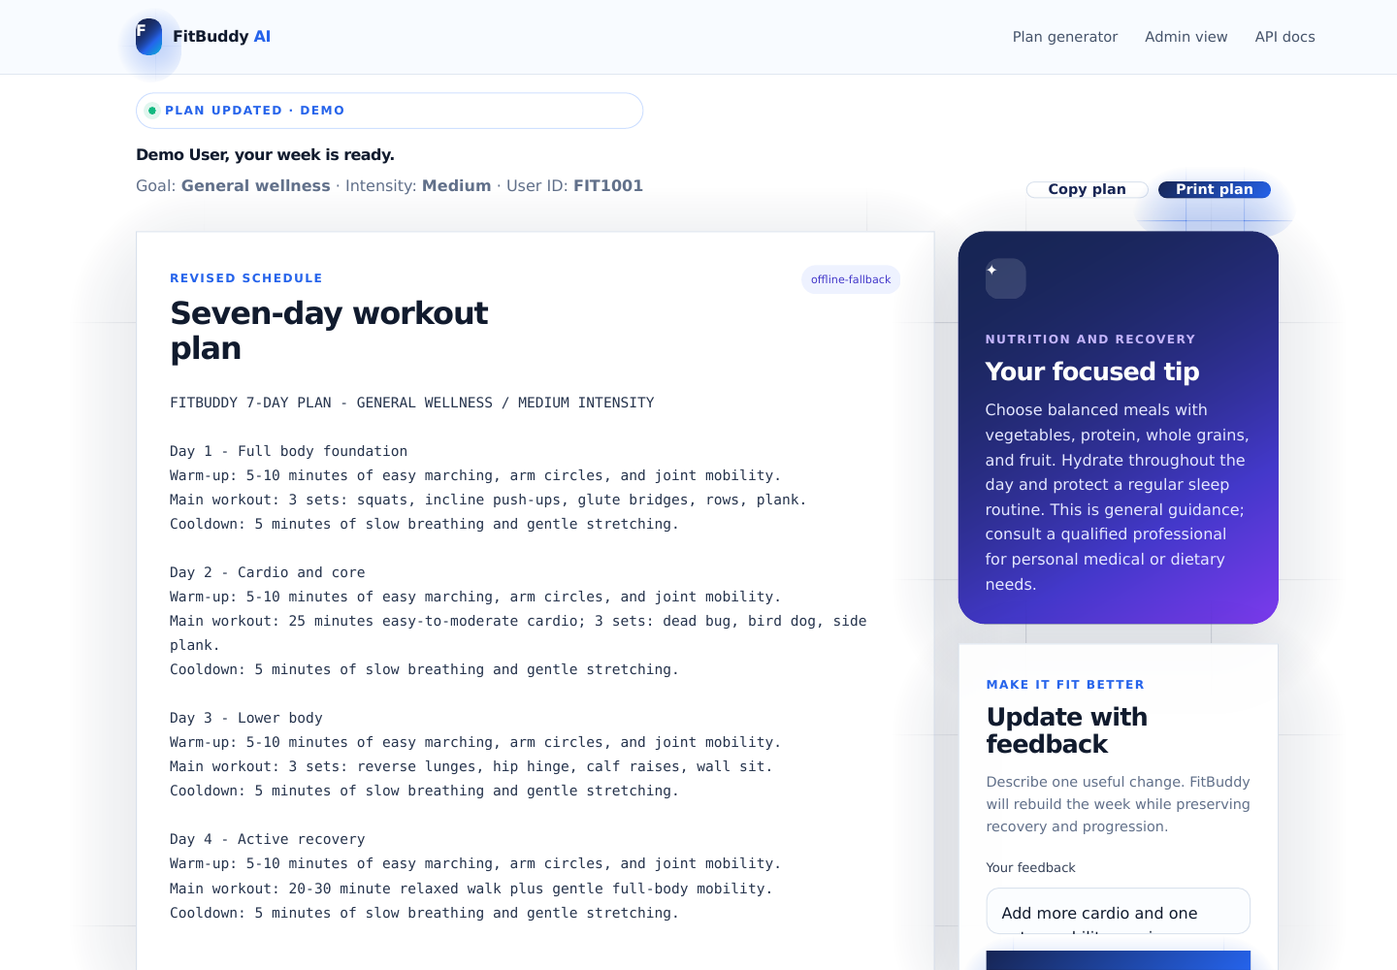
Figure 5 Feedback based plan update
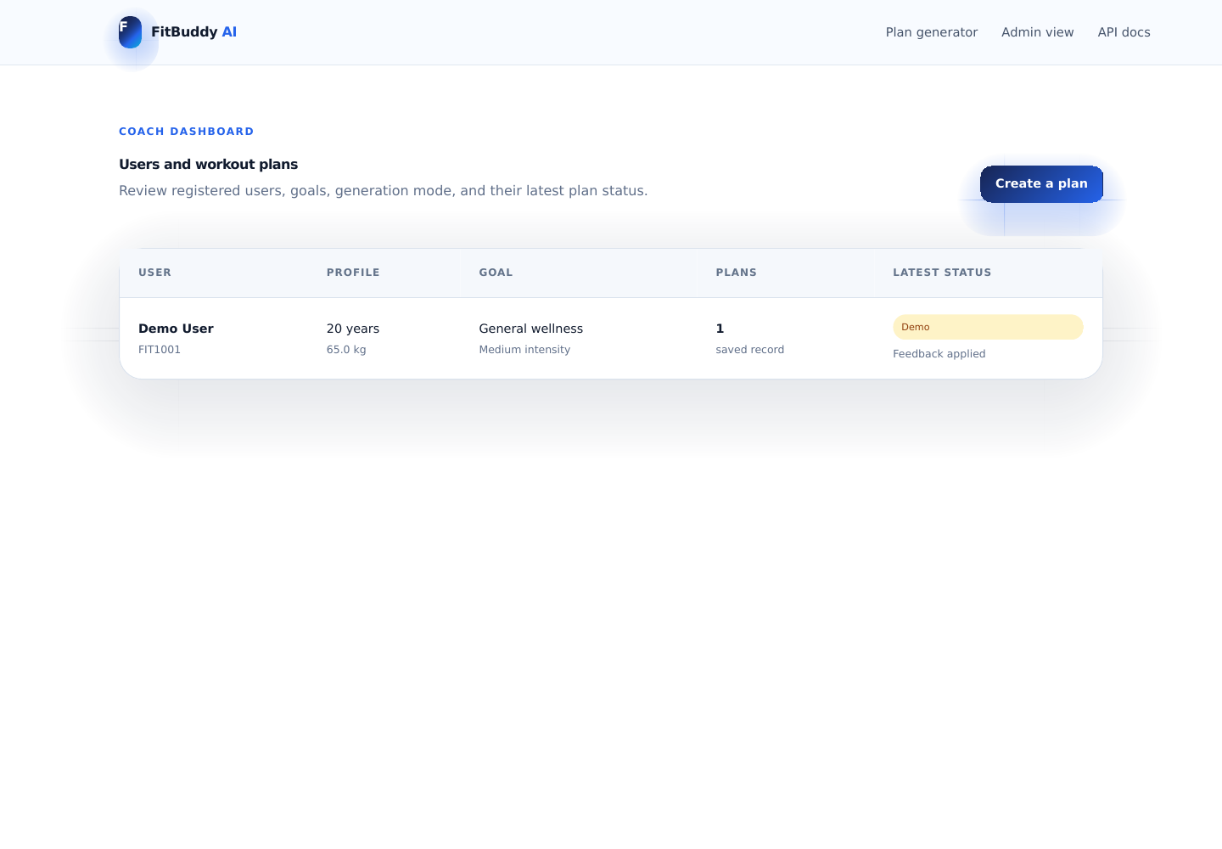
Figure 6 Admin dashboard

8 Testing and Results
Automated testing ran in demo mode with a separate SQLite database. This proves the required web, database, validation, feedback, admin, and API flows without consuming a live key.
Metric | Verified result
Tests | 9 passed
Failures | 0
Application code coverage | 91 percent
Database | Isolated SQLite test database
External AI calls | None during tests

8 1 Test Cases
ID | Scenario | Result
TC 01 | Home page and demo status | Pass
TC 02 | Generate and store a seven-day plan | Pass
TC 03 | List user on admin page | Pass
TC 04 | Update latest plan from feedback | Pass
TC 05 | Reject unknown feedback user | Pass
TC 06 | Reject invalid age | Pass
TC 07 | JSON create and update flow | Pass
TC 08 | Health endpoint | Pass
TC 09 | Fallback seven-day content and safety | Pass

python -m pytest --cov=app --cov-report=term-missing
......... [100%]
9 passed
TOTAL application coverage 91%

9 Security Safety and Limitations

9 1 Security
- Secret values stay in environment variables.
- Input ranges and lengths reduce malformed requests.
- Database operations use an ORM.
- The repository ignores secrets, local environments, caches, and databases.

9 2 Safety
FitBuddy provides general wellness information, not medical diagnosis or treatment. Prompts and fallback plans include a safety note. Users should stop if they feel sharp pain and seek qualified guidance for injuries or health concerns.

9 3 Limitations
- AI output can vary and may need professional review.
- The academic admin page does not include authentication.
- SQLite is suitable for local demonstration but not every large public deployment.
- The application does not integrate wearables or clinical data.
- A public production service would require formal privacy controls and rate limits.

10 Installation and Operation
- Install Python 3.11 or newer.
- Open the FitBuddy AI project folder in VS Code.
- Create and activate a virtual environment.
- Install requirements.
- Copy `.env.example` to `.env` and add a private key if live Gemini is required.
- Start Uvicorn and open the local URL.
python -m venv .venv
.venv\Scripts\activate
python -m pip install -r requirements.txt
python -m uvicorn app.main:app --reload

10 1 Main URLs
URL | Use
http://127.0.0.1:8000 | Plan generator
http://127.0.0.1:8000/view-all-users | Admin dashboard
http://127.0.0.1:8000/docs | Interactive API documentation
http://127.0.0.1:8000/api/health | Status check

11 Demonstration and Submission
The recommended demonstration lasts approximately five minutes and includes the code structure, local startup, plan generation, nutrition tip, feedback update, admin view, and passing tests.
Time | Demonstration activity
0 00 to 0 30 | Name purpose and technology stack
0 30 to 1 45 | Project tree core code and secure configuration
1 45 to 2 15 | Start Uvicorn
2 15 to 3 05 | Generate a seven-day plan
3 05 to 3 40 | Show plan and nutrition tip
3 40 to 4 15 | Apply feedback
4 15 to 4 35 | Show admin page
4 35 to 5 00 | Show tests and conclude

11 1 Submission Items
- Public GitHub repository containing source, tests, docs, screenshots, and reports.
- Google Drive demo video link set to Anyone with the link Viewer.
- Phase-wise documentation and final report.
- SkillWallet tasks moved to To Be Reviewed after links are submitted.

12 Conclusion
FitBuddy meets the required project goal by delivering a complete AI-assisted fitness planning application rather than an isolated prototype. It generates and stores a seven-day plan, provides a supporting tip, revises the plan from feedback, displays user status, and exposes tested API endpoints.
The modular code, configurable model, secret-safe setup, deterministic fallback, passing tests, screenshots, and phase-wise documentation make the project ready for local demonstration and GitHub submission. Future improvements can add authentication, production deployment, professional content review, progress tracking, and wearable integration.

References
1. Google AI for Developers. Gemini API documentation. https://ai.google.dev/gemini-api/docs
2. Google. Google Gen AI Python SDK documentation. https://googleapis.github.io/python-genai/
3. FastAPI. Official documentation. https://fastapi.tiangolo.com/
4. SQLAlchemy. Official documentation. https://docs.sqlalchemy.org/
5. Pydantic. Official documentation. https://docs.pydantic.dev/
6. Python Software Foundation. Python documentation. https://docs.python.org/3/

Appendix A Project File Inventory
Folder or file | Purpose
app | Application source templates and static assets
tests | Automated test suite
docs | Eight phases API guide script checklist and screenshots
reports | Editable and fixed-view reports
requirements.txt | Runtime packages
requirements-dev.txt | Testing packages
.env.example | Secret-safe configuration template
README.md | Main setup and submission guide
run.bat and run.sh | Convenient local startup
Dockerfile | Optional container startup

Appendix B Submission Checklist
- Public repository link works without sign-in.
- No `.env`, API key, virtual environment, or database is uploaded.
- All nine tests pass.
- DOCX and PDF reports are present.
- Demo video includes screen sharing and voice-over.
- Drive permission is Anyone with the link Viewer.
- GitHub documentation and video links are submitted in SkillWallet.
- Completed tasks are moved to To Be Reviewed.

