**ASSIGNMENT 01**

Q. Create a local git repository in your local machine first.

Commit the initial code

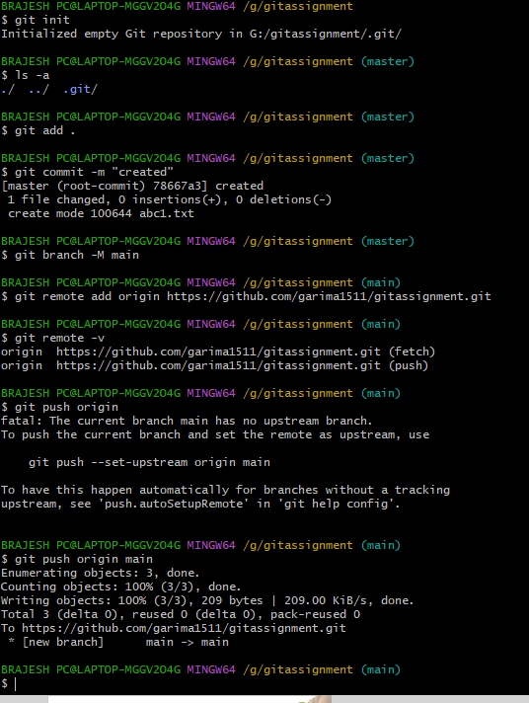

Q2. Update the code on the remote server . Also perform some changes on remote n reflect the same on local.[push/pull operations]

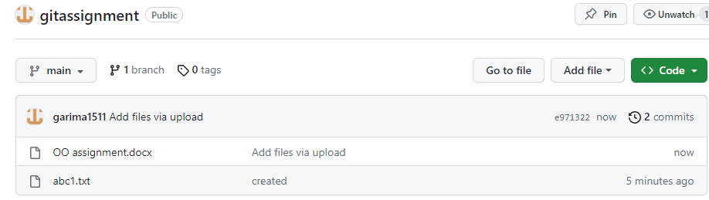

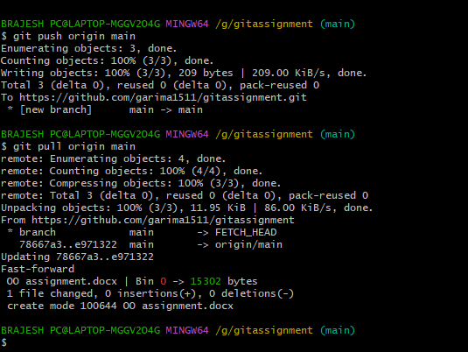

Q3. Create g1 branch on the github..................Add 1 txt file .................Raise a pull request on remote from g1 towards main........................... and merge without conflicts.

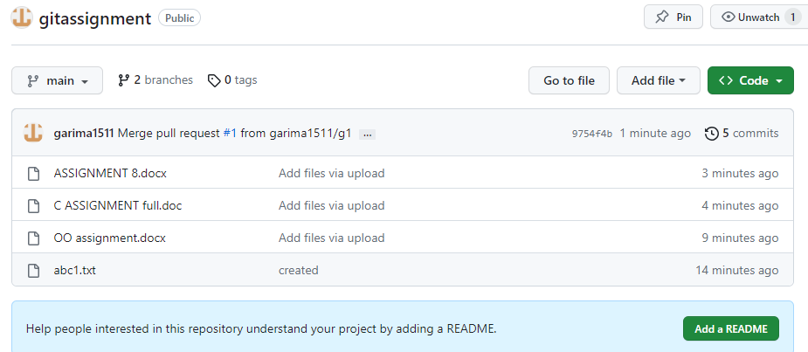

Local git: Use git commands to

o Get the updated files

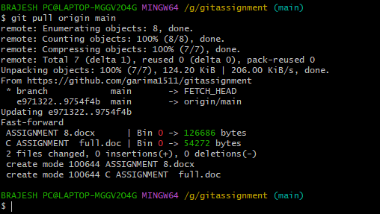

o Perform reset

o List the changes

o Create local branches main>>>b1,update........b1>>>>b2,update b2>>>>>b3

and update them as well.

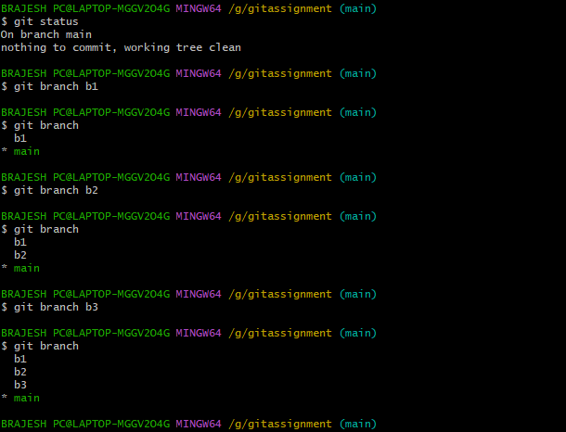

o List the changes [via diff and via ls]

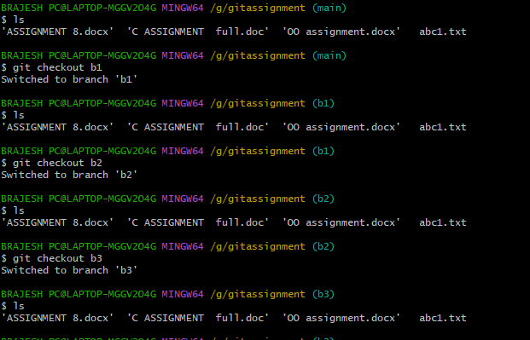

Demonstrate diff between local branches

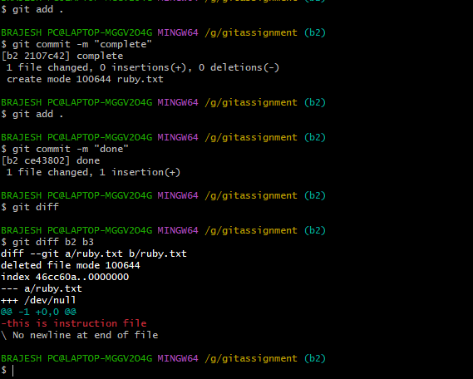

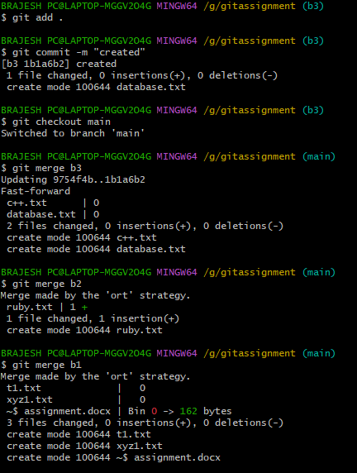

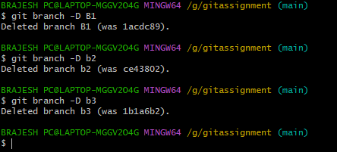

Perform fork operations on your repository as well.

