**Java Lab Exam 1**

Q  1  Given an array A of positive integers. Your task is to find the leaders in the array. An element of array is leader if it is greater than or equal to all the elements to its right side. The rightmost element is always a leader.

Example 1:

Input:

n = 6

A[] = {16,17,4,3,5,2}

Output: 17 5 2

Explanation: The first leader is 17

as it is greater than all the elements

to its right.  Similarly, the next

leader is 5. The right most element  is always a leader so it is also included.

package javaexam1;

public class LeadersInArray

{

void printLeaders(int arr[],int size)

{

for(int i=0;i<size;i++)

{

int j;

for(j=i+1;j<size;j++)

{

if(arr[i]<=arr[j])

break;

}

if(j==size)

System.***out***.print(arr[i]+" ");

}

}

public static void main(String[] args)

{

LeadersInArray lead=new LeadersInArray();

int arr[]={16,18,4,3,8,2};

int n=arr.length;

lead.printLeaders(arr,n);

}

}

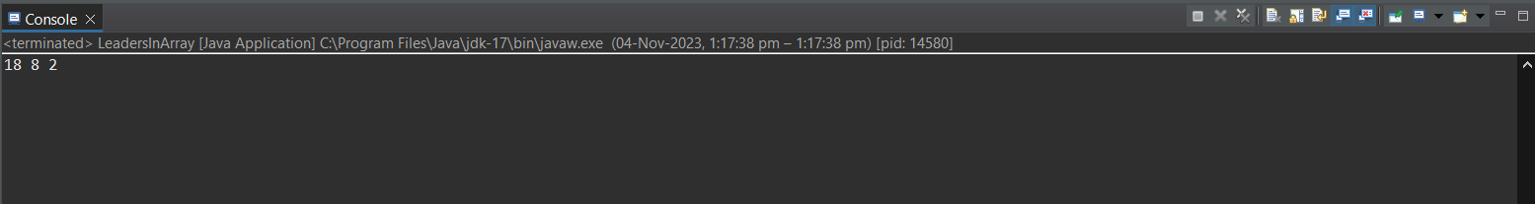

Q  2 Write a program to define two 3 * 3 matrix and perform matrix multiplication .

package javaexam1;

public class multiplication

{

public static void main(String[] args)

{

int[][] matrix1=

{

{1,2,3},

{4,5,6},

{7,8,9}

};

int[][] matrix2=

{

{9,8,7},

{6,5,4},

{3,2,1}

};

int[][] result=*multiplyMatrices*(matrix1,matrix2);

System.***out***.println("Matrix 1 is:");

*printMatrix*(matrix1);

System.***out***.println("Matrix 2 is:");

*printMatrix*(matrix2);

System.***out***.println("Matrix Multiplication Result is:");

*printMatrix*(result);

}

public static int[][] multiplyMatrices(int[][] matrix1,int[][] matrix2)

{

int rows1=matrix1.length;

int cols1=matrix1[0].length;

int cols2 = matrix2[0].length;

int[][] result=new int[rows1][cols2];

for(int i=0;i<rows1;i++)

{

for(int j=0;j<cols2;j++)

{

for(int k=0;k<cols1;k++)

{

result[i][j]+=matrix1[i][k]*matrix2[k][j];

}

}

}

return result;

}

public static void printMatrix(int[][] matrix)

{

for(int i=0;i<matrix.length;i++)

{

for(int j=0;j<matrix[i].length;j++)

{

System.***out***.print(matrix[i][j]+" ");

}

System.***out***.println();

}

}

}

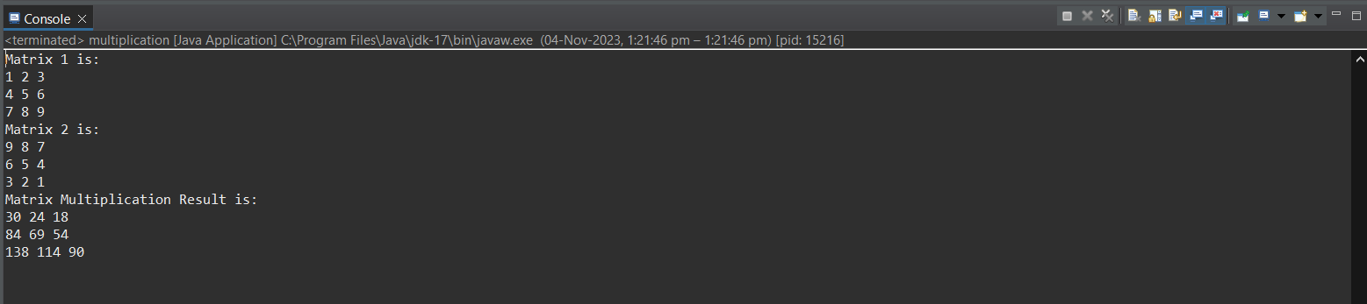

Q 3 write a program to define a 3*3 array and assign data within program .

Ask a number from user and search if that number exists in array or not .

If particular number exist with array then print “ **found** Message “ and also print row number and column of number if found .

Print “**data does not exists”**  if number not found.

package javaexam1;

import java.util.Scanner;

public class SearchArray

{

public static void main(String[] args)

{

int[][]array=

{

{1, 2, 3},

{4, 5, 6},

{7, 8, 9}

};

Scanner sc=new Scanner(System.***in***);

System.***out***.print("Enter the number to search for: ");

int target = sc.nextInt();

boolean found = false;

int row = -1;

int col = -1;

for(int i=0;i<3;i++)

{

for(int j=0;j<3;j++)

{

if(array[i][j]==target)

{

found=true;

row=i;

col=j;

break;

}

}

}

if(found)

{

System.***out***.println("Found: "+target);

System.***out***.println("Row: "+row);

System.***out***.println("Column: "+col);

}

else

{

System.***out***.println("Data does not exist");

}

}

}

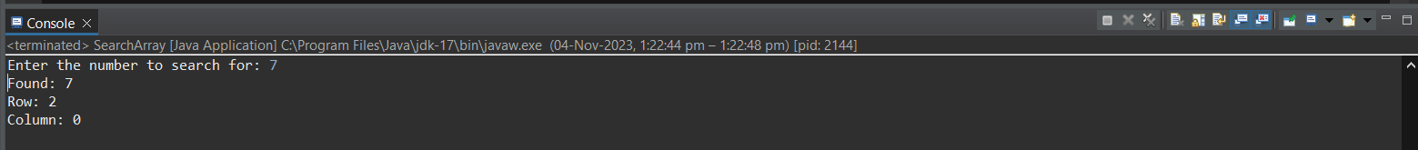

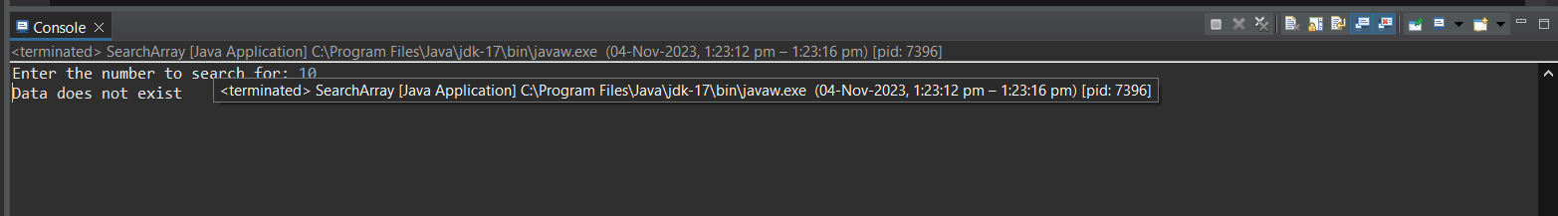

Q 4 Write a Java program to find the first  largest element in an array.

package javaexam1;

public class LargestElement_array

{

public static void main(String[] args)

{

int arr[]={100,20,50,5,2};

int max=arr[0];

for(int i=0;i<arr.length;i++)

{

if(arr[i]>max)

max=arr[i];

}

System.***out***.println("Largest element is:"+max);

}

}

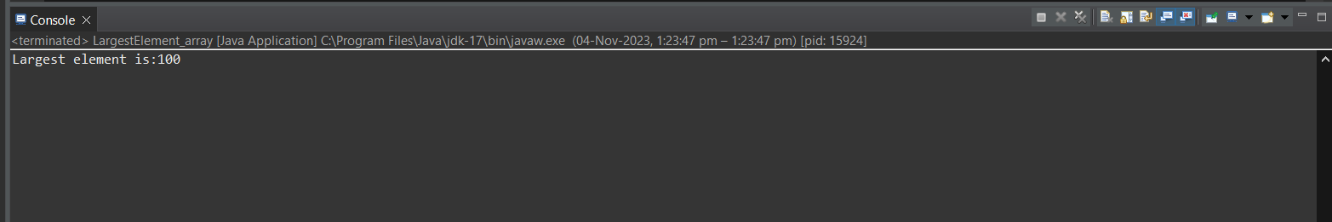

Q 5 Write a Java program to find the second largest element in an array.

package javaexam1;

public class SecondLargestNum

{

public static int getSecondLargest(int[]a,int total)

{

int temp;

for(int i=0;i<total;i++)

{

for(int j=i+1;j<total;j++)

{

if(a[i]>a[j])

{

temp=a[i];

a[i]=a[j];

a[j]=temp;

}

}

}

return a[total-2];

}

public static void main(String args[])

{

int a[]={1,2,8,6,3,0};

System.***out***.println("Second Largest is:"+*getSecondLargest*(a,6));

}

}

