Parallel action: replace text and image

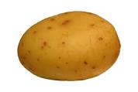

**A Potato a Day Keeps the Doctor Away.**