第三十三次课课堂笔记

1. gain a reputation for… 获得…的名声

# evil

2. The tiny village of Frinley is said to possess a cursed tree.

It is said that if anyone touches the tree, he will have bad luck.

当句子的动词是：**agree/announce/believe/consider/decide/expect/explain/hope/report/say/suggest/think** 可使用：（使句子更加正式/客观）

***# Sb/sth is said to do…***

***it is said that sb/sth…+句子***

e.g. (主) We expect the profit to increase by 10% next year.

(被) The profit is expected to increase by 10% next year.

(被) It is expected that the profit will increase by 10% next year.

(为了避免句子结构中 主语过长)

1) 强调动作本身/动作承受者—动作发出者无关紧要或者没必要提及

2) 客观性

双宾语结构的被动语态：

She gave me a pen. Give sb sth/give sth to sb

-- I was given a pen.

-- A pen was given to me.

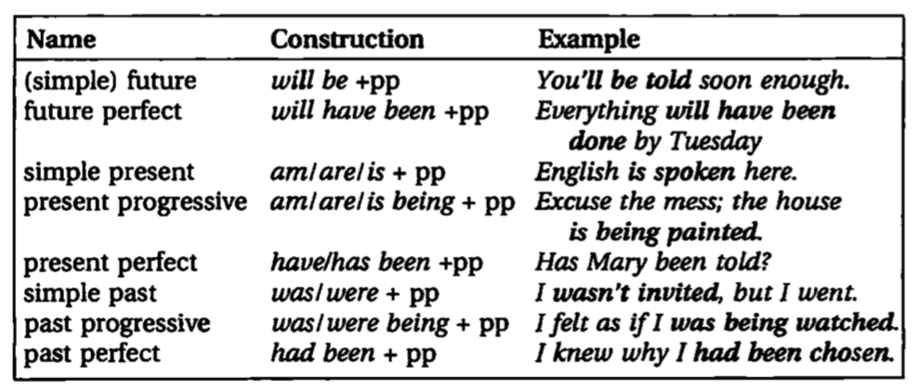

3. claim v. 宣称/宣布

v. 索赔 claim your money from the company 从公司报销

e.g. If you want to claim your money, you have to provide your invoice.

n. make a claim for 对…提出索赔

v. 夺走生命 claim a number of victims 夺走了好几个人的生命

4. complain about/of 抱怨…

5. spend time (in) doing sth 花时间做某事

spend weeks training him to press… train sb to do sth 训练某人做某事

6. an expert at… 一个…的专家

7. 目的状语

***to不定式/in order (not) to/so as (not) to + do sth 为了做某事***

***so that/in order that + 句子 目的状语从句***

e.g. He ran to the station in order to catch the train.

He works so hard in order that he may pass the exam.

8. in future 在未来

in the future

9. fair n. 集会 at a trade fair 交易会 Guangzhou Trade Fair

10. relative n. 亲人

11. 在, the moment/as soon as/when/before/after/until + 时间状语从句(将来时间)

或, if 一型主将从现 条件状语从句中，

***从句***要用一般现在时表将来

12. the fair in the village the village fair