practice DQL statement

Write SQL statement for the following

1. To find all managers with salary >1500 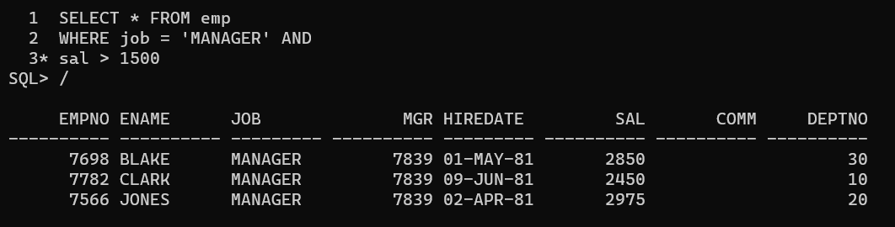
2. List all employees with sal >1200 and < 2000

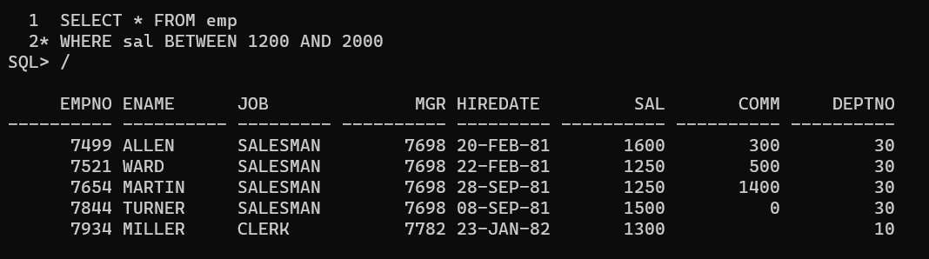

3.List all employees with sal is 1600 or sal is 800 or sal is 1900

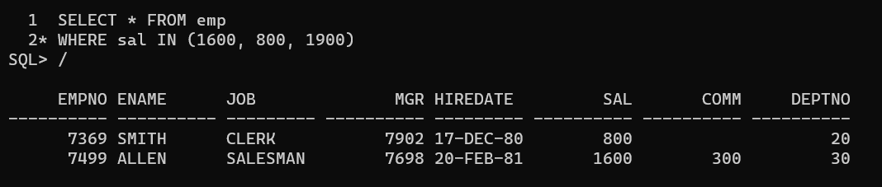

1. List all employees with R at second last position in name

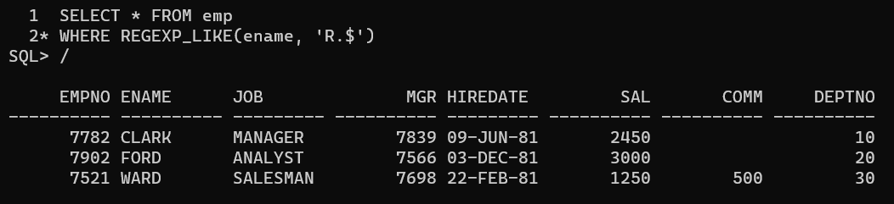

1. List all employees with name starts with A and ends with N

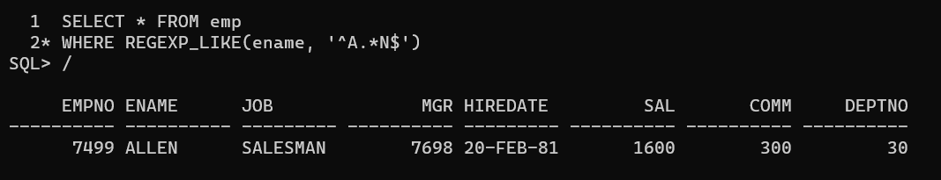

Q2. Solve following

* 1. List all employees with salary > 1250 and dept no=30

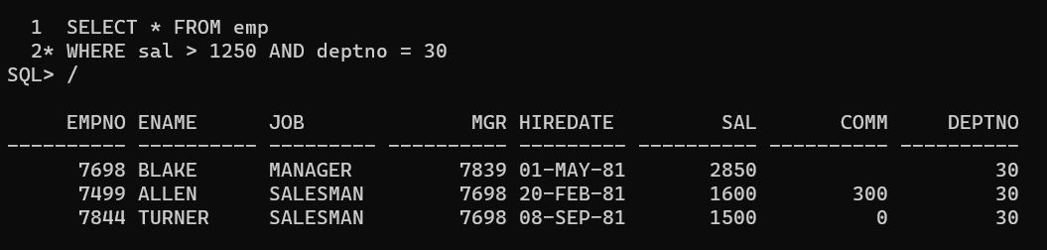

* 1. List all employees with salary >=1250 and <= 3000

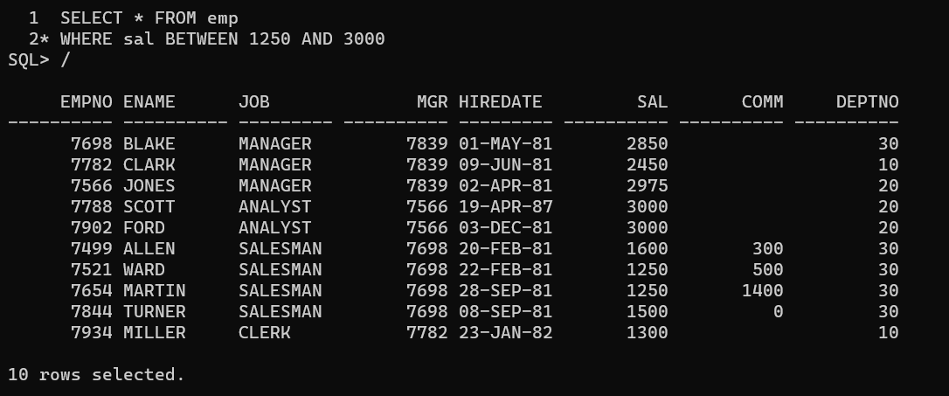

* 1. List all employees with salary >1250 and < 3000

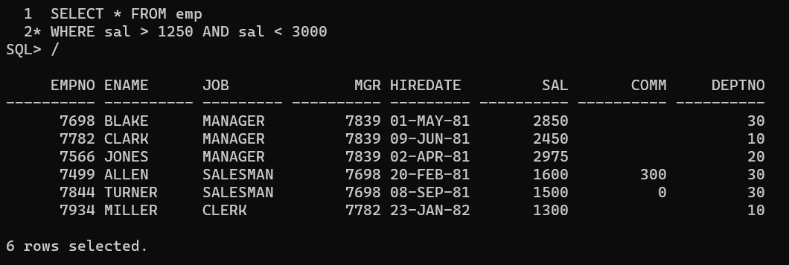

* 1. List all employees with salary either equal to 3000 or 1250

or 2500

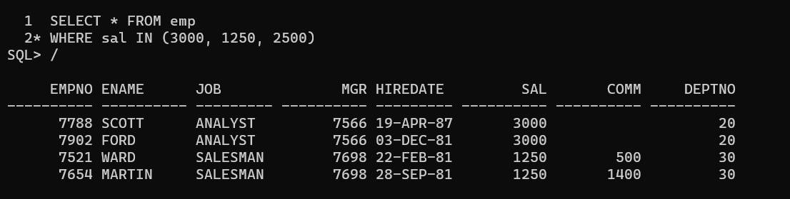

* 1. List all employee with name=SMITH

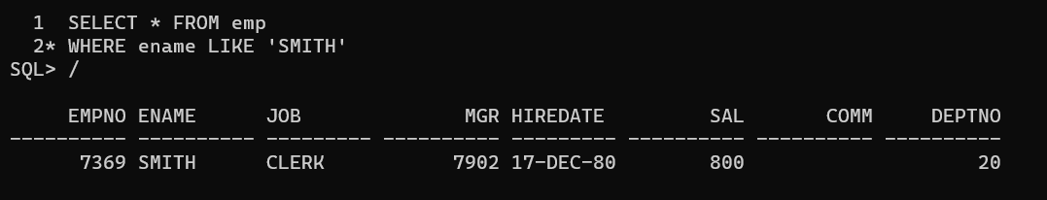

* 1. List all employees with name starting with S

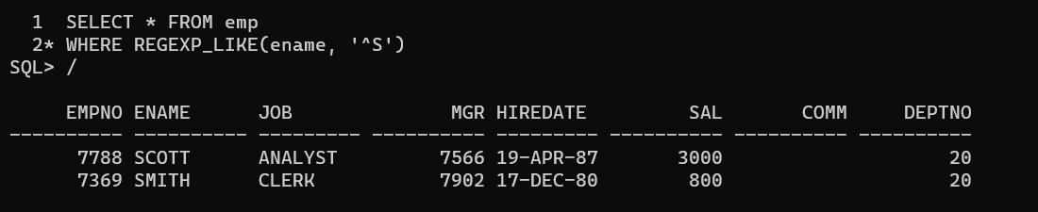

* 1. List all employees with name ending with S

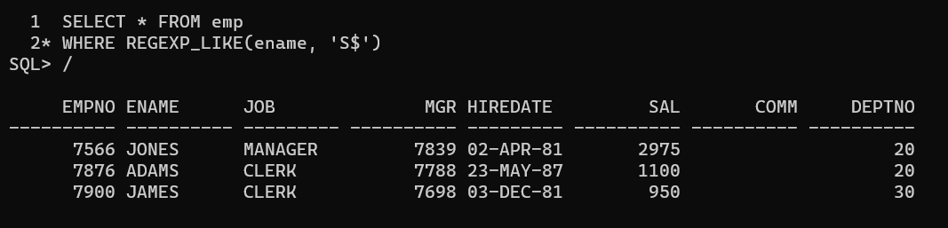

* 1. List all employees with name contains I at 2nd position

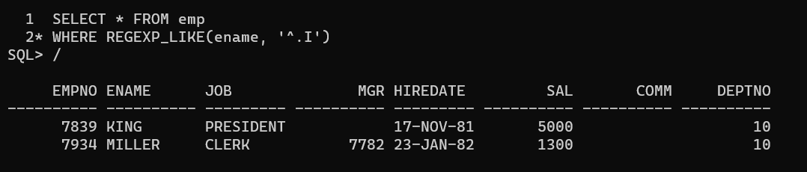

* 1. List all employees with name starts with A ends with N and somewhere in between L is there

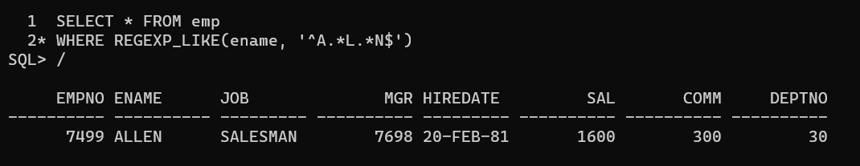

* 1. List all employees with name starts with A and B at 3rd position and P at second last position

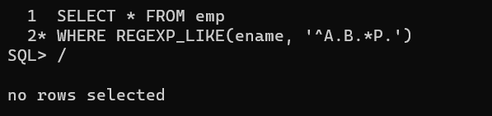

* 1. List all employees with name starts with either A or starts with S or starts with W

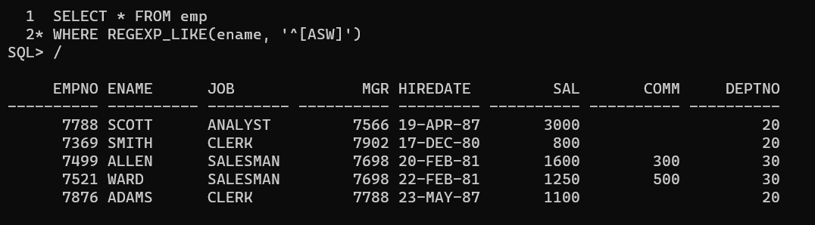

practice Aggregate functions

* 1. Find max sal and min sal for each job

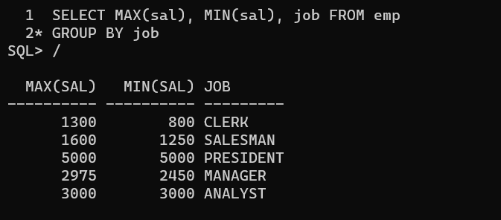

* 1. Find how many employees have not received commission

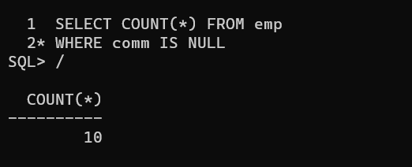

* 1. Find sum of sal of all employees working in dept no 10

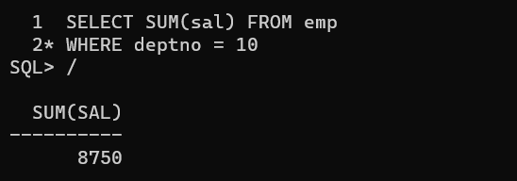

* 1. Find maximum salary, average sal for each job in every department

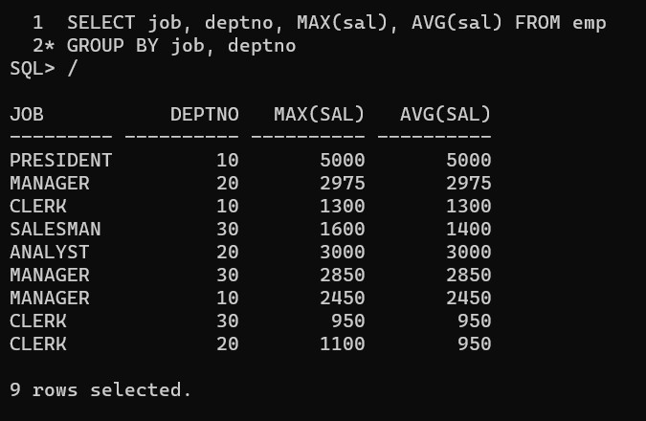

* 1. Find max salary for every department if deptno is > 15 and arrange data in deptno order.

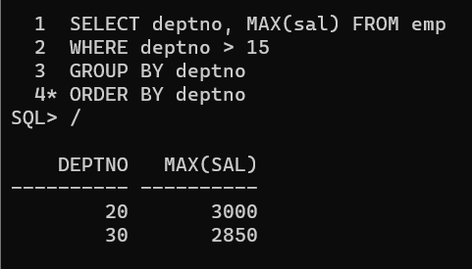

* 1. Find sum salary for every department if sum is > 3000

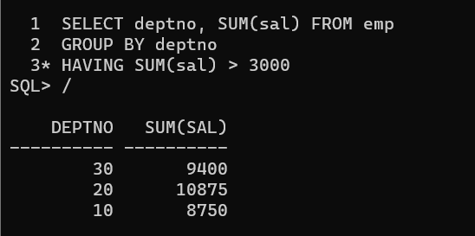

* 1. List all department which has minimum 5 employees

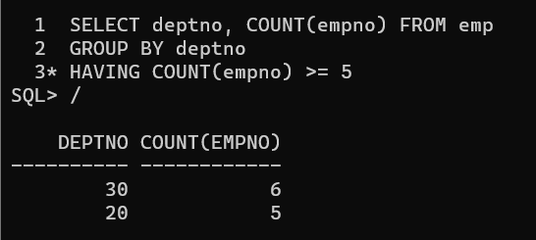

* 1. Count how many employees earn salary more than 2000 in each job

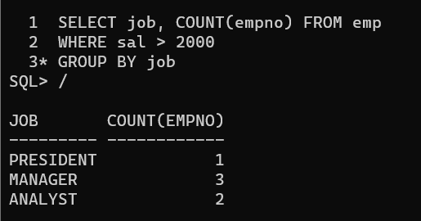

* 1. List all enames and jobs in small case letter

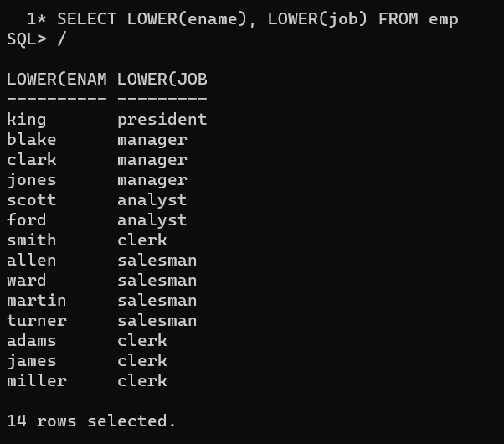

* 1. List all names and jobs so that the length of name should be 15 if it is smaller then add spaces to left

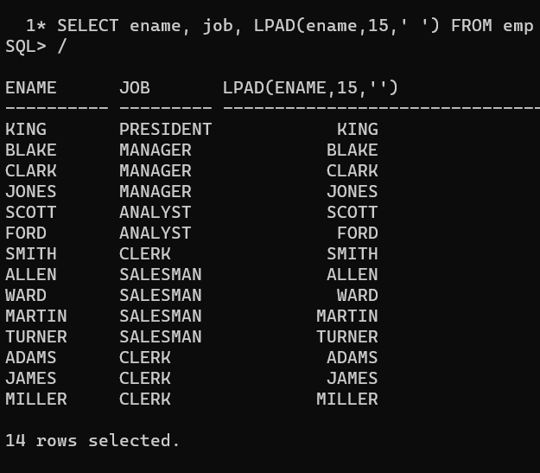

* 1. Display min sal, max sal, average sal for all employees working under same manager

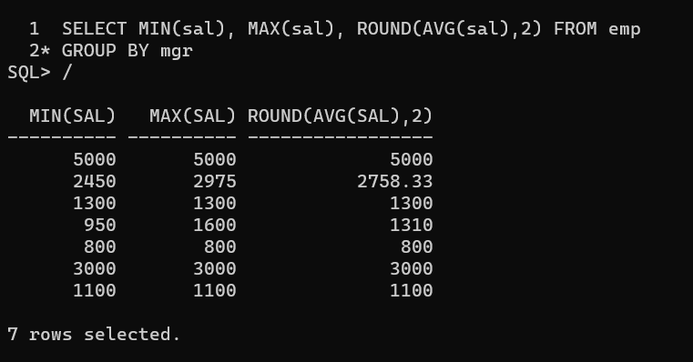

* 1. Find sum of total earnings(sal+comm), average of sal+comm for all employees who earn sal > 2000 and work in either dept no 10 or 20

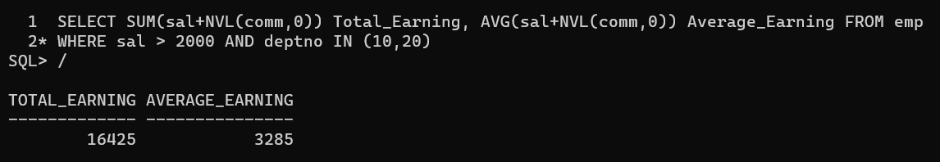

* 1. List all employees who joined in Aug 1980 and salary is >1500 and < 2500

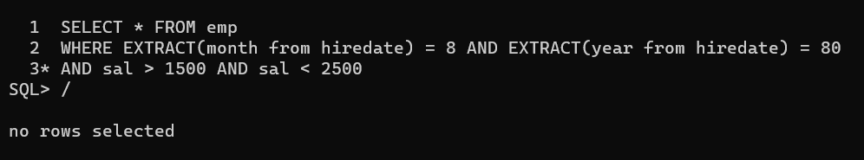

* 1. List all employees joined in either aug or may or dec

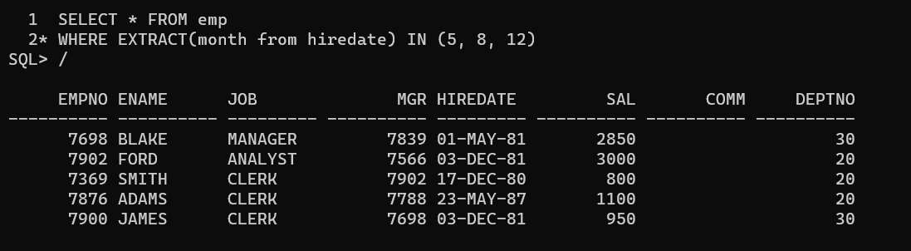

* 1. Display name and hiredate in dd/mm/yy format for all employees whose job is clerk and they earn some commission

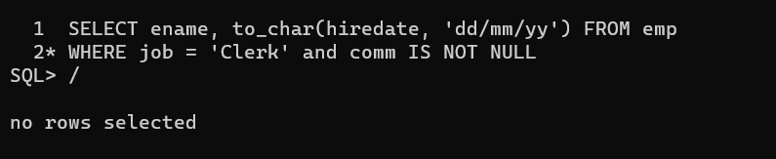

* 1. List empcode, empno, name and job for each employee. (note: empcode is 3 to 5 characters from name and last 2 characters of job)

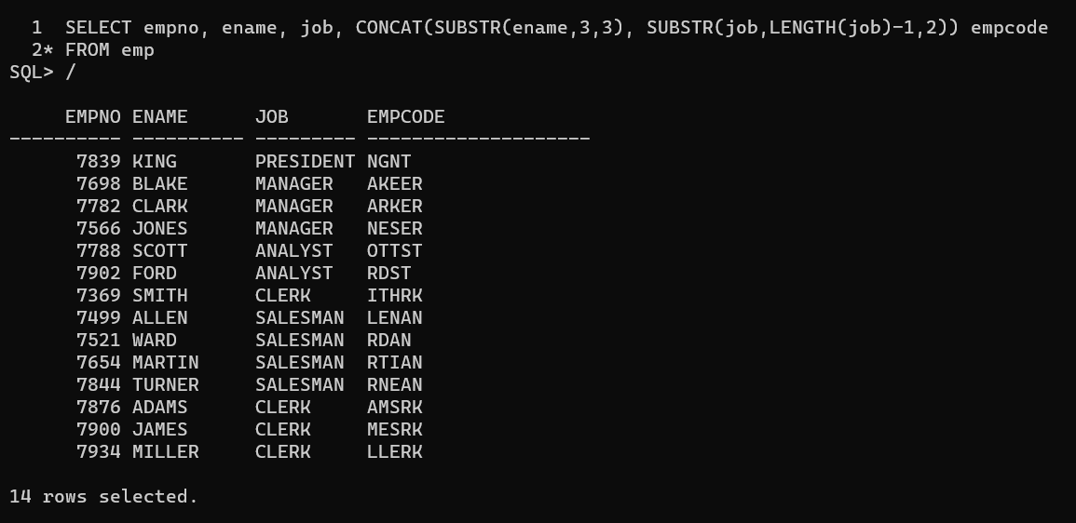

* 1. Display thousand separator and $ symbol for commission if it is null then display it as 0 for all employees whose name starts with A and ends with N

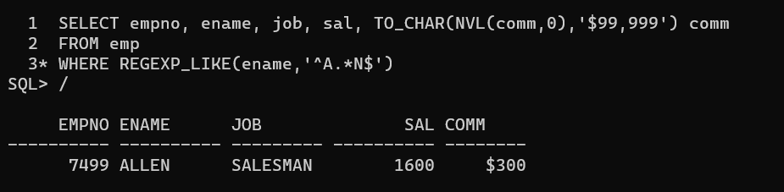

* 1. Display empid, name, sal, comm, remark Remark should base on following conditions

comm >= 600 "excellent Keep it up"

if it < 600 or not null "good"

otherwise "Need improvement"

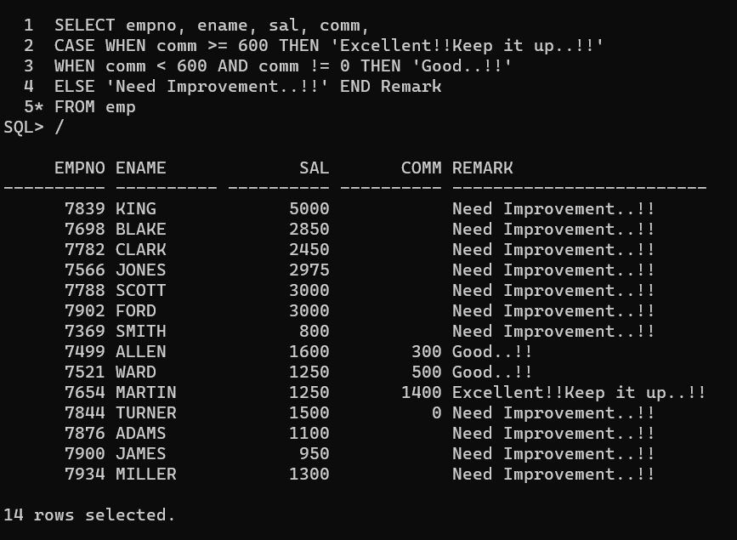

30. Display empid, name, deptno and department name by using following conditions.

dept 10 then "Hr"

if 20 then "Admin"

if 30 then "accounts"

otherwise purchase

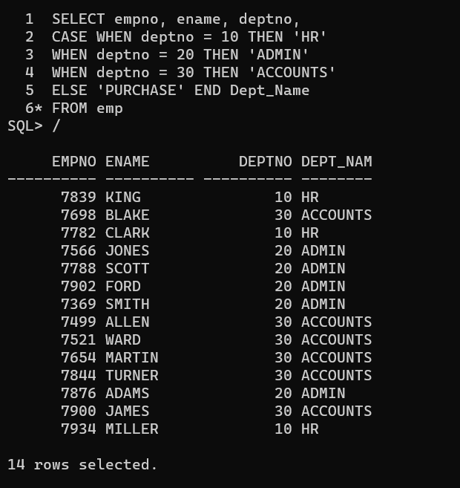

Topic ----------------- create Table, DML , subquery and joins

31. Practice creating following tables

create table mydept_DBDA

(

deptid number primary key,

dname varchar2(20) not null unique,

dloc varchar2(20)

)

insert into mydept_DBDA values(30,'Purchase','Mumbai');

create table myemployee

(

empno number(5) primary key,

fname varchar2(15) not null,

mname varchar2(15),

lname varchar2(15) not null,

sal number(9,2) check(sal >=1000),

doj date default sysdate,

passportnum varchar2(15) unique,

deptno number constraint fk_deptno references mydept_DBDA(deptid) on delete cascade

)

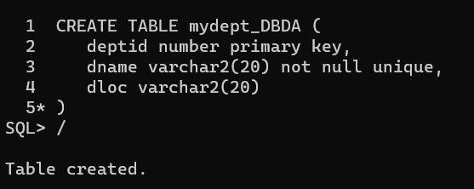

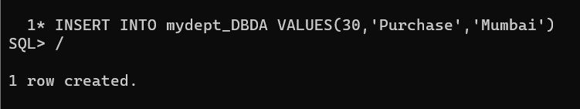

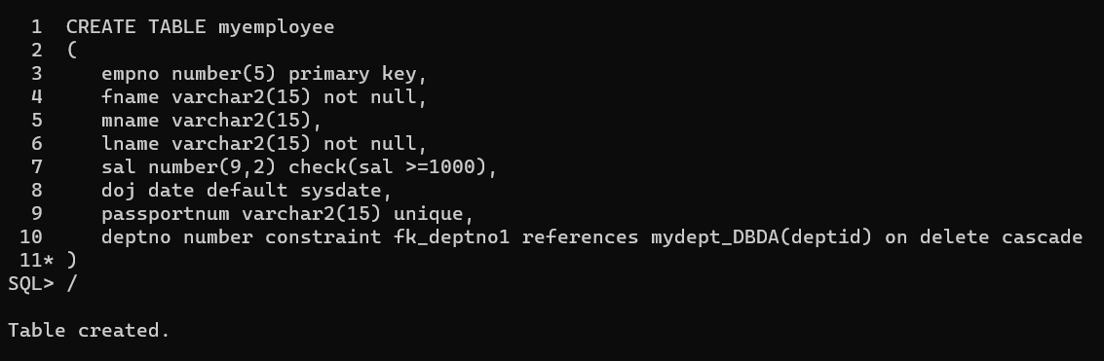

32. Create following tables Student, Course

Student (sid, sname) ---------------- sid ---primary key

Course(cid, cname)-------------- cid ---primary key

Marks(studid, courseid, marks)

Sample data for marks table

studid,courseid,marks

1 1 99

1 3 98

2 1 95

2 2 97

create table marks(

studid number,

courseid number,

marks number,

constraint pk primary key(studid, courseid),

constraint fk_sid foreign key (studid) references student(sid) on delete cascade,

constraint fk_cid foreign key (courseid) references course(cid))

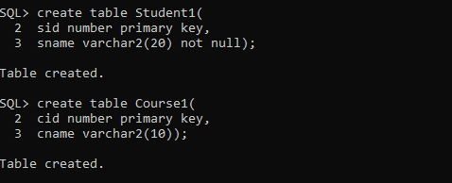

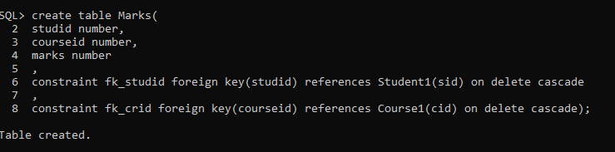

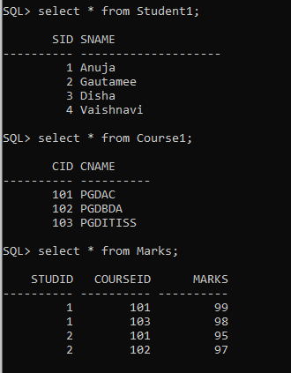

33. Create empty table emp10 with table structure same as emp table.

create table emp10 as

(

select *

from emp

where 1=2;

)

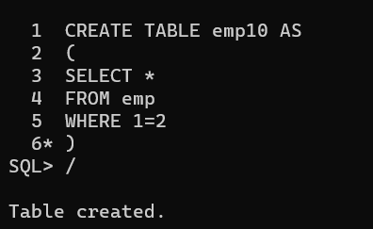

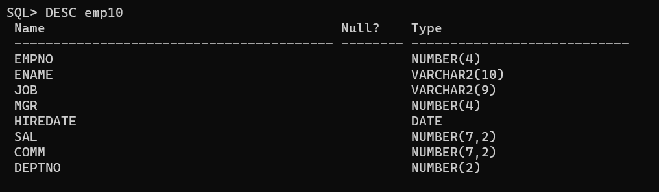

34. Solve following using alter table

add primary key constraint on emp, dept, salgrade

emp ----→ empno

dept---→ deptno

salgrade---→ grade

add foreign key constraint in emp

deptno --->> dept(deptno)

add new column in emp table netsal with constraint default 1000

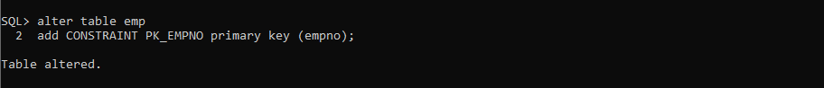

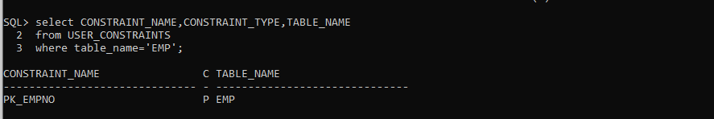

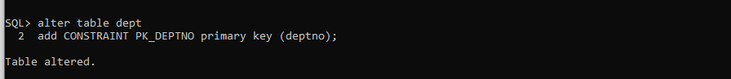



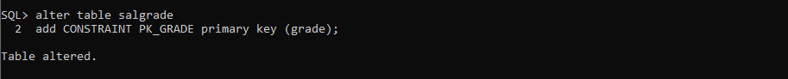

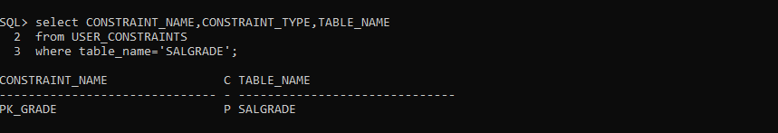

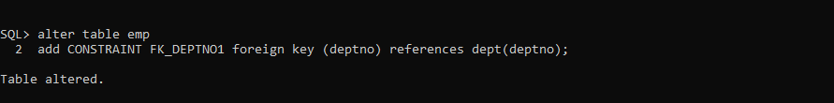

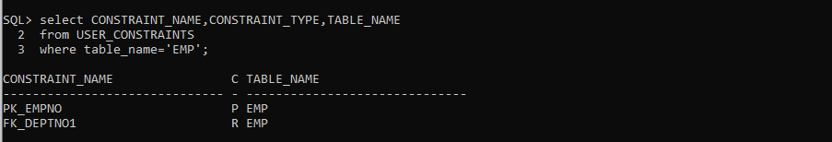

35. Update employee sal ---- increase sal of each employee by 15 % sal +comm, change the job to manager and mgr to 7777 for all employees in deptno 10.

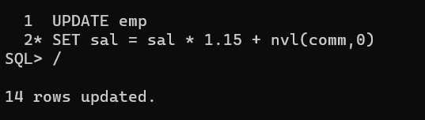

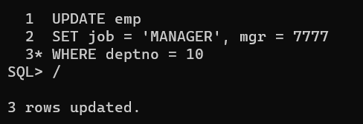

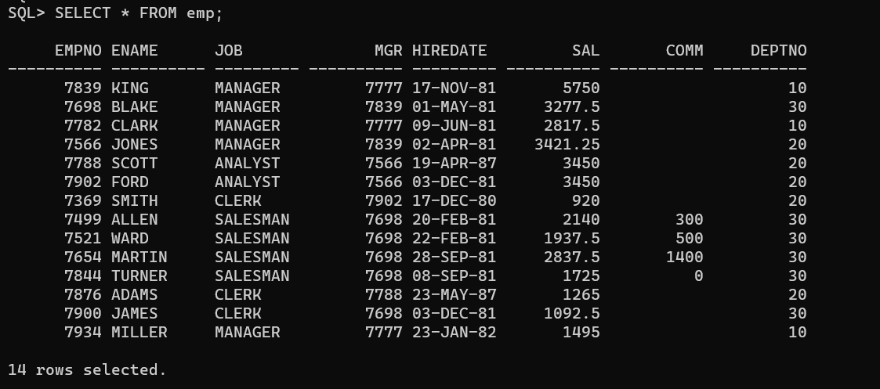

36. Change job of smith to senior clerk

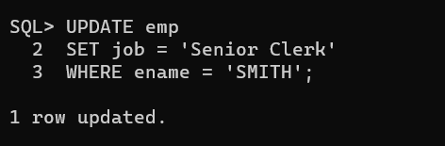

37. Increase salary of all employees by 15% if they are earning some commission

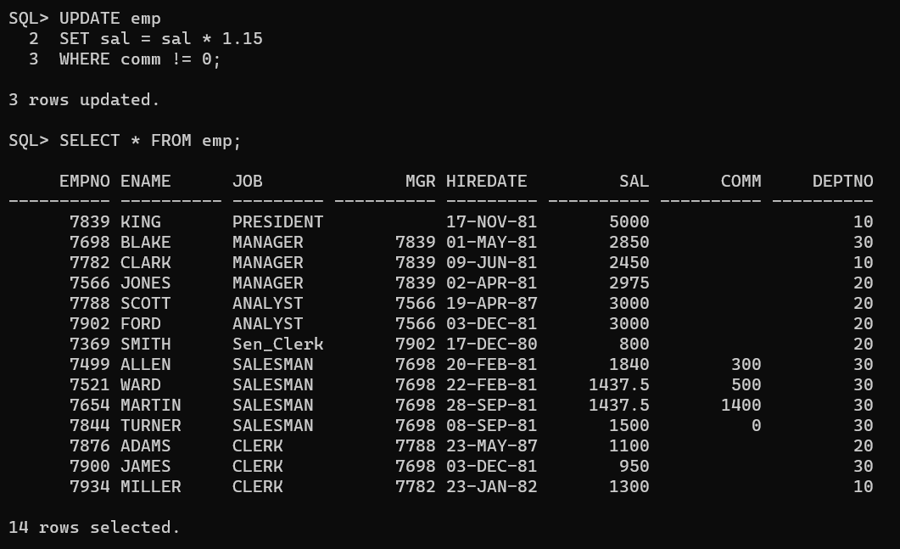

38. List all employees with sal > smith's sal

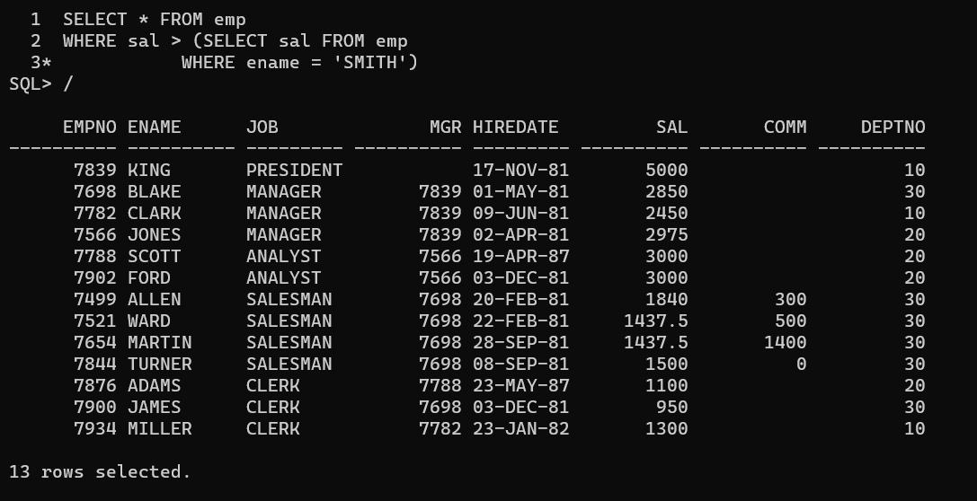

39. List all employees who are working in smith's department

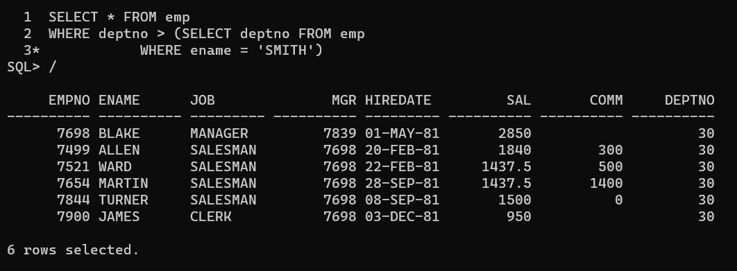

40. List all employees with sal < rajan's sal and salary > revati's sal

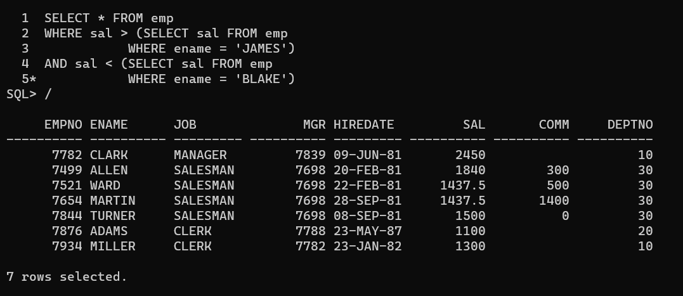

41. Delete all employees working in alan's department

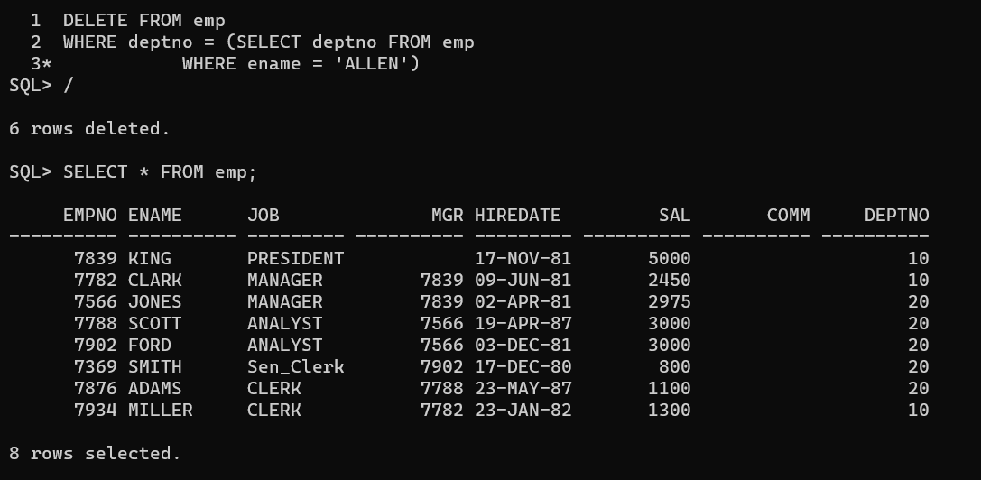

42. Change salary of Alan to the salary of Miller.

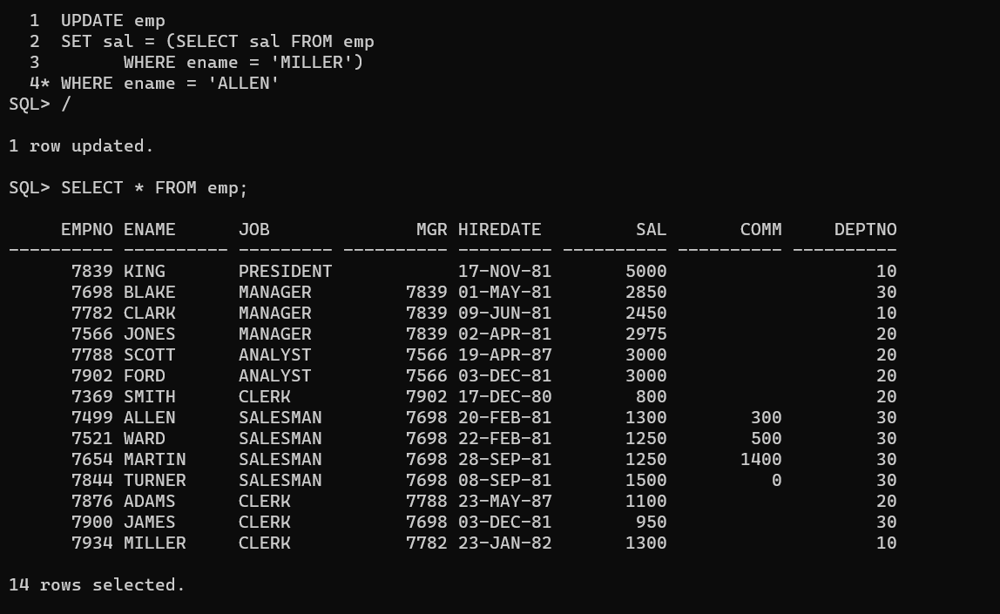

43. Change salary of all employees who working in Wall's department to the salary of Miller.

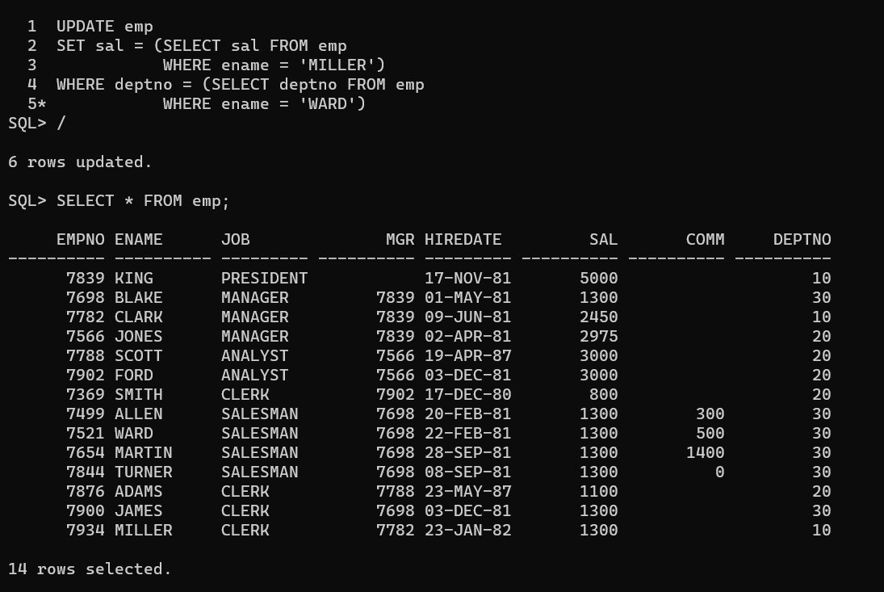

44. List all employees with salary > either Smith's salary or alan's sal

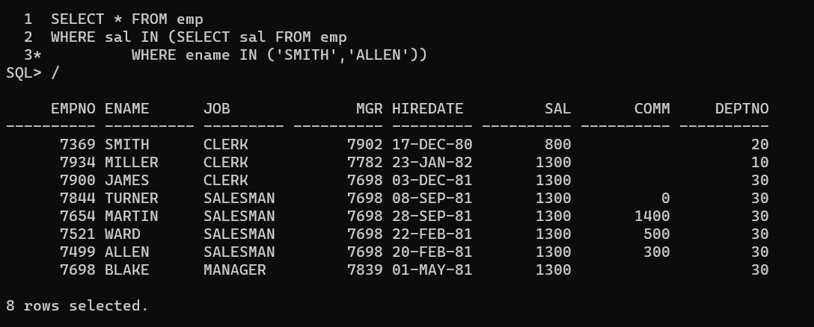

45. List all employees who earn more than average sal of dept 10

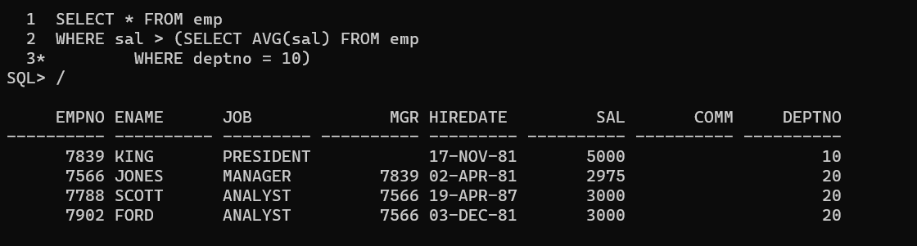

46. List all employees who earn more than average sal of Alan's department

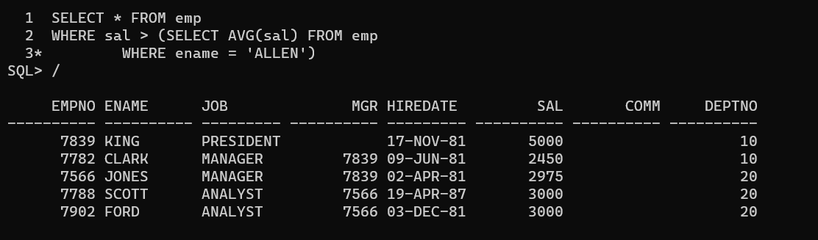

47. List all employees who are working in purchase department

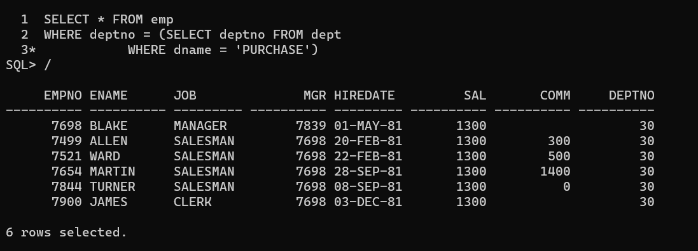

48. List all employees who earn more than average salary of their own department

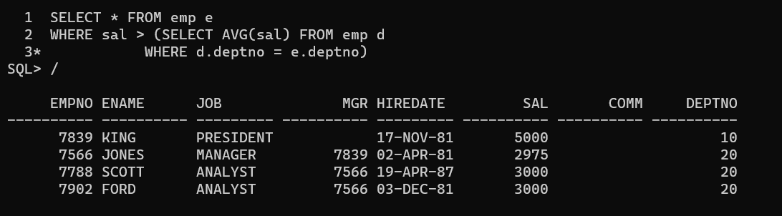

49. List all employees who earn sal < than their managers salary

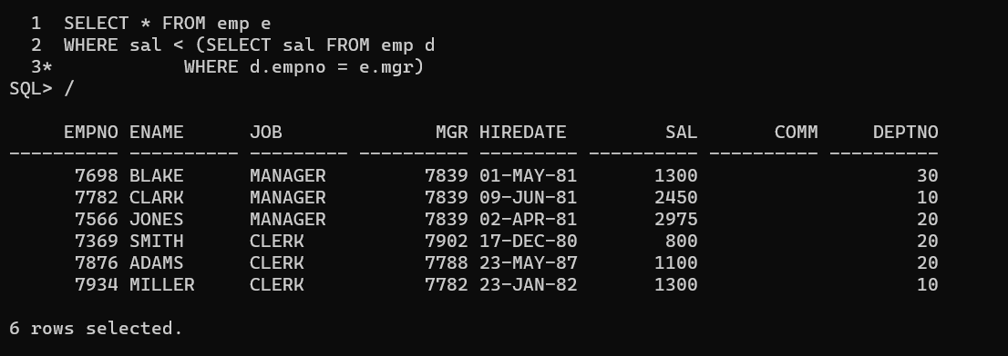

50. List all employees who are earning more than average salary of their job

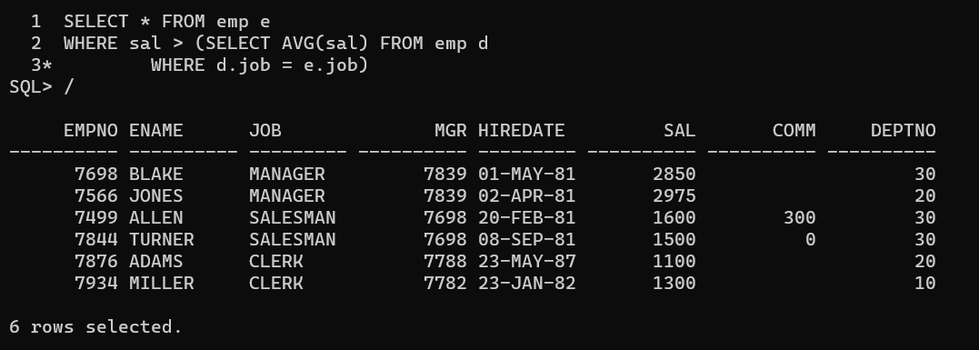

51. Display employee name and department

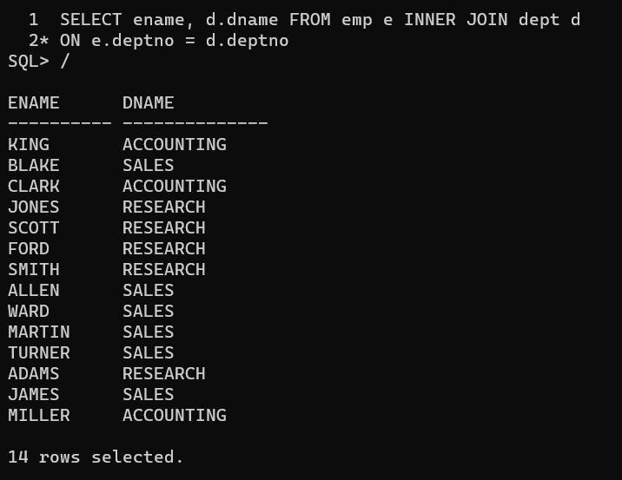

52. Display empno, name, department name and grade (use emp, dept and salgrade table)

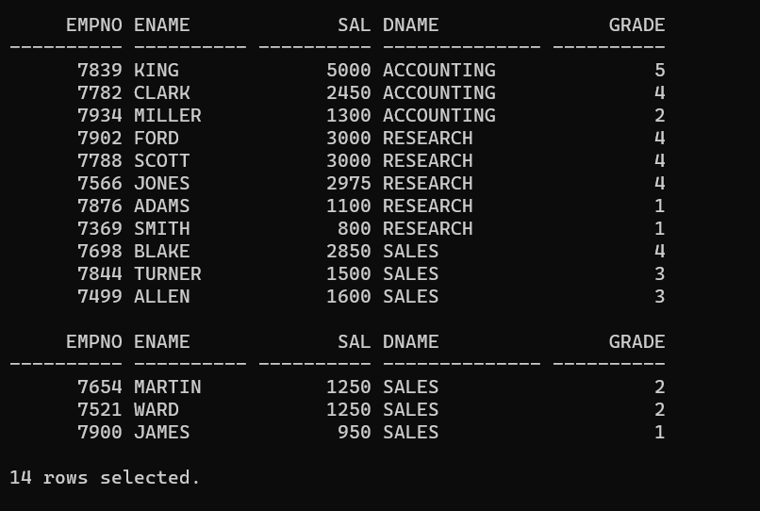

53. List all employees number, name, mgrno and manager name

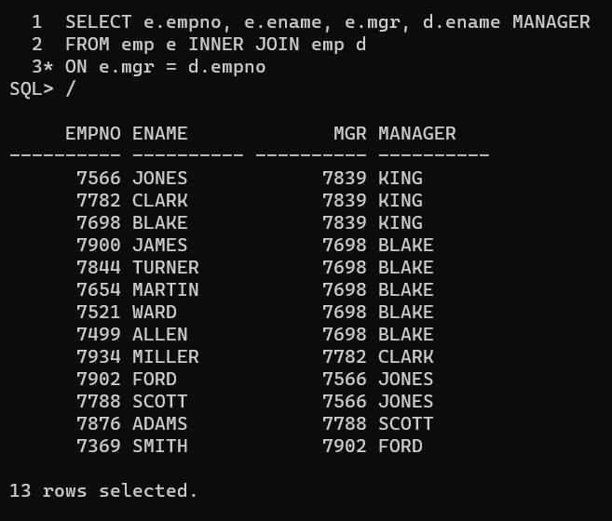

54.Create following tables and solve following questions(primary keys are marked in yellow)

foreign keys are marked in green

product(pid, pname, price, qty, cid, sid)

salesman (sid, sname, address)

category(cid, cname, descritpion)

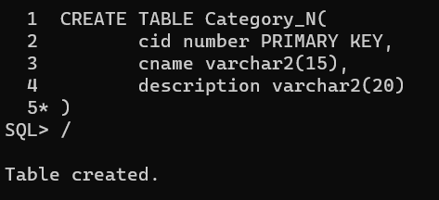

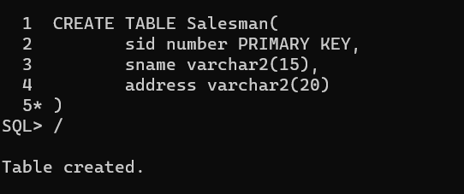

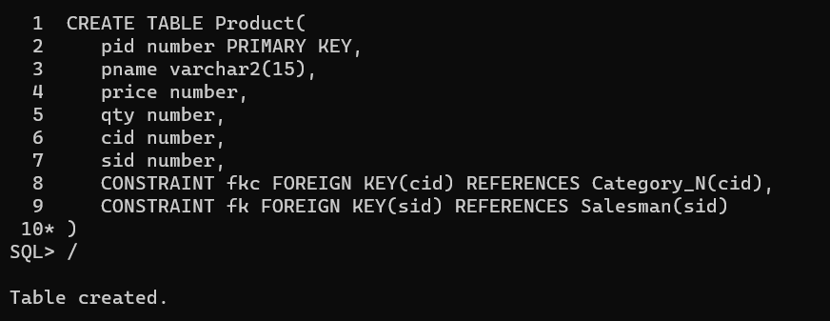

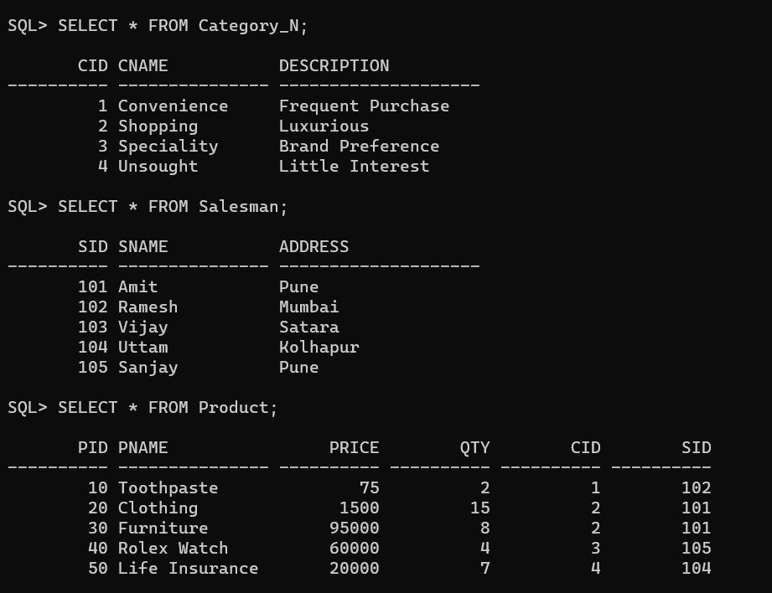

1. List all product name, their category name and name of a person, who sold that product

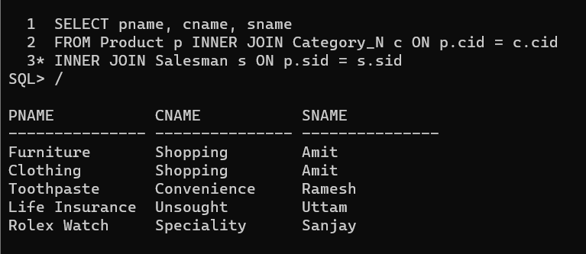

2. List all product name and salesman name for all salesman who stays in Pune

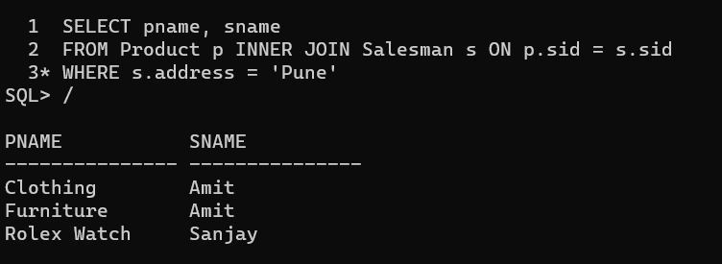

3. List all product name and category name

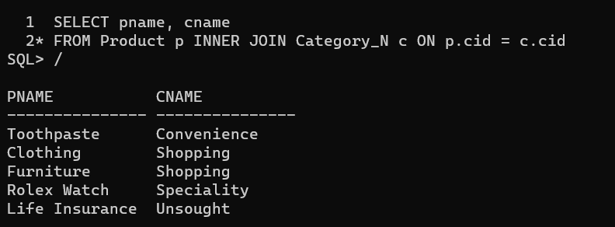

55. create following tables and solve following questions(primary keys are marked in yellow)

foreign keys are marked in green

faculty(fid,fname,sp.skill1,sp.skill2)

courses(cid,cname,rid,fid)

room(roomid,rname,rloc)

faculty

fid //fname spskill1 spskill2

10 kjzhcjhz a b

11 sdd x z

12 lksjk a x

13 ksdjlkj a b

//

courses

cid cname rid fid

121 DBDA 100 10

131 DAC 101

141 DTISS

151 DIOT 105 12

Room

roomid rname rloc

100 jasmin 1st floor

101 Rose 2nd floor

105 Lotus 1st floor

103 Mogra 1st floor

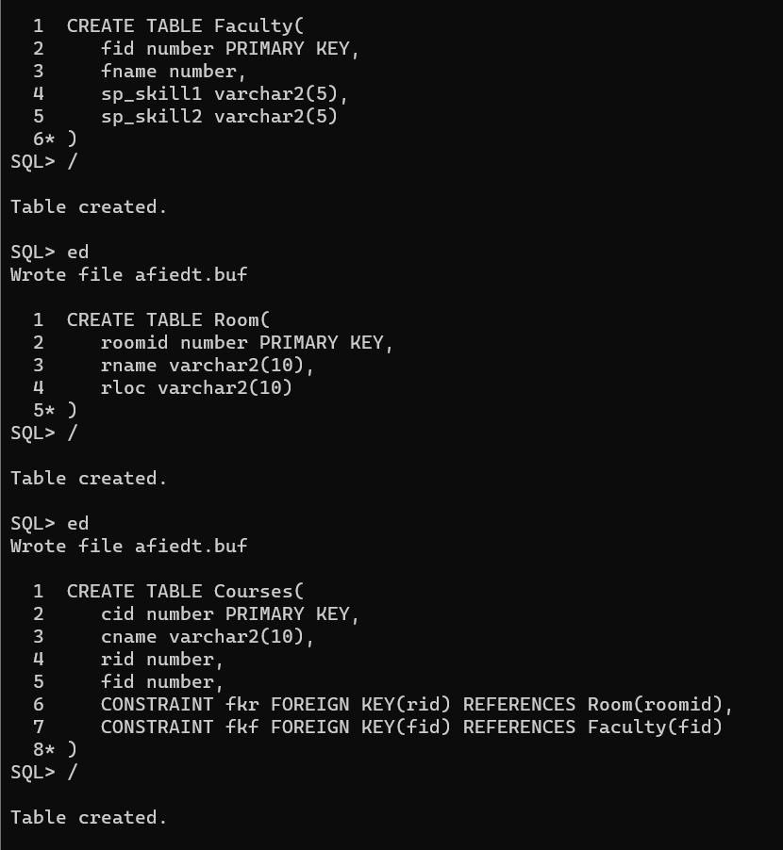

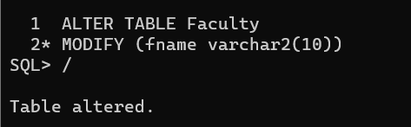

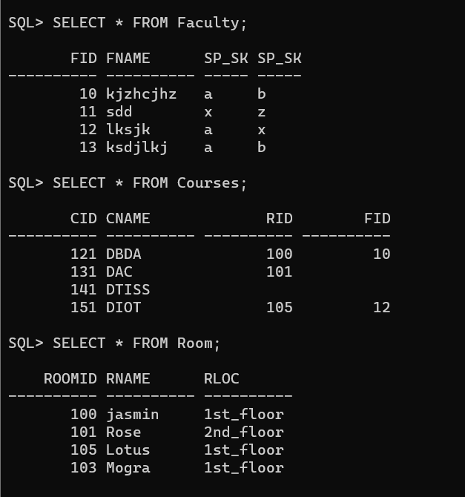

1. List all courses for which no room is assigned and all rooms for which are available

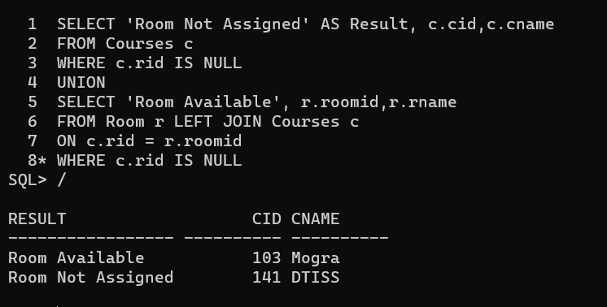

2. List all faculties who are not allocated to any course and rooms which are not allocated to any course

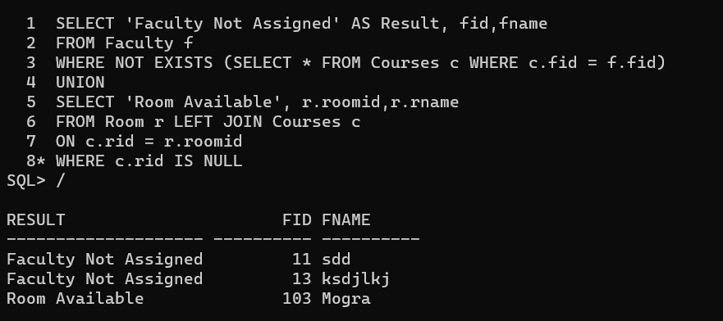

3. List all rooms which are allocated or not allocated to any courses

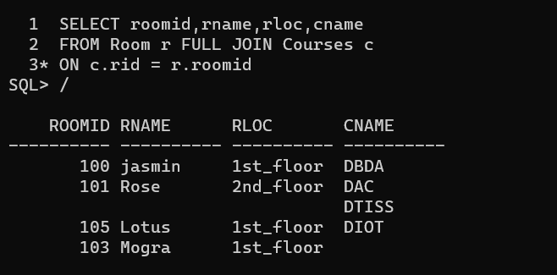

4. List all rooms which are not allocated to any courses

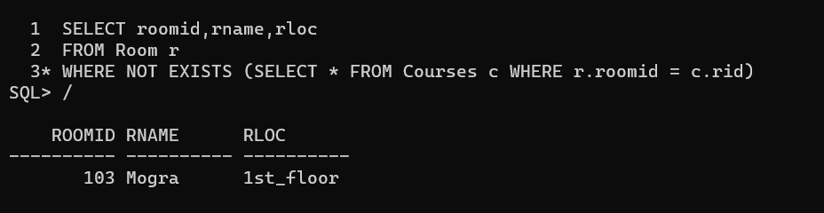

5. Display courses and faculty assigned to those courses whose special skill is database

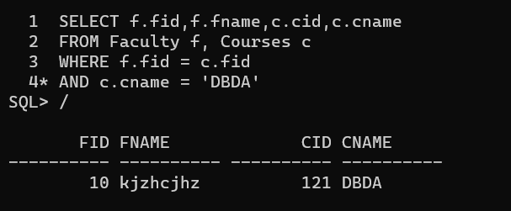

6. display time table --- it should contain course details , faculty and room details

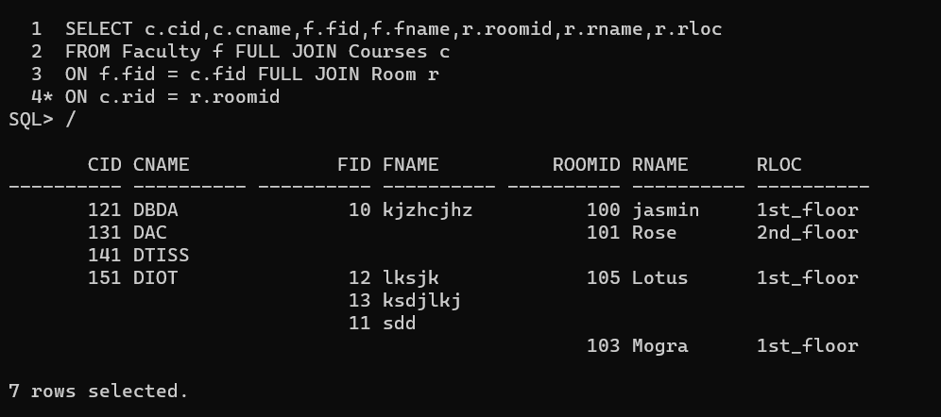

56. create following tables with given constraints

product---- qty >0, default 20.00,pname not null and unique

prodid pname qty price catid sid

123 lays 30 30.00 1 12

111 pepsi 40 50.00 4 11

134 nachos 50 50.00 1 12

124 dairy milk 40 60.00 2 14

124 pringles 40 60.00 1 14

saleman ----- sname -----not null

sid sname city

11 Rahul Pune

12 Kirti Mumbai

13 Prasad Nashik

14 Arnav Amaravati

category ---- cname unique and not null

cid cname description

1 chips very crunchy

2 chocolate very chocolaty

3 snacks yummy

4 cold drinks thanda thanda cool cool

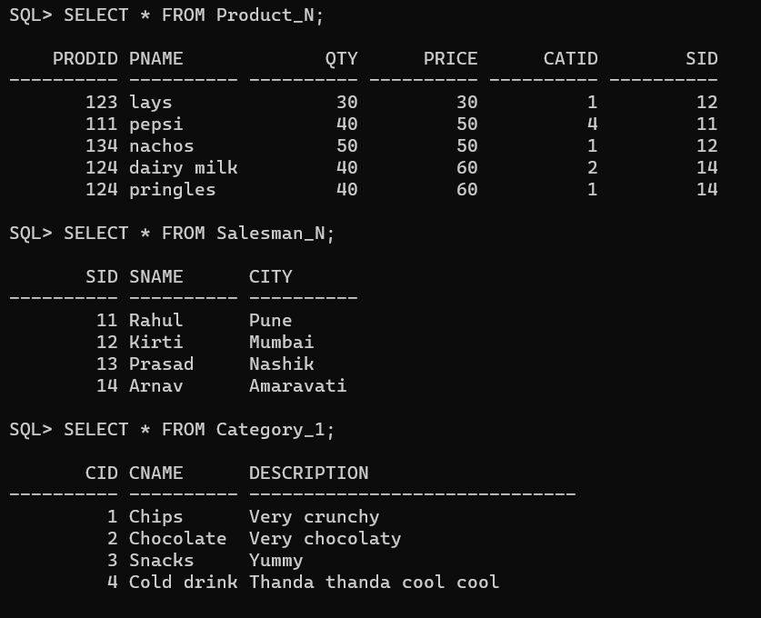

1. List all products with category chips

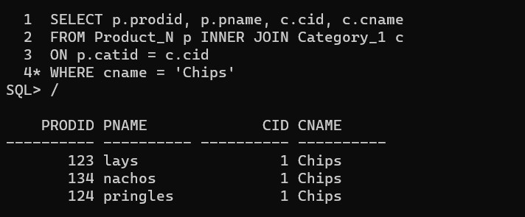

2. Display all products sold by Kirti

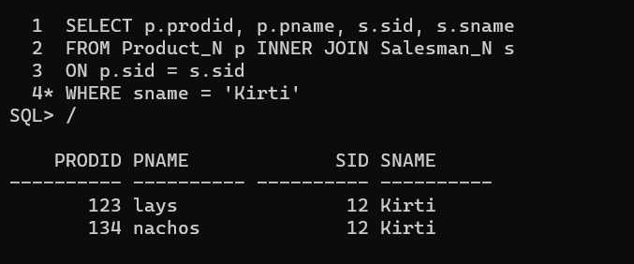

3. Display all salesman who do not sold any product

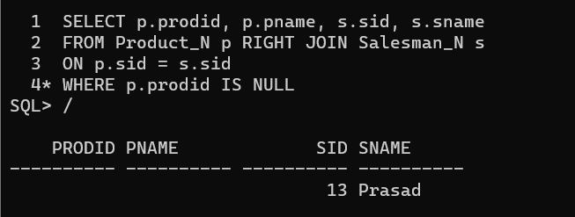

4. Display all category for which no product is there

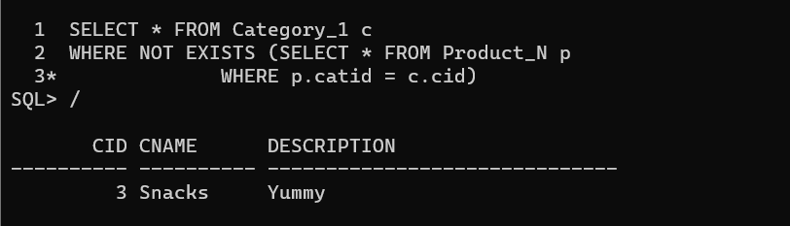

5. Display all products with no category assigned

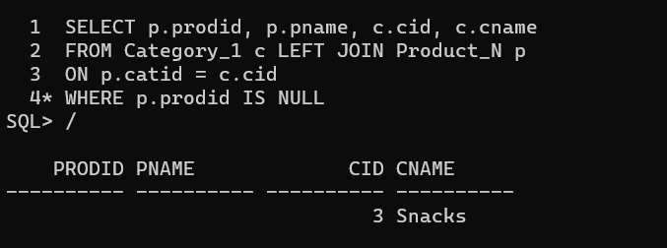

6. List all salesman who stays in city with name starts with P or N

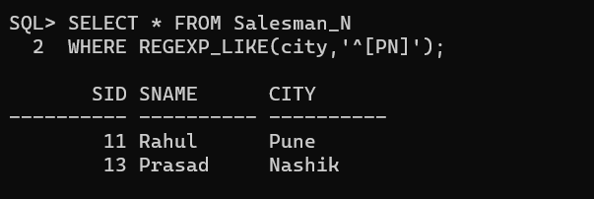

7. Add new column in salesman table by name credit limit

