Riphah International University
I-14 Campus Islamabad
Lab_Task_01
Department: Data Science
Subject: Data Structure
Submitted By:
Hammad Sajjad Awan
SAP ID:
76142
Submitted To:
Junaid Khan
Date Of Submission:
02-09-2026

Lab Report
Lab Task # 01:

Activity 1: Your First Program
Create, compile, and run a Java class.
public class Lab1 {
public static void main(String[] args) {
System.out.println("Welcome to Data Structures Lab");
}
}

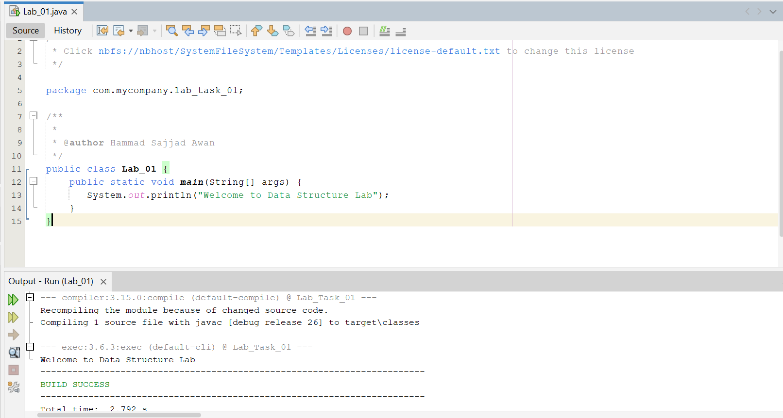

Activity 2: Working with Variables
Declare variables of different base types and display their values.
int age = 20;
double cgpa = 3.25;
char grade = 'A';
boolean passed = true;
System.out.println(age);
System.out.println(cgpa);
System.out.println(grade);
System.out.println(passed);
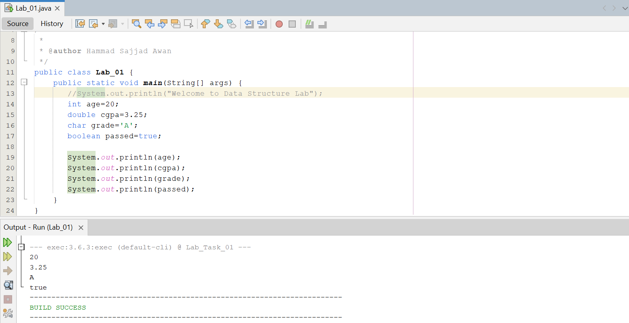

Activity 3: Modify and Trace
Predict the output before running.
int x = 10;
x = x + 5;
x++;
System.out.println(x);
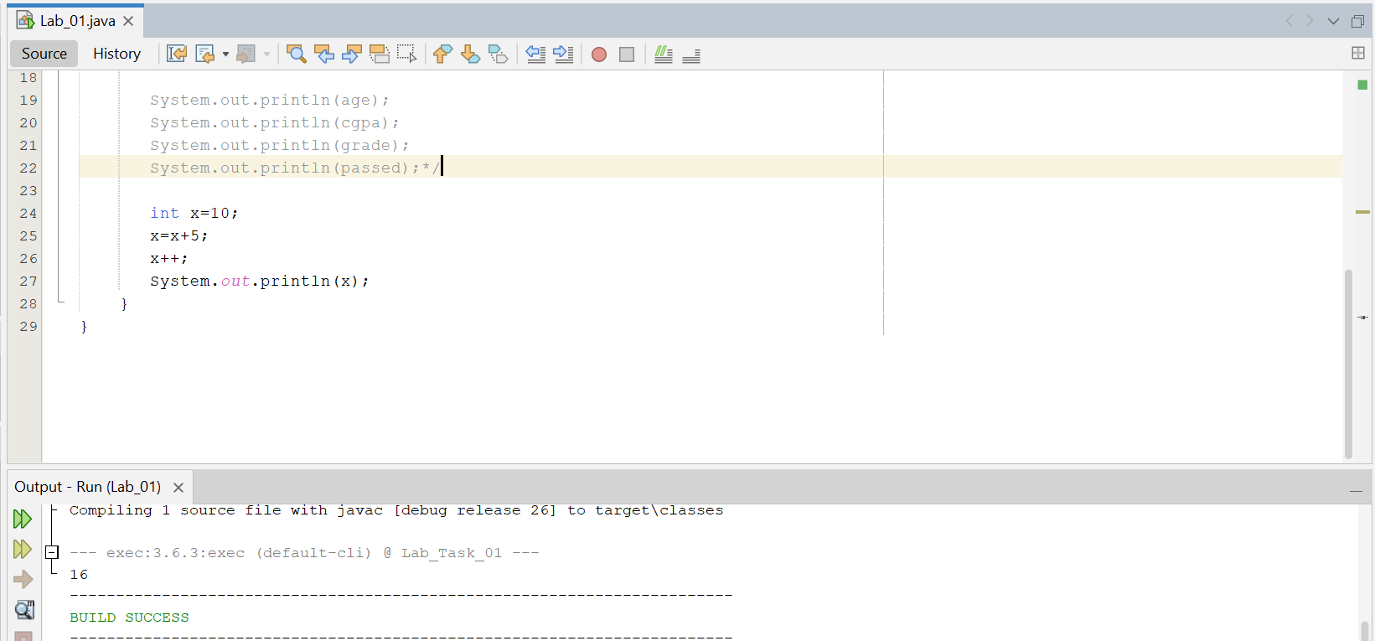
7. Write a program that stores your name, semester number, and CGPA, then displays them.
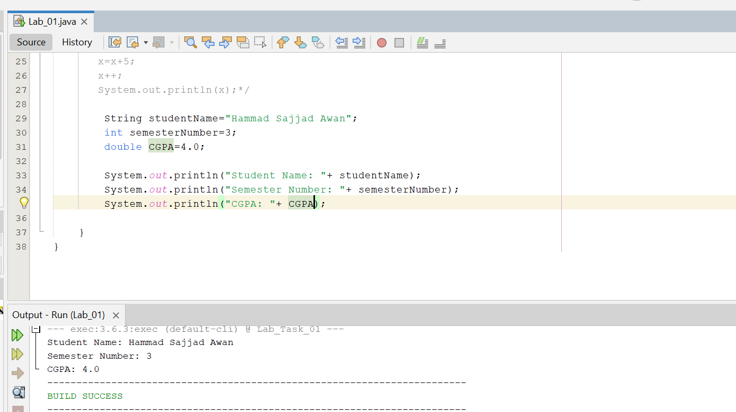
8. Declare two integers and print their sum, difference, product, and quotient.
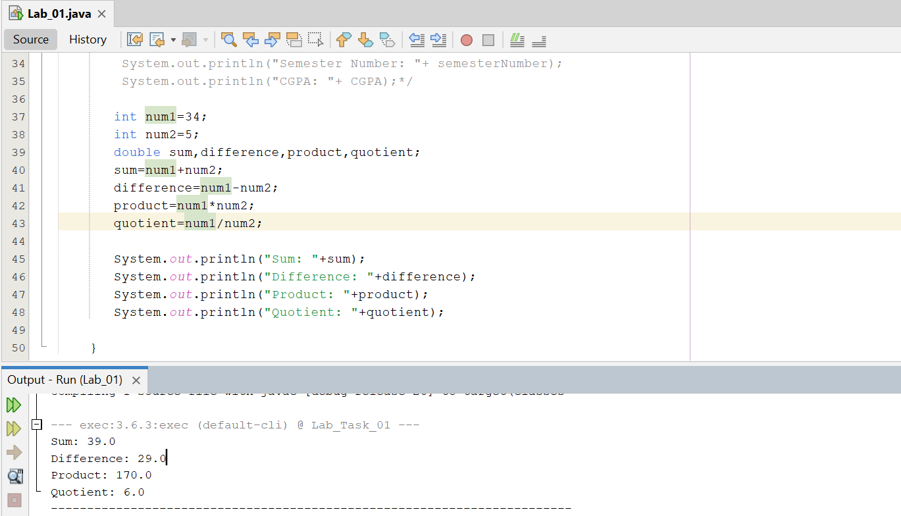
- Create meaningful identifiers for five student-related variables.
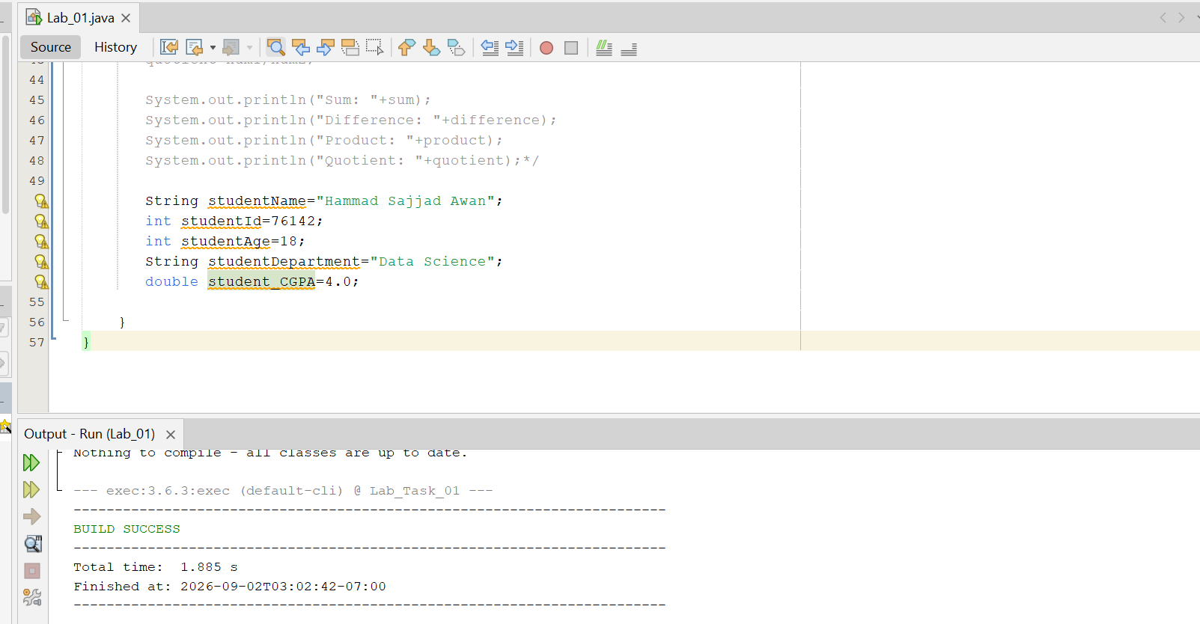
- Intentionally use an invalid identifier, observe the compiler response, then correct it.
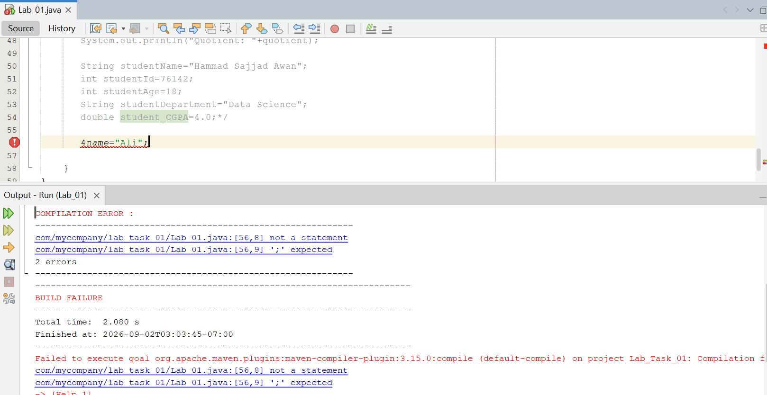
Challenging Task
1.Build a simple Student Information program using at least five variables of different suitable types. Display the information in a readable format.
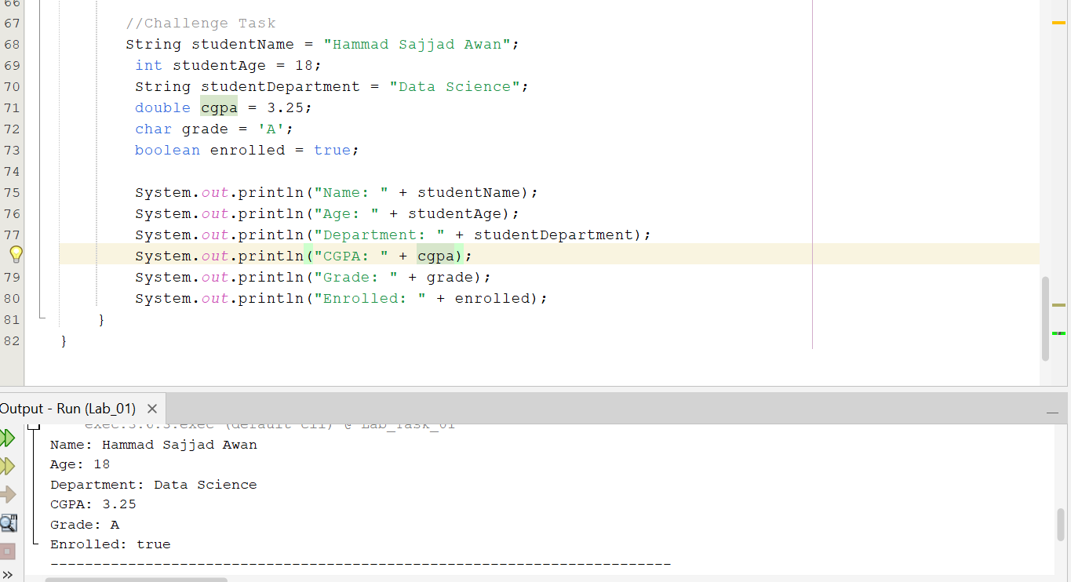

Lab Task # 02:

Activity 1: Read Student Data
Use Scanner to read input.
import java.util.Scanner;
Scanner input = new Scanner(System.in);
System.out.print("Enter marks: ");
int marks = input.nextInt();
System.out.println("Marks = " + marks);
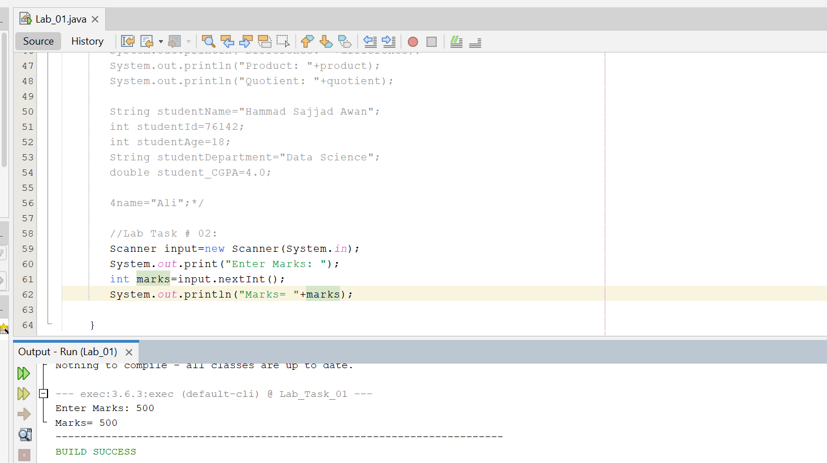

Activity 2: Grade Decision
Classify marks using if/else.
if (marks >= 85)
System.out.println("A");
else if (marks >= 70)
System.out.println("B");
else if (marks >= 50)
System.out.println("C");
else
System.out.println("Fail");
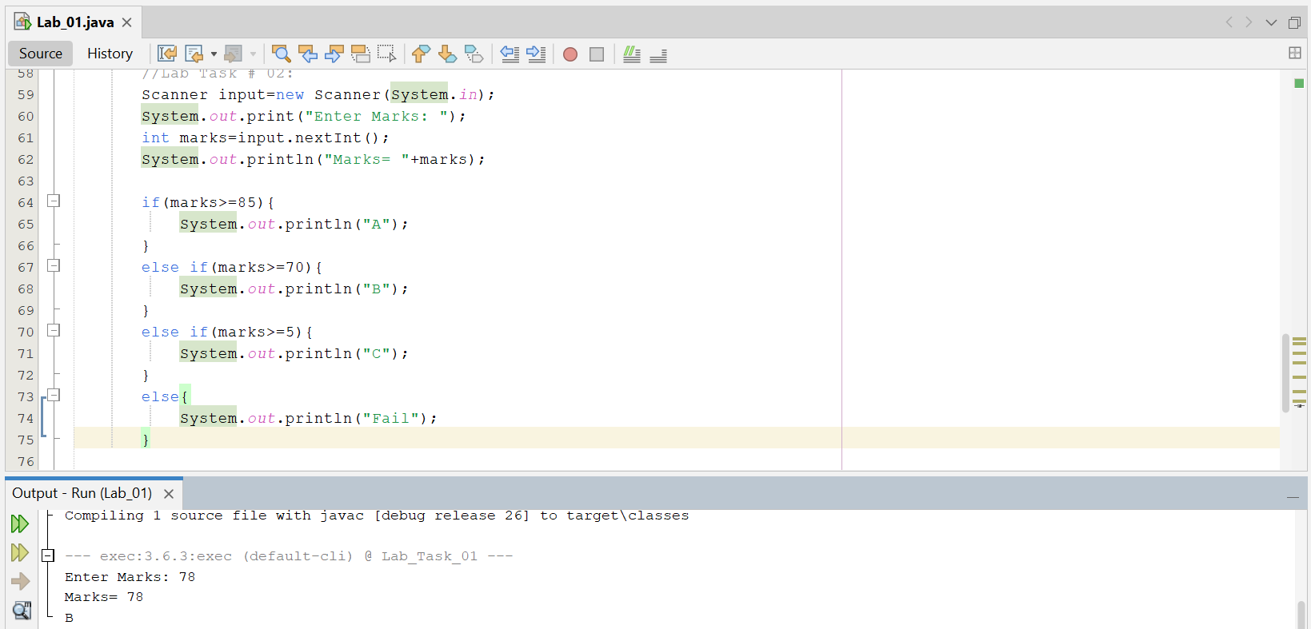

Activity 3: Menu Using switch
Create a simple selection menu.
int choice = input.nextInt();
switch (choice) {
case 1:
System.out.println("Insert");
break;
case 2:
System.out.println("Delete");
break;
default:
System.out.println("Invalid choice");
}
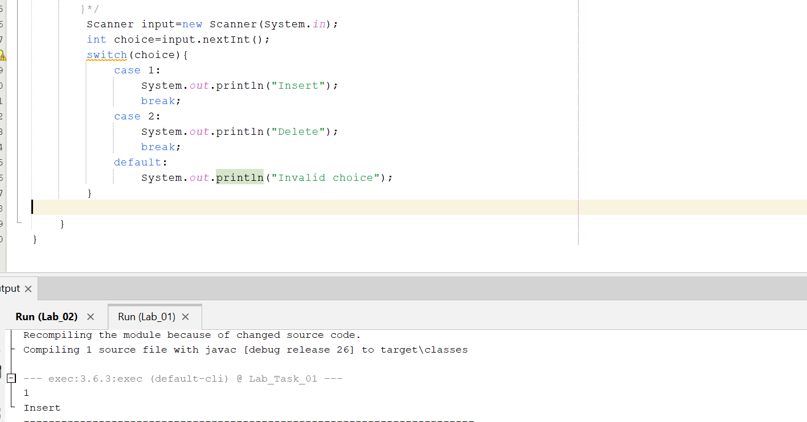
15.Input two integers and display the larger value.

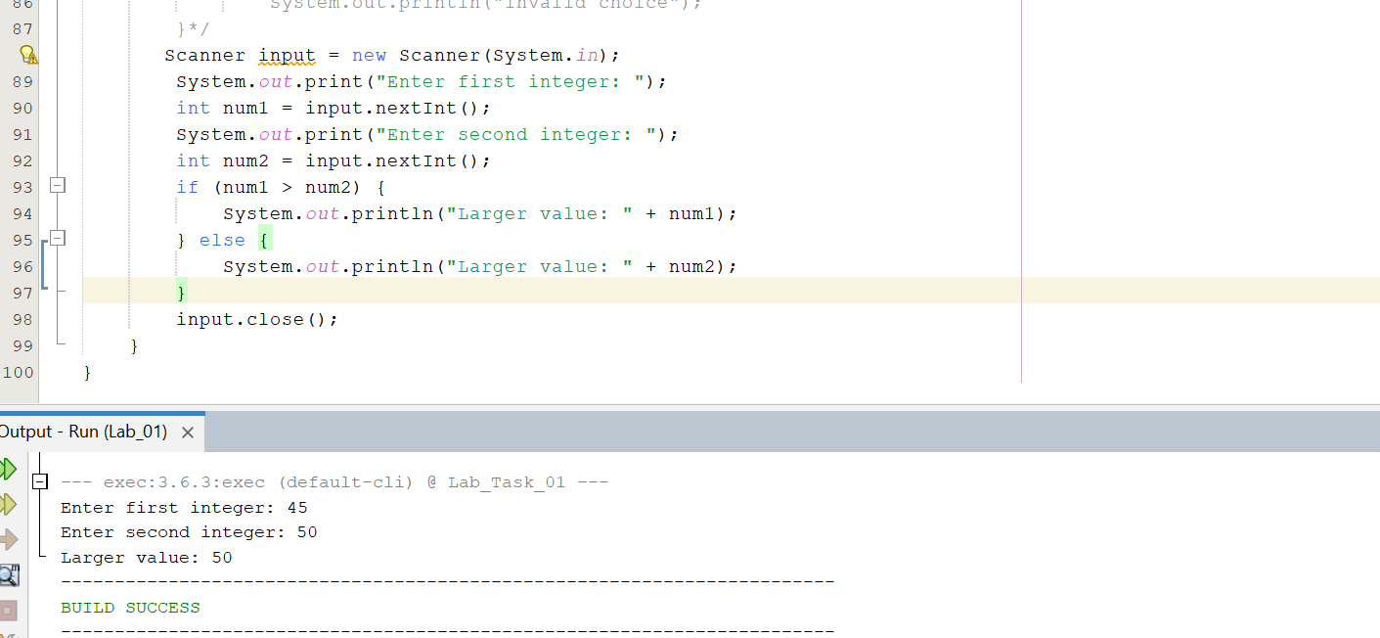
16.Input marks and attendance and decide eligibility using a compound condition.
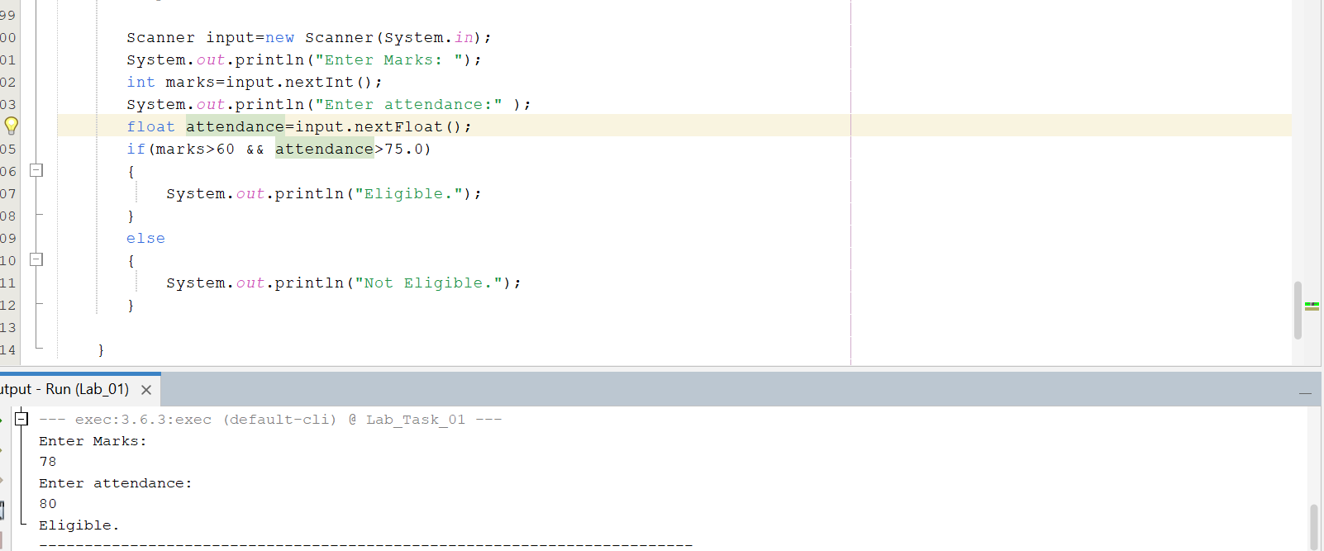
17.Build a weekday program using switch.
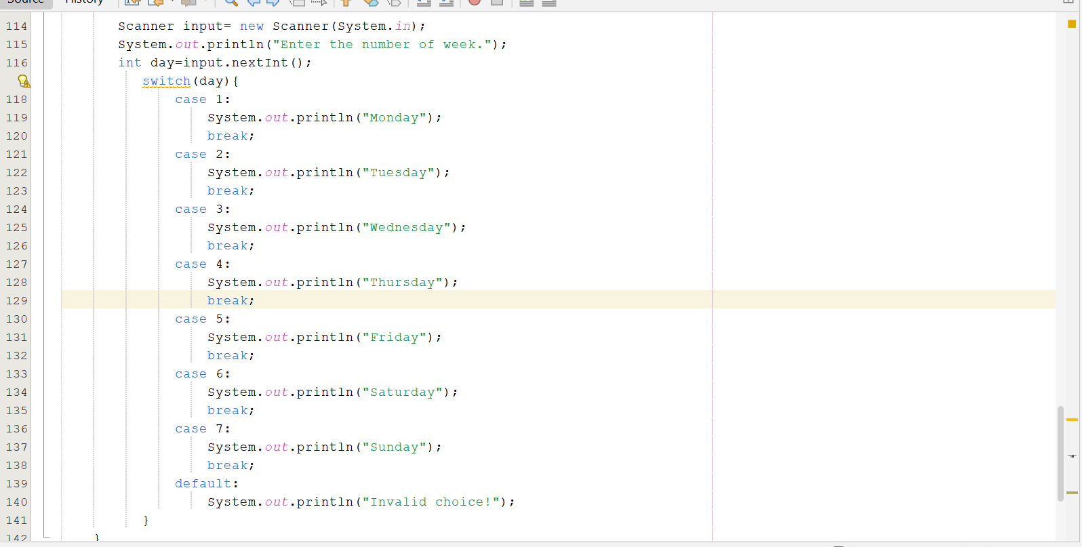
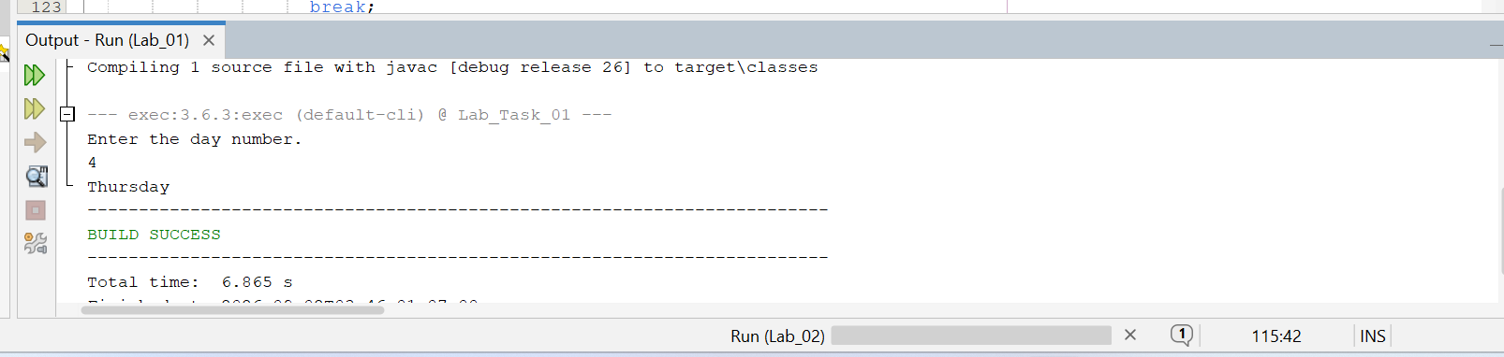
18.Remove a break from one switch case and record the fall-through behavior.
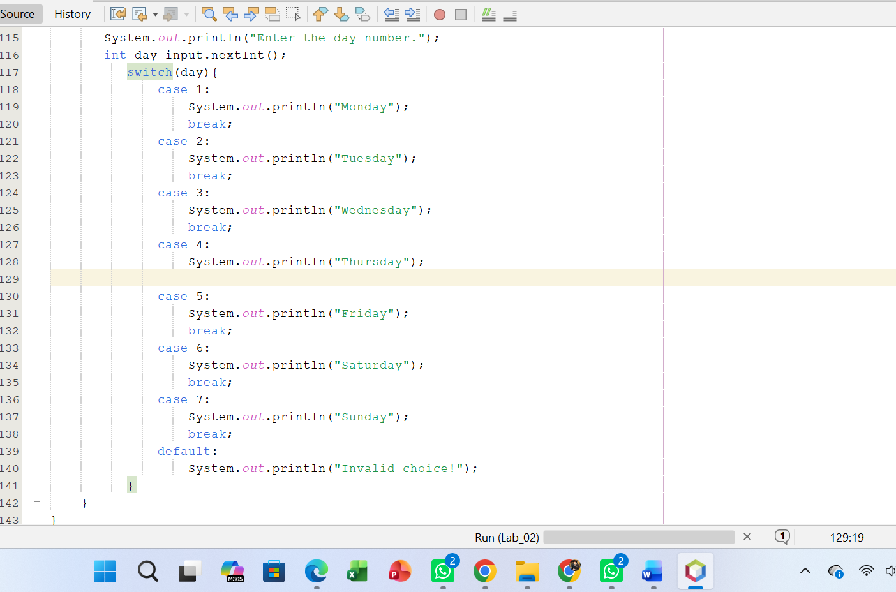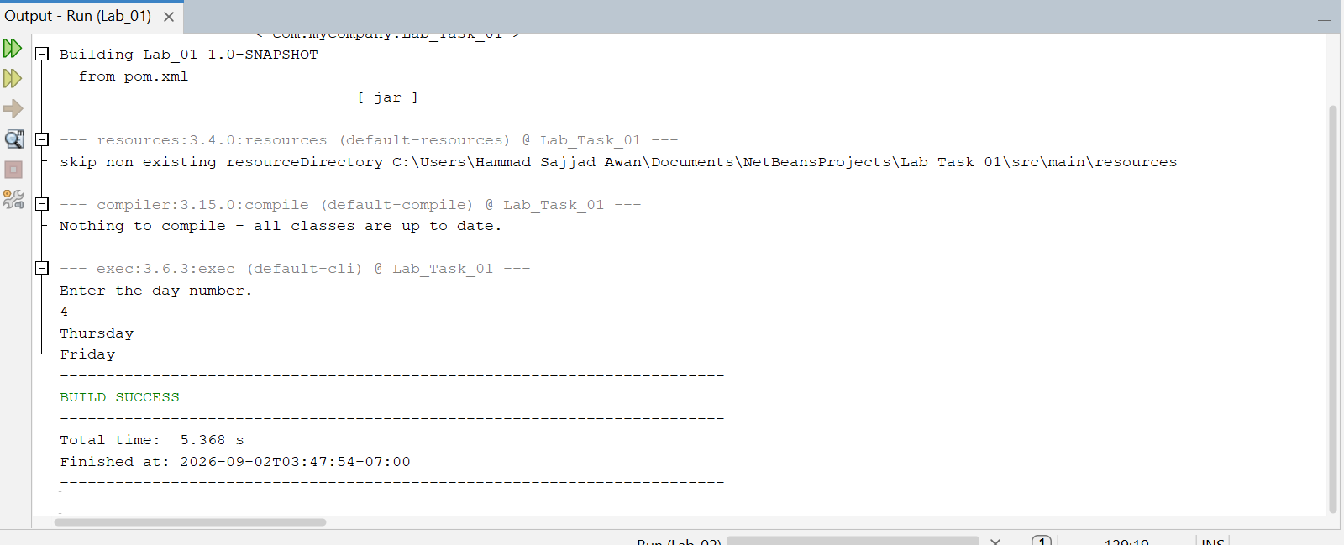

Challenging Task
1.Build a menu-driven calculator supporting addition, subtraction, multiplication, and division. Handle division by zero with an appropriate condition.
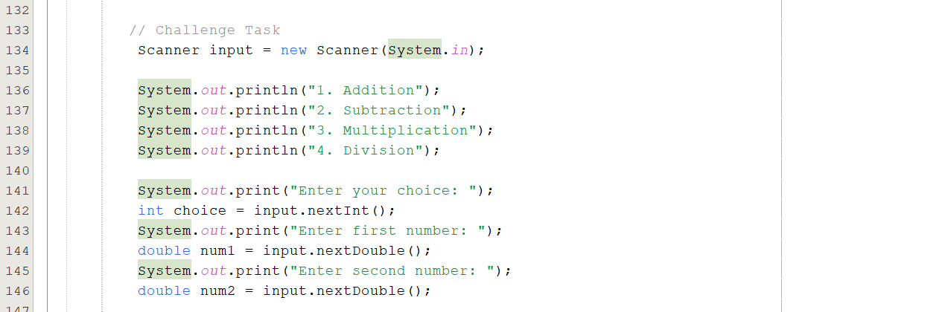
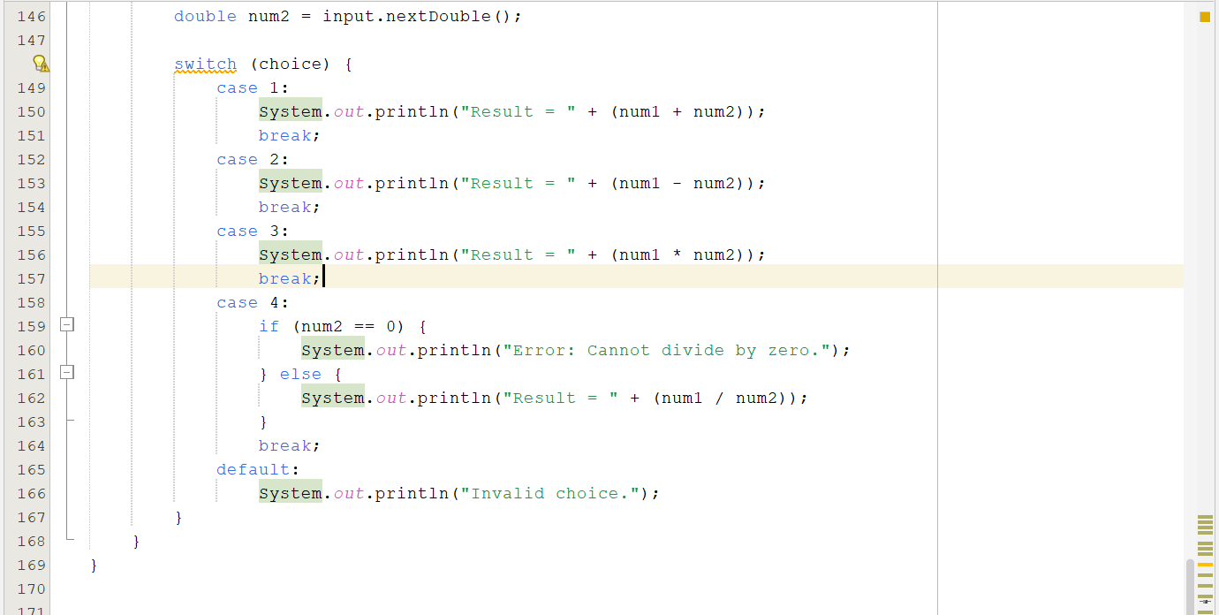
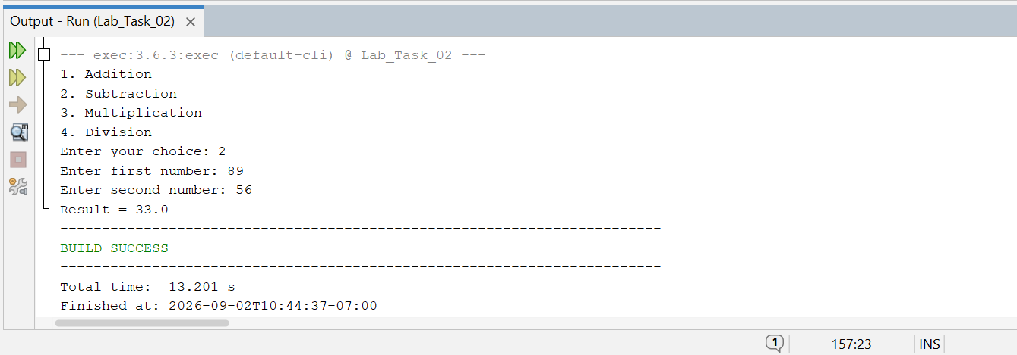

Lab Task # 03:

Activity 1: while Loop
Print numbers from 1 to 5.
int i = 1;
while (i <= 5) {
System.out.println(i);
i++;
}

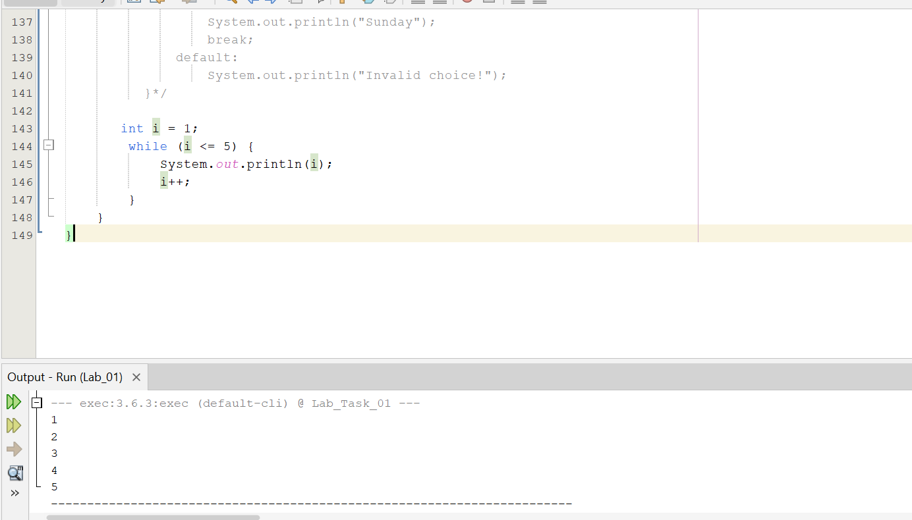

Activity 2: do-while Loop
Observe that the body executes before the condition is checked.
int i = 1;
do {
System.out.println(i);
i++;
} while (i <= 5);
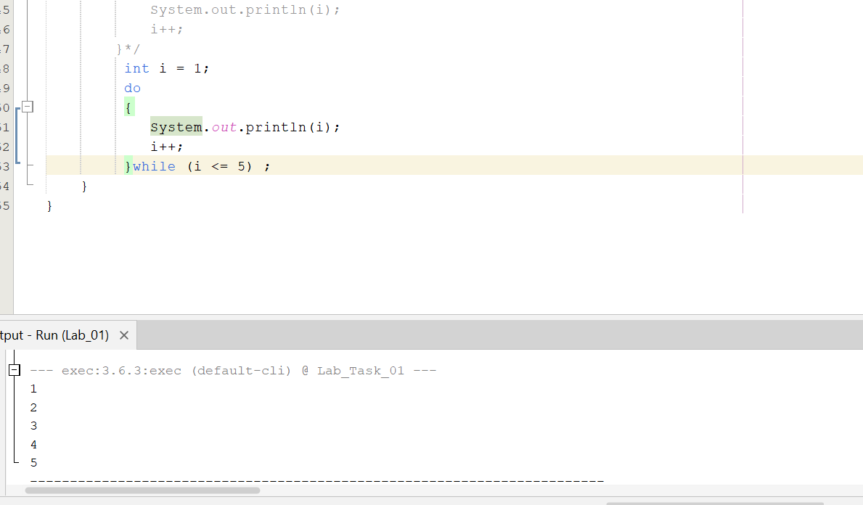

Activity 3: for Loop
Calculate the sum from 1 to n.
int sum = 0;
for (int i = 1; i <= n; i++) {
sum += i;
}
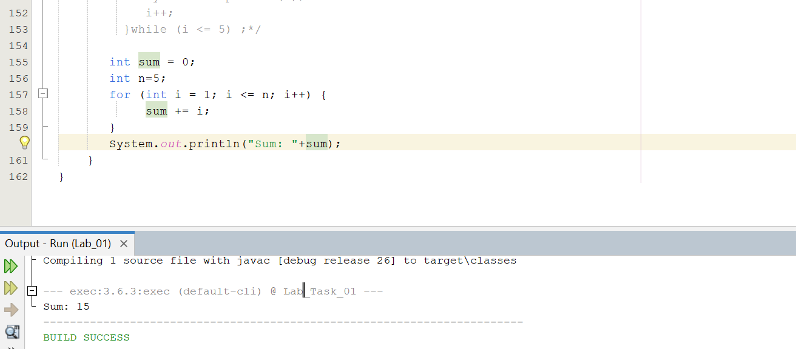

Activity 4: for-each and Arrays
Compute a sum without using explicit indices.
double[] values = {2.5, 3.0, 4.5};
double sum = 0;
for (double value : values) {
sum += value;
}
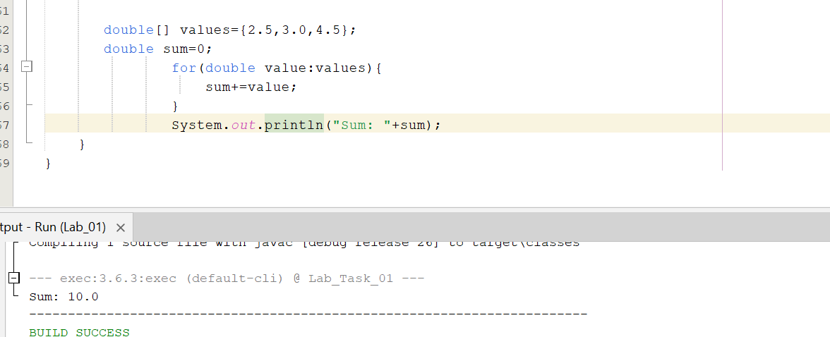

Activity 5: break and continue
Experiment with skipping and terminating iterations.
for (int i = 1; i <= 10; i++) {
if (i == 5)
continue;
if (i == 9)
break;
System.out.println(i);
}
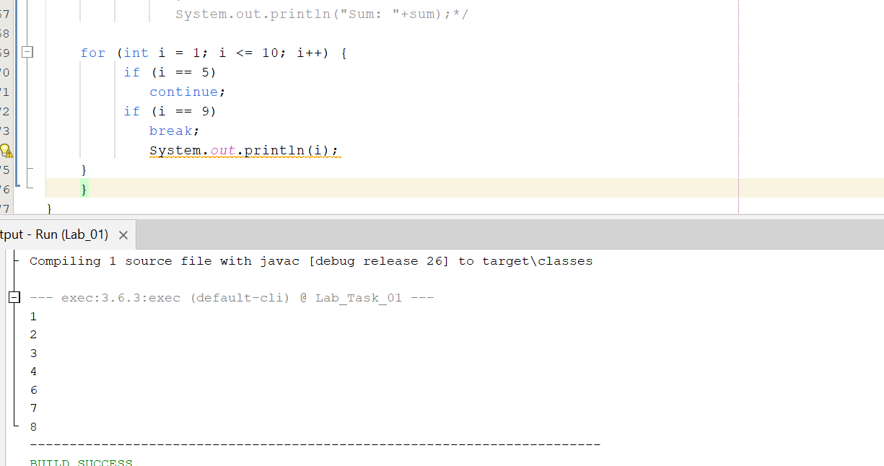
23.Use while to count down from 10 to 1.
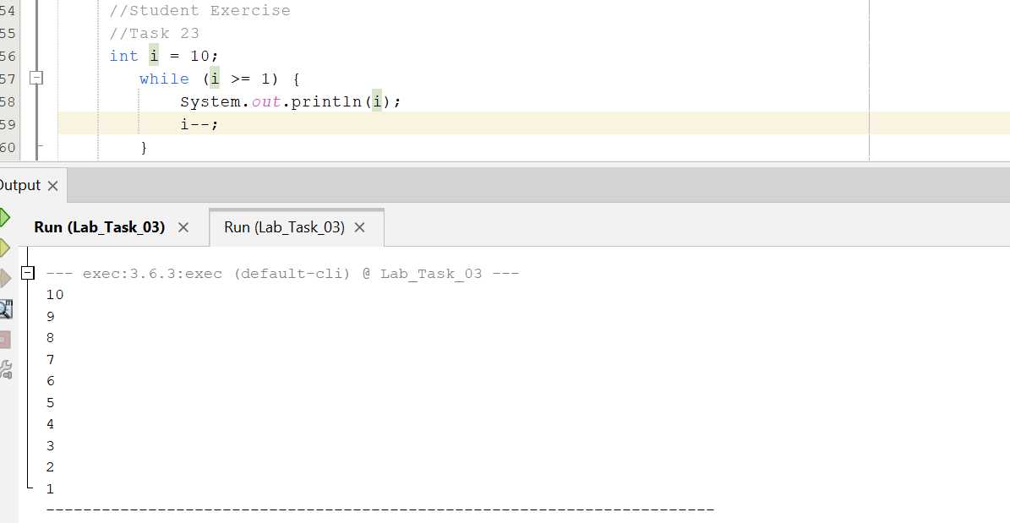
24.Use do-while to repeatedly request a positive number.
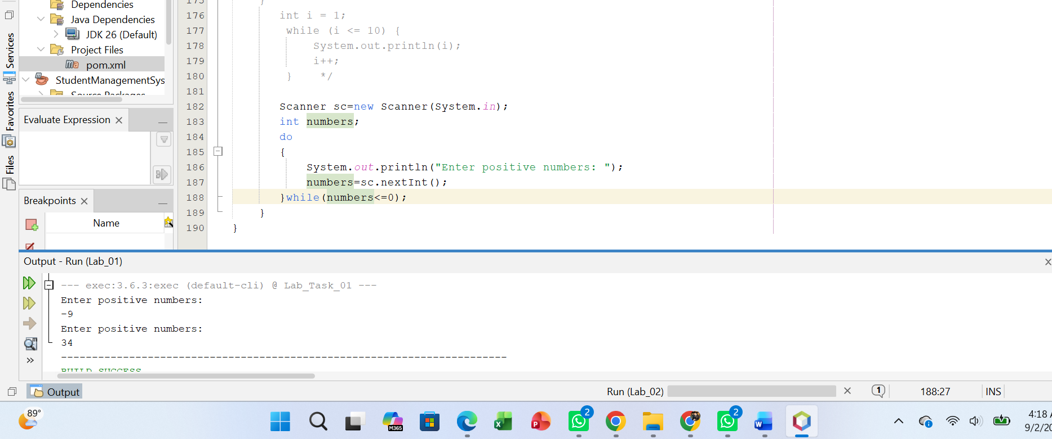
25.Use for to compute the factorial of n.
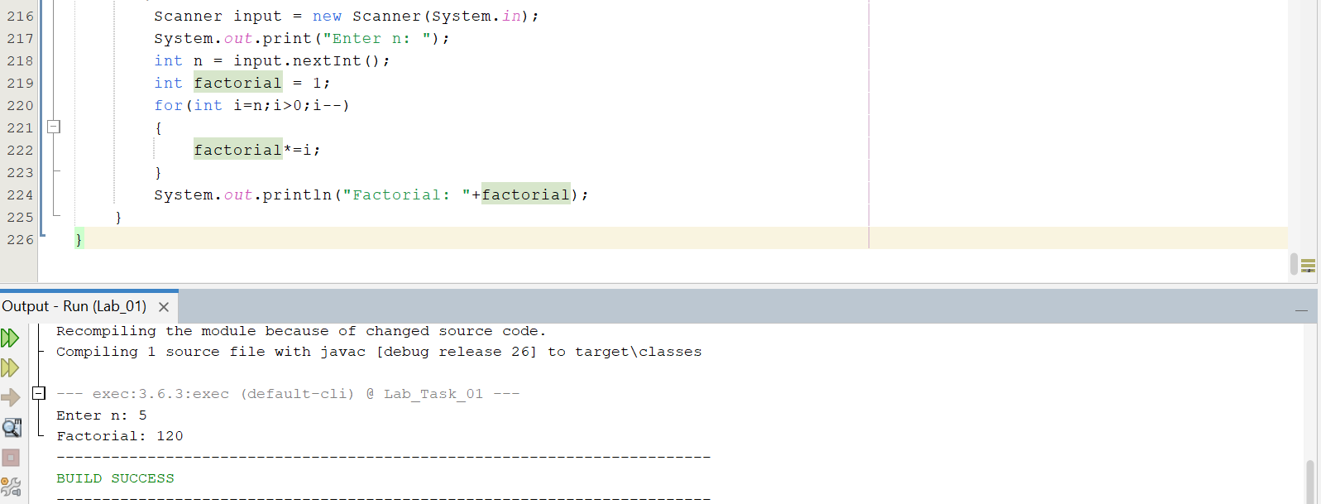
26.Use for-each to find the maximum value in an array.
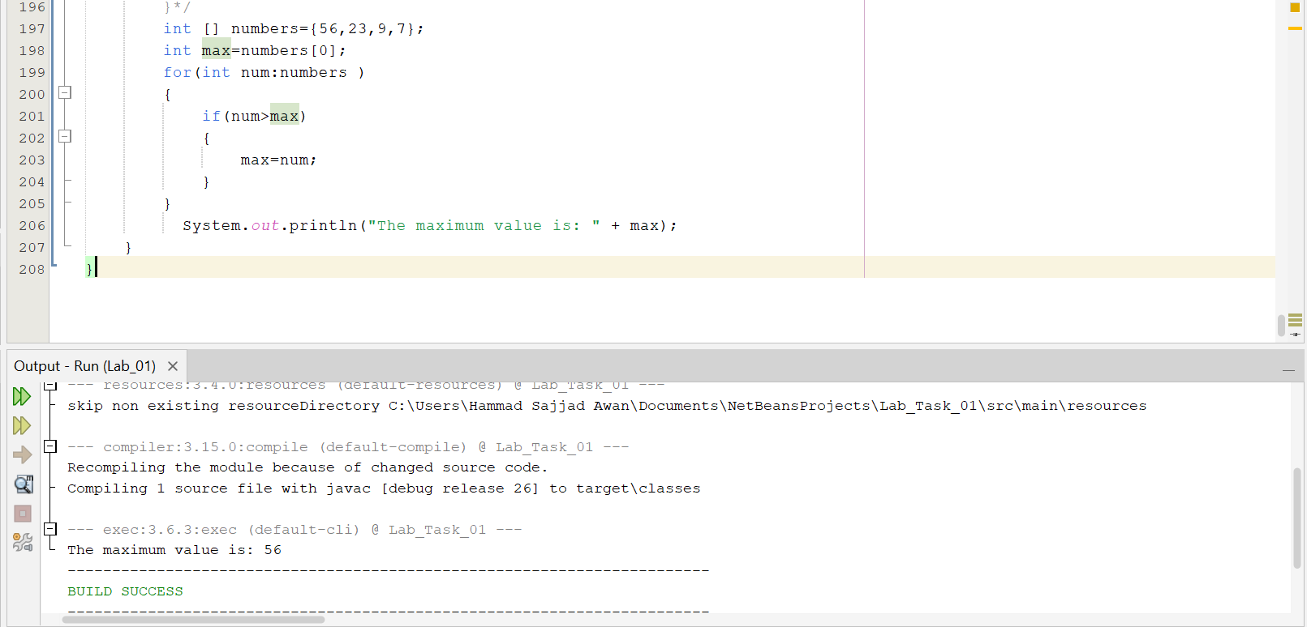
27.Print 1–20 but skip multiples of 3 using continue.
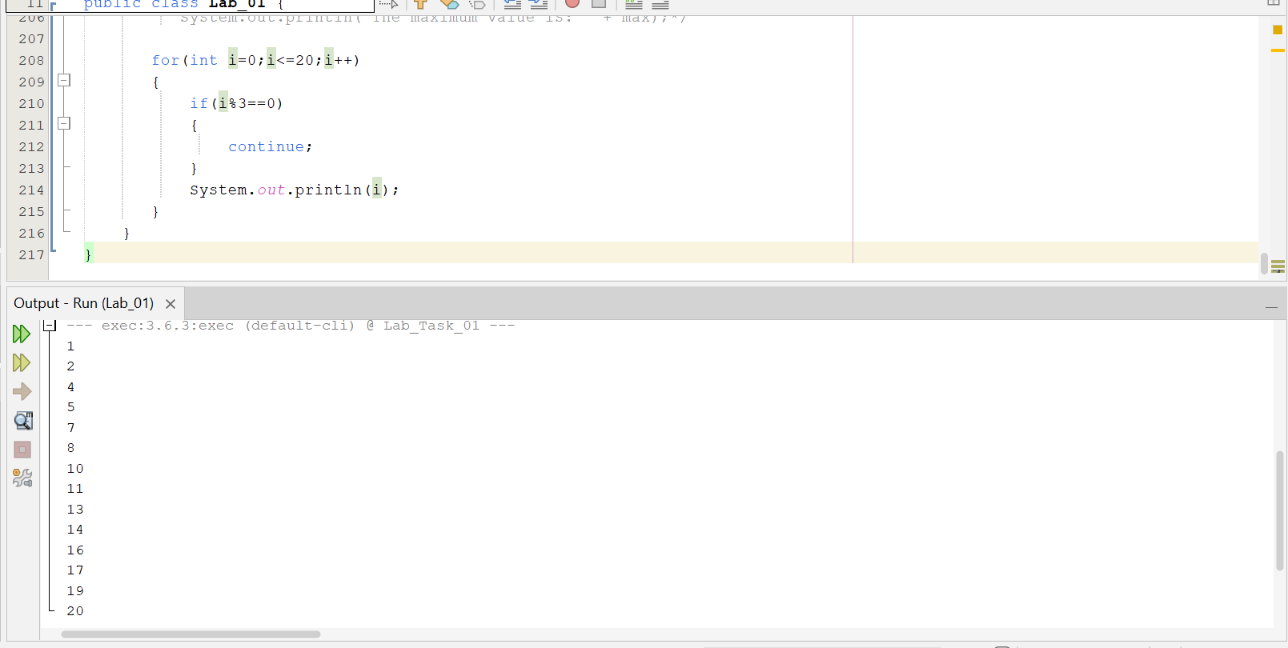
28.Stop a loop when a user enters -1 using break.
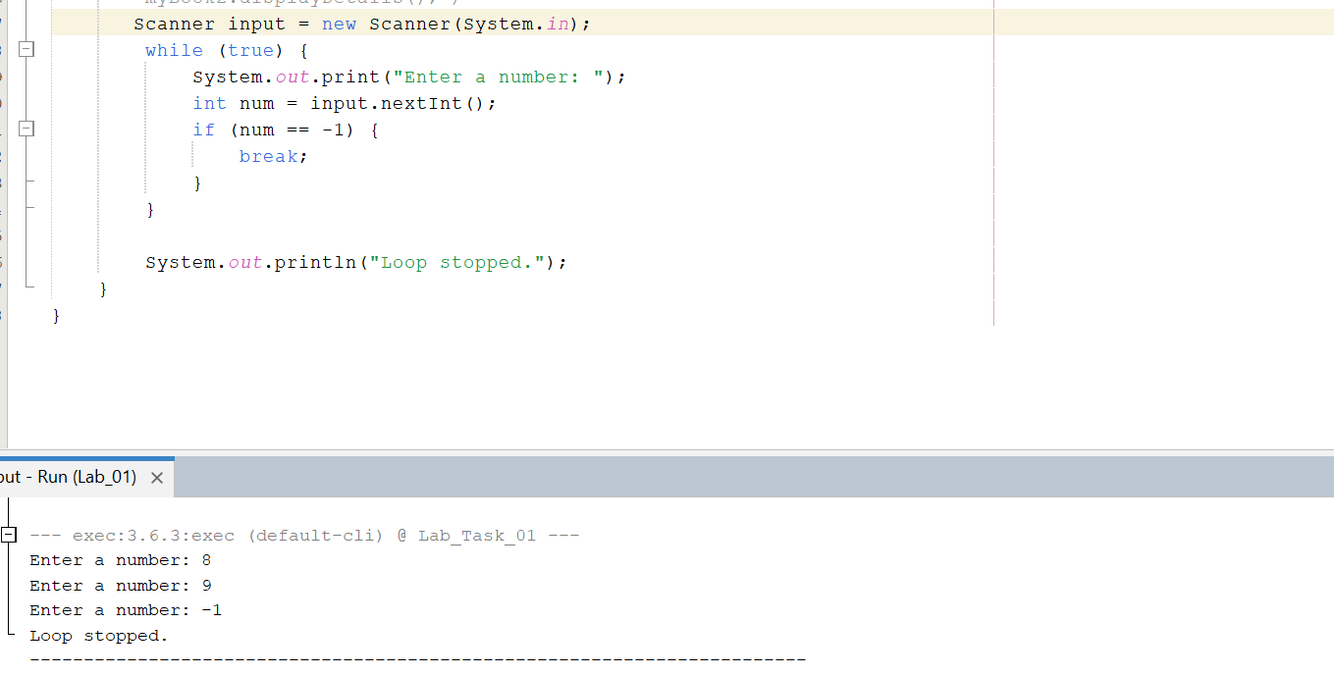
Challenging Task
1.Input n course marks, store them in an array, calculate the sum and maximum, and then use a for-each loop to count how many marks are at least 50.
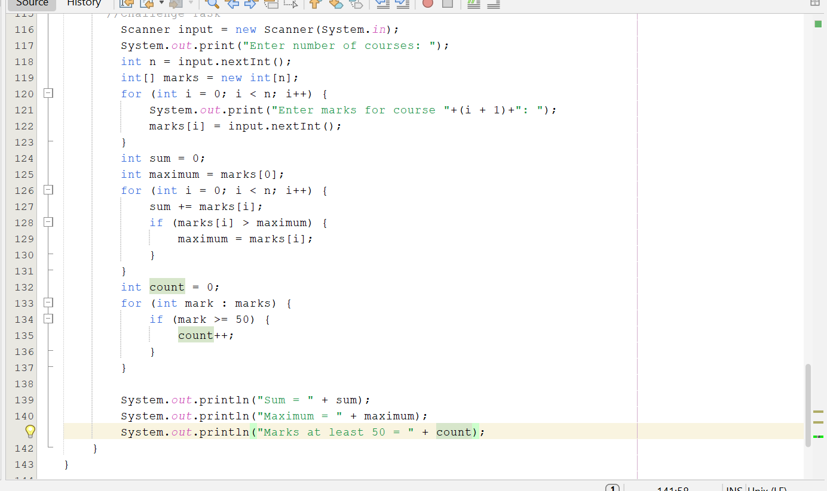
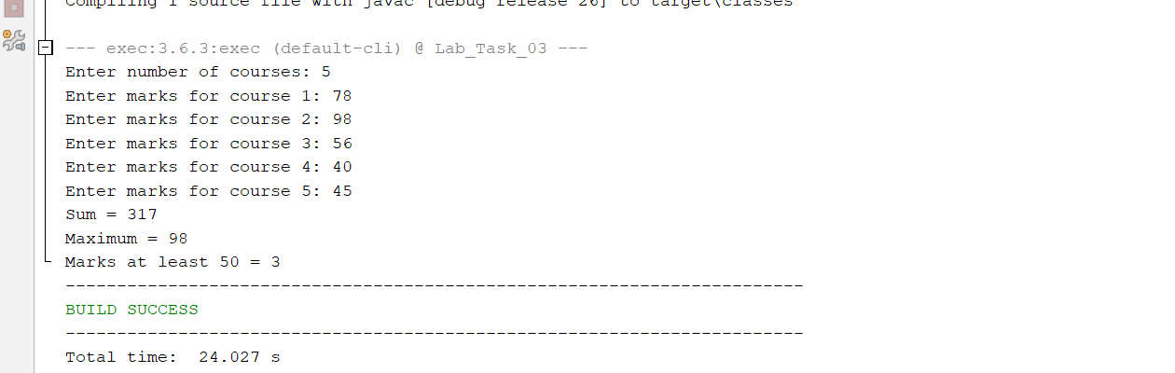
Lab Task # 04:

Activity 1: Create a Counter Class
Implement a class with state and behavior.
class Counter {
private int count;
public Counter() {
count = 0;
}
public int getCount() {
return count;
}
public void increment() {
count++;
}
}
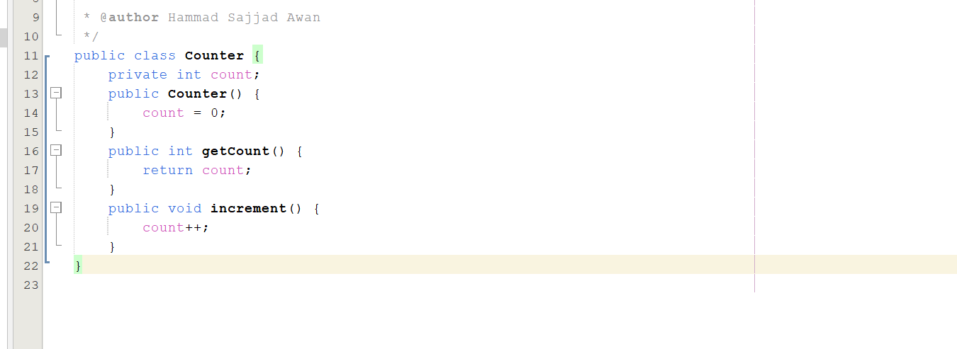

Activity 2: Use the Object
Create an instance and invoke its methods.
public class Lab2 {
public static void main(String[] args) {
Counter c = new Counter();
c.increment();
c.increment();
System.out.println(c.getCount());
}
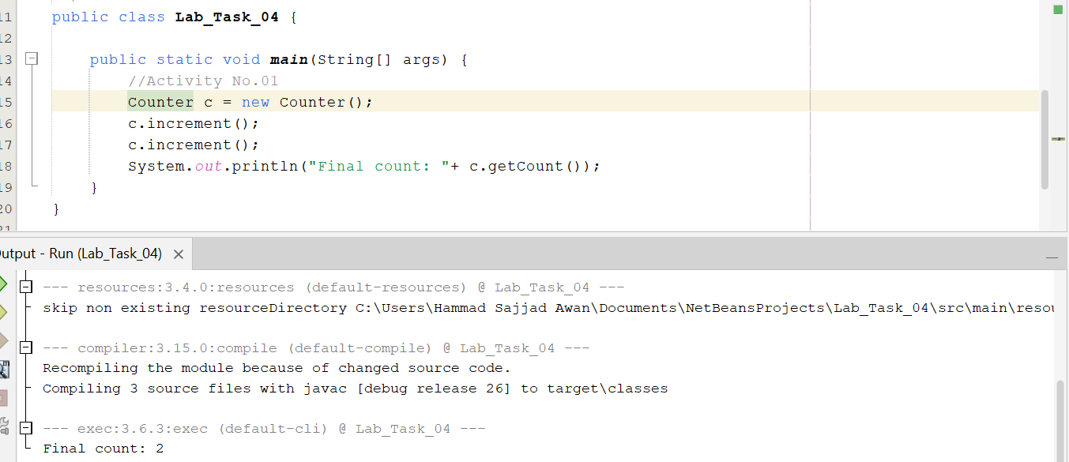

Activity 3: Extend the Class
Add a constructor that accepts an initial value and a decrement method.
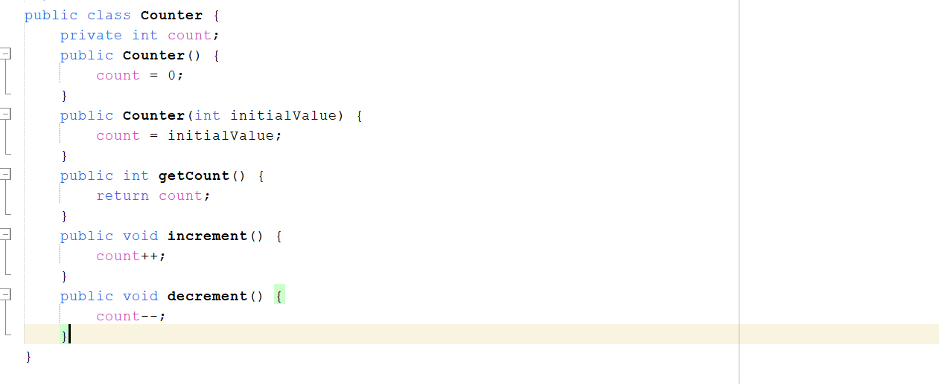
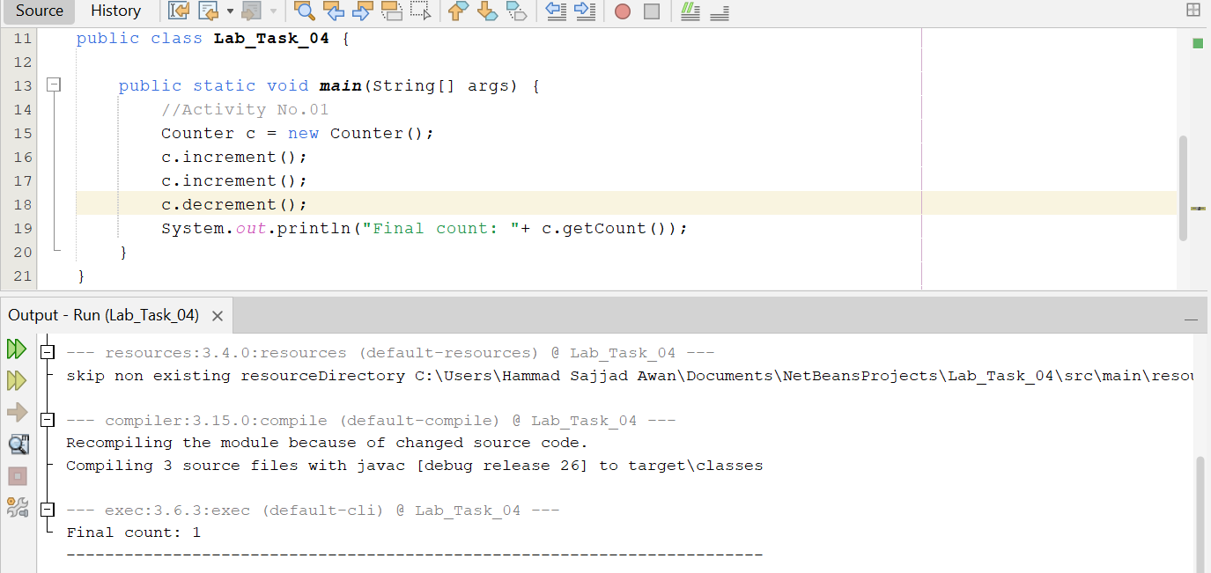

33.Create a Book class with title, author, and price.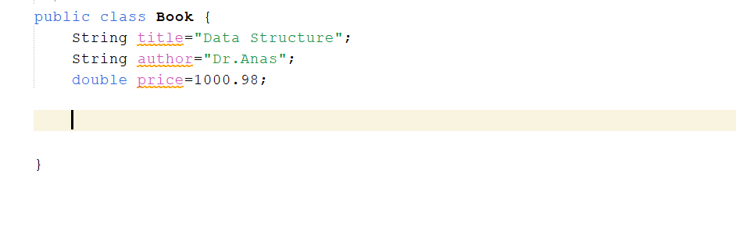34.Add a constructor and methods to display and update the price.
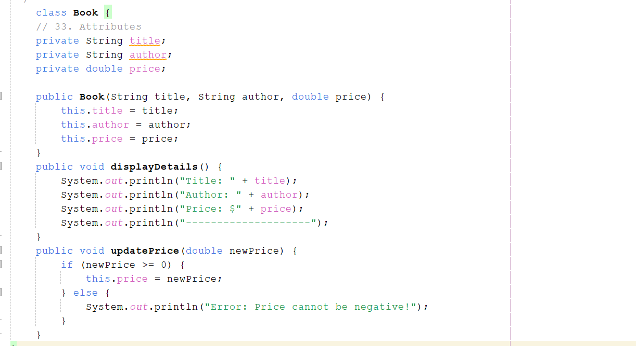
35.Create two Book objects and demonstrate that each object has its own state.
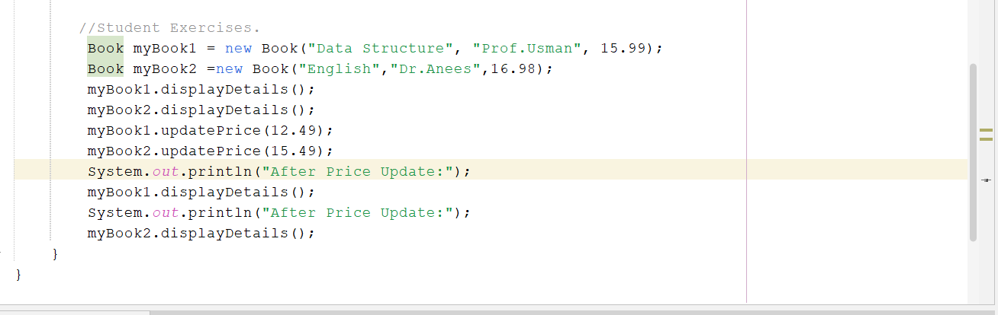
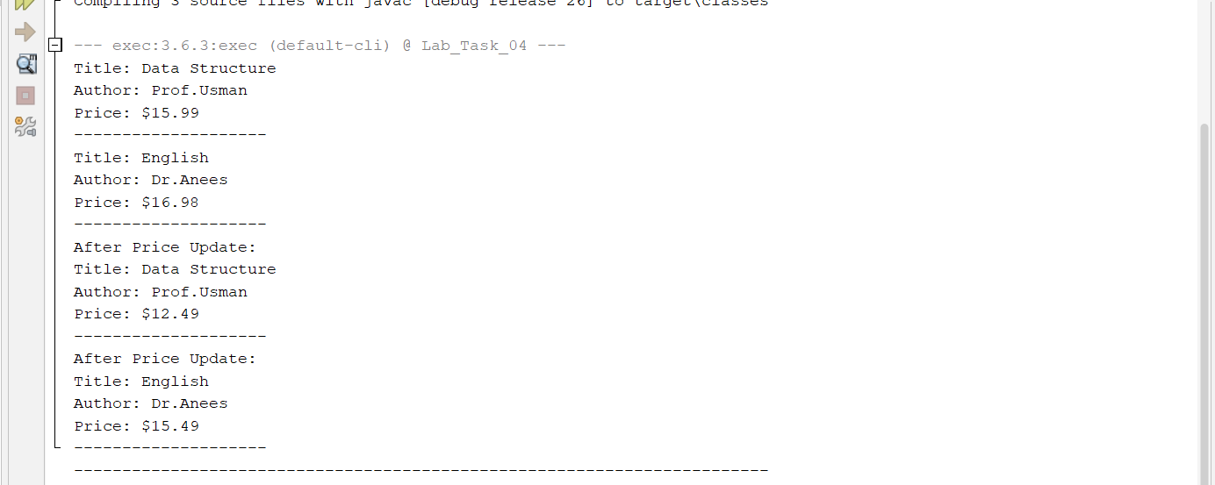
36.Create a Rectangle class with width and height and methods for area and perimeter.
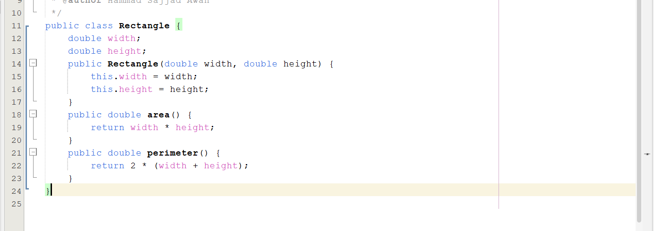
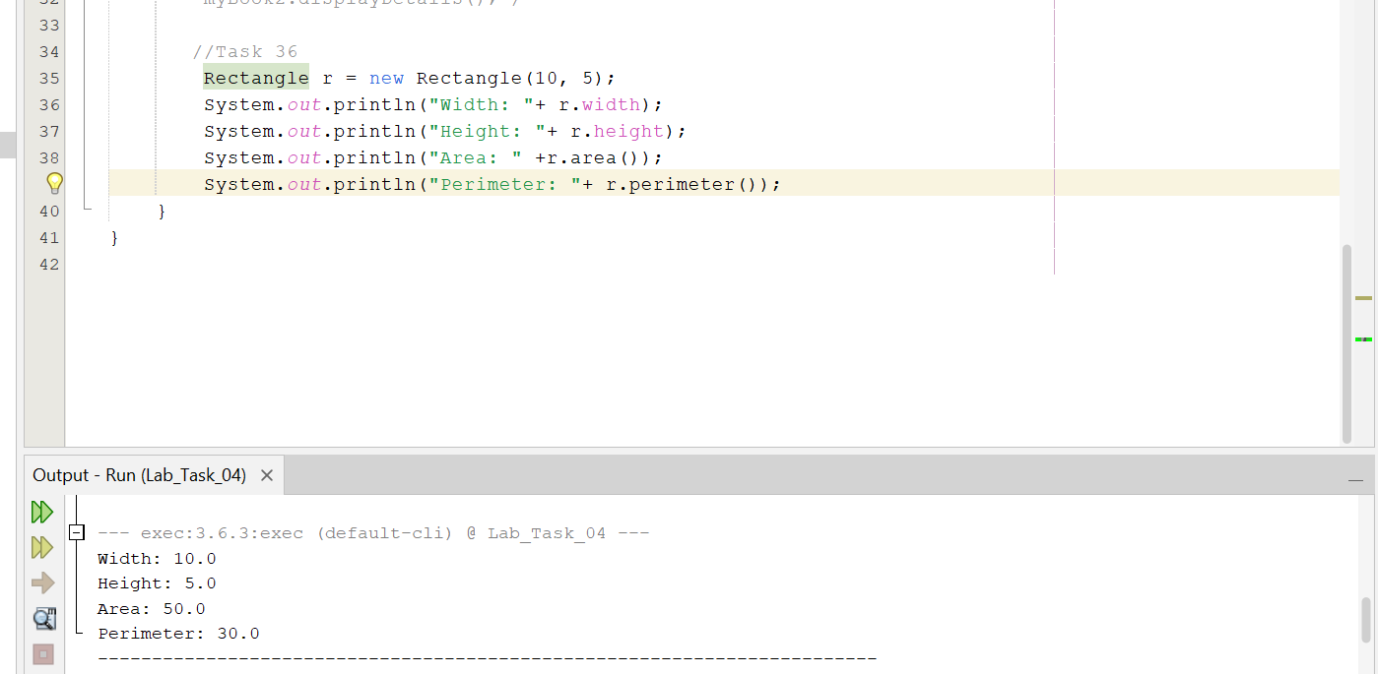

Challenging Task
1.Design a BankAccount class with account holder name and balance. Include a constructor, getBalance, deposit, and withdraw methods. Prevent a withdrawal from making the balance negative.
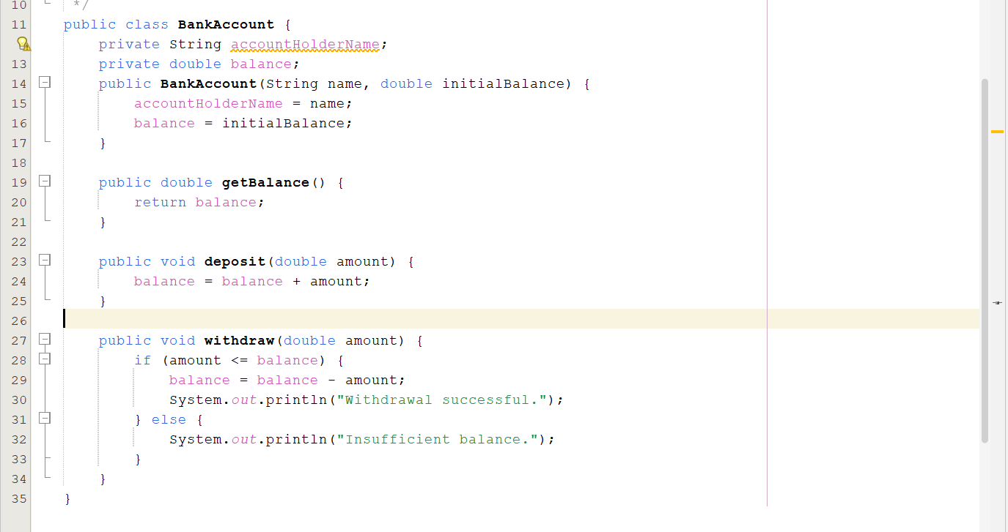
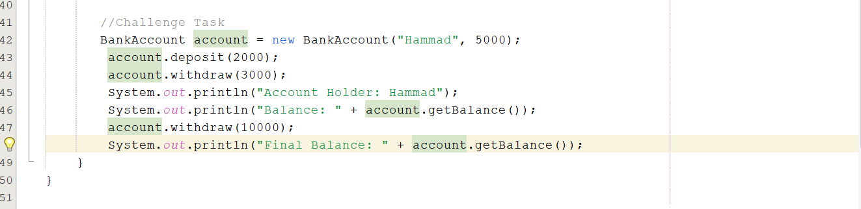
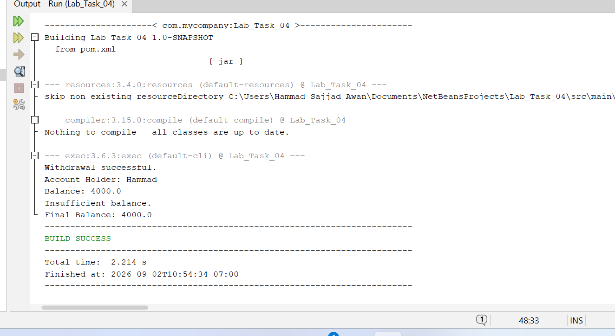

Lab Task # 05:

Activity 1: Arithmetic and Integer Division
Run and compare the results.
int a = 7;
int b = 2;
System.out.println(a / b);
System.out.println((double) a / b);

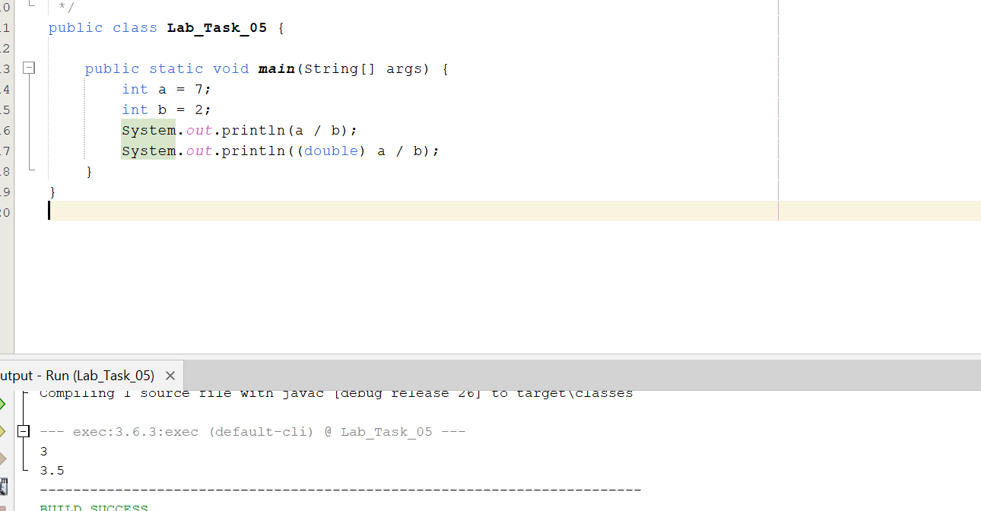

Activity 2: Increment Experiment
Predict each output.
int x = 5;
System.out.println(x++);
System.out.println(x);
System.out.println(++x);
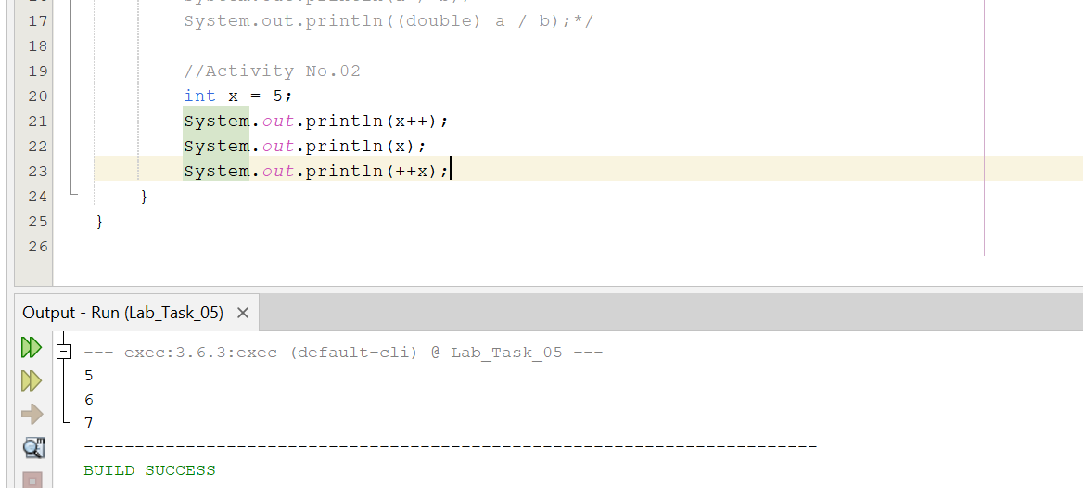

Activity 3: Logical Conditions
Experiment with && and ||.
int age = 20;
boolean hasCard = true;
System.out.println(age >= 18 && hasCard);
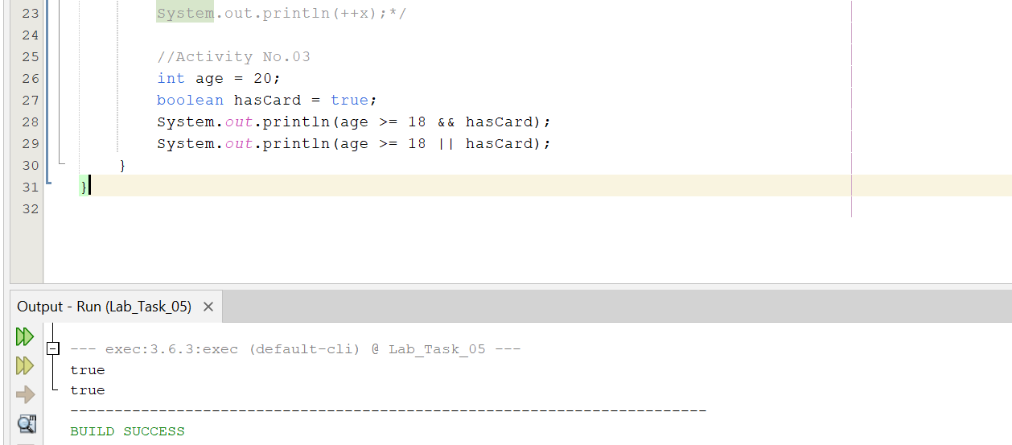

Activity 4: Casting
Compare explicit and widening conversions.
double d = 9.8;
int x = (int) d;
double y = 10;
System.out.println(x);
System.out.println(y);
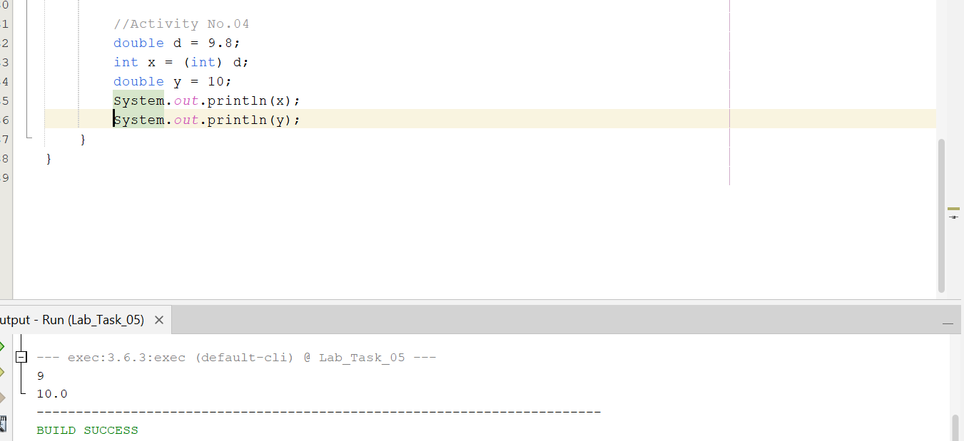

41.Write a program that calculates the average of three integers and ensures the result is displayed as a decimal.
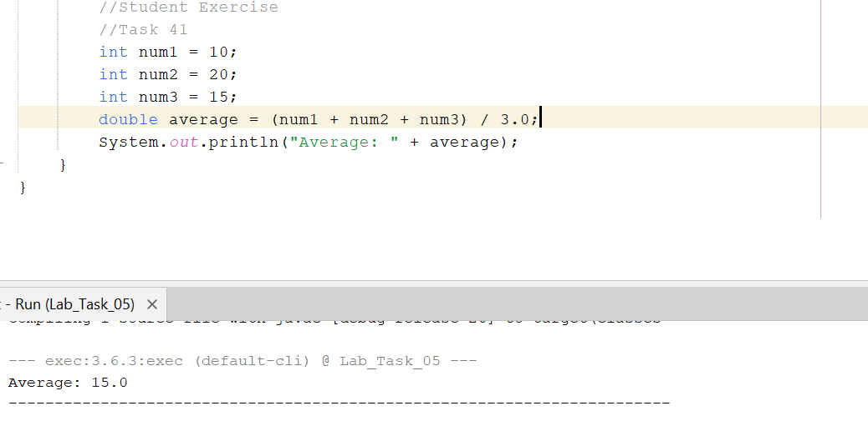
42.Predict the result of expressions containing both ++x and x++.
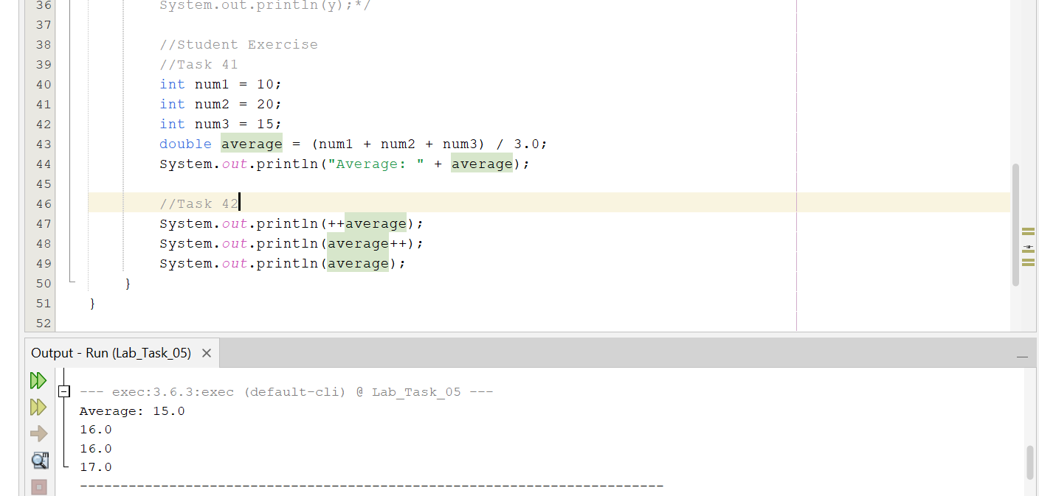
43.Write a Boolean expression that checks whether a student is eligible when attendance is at least 75 AND marks are at least 50.
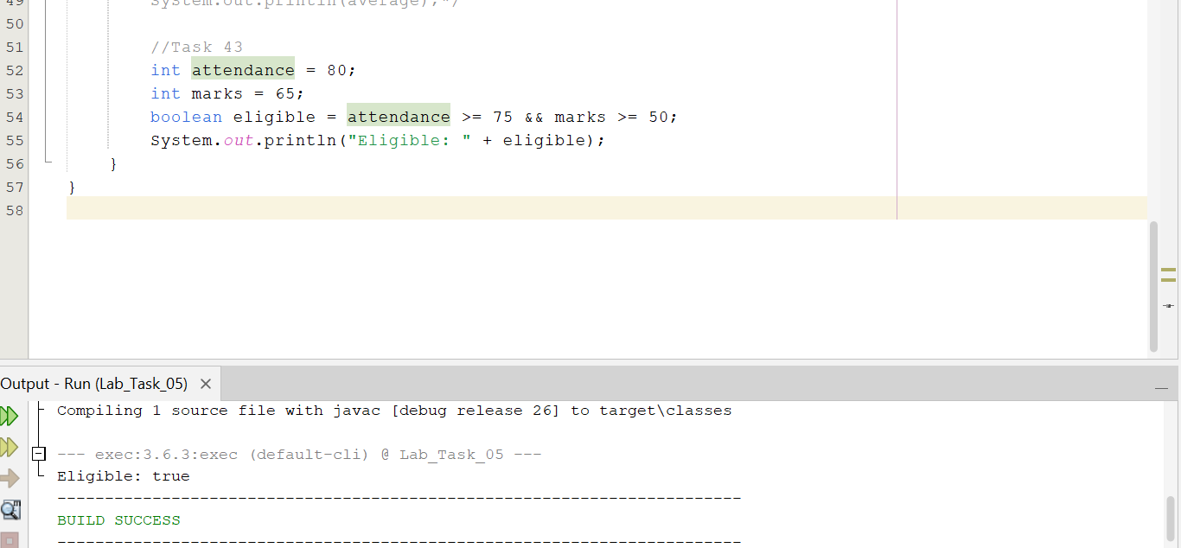
44.Convert a double to int explicitly and explain what happens to the fractional part.

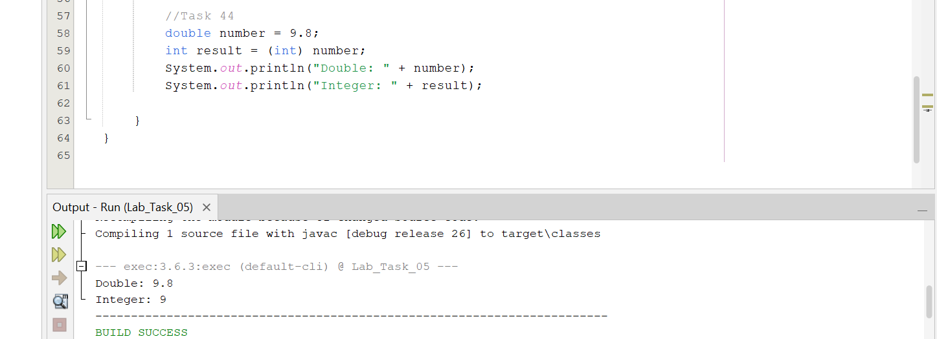
When you explicitly convert a double into an int, Java removes the fractional part.

Challenging Task
1.Create a mini grade calculator. Accept three marks, calculate average as double, and determine whether the student passes using logical operators.
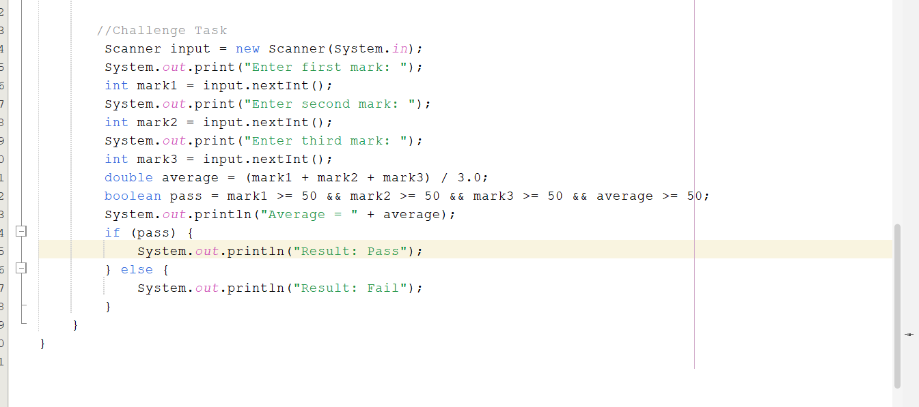
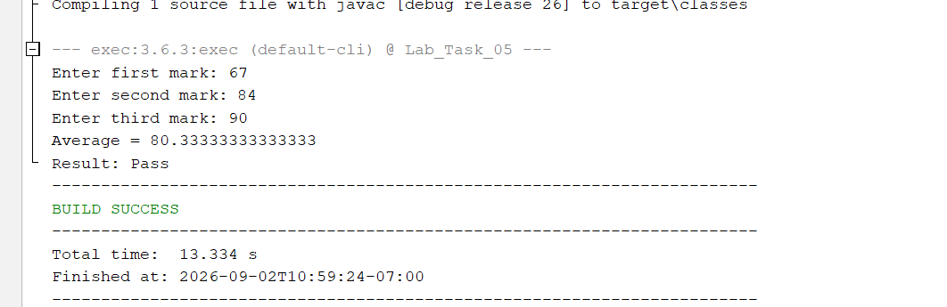

End

