实验报告7

姓名：鱼归霞 班级：17应用统计学一班 学号：117060400108 指导老师：林卫中

一．实验名称：字符串的反转，5.7，七段数码管

二．实验要求

掌握递归的方法，学会七段数码管的不同类型的实现方法

三．实验题目

1.实例5.3，字符串的反转

2.5.7实现汉洛塔的语法（递归算法的经典入门案例）

3．七段数码管（每段颜色随机，以及颜色不随机）

四．实验算法

1. def reverse(s):

return s[::-1]

str=input("请输入一个字符串: ")

print(reverse(str))

2. def hanoi(a,b,c,n):

if n==1:

print(a+"-->"+c)

else:

hanoi(a,c,b,n-1)

hanoi(a,b,c,n-1)

hanoi(b,a,c,n-1)

hanoi('a','b','c',3)

3.颜色不随机

1. import turtle, datetime, random

strcol = ['red','blue','yellow','gold','violet','purple','green']

def drawGap(): #绘制数码管间隔

turtle.penup()

turtle.fd(5)

def drawLine(draw): #绘制单段数码管

drawGap()

#turtle.colormode(255)

#r = random.randint(0, 255)

#g = random.randint(0, 255)

#b = random.randint(0, 255)

#turtle.pencolor((r, g, b))

turtle.pendown() if draw else turtle.penup()

turtle.fd(40)

drawGap()

turtle.right(90)

def drawDigit(d): #根据数字绘制七段数码管

turtle.pencolor(strcol[0])

drawLine(True) if d in [2, 3, 4, 5, 6, 8, 9] else drawLine(False)

turtle.pencolor(strcol[1])

drawLine(True) if d in [0, 1, 3, 4, 5, 6, 7, 8, 9] else drawLine(False)

turtle.pencolor(strcol[2])

drawLine(True) if d in [0, 2, 3, 5, 6, 8, 9] else drawLine(False)

turtle.pencolor(strcol[3])

drawLine(True) if d in [0, 2, 6, 8] else drawLine(False)

turtle.left(90)

turtle.pencolor(strcol[4])

drawLine(True) if d in [0, 4, 5, 6, 8, 9] else drawLine(False)

turtle.pencolor(strcol[5])

drawLine(True) if d in [0, 2, 3, 5, 6, 7, 8, 9] else drawLine(False)

turtle.pencolor(strcol[6])

drawLine(True) if d in [0, 1, 2, 3, 4, 7, 8, 9] else drawLine(False)

turtle.left(180)

turtle.penup()

turtle.fd(20)

def drawStr(str):

#r = random.randint(0, 255)

#g = random.randint(0, 255)

#b = random.randint(0, 255)

#turtle.pencolor((r, g, b))

turtle.write(str,font=("Arial", 18, "normal"))

turtle.fd(40)

def drawDate(date):

for i in date:

if i == '-':

drawStr('年')

elif i == '=':

drawStr('月')

elif i == '+':

drawStr('日')

else:

drawDigit(eval(i))

def main():

turtle.setup(800, 350, 200, 200)

turtle.penup()

turtle.fd(-350)

turtle.pensize(5)

drawDate(datetime.datetime.now().strftime('%Y-%m=%d+'))

turtle.hideturtle()

main()

2.颜色随机

import turtle, datetime, random

#strcol = ['red','blue','yellow','gold','violet','purple','green']

def drawGap(): #绘制数码管间隔

turtle.penup()

turtle.fd(5)

def drawLine(draw): #绘制单段数码管

drawGap()

turtle.colormode(255)

r = random.randint(0, 255)

g = random.randint(0, 255)

b = random.randint(0, 255)

turtle.pencolor((r, g, b))

turtle.pendown() if draw else turtle.penup()

turtle.fd(40)

drawGap()

turtle.right(90)

def drawDigit(d): #根据数字绘制七段数码管

#turtle.pencolor(strcol[0])

drawLine(True) if d in [2, 3, 4, 5, 6, 8, 9] else drawLine(False)

#turtle.pencolor(strcol[1])

drawLine(True) if d in [0, 1, 3, 4, 5, 6, 7, 8, 9] else drawLine(False)

#turtle.pencolor(strcol[2])

drawLine(True) if d in [0, 2, 3, 5, 6, 8, 9] else drawLine(False)

#turtle.pencolor(strcol[3])

drawLine(True) if d in [0, 2, 6, 8] else drawLine(False)

turtle.left(90)

#turtle.pencolor(strcol[4])

drawLine(True) if d in [0, 4, 5, 6, 8, 9] else drawLine(False)

#turtle.pencolor(strcol[5])

drawLine(True) if d in [0, 2, 3, 5, 6, 7, 8, 9] else drawLine(False)

#turtle.pencolor(strcol[6])

drawLine(True) if d in [0, 1, 2, 3, 4, 7, 8, 9] else drawLine(False)

turtle.left(180)

turtle.penup()

turtle.fd(20)

def drawStr(str):

r = random.randint(0, 255)

g = random.randint(0, 255)

b = random.randint(0, 255)

turtle.pencolor((r, g, b))

turtle.write(str,font=("Arial", 18, "normal"))

turtle.fd(40)

def drawDate(date):

for i in date:

if i == '-':

drawStr('年')

elif i == '=':

drawStr('月')

elif i == '+':

drawStr('日')

else:

drawDigit(eval(i))

def main():

turtle.setup(800, 350, 200, 200)

turtle.penup()

turtle.fd(-350)

turtle.pensize(5)

drawDate(datetime.datetime.now().strftime('%Y-%m=%d+'))

turtle.hideturtle()

main()

五．实验结果

1.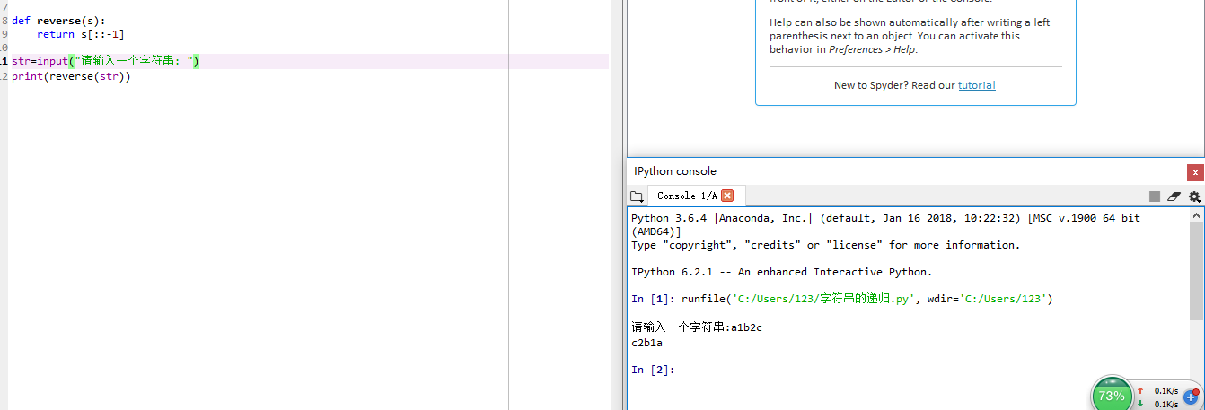

2.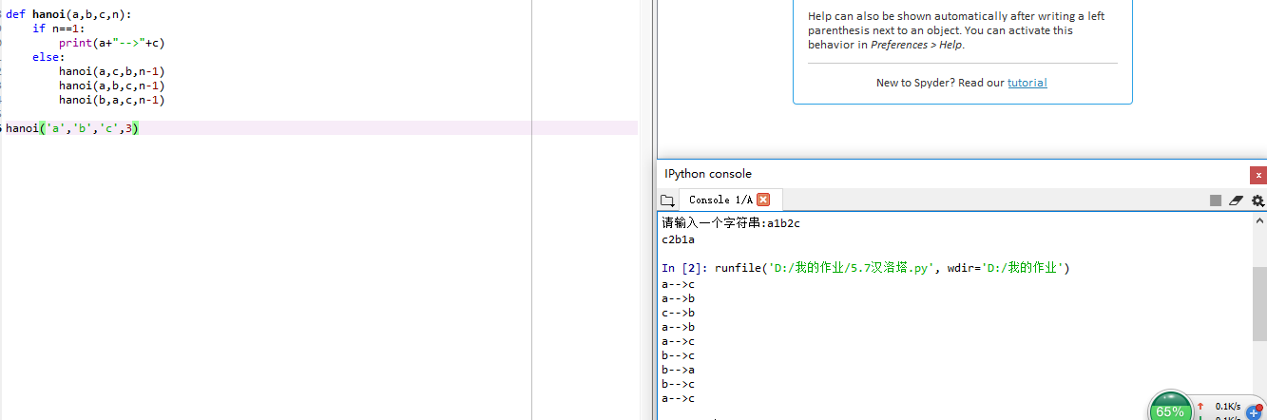

3.1

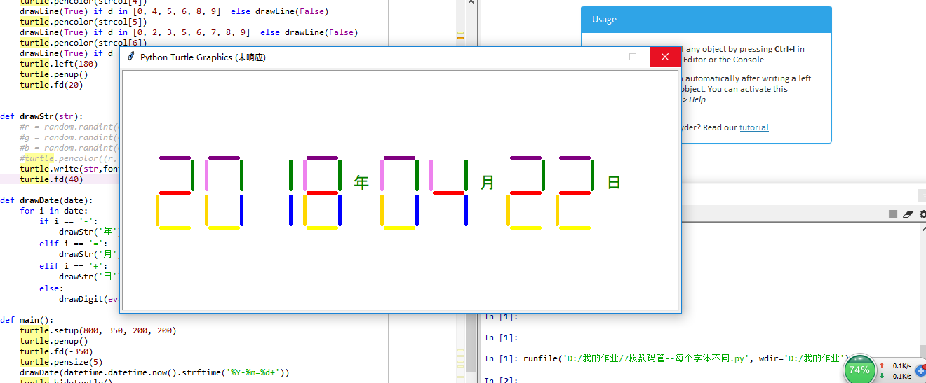

3.2

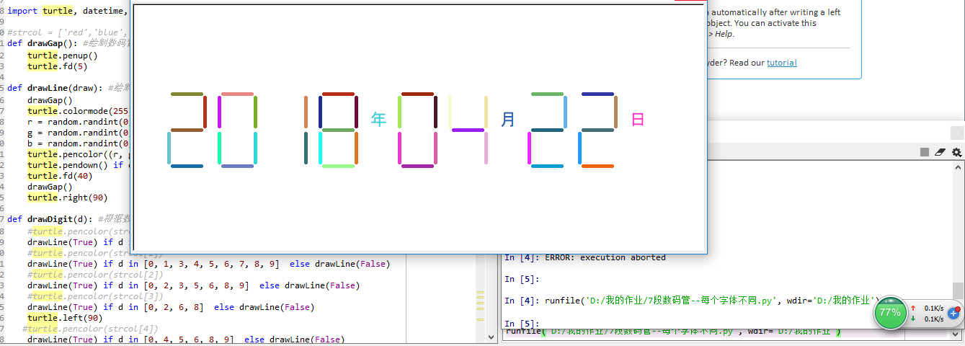

六．实验心得

通过本节的实验训练，对函数的递归有了一定的掌握，对于七段数码管的应用也有了创新。