**实验报告十二**

**姓名：鱼归霞 学号;117060400108 班级：17级应用统计学一班 指导老师：林卫中**

1. 实验内容

爬虫技术的练习

1. 实验算法：

1、import requests

from bs4 import BeautifulSoup

allUniv = []

def getHTMLText(url):

try:

r = requests.get(url, timeout=30)

r.raise_for_status()

r.encoding = 'utf-8'

return r.text

except:

return ""

def fillUnivList(soup):

data = soup.find_all('tr')

for tr in data:

ltd = tr.find_all('td')

if len(ltd)==0:

continue

singleUniv = []

for td in ltd:

singleUniv.append(td.string)

allUniv.append(singleUniv)

def printUnivList(province):

print("{:^4}{:^10}{:^5}{:^8}{:^10}".format("排名","学校名称","省份","总分","培养规模"))

for u in allUniv:

if province in u[2]:

print("{:^4}{:^10}{:^5}{:^8}{:^10}".format(u[0],u[1],u[2],u[3],u[4]))

def main(p):

url = 'http://www.zuihaodaxue.cn/zuihaodaxuepaiming2018.html'

html = getHTMLText(url)

soup = BeautifulSoup(html, "html.parser")

fillUnivList(soup)

printUnivList(p)

main('江西')

2、import requests

import re

from bs4 import BeautifulSoup

allUniv=[]

def getHTMLText(url):

send_headers = {

"User-Agent": "Mozilla/5.0 (Windows NT 10.0; Win64; x64) AppleWebKit/537.36 (KHTML, like Gecko) Chrome/61.0.3163.100 Safari/537.36",

"Connection": "keep-alive",

"Accept": "text/html,application/xhtml+xml,application/xml;q=0.9,image/webp,image/apng,*/*;q=0.8",

"Accept-Language": "zh-CN,zh;q=0.8"}

try:

r = requests.get(url, headers=send_headers)

r.raise_for_status()

print(r.status_code)

r.encoding = 'utf-8'

return r.text

except:

return ""

def fillUnivList(soup):

data = soup.find_all('div',{'class':re.compile('shadow-dark')})

for div in data:

singleUniv = []

div1 = div.find('div',{'style':'margin-left: 2.5rem;'})

rank = div1.get_text().strip()

singleUniv.append(rank.split(' ')[0])

div2 =div.find('h3')

singleUniv.append(div2.get_text().strip())

ldiv = div.find_all('div',{'style':'padding-right: 0.5rem;'})

singleUniv.append(ldiv[0].strong.string)

singleUniv.append(ldiv[1].strong.string)

allUniv.append(singleUniv)

def printUnivList():

print("{:<6}{:<20}{:<6}{:<10}".format("排名","学校名称","经费","培养规模"))

for u in allUniv:

print("{:<6}{:<20}{:<10}{:<10}".format(u[0],u[1],u[2],u[3]))

def main():

url = 'https://www.usnews.com/best-colleges/rankings/national-universities'

html = getHTMLText(url)

soup = BeautifulSoup(html,'html.parser')

fillUnivList(soup)

printUnivList()

main()

1. 实验结果

1、

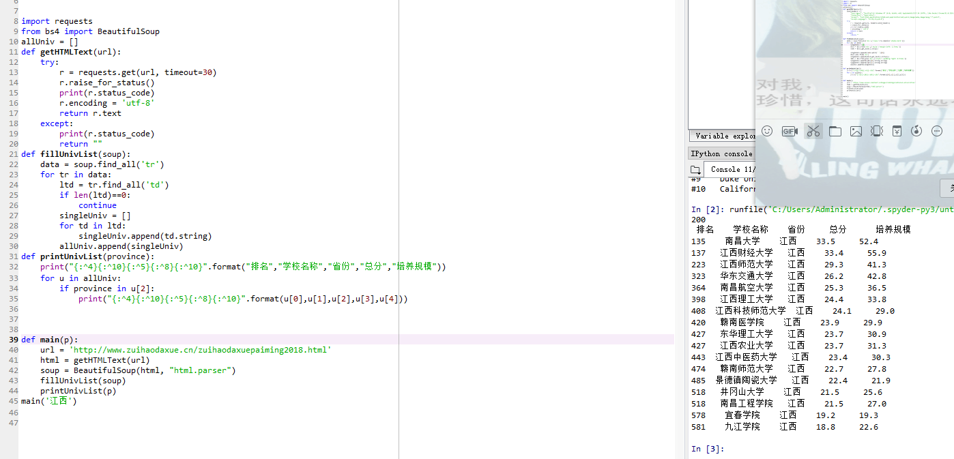

2、

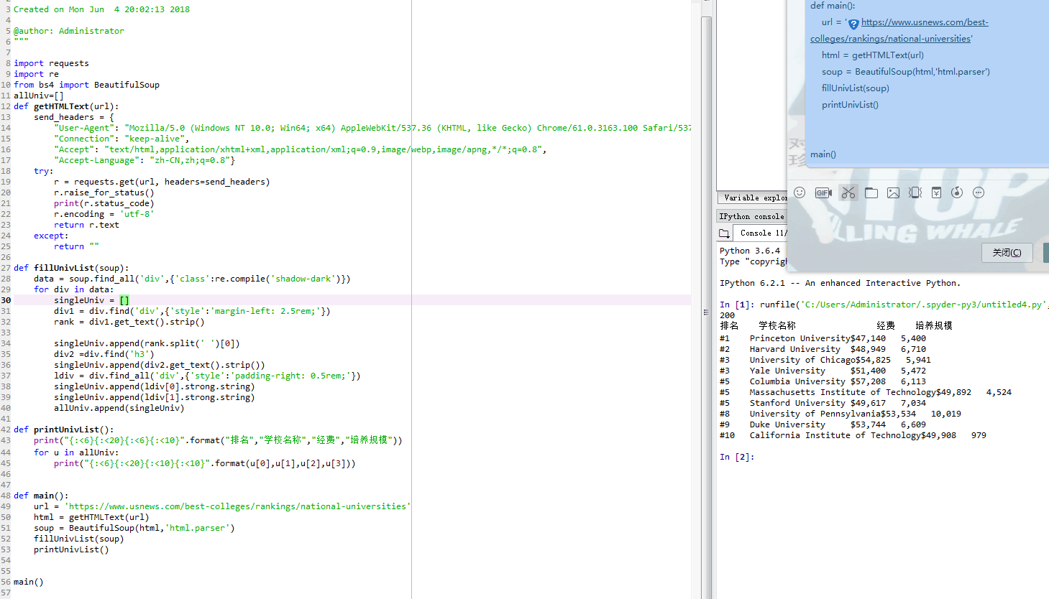

1. 实验心得

爬虫技术很有意思，但有很多东西还不是很明白。掌握了爬虫，可以做很多事，更有助于我们的学习生活。希望接下来可以把它学的很好。