**实验报告十六**

姓名：鱼归霞 学号：117060400108 班级：17级应用统计学一班 指导老师：林卫中

**一、实验名称**：分析微信朋友圈

**二、实验目的**：

更深一步掌握自顶向下的方法设计程序，综合所学的知识，应用到分析微信朋友圈中，巩固基础知识。

1. **实验内容**：
2. 分析朋友圈中的性别比例。通过设计程序，登录朋友圈，获取朋友圈数据，然后对朋友圈性别比例进行程序设计，用柱状图和饼状图表示出来。
3. 分析朋友圈里省份分布，用柱状图表示出来

**四、实验算法**：

1、

import itchat

import numpy as np

import matplotlib.pyplot as plt

import matplotlib as mpl

import re

import jieba

import PIL.Image as Image

def login():

itchat.login()

friends=itchat.get_friends(update=True)[0:]

return friends

def get_var(var, friends):

variable = []

for i in friends:

value = i[var]

variable.append(value)

return variable

def analyseGender(friends):

male=female=other=0

sexes = get_var('Sex', friends)

for sex in sexes:

if sex == 1:

male += 1

elif sex == 2:

female += 1

else:

other += 1

total = len(friends[1:])

malecol = round( float(male)/total * 100, 2)

femalecol = round( float(female)/total * 100, 2)

othercol = round( float(other)/total * 100, 2)

print('男性好友：{:.2f}%%'.format( malecol))

print('女性好友：{:.2f}%%'.format( femalecol))

print('不明性别好友：{:.2f}%%'.format( othercol))

mpl.rcParams['font.sans-serif']=['SimHei']

mpl.rcParams['axes.unicode_minus'] = False

map = {

'Female':(malecol, '#7199cf'),

'Male': (femalecol, '#4fc4aa'),

'other': (othercol, '#e1a7a2')

}

fig = plt.figure( figsize=(5,5))

ax = fig.add_subplot(111)

ax.set_title( '朋友圈性别')

xticks = np.arange(3) + 0.15

bar_width = 0.5

names = map.keys()

values = [ x[0] for x in map.values()]

colors = [ x[1] for x in map.values()]

bars = ax.bar( xticks, values, width=bar_width, edgecolor='none')

ax.set_ylabel('比例')

ax.set_xlabel('性别')

ax.grid()

ax.set_xticks( xticks)

ax.set_xticklabels( names)

ax.set_xlim( [bar_width/2 - 0.5, 3 - bar_width/2])

ax.set_ylim( [0, 100])

for bar, color in zip( bars, colors):

bar.set_color( color)

height = bar.get_height()

plt.text( bar.get_x(), bar.get_height()/4.+ height, '{:.2f}%'.format( float(height)))

plt.show()

fig1 = plt.figure( figsize=(5,5))

ax = fig1.add_subplot(111)

ax.set_title('饼图')

labels = ['{}\n{}%'.format(name, value) for name, value in zip( names, values)]

ax.pie(values, labels=labels, colors=colors)

plt.show()

friends = login()

analyseGender(friends)

2、

import itchat

import numpy as np

import matplotlib.pyplot as plt

import matplotlib as mpl

import re

import jieba

import PIL.Image as Image

def login():

itchat.login()

friends=itchat.get_friends(update=True)[0:]

return friends

def get_var(var, friends):

variable = []

for i in friends:

value = i[var]

variable.append(value)

return variable

def analyseGender(friends):

male=female=other=0

sexes = get_var('Sex', friends)

for sex in sexes:

if sex == 1:

male += 1

elif sex == 2:

female += 1

else:

other += 1

total = len(friends[1:])

malecol = round( float(male)/total * 100, 2)

femalecol = round( float(female)/total * 100, 2)

othercol = round( float(other)/total * 100, 2)

print('男性好友：{:.2f}%%'.format( malecol))

print('女性好友：{:.2f}%%'.format( femalecol))

print('不明性别好友：{:.2f}%%'.format( othercol))

#plot code

mpl.rcParams['font.sans-serif']=['SimHei']

mpl.rcParams['axes.unicode_minus'] = False

map = {

'Female':(malecol, '#7199cf'),

'Male': (femalecol, '#4fc4aa'),

'other': (othercol, '#e1a7a2')

}

fig = plt.figure( figsize=(5,5))

ax = fig.add_subplot(111)

ax.set_title( '朋友圈性别')

xticks = np.arange(3) + 0.15

bar_width = 0.5

names = map.keys()

values = [ x[0] for x in map.values()]

colors = [ x[1] for x in map.values()]

bars = ax.bar( xticks, values, width=bar_width, edgecolor='none')

ax.set_ylabel('比例')

ax.set_xlabel('性别')

ax.grid()

ax.set_xticks( xticks)

ax.set_xticklabels( names)

ax.set_xlim( [bar_width/2 - 0.5, 3 - bar_width/2])

ax.set_ylim( [0, 100])

for bar, color in zip( bars, colors):

bar.set_color( color)

height = bar.get_height()

plt.text( bar.get_x(), bar.get_height()/4.+ height, '{:.2f}%'.format( float(height)))

plt.show()

fig1 = plt.figure( figsize=(5,5))

ax = fig1.add_subplot(111)

ax.set_title('饼图')

labels = ['{}\n{}%'.format(name, value) for name, value in zip( names, values)]

ax.pie(values, labels=labels, colors=colors)

plt.show()

def analyseProvince(friends):

provlist = get_var('Province', friends)

provdict = {}

for p in provlist:

provdict[p] = provdict.get(p,0) + 1

provdict = sorted(provdict.items(), key= lambda x : x[1], reverse=True)

figpro = plt.figure(figsize=(10,5))

axpro = figpro.add_subplot(111)

axpro.set_title('省份')

xticks = np.linspace(0.5,20,10)

bar_width = 0.8

pros= []

values = []

count = 0

for d in provdict:

pros.append(d[0])

values.append(d[1])

count += 1

if count >= 10:

break

colors = ['#FFEC88', '#FFE4C4','#FFC125','#FFB6C1','#CDCDB4','#CDC8B1','#CDB79E','#CDAD00','#CD96CD',\

'#CD853F']

bars = axpro.bar( xticks, values, width=bar_width, edgecolor='none')

axpro.set_ylabel('人数')

axpro.set_xlabel('省份')

axpro.grid()

axpro.set_xticks( xticks)

axpro.set_xticklabels(pros)

axpro.set_xlim(0,20)

axpro.set_ylim([0,100])

for bar, color in zip( bars, colors):

bar.set_color(color)

height = bar.get_height()

plt.text( bar.get_x()+bar.get_width()/4., height, '{}'.format(height))

plt.show()

analyseProvince(friends)

1. **实验结果：**

1、

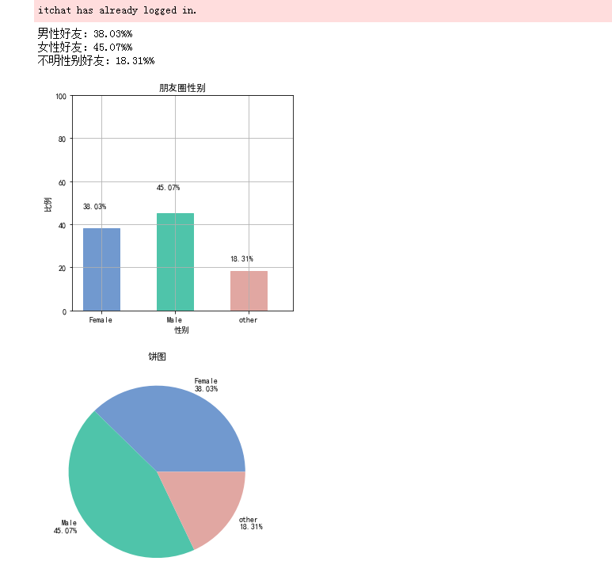

2、

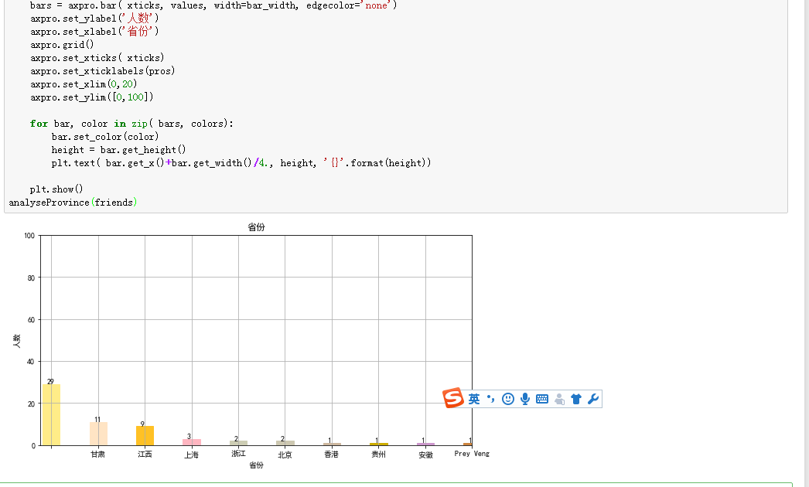五、**实验总结：**

通过这次实验课，学习了综合性较强的程序设计，对基础知识做了更深一步的复习。通过分析微信朋友圈程序设计的学习，方便了我们对朋友圈的信息查找。