**课外作业四**

1、课本211页程序练习题7.6

import os

def userOperateInterface():

print("\n请增加词典的功能模块")

print("i:增加单词")

print("s:查询单词")

print("Q:退出单词")

print("请选择功能：")

return input()

def addWord(wordDict:dict,fileName):

str = input("请输入您要加入的单词：")

if str in wordDict.keys():

print("该单词已经添加到字典库\n")

userOperateInterface()

else:

t1 = input("请输入此单词的第一个中文释义：")

wordDict.setdefault(str,[]).append(t1)

t2 = input("请输入此单词的第二个中文释义：")

wordDict.setdefault(str,[]).append(t2)

wordDict[str] = t1,t2

with open(fileName,'a') as fw:

fw.write(str + " " + t1,t2 + '\n')

def selectWord(wordDict:dict):

str = input("请输入您要查询的单词：")

if str not in wordDict.keys():

print("字典库中未找到这个单词\n")

else:

print(wordDict[str])

def main():

wordDict = ()

if os.path.exists("dict.txt"):

with open("dict.txt",'r') as fr:

for ln in fr:

s = ln.split(" ")

wordDict[s[0]] = s[1]

else:

fw = open("dict.txt",'w')

fw.close()

print("*********欢迎使用英文学习字典**********")

while True:

op = userOperateInterface()

if op == 'i':

addWord(wordDict,'dict.txt')

elif op == 's':

selectWord(wordDict)

elif op == 'Q':

break

else:

print("输入有误\n")

main()

实验结果

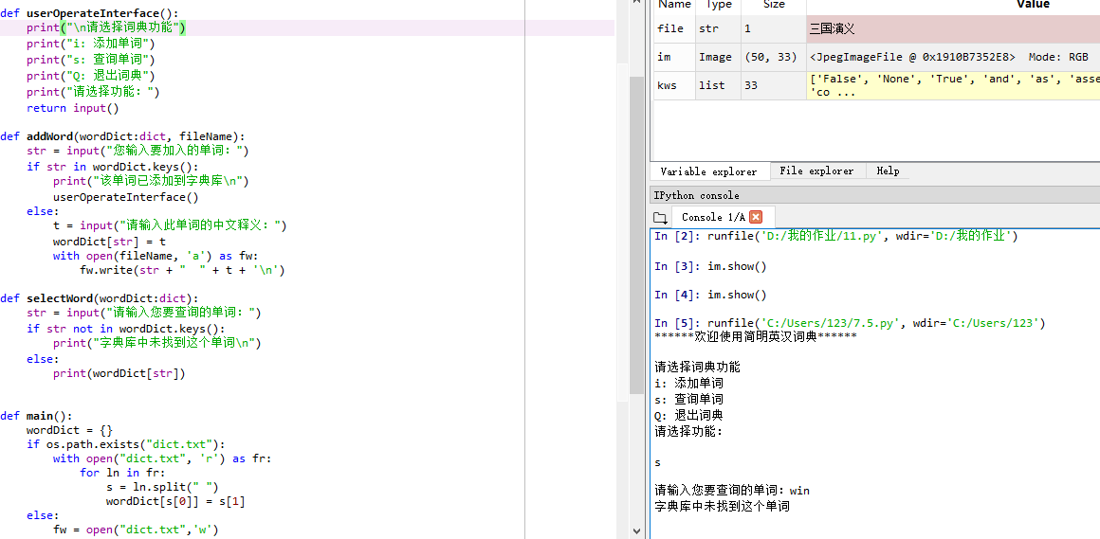

2.

fname = input("请输入要打开的文件：")

ls = {}

fo = open(fname,'r')

for line in fo:

line = line.replace("\n","")

ls.append(line.split(","))

fo.close

className = ls[0][1:]

max_score = [0,0,0]

min_score = [100,100,100]

avg_score = [0,0,0]

for stu in ls[1:]:

for i in range(3):

score = int(stu[i+1])

if score > max_score[i]:

max_score[i] = score

elif score < min_score[i]:

min_score[i] = score

avg_score[i] += score

for i in range(3):

avg_score[i] = avg_score[i]/(len(ls)-1)

for i in range(3):

avg_score[i] = avg_score[i]/(len(ls)-1)

for i in range(3):

print("{}的最高分是：{},最低分是：{},平均分是：{}".format(className[i],max_score[i],min_score[i]))

ls[0].append("总成绩")

for i in range(1,len(ls)):

total = 0

for j in range(1,len(ls[i])):

total += int(ls[i][j])

ls[i].append(str(total))

fw = open("score.csv","w")

for row in ls:

fw.write(",".join(row) + "\n")

fw.close()