## SSW567 HW 05 - Static Code Analysis

**Xiangyu Wang**

**GitHub URL: https://github.com/769978445/SSW567**

**Problem Statement/Objective:**

The objective of this assignment is to apply the techniques from the lecture to static testing of your Triangles program.

Specifically:

* You will run a static code analyzer on your code, e.g. Pylint, identify and fix any problems reported by the static code analyzer;
* You will run a code coverage tool on your code, e.g. Coverage.py, and extend your test cases to demonstrate at least 80% code coverage;

In this assignment, you will need to download and install the tools that you will need for static code analysis and code coverage. You will then run those tools locally on your laptop to get the results.

**Summary & Detailed Results:**

I used two tools for this assignment to perform the static code analysis.

The static code analyzer tool I used is “Pylint”. Before using it my code had a rating of 5.28/10, I was able to get a rate of 10/10 by making modifications according to the PEP8 style guide. Some changes in my previous code included changes in the argument name to conform to “snake_case” naming style, removal of unnecessary “else” and “elif”, and add final new line .

The code coverage tool I used is “Coverage.py”. It helped me in finding the effectiveness of the coverage of my test cases. The first analysis showed that my original code had a coverage of 92% with “3 lines” of missing code. After some changes to my test cases, I was able to achieve a 100% coverage with ‘0’ missing lines.

**Screen Shots:**

**Static code analysis report on original program:**

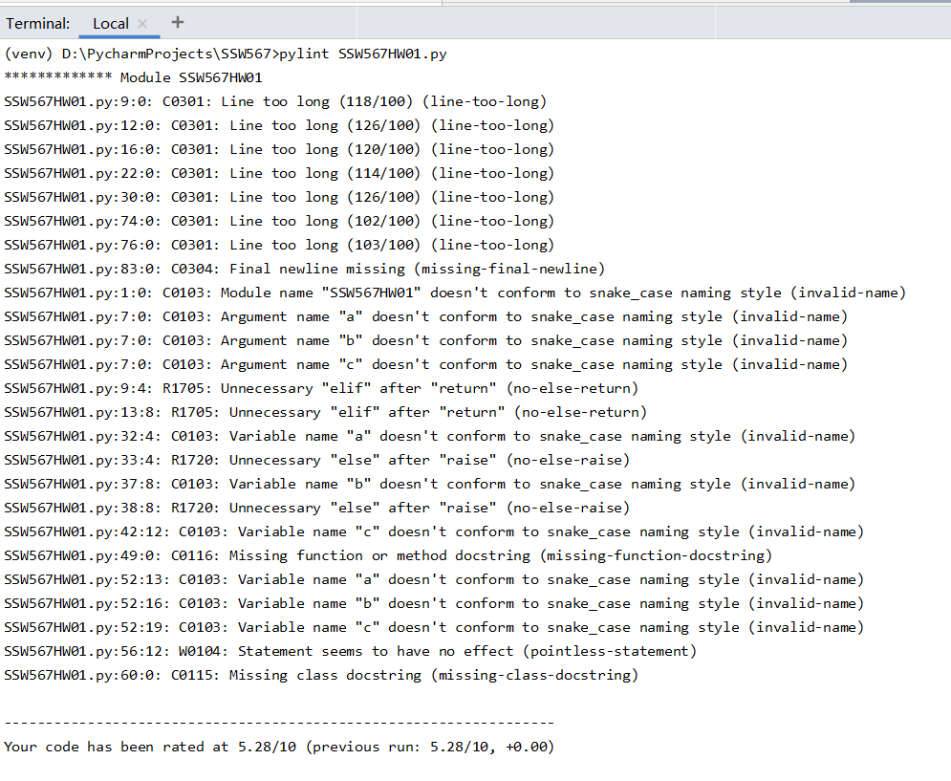

**Code coverage report before any changes to the program:**

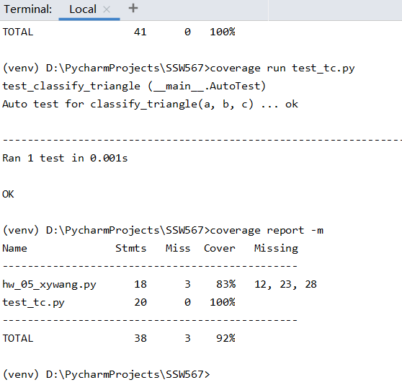

**Static code analysis report after you have made changes to eliminate issues:**

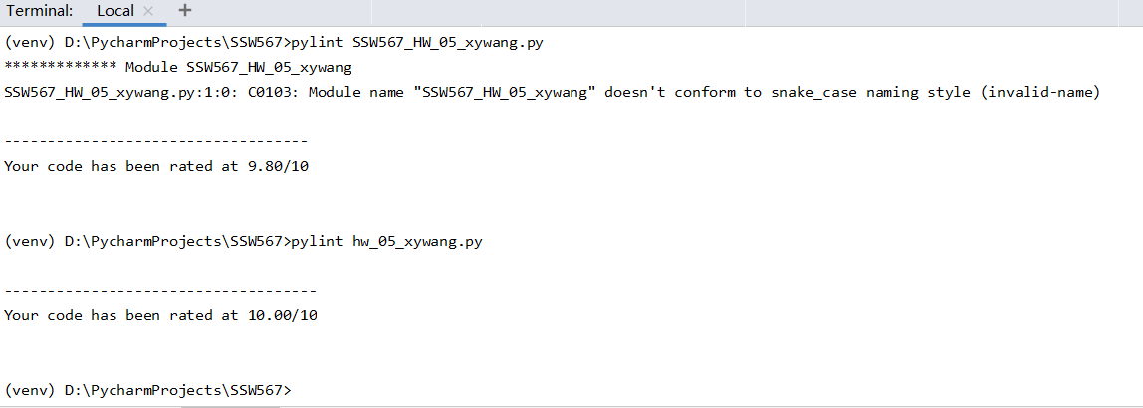

**Code coverage after any changes to the programs:**

