**TY B.Tech. (CSE) – II [ 2021-22 ]**

**Software Engineering Tools Lab**

**PRN/ Roll No: 2019BTECS00005**

**Name: Ashish Sutar**

**Batch: T3**

**Assignment No. 2**

**Module 2- Software Development Frameworks**

1. **Original author :**

Android Inc. was founded in [Palo Alto, California](https://en.wikipedia.org/wiki/Palo_Alto,_California), in October 2003 by [Andy Rubin](https://en.wikipedia.org/wiki/Andy_Rubin), [Rich Miner](https://en.wikipedia.org/wiki/Rich_Miner), Nick Sears, and Chris White.

1. **Developers :**

[Andy Rubin](https://en.wikipedia.org/wiki/Andy_Rubin), [Rich Miner](https://en.wikipedia.org/wiki/Rich_Miner), Nick Sears, and Chris White.

1. **A preview release** of the Android SDK was released on November 12, 2007.
2. **Initial release** Android SDK was released on November 12, 200
3. **Stable release –** On September 23, 2008, the Android 1.0 SDK (Release 1) was released.
4. **Repository (with cloud support)** <https://developer.android.com/topic/libraries/support-library/setup>
5. **Written in (Languages)** java
6. **Operating System support** Windows, ios, linux,
7. **Platform, portability**

Support on both windows and ios The dashboard for [Platform Versions](https://developer.android.com/about/dashboards/index.html) is updated regularly to show the distribution of active devices running each version of Android, based on the number of devices that visit the Google Play Store. Generally, it’s a good practice to support about 90% of the active devices, while targeting your app to the latest version.

1. **List of languages supported –** Kotlin java cpp
2. **Type** Android Studio is the official integrated development environment (IDE) for Google's Android operating system, built on JetBrains' IntelliJ IDEA software and designed specifically for Android development.
3. **Website** <https://developer.android.com/studio>
4. **Features**

Android SDK tool is an important component of Android SDK. It consists of a complete set of development and debugging tools. Below are the SDK developer tools:

Android SDK Build tool.

Android Emulator.

Android SDK Platform-tools.

Android SDK Tools.

* **Size : 2gb**

1. **Privacy and Security** Android is focused on helping users take advantage of the latest innovations, while making sure users' security and privacy are always a top priority.Build trust with your users by being transparent and providing users control over how they experience your app.If your app requests permission to access location, help users make an informed decision.Handle data safely Android has built-in security features that significantly reduce the frequency and impact of application security issues. The system is designed so that you can typically build your apps with the default system and file permissions and avoid difficult decisions about security.The following core security features help you build secure apps:The Android Application Sandbox, which isolates your app data and code execution from other apps. An application framework with robust implementations of common security functionality such as cryptography, permissions, and secure IPC.Technologies like ASLR, NX, ProPolice, safe_iop, OpenBSD dlmalloc, OpenBSD calloc, and Linux mmap_min_addr to mitigate risks associated with common memory management errors.An encrypted file system that can be enabled to protect data on lost or stolen devices.User-granted permissions to restrict access to system features and user data.Application-defined permissions to control application data on a per-app basis.
2. **Type of software (Open source/License)** Open source
3. **Licence :** Android Sdk licence agreement provide lots of information regarding privacy security, uses of sdk, Different credentials, limitations. All these are available on this website <https://developer.android.com/studio/terms>
4. **Latest version** 2021.1.1 Patch 1
5. **Cloud support** Yes
6. **Applicability** to reduce your Android app size by inspecting the contents of your app APK file, even if it wasn't built with Android Studio.
7. **Drawbacks (if any)** Security issue , Device fragmentation,Copyright problem, Device version incompatablity
8. **Implement linear regression problem using Google Colab (Perform pre-processing, training and testing)**

Dataset 2- <https://archive.ics.uci.edu/ml/datasets/Air+Quality>

Libraries:

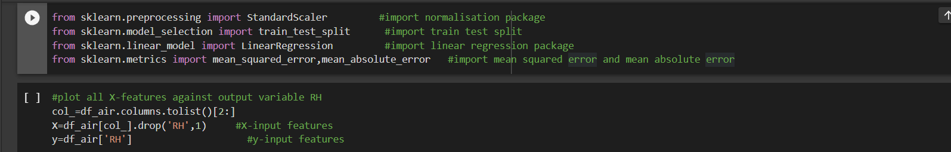

Training and testing :

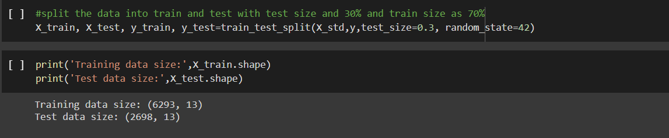

Linear Regression :

