# 猫视直播

# 系

# 统

# 设

# 计

# 文

# 档

版本号：V1.0

日 期：2018年9月11日

# 前 言

## 一、文档控制

### 1、文档更新记录

| 日期 | 更新人 | 版本 | 备注 |
| --- | --- | --- | --- |
|  |  |  |  |
| 2018-09-11 | 丁子豪 | V1.0 |  |
|  |  |  |  |
|  |  |  |  |
|  |  |  |  |

### 2、文档审核记录

| 日期 | 审核人 | 职务 | 备注 |
| --- | --- | --- | --- |
|  |  |  |  |
|  |  |  |  |
|  |  |  |  |

### 3、文档去向记录

| 拷贝份数 | 接受人 | 职务 | 备注 |
| --- | --- | --- | --- |
|  |  |  |  |
|  |  |  |  |
|  |  |  |  |

## 二、阅读提示

### 1、文档类别

系统设计文档

### 2、使用对象

猫视直播项目组成员

**目录**

**第1章 引言 1**

1.1 编写目的 1

1.2 项目来源 1

1.3 文档约定 1

1.4 预期读者和阅读建议 2

1.5 参考资料 2

**第2章 设备要求 3**

2.1 运行环境 3

开发工具/运行环境：MyEclipse/Eclipse、MySQL 3

硬件平台：PC 3

屏幕分辨率：1920*1080或以下 3

操作系统和版本：Windows 7/10； 3

其它运行环境：Tomcat 7.0 3

**第3章 主界面设计 3**

3.1 效果截图 3

3.2 主要代码 3

**第4章 直播间设计 8**

4.1 效果截图 9

4.2 主要代码 9

**第5章 电影分类页面设计 12**

5.1 效果截图 12

5.2 主要代码 12

**第6章 直播分类页面设计 18**

6.1 效果截图 18

6.2 主要代码 19

**第7章 登录注册页面设计 23**

7.1 效果截图 23

7.2 主要代码 24

**第8章 后台管理页面设计 28**

8.1 效果截图 28

8.2 主要代码 28

**第9章 个人信息页面设计 34**

9.1 效果截图 34

9.2 主要代码 35

**第10章 视频播放页面设计 36**

10.1 效果截图 36

10.2 主要代码 37

# 

# 第1章 引言

引言是对这份系统设计文档的概览，是为了帮助阅读者了解这份文档是如何编写的，并且应该如何阅读、理解和解释这份文档。

## 1.1 编写目的

这份系统设计文档基于猫视直播需求分析说明书而编写,开发这个产品的意义在于改进猫视直播原有的人工信息管理方式，改用先进的电子信息管理模式。在成功运营本软件后，猫视直播管理员对于猫视直播的日常管理将会变得简便。关于猫视直播的用户信息管理和视频信息管理等也会变得简便，且运营记录将会记录在管理员客户端，便于查看。通过这份软件系统概要设计报告详尽说明了该软件产品的软件结构，包括数据库结构和出错处理，从而对该软件产品的结构的描述。

## 1.2 项目来源

具体说明本软件开发项目的全部风险承担者，以及各自在本阶段所需要承担的主要风险，首要风险承担者包括：

任务提出者：xx；

承担风险：由于客观原因导致项目在开发过程中夭折。首要风险承担者为xx本人。

软件开发者：猫视直播开发团队；

承担风险：由于在某个阶段因为开发人员本身问题导致开发进度受阻。首要风险承担者为猫视直播团队

产品使用者：无。

## 1.3 文档约定

描述编写文档时所采用的各种排版约定。排版约定应该包括：

（1）标题格式；大标题：黑体二号；小标题：黑体四号

（2）正文格式；宋体小四

## 1.4 预期读者和阅读建议

列举本软件产品需求分析报告所针对的各种不同的预期读者，例如，可能包括：

用户：xx；

开发人员：猫视直播开发团队；

项目组长：郑宇程；

开发人员：丁子豪；

ui设计和页面美化：黄晓娟，林家宜；

文档编写入员：丁子豪，郑宇程；

## 1.5 参考资料

列举编写需求规格说明书时所用到的参考文献及资料，可能包括；

（1）本项目的合同书；

（2）上级机关有关本项目的批文；

（3）本项目已经批准的计划任务书；

（4）用户界面风格指导；

（5）开发本项目时所要用到的标准；

（6）系统规格需求说明；

（7）使用实例文档；

（8）属于本项目的其它已发表文件；

（9）本数据库设计说明书中所引用的文件、资料；

（10）相关软件产品数据库设计说明书；

**第2章 设备要求**

**2.1 运行环境**

开发工具/运行环境：MyEclipse/Eclipse、MySQL

硬件平台：PC

屏幕分辨率：1920*1080或以下

操作系统和版本：Windows 7/10；

其它运行环境：Tomcat 7.0

**第3章 主界面设计**

**3.1 效果截图**

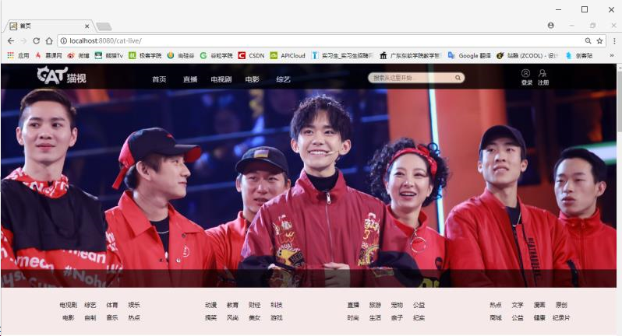

**3.2 主要代码**

<div id="head">

<div class="logo"><img src="${ctx}/images/logo.png"></div>

<!------------------导航-------------------->

<div class="nav">

<ul class="nav2">

<li onMouseOver=" displaysubMenu(this)" onMouseOut="hidesubMenu(this)">

<a href="home.jsp">首页&nbsp;&nbsp;&nbsp;&nbsp;&nbsp;&nbsp;|</a>

</li>

<li onMouseOver=" displaysubMenu(this)" onMouseOut="hidesubMenu(this)">

<a href="#">导航</a>

<ul>

<li><a href="live.jsp">直播</a></li>

<li><a href="tv.jsp">电视剧</a></li>

<li><a href="film.jsp">电影</a></li>

<li><a href="Var.jsp">综艺</a></li>

</ul>

</li>

</ul>

</div>

<!------------------搜索框-------------------->

<div class="search">

<form>

<input type="text" placeholder="搜索从这里开始...">

<button type="submit"></button>

</form>

<!------------------登录-------------------->

<div class="login"><img src="${ctx}/images/用户.png"><a href="#">登录</a></div>

<!------------------注册-------------------->

<div class="register"><img src="${ctx}/images/注册.png"><a href="#">注册</a></div>

</div>

</div>

<!---------------------------轮播图----------------------------->

<center>

<div id="demo1" class="slideBox">

<ul class="items">

<li><a href="#"><img src="${ctx}/images/film_slider/1.png" width="100%" ></a></li>

<li><a href="#"><img src="${ctx}/images/film_slider/2.png" width="100%" ></a></li>

<li><a href="#"><img src="${ctx}/images/film_slider/3.png" width="100%" ></a></li>

<li><a href="#"><img src="${ctx}/images/film_slider/4.png" width="100%"></a></li>

<li><a href="#"><img src="${ctx}/images/film_slider/5.png" width="100%" ></a></li>

</ul>

</div>

</center>

<script src="<%=request.getContextPath()%>/javascript/jquery.min.js" type="text/javascript"></script>

<script src="<%=request.getContextPath()%>/javascript/jquery.slideBox.min.js" type="text/javascript"></script>

<script>

jQuery(function($){

$('#demo1').slideBox();

$('#demo2').slideBox({

direction : 'top',//left,top#方向

duration : 0.3,//滚动持续时间，单位：秒

easing : 'linear',//swing,linear//滚动特效

delay : 5,//滚动延迟时间，单位：秒

startIndex : 1//初始焦点顺序

});

$('#demo3').slideBox({

duration : 0.3,//滚动持续时间，单位：秒

easing : 'linear',//swing,linear//滚动特效

delay : 5,//滚动延迟时间，单位：秒

hideClickBar : false,//不自动隐藏点选按键

clickBarRadius : 10

});

$('#demo4').slideBox({

hideBottomBar : true//隐藏底栏

});

});

</script>

<!---------------------------分类----------------------------->

<div id="classification">

<div class="cla">

<ul>

<li>

<a href="#">近期热门</a><a href="#">免费电影</a><a href="#">会员专区</a><a href="#">最新上线</a>

<a href="#">院线大片</a><a href="#">评分最高</a>

</li>

<li>

<p style="margin-left:28px">按地区</p>

<a href="#">华语</a><a href="#">美国</a><a href="#">日本</a><a href="#">欧洲</a>

<a href="#">英国</a><a href="#">韩国</a><a href="#">泰国</a><a href="#">其他</a>

</li>

<li>

<p style="margin-left:28px">按类型</p>

<a href="#">喜剧</a><a href="#">悲剧</a><a href="#">爱情</a><a href="#">动作</a>

<a href="#">悬疑</a><a href="#">动画</a><a href="#">家庭</a><a href="#">科幻</a>

</li>

<li> <p style="margin-left:28px">按年份</p>

<a href="#">2018</a><a href="#">2017</a><a href="#">2016</a><a href="#">2015</a>

<a href="#">2015</a><a href="#">2014</a><a href="#">00年代</a><a href="#">90年代</a>

</li>

</ul>

</div>

</div>

<!---------------------------版尾----------------------------->

<div id="buttom">

<div class="bottom-com">

<div class="bottom-left">

<ul>

<li><a href="#">关于</a></li>

<li><a href="#">关于我们</a></li>

<li><a href="#">版权声明</a></li>

<li><a href="#">用户协议</a></li>

</ul>

</div><!--bottom-left -->

<div class="bottom-middle">

<ul>

<li><a href="#">服务</a></li>

<li><a href="#">加入收藏</a></li>

<li><a href="#">官方微博</a></li>

<li><a href="#">联系方式</a></li>

</ul>

</div><!-- bottom-middle-->

<div class="bottom-right">

<img src="${ctx}/images/二维码.jpg" width="67px" height="66px">

<br>

<p style="margin-top:8px">扫一扫</p><p style="margin-top:8px"></p>为您送上猫视的最新动态

</div><!--bottom-right -->

</div><!-- bottom-com-->

</div><!--版尾 -->

**第4章 直播间设计**

**4.1 效果截图**

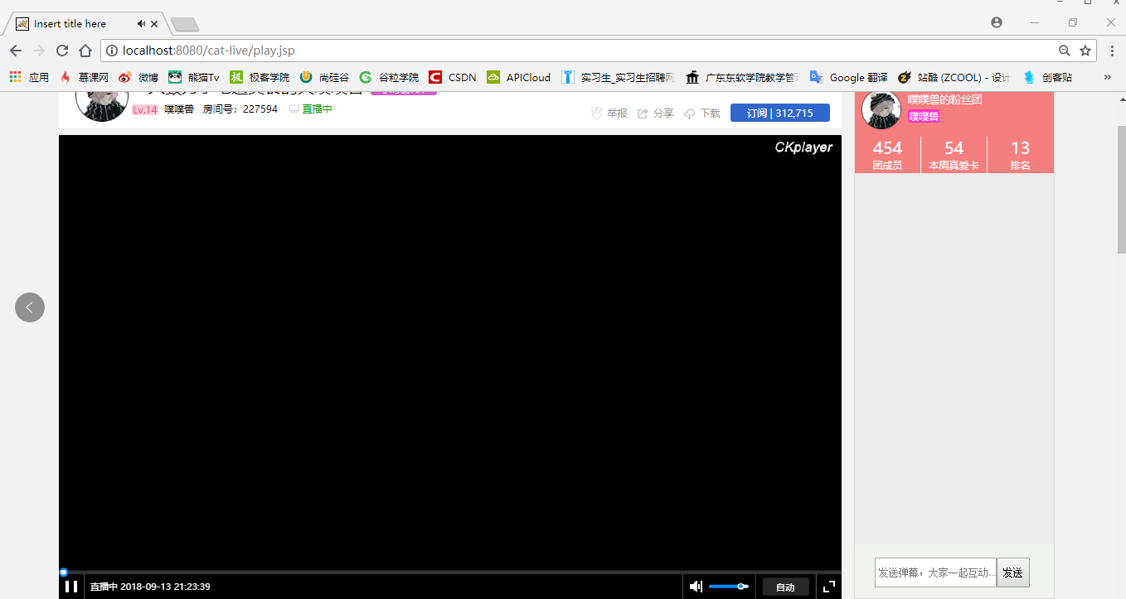

**4.2 主要代码**

<!------------------content-------------------->

<div id="content">

<div id="Introduction">

<div class="Anchor-img"><img src="${ctx}/images/主播头像.png"></div>

<div class="Anchor-name"><span class="title">一只致力于吃遍美食的大噗噗兽</span>

<span class="time">小时榜:&nbsp;57</span>

<a><span class="red">Lv.14</span>&nbsp;&nbsp;噗噗兽&nbsp;&nbsp;&nbsp;房间号：227594&nbsp;&nbsp;&nbsp;

<span class="green"><img src="${ctx}/images/直播中.png">&nbsp;直播中</span>&nbsp;&nbsp;&nbsp;

</a>

</div>

<div class="other"><span class="img"><img src="${ctx}/images/举报.png"></span>

<span class="word">&nbsp;举报</span>

<span class="img"><img src="${ctx}/images/分享.png"></span>

<span class="word">&nbsp;分享</span>

<span class="img"><img src="${ctx}/images/下载.png"></span>

<span class="word">&nbsp;下载</span>

<span class="blue">订阅&nbsp;|&nbsp;312,715</span>

</div>

</div>

<div id = "video" style = "width:1180px;height:700px;"></div>

<script type = "text/javascript">

var videoObject = {

container:'#video',

variable:'player',

autoplay:true,

//在推流端发布的rtmp地址

video:'rtmp://localhost/live/record1'

};

var play = new ckplayer(videoObject);

</script>

<div id="series">

<div class="fan-series">

<a>粉丝榜</a>

</div>

<div class="nav-series">

<a>日榜</a>

<a>总榜</a>

<a>守护</a>

</div>

<div class="series-anchor">

<span class="series-img"><img src="${ctx}/images/列表主播头像.png"></span>

<div class="series-Anchor-intro">

<span class="fan">噗噗兽的粉丝团</span><br>

<span class="series-Anchor-name">噗噗兽</span>

</div>

</div>

<div class="fan-sum">

<a>454<br><span class="size">团成员</span></a>

<a>54<br><span class="size">本周真爱卡</span></a>

<span class="week-series">13<br><span class="size">排名</span></span>

</div>

<div class="send">

<input type="text" placeholder="&nbsp;发送弹幕，大家一起互动..."><button>发送</button>

</div>

</div>

<div class="personal">

<div class="live-details">直播详情</div>

<div class="details">想成为噗噗家房管请噗噗吃5只龙虾或者守护噗噗，不卖私人<span class="green">微信</span>~~<br>改版后房管有限，几个月不见人可能会清理哦，抱歉！<br>噗噗是个很爱吃的人，看着胖乎乎软绵绵的，但是如果噗噗被人欺负了还是会怼回去的，<br>如果实在受不了的请见谅！<br>各种食物在线吃播，小到街边美食，大到跨国美食，各种美味告知你！<br><span class="live-time">每天下午3点半-6点，晚上8点半-10点半直播</span><br>微博：<span class="yello">噗噗</span><br>直播录像，B站：<span class="yello">噗噗直播录像</span>

</div>

<div class="personal-show"><img src="${ctx}/images/噗噗.jpg"></div>

</div>

</div>

**第5章 电影分类页面设计**

**5.1 效果截图**

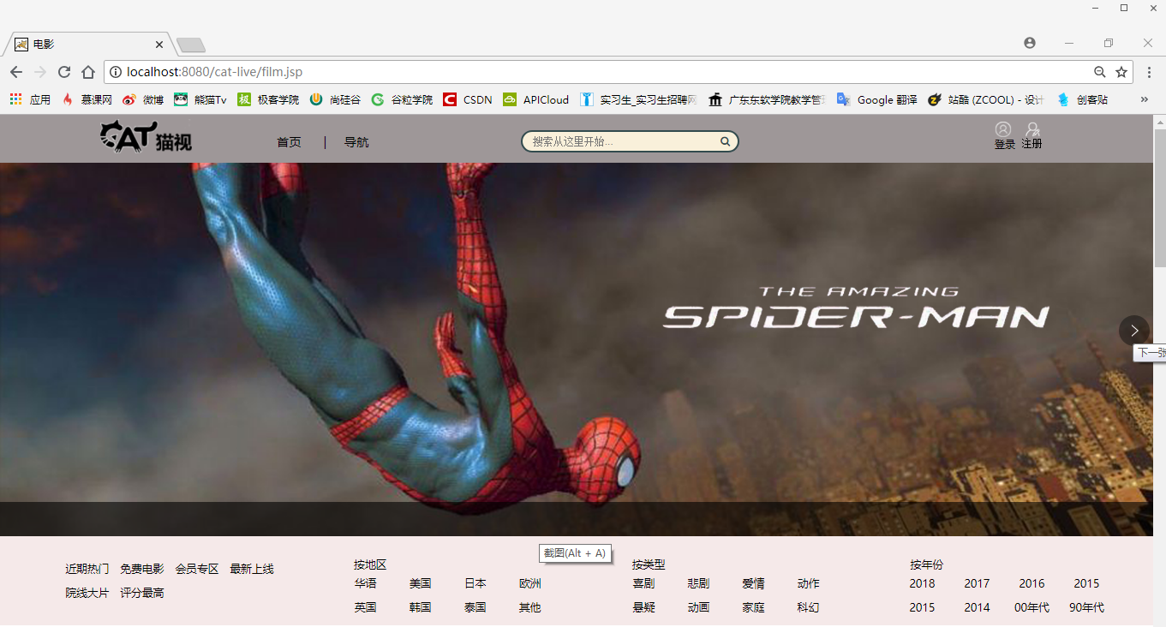

**5.2 主要代码**

<!---------------------------院线热映----------------------------->

<div id="hotspot">

<div class="title">院线热映<a>更多</a></div>

<div class="hotspot-slider"><img src="${ctx}/images/film_img/21.jpg"></div>

<div class="hotspot-vedio">

<ul>

<li>

<a><img src="${ctx}/images/film_img/13.jpg" >《无双》爆导演特辑</span><span class="live-user">&nbsp;庄文强挑战自我印伪钞</span></a>

</li>

<li>

<a><img src="${ctx}/images/film_img/14.jpg" >&nbsp;张艺谋作品《影》</span><span class="live-user">&nbsp;琴棋书画样样精通</span></a>

</li>

<li>

<a><img src="${ctx}/images/film_img/15.jpg" >&nbsp;《武林怪兽定档圣诞》</span><span class="live-user">&nbsp;古天乐携众星大战乱</span></a>

</li>

<li>

<a><img src="${ctx}/images/film_img/16.jpg" >&nbsp;《虎胆追凶》持枪出击版</span><span class="live-user">&nbsp;布鲁斯威利斯行侠仗义</span></a>

</li>

</ul>

<ul>

<li>

<a><img src="${ctx}/images/film_img/17.jpg" >&nbsp;《苏丹》格斗口碑特辑</span><span class="live-user">&nbsp;硬汉泪洒观影现场</span></a>

</li>

<li>

<a><img src="${ctx}/images/film_img/18.jpg" >&nbsp;《阿尔法：狼伴归途》</span><span class="live-user">&nbsp;有了狼不怕神对手</span></a>

</li>

<li>

<a><img src="${ctx}/images/film_img/19.jpg" >&nbsp;《李宗伟：败者为王》</span><span class="live-user">&nbsp;意外的感动和惊喜</span></a>

</li>

<li>

<a><img src="${ctx}/images/film_img/20.jpg" >&nbsp;《李茶的姑妈》傻瓜三兄弟</span><span class="live-user">&nbsp;戏里戏外都爆笑</span></a>

</li>

</ul>

</div>

</div>

<!---------------------------热播电影----------------------------->

<div id="First-broadcast">

<div class="title">首播影院<!--<span class="film-series-title">电影榜</span>--><span><a>更多</a></span></div>

<div class="First-broadcast-vedio">

<ul>

<li><a href="#"><img src="${ctx}/images/film_img/06.jpg">&nbsp;蚁人</a><span class="score">8.8</span><br><span><a>&nbsp;逗比英雄逆袭</a></span></li>

<li><a href="#"><img src="${ctx}/images/film_img/07.jpg">&nbsp;幸福马上来</a><span class="score">8.2</span><br><span><a>&nbsp;冯巩刘昊然父子档</a></span></li>

<li><a href="#"><img src="${ctx}/images/film_img/08.jpg">&nbsp;蚁人2：黄蜂女现身</a><span class="score"> 7.3</span><br><span><a>&nbsp;蚁人复联后再现身</a></span></li>

<li><a href="#"><img src="${ctx}/images/film_img/09.jpg">&nbsp;英伦对决</a><span class="score">8.7</span><br><span><a>&nbsp;成龙对决007</a></span></li>

<li><a href="#"><img src="${ctx}/images/film_img/10.jpg">&nbsp;银魂</a><span class="score">6.7</span><br><span><a>&nbsp;白夜叉血战群雄</a></span></li>

<li><a href="#"><img src="${ctx}/images/film_img/11.jpg">&nbsp;机器之血</a><span class="score">8.6</span><br><span><a>&nbsp;成龙血性搏杀</a></span></li>

<li><a href="#"><img src="${ctx}/images/film_img/12.jpg">&nbsp;王牌保镖</a><span class="score">9.0</span><br><span><a>&nbsp;贱萌搭档爆笑逃亡</a></span></li>

</ul>

</div>

</div>

<!---------------------------排行榜----------------------------->

<div id="series">

<div class="title">排行榜<a>热播</a><a>内地</a><a>美国</a><a>港台</a><a>院线</a><span><a>更多</a></span></div>

<div class="series-vedio">

<ul>

<li><a href="#"><img src="${ctx}/images/film_img/06.jpg">&nbsp;蚁人</a><span class="score">8.8</span><br><span><a>&nbsp;逗比英雄逆袭</a></span></li>

<li><a href="#"><img src="${ctx}/images/film_img/07.jpg">&nbsp;幸福马上来</a><span class="score">8.2</span><br><span><a>&nbsp;冯巩刘昊然父子档</a></span></li>

<li><a href="#"><img src="${ctx}/images/film_img/08.jpg">&nbsp;蚁人2：黄蜂女现身</a><span class="score"> 7.3</span><br><span><a>&nbsp;蚁人复联后再现身</a></span></li>

<li><a href="#"><img src="${ctx}/images/film_img/09.jpg">&nbsp;英伦对决</a><span class="score">8.7</span><br><span><a>&nbsp;成龙对决007</a></span></li>

<li><a href="#"><img src="${ctx}/images/film_img/10.jpg">&nbsp;银魂</a><span class="score">6.7</span><br><span><a>&nbsp;白夜叉血战群雄</a></span></li>

<li><a href="#"><img src="${ctx}/images/film_img/11.jpg">&nbsp;机器之血</a><span class="score">8.6</span><br><span><a>&nbsp;成龙血性搏杀</a></span></li>

<li><a href="#"><img src="${ctx}/images/film_img/12.jpg">&nbsp;王牌保镖</a><span class="score">9.0</span><br><span><a>&nbsp;贱萌搭档爆笑逃亡</a></span></li>

</ul>

</div>

</div>

<!---------------------------特色影院----------------------------->

<div id="features">

<div class="title">特色影院<!--<span class="film-series-title">电影榜</span>--><span><a>更多</a></span></div>

<div class="Cooldog_container">

<div class="Cooldog_content">

<ul>

<li class="p1">

<a href="#">

<img src="${ctx}/images/film_slider/1.png" alt="">

</a>

</li>

<li class="p2">

<a href="#">

<img src="${ctx}/images/film_slider/2.png" alt="">

</a>

</li>

<li class="p3">

<a href="#">

<img src="${ctx}/images/film_slider/3.png" alt="">

</a>

</li>

<li class="p4">

<a href="#">

<img src="${ctx}/images/film_slider/4.png" alt="">

</a>

</li>

<li class="p5">

<a href="#">

<img src="${ctx}/images/film_slider/5.png" alt="">

</a>

</li>

<li class="p5">

<a href="#">

<img src="${ctx}/images/film_slider/6.png" alt="">

</a>

</li>

<li class="p5">

<a href="#">

<img src="${ctx}/images/film_slider/7.png" alt="">

</a>

</li>

</ul>

</div>

<a href="javascript:;" class="btn_left">

<i class="iconfont icon-zuoyoujiantou"></i>

</a>

<a href="javascript:;" class="btn_right">

<i class="iconfont icon-zuoyoujiantou-copy-copy"></i>

</a>

<a href="javascript:;" class="btn_close">

<i class="iconfont icon-icon-test"></i>

</a>

<div class="buttons clearfix">

<a href="javascript:;" class="color"></a>

<a href="javascript:;"></a>

<a href="javascript:;"></a>

<a href="javascript:;"></a>

<a href="javascript:;"></a>

<a href="javascript:;"></a>

<a href="javascript:;"></a>

</div>

</div>

</div>

<script type="text/javascript" src="<%=request.getContextPath()%>/javascript/jquery.min.js"></script>

<script type="text/javascript" src="<%=request.getContextPath()%>/javascript/Cooldog.js"></script>

**第6章 直播分类页面设计**

**6.1 效果截图**

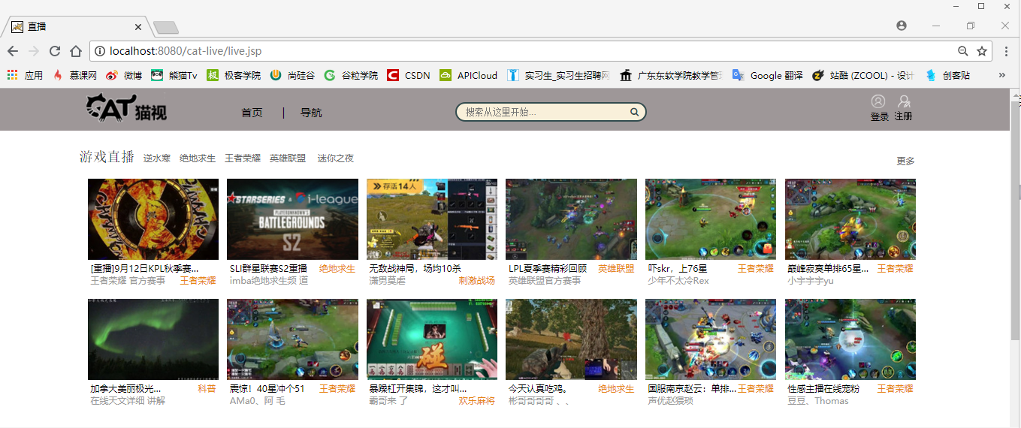

**6.2 主要代码**

<!---------------------------热门直播----------------------------->

<div id="game-live">

<div class="title">游戏直播<a>逆水寒</a><a>绝地求生</a><a>王者荣耀</a><a>英雄联盟

</a><a>迷你之夜</a><span><a>更多</a></span></div>

<div class="game-live-vedio">

<ul>

<li>

<a href="play.jsp"><img src="${ctx}/images/live_img/00.jpg">&nbsp;[重播]9月12日KPL秋季赛…<span class="game">王者荣耀&nbsp;</span><span class="live-user">&nbsp;王者荣耀 官方赛事</span></a>

</li>

<li>

<a href="playtest.jsp"><img src="${ctx}/images/live_img/01.jpg">&nbsp;SLI群星联赛S2重播<span class="game">绝地求生&nbsp;</span><span class="live-user">&nbsp;imba绝地求生频

道</span></a></li>

<li>

<a><img src="${ctx}/images/live_img/02.jpg">&nbsp;无敌战神局，场均10杀<span class="game">刺激战场&nbsp;</span><span class="live-user">&nbsp;潇男莫虐

</span></a></li>

<li><a>

<img src="${ctx}/images/live_img/03.jpg">&nbsp;LPL夏季赛精彩回顾<span class="game">英雄联盟&nbsp;</span><span class="live-user">&nbsp;英雄联盟官方赛事

</span></a>

</li>

<li>

<a><img src="${ctx}/images/live_img/04.jpg">&nbsp;吓skr，上76星<span class="game">王者荣耀&nbsp;</span><span class="live-user">&nbsp;少年不太冷Rex

</span></a>

</li>

<li>

<a><img src="${ctx}/images/live_img/05.jpg">&nbsp;巅峰寂寞单排65星…<span class="game">王者荣耀&nbsp;</span><span class="live-user">&nbsp;小宇宇宇yu

</span></a>

</li>

</ul>

<ul>

<li>

<a><img src="${ctx}/images/live_img/06.jpg">&nbsp;加拿大美丽极光…<span class="game">科普&nbsp;</span><span class="live-user">&nbsp;在线天文详细

讲解</span></a>

</li>

<li>

<a><img src="${ctx}/images/live_img/07.jpg">&nbsp;震惊！40星冲个51<span class="game">王者荣耀&nbsp;</span><span class="live-user">&nbsp;AMa0、阿

毛</span></a>

</li>

<li>

<a><img src="${ctx}/images/live_img/08.jpg">&nbsp;暴躁杠开集锦，这才叫…<span class="game">欢乐麻将&nbsp;</span><span class="live-user">&nbsp;霸哥来

了</span></a>

</li>

<li>

<a><img src="${ctx}/images/live_img/09.jpg">&nbsp;今天认真吃鸡。<span class="game">绝地求生&nbsp;</span><span class="live-user">&nbsp;彬哥哥哥哥

、、</span></a>

</li>

<li>

<a><img src="${ctx}/images/live_img/10.jpg">&nbsp;国服南京赵云：单排…<span class="game">王者荣耀&nbsp;</span><span class="live-user">&nbsp;声优赵猥琐

</span></a>

</li>

<li>

<a><img src="${ctx}/images/live_img/11.jpg">&nbsp;性感主播在线宠粉<span class="game">王者荣耀&nbsp;</span><span class="live-user">&nbsp;豆豆、Thomas

</span></a>

</li>

</ul>

</div>

</div>

<!---------------------------二次元直播----------------------------->

<div id="cosplay-live">

<div class="title">二次元<span><a>更多</a></span></div>

<div class="cosplay-live-vedio">

<ul>

<li>

<a><img src="${ctx}/images/live_img/13.jpg">&nbsp;月底最后一天拉拉啦<span class="game">萌妹&nbsp;</span><span class="live-user">&nbsp;Mo魔音兰兰呐</span></a>

</li>

<li>

<a><img src="${ctx}/images/live_img/14.jpg">&nbsp;佛系跳开心就好舞<span class="game">跳舞&nbsp;</span><span class="live-user">&nbsp;imba绝地求生频

道</span></a></li>

<li>

<a><img src="${ctx}/images/live_img/15.jpg">&nbsp;都哪个小宝贝要开学了呀<span class="game">唱歌&nbsp;</span><span class="live-user">&nbsp;小闹闹2333

</span></a></li>

<li><a>

<img src="${ctx}/images/live_img/16.jpg">&nbsp;新主播、求求求罩顾<span class="game">萌妹&nbsp;</span><span class="live-user">&nbsp;泊含、阿蛮蛮

</span></a>

</li>

<li>

<a><img src="${ctx}/images/live_img/17.jpg">&nbsp;吃播来啦！带你去吃好吃的<span class="game">吃播&nbsp;</span><span class="live-user">&nbsp;瑶瑶小公主

</span></a>

</li>

<li>

<a><img src="${ctx}/images/live_img/18.jpg">&nbsp;开跳跳跳跳啦！民族舞<span class="game">跳舞&nbsp;</span><span class="live-user">&nbsp;小宇宇宇yu

</span></a>

</li>

</ul>

</div>

</div>

**第7章 登录注册页面设计**

**7.1 效果截图**

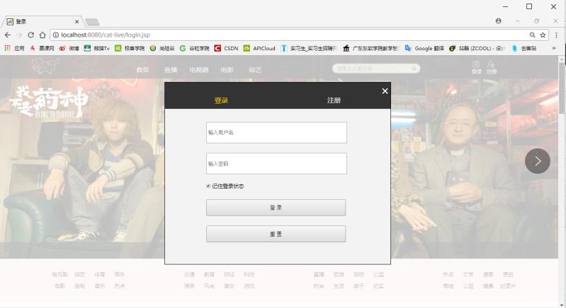

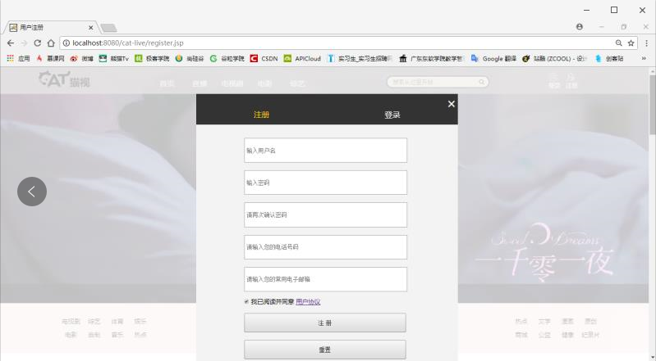

**7.2 主要代码**

<div id="login-in">

<div class="return-page">

<div class="return-home">

<a href="home.jsp">&times;</a>

</div></div>

<div class="main_nav">

<ul>

<li><a class="cd-signin" href="#"><span style="color:#ffcd02">登录</span></a></li>

<li><a class="cd-signup" href="register.jsp">注册</a></li>

</ul>

</div><!--main_nav-->

<div id="cd-login"> <!-- 登录表单 -->

<form class="cd-form" method="post" action="user/login.do">

<p class="fieldset">

<label class="image-replace cd-username" for="signin-username"></label>

<input class="full-width has-padding has-border" id="signin-username"

type="text" placeholder=" 输入用户名" name="username">

</p>

<p class="fieldset">

<label class="image-replace cd-password" for="signin-password"></label>

<input class="full-width has-padding has-border" id="signin-password"

type="text" placeholder=" 输入密码">

</p>

<p class="fieldset">

<input type="checkbox" id="remember-me" checked>

<label for="remember-me">记住登录状态</label>

</p>

<p class="fieldset">

<a href="#"><input class="full-width2" type="submit" value="登 录" ></a>

<a href="#"><input class="full-width3" type="reset" value="重 置" ></a>

</p>

</form>

</div>

</div><!-- login-in-->

<div id="register">

<div class="register-page">

<div class="register-close">

<a href="home.jsp">&times;</a>

</div><!-- register-close-->

</div><!--register-page -->

<div class="main_nav">

<ul>

<li><a class="cd-signin" href="#"><span style="color:#ffcd02">注册</span></a></li>

<li><a class="cd-signup" href="login.jsp">登录</a></li>

</ul>

</div><!--main_nav-->

<div id="cd-login"> <!-- 注册表单 -->

<form class="cd-form" method="post" action="user/register.do">

<p class="fieldset">

<label for="username"></label>

<input id="signin-username" type="username" name="username"placeholder=" 输入用户名">

</p>

<p class="fieldset">

<label for="password"></label>

<input id="signin-password" type="password" name="password" placeholder=" 输入密码">

<p class="fieldset">

<label for="password"></label>

<input id="signin-password-again" type="password" name="password" placeholder=" 请再次确认密码">

</p>

<p class="fieldset">

<label for="phone"></label>

<input id="input-test" type="phone" name="phone" placeholder=" 请输入您的电话号码">

</p>

<p class="fieldset">

<label for="email"></label>

<input id="input-test" type="email" name="email" placeholder=" 请输入您的常用电子邮箱">

</p>

<p class="fieldset">

<input type="checkbox" id="remember-me" checked>

<label for="remember-me">我已阅读并同意 <a href="#" style="text-decoration:underline">

用户协议</a></label>

</p>

<p class="fieldset" >

<a href="home.jsp"><input class="full-width2" type="submit" value="注 册" ></a>

<a href="#"><input class="full-width3" type="reset" value="重置" ></a>

</p>

</form>

</div>

</div><!--register -->

**第8章 后台管理页面设计**

**8.1 效果截图**

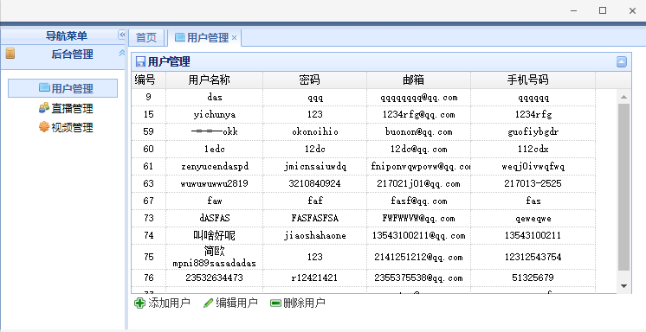

**8.2 主要代码**

<script type="text/javascript">

var _menus = {

"menus":[

{"menuid":"1","icon":"icon-sys","menuname":"后台管理",

"menus":[

{"menuid":"12","menuname":"用户管理","icon":"icon-page","url":"menu1/user.jsp"},

{"menuid":"13","menuname":"直播管理","icon":"icon-role","url":"menu1/live.html"},

{"menuid":"14","menuname":"视频管理","icon":"icon-class","url":"menu1/video.jsp"}

]}

]};

//设置登录窗口

function openPwd() {

$('#w').window({

title: '修改密码',

width: 300,

modal: true,

shadow: true,

closed: true,

height: 160,

resizable:false

});

}

//关闭登录窗口

function closePwd() {

$('#w').window('close');

}

//修改密码

function serverLogin() {

var $newpass = $('#txtNewPass');

var $rePass = $('#txtRePass');

if ($newpass.val() == '') {

msgShow('系统提示', '请输入密码！', 'warning');

return false;

}

if ($rePass.val() == '') {

msgShow('系统提示', '请在一次输入密码！', 'warning');

return false;

}

if ($newpass.val() != $rePass.val()) {

msgShow('系统提示', '两次密码不一至！请重新输入', 'warning');

return false;

}

$.post('/ajax/editpassword.ashx?newpass=' + $newpass.val(), function(msg) {

msgShow('系统提示', '恭喜，密码修改成功！<br>您的新密码为：' + msg, 'info');

$newpass.val('');

$rePass.val('');

close();

})

}

$(function() {

openPwd();

$('#editpass').click(function() {

$('#w').window('open');

});

$('#btnEp').click(function() {

serverLogin();

})

$('#btnCancel').click(function(){closePwd();})

$('#loginOut').click(function() {

$.messager.confirm('系统提示', '您确定要退出本次登录吗?', function(r) {

if (r) {

location.href = '/ajax/loginout.ashx';

}

});

})

});

</script>

</head>

<body class="easyui-layout" style="overflow-y: hidden" scroll="no">

<noscript>

<div style=" position:absolute; z-index:100000; height:2046px;top:0px;left:0px; width:100%; background:white; text-align:center;"> <img src="images/noscript.gif" alt='抱歉，请开启脚本支持！' /> </div>

</noscript>

<div region="north" split="true" border="false" style="overflow: hidden; height: 30px;

background: url(images/layout-browser-hd-bg.gif) #7f99be repeat-x center 50%;

line-height: 20px;color: #fff; font-family: Verdana, 微软雅黑,黑体"> <span style="float:right; padding-right:20px;" class="head">欢迎 管理员 <a href="#" id="editpass">修改密码</a> <a href="#" id="loginOut">安全退出</a></span> <span style="padding-left:10px; font-size: 16px; "><img src="images/blocks.gif" width="20" height="20" align="absmiddle" />项目管理系统</span> </div>

<div region="south" split="true" style="height: 30px; background: #D2E0F2; ">

<div class="footer"> CATLIVE TV</div>

</div>

<div region="west" hide="true" split="true" title="导航菜单" style="width:180px;" id="west">

<div id="nav" class="easyui-accordion" fit="true" border="false">

<!-- 导航内容 -->

</div>

</div>

<div id="mainPanle" region="center" style="background: #eee; overflow-y:hidden">

<div id="tabs" class="easyui-tabs" fit="true" border="false" >

<div title="首页" style="padding:20px;overflow:hidden; color:red; " >

<h1 style="font-size:24px;">欢迎使用猫视TV后台管理系统</h1>

</div>

</div>

</div>

<div region="east" title="其他" split="true" style="width:180px;overflow:hidden;">

<div class="easyui-calendar"></div>

</div>

<!--修改密码窗口-->

<div id="w" class="easyui-window" title="修改密码" collapsible="false" minimizable="false"

maximizable="false" icon="icon-save" style="width: 300px; height: 150px; padding: 5px;

background: #fafafa;">

<div class="easyui-layout" fit="true">

<div region="center" border="false" style="padding: 10px; background: #fff; border: 1px solid #ccc;">

<table cellpadding=3>

<tr>

<td>新密码：</td>

<td><input id="txtNewPass" type="Password" class="txt01" /></td>

</tr>

<tr>

<td>确认密码：</td>

<td><input id="txtRePass" type="Password" class="txt01" /></td>

</tr>

</table>

</div>

<div region="south" border="false" style="text-align: right; height: 30px; line-height: 30px;"> <a id="btnEp" class="easyui-linkbutton" icon="icon-ok" href="javascript:void(0)" > 确定</a> <a id="btnCancel" class="easyui-linkbutton" icon="icon-cancel" href="javascript:void(0)">取消</a> </div>

</div>

</div>

<div id="mm" class="easyui-menu" style="width:150px;">

<div id="mm-tabupdate">刷新</div>

<div class="menu-sep"></div>

<div id="mm-tabclose">关闭</div>

<div id="mm-tabcloseall">全部关闭</div>

<div id="mm-tabcloseother">除此之外全部关闭</div>

<div class="menu-sep"></div>

<div id="mm-tabcloseright">当前页右侧全部关闭</div>

<div id="mm-tabcloseleft">当前页左侧全部关闭</div>

<div class="menu-sep"></div>

<div id="mm-exit">退出</div>

</div>

1. **个人信息页面设计**

**9.1 效果截图**

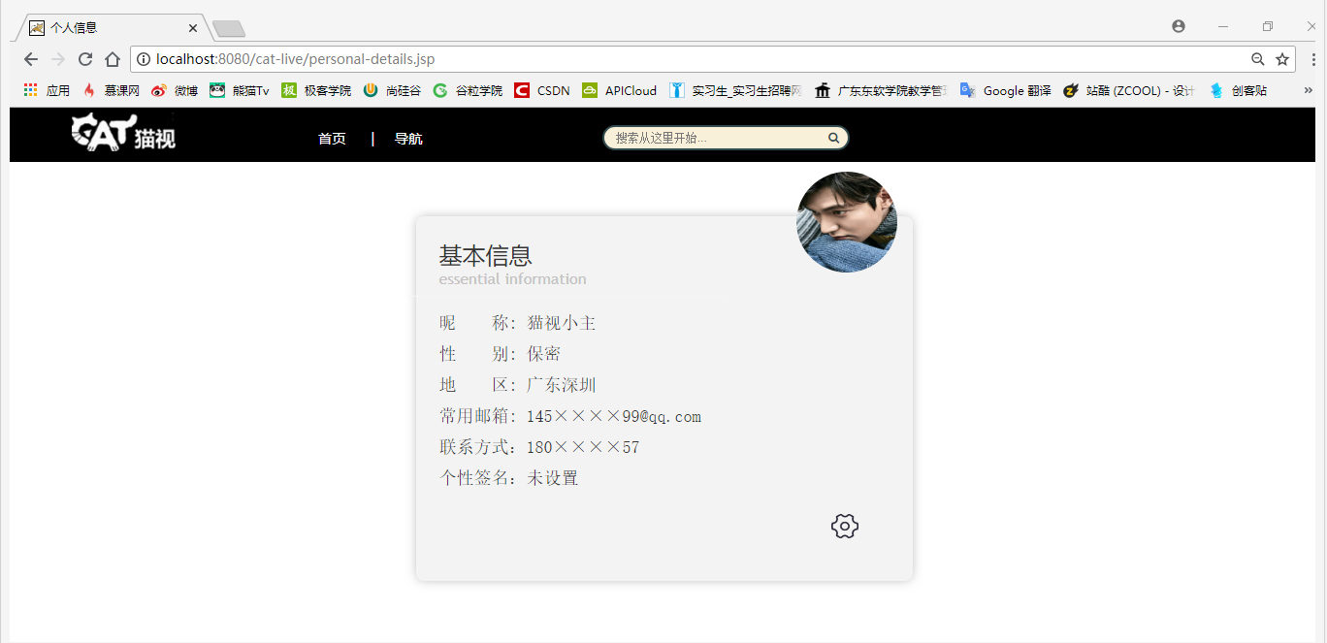

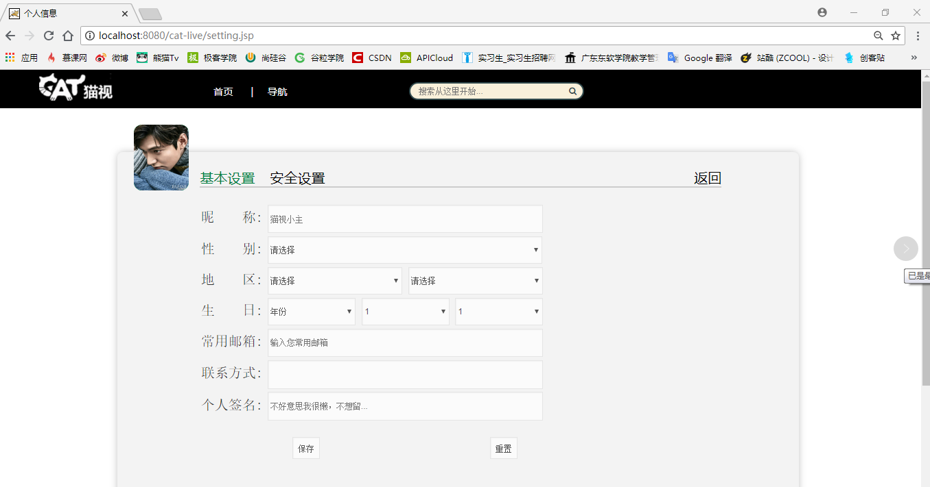

**9.2 主要代码**

<!--.........................................个人信息..................................... -->

<div id="information">

<form action="" method="post" class="STYLE-NAME">

<h1>基本信息

<span>essential information</span>

<img src="${ctx}/images/头像.jpg" width="130" height="150">

</h1>

<label>

<span>昵&nbsp;&nbsp;称: 猫视小主</span>

</label>

</br>

<label>

<span>性&nbsp;&nbsp;别: 保密</span>

</label>

</br>

<label>

<span>地&nbsp;&nbsp;区: 广东深圳</span>

</label>

</br>

<label>

<span>常用邮箱: 145&times;&times;&times;&times;99@qq.com</span>

</label>

</br>

<label>

<span>联系方式：180&times;&times;&times;&times;57</span>

</label>

</br>

<label>

<span>个性签名：未设置</span>

</label>

</br>

<a href="setting.jsp">

<img src="${ctx}/images/设置.png" width="35px" height="31px">

</a>

</form>

</div><!--information -->

1. **视频播放页面设计**

**10.1 效果截图**

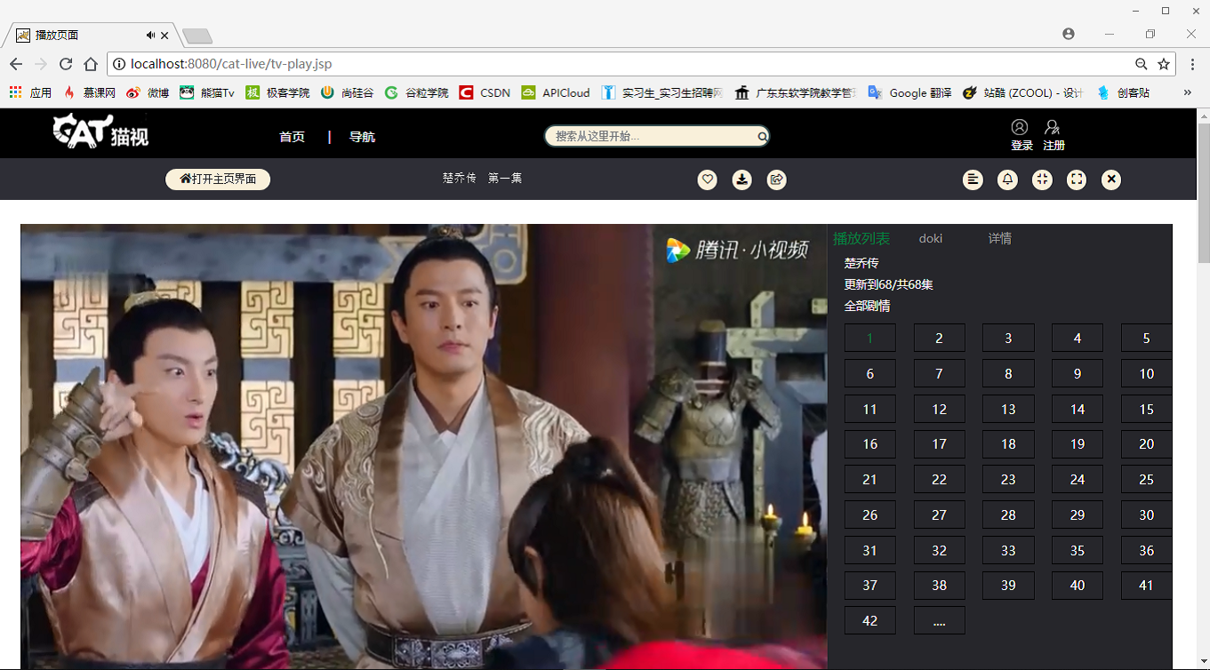

**10.2 主要代码**

</header><!-- /header --> -->

<div class="head_persion">

<div class="home">

<div class="text">

<span><i class="fas fa-home"></i>打开主页界面</span>

</div>

</div>

<div class="title">

<div>

<span>楚乔传&nbsp;第一集</span>

</div>

</div>

<div class="collect">

<div class="text">

<span><i class="far fa-heart"></i></span>

</div>

<div class="text">

<span><i class="fas fa-download"></i></span>

</div>

<div class="text">

<span><i class="far fa-share-square"></i></span>

</div>

</div>

<div class="control">

<div class="text">

<span><i class="fas fa-align-left"></i></span>

</div>

<div class="text">

<span><i class="far fa-bell"></i></span>

</div>

<div class="text">

<span><i class="fas fa-compress"></i></span>

</div>

<div class="text">

<span><i class="fas fa-expand"></i></span>

</div>

<div class="text">

<span><i class="fas fa-times"></i></span>

</div>

</div>

</div>

<div class="content">

<div>

<div class="left">

<video src="${ctx}/images/t1693h9gjuy.mp4" autobuffer autoloop loop controls poster="../img/play_tv.png" id="video"></video>

<div class="left_paly">

<div>

<button onClick="bofang()"><i class="fas fa-play"></i></button>

<button onClick="zanting()"><i class="fas fa-pause"></i></button>

<button onClick="kuaijin()"><i class="fas fa-forward"></i></button>

<button onClick="kuaitui()"><i class="fas fa-backward"></i></button>

<button onClick="shutup(this)"><i class="fas fa-bell"></i></button>

</div>

</div>

<div>

<div class="left_title">

<h3>第1集：楚乔偶遇宇文玥</h3>

</div>

</div>

</div>

<div class="right">

<div class="right_head">

<ul>

<li class="cur">播放列表</li>

<li>doki</li>

<li>详情</li>

</ul>

</div>

<div class="right_title">

<span>楚乔传</span>

<span>更新到68/共68集</span>

<span>全部剧情</span>

</div>

<div class="right_span">

<ul>

<li ><a href="#" style="color:#008040;">1</a></li>

<li><a href="#">2</a></li>

<li><a href="#">3</a></li>

<li><a href="#">4</a></li>

<li><a href="#">5</a></li>

<li><a href="#">6</a></li>

<li><a href="#">7</a></li>

<li><a href="#">8</a></li>

<li><a href="#">9</a></li>

<li><a href="#">10</a></li>

<li><a href="#">11</a></li>

<li><a href="#">12</a></li>

<li><a href="#">13</a></li>

<li><a href="#">14</a></li>

<li><a href="#">15</a></li>

<li><a href="#">16</a></li>

<li><a href="#">17</a></li>

<li><a href="#">18</a></li>

<li><a href="#">19</a></li>

<li><a href="#">20</a></li>

<li><a href="#">21</a></li>

<li><a href="#">22</a></li>

<li><a href="#">23</a></li>

<li><a href="#">24</a></li>

<li><a href="#">25</a></li>

<li><a href="#">26</a></li>

<li><a href="#">27</a></li>

<li><a href="#">28</a></li>

<li><a href="#">29</a></li>

<li><a href="#">30</a></li>

<li><a href="#">31</a></li>

<li><a href="#">32</a></li>

<li><a href="#">33</a></li>

<li><a href="#">35</a></li>

<li><a href="#">36</a></li>

<li><a href="#">37</a></li>

<li><a href="#">38</a></li>

<li><a href="#">39</a></li>

<li><a href="#">40</a></li>

<li><a href="#">41</a></li>

<li><a href="#">42</a></li>

<li><a href="#">....</a></li>

</ul>

</div>

<div class="right_foot">

<div>

<img src="${ctx}/images/0.jpg" alt="">

</div>

<span>点赞</span>

<span>分享</span>

<span>缓存</span>

<span>查看更多</span>

</div>

</div>

</div>

</div>

<div class="content_body">

<div class="body">

<div class="body_left">

<div class="actor">

<h3>《楚乔传》主演</h3>

<div class="actor_img">

<ul>

<li><a href="#"><span style="font-family:16px"><img src="${ctx}/images/chuqiaozhuan-img/赵丽颖.jpg" alt=""></span>&nbsp;<a style="color:#008040;">赵丽颖</a>&nbsp;饰演&nbsp;楚乔</a></li>

<li><a href="#"><span span style="font-family:16px"><img src="${ctx}/images/chuqiaozhuan-img/林更新.jpg" alt="" ></span><a style="color:#008040;">林更新</a></a>&nbsp;饰演&nbsp;宇文玥</a></li>

<li><a href="#"><span span style="font-family:16px"><img src="${ctx}/images/chuqiaozhuan-img/李沁.jpg" alt="" ></span><a style="color:#008040;">李沁</a>&nbsp;饰演&nbsp;元淳</a></li>

<li><a href="#"><span span style="font-family:16px"><img src="${ctx}/images/chuqiaozhuan-img/窦骁.png" alt=""></span><a style="color:#008040;">窦骁</a>&nbsp;饰演&nbsp;燕洵</a></li>

</ul>

</div>

</div>

<div class="video">

<h3>《楚乔传》小视频</h3>

<div class="video_img">

<ul>

<li><video src="${ctx}/images/play/p1839yytgex.mp4" autobuffer autoloop loop controls poster="../img/play/1.png"></video></li>

<li><video src="${ctx}/images/play/v1698isdb3q.mp4" autobuffer autoloop loop controls poster="../img/play/2.png"></video></li>

<li><video src="${ctx}/images/play/y1808ggdyyu.mp4" autobuffer autoloop loop controls poster="../img/play/3.png"></video></li>

<li><video src="${ctx}/images/play/z1695jpe6bq.mp4" autobuffer autoloop loop controls poster="../img/play/4.png"></video></li>

</ul>

</div>

</div>

<div class="juchang">

<h3>《楚乔传》剧照</h3>

<div class="juchang_img">

<ul>

<li><img src="${ctx}/images/play/juchang1.jpg" alt=""></li>

<li><img src="${ctx}/images/play/juchang2.jpg" alt=""></li>

<li><img src="${ctx}/images/play/juchang3.jpg" alt=""></li>

<li><img src="${ctx}/images/play/jucahng4.jpg" alt=""></li>

</ul>

</div>

</div>

<div class="juchang">

<h3>《楚乔传》表情包</h3>

<div class="biaoqinbao_img">

<ul>

<li><img src="${ctx}/images/play/0.gif" alt=""></li>

<li><img src="${ctx}/images/play/1.gif" alt=""></li>

<li><img src="${ctx}/images/play/2.gif" alt=""></li>

<li><img src="${ctx}/images/play/3.gif" alt=""></li>

<li><img src="${ctx}/images/play/4.gif" alt=""></li>

</ul>

</div>

</div>

<div class="juchang">

<h3>《楚乔传》相关作品</h3>

<div class="zuoping">

<ul>

<li><img src="${ctx}/images/chuqiaozhuan-img/花千骨.jpg" alt=""></li>

<li><img src="${ctx}/images/chuqiaozhuan-img/诛仙青云志.jpg" alt=""></li>

<li><img src="${ctx}/images/chuqiaozhuan-img/幸福归来.jpg" alt=""></li>

<li><img src="${ctx}/images/chuqiaozhuan-img/我是女王.jpg" alt=""></li>

<li><img src="${ctx}/images/chuqiaozhuan-img/同桌的你.jpg" alt=""></li>

<li><img src="${ctx}/images/chuqiaozhuan-img/新步步惊心.jpg" alt=""></li>

<li><img src="${ctx}/images/chuqiaozhuan-img/杉杉来了.jpg" alt=""></li>

<li><img src="${ctx}/images/chuqiaozhuan-img/武神赵子龙.jpg" alt=""></li>

<li><img src="${ctx}/images/chuqiaozhuan-img/花开半夏.jpg" alt=""></li>

<li><img src="${ctx}/images/chuqiaozhuan-img/轩辕剑之天之痕.jpg" alt=""></li>

<li><img src="${ctx}/images/chuqiaozhuan-img/极品新娘.jpg" alt=""></li>

<li><img src="${ctx}/images/chuqiaozhuan-img/狼图腾.jpg" alt=""></li>

<li><img src="${ctx}/images/chuqiaozhuan-img/白鹿原.jpg" alt=""></li>

<li><img src="${ctx}/images/chuqiaozhuan-img/破风.jpg" alt=""></li>

<li><img src="${ctx}/images/chuqiaozhuan-img/舞乐传奇.jpg" alt=""></li>

</ul>

</div>

</div>

</div>

<div class="body_right">

<div class="body_title">

<h3>电视剧每日热播榜</h3>

<span>更多</span>

</div>

<div class="right_img">

<div class="tv_img">

<img src="${ctx}/images/play/1.jpg" alt="">

</div>

<div class="tv_text">

<span class="tv_name">1.如懿传</span><span class="tv_actor">周迅 / 霍建华 / 张钧甯 / 董洁<span class="hearts" title="点个赞"><a>&hearts;</a></span></span>

<span class="tv_play"><i class="fas fa-play"></i>&nbsp;2.6亿</span>

</div>

</div>

<div class="right_img">

<div class="tv_img">

<img src="${ctx}/images/play/2.jpg" alt="">

</div>

<div class="tv_text">

<span class="tv_name">2.沙海</span><span class="tv_actor">吴磊 / 秦昊 / 张萌 / 杨蓉<span class="hearts" title="点个赞"><a>&hearts;</a></span></span>

<span class="tv_play"><i class="fas fa-play"></i>&nbsp;1.3亿</span>

</div>

</div>

<div class="right_img">

<div class="tv_img">

<img src="${ctx}/images/play/3.jpg" alt="">

</div>

<div class="tv_text">

<span class="tv_name">3.香蜜沉沉烬如霜</span><span class="tv_actor">杨紫 / 邓伦 / 陈钰琪 / 罗云熙<span class="hearts" title="点个赞"><a>&hearts;</a></span></span>

<span class="tv_play"><i class="fas fa-play"></i>&nbsp;7258.4万</span>

</div>

</div>

<div class="right_img">

<div class="tv_img">

<img src="${ctx}/images/play/4.jpg" alt="">

</div>

<div class="tv_text">

<span class="tv_name">4.斗破苍穹</span><span class="tv_actor">吴磊 / 林允 / 李沁 / 陈楚河<span class="hearts" title="点个赞"><a>&hearts;</a></span></span>

<span class="tv_play"><i class="fas fa-play"></i>&nbsp;5034.5万</span>

</div>

</div>

<div class="right_img">

<div class="tv_img">

<img src="${ctx}/images/play/5.jpg" alt="">

</div>

<div class="tv_text">

<span class="tv_name">5.夜天子</span><span class="tv_actor">徐海乔 / 宋祖儿 / 王紫潼 / 肥龙<span class="hearts" title="点个赞"><a>&hearts;</a></span></span>

<span class="tv_play"><i class="fas fa-play"></i>&nbsp;3298.2万</span>

</div>

</div>

<div class="right_img">

<div class="tv_img">

<img src="${ctx}/images/play/6.jpg" alt="">

</div>

<div class="tv_text">

<span class="tv_name">6.法医秦明之幸存者</span><span class="tv_actor">经超 / 余心恬 / 艾晓琪 / 刘海宽<span class="hearts" title="点个赞"><a>&hearts;</a></span></span>

<span class="tv_play"><i class="fas fa-play"></i>&nbsp;3200.5万</span>

</div>

</div>

<div class="right_img">

<div class="tv_img">

<img src="${ctx}/images/play/7.jpg" alt="">

</div>

<div class="tv_text">

<span class="tv_name">7.我们的千阙歌</span><span class="tv_actor">贾清 / 陈键锋 / 周楚濋 / 王钧赫<span class="hearts" title="点个赞"><a>&hearts;</a></span></span>

<span class="tv_play"><i class="fas fa-play"></i>&nbsp;2675万</span>

</div>

</div>

<div class="right_img">

<div class="tv_img">

<img src="${ctx}/images/play/8.jpg" alt="">

</div>

<div class="tv_text">

<span class="tv_name">8.胜利之路</span><span class="tv_actor">郭京飞 / 郭珍霓 / 高洋 / 冯恩鹤<span class="hearts" title="点个赞"><a>&hearts;</a></span></span>

<span class="tv_play"><i class="fas fa-play"></i>&nbsp;2398.7万</span>

</div>

</div>

<div class="right_img">

<div class="tv_img">

<img src="${ctx}/images/play/9.jpg" alt="">

</div>

<div class="tv_text">

<span class="tv_name">9.娘演</span><span class="tv_actor">岳丽娜 / 于毅 / 刘智扬 / 张少华<span class="hearts" title="点个赞"><a>&hearts;</a></span></span>

<span class="tv_play"><i class="fas fa-play"></i>&nbsp;1900万</span>

</div>

</div>

<div class="right_img">

<div class="tv_img">

<img src="${ctx}/images/play/10.jpg" alt="">

</div>

<div class="tv_text">

<span class="tv_name">10.桃花依旧笑春风</span><span class="tv_actor">苗圃 / 陈龙 / 郑国霖 / 徐小飒<span class="hearts" title="点个赞"><a>&hearts;</a></span></span>

<span class="tv_play"><i class="fas fa-play"></i>&nbsp;8394万</span>

</div>

</div>

<div class="huiyuan">

<h3>会员福利</h3>

<div>

<img src="${ctx}/images/play/huiyuan1.jpg" alt=""><span>学生专享VIP10元/月</span>

</div>

<div>

<img src="${ctx}/images/play/huiyaun2.jpg" alt=""><span>V爱献礼，VIP连续包月仅19元/月</span>

</div>

</div>

</div>

</div>

</div>

<script>

var video=document.getElementById("video");

//播放方法

function bofang(){

video.play();

}

//暂停

function zanting(){

video.pause();

}

//快进

function kuaijin(){

video.currentTime+=3;

}

//快退

function kuaitui(){

video.currentTime-=3;

}

//静音

function shutup(obj){

if(video.muted){

obj.innerHTML="静音";

video.muted=false;

}else{

obj.innerHTML="有声";

video.muted=true;

}

}

</script>