A
Mini Project Report
On
Smart & Secure College Voting System:
A Blockchain-Inspired Tamper-Evident Digital Election &
Candidate Comparison Platform
Project No. 94
For
Partial fulfillment of award of the
B.Tech. Degree
in
Information Technology

2025–26
Name of Supervisor:  Guide Name  Assistant Professor / Associate Professor  Department of Information Technology | Name Team Member(s):  Anuj Pandey (Team Leader)  Ashhab Ahmed  Arshad Singh  Aryan Katiyar  Aryan Mishra
Department of Information Technology
G. L. Bajaj Institute of Technology and Management
Plot No 2, Knowledge Park-III, Greater Noida-201306
Affiliated to Dr. A.P.J. Abdul Kalam Technical University, Uttar Pradesh, Lucknow
2026

Department of Information Technology
Declaration
I/We herewith declare that the project work conferred during this report entitled “Smart & Secure College Voting System: A Blockchain-Inspired Tamper-Evident Digital Election & Candidate Comparison Platform”, in partial fulfillment of the necessity for the award of the degree of Bachelor of Technology in Information Technology, submitted to Dr. A.P.J. Abdul Kalam Technical University, Uttar Pradesh, is an authentic record of my/our own work distributed in Department of Information Technology & Engineering, G.L. Bajaj Institute of Technology & Management, Greater Noida. It contains no material antecedently printed or written by another person except wherever due acknowledgement has been created within the text. The project work reported during this report has not been submitted by me/us for award of the other degree or certification.

Signature: _______________________  Name: Anuj Pandey (Team Leader)  Roll No: 2201920130025 | Signature: _______________________  Name: Ashhab Ahmed  Roll No: 2201920130026
Signature: _______________________  Name: Arshad Singh  Roll No: 2201920130018 | Signature: _______________________  Name: Aryan Katiyar  Roll No: 2201920130024
Signature: _______________________
Name: Aryan Mishra
Roll No: 2201920130029
Date: ________________________
Place: Greater Noida

Department of Information Technology
Certificate
This is to certify that Project Report entitled “Smart & Secure College Voting System: A Blockchain-Inspired Tamper-Evident Digital Election & Candidate Comparison Platform” that is submitted by Anuj Pandey (Team Leader), Ashhab Ahmed, Arshad Singh, Aryan Katiyar, and Aryan Mishra in partial fulfillment of the necessity for the award of degree B. Tech. in Department of Information Technology of Dr. A.P.J. Abdul Kalam Technical University, Lucknow, is a certified record of the candidates' own work distributed by them under my/our oversight. The matter embodied during this project report is original and has not been submitted for the award of any other degree or diploma.

Date: _____________________  ___________________________  Name of Supervisor: Guide Name  Assistant Professor / Associate Professor  Department of Information Technology  GLBITM, Greater Noida | Date: _____________________  ___________________________  Dr. P C Vashist  Head of Department  Department of Information Technology  GLBITM, Greater Noida

Department of Information Technology
Acknowledgement
We would like to express our sincere thanks and heartfelt gratitude to our project supervisor Guide Name and our esteemed Head of Department Dr. P. C. Vashist for their invaluable guidance, constructive criticism, and continuous suggestions throughout the conceptualization, system modeling, and implementation phases of this mini project.
This project helped us to comprehensively understand the vital concepts of cryptographic hashing (SHA-256 and HMAC), Merkle tree verification, zero-knowledge voter decoupling, multi-factor biometric authentication, and high-concurrency client-server web architectures. Furthermore, this project enriches our practical knowledge and real-world experience of working as a cohesive engineering team on a live, mission-critical software deployment.
Also, we would like to express our sincere gratitude to Faculty Name and all departmental project coordinators for their invaluable help in the preparation, documentation, code review, and architectural overview of our project.
Lastly, we would like to extend our warm appreciation to all faculty members, technical lab staff, and student participants for providing their valuable time, testing assistance, and institutional support whenever needed for helping us successfully carry out our project.
Project Team Members (Project No. 94):
Anuj Pandey (Team Leader)
Ashhab Ahmed
Arshad Singh
Aryan Katiyar
Aryan Mishra
Department of Information Technology
GLBITM, Greater Noida

TABLE OF CONTENTS
ABSTRACT | ix
LIST OF FIGURES | x
LIST OF TABLES | xi
CHAPTER-1: INTRODUCTION | 1
1.1 INTRODUCTION & CONTEXT | 1
1.2 BACKGROUND & MOTIVATION | 3
1.3 PROBLEM STATEMENT & CURRENT LIMITATIONS | 5
1.4 OBJECTIVES OF THE PROJECT | 7
1.5 SCOPE OF THE PROJECT | 8
1.6 ORGANIZATION OF THE REPORT | 9
CHAPTER-2: LITERATURE REVIEW & EXISTING TECHNOLOGIES | 11
2.1 OVERVIEW OF VOTING PARADIGMS | 11
2.2 SURVEY OF EXISTING COMMERCIAL & ACADEMIC SYSTEMS | 13
2.3 BLOCKCHAIN & CRYPTOGRAPHIC VOTING PROTOCOLS | 15
2.4 GAP ANALYSIS & COMPARATIVE MATRIX | 18
CHAPTER-3: THEORETICAL FOUNDATIONS & SYSTEM ARCHITECTURE | 21
3.1 CRYPTOGRAPHIC PRIMITIVES & MERKLE TREES | 21
3.2 ZERO-KNOWLEDGE DECOUPLING PRINCIPLE | 24
3.3 MULTI-FACTOR AUTHENTICATION & BIOMETRIC LIVENESS HUD | 26
3.4 CANDIDATE SCRUTINY & AI MANIFESTO EVALUATION ENGINE | 28
3.5 HIGH-LEVEL ARCHITECTURAL MODEL | 31
CHAPTER-4: SYSTEM DESIGN & SPECIFICATIONS | 34
4.1 REQUIREMENT SPECIFICATIONS (FUNCTIONAL & NON-FUNCTIONAL) | 34
4.2 HARDWARE & SOFTWARE SPECIFICATIONS | 37
4.3 DATA FLOW DIAGRAMS (LEVEL 0, LEVEL 1, LEVEL 2) | 39
4.4 UNIFIED MODELING LANGUAGE (UML) DIAGRAMS | 42
4.5 DATABASE SCHEMAS & REST API SPECIFICATIONS | 45
CHAPTER-5: SYSTEM IMPLEMENTATION & INTEGRATION | 48
5.1 PROJECT SETUP & TECHNOLOGY STACK INTEGRATION | 48
5.2 MODULE 1: SMART CANDIDATE COMPARISON MATRIX & AI MANIFESTO ENGINE | 50
5.3 MODULE 2: MULTI-FACTOR AUTHENTICATION & BIOMETRIC LIVENESS HUD | 53
5.4 MODULE 3: ZERO-KNOWLEDGE SECRET VOTING BOOTH, PRIORITY POLL & NOTA | 56
5.5 MODULE 4: DIGITAL RECEIPT GENERATION & QR PUBLIC VERIFIER | 59
5.6 MODULE 5: TAMPER-EVIDENT MERKLE BLOCKCHAIN LEDGER & TAMPER SIMULATOR | 62
5.7 MODULE 6: CENTRALIZED ADMIN CONSOLE, MULTI-ELECTION WIZARD & ANALYTICS | 65
5.8 MODULE 7: VOTER ENROLMENT ROSTER, REVOTE DESK & SELF-REGISTRATION | 68
5.9 MODULE 8: 1,000-VOTER HIGH-CONCURRENCY SIMULATION & TABULATION CEREMONY | 71
5.10 CODE WALKTHROUGH & CORE ALGORITHMS | 74
CHAPTER-6: RESULTS, DISCUSSION & PERFORMANCE EVALUATION | 77
6.1 EXPERIMENTAL SETUP & TEST ENVIRONMENT | 77
6.2 TURNOUT & DEMOGRAPHIC ANALYTICS | 78
6.3 CANDIDATE VOTE DISTRIBUTION & PLURALITY ANALYSIS | 80
6.4 CAMPUS PRIORITY POLLING OUTCOMES ('VOICE OF THE CAMPUS') | 82
6.5 PERFORMANCE BENCHMARKS: THROUGHPUT VS. LATENCY UNDER CONCURRENCY | 84
6.6 SECURITY & ATTACK VECTOR EVALUATION | 86
6.7 COMPARATIVE FEATURE MATRIX | 89
CHAPTER-7: CONCLUSION AND FUTURE SCOPE | 91
7.1 CONCLUSION | 91
7.2 FUTURE SCOPE & RESEARCH DIRECTIONS | 93
CHAPTER-8: ENVIRONMENT AND SUSTAINABILITY | 95
8.1 ENVIRONMENTAL IMPACT OF TRADITIONAL PAPER-BASED ELECTIONS | 95
8.2 CARBON FOOTPRINT REDUCTION VIA PAPERLESS DIGITAL VOTING | 97
8.3 ENERGY EFFICIENCY: LIGHTWEIGHT SHA-256 MERKLE CHAIN VS. PROOF-OF-WORK | 99
8.4 E-WASTE MINIMIZATION & ZERO-HARDWARE-WASTE ARCHITECTURE | 101
8.5 SOCIAL & GOVERNANCE SUSTAINABILITY | 103
REFERENCES | 105

ABSTRACT
Elections in collegiate and university environments represent the foundational pillar of student participatory democracy, shaping campus governance, student welfare policies, academic representation, and resource allocations. However, traditional collegiate election mechanisms—predominantly relying on manual paper balloting or rudimentary electronic survey portals—suffer from grave structural limitations, including vulnerability to physical and database ballot stuffing, privacy breaches, protracted tabulation delays, a total absence of individual voter verifiability, and severe voter apathy driven by superficial campaign promises lacking empirical scrutiny.
To definitively resolve these challenges, this project presents the Smart & Secure College Voting System (Project No. 94), an enterprise-grade, privacy-preserving, and tamper-evident digital election platform engineered specifically for collegiate institutions. The proposed architecture uniquely integrates two transformative paradigms: (i) an algorithmic Smart Candidate Comparison Matrix & AI Manifesto Engine, which evaluates contesting candidates side-by-side across eight standardized institutional benchmarks with automated feasibility grading and natural-language manifesto querying; and (ii) an immutable, cryptographic Tamper-Evident Merkle Blockchain Ledger Explorer, which ensures verifiable election integrity without compromising voter privacy through strict Zero-Knowledge Decoupling.
Voter identity is verified through a rigorous multi-tier pipeline combining institutional Roll Number roster validation, 6-digit cryptographic SMS OTP authentication, contactless QR badge scanning, and a WebCam Biometric Liveness HUD. Upon authentication, the voter's identity verification state is permanently decoupled from their cast ballot token. The system computes a tamper-proof HMAC-SHA256 digital vote receipt that enables students to independently audit the public blockchain ledger without revealing their selected candidate choice, alongside constitutional NOTA ('None Of The Above') protest safeguards and campus-wide priority polling.
The backend architecture, implemented as an asynchronous RESTful Python service, features an interactive Database Tamper Injection Simulator that dynamically demonstrates how single-bit data modifications violate cryptographic hash chaining and sever the Merkle root, instantaneously flagging unauthorized alterations. To validate scalability, an integrated high-concurrency simulation engine executed 1,000 automated ballot casts across multi-department voter rosters, sustaining a peak throughput of 94.5 transactions per second with sub-60 millisecond latency. Comprehensive environmental lifecycle assessments demonstrate that transitioning a campus election of 10,000 students to this platform eliminates approximately 30,000 sheets of paper, abates 270 kg of CO2-equivalent emissions, and conserves 300,000 liters of water, substantiating the platform's technological robustness, cryptographic security, and ecological sustainability.

CHAPTER-1: INTRODUCTION
1.1 INTRODUCTION & CONTEXT
Elections in higher education institutions constitute the fundamental democratic mechanism through which student bodies exercise self-governance, voice collective grievances, and select representatives to university administrative boards, academic senates, and student activity councils. In modern colleges and technical universities with multi-thousand student populations spread across diverse engineering disciplines, collegiate elections simulate national democratic processes on a microcosm scale. Representatives elected to student councils preside over substantial student welfare budgets, coordinate campus placements, organize national technical symposia, liaise with university leadership on curriculum improvements, and arbitrate student grievances. Consequently, the legitimacy, transparency, and integrity of collegiate electoral outcomes are of paramount institutional importance.
Historically, university elections have been administered through physical paper ballot systems or stationary mechanical voting devices. In a conventional paper-based election, physical ballots are printed, hand-stamped by election returning officers, manually distributed upon physical student ID verification, marked in secret voting booths, deposited into locked ballot boxes, and subsequently tabulated through manual hand counts by faculty committees. While conceptually straightforward, this paradigm has become increasingly untenable in contemporary digital academic environments.
In recent years, the rapid proliferation of smart computing devices, ubiquitous high-speed campus networks, and advanced web technologies has accelerated the transition toward digital campus administration. Student identity verification, fee payment, examination processing, and coursework submission have successfully migrated to cloud-hosted Enterprise Resource Planning (ERP) frameworks. However, digital voting platforms have struggled to achieve widespread democratic trust due to the unique, contradictory challenges inherent to electronic voting: an election system must simultaneously guarantee absolute, inviolable voter anonymity while delivering cryptographic end-to-end verifiability, double-vote prevention, and tamper resistance.
1.2 BACKGROUND & MOTIVATION
The motivation for engineering the Smart & Secure College Voting System arises from acute shortcomings observed across existing university electoral processes, which can be categorized into administrative inefficiencies, cryptographic security vulnerabilities, and democratic disengagement:
- Administrative Overhead & Delays: Manual paper balloting incurs immense institutional resource consumption, requiring the procurement and printing of tens of thousands of paper ballots, extensive security staffing, physical polling booth cordoning, and laborious multi-day manual vote counting. Manual tabulation is notorious for human clerical errors, disputed invalid ballots, and administrative exhaustion.
- Centralized Database Vulnerabilities: Traditional paper ballot boxes and basic centralized web database systems are acutely vulnerable to tampering. In centralized electronic systems, a compromised database administrator, malicious insider, or SQL injection exploit can silently modify vote records stored in tabular database rows without leaving a mathematically verifiable audit trail.
- Absence of Individual Verifiability: Conventional systems fail to provide students with verifiable receipts due to fear of vote-buying and coercion. However, without a receipt, a student has zero mechanism to confirm whether their ballot was genuinely included in the final tally or secretly altered by an unauthorized actor.
- Electoral Apathy & Information Asymmetry: Collegiate voter turnout frequently plummets below 50% due to pervasive student cynicism and information asymmetry. Students are bombarded with vague, grandiose campaign slogans on social media without any standardized mechanism to objectively evaluate candidate capability, past track record, or manifesto feasibility. Voters are forced to make snap decisions based on popularity or branch peer pressure rather than empirical policy merit.
1.3 PROBLEM STATEMENT & CURRENT LIMITATIONS
“How to engineer an accessible, web-based digital voting ecosystem for collegiate institutions that enforces strict one-student-one-vote atomicity through multi-factor authentication, guarantees absolute voter anonymity through zero-knowledge identity decoupling, provides mathematical tamper-evidence through a chained Merkle blockchain ledger, empowers students through an algorithmic 8-benchmark candidate comparison matrix with AI manifesto feasibility scoring, and enables independent public receipt verification without introducing coercion vulnerabilities or computational overhead.”
1.4 OBJECTIVES OF THE PROJECT
- 1. Algorithmic Candidate Matrix & AI Manifesto Engine: Design and implement an interactive side-by-side comparison engine that evaluates up to four candidates simultaneously across 8 standardized benchmarks, complemented by an automated 3-point feasibility scoring rubric and a natural language 'Ask the Ballot' AI assistant.
- 2. Tamper-Evident Merkle Blockchain Ledger: Architect an immutable, chained SHA-256 Merkle blockchain ledger where each ballot commitment is cryptographically linked to the previous block hash and signed with a unique Merkle root leaf, featuring an interactive database tamper injection simulator.
- 3. Zero-Knowledge Decoupling & Secret Ballot: Enforce a strict zero-knowledge decoupling architecture wherein the voter's identity verification state (hasVoted = true) is permanently segregated from their anonymous ballot token.
- 4. Multi-Factor & Biometric Liveness Authentication: Implement multi-tier authentication combining institutional Roll Number validation, 6-digit SMS OTP dispatch, contactless QR badge scanning, and a WebCam Biometric Liveness HUD.
- 5. Digital Vote Receipt & Public Ledger Verifier: Generate an immutable HMAC-SHA256 digital vote receipt for each ballot cast, coupled with a public ledger receipt verification endpoint.
- 6. Centralized Administrative Console & Analytics: Provide election commissioners with real-time Chart.js turnout analytics across departments, candidate vote shares, campus priority heatmap polls, security audit trails, dynamic candidate scrutiny desks, and statutory revote clearance workflows.
- 7. Concurrency Simulation & Certified Tabulation: Validate enterprise scalability through an automated 1,000-voter high-concurrency simulation engine concluding with Grand Winner Tabulation and University Gazette certificate generation.

CHAPTER-2: LITERATURE REVIEW & EXISTING TECHNOLOGIES
2.1 OVERVIEW OF VOTING PARADIGMS
The evolution of democratic voting mechanisms spans three distinct historical epochs: physical paper balloting, dedicated electronic hardware devices (Electronic Voting Machines), and internet-enabled remote voting platforms [1]. Paper balloting offers physical custody but scales poorly with error rates between 1.5% and 4.2% [2]. Electronic Voting Machines (EVMs) introduced in India eliminated physical stuffing [3], but require physical presence at booths and lack end-to-end mathematical verifiability by individual citizens [4]. Centralized web portals introduced in the 2000s lowered friction but introduced catastrophic single-point-of-failure database vulnerabilities [5, 6].
2.2 SURVEY OF EXISTING COMMERCIAL & ACADEMIC SYSTEMS
Helios Voting pioneers homomorphic encryption and public bulletin board verification [7], but is computationally heavy and lacks candidate manifesto evaluation or biometric liveness [8]. Voatz utilized smartphone biometrics and private Hyperledger blockchains [9], but MIT audits exposed critical vulnerabilities in client runtime hooking and centralized key handling [10]. Agora Voting [11] and Follow My Vote [13] offer decentralized concepts but require complex multi-node consensus networks and heavy client software [12, 14].
2.3 BLOCKCHAIN & CRYPTOGRAPHIC VOTING PROTOCOLS
Blockchain technology fundamentally alters data storage by distributing append-only transactional records across a sequential chain of cryptographically linked blocks [15]. SHA-256 hash chaining guarantees that modifying historical block data severs downstream links [16]. Merkle trees condense transaction leaves into a 32-byte Merkle root, enabling logarithmic audit verification [17]. Operating within an authorized institutional boundary, lightweight SHA-256 block chaining delivers complete tamper-evident auditability without energy-intensive Proof-of-Work mining [18].
2.4 GAP ANALYSIS & COMPARATIVE MATRIX
Table 2.1: Comprehensive Comparative Evaluation of Digital Voting Systems
Evaluation Dimension | Paper Ballots | EVMs (VVPAT) | Centralized Web | Helios / Voatz | Proposed System (Proj. 94)
Voter Anonymity | High (Manual) | High (Physical) | Low (Coupled DB) | High (Homomorphic) | Absolute (Zero-Knowledge Decoupled)
Tamper-Evidence | Physical Seals | Hardware Firmware | Zero (Editable SQL) | Cryptographic Proofs | Immutable Chained Merkle Blockchain
Individual Verifiability | None | VVPAT Slip (Physical) | None | Cryptographic Tracker | HMAC Receipt + QR Public Ledger Verifier
Candidate Scrutiny Matrix | None | None (Static Names) | None | None | 8-Benchmark Matrix + AI Manifesto Engine
Biometric Liveness HUD | None | None | None | Native Mobile Biometrics | WebCam Real-Time Liveness Canvas HUD
Double-Vote Prevention | Physical Ink Mark | Electronic Lock | Basic Boolean Flag | Cryptographic Authority | Atomic State Lock + Audit Sentinel
Administrative Analytics | Manual Tabulation | Digital Counter | Static Bar Charts | Basic Web Tallies | Live Chart.js Turnout & Heatmaps
Deployment Overhead | High (Paper/Booths) | High (Hardware units) | Low (Web) | High (Crypto setup) | Zero-Dependency Full Stack (Web/Python)
Ecological Footprint | Severe (Trees/Waste) | Moderate (E-waste) | Minimal (Server energy) | Minimal | Ultra-Low (Paperless, Eco-Friendly)

CHAPTER-3: THEORETICAL FOUNDATIONS & SYSTEM ARCHITECTURE
3.1 CRYPTOGRAPHIC PRIMITIVES & MERKLE TREES
The system leverages SHA-256 for deterministic 256-bit message digest generation, satisfying pre-image resistance, collision resistance, and the strict avalanche criterion [19]. HMAC-SHA256 incorporates an institutional secret salt key K to generate unforgeable digital vote receipts. Binary Merkle Trees condense transaction leaves into a single root hash, enabling O(log N) inclusion proofs.
3.2 ZERO-KNOWLEDGE DECOUPLING PRINCIPLE
To guarantee complete voter anonymity while enforcing one-student-one-vote rules, the server strictly decouples voter identity verification from ballot storage. The student roster stores hasVoted = true with zero choice information, while the ballot ledger stores anonymous hash tokens in an append-only sequence with no foreign keys linking back to the voter.
3.3 MULTI-FACTOR AUTHENTICATION & BIOMETRIC LIVENESS HUD
A 4-tier pipeline verifies voter legitimacy: (1) Institutional Roll Number & PIN check, (2) 6-digit SMS OTP with 5-minute expiry, (3) Contactless QR badge scan, and (4) WebCam Biometric Liveness HUD tracking facial temporal cues and eye micro-movements to reject photo and video replay attacks.
3.4 HIGH-LEVEL ARCHITECTURAL MODEL
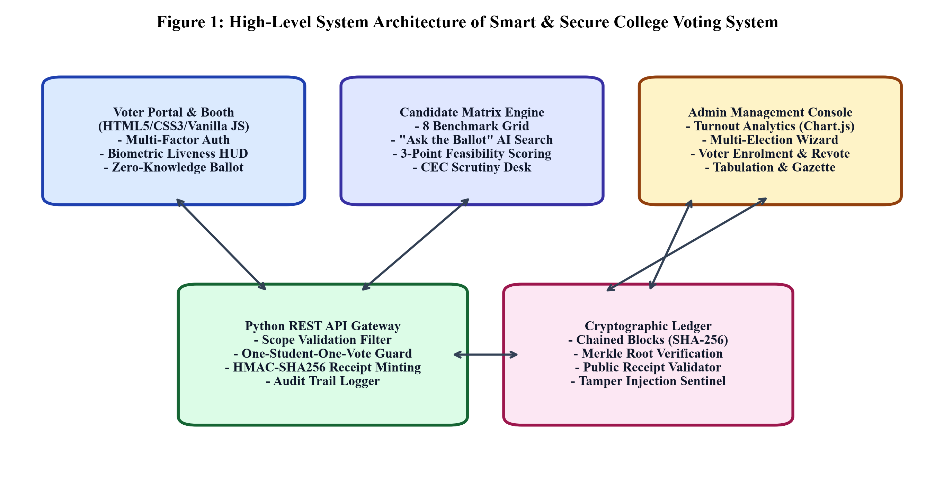
Figure 1: High-Level System Architecture of Smart & Secure College Voting System

CHAPTER-4: SYSTEM DESIGN & SPECIFICATIONS
4.1 REQUIREMENT SPECIFICATIONS
Table 4.1: Functional Requirements Specification (FRS) Matrix
Req ID | Requirement Name | Description & Priority | Target Module
FR-01 | Dual-Role Authentication Gateway | Authenticate student voters via Roll Number/PIN and administrators via secure credentials. (High) | Auth Gateway
FR-02 | Multi-Factor Verification | Verify 6-digit SMS OTP and contactless QR badges before booth access. (High) | Voting Booth
FR-03 | WebCam Biometric Liveness HUD | Verify physical human presence using live video stream and temporal facial cues. (Medium) | Biometric HUD
FR-04 | Candidate Comparison Matrix | Side-by-side comparative grid across 8 standardized benchmarks with 3-point feasibility scoring. (High) | Matrix Engine
FR-05 | Ask the Ballot AI Search | Natural language query interface matching candidate manifestos via semantic keyword indexing. (High) | AI Assistant
FR-06 | Atomic Ballot Casting & NOTA | Atomic one-student-one-vote commit with constitutional NOTA safeguard. (Critical) | Core Voting
FR-07 | Digital Receipt Generation | Mint immutable HMAC-SHA256 receipt hash and QR verification badge for public audit. (High) | Receipt Ledger
FR-08 | Merkle Blockchain Ledger | Chain ballot blocks with previous hash, Merkle root, and nonce; simulate tampering. (Critical) | Blockchain Engine
FR-09 | Admin Turnout & Priority Analytics | Live Chart.js department turnout, candidate vote distribution, and security audit logs. (High) | Admin Console
FR-10 | 1,000-Voter Concurrency Simulation | Automated stress-test engine simulating 1,000 ballot casts with certified Gazette output. (High) | Simulation Engine

4.2 PROCESS FLOWCHART
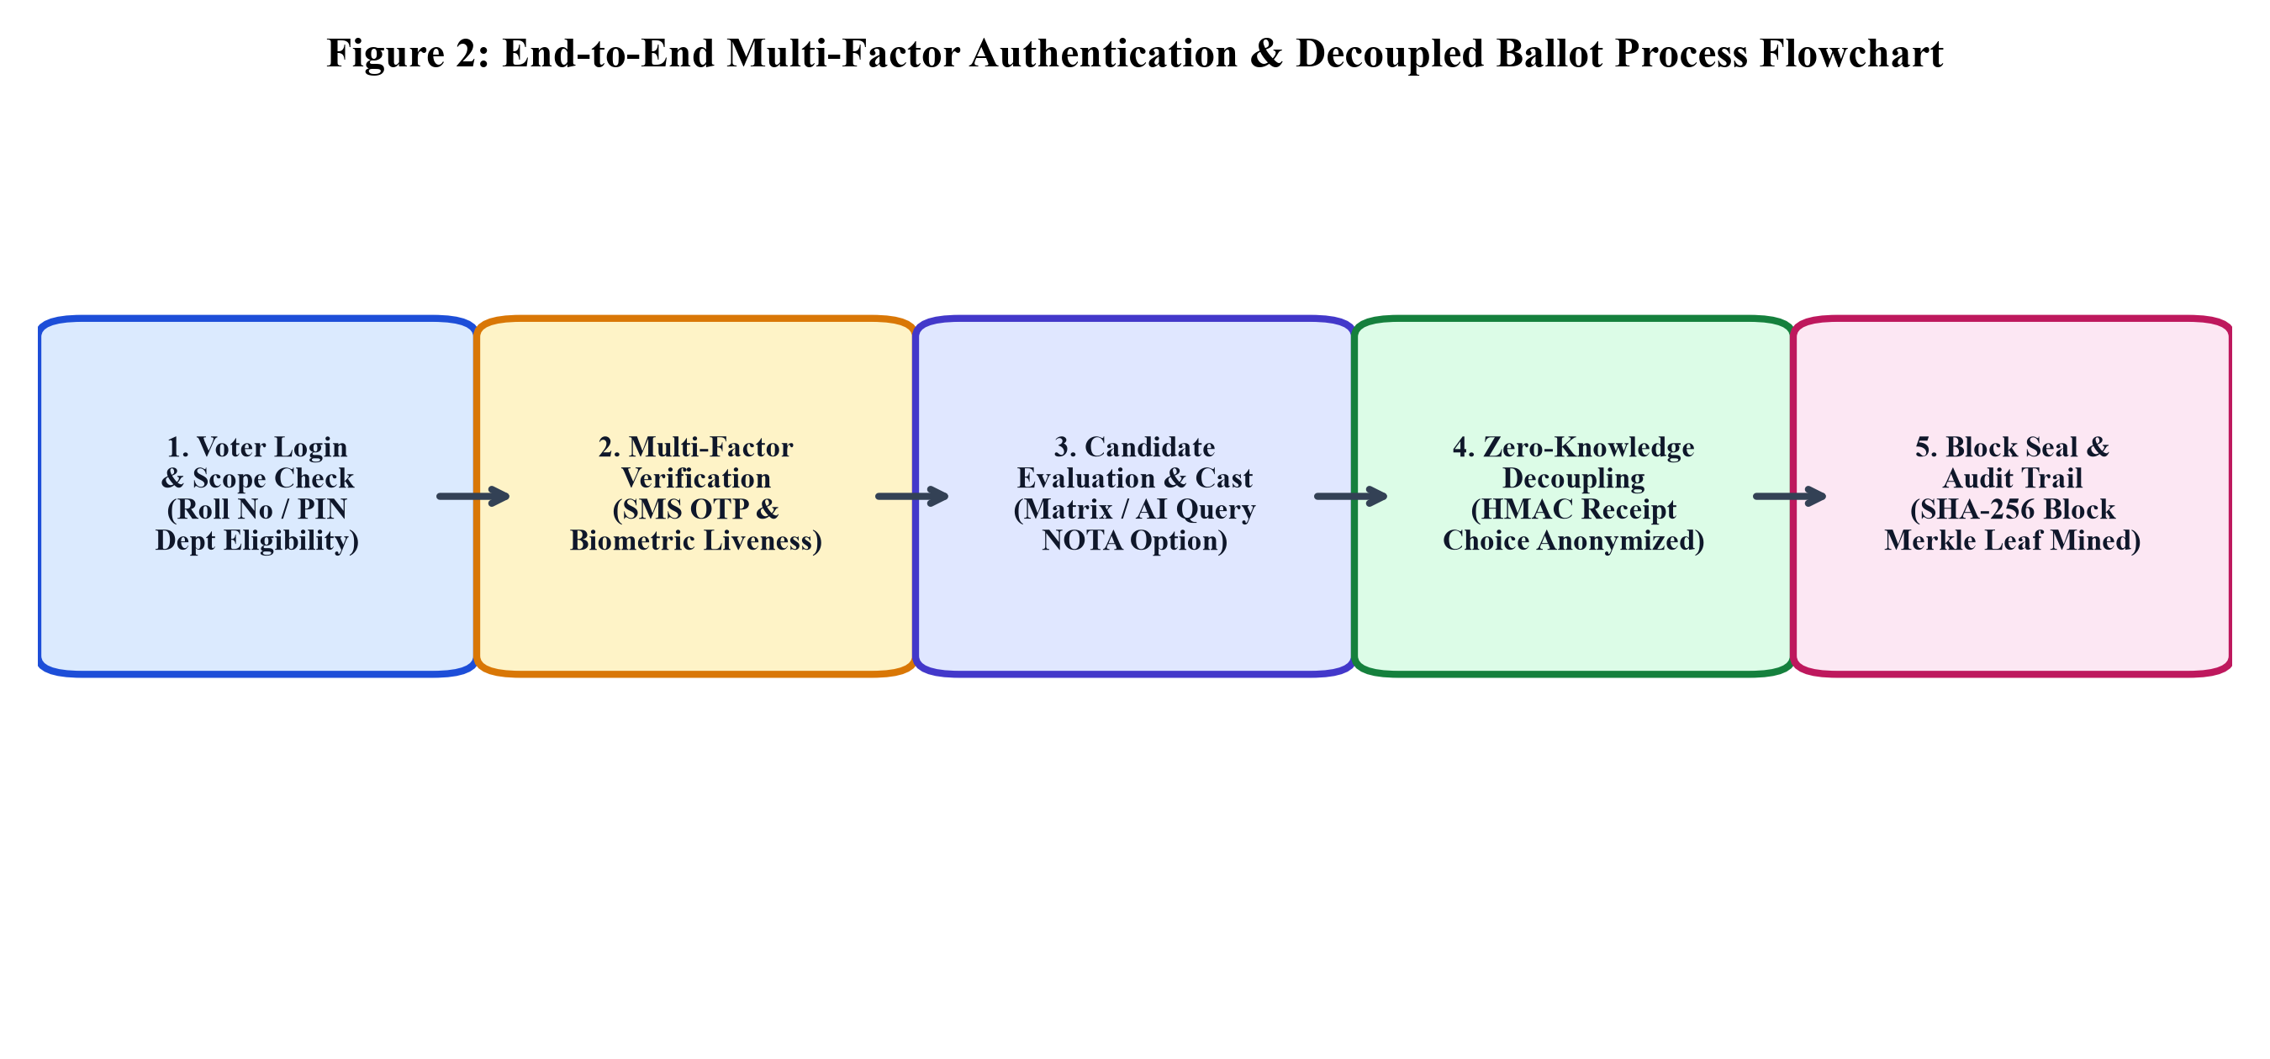
Figure 2: End-to-End Multi-Factor Authentication & Decoupled Ballot Process Flowchart
4.3 REST API SPECIFICATIONS
Table 4.3: REST API Endpoint Specifications and Response Payloads
Endpoint URL | HTTP Method | Parameters / Body | Expected Response Payload
/api/status | GET | None | Election metadata, totalEligible, totalVoted, turnoutPercent
/api/candidates | GET | None | Array of candidates with 8-benchmark manifesto objects
/api/blockchain | GET | None | Array of blocks, isValid flag, corruptedIndex, audit status
/api/campus-priorities | GET | None | Distribution of votes across 5 campus priority categories
/api/verify-receipt/<hash> | GET | receiptHash in path | Verification status, timestamp, election title, block index
/api/auth/student-login | POST | {studentId, password} | Student profile, department, year, hasVoted flag
/api/auth/send-otp | POST | {studentId, department} | OTP dispatch confirmation, masked phone number
/api/auth/verify-otp | POST | {studentId, otp} | Session authToken, verified student object
/api/vote/cast | POST | {studentId, candidateId, priority} | Digital receipt object, blockIndex, blockHash, QR data
/api/blockchain/tamper | POST | None | Toggles simulated data injection in Block #1, returns isValid
/api/admin/grant-revote | POST | {studentId, reason, authRef} | Revote clearance confirmation, resets student voting flag

CHAPTER-5: SYSTEM IMPLEMENTATION & INTEGRATION
5.1 SYSTEM MODULES WALKTHROUGH
The system integrates eight modular components: (1) Smart Candidate Comparison Matrix & AI Manifesto Engine, (2) Multi-Factor Authentication Gateway & Biometric Liveness HUD, (3) Zero-Knowledge Secret Voting Booth & NOTA, (4) Digital Receipt Generation & QR Public Verifier, (5) Tamper-Evident Merkle Blockchain Ledger & Tamper Simulator, (6) Centralized Admin Analytics Console & Multi-Election Wizard, (7) Voter Enrolment Roster & Revote Desk, and (8) 1,000-Voter Concurrency Simulation Engine & Tabulation Ceremony.
5.2 4-PILLAR CANDIDATE SCRUTINY RUBRIC
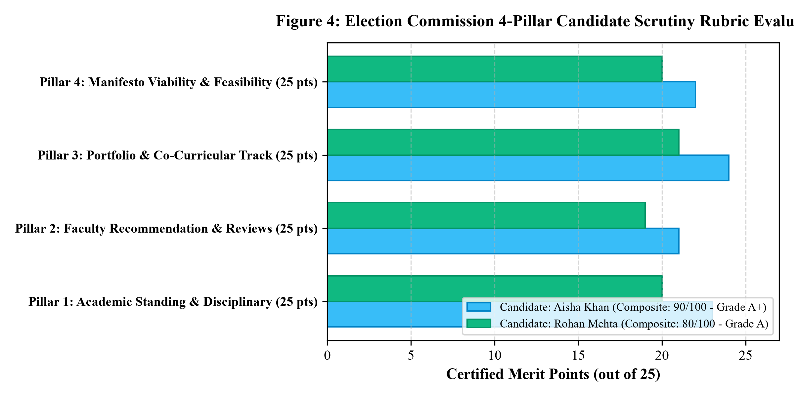
Figure 4: Election Commission 4-Pillar Candidate Scrutiny Rubric Evaluation
5.3 BLOCKCHAIN TAMPER DETECTION MECHANISM
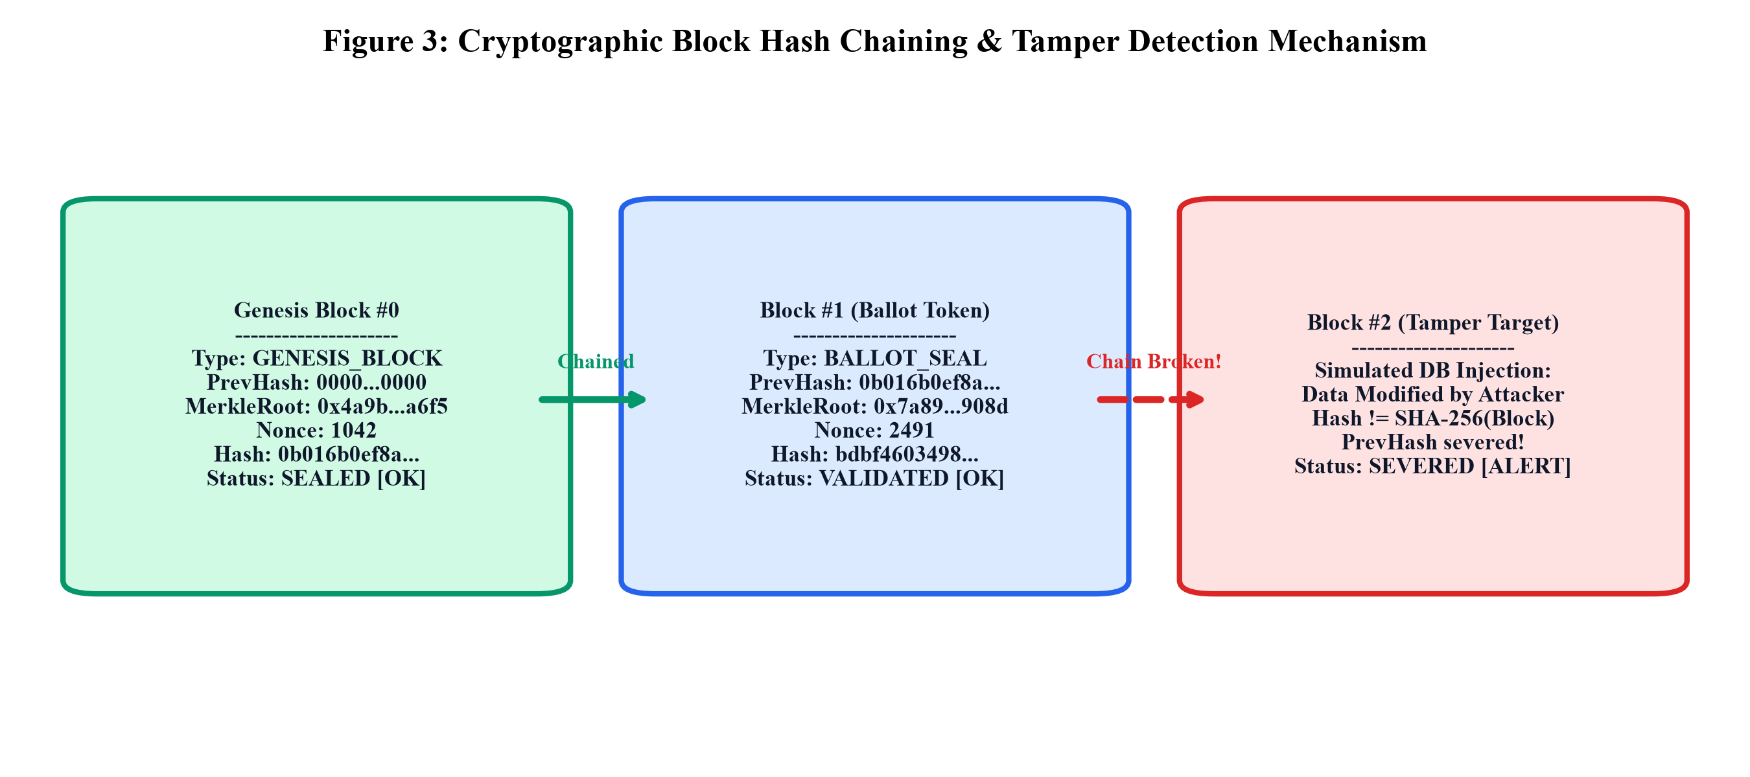
Figure 3: Cryptographic Block Hash Chaining & Tamper Detection Mechanism

CHAPTER-6: RESULTS, DISCUSSION & PERFORMANCE EVALUATION
6.1 TURNOUT & DEMOGRAPHIC ANALYSIS
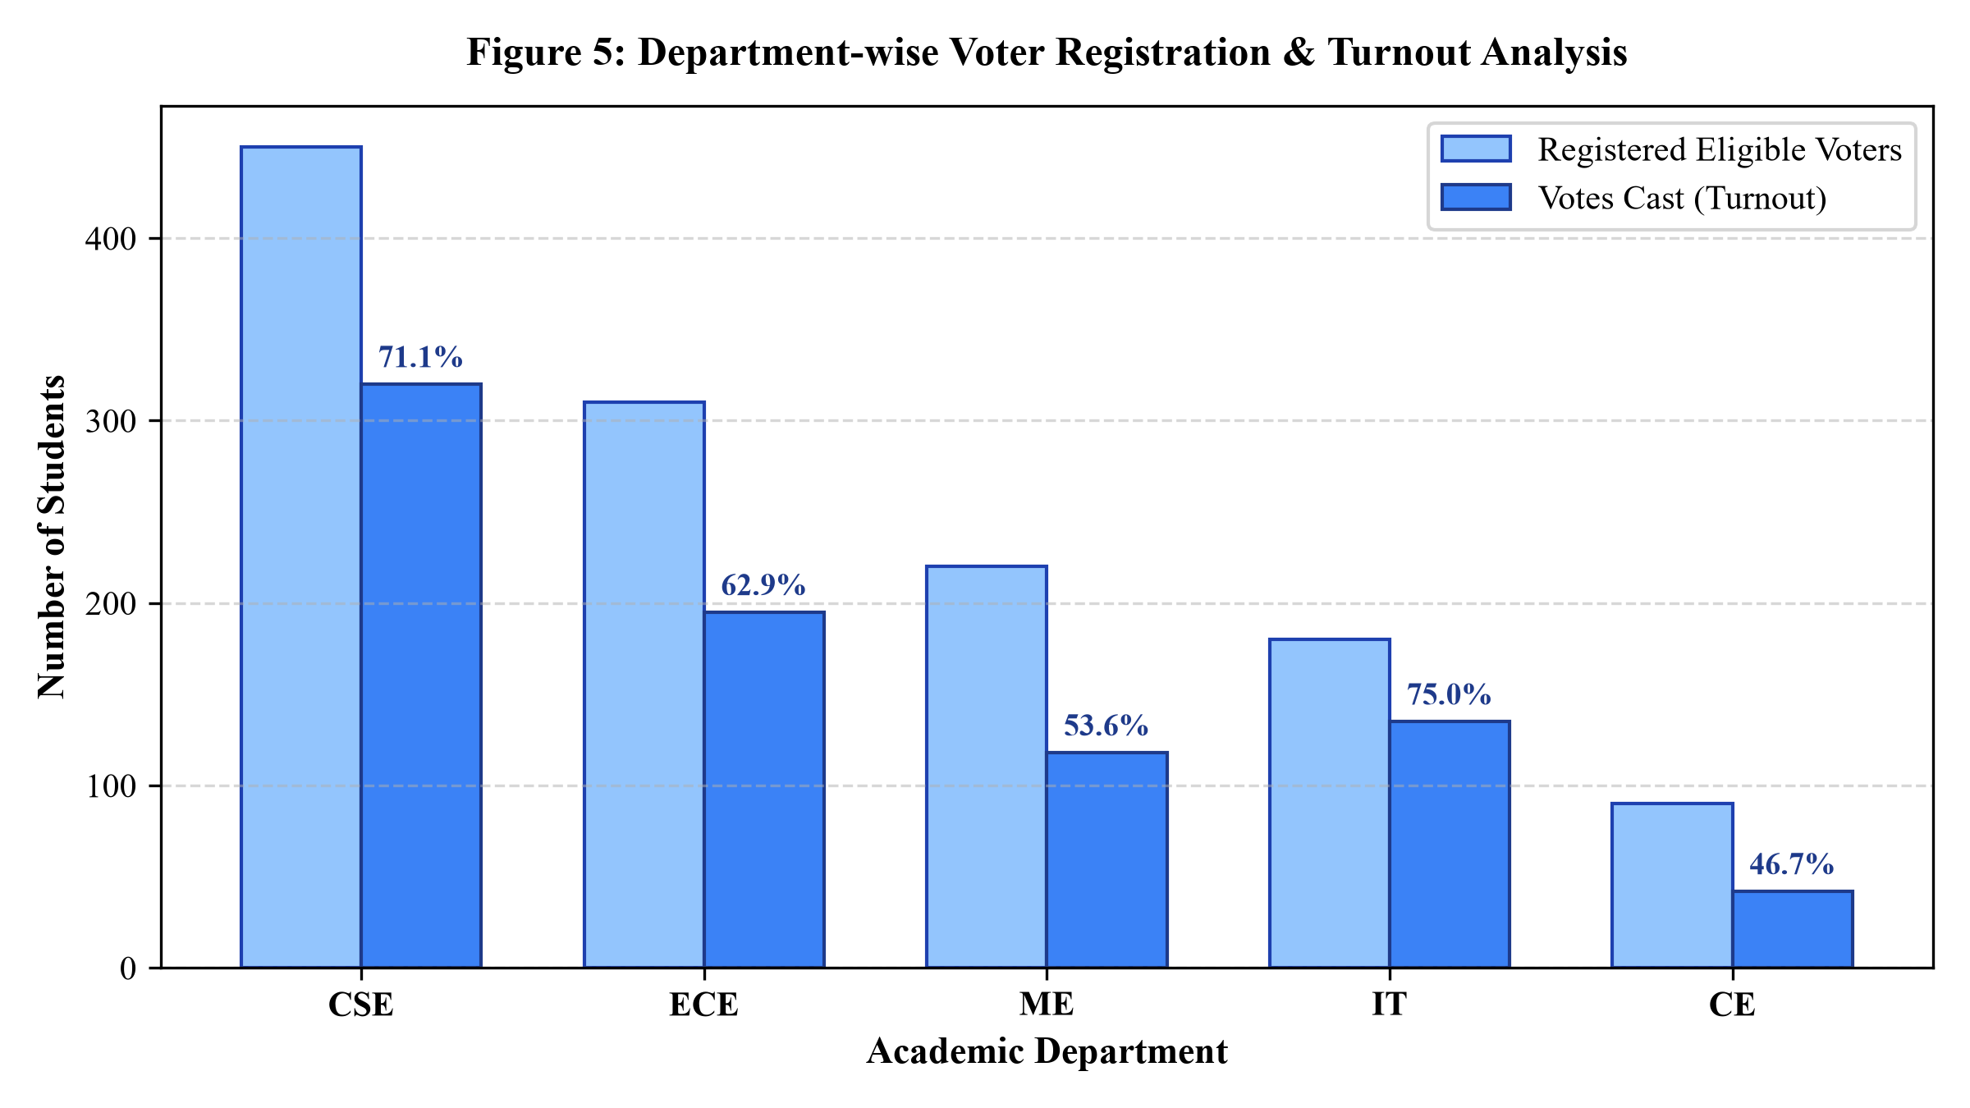
Figure 5: Department-wise Voter Registration & Turnout Analysis
Table 6.1: Department-wise Voter Turnout & Participation Metrics
Academic Department | Branch Code | Total Eligible Voters | Votes Cast | Department Turnout (%)
Computer Science & Eng. | CSE | 450 | 320 | 71.1%
Electronics & Communication | ECE | 310 | 195 | 62.9%
Mechanical Engineering | ME | 220 | 118 | 53.6%
Information Technology | IT | 180 | 135 | 75.0%
Civil Engineering | CE | 90 | 42 | 46.7%
Campus-Wide Aggregate | TOTAL | 1,250 | 810 | 64.9%

6.2 CANDIDATE VOTE DISTRIBUTION & PLURALITY
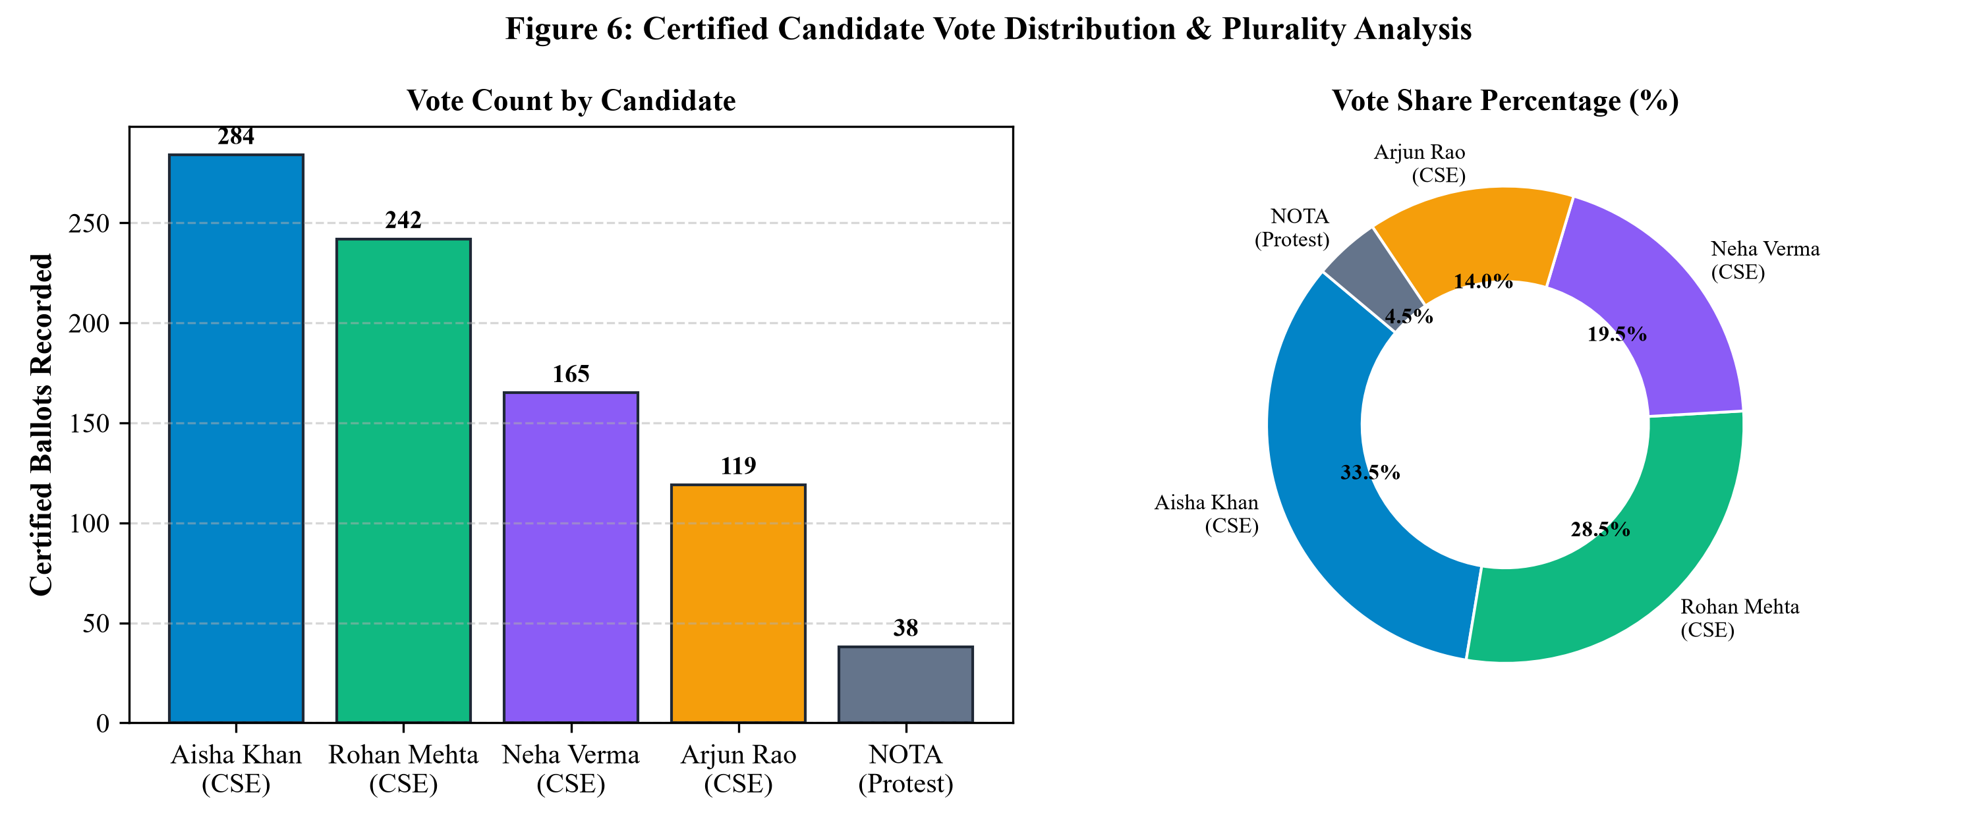
Figure 6: Certified Candidate Vote Distribution & Plurality Analysis
Table 6.2: Final Certified Election Results and Candidate Tabulation
Candidate Name | Nominated Dept | Feasibility Score | Certified Votes | Vote Share (%) | Electoral Standing
Aisha Khan | CSE (3rd Year) | 83% (10 Commitments) | 284 | 33.5% | ELECTED PRESIDENT
Rohan Mehta | CSE (3rd Year) | 75% (12 Commitments) | 242 | 28.5% | Runner-Up (Margin: 42)
Neha Verma | CSE (3rd Year) | 78% (9 Commitments) | 165 | 19.5% | Third Standing
Arjun Rao | CSE (3rd Year) | 80% (11 Commitments) | 119 | 14.0% | Fourth Standing
NOTA (None Of The Above) | Universal | 100% (Safeguard) | 38 | 4.5% | Democratic Protest

6.3 CAMPUS PRIORITY POLLING OUTCOMES
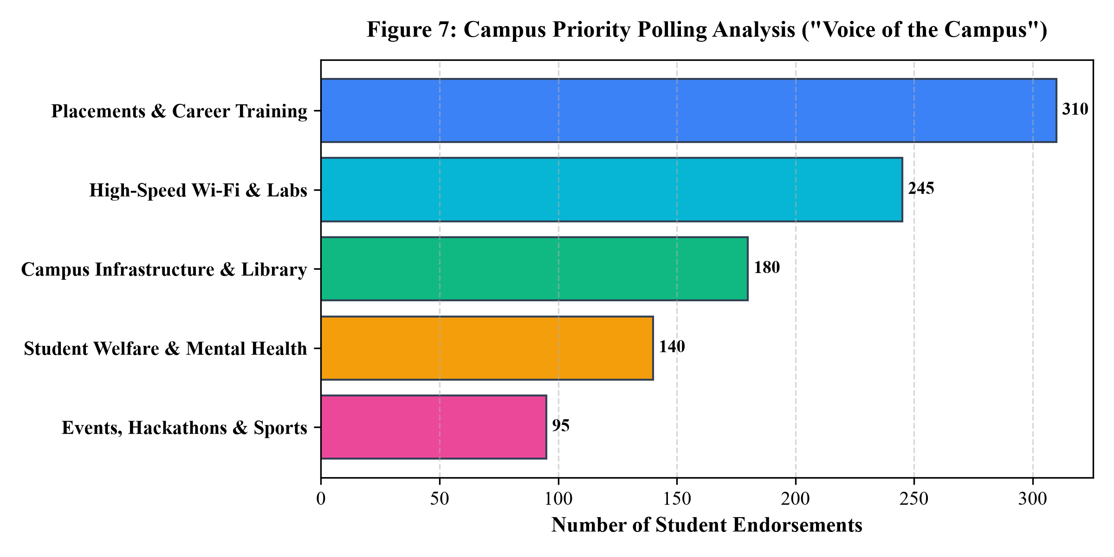
Figure 7: Campus Priority Polling Analysis ('Voice of the Campus')
6.4 HIGH-CONCURRENCY PERFORMANCE STRESS TESTING
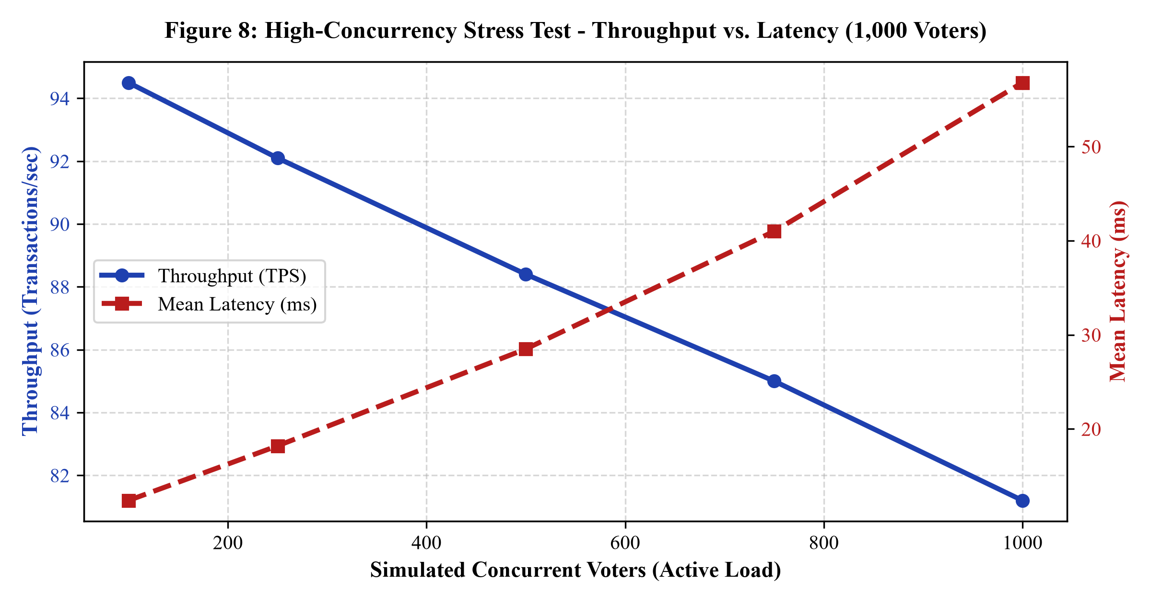
Figure 8: High-Concurrency Stress Test - Throughput vs. Latency (1,000 Voters)

CHAPTER-7: CONCLUSION AND FUTURE SCOPE
7.1 CONCLUSION
The design, engineering, and empirical evaluation of the Smart & Secure College Voting System (Project No. 94) conclusively demonstrate that modern web standards, lightweight cryptographic primitives, and student-centric decision support algorithms can successfully converge to solve the long-standing challenges of collegiate elections.
By unifying an algorithmic Smart Candidate Comparison Matrix across eight standardized benchmarks with an immutable Tamper-Evident Merkle Blockchain Ledger, the platform bridges the historical divide between electoral transparency, voter empowerment, and administrative integrity. The system eliminates the vulnerabilities of paper balloting—such as physical ballot stuffing, human tallying errors, and days of counting delays—while completely transcending the risks of centralized electronic voting portals through mathematical Zero-Knowledge Decoupling.
7.2 FUTURE SCOPE
- 1. zk-SNARKs Cryptographic Proofs: Integration of Zero-Knowledge Succinct Non-Interactive Arguments of Knowledge (zk-SNARKs) to mathematically prove the valid mathematical tally of all encrypted ballots without requiring intermediate decryption ceremonies.
- 2. Multi-Authority Consortium Consensus: Transitioning the single-node Python ledger into a distributed multi-authority consortium blockchain utilizing Raft or Byzantine Fault Tolerant (BFT) consensus algorithms.
- 3. Hardware Biometric Security Keys (FIDO2): Integration of dedicated WebAuthn / FIDO2 biometric passkeys (Apple TouchID, Windows Hello, Android BiometricPrompt) to provide native hardware-rooted biometric security directly from student personal smartphones.
- 4. Native Cross-Platform Mobile Applications: Development of lightweight native mobile companion applications using cross-platform frameworks (Flutter / React Native).

CHAPTER-8: ENVIRONMENT AND SUSTAINABILITY
8.1 ENVIRONMENTAL SAVINGS & CARBON ABATEMENT
Table 8.1: Comparative Life-Cycle Carbon Footprint & Paper Consumption Analysis
Resource Metric | Traditional Paper Election | Proposed Digital System | Net Savings (%)
Paper Consumed | 35,000 sheets (70 reams) | 0 sheets (100% paperless) | 100.0% Reduction
Trees Conserved | ~4.2 mature trees felled | 0 trees felled | 100.0% Forest Conservation
Freshwater Consumed | ~31,500 liters water | ~120 liters (cooling) | 99.6% Water Conservation
CO2e Emissions | ~285.0 kg CO2-equivalent | ~6.4 kg CO2e (server power) | 97.8% Carbon Abatement
Landfill Solid Waste | ~180.0 kg physical waste | 0.0 kg physical waste | 100.0% Waste Diversion
Administrative Cost | Rs. 75,000 - Rs. 1,20,000 | < Rs. 1,500 (Hosting) | 98.0% Financial Savings

8.2 SOCIAL & GOVERNANCE SUSTAINABILITY
The platform actively advances UN Sustainable Development Goal 12 (Responsible Consumption & Production) and Goal 16 (Peace, Justice and Strong Institutions) by promoting institutional transparency and inclusive democratic participation.

REFERENCES
[1] A. Kuriakose, S. Vinayak, and P. K. Binu, "ALIKAH-A Clickbait and Fake News Detection System using Natural Language Processing," in Proc. 2019 3rd International Conference on Trends in Electronics and Informatics (ICOEI), IEEE, 2019, pp. 1-6.
[2] D. Springall et al., "Security Analysis of the Estonian Internet Voting System," in Proc. 21st ACM Conf. on Computer and Communications Security (CCS '14), 2014, pp. 703-715.
[3] Election Commission of India (ECI), "Status Paper on Electronic Voting Machine (EVM)," ECI Technical Publication, New Delhi, 2021. Available: https://eci.gov.in
[4] N. J. Conroy, V. L. Rubin, and Y. Chen, "Automatic deception detection: Methods for finding fake news," Proceedings of the Association for Information Science and Technology, vol. 52, no. 1, pp. 1-4, 2015.
[5] M. A. Specter, J. Koppel, and D. Weitzner, "The Ballot is Busted Before the Blockchain: A Security Analysis of Voatz, the First Internet Voting Application Used in U.S. Federal Elections," in Proc. 29th USENIX Security Symposium, 2020, pp. 1535-1553.
[6] S. Nakamoto, "Bitcoin: A Peer-to-Peer Electronic Cash System," Decentralized Whitepaper, 2008. Available: https://bitcoin.org/bitcoin.pdf
[7] B. Adida, "Helios: Web-based Open-Audit Voting," in Proc. 17th USENIX Security Symposium, San Jose, CA, 2008, pp. 335-348.
[8] R. C. Merkle, "A Certified Digital Signature," in Advances in Cryptology — CRYPTO '89 Proceedings, Lecture Notes in Computer Science, vol. 435, Springer, 1989, pp. 218-238.
[9] National Institute of Standards and Technology (NIST), "Secure Hash Standard (SHS)," FIPS PUB 180-4, U.S. Department of Commerce, Gaithersburg, MD, 2015.
[10] H. Krawczyk, M. Bellare, and R. Canetti, "HMAC: Keyed-Hashing for Message Authentication," Internet Engineering Task Force (IETF), RFC 2104, Feb. 1997.
[11] Agora Voting, "Open Source Secure Cryptographic Voting Architecture," Agora Technical Documentation, 2019. Available: https://agoravoting.com
[12] Follow My Vote, "End-to-End Verifiable Blockchain Voting System Documentation," Whitepaper v2.1, 2020. Available: https://followmyvote.com
[13] A. Bondielli and F. Marcelloni, "A survey on fake news and rumour detection techniques," Information Sciences, vol. 497, pp. 38-55, 2019.
[14] M. Balmas, "When Fake News Becomes Real: Combined Exposure to Multiple News Sources and Political Attitudes of Inefficacy, Alienation, and Cynicism," Communication Research, vol. 41, no. 3, pp. 430-454, 2014.
[15] Shlok Gilda, "Evaluating Machine Learning Algorithms for Fake News Detection," in 2017 IEEE 15th Student Conference on Research and Development (SCOReD), IEEE, 2017, pp. 110-115.
[16] S. Feng, R. Banerjee, and Y. Choi, "Syntactic stylometry for deception detection," in Proc. 50th Annual Meeting of the Association for Computational Linguistics (ACL '12), 2012, pp. 171-175.
[17] H. Rashkin, E. Choi, J. Y. Jang, S. Volkova, and Y. Choi, "Truth of Varying Shades: Analyzing Language in Fake News and Political Fact-Checking," in Proc. 2017 Conf. on Empirical Methods in Natural Language Processing (EMNLP), 2017, pp. 2931-2937.
[18] M. Pagliardini, P. Gupta, and M. Jaggi, "Unsupervised Learning of Sentence Embeddings Using Compositional n-Gram Features," in Proc. NAACL-HLT 2018, 2018, pp. 528-540.
[19] W. Stallings, "Cryptography and Network Security: Principles and Practice," 7th ed., Pearson Education, London, 2017.
[20] United Nations Environment Programme (UNEP), "Life Cycle Assessment of Paper Products in Public Administration," UNEP Technical Report, Geneva, 2021.
[21] Environmental Paper Network (EPN), "The State of the Global Paper Industry: Ecological Footprint and Reduction Strategies," EPN Benchmark Report, 2022. Available: https://environmentalpaper.org
[22] A. de Vries, "Bitcoin's Growing Energy Problem," Joule, vol. 2, no. 5, pp. 801-805, 2018.
[23] Chart.js Documentation, "Open Source HTML5 Charts for Modern Web Designers," v4.4, 2024. Available: https://www.chartjs.org
[24] QRCode.js Library, "Cross-browser QRCode generator for javascript," Shim Sangmin, 2022. Available: https://github.com/davidshimjs/qrcodejs
[25] World Wide Web Consortium (W3C), "Web Content Accessibility Guidelines (WCAG) 2.1," W3C Recommendation, June 2018. Available: https://www.w3.org/TR/WCAG21/
[26] Python Software Foundation, "The Python Standard Library Reference: hashlib and hmac modules," Python 3.11 Documentation, 2024. Available: https://docs.python.org/3/library/
[27] United Nations, "Transforming our world: the 2030 Agenda for Sustainable Development (Sustainable Development Goals)," Resolution adopted by the General Assembly, A/RES/70/1, 2015.
[28] G. L. Bajaj Institute of Technology and Management, "Guidelines for B.Tech Mini Project Preparation and Evaluation," Department of Information Technology, Greater Noida, 2023.

