**数据结构实验报告13**

**学号：** 117060400211 **姓名**：王婕冉 **班级：** 应用统计学2班 **指导老师：林卫中**

**实验名称**： 网络爬虫和自动化

**实验要求：** 运用requests库编写基本URL访问过程

运用beautifulsoup4库解析和处理HTML

**实验题目：一：运用爬虫爬取各省份的学校排名**

**二：爬取美国大学排名前30名的学校名称、学费、培养规模。**

**三：从百度图片上爬取90张范冰冰（或其他明星）的照片**

**四：爬取网易云音乐上所有播放次数超过500万次的歌曲信息，包括：歌曲名，播放次数，歌曲链接地址等信息**

**算法实现：**

**实验1：**

#e23.1CrawUnivRanking.py

import requests

from bs4 import BeautifulSoup

allUniv = []

def getHTMLText(url):

    try:

        r = requests.get(url, timeout=30)

        r.raise_for_status()

        r.encoding = 'utf-8'

        return r.text

    except:

        return ""

def fillUnivList(soup):

    data = soup.find_all('tr')

    for tr in data:

        ltd = tr.find_all('td')

        if len(ltd)==0:

            continue

        singleUniv = []

        for td in ltd:

            singleUniv.append(td.string)

        allUniv.append(singleUniv)

def printUnivList(province):

    print("{:<2}{:<10}{:<6}{:<4}{:<10}".format("排名","学校名称","省市","总分","培养规模"))

    for u in allUniv:

        if province in u[2]:

            print("{:<2}{:<10}{:<6}{:<4}{:<10}".format(u[0],u[1],u[2],u[3],u[6]))

def main(p):

    url = 'http://www.zuihaodaxue.cn/zuihaodaxuepaiming2018.html'

    html = getHTMLText(url)

    soup = BeautifulSoup(html, "html.parser")

    fillUnivList(soup)

    printUnivList(p)

main('山西')

**实验2：**

import requests

import re

from bs4 import BeautifulSoup

allUniv=[]

def getHTMLText(url):

    send_headers = {

        "User-Agent": "Mozilla/5.0 (Windows NT 10.0; Win64; x64) AppleWebKit/537.36 (KHTML, like Gecko) Chrome/61.0.3163.100 Safari/537.36",

        "Connection": "keep-alive",

        "Accept": "text/html,application/xhtml+xml,application/xml;q=0.9,image/webp,image/apng,*/*;q=0.8",

        "Accept-Language": "zh-CN,zh;q=0.8"}

    try:

        r = requests.get(url, headers=send_headers)

        r.raise_for_status()

        print(r.status_code)

        r.encoding = 'utf-8'

        return r.text

    except:

        return ""

def fillUnivList(soup):

    data = soup.find_all('div',{'class':re.compile('shadow-dark')})

    for div in data:

        singleUniv = []

        div1 = div.find('div',{'style':'margin-left: 2.5rem;'})

        rank = div1.get_text().strip()

        singleUniv.append(rank.split(' ')[0])

        univName = div.find('h3')

        singleUniv.append(univName.get_text().strip())

        ldiv = div.find_all('div',{'style':'padding-right: 0.5rem;'})

        singleUniv.append(ldiv[0].strong.string)

        singleUniv.append(ldiv[1].strong.string)

        allUniv.append(singleUniv)

def printUnivList():

    print("{:<6}{:<20}{:<6}{:<10}".format("排名","学校名称","学费","培养规模"))

    for u in allUniv:

        print("{:<6}{:<20}{:<10}{:<10}".format(u[0],u[1],u[2],u[3]))

def main(n):

    for n in range(1,n):

        url = 'https://www.usnews.com/best-colleges/rankings/national-universities?_page='+str(n)

        html = getHTMLText(url)

        soup = BeautifulSoup(html,'html.parser')

        fillUnivList(soup)

    printUnivList()

main()

**拓展：**列出前100名高校中学费低于$50,000的所有学校

**只改这里：**

def printUnivList():

    print("{:<6}{:<20}{:<6}{:<10}".format("排名","学校名称","学费","培养规模"))

    for u in allUniv:

        ls = u[2].split(" ")

        s = ls[0].replace(',','')

        f = s[1:]

        if int(f) < 50000:

            print("{:<6}{:<20}{:<10}{:<10}".format(u[0],u[1],u[2],u[3]))

def main(n):

    for n in range(1,n):

        url = 'https://www.usnews.com/best-colleges/rankings/national-universities?_page='+str(n)

        html = getHTMLText(url)

        soup = BeautifulSoup(html,'html.parser')

        fillUnivList(soup)

    printUnivList()

main(11)

**实验3：**

from bs4 import BeautifulSoup

import re

import requests

def downloadImageFile(imgUrl, destUrl, fname=''):

local_filename = imgUrl.split('/')[-1]

print('Download Image File={}'.format(local_filename))

try:

r = requests.get(imgUrl, stream=True)

r.raise_for_status()

if len(fname) == 0:

fname = local_filename

print('fname={}'.format(fname))

with open(destUrl + "/" + fname, 'wb') as f:

for chunk in r.iter_content(chunk_size=1024):

if chunk:

f.write(chunk)

f.flush()

f.close()

return r.status_code

except:

return r.status_code

def getMorePages(kw, pages):

params = []

for i in range(30, 30*pages+30, 30):

params.append({

'ipn': 'rj',

'ct': 201326592,

'is': '',

'fp': 'result',

'queryWord': kw,

'cl': 2,

'lm': -1,

'ie': 'utf-8',

'oe': 'utf-8',

'adpicid': '',

'st': -1,

'z': '',

'ic': 0,

'word': kw,

's': '',

'se': '',

'tab': '',

'width': '',

'height': '',

'face': 0,

'istype': 2,

'qc': '',

'nc': 1,

'fr': '',

'pn': i,

'rn': 30,

'gsm': '1e',

'1528253616462': ''

})

url = 'https://image.baidu.com/search/acjson?tn=resultjson_com'

datalist = []

for param in params:

dj = requests.get(url, params=param).json()

data = dj['data']

if data is not None and len(data) > 0:

datalist.append(data)

return datalist

def main(kw, pages, desurl):

datalist = getMorePages(kw, pages)

index = 1

for data in datalist:

for i in data:

if i.get('thumbURL') is not None:

ir = i.get('thumbURL')

downloadImageFile(ir, desurl, str(index)+'.jpg')

index = index + 1

main('范冰冰',3, 'e:/baidupic')

**实验4：**

import requests

from selenium import webdriver

from selenium.webdriver.common.by import By

from NetSpider import *

from bs4 import BeautifulSoup

import re

allMusics=[]

url = 'http://music.163.com/#/discover/playlist/?order=hot&cat=%E5%85%A8%E9%83%A8&limit=35&offset=0'

def getHTMLTextByHeadless(url):

broswer = webdriver.Firefox()

while url != 'javascript:void(0)':

broswer.get(url)

broswer.switch_to.frame("contentFrame")

data = broswer.find_element_by_id("m-pl-container").find_elements_by_tag_name("li")

for d in data:

music = []

nb = d.find_element(By.CLASS_NAME,'nb').text

if '万' in nb:

n = nb[:-1]

if int(n) > 500:

music.append(n)

al = d.find_elements_by_tag_name('a')

title = al[0].get_attribute('title')

music.append(title)

hr = al[0].get_attribute('href')

music.append(hr)

author = al[3].get_attribute('title')

music.append(author)

allMusics.append(music)

url = broswer.find_element_by_css_selector("a.zbtn.znxt").get_attribute('href')

broswer.close()

def fillMusicList():

html = getHTMLText(url, coding='utf-8')

soup = BeautifulSoup(html,'html.parser')

ul = soup.find('ul', {'id':'m-pl-container'})

divs = ul.find_all('div', {'class': re.compile('u-cover')})

for div in divs:

music = []

nb = div.find('span', {'class': 'nb'}).string

if '万' in nb:

n = nb[:-1]

if int(n) > 500:

music.append(n)

a = div.find('a')

title = a.title

music.append(title)

hr = musicurl + a.href

music.append(hr)

a2 = div.find('a', {'class':re.compile('nm nm-icn f-thide')})

author = a2.string

music.append(author)

allMusics.append(music)

def printMusicList():

print('{:<8}{:<20}{:<8}{:<20}'.format('下载次数', '歌曲名称', '歌手', '歌曲链接地址'))

for music in allMusics:

print('{:<8}{:<20}{:<8}{:<20}'.format(str(music[0]), music[1], music[3], music[2]))

#fillMusicList()

#printMusicList()

getHTMLTextByHeadless(url)

printMusicList()

**实验结果：**

实验一：

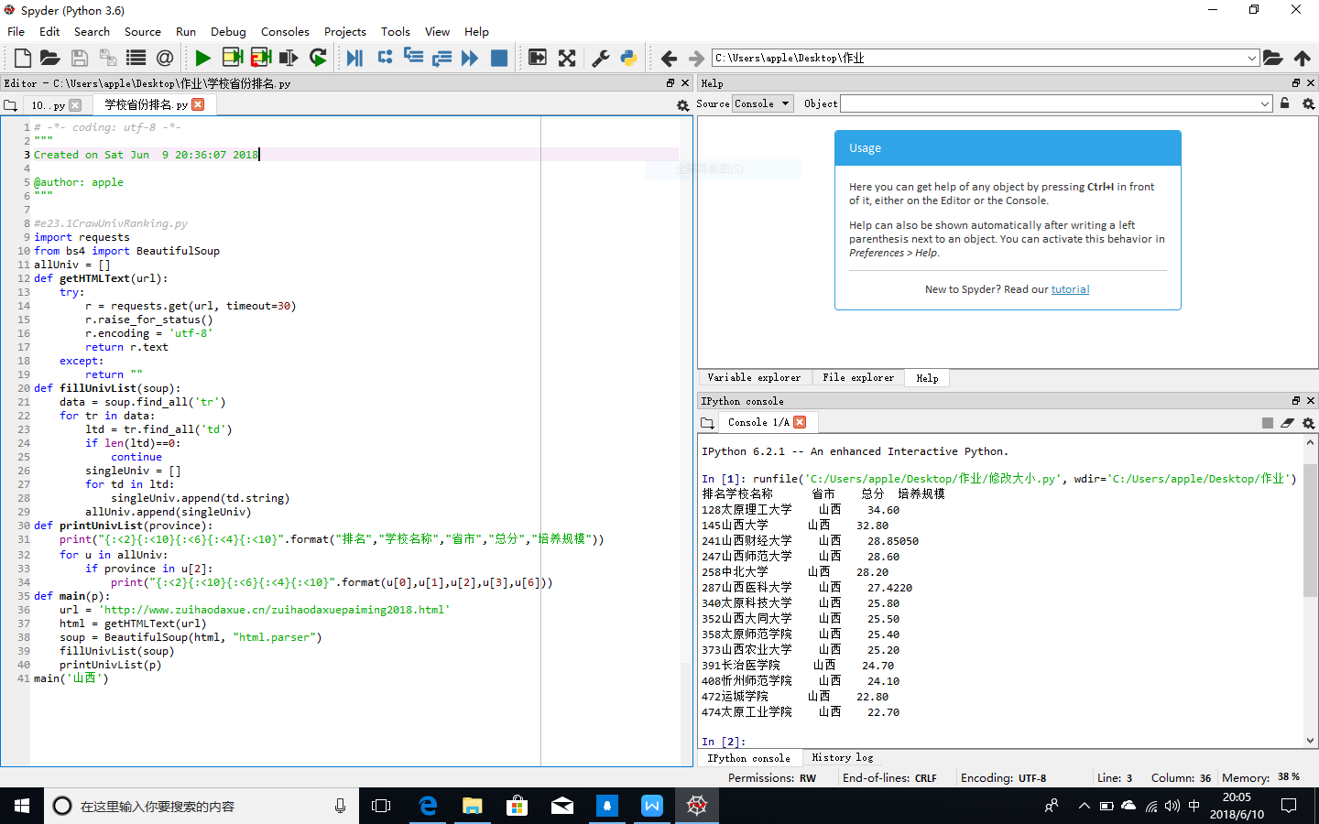

实验2：

