# 作业3

**学号：** 117060400211 **姓名**：王婕冉 **班级：** 应用统计学2班 **指导老师：林卫中**

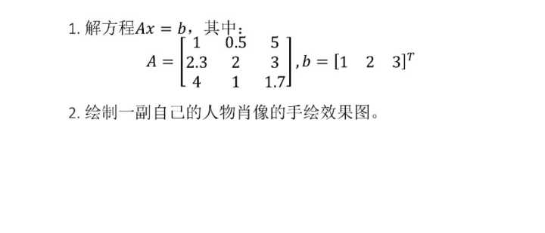

1. 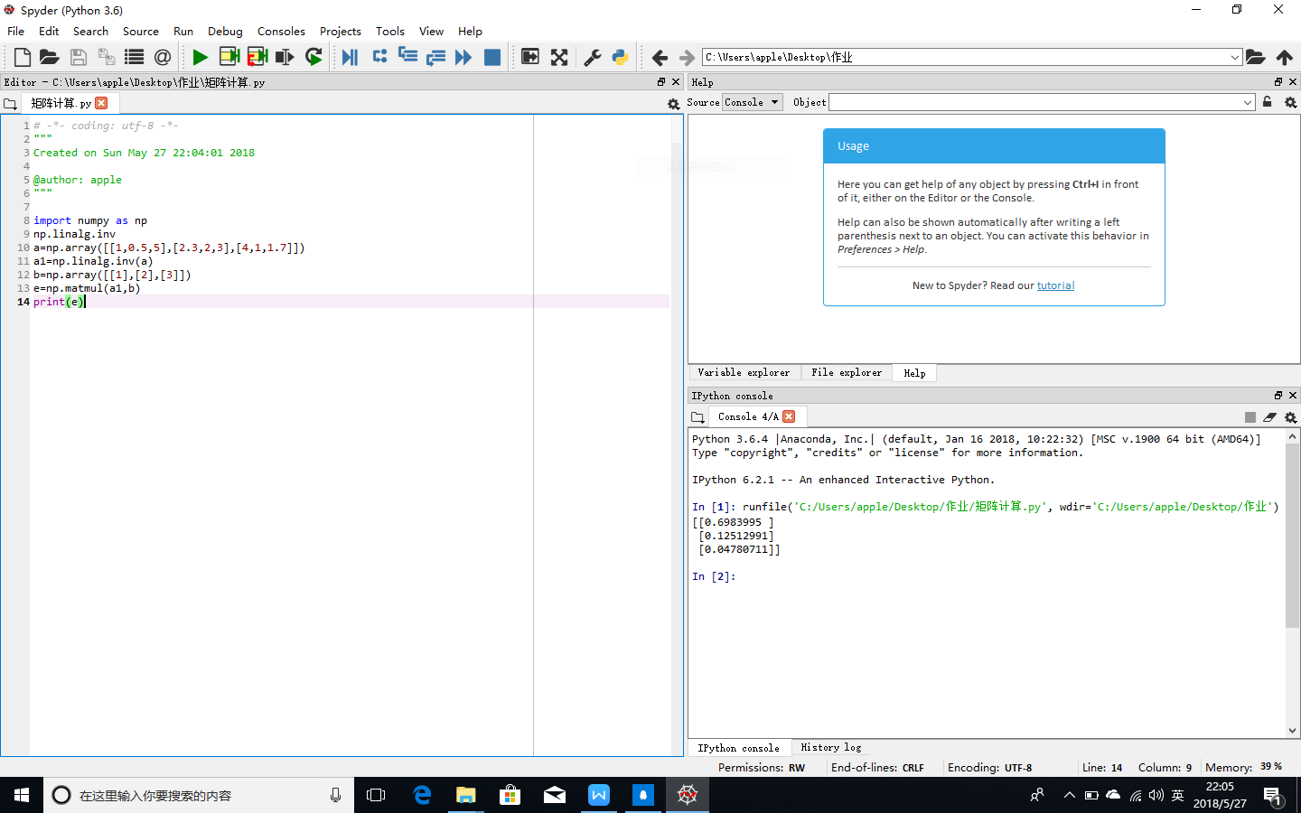

2.from PIL import Image

import numpy as np

vec_el = np.pi/2.2

vec_az = np.pi/4

depth = 10.

im = Image.open("me.jpg").convert("L")

a = np.asarray(im).astype("float")

grad = np.gradient(a)

grad_x,grad_y = grad

grad_x=grad_x*depth/100.

grad_y=grad_y*depth/100.

dx = np.cos(vec_el)*np.cos(vec_az)

dy = np.cos(vec_el)*np.sin(vec_az)

dz = np.sin(vec_el)

A = np.sqrt(grad_x**2+grad_y**2+1.)

uni_x = grad_x/A

uni_y = grad_y/A

uni_z = 1./A

a2 = 255*(dx*uni_x + dy*uni_y + dz*uni_z)

a2 = a2.clip(0,255)

im2 = Image.fromarray(a2.astype("uint8"))

im2.save("me2.jpg")

