TASK 17 – MONTHLY SALES TREND
Project Report
Prepared by: Sakshi Varne

1. Introduction
This project analyzes monthly sales performance using a retail sales dataset. The objective is to summarize total sales for each month and visualize the sales trend using Microsoft Excel and Python.

2. Objective
- Calculate total sales for each month from January to December 2025.
- Create a monthly sales summary using an Excel PivotTable.
- Visualize the monthly sales trend using a line chart.
- Perform the analysis programmatically using Python, Pandas, and Matplotlib.
- Identify the highest and lowest sales months.

3. Dataset Description
The dataset contains retail sales records. The analysis mainly uses Order Date and Sales. Order Date is used to group records by month, while Sales is summed to calculate monthly sales.

4. Tools and Technologies
- Microsoft Excel
- Python
- Pandas
- Matplotlib
- OpenPyXL

5. Excel Analysis
A PivotTable was created in Excel to summarize Sales by Month. Order Date was grouped into months and Sales was summarized using Sum of Sales. A line chart titled 'Monthly Sales Trend' was created from the monthly summary.

6. Monthly Sales Summary
Month | Total Sales | Observation
January | 99,578.47
February | 101,490.96
March | 79,752.72 | Lowest sales
April | 112,030.45
May | 141,991.96 | Highest sales
June | 121,345.77
July | 108,925.77
August | 87,081.24
September | 138,123.42
October | 104,126.49
November | 106,739.40
December | 95,371.63
Grand Total | 1,296,558.28 | Total annual sales

7. Key Findings
- Total sales for 2025 were 1,296,558.28.
- May recorded the highest monthly sales at 141,991.96.
- March recorded the lowest monthly sales at 79,752.72.
- Sales increased strongly from March to May, reaching the highest point in May.
- Sales declined from May through August, followed by a strong increase in September.
- After September, sales decreased in October, increased slightly in November, and decreased again in December.
- The line charts clearly show month-to-month fluctuations in sales.

8. Python Analysis
Python was used to reproduce the monthly sales analysis. Pandas was used to load the Excel dataset and aggregate Sales by month. Matplotlib was used to create the line chart.
df = pd.read_excel("../Dataset/Sales_Data.xlsx", sheet_name="Raw_Data")
df["Order Date"] = pd.to_datetime(df["Order Date"])
monthly_sales = (
df.groupby(df["Order Date"].dt.to_period("M"))["Sales"]
.sum().reset_index()
)

9. Excel Visualization
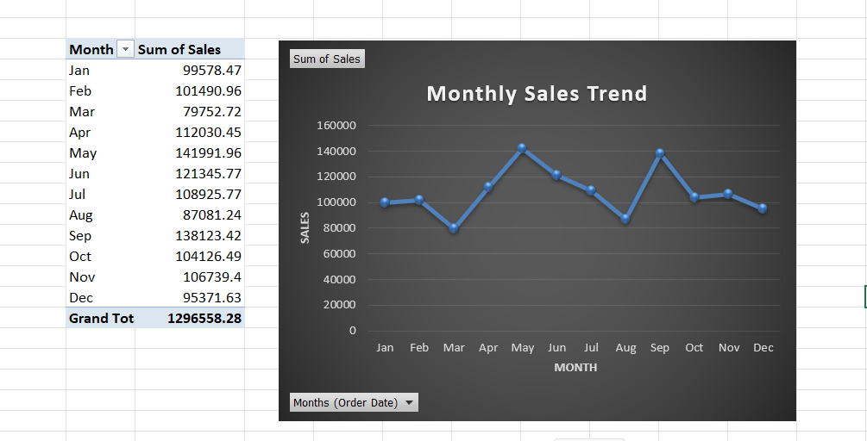
Figure 1: Excel PivotTable and Monthly Sales Trend

10. Python Visualization
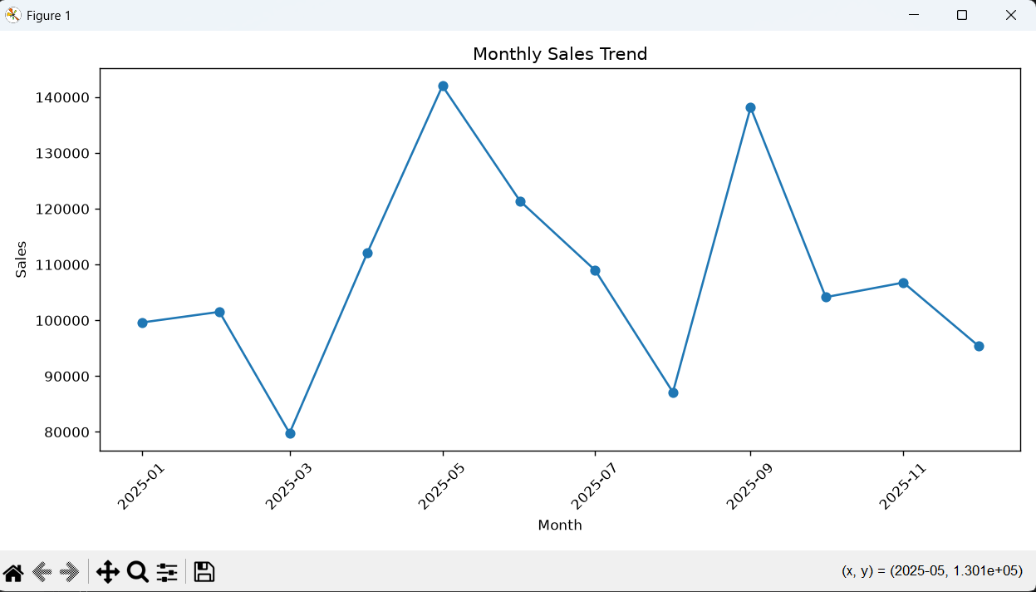
Figure 2: Python Matplotlib Monthly Sales Trend

11. Learning Outcomes
- Working with date-based sales data.
- Grouping data by month.
- Creating PivotTables and charts in Excel.
- Using Pandas for data aggregation.
- Creating line charts using Matplotlib.
- Identifying trends and fluctuations in sales data.

12. Conclusion
Task 17 was completed successfully by analyzing monthly sales using Excel and Python. The monthly summary and line charts provide a clear view of sales performance throughout 2025. The analysis shows noticeable fluctuations across the year, with May having the highest sales and March having the lowest sales.

13. Interview Questions
Why is a line chart used for monthly sales?
It is suitable for showing trends and changes over time.
Which Pandas function is used for grouping data?
The groupby() function is used to group records.
Why is Order Date converted to datetime?
It allows dates to be correctly grouped and analyzed by month.
What was the highest sales month?
May, with sales of 141,991.96.
What was the lowest sales month?
March, with sales of 79,752.72.

14. Author
Sakshi Varne
Data Analytics Internship Project – Task 17

