**CHAPTER NO. 1**

**INTRODUCTION**

**1.1 Introduction**

Agriculture has been the spine of the Indian economy and it will continue to remain for the long time. Over 70 per cent of the rural households depend on agriculture. One-third of our national income comes from agriculture. The economic improved started off in the country during the early 1990s have put the economy on a higher growth rate trajectory. Annual growth rate in gross domestic product (GDP) has accelerated about 25%. Indian agriculture has registered impressive growth over last few decades. The growth in agricultural production has been still for the past several years.

The significance of agriculture is: 1) Contribution to national income, 2) Main source of food, 3) Agriculture and industrial development, 4) Sources of revenue, 5) Source of foreign trade, 6) Transport, 7) Source of saving, 8) Capital formation, 9) International importance, 10) Effect on prices, 11) Economic development**.**

Land was losing its fertility being put to cultivation continuously for years together. After

reading all the existing system and their working and found out that there is no system that uses the Arduino, LCD, Moisture sensor and solar energy all together. So combining all the existing system to get the hybrid system called ‘Solar-Based automatic water irrigation system using Arduino’. Solar-Based automatic water irrigation system has been studied in much application. These sensors send real time values to Arduino and Arduino send these values to display device via serial communication [2]. The system suggests an economical and easy-to-use Arduino-based automated irrigation system that utilizes the Android for motor control and detection of moisture level. The data received by the Arduino is displayed on the LCD [3]. The volumetric data of water utilized and crop yield were collected and the results showed that the water consumption is reduced in the automated field as compared to the manually irrigated field [4].

Only 0.01 % water is available on the earth surface of overall exists of water. So water is a rare resource. Irrigation system also facing problem of water scarcity. Therefore it is necessity to have a smart irrigation system where the water is precisely using. The requirement of water in irrigation system is very crucial so the new irrigation methods should implement in such a manner that requires less water consumption when compare to old technologies. Automatic irrigation means not only consuming less water it also provide water supply depending on requirement. In this manner increases the efficiency of agriculture and possibility to reduce the risks. This system monitors the weather conditions, soil conditions of plant and water level in using sensor. The smart irrigation techniques can able to control the water waste up to 95% whereas the traditional methods results around 20% to 70%.

Agriculture plays an important role in every country’s economy and so many countries depend on it, whether in a large country or a small one. However the growth of population affect on other environment factor like shortage of water has become one of the main challenge of agriculture. Usually the problem arises from many different cases and in some cases as a combination of those causes. The UAE is listed by the United Nations as a high-rank country when it comes to water stress a situation which occurs when the availability of water is not in balance with the demand for water. While resources are limited, the UAE has one of the highest water consumption rates in the world [1].

Despite the dried climate nature, in the UAE agriculture is considered as one of important economic sector which need special attention. Toward that end the use of the latest technologies to improve agriculture activities has become a part of the solution. Irrigation is mostly done using canal systems in which water is pumped into fields after steady interval of time with the lacking of result and feedback of water in the field which affect the production and health of the crops. That is why automatic irrigation system is built to help with the crops and save the amount of water to be used when needed.

The main advantage of this project is to detect the amount of water that plants need and to supply it accurately. The power supply has been chosen to make the system more efficient, sustainable and up to date therefore we are using a renewable source to power the irrigation system which is the solar panel. Proposed irrigation system is going to supply the plants with a specific amount of water and to reduce the amount of water that goes to waste. In addition to protecting the plants from one of two things: first is wilting from lack of water and nutrients the plant needs to survive and second is supplying the plant with too much water which will cause the roots to root of oxygen deprivation.

The main imperfection of normal irrigation system is wasting the water during filling in a

reservoir and one more reason is over watering to plant. It is the main scenario where shortage of the water will arrives. The important factor in a smart irrigation system is monitoring soil moisture of plant. Depends on this one can assure that whether the plant is having sufficient water for its growth or not. Without sufficient water the growth of a plant is unattainable. Smartness in system means it should monitor the condition of plant continuously for excellent result. A soil moisture sensor helps out to measure the soil moisture content of a plant monotonously and the system directs the irrigation system in such a way that it gets required quantity of water need to be supply using relay. The water will release from reservoir whenever plant requires.

Sensor is available in markets with very less prize anyone can purchase to develop an automatic irrigation. The association of irrigation with IoT possible to get best results from the irrigation using innovative techniques. It has a potential to estimate the strong contents of automatic irrigation like sensing water level, supplying water whenever required and finally analysis the amount of water consuming per day. In this proposed system Arduino used for controlling whole system.

Agriculture is the strength of Indian Economy. For agriculture water consumption is more than rainfall every year. Improving farm yield is essential to meet the rapidly growing demand of food for population growth across the world. By considering and predicting ecological circumstances, farm productivity can be increased. Crop quality is based on data collected from field such as soil moisture, ambient temperature and humidity etc. Advanced tools and technology can be used to increase farm yield. Developing IoT technologies can help to collect large amount of ecological and crop recital data. IoT encompasses many new intelligent concepts for using in the near future such as smart home, smart city, smart transportation, and smart farming. The technique can be used for application of accurate amount of fertilizer, water, pesticide etc. to enhance productivity and excellence. Sensors are hopeful device for automatic agriculture. The real-time environmental parameters like soil moisture level, ambient temperature and tank water level have continuous influence on the crop lifecycle. By forming sensor network, good monitoring of water regulation in the agriculture field can be achieved.

This project presents irrigation monitoring and controlling system. The system uses the moisture sensor to monitor the environmental condition such as moisture content in soil and provide water after requirement of agriculture land for controlling the irrigation. The real time sensed data is send to LCD using Arduino for decision making and controlling actions. The user can monitor the controlling actions taken at the farm by using Arduino.

**1.2 Need of Project**

1. In term of population India is the second largest country after China so it is necessary to increase the production of food to feedstuff millions of people.
2. There is uneven and indeterminate distribution of rainfall which cause drought.
3. For different water necessities of crops can only be met through irrigation amenities.
4. Being tropical country there is quick increase in the high temperature and evaporation. For abundant cause of water artificial irrigation is essential.
5. Increasing Population use of energy sources are increases hence solar energy is renewable energy source and it is free from nature.
6. Solar energy can be store for later use and it operate in complete silence also it is pollution free.
7. Less space required and provides life time energy hence affordable for farmer.

* 1. **Objectives of Project**

The main objective of this project is to design a small scale irrigated system that would use water in more well-organized way in order to prevent excess water loss and minimize the cost of labor. The following aspects are considered in the choice of design solution:

1. Installation cost
2. Water saving
3. Human intervention
4. Reliability
5. Power consumption
6. Maintenance
7. Expandability

Its goal to protect plants from dying due to many reasons such as: dryness, excessive water and high temperature. A critical consideration in the segment costs, since cost defines the viability and feasibility of a project. The water saving is also an important feature since there is demand to decrease water loss and to maximize the efficiency use. The Power consumption must also be monitor.

**CHAPTER NO. 2**

**LITERATURE SURVEY**

**2.1 National Survey**

According to the survey conducted by the Bureau of Electrical Energy in India in 2011 there are around 18 million agricultural pump sets and around 0.5 million new connections per year is installed with average capacity 5HP. Total annual consumption in agriculture sector is 131.96 billion KWh (19% of total electricity consumption). As cited in paper [1] solar powered smart irrigation technique is the future for the farmers and a solution for energy crisis.

Agriculture has been the spine of the Indian economy and it will continue to remain for the long time. Over 70% of the rural households depend on agriculture. The economic improved, started off in the country during the early 1990s have put the economy on a higher growth rate trajectory [2]. Annual growth rate in gross domestic product (GDP) has accelerated about 25% Indian agriculture has registered impressive growth over last few decades [4].

**2.2 Comparison between Old model & Proposed model**

|  |  |  |
| --- | --- | --- |
| **Sr.No.** | **Old Model** | **Proposed Model** |
| 1 | This system is automatic. According to moisture level relay is ON/OFF. Electricity bill is more. | In this system use solar energy for electricity generation hence the electricity cost reduces. |
| 2 | When power is loss the system will automatic stop there is no any storage device hence it is harmful for plant. | In this system battery is used for continuous supply hence it is suitable for any weather condition. |
| 3 | Photosynthesis rate has been improved by 20 percent with the usage of automated irrigation system. | There has been a slight increase in the photosynthesis rate than the above mentioned model i.e., by 22 percent. |
| 4 | Efficiency of water supply is limited as efficiency of water supply has been increased by weather prediction is absent. | Efficiency of water supply has been increased by weather prediction is absent. 20 % weather prediction in proposed model. |

Table 1. Comparison between old model and proposed model

**Author**: S.Reshma and B.A.Sarath (2016) proposed an IOT based automatic irrigation system Paper: - International Research Journal of Engineering and Technology (IRJET) e-ISSN: 2395-0056 Volume: 05 Issue: 06 | June 2018 www.irjet.net p-ISSN: 2395-0072 ©

1. **Conventional Irrigation Methods**

The conventional irrigation methods like overhead sprinklers, flood type feeding systems usually wet the lower leaves and stem of the plants. The entire soil surfaces saturated and often stays wet long after irrigation is completed. Such condition promotes infections by leaf mold fungi. On the contrary the drip or trickle irrigation is a type of modern irrigation technique that slowly applies small amounts of water to part of plant root zone. Water is supplied frequently often daily to maintain favorable soil moisture condition and prevent moisture stress in the plant with proper use of water resources. Drip irrigation saves water because only the plant’s root zone receives moisture. Little water is lost if the proper amount is applied. Drip irrigation is popular because it can increase yields and decrease both water requirements & labor.

Drip irrigation requires about half of the water needed by sprinkler or surface irrigation. Lower operating pressures and flow rates result in reduced energy costs. A higher degree of water control is attainable. Plants can be supplied with more precise amounts of water. Disease and insect damage is reduced because plant foliage stays dry. Operating cost is usually reduced. Federations may continue during the irrigation process because rows between plants remain dry.

**B. Problems in Traditional System**

In the case of traditional irrigation system irrigation is done manually by farmers. Since the water is irrigated directly in the land, plants under go high stress from variation in soil moisture therefore plant appearance is reduced. In absence of automatic control system result is improper water management. The major reason for these limitations is the growth of population which is increasing at a faster rate. At present there is emerging global water crisis where managing scarcity of water has become a serious job. This growth can be seen in countries which have shortage of water resources and are economically poor.

Limitations of existing system:

* Physical work of farmer to control drip irrigation
* Wastage of water
* Wastage of time
* As water sits in irrigation channels malarial mosquitoes can breed.

**C. Automatic Irrigation System**

Automatic irrigation system offers a variety of advantages over traditional system. Automatic irrigation system can optimize water level based on things such as soil moisture and weather prediction. These is done with moisture sensor that communicates with the Automatic irrigation control and help inform the system whether or not the landscape is in need of water. Additionally, the automatic irrigation controlled receives local weather data that can help it determine when a landscape should be watered. The automatic irrigation system is an IoT based device which is capable of automating the irrigation process by analyzing the moisture of soil and the climate condition (like raining).

The advantages of these automatic irrigation systems are wide reaching. The automatic irrigation system will help for better control of landscape and irrigation needs as well as peace of mind that the smart system can make decisions independently. It will save a significant amount of money on water bills because through intelligent control and automation, automatic irrigation system will optimize resources so that everything gets what it needs without needless waste, additionally many places in the country that have experienced droughts and that’s why water resources are precious. With automatic irrigation system can be better stewards of resources which are better for the environment. The opportunity to save dramatically has better control and be more eco-friendly while maintaining a lush and beautiful landscape are just a few of the advantages a automatic irrigation system provides and would make a wonderful addition to any home. Automatic irrigation system uses valves to turn irrigation ON and OFF. These valves may be easily automated by using controllers and solenoids. Automating farm or nursery irrigation allows farmers to apply the right amount of water at the right time, regardless of the availability of labor to turn valves on and off.

Benefits of automatic Irrigation are:

* Save water and money
* Save your customers money
* Make maintaining yard easy and convenient
* Minimize the infrastructure to store and carry water
* Protect the water resources for future generations

**2.3 Component Survey**

The proposed system provides automatic monitoring and automatic controlling of irrigation with real time sensing of atmospheric and soil moisture condition. IoT based irrigation improves farm production without any human interloping and controls all process using Arduino. Moisture sensor use for sense the water content in soil. The sensor sends real time value to Arduino and Arduino display it on LCD. They use Hardware like 16x2 LCD display, Moisture sensor, Water pump (DC motor), Arduino uno, Solar panel, Battery. This project is develop for Implement hardware of drip irrigation control using Arduino that is suitable for real life implementation, control drips automatically that reduce overhead of farmer and it also reduce manpower that farmer needs to supply water to plants, it is very beneficial for increasing crops production.

The sensor is all routed through underground pipelines to the processing system. Here sensor has a separate circuit dedicated to it. The chosen embedded processor system is ATmega328P as it is widely used for collecting and processing analog data quickly becoming a de facto standard. When the voltage across the sensor falls below the lower threshold value, the solenoid valve is turned ON. It turns OFF only when sensor feed a value which is above the upper threshold. The ON condition of the relay opens a 12V DC Solenoid valve.

The battery is charged at 12V through monocrystalline solar panel one terminal connected to battery positive terminal and other one to battery negative terminal. It charge 12v battery in 8hr 23sec [3] .This project introduce for detection of soil-moisture the sensor is placed in the root zone of the plants.

The project is assign threshold value of soil moisture that is programmed into an Arduino

to control water quantity [5]. In this project they have used micro-controller ATmega328P inbuilt in Arduino that acts as main component of the entire system. It controls the motor and LCD transmission and display signals. The received signals from the moisture sensor are processed by the micro-controller. According to the command or operation given by the user the relay circuits of the motors are on/off. LCD is used to know the working status of the moisture sensor and water pump [6]. In this proposed system the moisture measure sensor is used in which LM393 comparator is inbuilt to sending the data and also used drip irrigation automation for soil moisture measurement [7].

Archana and Priya (2016) proposed a paper in which most of literature available concentrated on the automatic control soil moisture sensing assuming a wired connection and it used electricity. The renewable energy source like solar energy using the suitable multiplexing technique in controlling process is critical in enhancing the efficiency, increasing the controlled area and saving power and bandwidth. So the literature used in this research 22 merged the core and different multiplexing techniques with input/output parameters of the irrigation system.

Sonali D.Gainwar and Dinesh V.Rojatkar (2015) proposed a paper in which using Electronics measurement and control theories, a complete description of electronic and electrical components combined with digital multiplexing techniques will be introduced. The measuring part performs the measuring task by sensing and evaluating the measured variable. The error detection component first compares the value of the measured variable to the wanted value and then signals an error if an abnormality exists between the actual and desired values. The final control element responds to the error signal by correcting the manipulated variable of the process.

This system can be used in area where water resources are less. This type of application use for large area farms [1]. This project makes use of the Arduino based automated irrigation system that uses the solar energy for electricity generation. The system is designed using a soil and moisture sensor that provides a voltage signal that is proportional to the moisture content in the soil and then compared with the predetermined threshold value obtained by sampling of various soils for specific crops. The outcome of the comparison is that the appropriate data is fed to the Arduino processor. The Arduino is linked to LCD display. The data displayed on the LCD display.

This type of studies are conducted on a laboratory prototype suggests that this design is valuable and can be easily implemented on real time applications [2].In this model, data is generated locally. Nodes do not analyze the data they collect; they transmit them to a central system, where they are stored and processed. The sensors sense the moisture level of the soil by measuring the conductivity of the soil which is due to the presence of flow ions contained in the soil. The flow of ions increases as the moisture content increases. Thus a decrease in the resistance of the soil indicates an increase in the moisture level. By measuring the voltage drop across the soil and by properly calibrating it against the moisture level, we measured the moisture content of the soil. It is the application of control theory for regulation of procedures without direct human involvement. In the simplest type of an automatic control loop, a controller measure a value of a process and compare with the reference set value and processes the resulting error signal to adapt some input to the process, in such a way that the process stays at its reference point despite disturbances.

In work [1], a methodology to optimize the design of the automatic water irrigation system is presented. Such systems taking into account the limitations, aims, options of the position, transportation and application approaches; crops and their irrigation levels, productivity, request of the population dependent upon that area in terms of amount of food grains, pulses, oilseeds, nutrients, and the accessibility of different inputs to achieve an optimal design of all components of the system is presented. The system suffered from no using new communications, control technologies.

In 1997, the work [2] concentrated on the water depth measured using the pulsed irrigation. This work can be considered as a part of all system and can be utilized as a feedback of the control system. May we can find out that all techniques in this research are already studied, analyzed, manufactured and implemented. But on the other hand, in work [3] a control system is comprised of readily available commercial components and provides an efficient way of implementing variable rate water and chemical application in production studies for evaluating potential benefits. The soil and chemical applications in KSA need more studies and analysis. In [4-10], individual problems related to land, control system, chemical applications are considered. In our work, a complete full-controlled system with full applications and independent power supply unit will be explored and implemented for KSA environment. In 2009, the work [11] presented a wireless solution for intelligent field irrigation system dedicated to Jew's-ear planting in Lishui, Zhejiang, China, based on Microcontroller and PLC technology.

Plenty of research work has been done to improve the performance of agriculture field. Muhammad (2010), [3] Proposed a simple approach to automatic irrigation control problem using artificial neural network controller. The proposed system is compared with ON/OFF controller and it is shown that ON/OFF controller based system fails miserably because of its limitations. On the other hand ANN based approach has resulted in possible implementation of better and more efficient control. These controllers do not require a prior knowledge of system and have inherent ability to ANN based systems can save lot of resources (energy and water) and can provide optimized results to all type of agriculture areas.

Sanjukumar (2013), [4] Proposed advance technique for soil moisture content based automatic motor pumping for agriculture land purpose was developed and successfully implemented along with moisture sensor.

Salient features of the system are: closed loop automatic irrigation system, moisture and water usage monitoring. User can easily preset the levels of the moisture and is regularly updated about current value of all parameter on LCD display. In future, other important soil parameters namely soil pH, soil electrical conductivity will also be incorporated in the system.System is implemented with components as soil moisture sensor, water pump, LCD. The data is transmitted to Arduino through wired network. The data monitoring can be achieved using Arduino.

Chetana (2012) proposed the automated watering system is a user friendly system which notifies the user about its status. The 2 modes of operations provide the user with the option of automatic and manual process. In [8] the paper explains sensor network for sensing soil moisture level. Network lifetime of the node is increased by using sleep - wake up plan. The system in this project implements clustering of nodes. It utilizes wired sensor network for getting different information from soil properties and environmental data using sensors.

**CHAPTER NO. 3**

**SYSTEM DEVELOPMENT**

**3.1 Block Diagram**

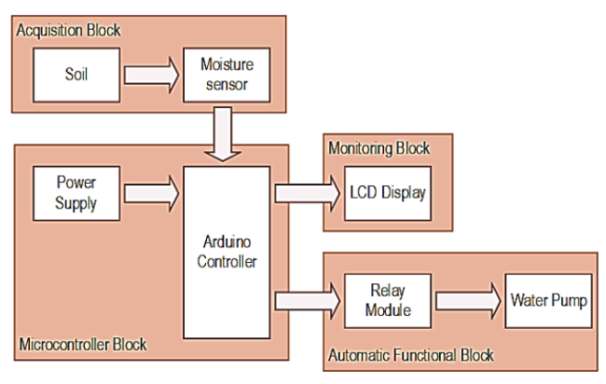

Fig.3.1 Block diagram of Irrigation system

Block diagram of Solar based automatic water irrigation system using arduino, shown in Fig.3.1. The main working principle behind this system is in connecting the soil moisture sensor, which was previously embedded into the plant. Sensor works on principle of capacitance to measure dielectric permittivity of the surrounding medium. The sensor creates a voltage proportional to the dielectric permittivity, and therefore it sense the condition of the soil, whether it is wet or dry.

Moisture sensor sense the moisture level soil is dry or wet to the Arduino, which is also connected to other electronic components listed above as shown in Fig.3.1. Measurement of soil moisture is done by the sensor which forwards the information and parameters regarding the soil moisture to the microcontroller, which controls the pump. If the level of soil moisture drops below a certain value, the microcontroller sends the signal to the relay module which then runs a pump and certain amount of water is delivered to the plant. Once the enough water is delivered then pump stops doing its work, moisture sensor continuously sends the moisture level to microcontroller.

Power supply has a task to power the complete system and the recommended voltage for moisture sensor and LCD display 5V by using 12V rechargeable battery over all should respect the input supply range for the microcontroller as well as motor(DC motor) that is from 6V to 12V for system opration. This battery is charge by using monocrystalline solar panel.

An automatic plant watering system using Arduino Uno microcontroller is programmed such that it gives the interrupt signals to the motor via the motor driver module. Soil sensor is connected to the A0 pin to the Arduino board which senses the moisture content present in the soil. Whenever the soil moisture content values goes down, giving signal to the microcontroller so that the pump (motor) can be activated. This concept can be used for automatic plant watering system. The circuit comprises an Arduino UNO board, soil moisture sensor and 12V motor.

An Arduino in this project is used to control the whole system by observing the sensors. When the sensors sense the soil condition is dry/wet, then the comparator sends the command to the Arduino and also it sends instruction to the relay-driver IC then, it reminds the motor to pump on/off. Here comparator acts as an interface between the sensing arrangement and the  Arduino. The status of the soil moisture and the water pump is displayed on the LCD display which is interfaced to the Arduino.

**3.2 Functional Partition**

For hardware implementation there are mainly four functional blocks as show in Fig.3.1 namely:

1. Microcontroller Block
2. Acquisition Block
3. Automatic functional Block
4. Monitoring Block

Description of each block as follows,

**3.2.1 Microcontroller Block**

In this block, Arduino Uno is the microcontroller which is the core hardware of this project. It receives the input from the soil moisture sensor and processes the input based on the requirement coded in the microcontroller.

**3.2.1.1 Arduino Uno**

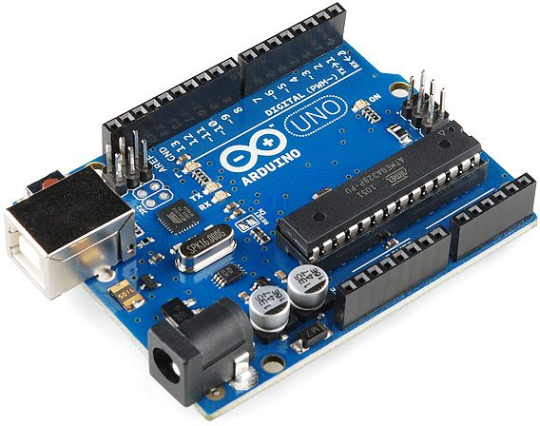

Fig 3.2.1.1 Arduino Uno

Arduino is used for controlling whole the process of this Automatic water irrigation system. The output of soil sensor circuit is directly connected to the analog pin A0 of Arduino. Arduino UNO is the brain of this system and all the sensor and display devices are controlled by it. Arduino is a programmable circuit board which we can write a program based on project. Arduino program will be uploading with IDE (Integrated Development Environment) software that runs on your computer, it is used to write and upload computer code to the Arduino physical board. Arduino language is merely a set of C/C++ functions that can be called from code.

The Uno is a single-board microcontroller and its open-source platform allows user to extend the environment by using [libraries](http://arduino.cc/en/Reference/Libraries) to share user’s developments with the vast, growing  **Arduino** community. Although other [Arduino microcontroller boards](https://www.jameco.com/webapp/wcs/stores/servlet/JamecoSearch?langId=-1&storeId=10001&catalogId=10001&freeText=arduino%20microcontroller%20board&search_type=jamecoall) are available, the Uno continues to be the standard for many projects. Arduino hardware and software are simple for developers of all levels to use, but when started with the Uno, it's helpful to have a pinout diagram for reference.

**3.2.1.2 Power Supply**

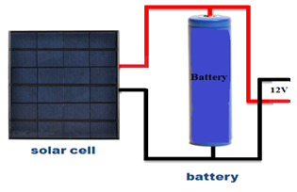

Fig. 3.2.1.2 Power Supply

Solar power is the alteration of energy from sunlight into electricity, either directly by means of photovoltaic’s (PV), or indirectly by means of intense solar power. Solar energy is most abundant source of energy in world. Photovoltaic is an effective approach for using solar energy. Solar powered irrigation system can be appropriate alternative for farmers in present state of energy disaster automatic system using solar power. The main objective of this project is to advance an irrigation system in field of agriculture by using solar energy.

These panels are designed with solar cells composed of [semiconductor material](https://www.elprocus.com/what-are-the-reasons-behind-silicon-uses-in-electronics/)s. The main function of solar panel is to convert solar energy into DC electrical energy generally of 12V, which is further used for the rest of the circuit. The number of cells required and their size depends on the rating of the load. The photo voltaic cells depend on the size of the pump. The collection of solar cells can produce maximum electricity. But, the solar panel must place exactly at right angles to the sun rays.

A [solar charge controller](https://www.elprocus.com/solar-charge-controller-using-mppt-technology/)is very important device in any solar power system. It is used to

maintain proper charging voltages of the batteries. The charge controller controls current and voltage from the solar panel and charges the battery and also stops the charging of the battery from over and undercharging conditions. The battery is an electric device that is used to store current which is produced from the solar panel and supplied to the corresponding loads. The number of batteries required depends on the load requirement.

A rechargeable battery, storage battery, secondary cell or accumulator is a type of electric

battery which can be charged many times, while a non-rechargeable or primary battery is supplied fully charged and discarded once discharged. It is composed of one or more electromechanical cells. The term accumulator is used as it accumulates and stores energy through a reversible electromechanical reaction.

Rechargeable batteries are produced in many different shapes and sizes, ranging from button cell to megawatt system connect to stabilize an electrical distribution network. Several different combinations of electrode materials and electrolytes are used, including lead-acid, nickel cadmium (NiCd) , nickel metal hydride (NiMH), lithium ion(Li-ion), and lithium ion polymer(Li-ion polymer).

**3.2.2 Acquisition Block**

This block consists of one soil moisture sensor which takes the data from the soil. It depends on the moisture level of the soil whether to send high or low voltage to the microcontroller to show that it is wet or dry. When the soil is wet, it will send the low output voltage, whereas when it is dry, it will send the high output voltage. This sensor is directly connected to Arduino microcontroller.

**Moisture sensor**

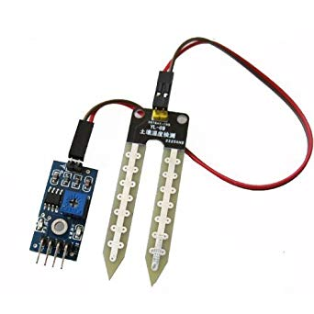

Fig 3.2.2 Moisture sensor

The Moisture sensor is used to measure the water content of soil. It acts as an input in this project. When the soil is having water shortage, the module output is at high level else the output is at low level. This sensor reminds the user to water their plants and also monitors the moisture content of soil. It has been widely used in agriculture, land irrigation and botanical gardening.

A Soil Moisture Sensor has many applications especially in agriculture. Irrigation is a key factor in farming. Detecting the amount of moisture in the soil and managing irrigation systems (turn on the system when the moisture level falls below a certain predefined value) helps to avoid a lot of wastage of water and human resources. These kinds of sensors make automation of farming easier. This is also used in controlled environments where experiments are conducted.

Working principle of moisture sensor is, the soil moisture sensor uses capacitance to measure dielectric permittivity of the surrounding medium. In soil, dielectric permittivity is a function of the water content. The sensor creates a voltage proportional to the dielectric permittivity, and therefore the water content of the soil. The sensor averages the water content over the entire length of the sensor. There is a 2 cm zone of influence with respect to the flat surface of the sensor, but it has little or no sensitivity at the extreme edges. The soil moisture sensor is used to measure the loss of moisture over time due to evaporation and plant uptake, evaluate optimum soil moisture contents for various species of plants, monitor soil moisture content to control irrigation in greenhouses and enhance bottle biology experiments.

**3.2.3 Automatic functional Block**

This block includes the automated watering function of the system. The automated function consists of main controlling hardware, which is relay module and DC watering pump. The relay is an automatic electric switch that uses an electromagnet to move the switch from OFF to ON or vice versa. The switch controls the electric signal that pass through the water pump. When the moisture level is below the threshold level, Arduino sends a signal to the relay module to automatically open the path for the electric to pass through the water pump to water the plant. After the system detects the sufficient level of the water in the soil, the relay will close the path for electric and thus the water pump will be stop immediately pumping the water. Automatic functional block contain two components relay module and water pump (DC Motor).

**3.2.3.1 Relay Module**

DC motor is use to make water pump. DC motor has two leads one is positive and another one is negative. If connect them directly to the Arduino board then it will damage the board. To overcome this problem, relay circuit is design by using NPN transistor. NPN transistor is used to control the switching activity of the motor according to the code.

Relay is electrically operated switch. Many relays use an electromagnetic to mechanical operation a switch, but other operating principles are also used, such as solid-state relay. Relay is used where it is necessary to control a circuit by a separate low-power signal or when several circuits must be controlled by one signal. A type of relay that can handle the high power required to directly control an electric motor or other loads is called a contactor. Solid-state relays control power circuits with no moving parts, instead using a semiconductor device to perform switching.

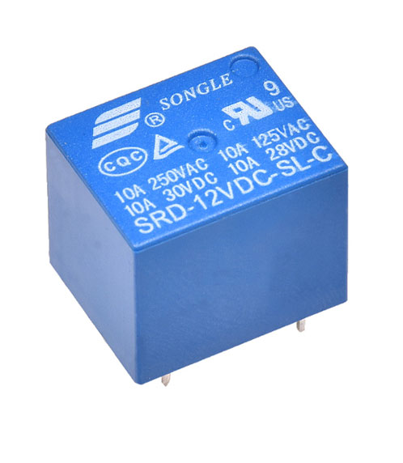

Fig. 3.2.3.1 Relay Module

Below is the circuit of a relay driver using the NPN transistor BC 548. The relay is connected between the positive rail and the collector of the transistor. When the input signal passes through the 1 KΩ resistor to the base of the transistor it conducts and pulls the relay. By adding a 470 µF electrolytic capacitor at the base of the relay driver transistor, a short lag can be induced so that the transistor switches on only if the input signal is persisting. Again, even if the input signal causes, the transistor remains conducting till the capacitor discharges completely. This avoids relay clicking and the offers clean switching of the relay.

**3.2.3.2 Water pump**

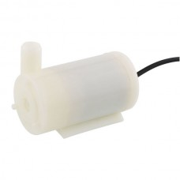

Fig. 3.2.3.2 Water pump

Water pump is controlled by the relay circuit, it cannot connect water pump directly to the Arduino board then it will damage the board. Water pump (DC motor) required 6V to12V for working this supply is provided through battery. Here the Working Principle of DC Motor is A DC motor is an electrical machine which converts electrical energy into mechanical energy. The working of DC motor is based on the principle that when a current carrying conductor is placed in a magnetic field, it experiences a mechanical force.

Moisture sensor sense the moisture level in soil if moisture level is low means soil is dry and plant required water then Arduino send the signal to relay circuit when relay energized water pump start and it provide water to plant after sufficient level of water provided to plant moisture sensor sense the moisture level of soil again Arduino send the signal to relay circuit and relay is de-energies and water pump stop water flow.

A pump is a device that moves liquid (fluids) or sometimes slurries, by mechanical action. Pumps can be classified into three major groups according to the method they use to move fluid: 1. Direct lift pumps,

2. Displacement pumps,

3. Gravity pumps.

Pumps operated by some mechanism (typically reciprocating or rotary), and consume energy to perform mechanical work by moving the fluid. A pump are operated via many energy sources including manual operation, electricity, engines or wind power, comes in many sizes, from microscopic for use in medical applications to large industrial pumps.

* + 1. **Monitoring Block**

This block includes an LCD display, which is used to monitor the level of soil moisture by showing the percentage of the moisture on the screen. When the soil is dry the percentage will be lower and vice versa. In addition, it also shows the pump status which is on or off, in which users will know the current pump status.

**LCD Display**

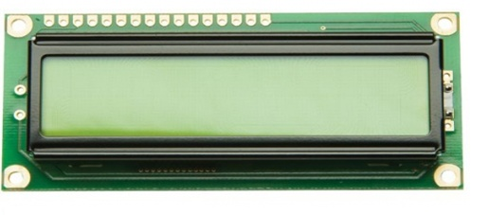

Fig. 3.2.4 LCD Display

An **LCD** is provided to monitor the soil status and status of water supply (water pump). When the system is start LCD display gives the indication as “WELCOME” moisture sensor sense the moisture level which is display on LCD display continuously. It displays two value of moisture, analog value and digital value. Moisture sensor consists of two pins analog pin and digital pin, analog value display on first row of LCD and digital value display on second row of LCD. This system use 16x2 (16 Characters x 2 Lines), Green Backlight, 5x7 Dot Matrix Character + Cursor, 4-bit or 8-bit MPU Interface, Standard Type, Works with almost any Microcontroller, type LCD display.

When the moisture level decreases and soil is dry then motor is on and give the water to the plant and when moisture level increases motor is off this action is controlled by Arduino because moisture sensor and relay is linked with Arduino, same way LCD display linked with the Arduino according to given condition it displays moisture level two values analog value and digital value also it displays motor status by using relay condition. When relay is high then LCD display “MOTOR ON” and when relay is low according to soil moisture level LCD display “MOTOR OFF’.

* 1. **Power Supply Design**

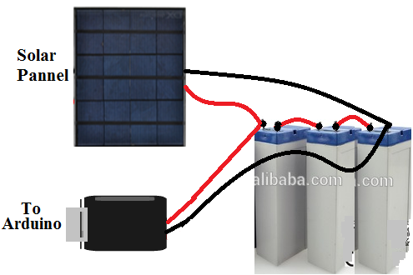

Fig. 3.3 Power supply

**1) Battery selection**

System has two components Arduino Uno & Water pump which directly operated on battery other component Moisture sensor and LCD display connected to arduino.

**Solution:**

**Step 1: Calculate capacity:** If the current drawn is *x* amps, the time is T hours then the capacity C in amp-hours is, C = xT

For water pump is drawing 120 mA and you want it to run for 8hr,                      C1 = 0.22 Amps * 8 hours = 1.76 amp hours

For Arduino uno is drawing 45 mA and you want it to run for 24hr,                      C2 = 0.045 Amps * 24 hours = 1.08 amp hours

Total C = C1 + C2 = 1.76 amp hours + 1.08 amp hours

= 2.84 ≈ 3 amp hours

**Step 2: Voltage requirement:**

* 1. **Arduino uno :** Operating voltage : 7V to 12V
  2. **Water pump :** Operating voltage : 3V to 12V

Hence our system required: 12V, 3AH battery

Therefore we connected three 4V, 1.5AH, batteris in series hence finally our battery specification is,

|  |
| --- |
| **Battery : 12V, 7.5AH** |

**2) Solar Panel selection for charge the battery**

Photovoltaic cell use sun light to generate electricity, the generated power is the product of voltage times the current (i.e., P = V x I). The amount of electrical power generated by an individual photovoltaic cell at its output terminals depends upon the amount of solar radiation that hits its PN junction as well as the percentage of solar radiation it actually converts into electricity, in other words its efficiency. It is known that the optimum operating voltage of a PV cell under load is about 0.46 volts, generating a 3A current in full sunlight. Hence, the power output of typical solar photovoltaic cell is 1.38W. The power generated by a single cell is not enough to do any useful work. In our case, the battery theoretical capacity is,

Watt hour = Ampere hour * Voltage

= 90W

Therefore, generated power is more than our system requirement hence we selected 1 solar panel as per specification for battery charging,

* Maximum Power : 5Wp-0 / +3%
* Open circuit Voltage : 10.5V / 21V
* Short circuit current : 0.61 / 0.31A
* Voltage at maximum power : 8.80 / 18.0V
* Current at maximum power : 0.28 / 0.57A

**3.4 Hardware Specification**

**3.4.1 Arduino Uno**

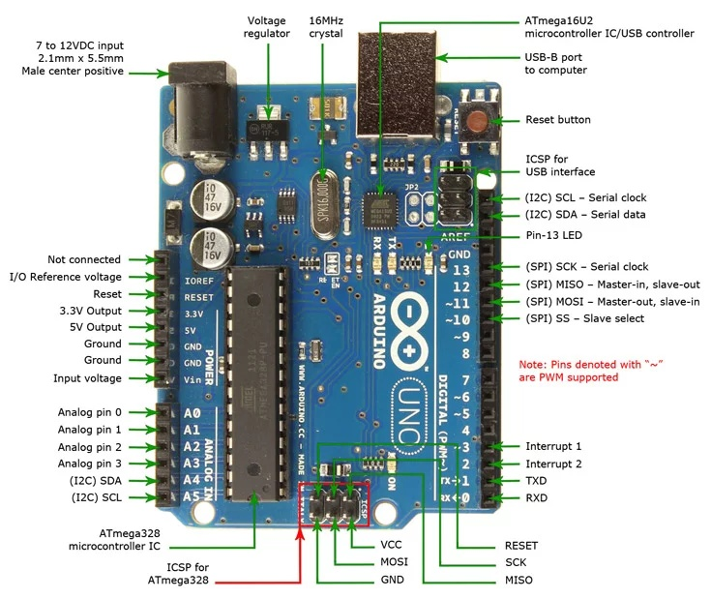

Fig. 3.4.1 Pin out of Arduino Uno

**Pin out**

Arduino Uno is based on AVR microcontroller called Atmega328. This controller comes with 2KB SRAM, 32KB of flash memory and 1KB of EEPROM. Arduino Board comes with 14 digital pins and 6 analog pins. ON-chip ADC is used to sample these pins. A 16 MHz frequency crystal oscillator is equipped on the board.

**Pin description**

There are several I/O digital and analog pins placed on the board which operates at 5V. These pins come with standard operating ratings ranging between 20mA to 40mA. Internal pull-up resistors are used in the board that limits the current exceeding from the given operating conditions. However, too much increase in current makes these resisters useless and damages the device.

|  |  |  |
| --- | --- | --- |
| **Pin Category** | **Pin Name** | **Details** |
| Power | Vin,  5V,  3.3V,  GND | Vin: Input voltage to Arduino when using an external power source.  5V: Regulated power supply used to power microcontroller and other components on the board.  3.3V: 3.3V supply generated by on-board voltage regulator. Maximum current draw is 50mA.  GND: ground pins. |
| Reset | Reset | Resets the microcontroller. |
| Analog Pins | A0 – A5 | Used to provide analog input in the range of 0-5V |
| Input/Output Pins | Digital Pins 0 – 13 | Can be used as input or output pins. |
| Serial | 0(Rx), 1(Tx) | Used to receive and transmit TTL serial data. |
| External Interrupts | 2, 3 | To trigger an interrupt. |
| PWM | 3, 5, 6, 9, 11 | Provides 8-bit PWM output. |
| SPI | 10 (SS), 11 (MOSI), 12 (MISO) and 13 (SCK) | Used for SPI communication. |
| Inbuilt LED | 13 | To turn on the inbuilt LED. |
| TWI | A4 (SDA), A5 (SCA) | Used for TWI communication. |
| AREF | AREF | To provide reference voltage for input voltage. |

Table 2. Pin description of Arduino Uno

* Arduino Uno is a microcontroller board developed by Arduino.cc which is an open-source electronics platform mainly based on AVR microcontroller Atmega328.First Arduino project was started in Interaction Design Institute Ivrea in 2003 by David Cuartielles and Massimo Banzi with the intention of providing a cheap and flexible way to students and professional for controlling a number of devices in the real world.
* The current version of Arduino Uno comes with USB interface, 6 analog input pins, 14 I/O digital ports that are used to connect with external electronic circuits. Out of 14 I/O ports, 6 pins can be used for PWM output.
* It allows the designers to control and sense the external electronic devices in the real world.
* This board comes with all the features required to run the controller and can be directly connected to the computer through USB cable that is used to transfer the code to the controller using IDE (Integrated Development Environment) software, mainly developed to program Arduino. IDE is equally compatible with Windows, MAC or Linux Systems, however, Windows is preferable to use. Programming languages like C and C++ are used in IDE.
* Apart from USB, battery or AC to DC adopter can also be used to power the board.
* Arduino Uno boards are quite similar to other boards in Arduino family in terms of use and functionality; however, Uno boards don’t come with FTDI USB to Serial driver chip.
* There are many versions of Uno boards available; however, Arduino Nano V3 and Arduino Uno are the most official versions that come with Atmega328 8-bit AVR Atmel microcontroller where RAM memory is 32KB.
* When nature and functionality of the task go complex, Mirco SD card can be added in the boards to make them store more information.

**Features**

1. Arduino Uno comes with USB interface i.e. USB port is added on the board to develop serial communication with the computer.
2. [Atmega328](https://www.theengineeringprojects.com/2017/08/introduction-to-atmega328.html) microcontroller is placed on the board that comes with a number of features like timers, counters, interrupts, PWM, CPU, I/O pins and based on a 16MHz clock that helps in producing more frequency and number of instructions per cycle.
3. It is an open source platform where anyone can modify and optimize the board based on the number of instructions and task they want to achieve.
4. This board comes with a built-in regulation feature which keeps the voltage under control when the device is connected to the external device.
5. Reset pin is added in the board that reset the whole board and takes the running program in the initial stage. This pin is useful when board hangs up in the middle of the running program; pushing this pin will clear everything up in the program and starts the program right from the beginning.
6. There are 14 I/O digital and 6 analog pins incorporated in the board that allows the external connection with any circuit with the board. These pins provide the flexibility and ease of use to the external devices that can be connected through these pins. There is no hard and fast interface required connecting devices to the board. Simply plug the external device into the pins of the board that are laid out on the board in the form of the header.
7. The 6 analog pins are marked as A0 to A5 and come with a resolution of 10bits. These pins measure from 0 to 5V, however, they can be configured to the high range using analogReference() function and AREF pin.
8. 13KB of flash memory is used to store the number of instructions in the form of code.
9. Only 5 V is required to turn the board on, which can be achieved directly using USB port or external adopter, however, it can support external power source up to 12 V which can be regulated and limit to 5 V or 3.3 V based on the requirement of the project.

**Communication and programming**

Arduino Uno comes with an ability of interfacing with other other Arduino boards, microcontrollers and computer. The Atmega328 placed on the board provides serial communication using pins like Rx and Tx. The Atmega16U2 incorporated on the board provides a pathway for serial communication using USB com drivers. Serial monitor is provided on the IDE software which is used to send or receive text data from the board. If LEDs placed on the Rx and Tx pins will flash, they indicate the transmission of data. Arduino Uno is programmed using Arduino Software which has cross-platform application called IDE is written in Java. The AVR microcontroller Atmega328 laid out on the base comes with built-in boot loader that sets you free from using a separate burner to upload the program on the board.

**3.4.2 Moisture Sensor**

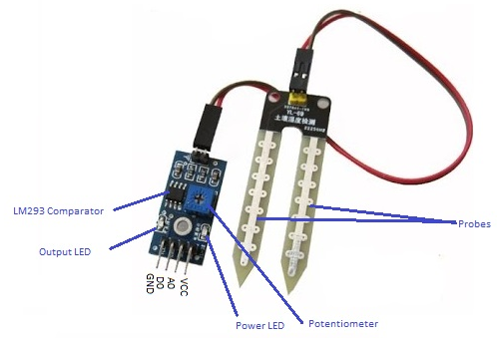

Fig.3.4.2 Pin out of Moisture Sensor

The Moisture sensor is used to measure the water content (moisture) of soil. When the soil is having water shortage, the module output is at high level; else the output is at low level. This sensor reminds the user to water their plants and also monitors the moisture content of soil. It has been widely used in agriculture, land irrigation and botanical gardening.

**Selection of moisture sensor**

|  |  |  |  |
| --- | --- | --- | --- |
| **Parameter** | **Moisture sensor 1** | **Moisture sensor 2** | **Moisture sensor 3** |
| Model | EC-1258 | eHub | Evana |
| Operating voltage | 3.3V to 5V | 3.3V to 5V | 3.3V to 5V |
| Installation | Easy | Easy | Easy |
| Cable length | 21cm | 21cm | 23cm |
| Adjustable sensitivity | ___ | ­­­___ | Blue digital potentiometer |
| Cost | 120 Rs. | 138 Rs. | 100 Rs. |

Table 3. Comparison Chart of Moisture sensors

**Selected component:** Evana

Selected due to low cost, performance is better and more operating parameter as compare with other sensors.

**Specifications**

* Working Voltage: 5V
* Working Current: **<**20mA
* Interface type: Analog and Digital
* Working Temperature: 10°C~30°C

**Working principle**

The Soil Moisture Sensor uses capacitance to measure dielectric permittivity of the surrounding medium. In soil, dielectric permittivity is a function of the water content. The sensor creates a voltage proportional to the dielectric permittivity, and therefore the water content of the soil. The sensor averages the water content over the entire length of the sensor. There is a 2 cm zone of influence with respect to the flat surface of the sensor, but it has little or no sensitivity at the extreme edges. The Soil Moisture Sensor is used to measure the loss of moisture over time due to evaporation and plant uptake, evaluate optimum soil moisture contents for various species of plants, monitor soil moisture content to control irrigation in greenhouses and enhance bottle biology experiments.

**Hardware and Software Required**

* Moisture Sensor Module
* Arduino Uno
* Arduino IDE(1.0.6 Version)

**Hardware connection**

The moisture sensor module should be connected to the as follows:

* Vcc to 5V
* GND to GND
* A0 to Analog 0 of Arduino

**3.4.3 LCD Display**

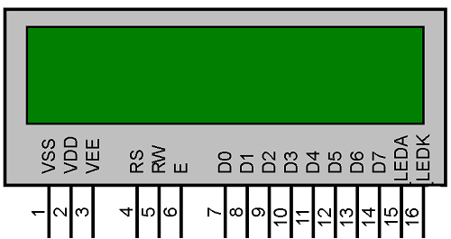

Fig. 3.4.3 Pin out of 16x2 LCD display

LCD (Liquid Crystal Display) screen is an electronic display module and find a wide range of applications. A 16x2 LCD display is very basic module and is very commonly used in various devices and circuits. The reasons being: LCDs are economical; easily programmable; have no limitation of displaying special & even [custom characters](http://www.engineersgarage.com/microcontroller/8051projects/create-custom-characters-LCD-AT89C51) (unlike in seven segments) [animations](http://www.engineersgarage.com/microcontroller/8051projects/display-custom-animations-LCD-AT89C51) and so on.

**Selection of LCD display**

|  |  |  |  |
| --- | --- | --- | --- |
| **Parameter** | **LCD display 1**  **(Robotbanao)** | **LCD display 2**  **(JHD162A)** | **LCD display 3**  **(Silicon Technolabs)** |
| MUP interface | 4 Bit | 4 Bit or 8 Bit | 4 Bit or 8 Bit |
| Backlight | Blue | Yellow | Blue |
| Cost | 135 Rs | 200 Rs | 190 Rs |

Table 4. Comparison Chart of LCD display

**Selected component:** JHD162A

Selected due to performance is better, it is easy for operating and more operating parameter as compare to other displays.

#### Interfacing 16×2 LCD to Arduino uno

LCD modules form a very important part in many arduino based embedded system designs. So the knowledge on interfacing LCD module to arduino is very essential in designing embedded systems. This section of the article is about interfacing an Arduino to 16×2 LCD. JHD162A is the LCD module used here. JHD162A is a 16×2 LCD module based on the **HD44780 driver from Hitachi.** The JHD162A has 16 pins and can be operated in 4-bit mode (using only 4 data lines) or 8-bit mode (using all 8 data lines). Here we are using the LCD module in 4-bit mode.

**Pin description**

|  |  |  |
| --- | --- | --- |
| **Pin No** | **Function** | **Name** |
| 1 | Ground (0V) | Ground |
| 2 | Supply voltage; 5V (4.7V – 5.3V) | Vcc |
| 3 | Contrast adjustment; through a variable resistor | VEE |
| 4 | Selects command register when low; and data register when high | Register Select |
| 5 | Low to write to the register; High to read from the register | Read/write |
| 6 | Sends data to data pins when a high to low pulse is given | Enable |
| 7 | 8-bit data pins | DB0 |
| 8 | DB1 |
| 9 | DB2 |
| 10 | DB3 |
| 11 | DB4 |
| 12 | DB5 |
| 13 | DB6 |
| 14 | DB7 |
| 15 | Backlight VCC (5V) | Led+ |
| 16 | Backlight Ground (0V) | Led- |

Table 5. Pin description of 16x2 LCD display

**Programming**

To facilitate communication between Arduino and LCD, use of a built in library in Arduino **<LiquidCrystal.h>** this library can handle LCD both 4 bit mode and 8 bit mode

* [**LiquidCrystal lcd()**](https://www.arduino.cc/en/Reference/LiquidCrystalConstructor)– is  a constructor used to declare a variable of its type. Here ‘lcd’ is the variable declared using the constructor and is used to invoke methods defined inside library.
* [lcd.begin()](https://www.arduino.cc/en/Reference/LiquidCrystalBegin)– is called to initialize the lcd screen and to pass the dimension of lcd screen (columns, rows) as parameters of the invoked method.

**3.4.4 Water Pump (Motor)**

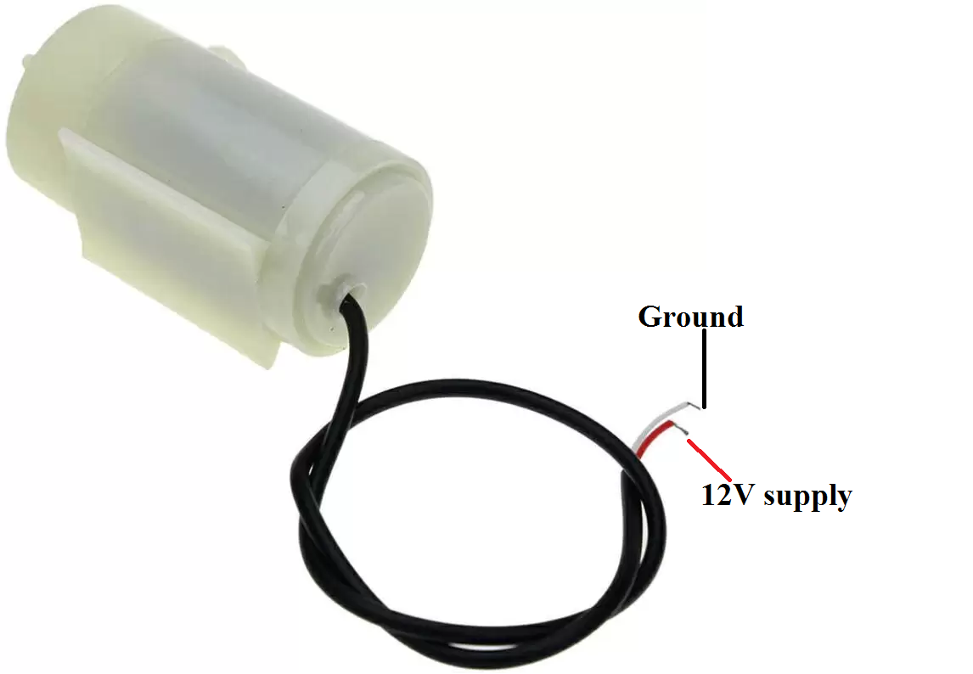

Fig. 3.4.4 Pin out of Water Pump

A DC motor is an electrical machine which **converts electrical energy into mechanical energy**. The working of DC motor is based on the principle that when a current carrying conductor is placed in a magnetic field, it experiences a mechanical force. The direction of the mechanical force is given by **Fleming’s Left-hand Rule, ac**cording to Fleming’s left-hand rule when an electric current passes through a coil in a magnetic field, the magnetic force produces a torque which turns the DC motor. The direction of this force is perpendicular to both the wire and the magnetic field and its magnitude is given by,

**F = BIL** Newton.

There is no basic difference in the [construction of a DC generator and a DC motor](https://studyelectrical.com/2014/06/construction-dc-motor-dc-motor-construction.html). In fact, the same DC machine can be used interchangeably as a generator or as a motor. Like generators. There are [different types of DC motors](https://studyelectrical.com/2014/12/types-of-dc-motors.html) which are also classified as:

* [Shunt-wound](http://www.studyelectrical.com/2013/11/speed-control-of-dc-shunt-motors.html) **dc motor,**
* [Series-wound](http://www.studyelectrical.com/2013/11/speed-control-of-dc-series-motors.html) **dc motor,**
* **Compound-wound dc motor**.

The Motor (Smaller electric water pumps), such as the kinds used in homes and mini project motors usually have small DC motors. The DC motor is contained in a sealed case attached to the impeller and powers it through a simple gear drive. In the center of the motor is a rotor with coils around it. Around those coils are magnets, which create a permanent magnetic field that flows through the rotor. When the motor turns on, electricity runs through the coils, producing a magnetic field that repels the magnets around the rotor, causing the rotor to spin around 180 degrees, when the rotor spins the direction of the electricity in the coils flips, pushing the rotor again and causing it to spin the rest of the way around. Through a series of pushes, the rotor continues to spin, driving the impeller and powering the pump.

In principal, many different types of pumps can be used to pump water. The most common kind, however, is the centrifugal pump. A centrifugal pump is powered by a device called an impeller. The impeller is a bit like a turbine. It has many curved blades, which channel the water through the pump.

## How the Impeller works

## The impeller spins very fast. The curved blades channel water into the eye, or center of the impeller, but that water flows along to the outside of the blades. Because the impeller moves fast, the centrifugal force compresses the water against the outside of the blade. This pressure causes the water to rocket forward in a high-speed jet out of the impeller. This speed creates pressure on the outlet side of the pump, pushing the water through the pipe.

**Selection of Water Pump**

|  |  |  |  |
| --- | --- | --- | --- |
| **Parameter** | **Water Pump 1** | **Water Pump 2** | **Water Pump 3** |
| Model | Robatbanao | Generic AX199 | SEBA mini submersible water pump |
| Operating Voltage | 6V to 12V | 6V to 12V | 6V to 12V |
| Rate of Flow | 80-120 L/Hr | 80-120 L/Hr | 80-120 L/Hr |
| Cost | 240 Rs | 260 Rs | 200 Rs |

Table 6. Comparison Chart of Water Pump

**Selected Component:** SEBA mini submersible water pump due to low cost other all parameters are same for all motors.

**Specification**

* Runs on : DC 3v to 12v,
* High power, Low noise small water pump,
* Power consumption: 0.4W to 1.5W,
* Flow rate: 80 - 120 L or h,
* Maximum Lift: 40cm
  + 1. **Relay**

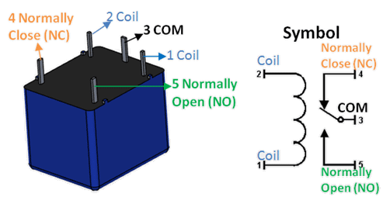

Fig. 3.4.5 Pin out of Relay

Relays are most commonly used switching device in electronics. There are two important parameters of relay, first is the trigger voltage, this is the voltage required to turn on the relay that is to change the contact from Common → NC to Common → NO. The other parameter is load voltage & current, this is the amount of voltage or current that the NC, NO or Common terminal of the relay could withstand, in our case for DC it is maximum of 30V and 10A. Make sure the load you are using falls into this range.

**Pin description**

|  |  |  |
| --- | --- | --- |
| **Pin Number** | **Pin Name** | **Description** |
| 1 | Coil End 1 | Used to trigger(On/Off) the Relay, Normally one end is connected to 12V and the other end to ground |
| 2 | Coil End 2 | Used to trigger(On/Off) the Relay, Normally one end is connected to 12V and the other end to ground |
| 3 | Common (COM) | Common is connected to one End of the Load that is to be controlled |
| 4 | Normally Close (NC) | The other end of the load is either connected to NO or NC. If connected to NC the load remains connected before trigger |
| 5 | Normally Open (NO) | The other end of the load is either connected to NO or NC. If connected to NO the load remains disconnected before trigger |

Table 7. Pin description of Relay

* 1. **Circuit Diagram**

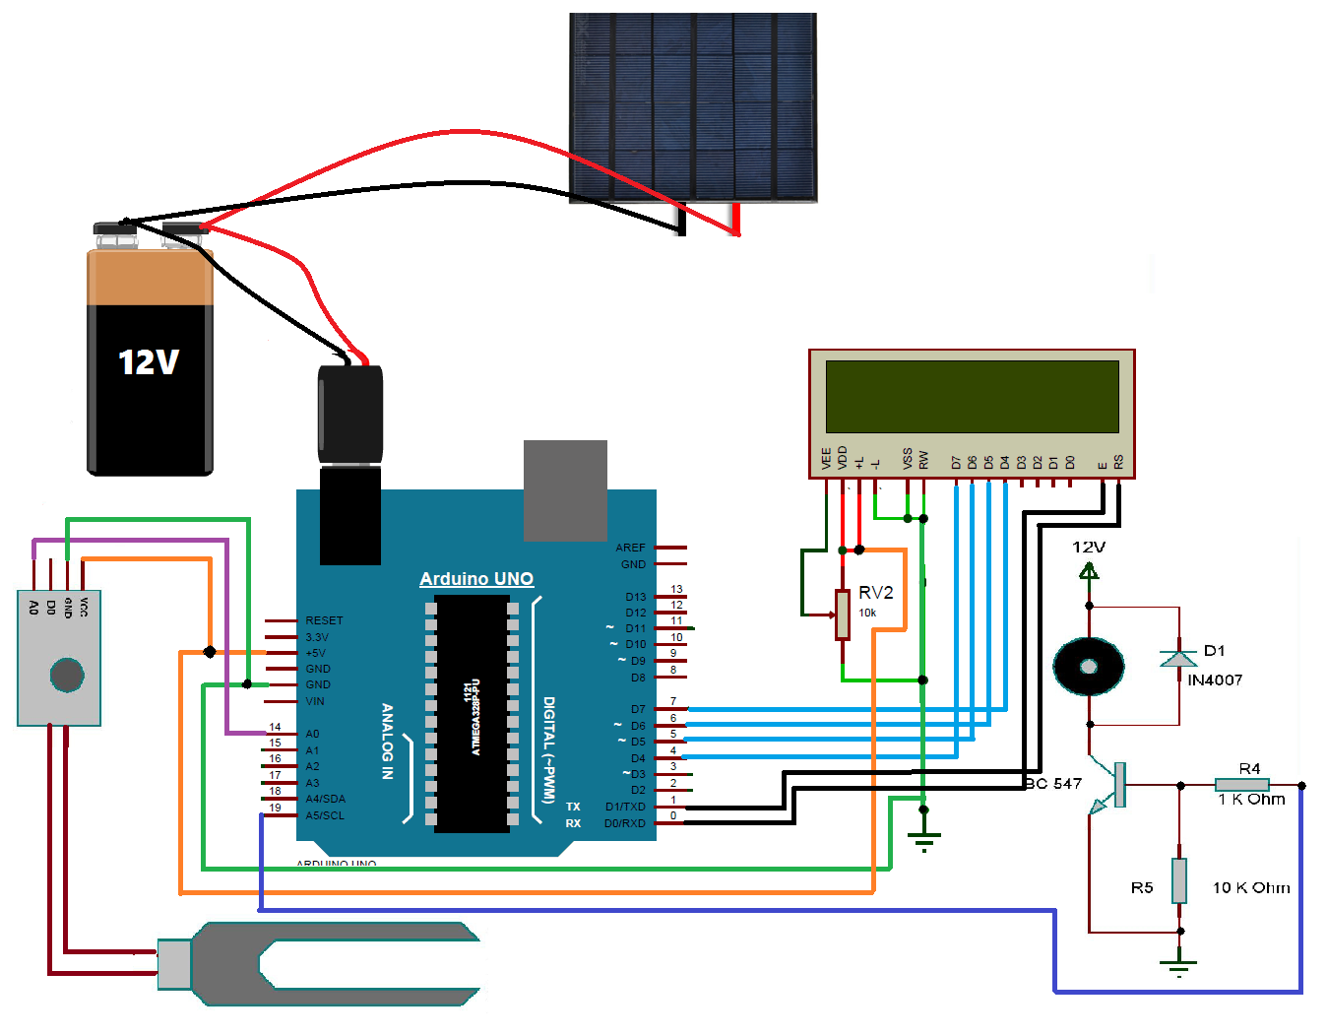

Fig.3.5 Circuit Diagram

**CHAPTER NO.4**

**PCB MANUFACTURING**

**4.1 PCB manufacturing process**

A PCB is used to connect electronic components electrically. This is done by making conductive path ways for circuit connections by etching tracks from copper sheet laminated onto a non-conductive substrate. A PCB consists of a conducting layer that is made up of thin copper foil. The insulating layer dielectric is laminated together with epoxy resin prepreg. The most commonly used PCB type is the FR-4. Boards may be single sided or double sided. Double sided PCB can be used to connect electronic components on both sides through through-hole plating. This is done by copper plating the walls of each hole so as to connect the conductive layers of the PCB.

**Advantages of PCB over Bread-board**

1. Get a much higher density board with PCB.
2. PCB design to be more reliable than the one made on a bread board. The circuit will look neat without any wires popped up and will not fall apart.
3. Very precise control over the circuit component and comfortably fit in odd shaped components that are difficult to fix on a bread board.
4. For production of large volume of circuit boards, the costs become less and the soldering can be done by fully automated machines.

**PCB fabrication steps**

Once decided which electronic circuit is to be made on a PCB, to make the design for the board on PC. There are different PCB designing softwares like CAD, EAGLE. The next step is to print out the layout using a laser printer. Take special care in the type of paper that use for printing. Though a little expensive, photo basic gloss transparent papers are known to be the most suitable for the process.

Make sure that all components fit on to the print. First take copy of the print on ordinary paper and lay down all the IC’s and other components. The size of the layout must also fit the size of the PCB. Try to get the highest resolution when printing design on the paper. Always use black ink to take the layout. Increase the contrast and make the print more dark and thick. Do not take the print as soon as it comes out. Wait for some time for the ink to dry out.

Cut the layout by leaving a generous amount of blank space. Place the paper layout on the PCB and apply some heat by pressing an iron box on top of the paper on to the printed circuit board. Apply pressure for some time and keep the PCB intact for a few minutes. Now the layout is attached to both the board and the paper. Rid of the paper gets permanently attached to the board. The only way to do this is to soak it in water. After two minutes, peel off the first layer of paper. After two to three hours of soaking, take it out and rub it with your finger to remove all the paper bits off.

**PCB Etching Process**

All PCB’s are made by bonding a layer of copper over the entire substrate, sometimes on both sides. Etching process has to be done to remove unnecessary copper after applying a temporary mask, leaving only the desired copper traces. Though there are many methods available for etching, the most common method used by electronics hobbyists is etching using ferric chloride hydrochloric acid. Both are abundant and cheap. Dip the PCB inside the solution and keep it moving inside. Take it out at times and stop the process as soon as the copper layer has gone. After etching, rub the PCB with a little acetone to remove the black colour, thus giving the PCB a shining attractive look. The PCB layout is now complete.

**PCB Drilling**

The components that have to be attached to the multi-layered PCB can be done only by VIAS drilling. That is, a pated-through hole is drilled in the shape of annular rings. Small drill bits that are made out of tungsten carbide is used for the drilling. A Dremel drill press is normally used to punch the holes. Usually, a 0.035 inch drill bit is used. For high volume production automated drilling machines are used. Sometimes, very small holes may have to be drilled, and mechanical methods may permanently damage the PCB. In such cases, laser drilled VIAS may be used to produce an interior surface finish inside the holes.

**Conductor Plating**

The outer layer of the PCB contains copper connections (the part where the components are placed) which do not allow solderability of the components. To make it solderable, the surface of the material has to be plated with gold, tin, or nickel.

**Solder Resist**

The other areas which are not to be solderable are covered with a solder resist material. It is basically a polymer coating that prevents the solder from bringing traces and possibly creating shortcuts to nearby component leads.

**PCB Testing**

In industrial applications, PCB’s are tested by different methods such as Bed of Nails test, Rigid Needle adaptor, CT scanning test so on. The basic of all tests include a computer program which will instruct the electrical test unit to apply a small voltage to each contact point, and verify that a certain voltage appears at the appropriate contact points.

**PCB Assembling**

PCB assembling includes the assembling of the electronic components on to the respective holes in the PCB. This can be done by through-hole construction or surface-mount construction. In the former method, the component leads are inserted into the holes drilled in the PCB. In the latter method, a pad having the legs similar to the PCB design is inserted and the IC’s are placed or fixed on top of them. The common aspect in both the methods is that the component leads are electrically and mechanically fixed to the board with a molten metal solder.

**4.1 PCB Layout**

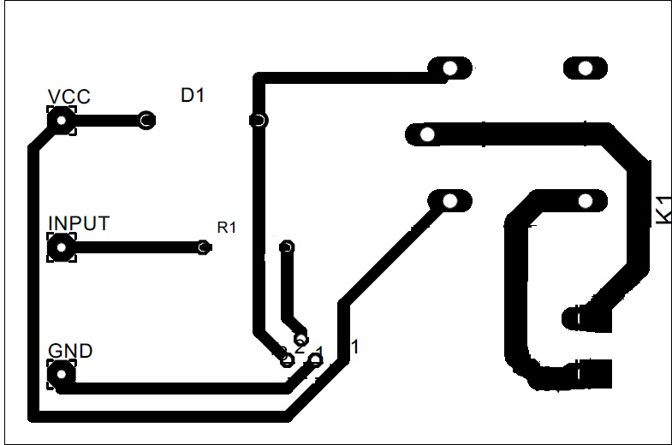

Fig. 4.1 PCB Layout

**4.2 Working of model**

Soil moisture sensor is used to measure the moisture content present in the soil. Moisture sensor senses the two values analog value and digital value. When the soil moisture value read by the sensor is above the threshold value, low level (0V) will be the digital output and if it is below the threshold level, high level (5V) will be the digital output. The digital and analog pin are used to directly read current soil moisture value to see if it is above threshold or not. The threshold voltage can be regulated with help of potentiometer. A DC motor is an electrical machine which converts electrical energy into mechanical energy. Moisture sensor sense the moisture level in soil if moisture level is low means soil is dry and plant required water then Arduino send the signal to relay circuit when relay energized water pump start and it provide water to plant after sufficient level of water provided to plant moisture sensor sense the moisture level of soil, again Arduino send the signal to relay circuit and relay is de-energies and water pump stop water flow.

When the moisture level decreases and soil is dry then motor is on and give the water to the plant and when moisture level increases motor is off this action is controlled by Arduino because Arduino is the brain of the system, moisture sensor and relay are linked with Arduino, LCD display linked with the Arduino according to given condition it displays moisture level two values analog value and digital value also it displays motor status by using relay condition. When relay is high then LCD display “MOTOR ON” and when relay is low according to soil moisture level LCD display “MOTOR OFF’.

**4.3Model Photograph**

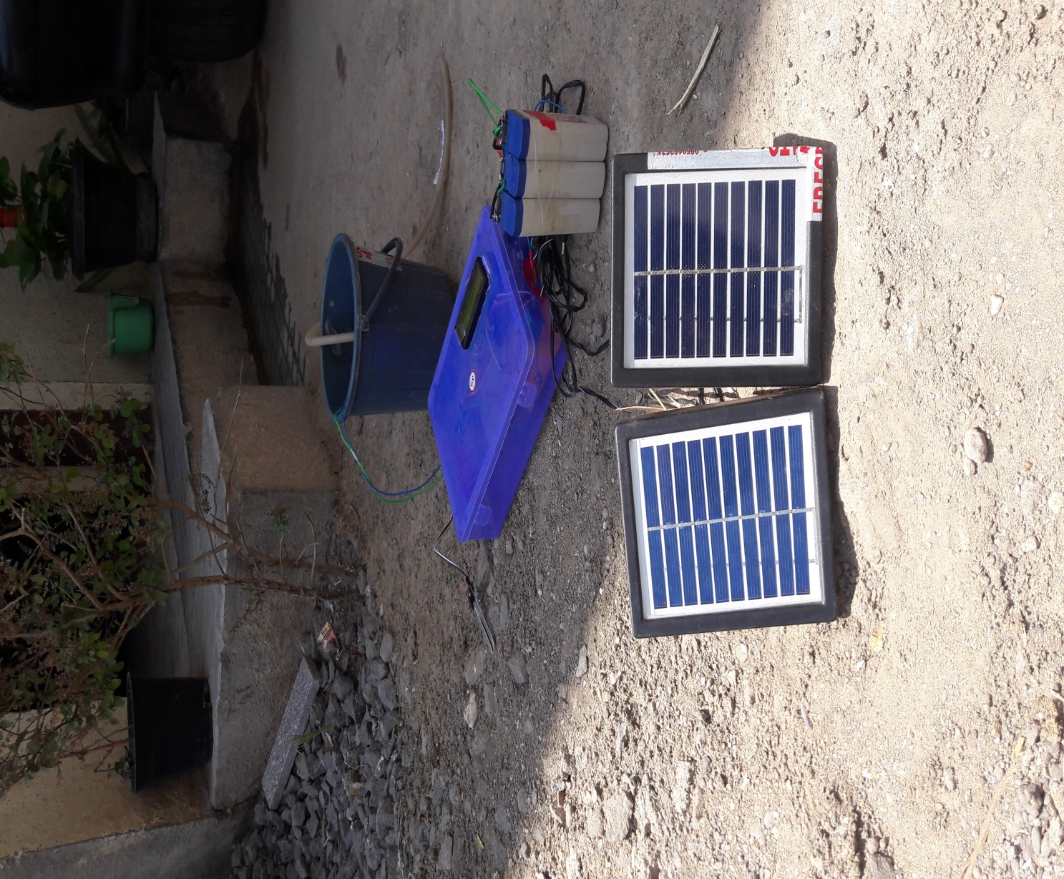

**CHAPTER 5**

**SOFTWARE DESIGN**

**5.1 Steps to How to Debug Arduino Project**

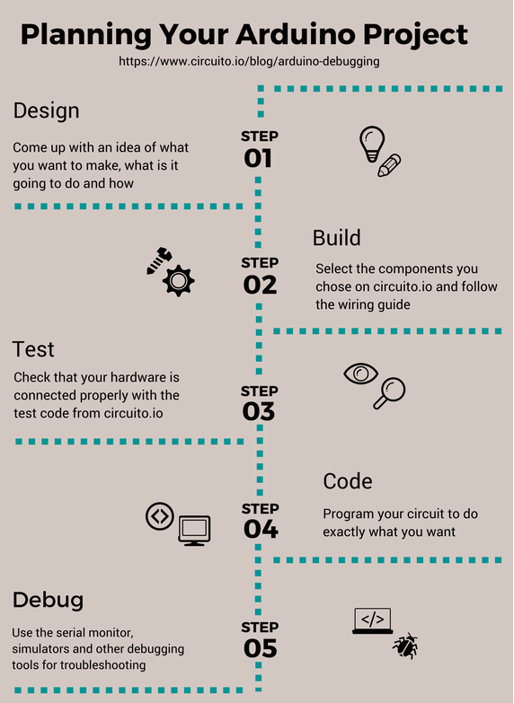

Fig. 5.1 Planning of Arduino based Project

[**Start Circuit**](https://www.circuito.io/)

Most programs will use a debugger to help the programmer locate bugs and address them. Yet Arduino has no such debugging system. Arduino Debugging is one of the more challenging tasks of managing an Arduino project. Unlike most other IDEs, there is no official Arduino debugging feature onboard the Arduino IDE. Many users are surprised at the absence of a dedicated Arduino debugging tool.

On Arduino, once run developed program users unable to see what’s happening inside device and how the code is running. The only assistance given comes in the form of messages on serial monitor or by LED display. Especially when other IDEs usually have debugging tools that utilize breakpoints, steps, call stack, watch, local/global variables and other components to double check through code.

However, debugging Arduino code isn’t the same as debugging code on a PC. The main reason for this is that Arduino code is usually used to control physical outputs or receiving physicals inputs to/from the real world and the debugging process has to take those into account. In practice, this means that Arduino developers often have to explore alternative methods and tools to debug their code.

**Design**

When creating an Arduino project overall design is very important, from the moment start [choosing components for project](https://www.circuito.io/blog/arduino-parts/), need to have a clear idea of at the end product in mind. For example, To design a sketch that runs on an Arduino board and lights up LEDs, it need to provide the foundations within the design phase of project. The overall design of sketches and circuits will determine how finished project looks.

**Build**

In terms of building project, this is where actually give life to circuit. The build process is the Arduino IDE compiles with C++ sketch into machine code which is then uploaded straight to Arduino board Circuito.io**code.** The code get from Circuito.io is actually a test code without any logic. This test code is used to check that all components are wired properly and function correctly. This helps to check that there are no faults with hardware setup. Circuito.io also provides with code libraries for all the different components choose. If test code fails, then need to start the debugging process.

**Step 1: Check the hardware**

As mentioned above, if circuito.io code doesn’t work, chances have a problem with system hardware this means it has needed to begin hardware debugging. Here are some basic troubleshooting steps for hardware issues:

1. **Check wiring -**One of the first things to check that connected everything correctly. If the jumper wires in the wrong pin of the Arduino or the wrong placement on the breadboard program will not be able to interact with the component. Double check all the components and wires to make sure everything is securely in place. If a complex circuit sometimes it’s just better to start from scratch, testing each component at a time to eliminate the problem.
2. **Check Soldering -**If some parts required soldering during setup, make sure that soldered them properly. Poorly soldered parts are one of the most common causes of technical failure.
3. **Check Power Supply -** If there’s still a problem with circuit, need to check the [power supply](https://www.circuito.io/blog/arduino-power-supply/) using a multimeter.

**Step 2: Code debugging**

Arduino code has number of basic rules and best practices should follow by following instructions to debug:

* Write code in small parts and test each of them.
* Provide meaningful names for variables and functions
* Use functions
* Use constants rather than numbers
* Write comments to explain coding choices for future reference
* Make sure code has a proper format and remains readable at all times use Alt-t to auto-indent the whole sketch.

**Compilation >>**

If get compilation error when trying to compile or upload code to board check for errors in syntax typos and more. Using the correct syntax is vital for making sure code compiles. When compilation fails, the IDE will present with the errors on its bottom part. However, the error messages generated by the Arduino IDE limited in their description and therefore not always very helpful.

If understand what the error message means, try fixing the problem it indicates compiles again. This is a convenient form of Arduino troubleshooting. However, if address an error listed on the IDE and the sketch still doesn’t compile, it’s good idea to use Google to search for solutions to the problem. Arduino has a large open source community with extensive troubleshooting guides, which will help to identify problems with in code then click run.

**Run code**

If code compiles and uploaded successfully to the board but doesn’t run as expected need to begin debugging.

**Serial Monitor**

Define which parameters to print and use the serial monitor on screen. The aim is to print an overview of the current state of the program as such variables:

Inputs – sensor readings, prints that indicate the programs flow, like inside an ‘if’ statement to see whether the condition was met

Outputs – e.g. PWM values before writing them to the pin

**Check Code Manually**

One good way to assess the quality of code and check for errors is by going through code manually. In this state, it’s easy to lose connection to the initial idea, go over code and add comments (as much as needed) to explain.

**Step 3: Using external software Debugging tools**

If check code manually and still can’t find the problem, it’s time to use an advanced debugging tool. Whereas many IDE’s have their own onboard debugging tool, Arduino doesn’t. However, there are a number of external tools use to make sure code is running correctly.

**Step 4: Using Arduino simulators and emulators**

More tools use for monitoring and debugging are Arduino emulators and simulators. Arduino simulators have made it easier than ever before for experts and hobbyists like to program and test their ideas until they run efficiently. Hardware simulation is a complex process and while in the industry there are amazing tools for hardware debugging these tools are quite limited for makers and hobbyists.

However, simulators and emulators still have a place among the Arduino user’s debugging tool kit. Arduino simulators support line-to-line debugging which allows the user to look through their code and establish where they went wrong. Here are just a few advantages of using simulators:

1. **Debugging:** As mentioned above, simulators are great for debugging Arduino both in terms of syntax and functional errors. Simulators makes suitable for debugging that can write code and create electronic circuits to test the integrity of code. Some simulators will offer a limited library of hardware to test whereas others will allow developing complex virtual environments.

One of the biggest advantages provided by simulators is transparency. This allows users to run new code without worrying about damaging board or equipment. Compared to IDE and hardware setups, simulators allow users to correct functional programming errors. Without a simulator, only address non-functional, technical mistakes in code such as syntax errors. This makes simulators ideal for newer users who will need to undergo a lot of trial and error before they reach the finished product. Testing code via a simulator ensures that hardware stays operational, saving time and money.

1. **Plotting and logging:** Simulators not only allow testing code runs, but allow to log and plot the data generated as well. Take note of programming data and plot it on an external program like Excel. Logging data on program and additional devices helps to develop insights that can help refine coding.
2. **Experimentation:** In terms of experimentation, simulators and emulators are hard to beat a well. Without a simulator, the user is confined to creating code based on their theoretical knowledge and has limited opportunities to try out new code and new components (especially when mistakes result in damaged hardware). With a simulator, can test the code in a virtual environment and try out new ideas without worrying about the end result.
3. **Testing new components:** Likewise, simulators offer a way to test out components before pull the trigger and make a purchase. This way can see if a part will be of use to project, and practice integrating it into overall environment. This ensures that don’t waste money on buying parts that are of little to no use.
4. **Create blueprints for electronic circuits: when** constructing an electronic circuit simulator use to design, build and preview schematics. This cuts out much of the legwork of needing to manually draw up blueprints for electronic circuits saving time. In addition, it also ensures that the end [circuit design](https://www.circuito.io/blog/circuit-design/) is adequately optimized.

**Electronics Lab on Tinkercad (formerly circuits.io):** The [Circuits.io](http://circuits.io/) platform makes easy for users to simulate real-world electronics through a circuit simulator. This online simulator allows the user to drag in an Arduino board and start programming. It also offers the user a circuit diagram maker, multimeter measurement tool and oscilloscope. This Arduino simulator allows you to build design from scratch whilst enabling to take precise measurements of the power supply throughout your circuit.

**Virtual Breadboard:** [Virtual Breadboard](http://www.virtualbreadboard.com/) has established a name for itself as one of the most powerful and advanced Arduino simulators available today. Virtual Breadboard has grown within the electronic circuit industry and today can simulate Arduino devices, Netduino and PIC microcontrollers. On start up the user has access to a complete virtual development environment where they can program directly to an Arduino board. It’s also worth noting that it can act as an AVR emulator as well.

**5.2 Flowchart**

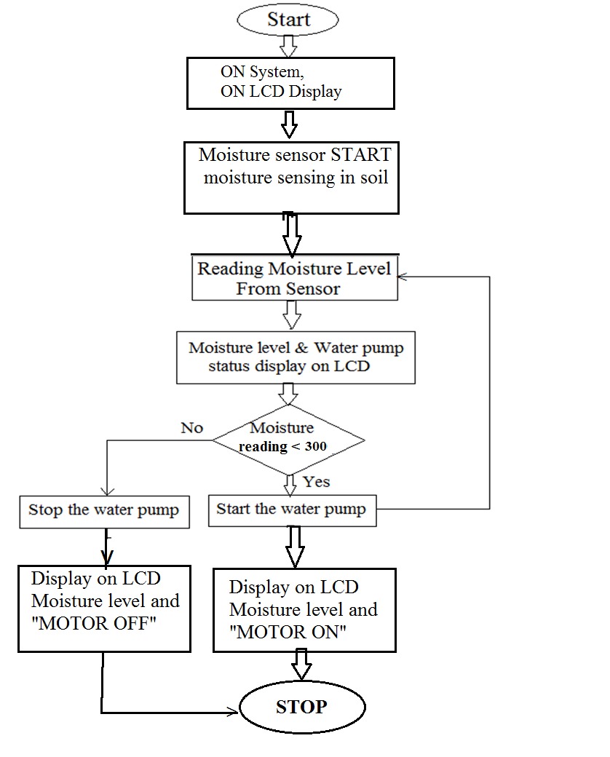

Fig. 5.2 Flowchart

**5.3 Program**

#include <LiquidCrystal.h>

// initialize the library with the numbers of the interface pins

LiquidCrystal lcd(0, 1, 8, 9, 10, 11);

/// REGISTER SELECT PIN,ENABLE PIN,D4 PIN,D5 PIN, D6 PIN, D7 PIN

int Digi_Moist = 2;

int Digi_MOTOR = 5;

//////////////////////////////////////////////////////////////////////////////////////////////////////////////////////////////////////////////

void setup()

{

pinMode(Digi_Moist, INPUT);

pinMode(Digi_MOTOR, OUTPUT);

//Serial.begin(9600);

//Serial.print("Welcome");

// set up the LCD's number of columns and rows:

lcd.begin(16, 2);

}

void loop()

{

// set the cursor to column 0, line 1

lcd.clear();

lcd.print(" MAHASHAKTI ");

//print name

lcd.setCursor(0, 1);

// set the cursor to column 0, line 2

lcd.print("JAY Hind");

//print name

delay(2000); //delay of 0.75sec

//lcd.scrollDisplayLeft();

//shifting data on LCD

lcd.setCursor(0, 0);

// set the cursor to column 0, line1

while(1)

{

int const Sens_min = 300;

lcd.clear();

int buttonState = digitalRead(Digi_Moist);

lcd.print("DIG_Sense:");

//Serial.println(buttonState);

lcd.print(buttonState);

lcd.setCursor(0, 1);

lcd.print("Moisture:");

int sensorValue = analogRead(A0);

// print out the value you read:

lcd.print(sensorValue);

delay(750);//delay of 0.75sec

if(sensorValue == Sens_min)

{

digitalWrite(LED_BUILTIN, HIGH);

}

}

}

**CHAPTER 6**

**CONCLUSION**

**6.1 Advantages**

1. Using the automated irrigation system optimizes the uses of water by reducing wastage of water.
2. The proposed controller eliminates the manual switching mechanism used by the farmers.
3. It is fast response also user friendly and contributes to the socio-economic development of the nation.
4. It is convenient to all climatic conditions and all sorts of irrigation.
5. Improved and better crop production.
6. By using solar energy reduces electricity bills.
7. This project can be implement so that it minimizing the manpower, saving the time and also reducing the cost as well as complexities.
   1. **Conclusion**

An automatic irrigation system is one of the best devices that can help to detect, measure, and control the amount of water in the soil accurately because it uses sensors that can detect the plant’s water needs and satisfy them. The project is basically to control the amount of water that is supplied to the plants and to ensure each plant has enough water and to protect plants from dying by using a moisture sensor. The device will work as a control system and sense plant is dry or how much of water is needed. Its purpose is to save the huge amount of water that goes to waste and to save money. Its goal to protect plants from dying due to many reasons such as: dryness, excessive water and high temperature.

By using solar energy save money, increase self-reliance and reduce pollution. The project is accessible, its energy renewable and sustainable, inexpensive and portable, and its components are simple and small.

**6.3 Future Scope**

1. GSM can add for sending SMS to the concerned person in case of any problem.
2. Pesticides & fertilizers can also be added automatically in water.
3. This Smart system can be further enhanced by using a web scraper which will help the smart system to work according to the weather forecast, if heavy rain is forecasted then less water is supplied to the plants.
4. In future, we can also add quality sensors for the farming product like vegetables and fruits. This quality sensor will contain biosensors for measuring pH level of every vegetable or fruit.
5. In irrigation system, we can add relay circuit and give the sprinkler water supply to the farming field.
6. Combined with the principle of rainwater harvesting, it could lead to great water savings if applied in the right way.
7. By developing an intelligent wireless sensor and using techniques coming from a farmer can increase your profit by solving various problems faced by farmers in their routine life. And also to involve Arduino Regulator with a video capture using a material management structure on the crop location and at the same time sending video to the farmer.
8. We can use the concept of solar tracking to make our solar panel, a solar tracker which will track sunlight and increase efficiency of system by giving more output.

**6.4 Applications**

1. Cultivation purpose.
2. Agricultural fields, lawns and drip irrigation system.
3. To provide water in nursery planting area.
4. Pond water management and water transfer.
5. This irrigation system is very efficient for Paddy, rice fields.
6. It is effective for Pisciculture also.

**References**

1. H. Kenneth, Solomon, “Irrigation Systems”, Chapter 4, Published in “Management of Drip/Trickle or Microirregation”, CRC Press, Taylor & Francis Group, Page 72.
2. S. Reshma and B.A. Sarath Manohar Babu, “Internet of Things (IOT) based Automated Irrigation System Using Wireless Sensor Network”, International Journal & Magazine of Engineering, Technology, Management and Research, ISSN No. 2348-4845, Vol. No. 3 (2016), Issue NO.9 (September), Pages 562-566.
3. G.L. Barbosa, F. D. A. Gadelha, N. Kublik, R. U. Halden, “Comparison of Land, Water, and Energy Requirements of Lettuce Grown Using Bydroponic vs. Conventional Agricultural Methods”, International Journal of Environmental Research and Public Health, ISSN 1660- 4601, 2015, 12, pages 6879-6891.
4. Killebrew,, K.; Wolff, H. Environmental Impacts of Agricultural Technologies,. Evans school of Public Affairs. University of Washington.
5. Gregory E. Welbaum, “Vegetable Production and Practices, Google books, [www.cabi.org](http://www.cabi.org), Chapter 5, Irrigation of vegetable crops. Page. 66
6. Marlon Henkel, “21st Century Homestead: Sustainable Agricultural III: Agricultural Practices”, http://books.google.co.in/books?isbn:1312939753, Pg. 87
7. A. Binsal, “New Abu Dhabi irrigation system saves 46% water”, 2014, Available: <http://gulfnews.com/news/uae/environment/new-abudhabi-irrigation-system-saves-46-water->1.1338984.[Accessed: 19-Sep-17][8] Y. Kim, R. Evans, W. Iversen, “Remote sensing and control of an irrigation system using a Distributed wirless sensor network”, IEEE transactions on instrumentation and measurement,Vol. 57, 2008.
8. Tameem Ahmad, Shamim Ahmad ,Mohammed Jamshed , “A knowledge based Indian Agriculture: With Cloud ERP Arrangement” 2015 IEEE
9. S.Sumeetha, D.Sharmila, “Embedded based Remote Control Application using Mobile Phone in Irrigation”, International Journal of Power Control Signal and Computation (IJPCSC), Vol3. No1. Jan-Mar 2012 ISSN: 0976-268X
10. Santoshkumar, Udaykumar R.Y,“Development of WSN System for Precision Agriculture”,EEE Sponsored 2nd International Conference on Innovations in Information Embedded and Communication Systems ICIIECS’15 , 2016 IEEE
11. Jayavardhana Gubbi, Rajkumar Buyya,Slaven Marusic,Marimuthu palaniswami, Internet ofThings(January2013):A Vision,architectural elements and future directions ,The University of Melbourne,Vic-3010,Australia
12. Aurelice B. Oliveira, Carlos F. H. Moura, The impact of organic farming on quality of tomatoes is associated to increase oxidative stress during fruit development (2013)
13. Proceedings of the 2nd International Conference on Inventive Communication and Computational Technologies (ICICCT 2018) IEEE Xplore Compliant - Part Number:CFP18BAC-ART; ISBN:978-1-5386-1974-2 IoT based low cost smart irrigation system Kiranmai Pernapati.
14. D. K. Sreekantha; Kavya A. M.,”Agricultural crop monitoring using IOT - a study”,2017 11th International Conference on Intelligent Systems and Control (ISCO),Pages: 134 – 139,Feb.2017
15. S,muthunpandian, S.Vigneshwaran , R.C Ranjitsabarinath ,Y.Manoj kumar reddy “IOT Based Crop-Field Monitoring And Irrigation Automation” Vol. 4, Special Issue 19, April 2017
16. Joaquín Gutiérrez, Juan Francisco Villa-Medina, Alejandra Nieto-Garibay, and Miguel Ángel Porta-Gándara” Automated Irrigation System Using a Wireless Sensor Network and GPRS Module” IEEE Transactions On Instrumentation And Measurement,Vol 17,2017
17. Jayavardhana Gubbi, Rajkumar Buyya, Slaven Marusic, Marimuthu Palaniswami, “Internet of Things (IoT): A vision, architectural elements, and future directions”, Future Generation Computer Systems, vol 29, ELSEVIER 2013, 1645–1660.
18. A.R. Sepaskhah, S.H. Ahmadi, “A review on partial root zone drying irrigation. International Journal of Plant Production”,October 2010.
19. https://www.arduino.cc/en/Guide/Introduction,[Accessed: 1-Jan-18]