**Signin:**

While sign to the page, user receiving an error message:

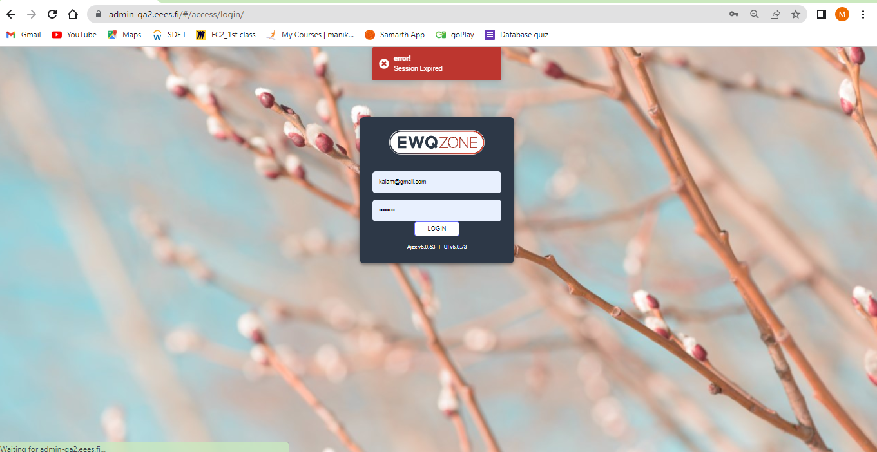

**Logout:**

Logout button is not working

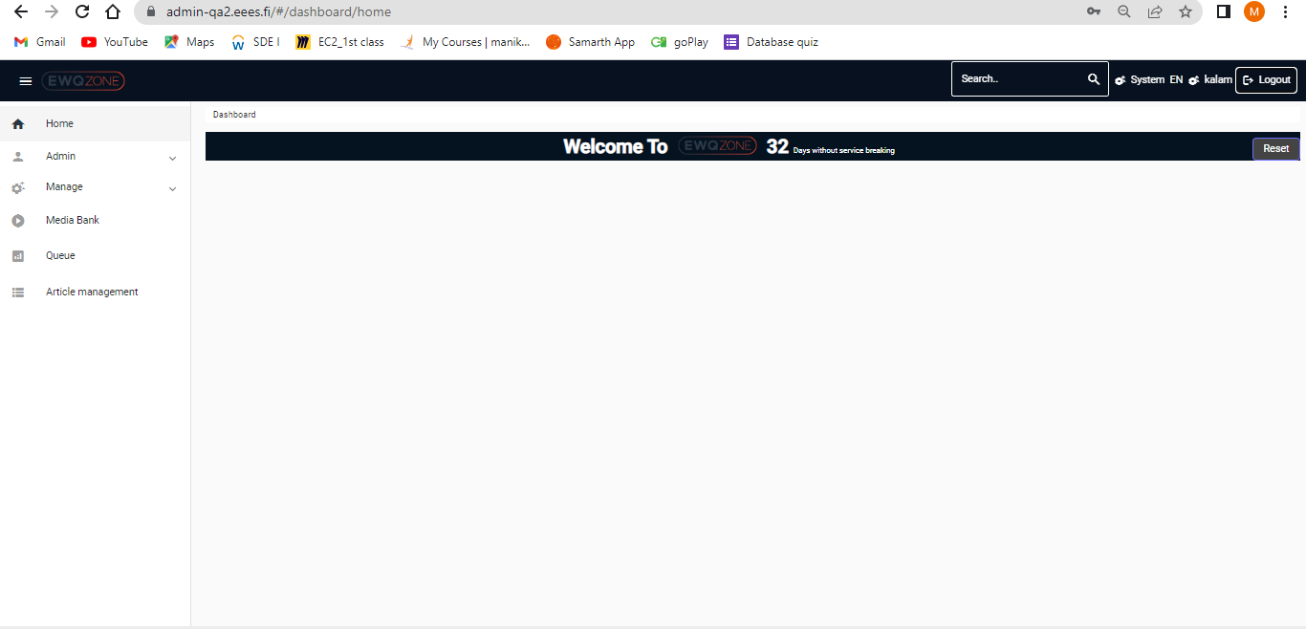

**Account page:**

Un proffer symbol in in Account page

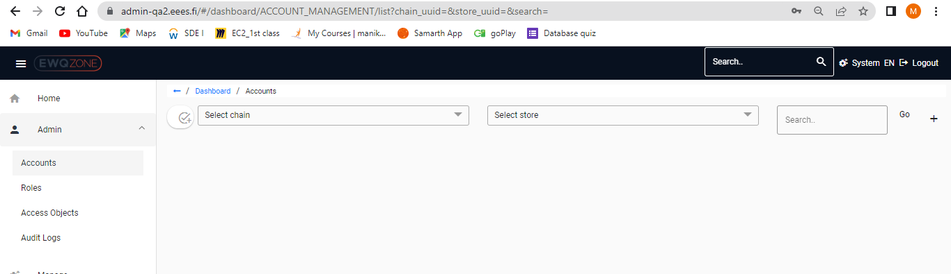

Privileges page is Not proffer in Admin -Role Page

1.Scroll Bar Missing

2.Page Needs to be Proffer alignment

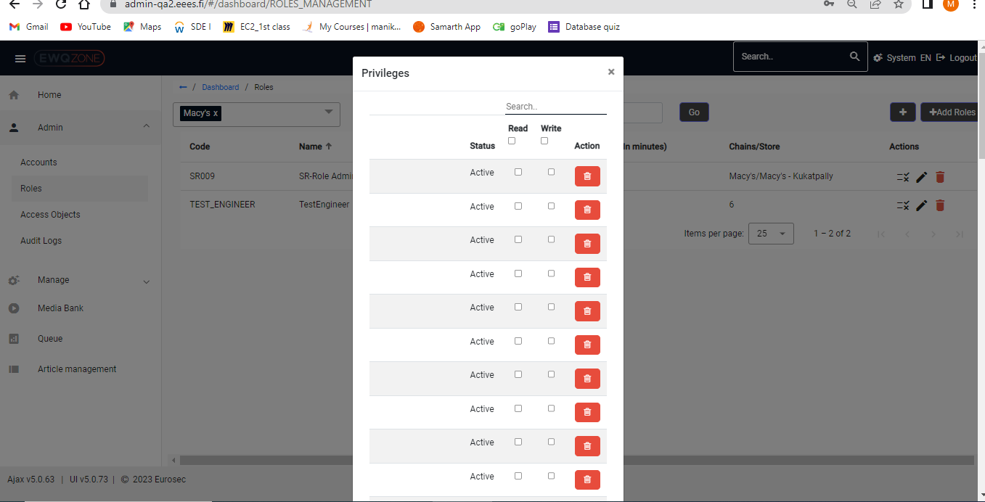

In Privileges page not able to delete and not able to add Privileges pages.

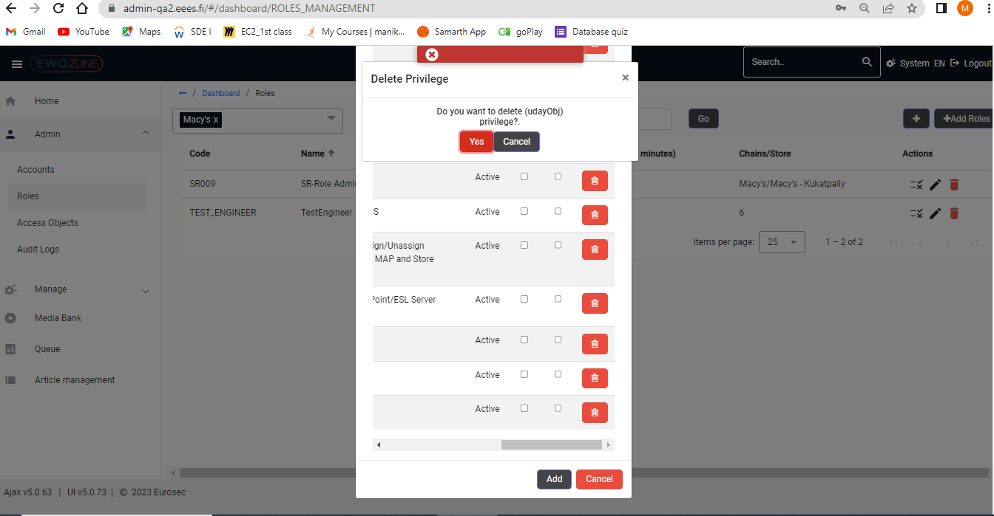

In Admin Roles page dual symbol or add roles:

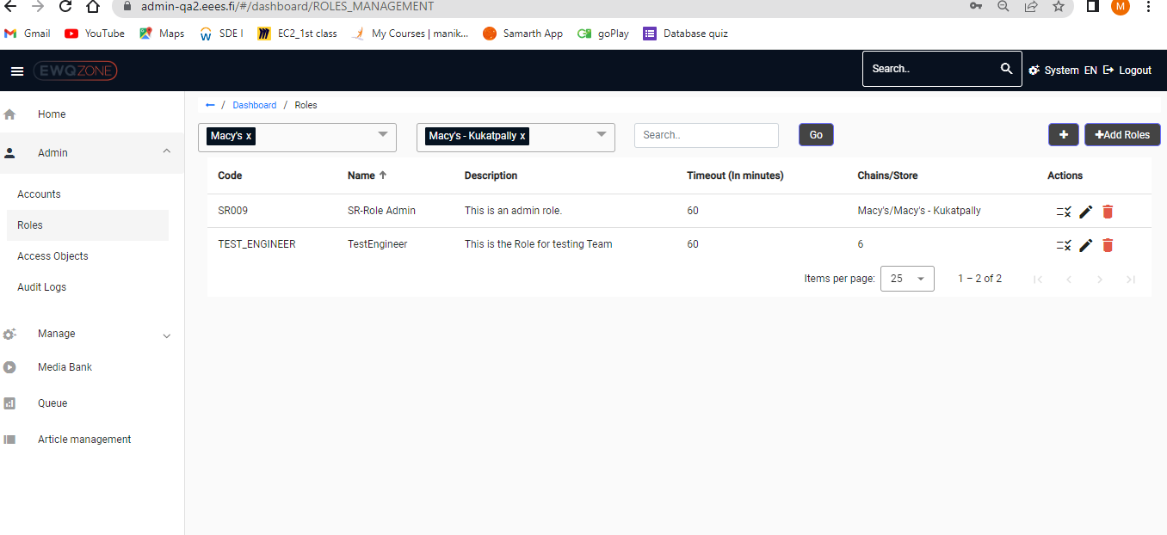

Without selecting chain auto detecting of Previous store:

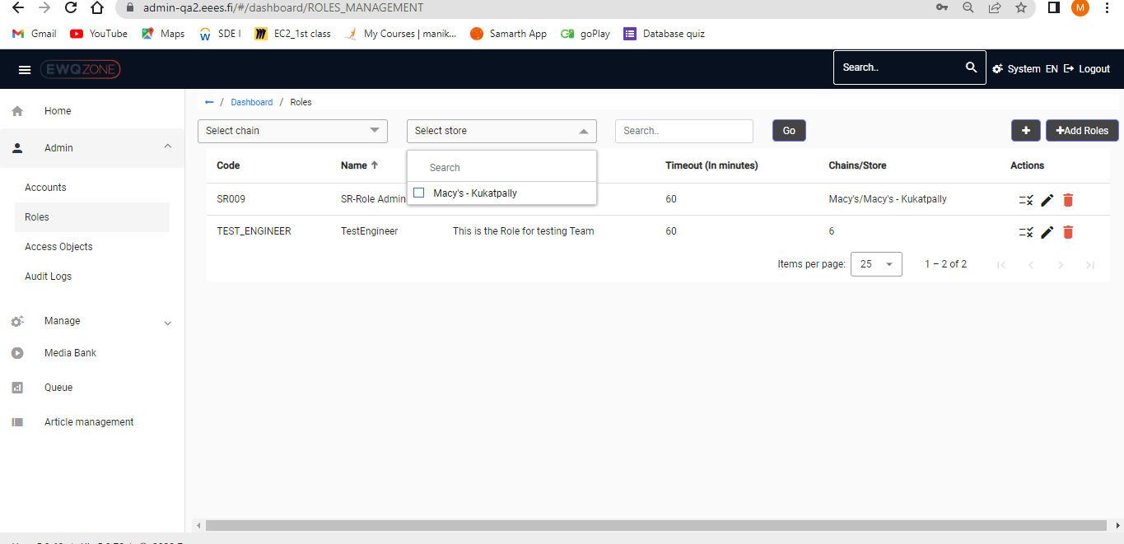

**Access Objects:**

Search Functionality is not Proffer and Not working as well.

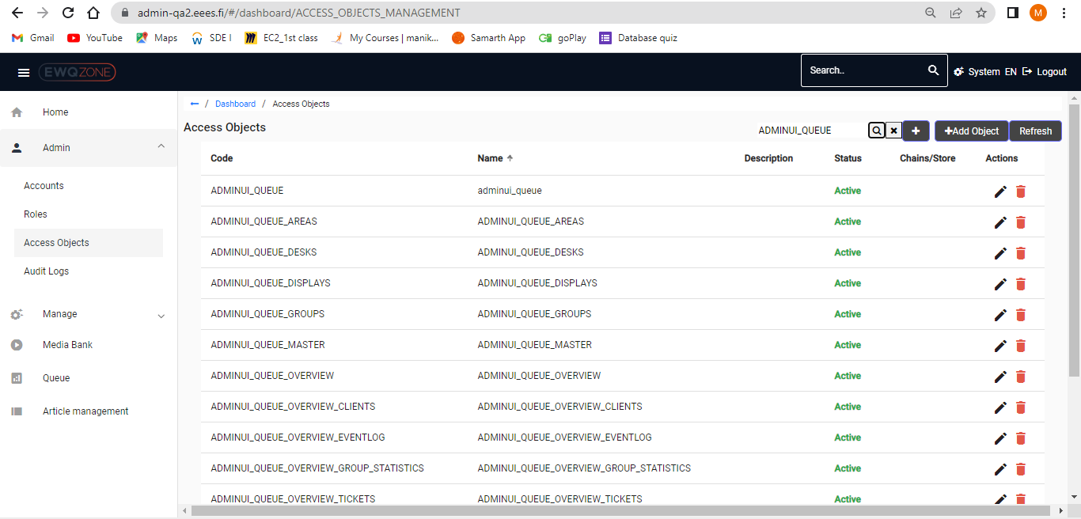

Pages are Irresponsive and Not proffer, if user changes items for page in Access objects:

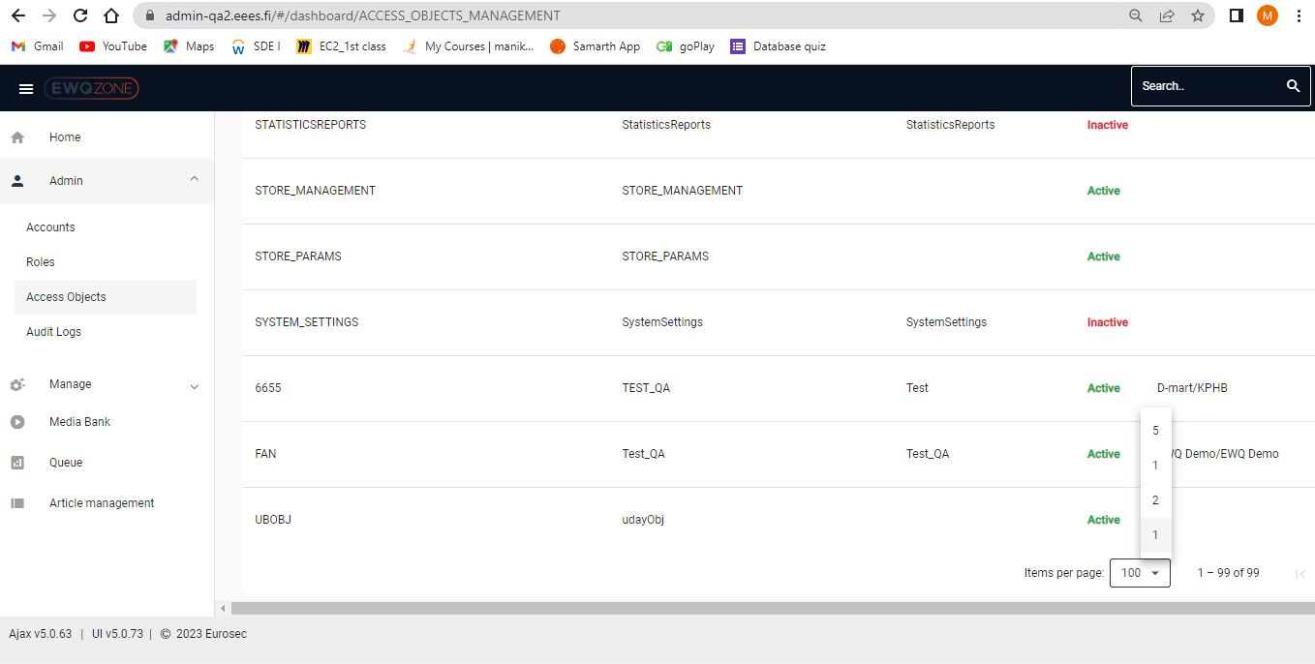

Headers should be fixed in Access objects page if user scrolls to down.

Headers should be fix in Audit Logs page if user scrolls down to page

**Organization:**

Header is Missing in Organization page: **Dashboard/Manage/Organization**

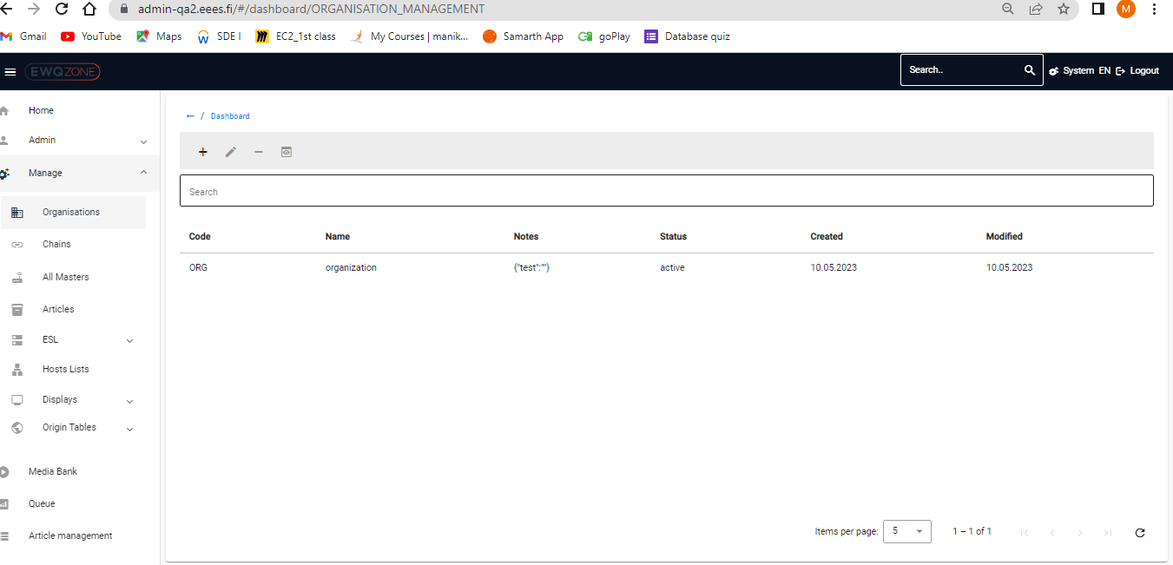

**Chains:**

**Dashboard/Manage/chains is missing in Chains page**

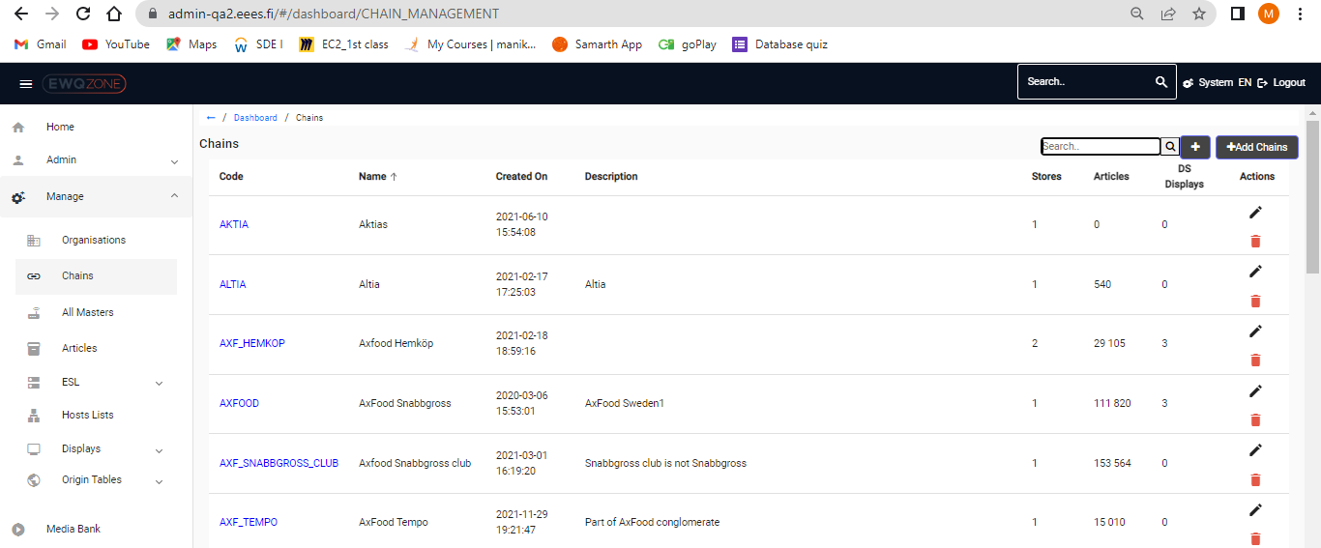

Chains page is too irresponsive, page is also not proffer.

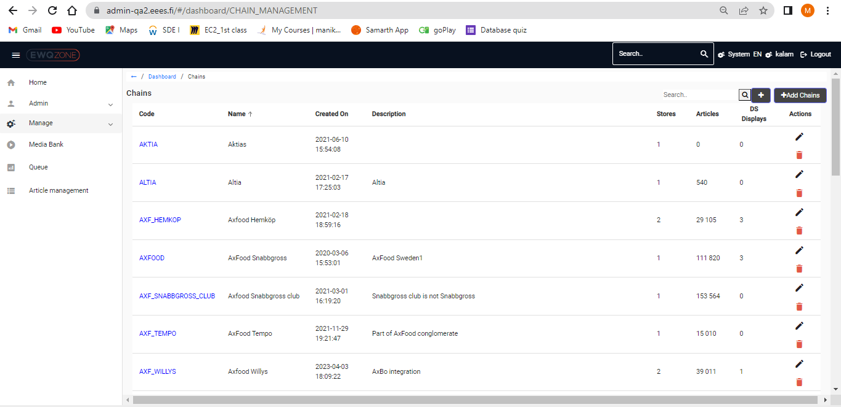

**All Masters:**

Missing header Dashboard/Manage/All Masters

Invalid error message user click on any UUID in the page, page is continuously loading

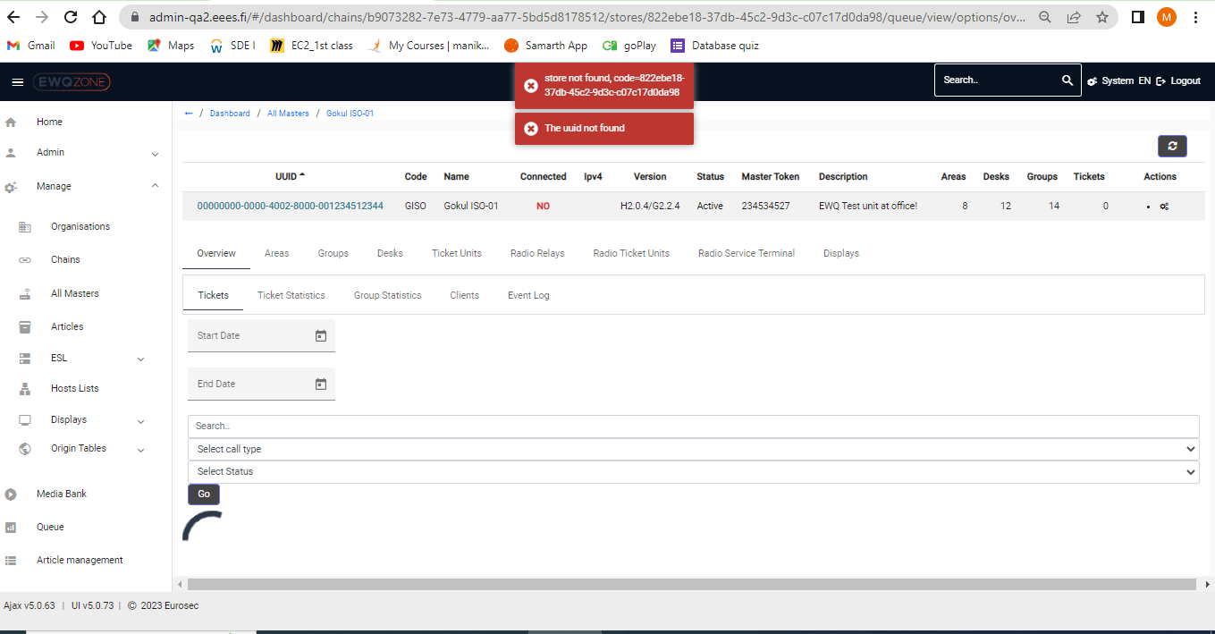

**Articles:**

In proffer directory:

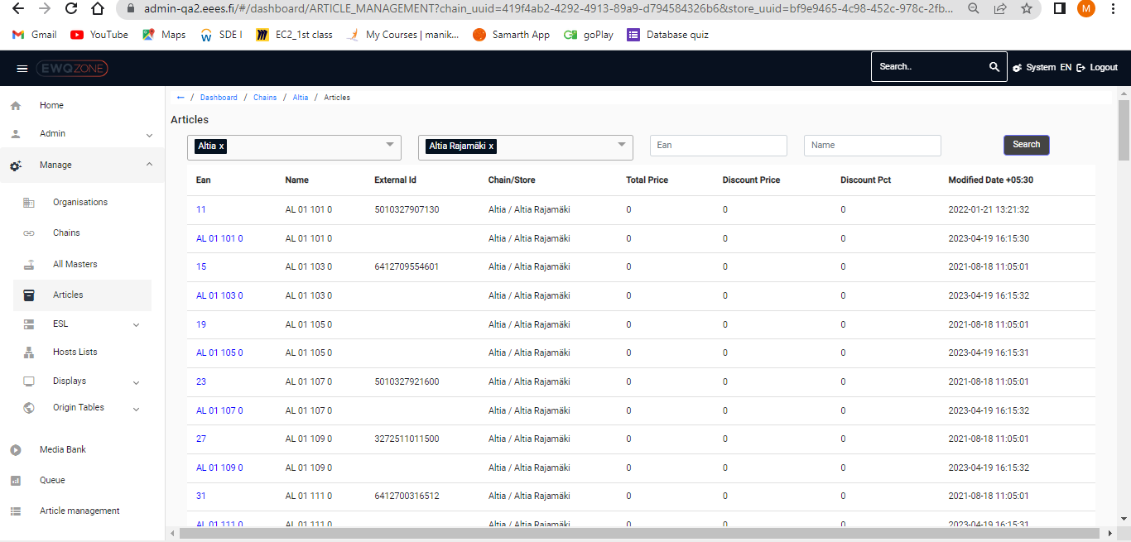

If user click on back button, user directly re directing to chains page from articles page

**Host List:**

Host List page is very irresponsive in newtab and takes time for loading

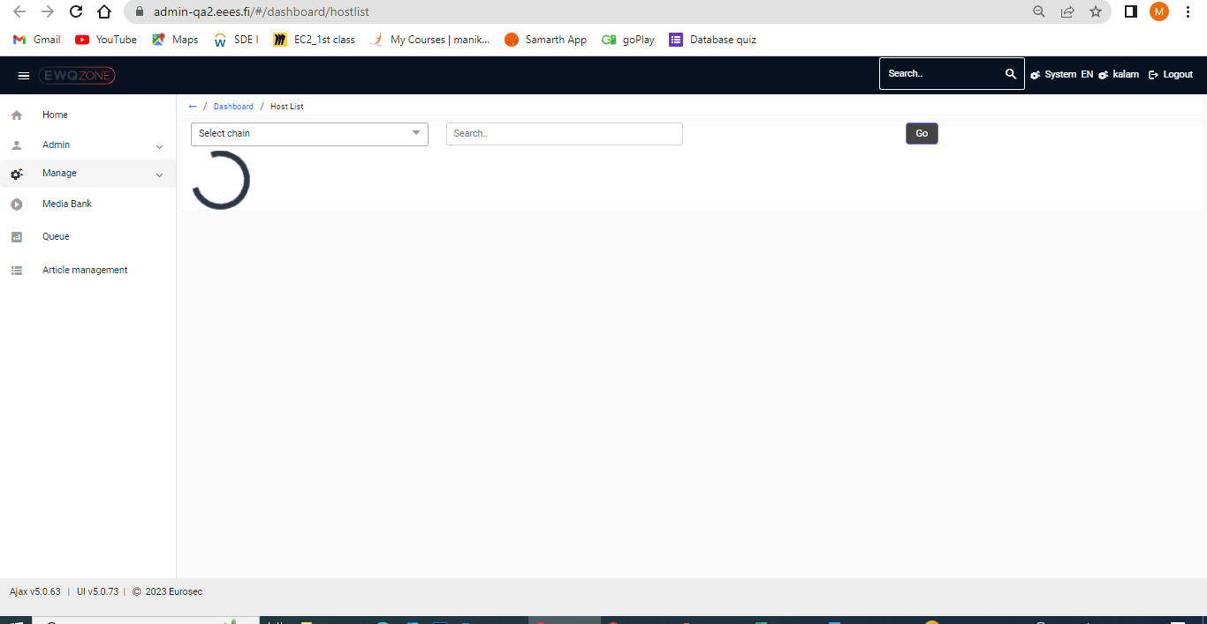

Update and Delete Buttons are not working properly

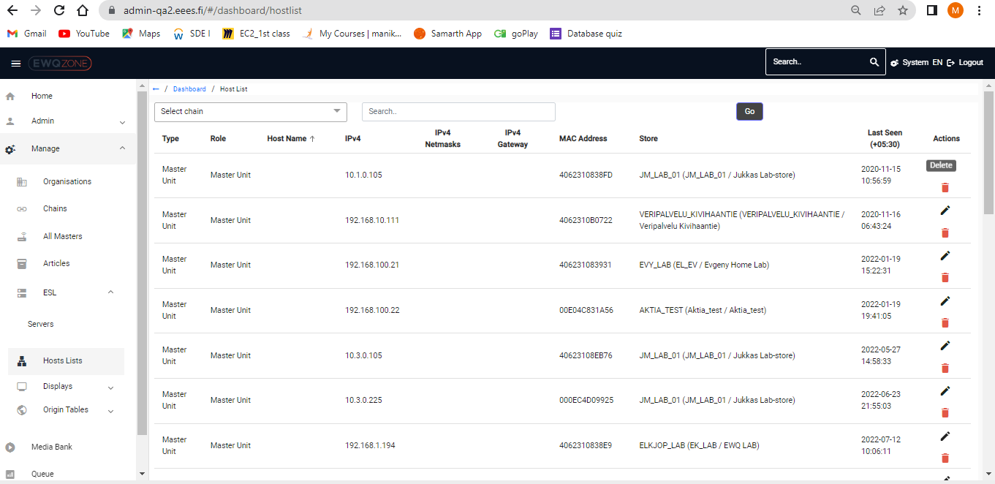

**Displays:**

Two extra options for Add new Symbol

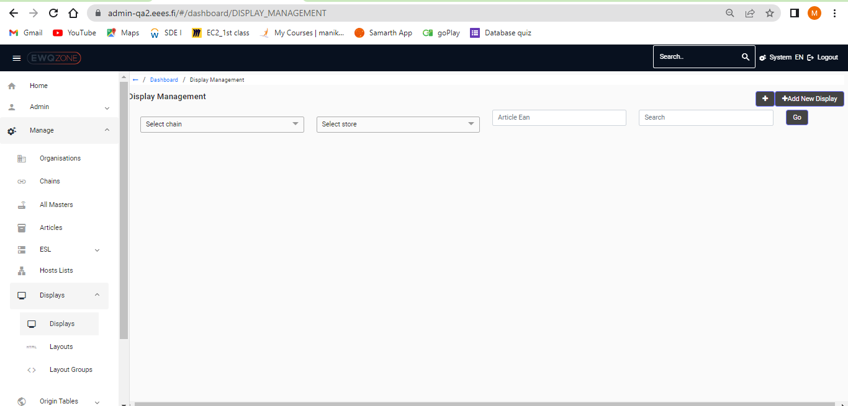

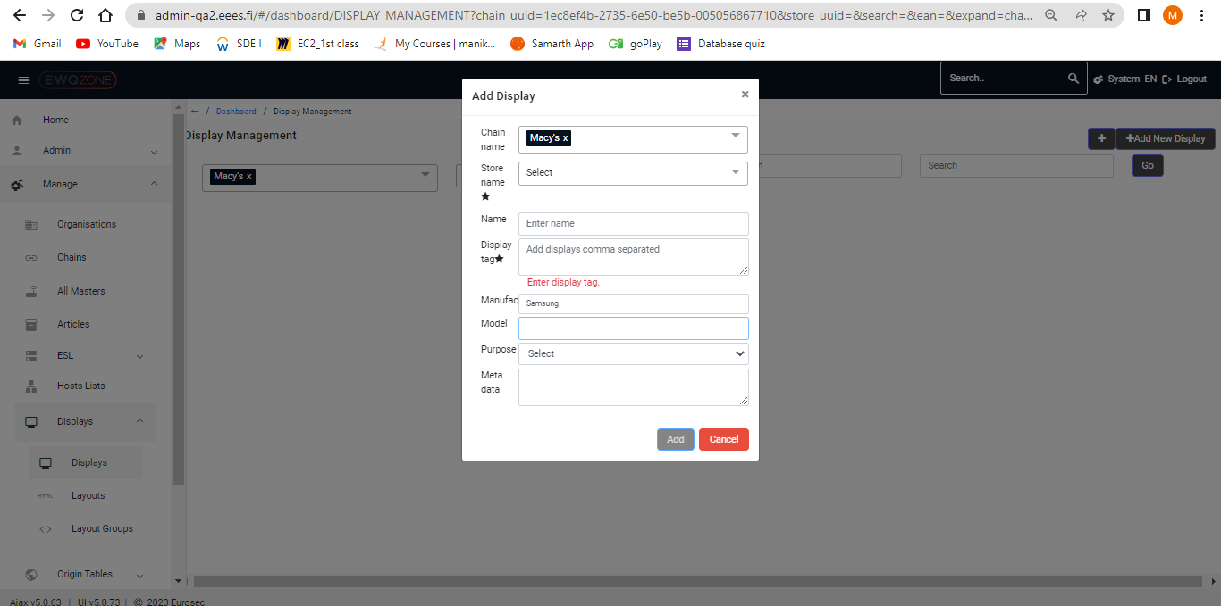

**Layout:**

In proffer alignment of Page

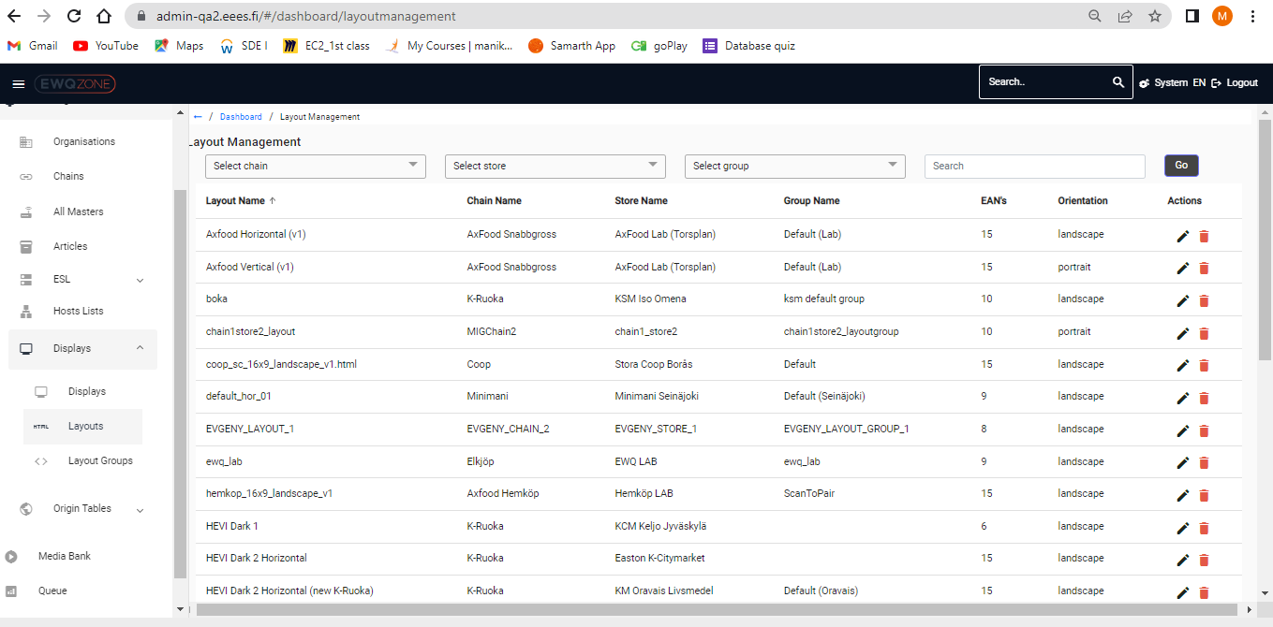

**Layout Groups:**

Layout groups page is not proffer

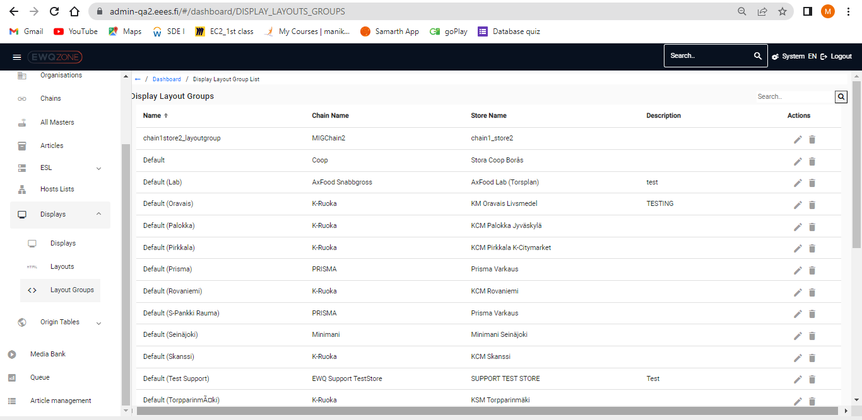

User not able to update or delete in display layout groups

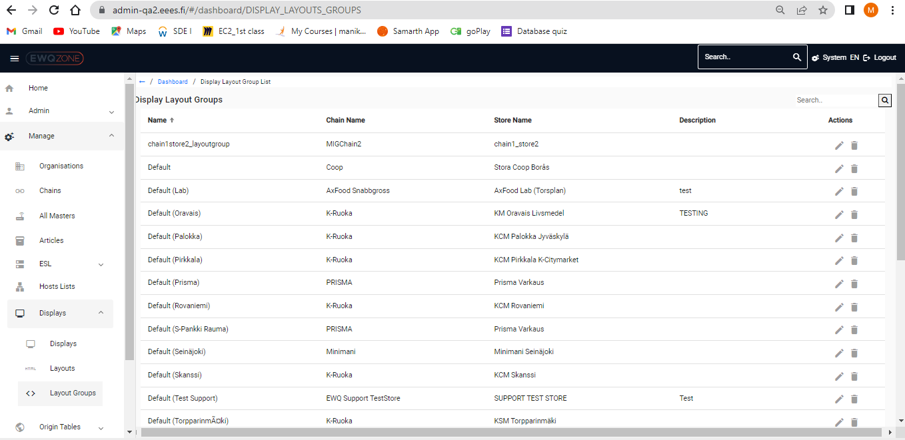

**Origin tables:**

Page alignment is not in Proffer

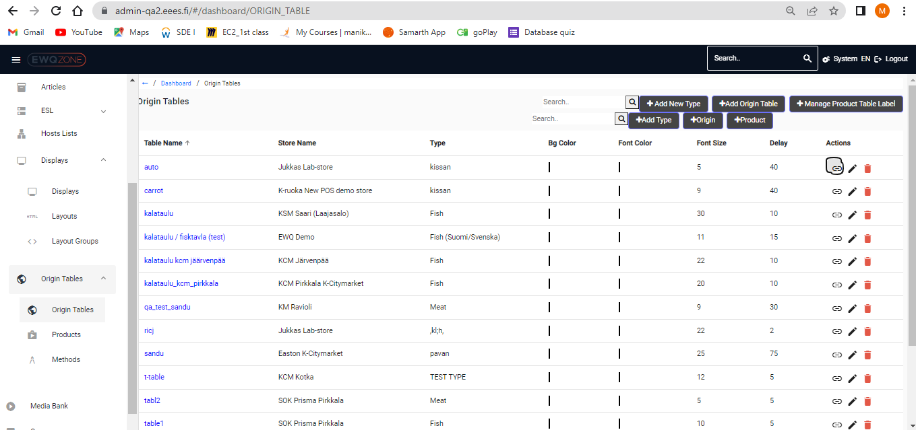

User receiving an irresponsive message sometimes if he clicks on action link origin tables:

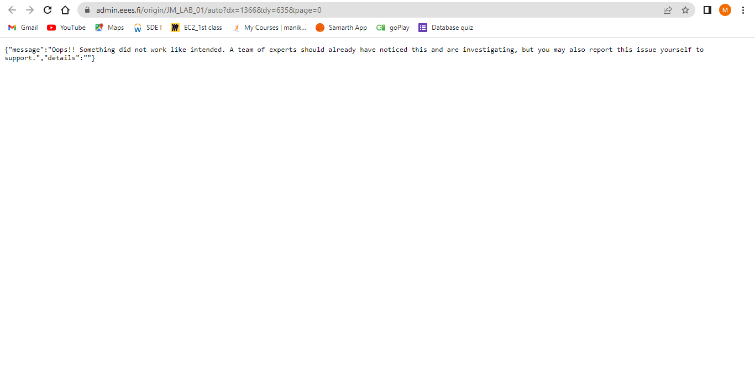



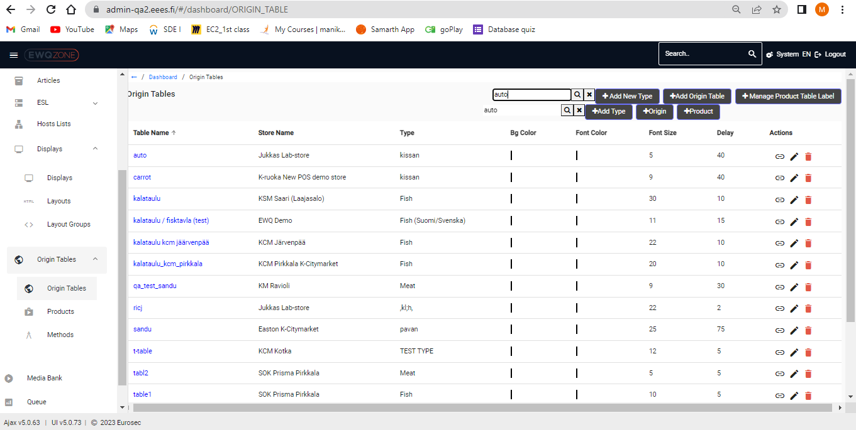

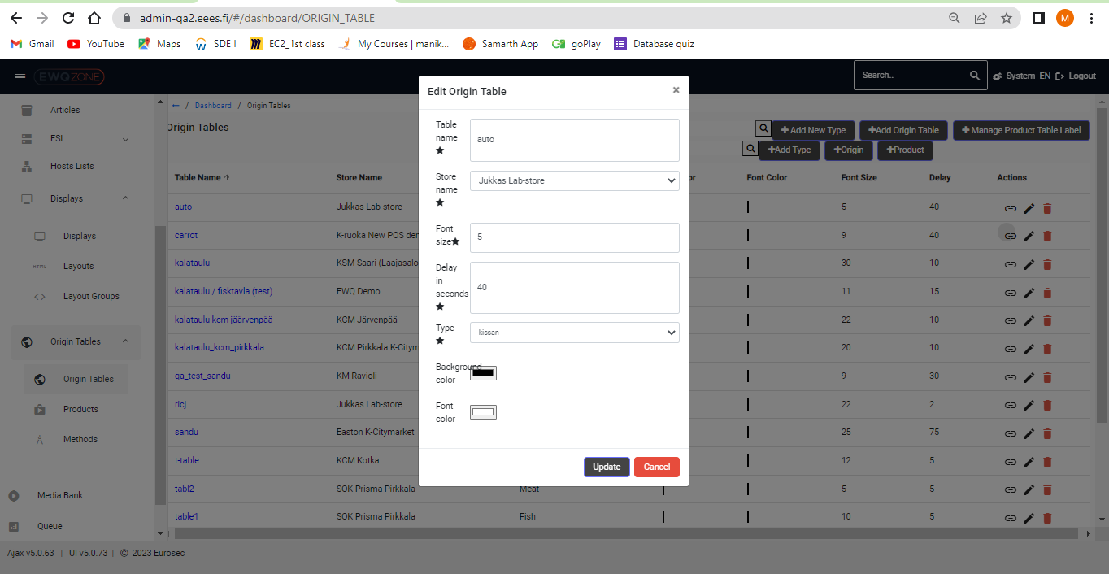

User receives different page in when he tries to open origin tables in new tab :

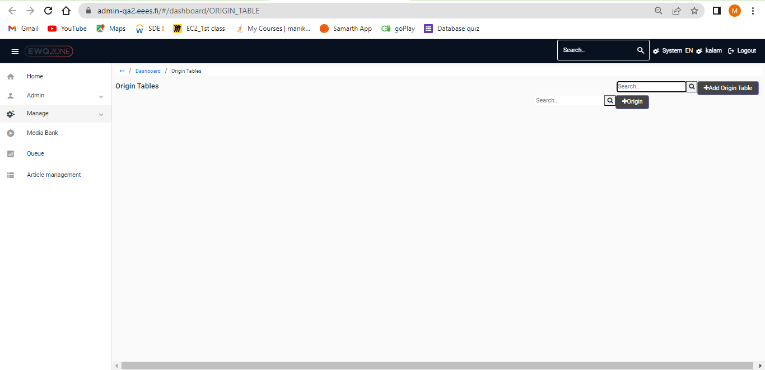

**Products:**

Page alignment is not good

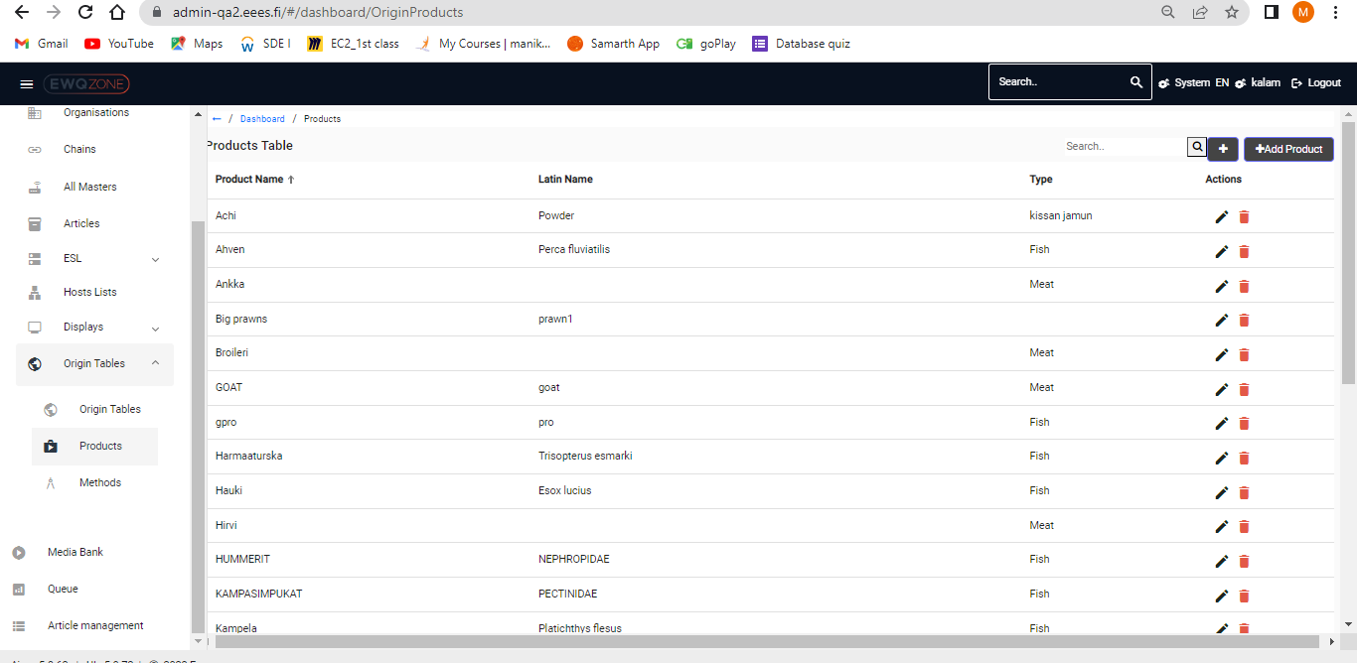

**Methods:**

Page alignment should be proffer

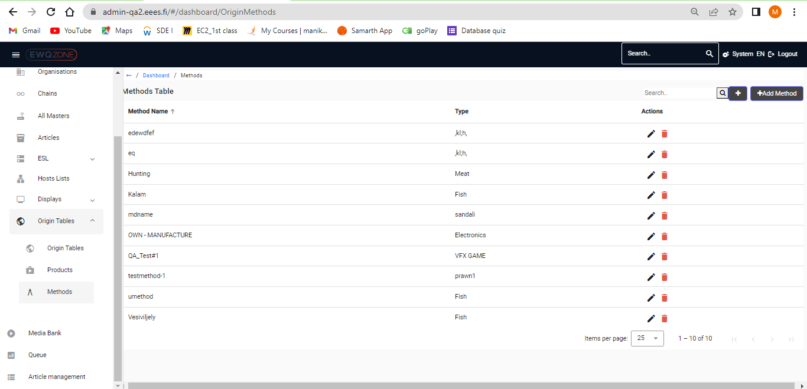

**Media Store:**

Page alignment should be proffer in Media Bank:

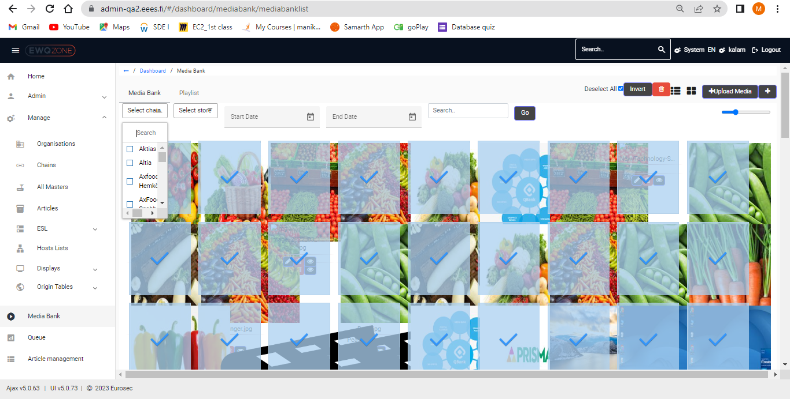

If user Click on play list, page is irresponsive (not loading )

