**EWQ Account _Bug report**

URl: https: <http://admin-qa2.eees.fi/>

User Name: kalam@gmail.comPassword:

# Sign In:

First time login also user sign in to the page, user received an error message in in the top of the application.

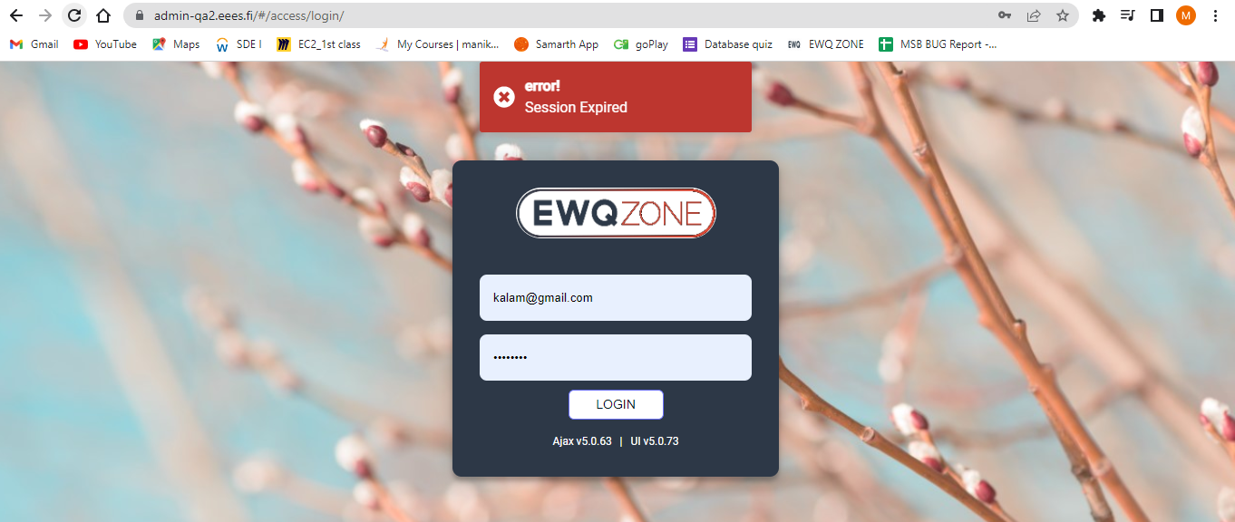

# Logout:

**Suggestion:** User Able to logout from Application without any pop-up or Intimation.

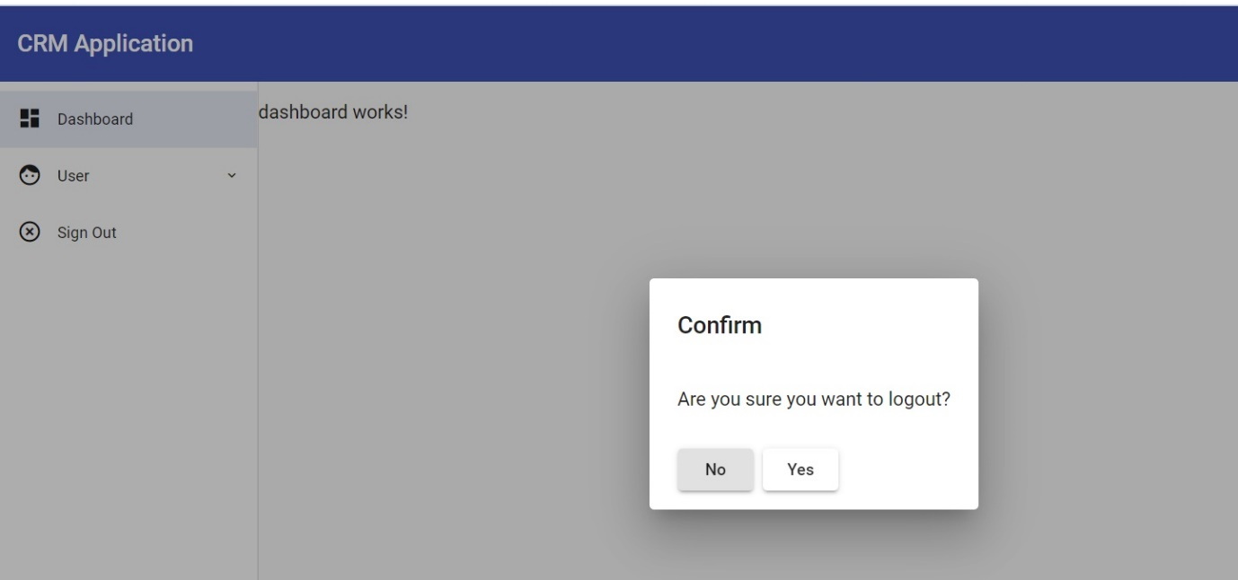

# Account Page:

1. This symbol shown in UI have no functionality, pls remove if it’s not required.
2. Search bar/Go and “+” have extra height can we align all three boxes in same.

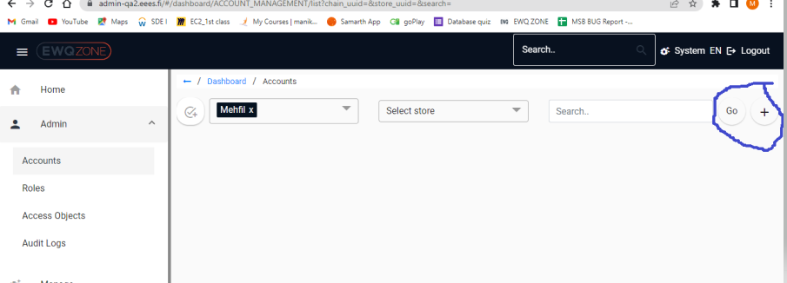

3.Scroll bar is missing in once re directed to add account page.

4. user not able to see entire page of Add Account Page. ( Need to add Scroll bar to see full page ).

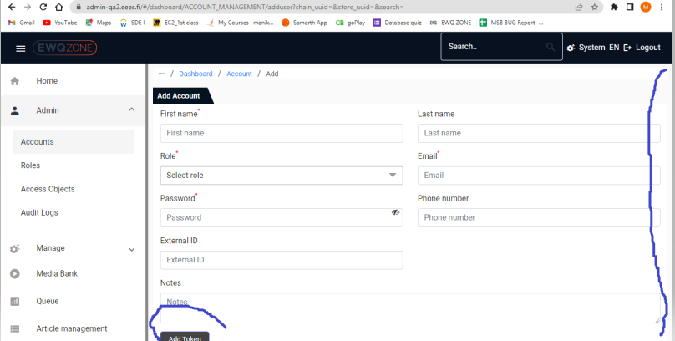

If User click on Name Directory in edit account page, user needs to navigate User Account page, but the option is Not working in edit page option.

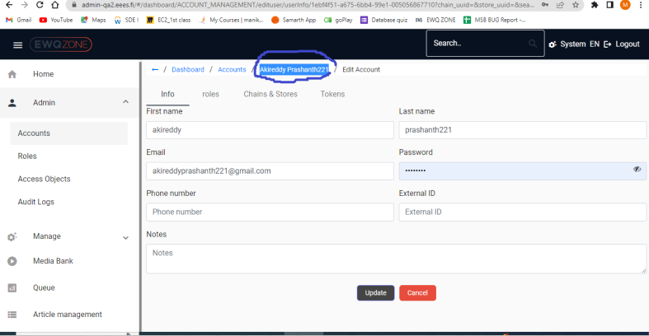

# Roles:

User unable to delete Privileges in role privileges page.

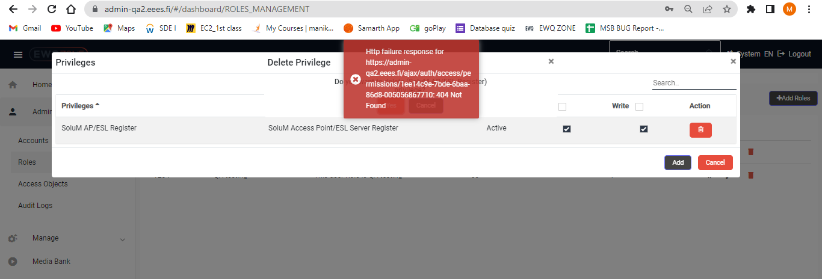

Page Should be high in responsive once we change item per page.

# Access Objects:

User able to see an error message while click on Edit button in access object page.

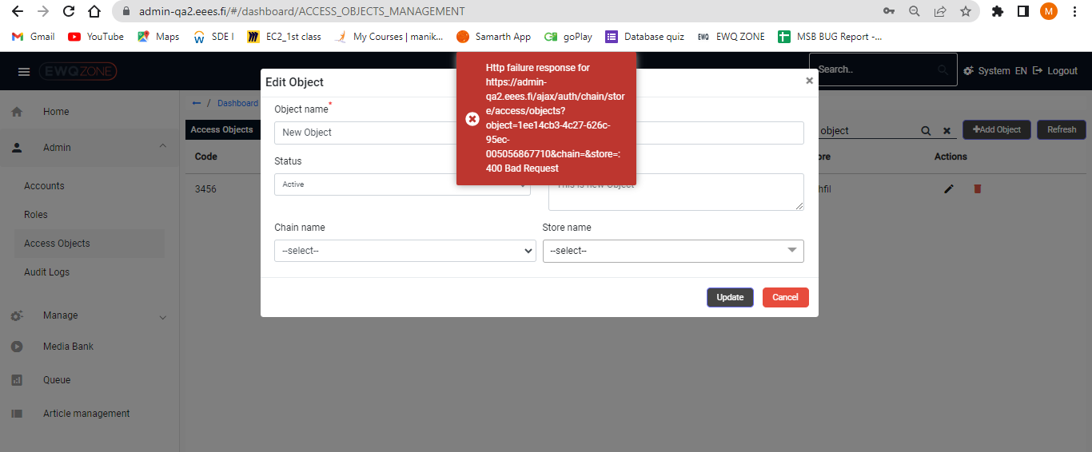

User Able to see an error message while deleting an object:

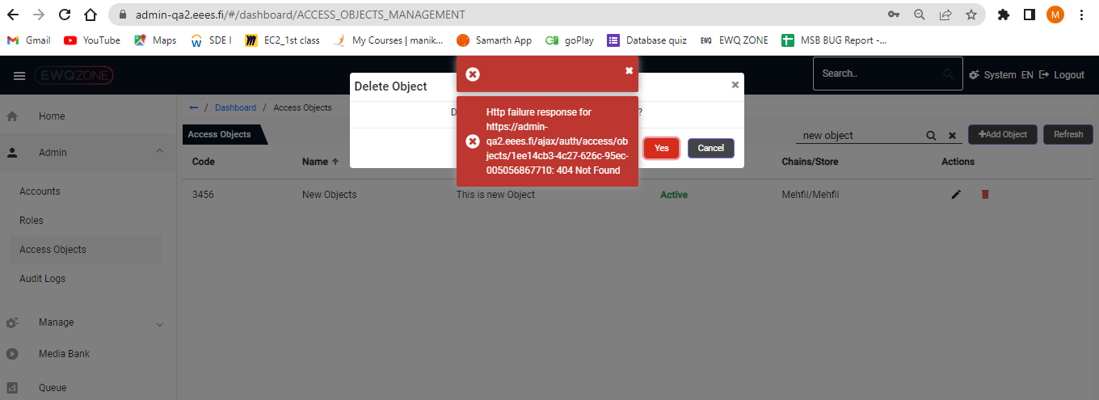

User Unable to click on Refresh Button. (For Refresh Button Does Not have any functionality).

If we don’t need Refresh button, please remove the same.( We can check in network tab)

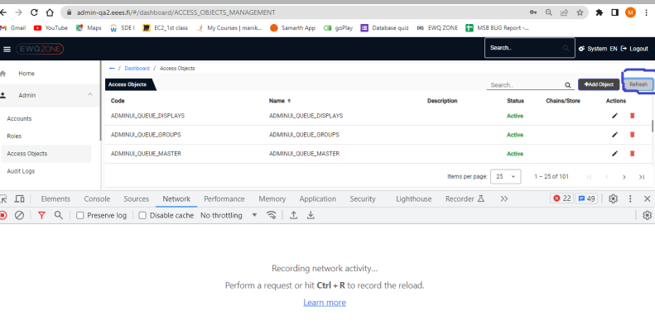

In Access Objects page pagination should be in highly responsive.

If user Click on to change item Per page, automatically page zoom In.

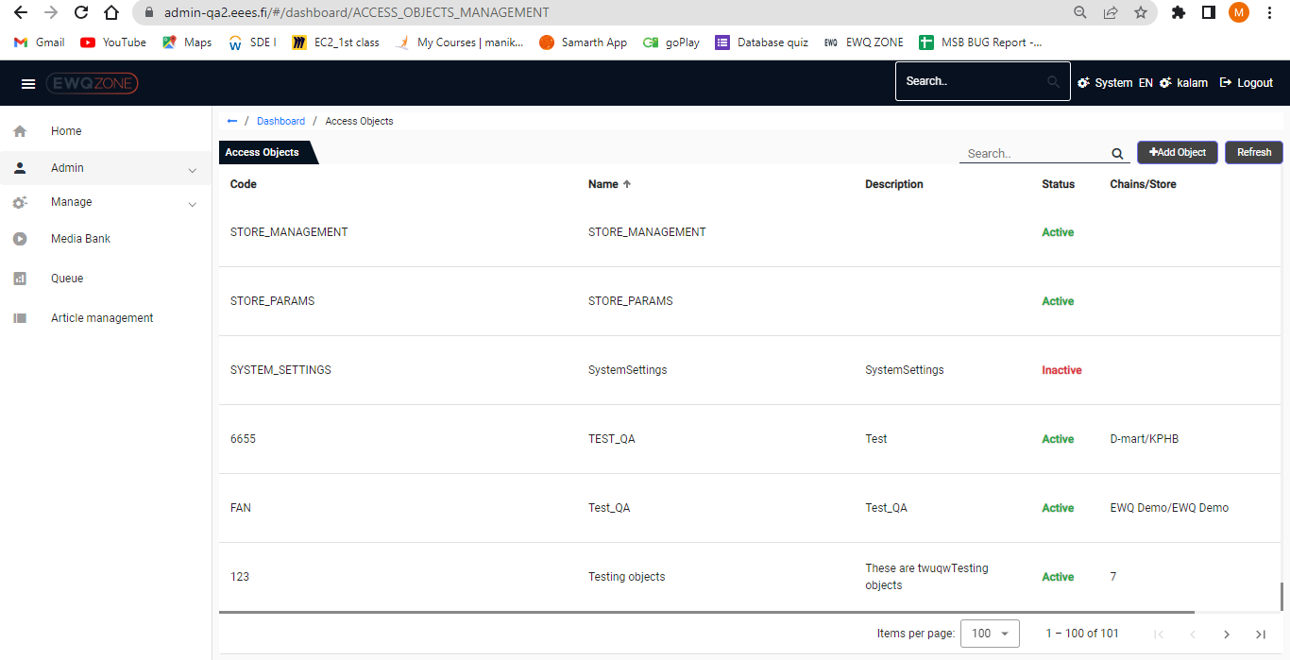

# Audit Logs:

In Audit logs page, if User Click on tokens user unable to see any delete functionality of token in Actions page.

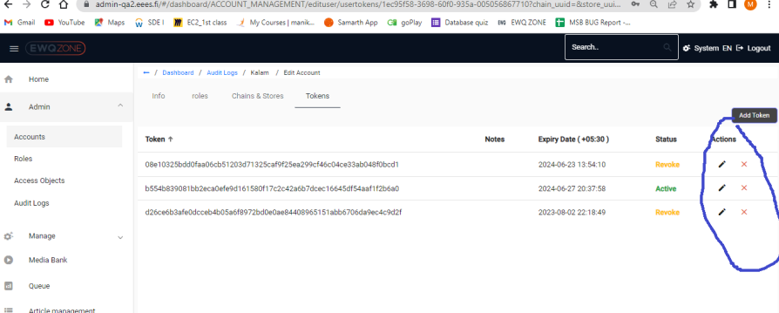

# Organizations:

In organizations page directory is missing on top.**(Dashboard/Organizations)**

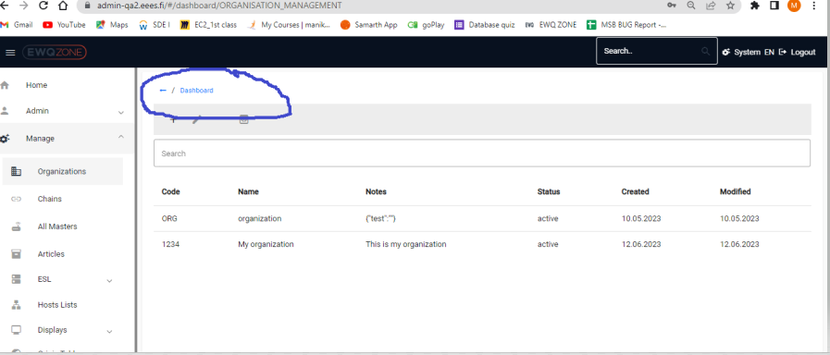

IF user click on back button/Dashboard in Organization page, user directly navigated to login page of the Application not to the back page.



Navigated to this page:

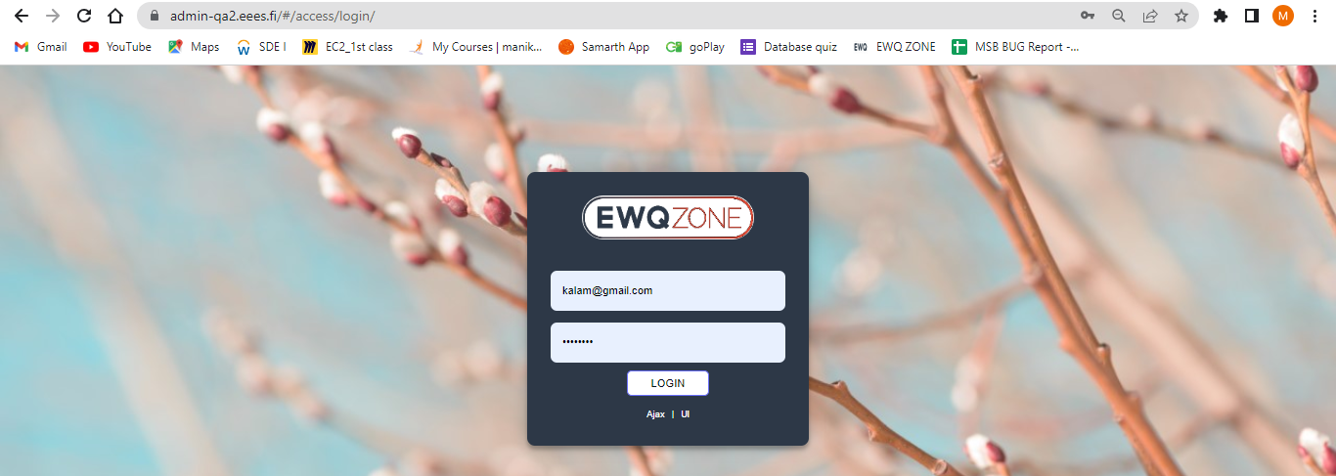

User unable to identify once he selected any row in the organization. (Selected row should be highlight with dif colour).

User has selected her last row.

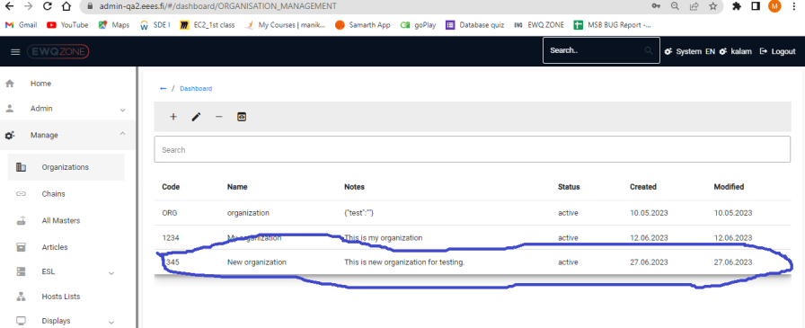

Header Directory should be: **Dashboard/Organizations/info**

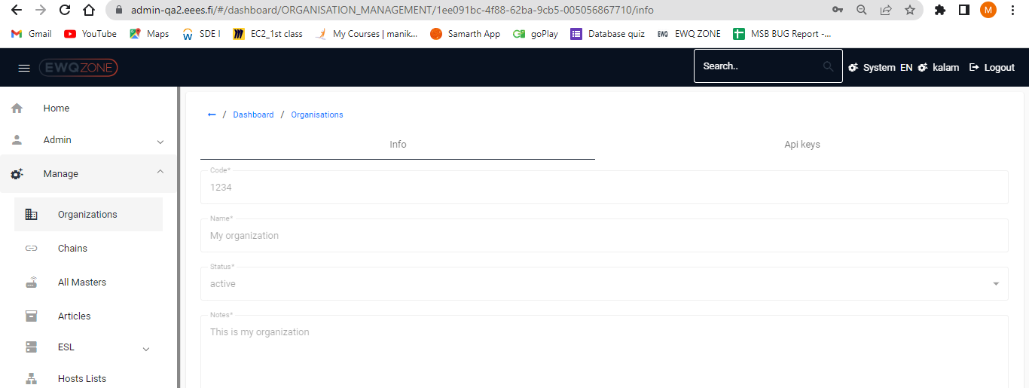

## Chains:

If user trying to open API keys in new tab, user able to Navigate to Info page.

Steps:

Click on chains

Click on any Code

Click on Api keys and try to open in new tab

Check the Navigation Page in new tab

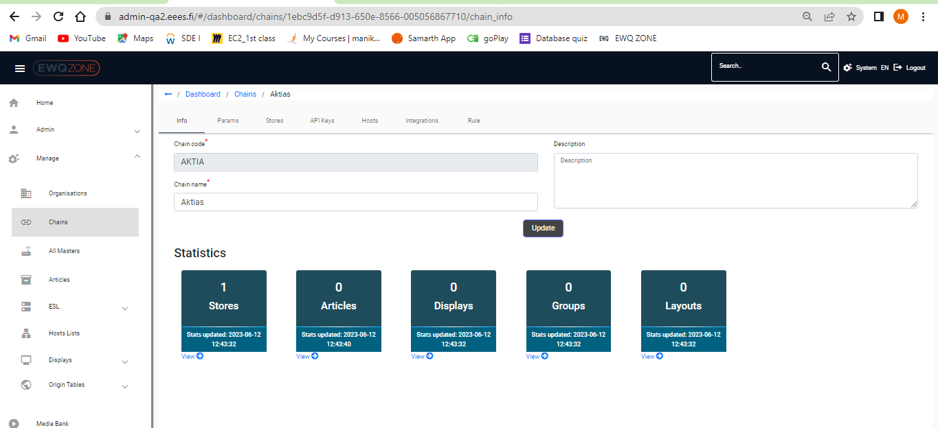

Use unable to update Chain_Params:

User unable to edit value of chain

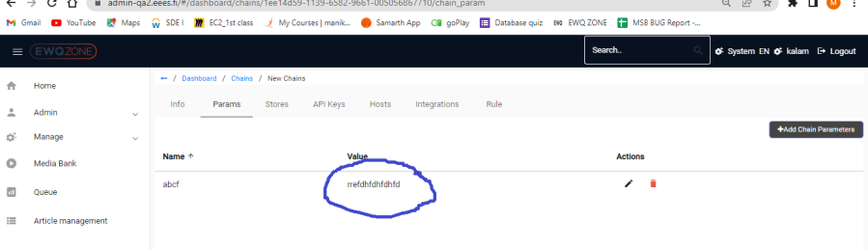

User unable to delete API keys in Specific chain:

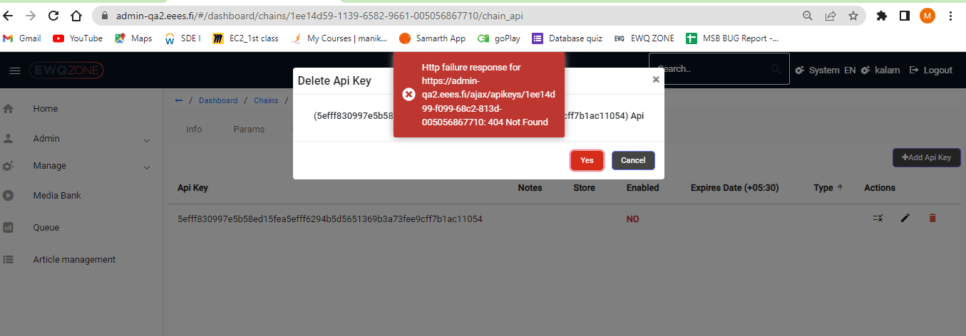

In Integrations page Scroll bar is missing to add details:

User able to see all fields in Integration page only when he Zoomout.

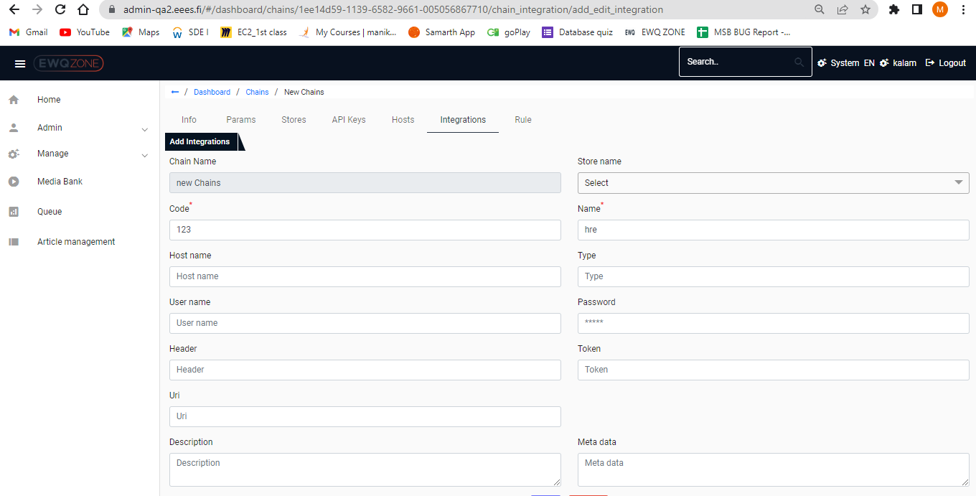

# Articles:

Pagination is missing in Articles page.

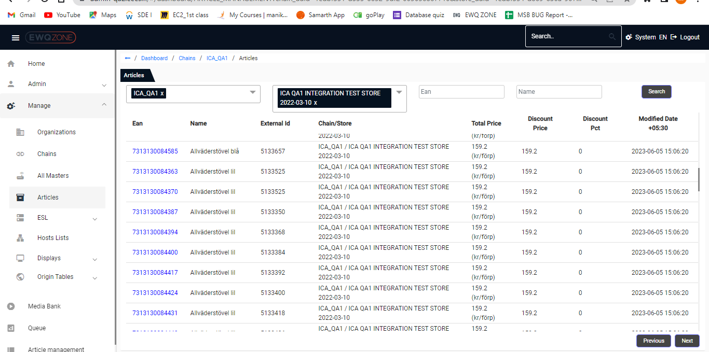

Page Directory is missing in Article page header;

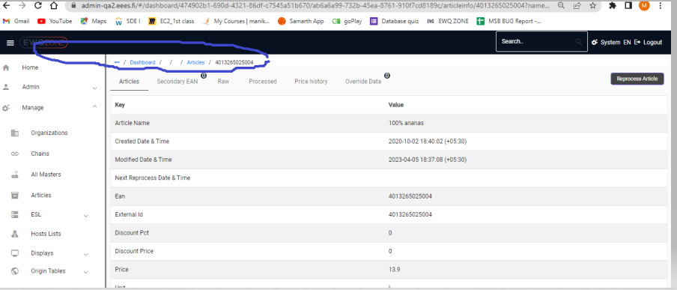

Scroll bar is missing

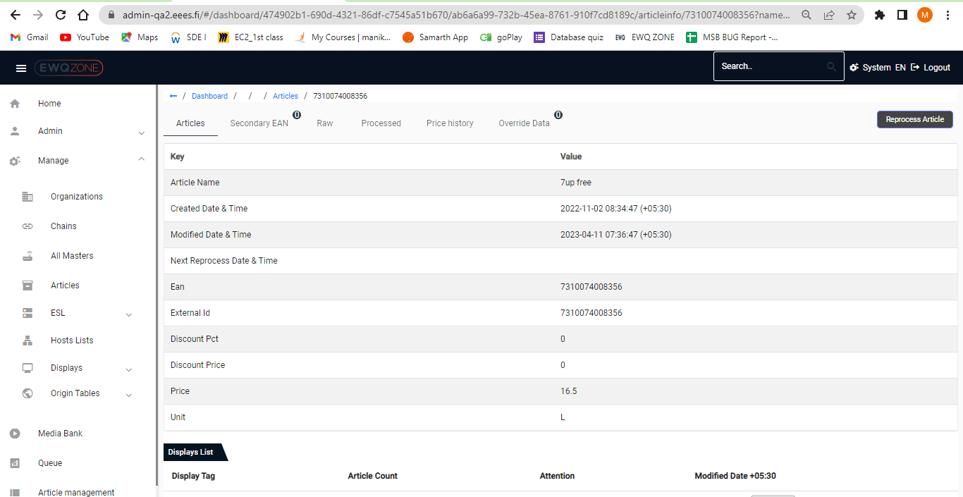

# ESL:

Scroll bar is missing in ESL page.

In ESL page naming convention is Mismatch. (Please confirm)

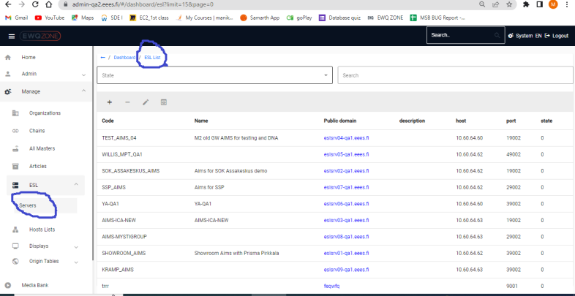

Field name “State” is missing:

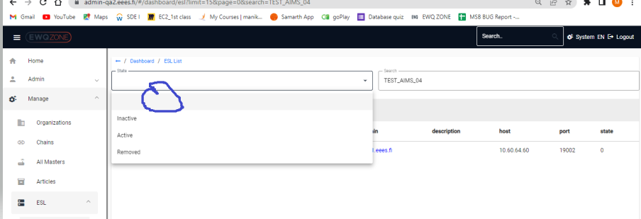

## Host List:

User Unable to open Host List page in new Window.

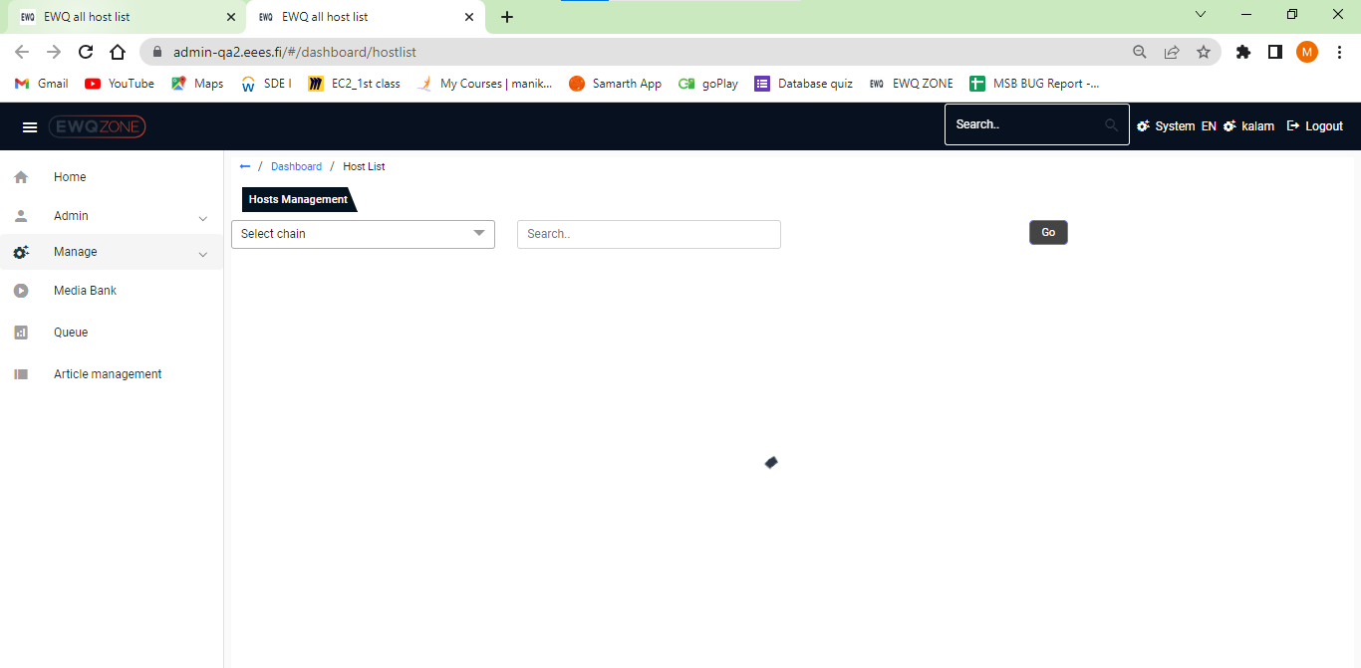

# Displays:

## Displays:

Scroll bar is missing in Displays Page.

In filter section it would be good we have an option for selecting /de selecting all option.

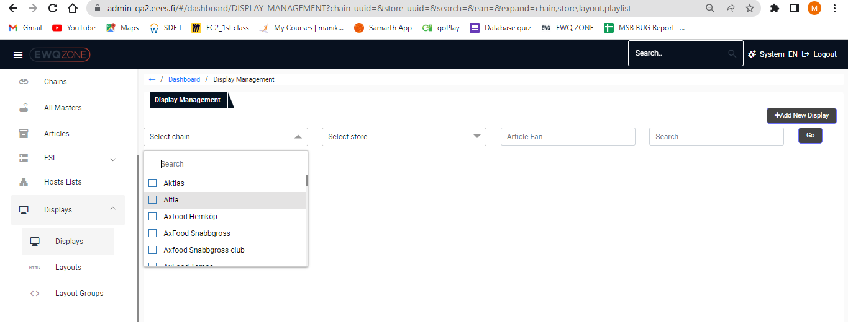

User unable to add new display to List.

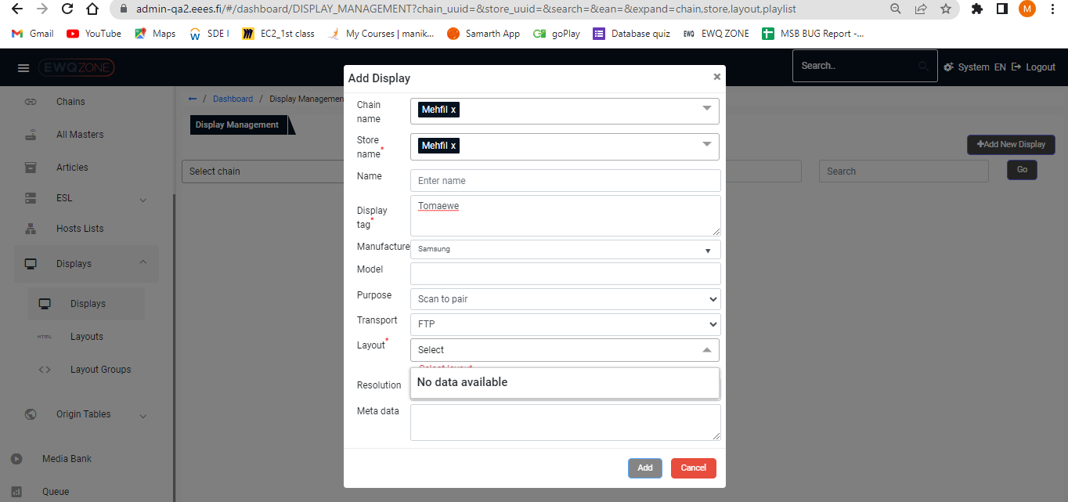

## Layout:

We Need to check whether the header is Layout or Layout Management

Extra Symbol or Names displaying in Task bars

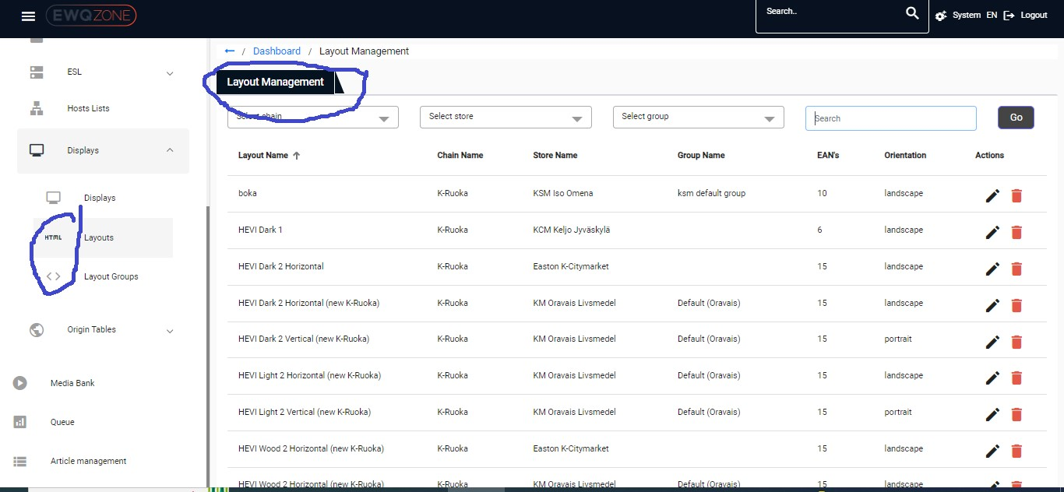

## Layout Groups:

We Need to check whether the header is Layout groups or Display Layout group List

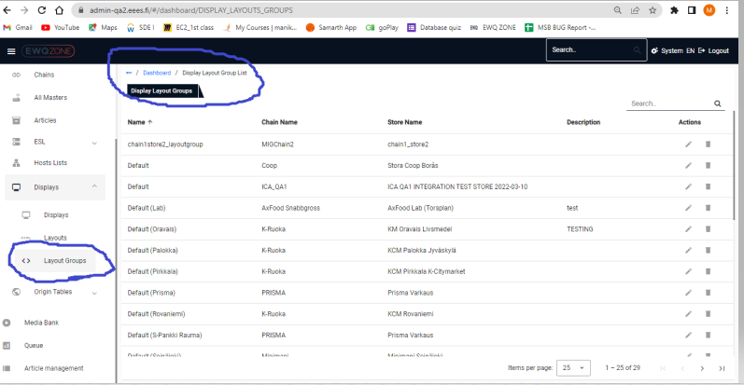

Action button are Not active in Layout groups page:

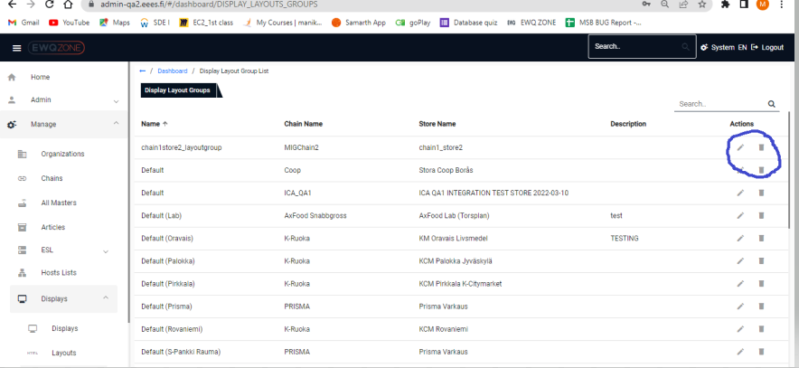

# Origin Tables

## Origin tables:

Scroll bar is missing Origin tables page.

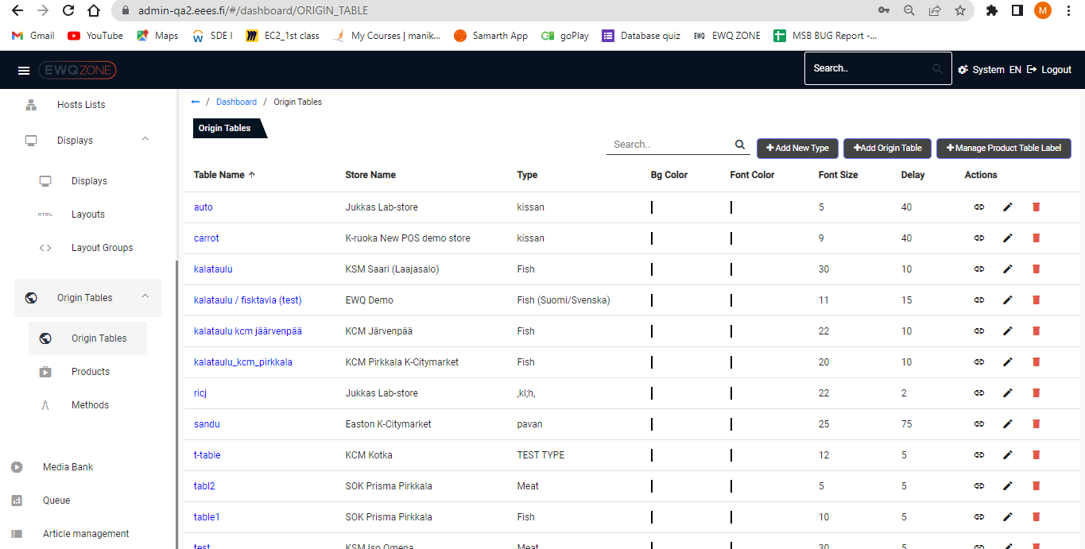

All elements are should be in Proper Alignment.

User unable to see properly due to the letters are in white colour.

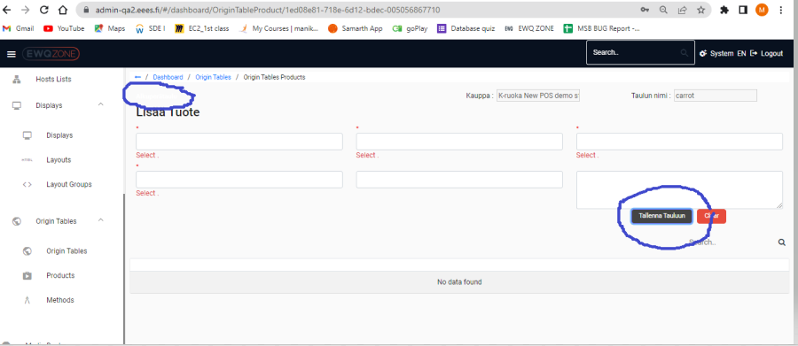

## Methods:

Scroll bar is missing.

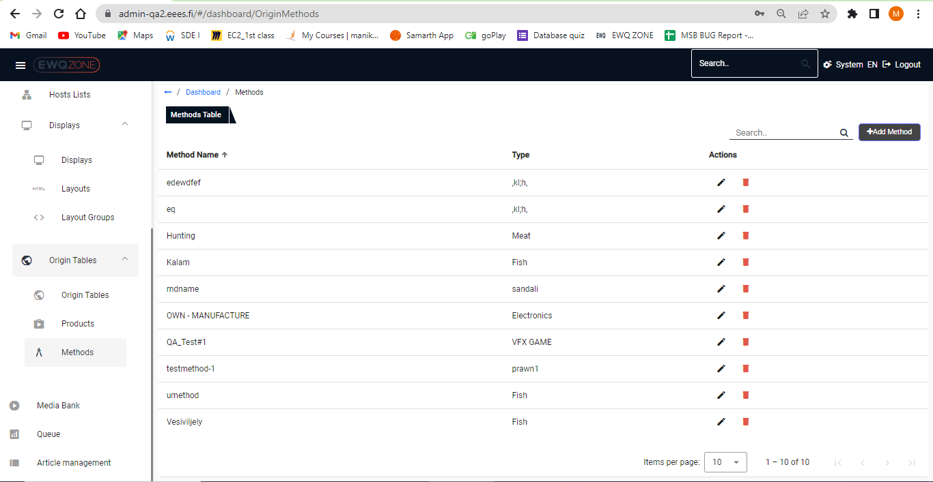

# Media Bank:

Distorted Ui in media bank page.

Edit, Delete and View details are Interloping with other pic.

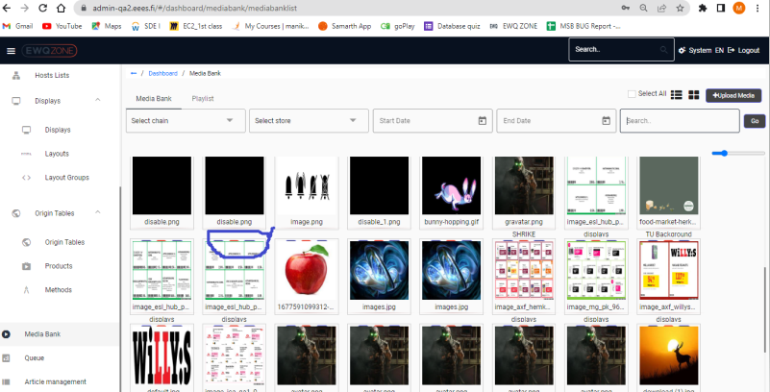

### Plalist:

Pleader should be in the middle of the Page.

User unable to Load the playlist page.

Scroll bar is missing from the playlist page.

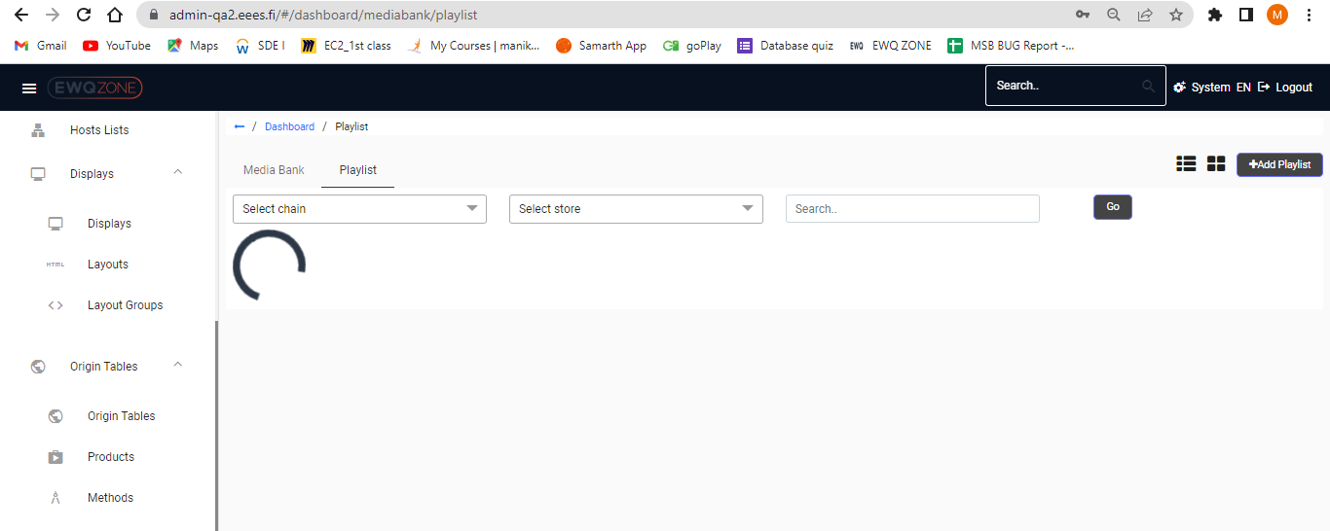

# Article management:

We Need to check whether the header is Articles or Article Management

Scroll bar is missing

All elements should be in proper alignment

