**EWQ Account _Bug report**

URl: https: <http://admin-qa2.eees.fi/>

User Name: kalam@gmail.comPassword:

# Sign In:

First time login also user sign in to the page, user received an error message in in the top of the application.

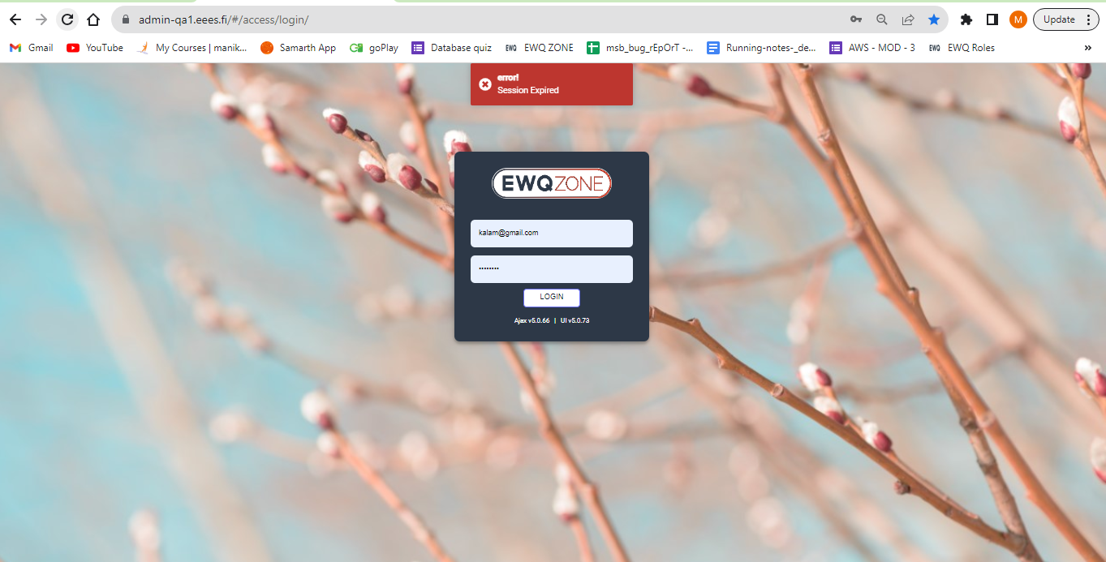

Access_Objects:

While Editing Access_Objects, user able to see an Error message.

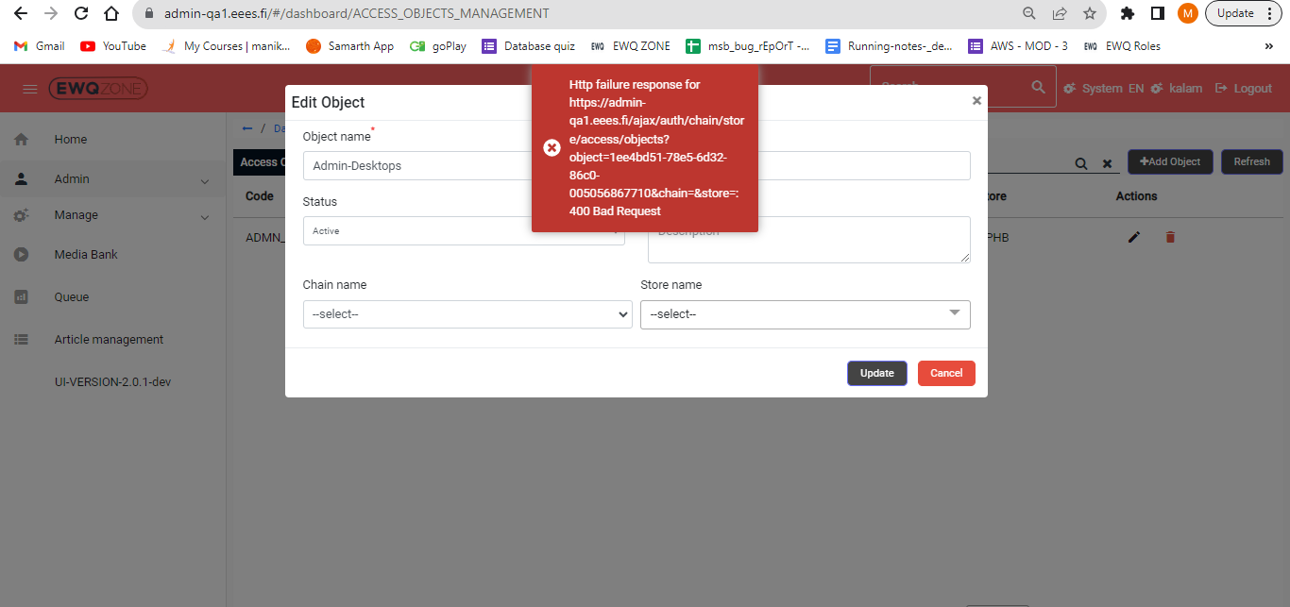

-In Access Objects page, if user trying change the Number items per page ( pagination) ,the screen Automatically Zooms in.

Higher number = Zooms In

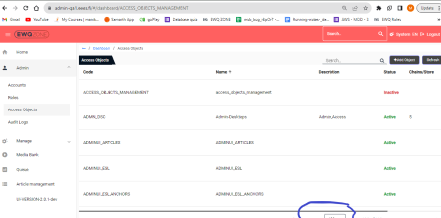

User unable to see any Functionality for refresh button in Access_objects page.

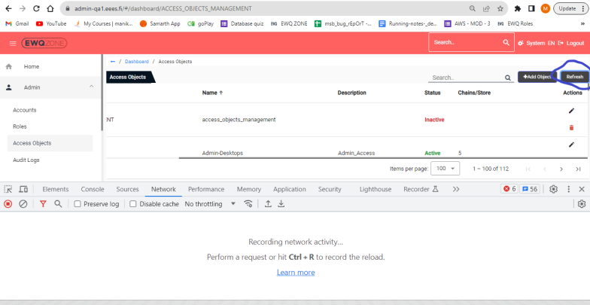

User unable to delete any Access objects:

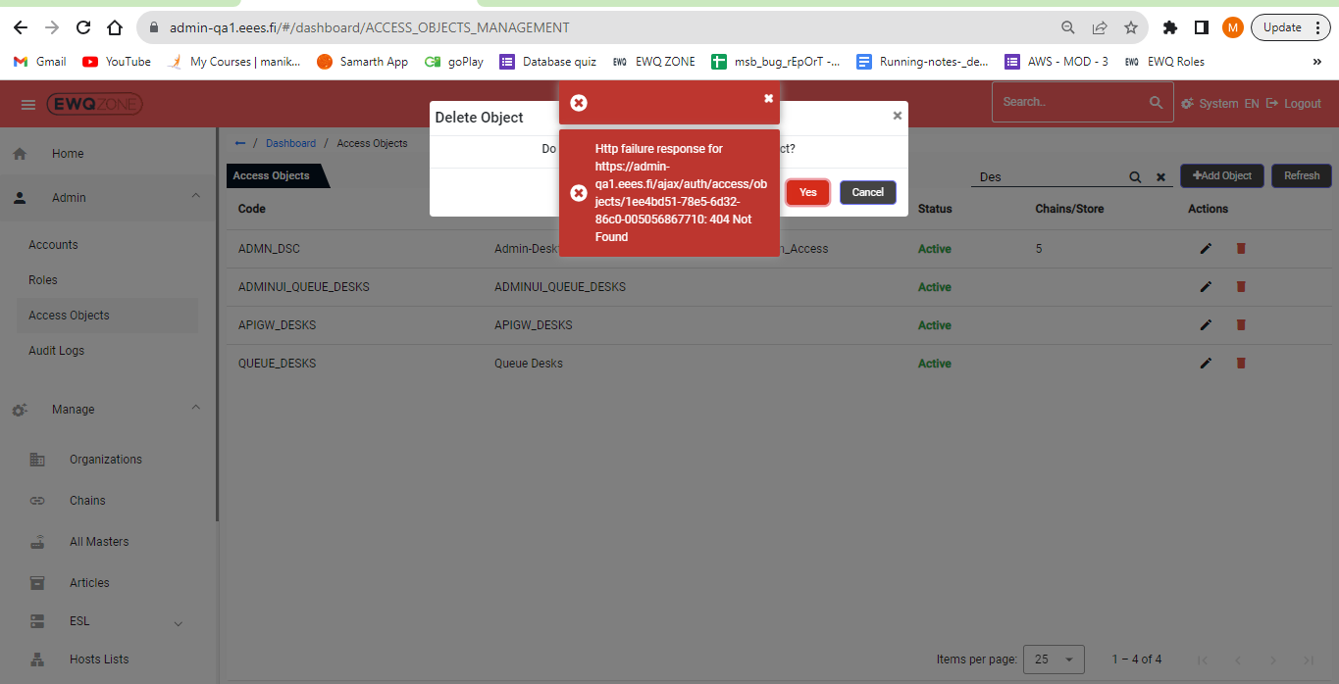

**Roles:**

User unable to delete any privileges in Roles:

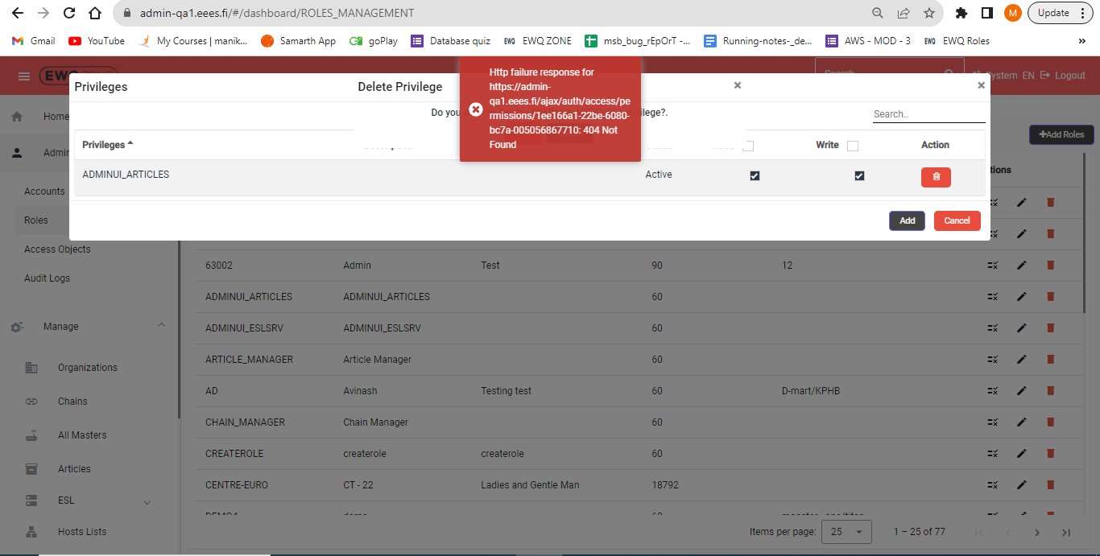

# Account Page:

1. This symbol shown in UI have no functionality, pls remove if it’s not required.
2. Search bar/Go and “+” have extra height can we align all three boxes in same.

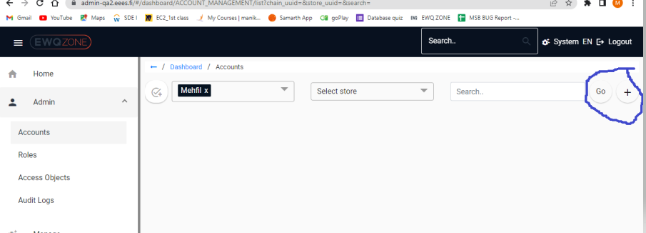

**Chains:**

In Chains, if user trying change the Number items per page ( pagination) ,the screen Automatically Zooms in.

Higher number = Zooms In.

