**LAB 1 – PYTHON EXPERIMENTS**

1.1 Install different tools/packages on Ubuntu DEVASC-LABVM:

* Python 3.8 and PIP
* Visual Studio Code
* Jupyter Notebook
* Python IDLE

Document your findings in 3 steps:

* Task preparation and implementation:

1. Update & grade to prevent errors: sudo apt upgrade && sudo apt upgrade
2. Install python & pip3(already done): sudo apt install python3 python3-pip
3. Install vscode(already done): sudo snap install –classic code
4. Install jupyter notebook: sudo pip3 install jupyter
5. Install idle: sudo apt install idle3

* Task troubleshooting:

Sudo apt upgrade && update prevents errors from occuring

* Task verification: Text

  Description automatically generated
* Text

  Description automatically generated

1.2 Run geopy and timedate Python Scipts on the DEVASC-LABVM using the tools above (1.1):

* timedate.py
* geopy-geocoders_location.py
* location.py

Document your findings in 3 steps:

* Task preparation and implementation:

1. Clone repo: git clone <https://github.com/wleppens/PythonExperiments>
2. Run scripts > python3 <script>

* Task troubleshooting:

Geopy: No module named folium, geopy

* Pip3 install geopy
* Pip3 install folium
* Task verification: 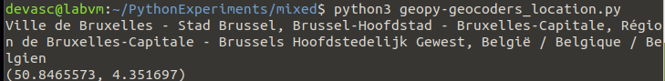Text

  Description automatically generated

1.3 Install different tools/packages on Windows OS (deep dive exercise) ++

* Python 3.8 and PIP
* Visual Studio Code
* Jupyter Notebook
* Python IDLE

Investigate the compatibility of the tools with Windows OS and explain briefly if necessary.

Document your findings in 3 steps:

* Task preparation and implementation:

1. Download python with installer for windows: (x86 executable installer)

From: <https://www.python.org/downloads/release/python-380/>

1. Download visual studio code for windows

From: <https://code.visualstudio.com/download>

1. Download jupyter notebook

Pip install jupyter

1. Download idle:

Pip install idle

* Task troubleshooting:

Jupyter gives errors if installed using pip install jupyter

Use: python -m pip install --upgrade pip

Then python -m pip install jupyter

* Task verification:

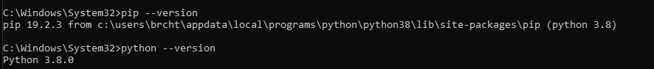

1.4 Install different tools/packages on Ubuntu 22.04.01 LTS (deep dive exercise) ++

* Python 3.8 and PIP
* Visual Studio Code
* Jupyter Notebook
* Python IDLE

Document your findings in 3 steps:

* Task preparation and implementation:

Download 22.04.1 iso:

<https://old-releases.ubuntu.com/releases/22.04.1/>

Install the VM

1. Update & upgrade to prevent errors: Sudo apt update && upgrade
2. Install snap for vscode: Sudo apt install snapd

Sudo snap install –classic code

1. Install python & pip: Sudo apt install python3 python3-pip
2. Install jupyter: Pip install jupyter
3. Install idle: Sudo apt install idle

* Task troubleshooting: sudo apt upgrade && update

Jupyter: pip doesn’t work, sudo apt install jupyter

* Task verification: A screenshot of a computer

  Description automatically generated with medium confidence