Ship Manual

Table of Contents
- Power
- Movement
  - Thruster Controls
  - Hyper-drive Controls
- Life Support
  - Air Balance
  - Water Purification
  - Nutrient Paste
  - Pee Vent
- Shields
- Weapons
  - Machine Gun
  - Missile Launcher
  - Laser
- Repair Drones
  - Internal Repair
  - External Repair
- Communication
  - Transmitting
  - Receiving
- Navigation
  - Sensors
  - Star Chart

1. Power
The power module is located at the center of the ship.

2. Movement

a) Thruster Controls
The thruster controls contains the following:
- A lever for main booster power – this can be used to set the speed at which the ship is moving.
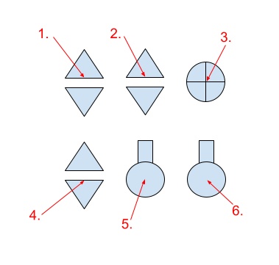
- A lever for controlling oxidizer level – this should be defaulted to 25% for safety reasons.
- A knob for frequency shifting the stabilization crystal – this is used to offset the NFD.
- A lever for acceleration dampener power – allows for braking and stabilizing during landing.
- A switch for Stability Augmentation System (SAS) – automated pitch, yaw, roll stabilization.
- A switch for Vector Control System (VCS) – automated vector stabilization.
Take off procedure:
- Set oxidizer level to 25%.
- Turn on SAS.
- Set acceleration dampener to 0%.
- Set main booster power as desired for comfortable flying experience.
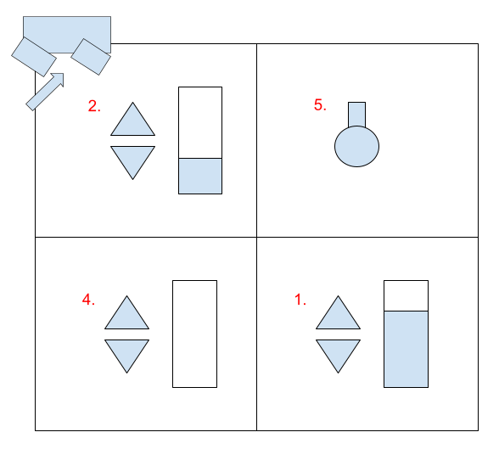
During flight the VCS can be used to autopilot to your destination. If a destination is set the VCS will automatically adjust the vector towards your destination during flight.
For advanced pilots the SAS may be turned off for more maneuverability.
Landing procedure:
- Set acceleration dampener to 25%.
- Slowly release main booster power until landed.
- Once landed disable the SAS.
- For safety and to avoid leakage, set oxidizer to 0%.
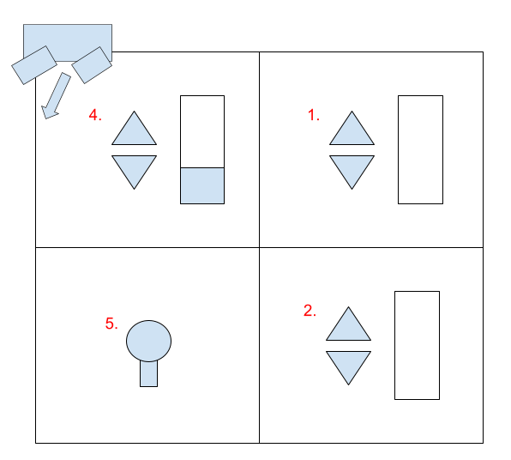
The stabilization crystal is only used to set the thrusters relative to the Nuclear Fusion Drive. By default this should be properly accounted for on your ship. In the case of ship modification, the stabilization crystal will need to be edited.

b) Hyper-drive Controls
The Hyper-drive console contains the following controls:
- A switch for enabling hyper-drive movement controls.
- A switch for connecting the hyper-drive to the nuclear fusion drive for power.
- A lever controlling the eights place of the hyper-drive’s horizontal movement.
- A lever controlling the sixteenths place of the hyper-drive’s horizontal movement.
- A lever controlling the eights place of the hyper-drives vertical movement.
- A lever controlling the sixteenths place of the hyper-drive’s vertical movement.
- A button for ejecting old hyper-drive cells.
- A button for injecting a new hyper-drive cell.
- This button does not do anything by default.
- Enables jump.
- This knob is a stabilization frequency knob for the system you are currently in.
- This knob is a stabilization frequency knob for the system you are jumping to.
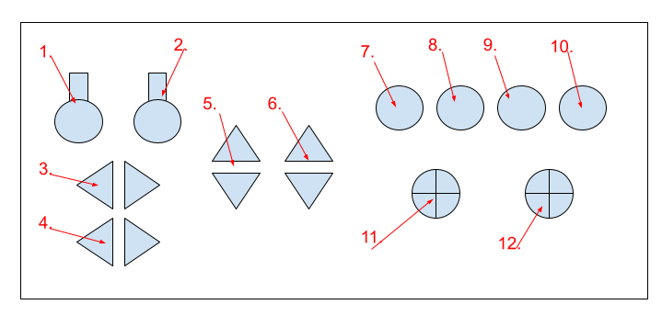
In order to jump to a system follow these steps:
- Disconnect the hyper-drive from the nuclear fusion drive.
- Enable movement controls.
- Use movement levers to set destination.
- Disable movement controls.
- Eject the old hyper-drive cell.
- Inject a fresh hyper-drive cell.
- Set the current stabilization frequency as appropriate for your system.
- Set the destination stabilization frequency as appropriate for the target system.
- Jump.

