AI tools help designers and developers automate tasks, improve content creation, optimize testing, and streamline development and deployment processes overall.

To help web developers and web designers make the most of emerging tech, we have compiled a list of the top AI tools for web developers in 2024. In this article, we will discuss the effectiveness and user-friendliness of these AI tools and how you can use them to work smarter rather than harder.

**AI Tools for Web Design - Fast and easy website creation and deployment**

When exploring AI design tools, you should focus on features like drag-and-drop interfaces, automated design generation, and responsive design capabilities. These tools empower you to create visually appealing, user-friendly websites without needing to write code.

**Hostinger** AI Website Maker

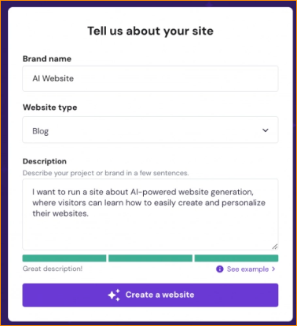

Hostinger’s AI Website Builder takes the complexity out of web development. It’s an ideal tool for small businesses, bloggers, and non-tech-savvy web designers needing professional-looking websites. it can make a fully-fledged website without any code-writing. Thanks to the intuitive interface and built-in AI tools, you simply choose your favorite website layout template, customize the design, and deploy your website in just a few clicks.

Choose what type of website we want to make from a short drop-down menu and then start describing about website in the text bar. There’s a little bar at the bottom that tells you when you’ve given the prompt enough suitable info for the AI.

Key Features:

* AI assistant for website development

AI Features

* AI website builder
* AI heat map
* AI logo maker
* AI hosting assistants
* User-friendly interface
* Built-in AI tools for design, content, and optimization
* Wide range of customizable templates
* Seamless integration with Hostinger’s hosting services

In the menu can see a whole section dedicated to AI tools: Logomaker, heatmap, and AI writer. The AI writer is probably the weakest of these. Rather than allowing you to write a prompt, it makes choose from a list of categories.

Logomaker –

The logo maker is perhaps Hostinger’s most interesting AI feature because it auto-generates images – the first implementation of its kind in a website builder. Put business name, slogan, industry, and even describe what you want in the prompt bar and Hostinger will generate four logos. These can be a mixed bag, but the potential is certainly there, especially for businesses not wanting to spend money on getting a professional designer.

* The AI logo maker is a great tool for starting businesses to come up with a logo on the cheap with no graphic design expertise needed.

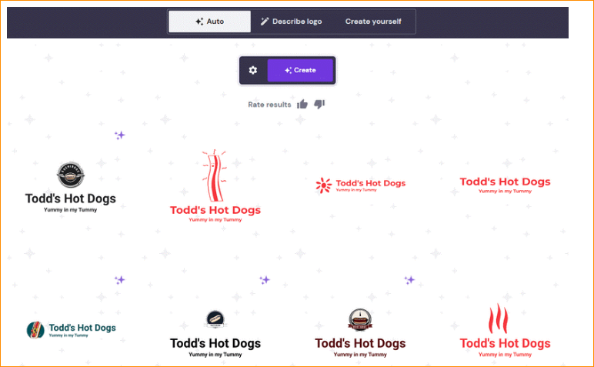

Heatmap

The last AI feature is the heatmap, which uses AI to simulate where the points of attention are on our website. This tool is useful for simulating what visitors will be seeing when they come to the site and helps beginners lay out their sites better and subtly learn the basics of web design.

* The AI heatmap uses AI to predict what will draw visitors’ attention to your page. Here, you can learn web design basics of putting your most important information upfront.

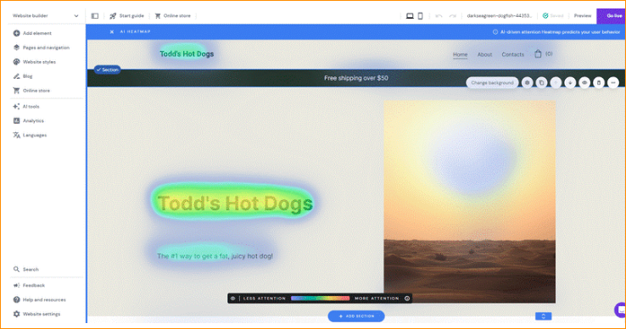

Drawbacks:

* May lack advanced features desired by experienced web developers and web designers
* Customization options may be limited compared to traditional code-based development

Pricing –

* 1 month – $11.99 USD / month - Plan renews at $11.99/month on
* 12 Months - $2.99 / month Plan renews at $9.99/month - Free domain for 1st year
* 24 Months – $2.79 / month Plan renews at $8.99/month - Free domain for 1st year
* 48 Month - $2.49 / month Plan renews at $7.99/month - Free domain for 1st year
* All-in-one solution
* 100 Websites
* Unmetered Traffic (Unlimited GB)
* 24/7 Customer Support
* Security
* Unlimited Free SSL- Protect all of your website with an unlimited amount of automatic lifetime Let's Encrypt SSL certificates.
* 99.9% Uptime Guarantee - Maximize your presence online. We keep our annual uptime rates at a 99.9% height to ensure accessibility of your website at all times. When your website’s down, that’s a potentially missed opportunity to engage with a customer (or potential customer). That’s why we guarantee you one of the best service uptimes globally.
* Weekly Backups
* Extra
* Free Website Migration- We will move your website to Hostinger from another hosting provider for free.
* Cloudflare Protected Nameservers-
* Malware Scanner

Leverage the Power of Artificial Intelligence

* Instant Website Creation

Save time – powered by an advanced machine learning algorithm. Our AI website builder will generate a custom site based on your description. Not a writer? No problem – use our AI content creation tools to produce unique, SEO-friendly website copy and launch your site in no time.

* Optimized for Search Engines

Beat the competition on Google with our SEO tools, designed to help you intuitively optimize your web pages for search engines. Thanks to lightning-fast loading times, you can ensure the best user experience for your audience, at all times.

Pros

* Your website is created via prompt
* AI Logo-maker can auto-generate twelve designs in seconds
* AI Heatmap predicts where visitors’ eyes will be drawn

Cons

* ADI design is ugly compared to Wix or GoDaddy
* Text can be off-center with bad font choices
* AI Logo-maker can sometimes create unintelligible designs

Steps to making web site - <https://www.hostinger.com/tutorials/how-to-make-a-website#1_Pick_a_Template>

<https://www.hostinger.com/ai-website-builder>