**Squarespace Web Designer**

* Squarespace is known for its fantastic design
* Its templates are at the pinnacle of web design, and it is suited to more creatively-minded website owners.
* AI integration, recently adding Squarespace AI for text generation. Using OpenAI, it is able to generate text from the toolbar in the editor.

Can use Squarespace AI for any text on your website. Here’s the selection of prompts it gives.

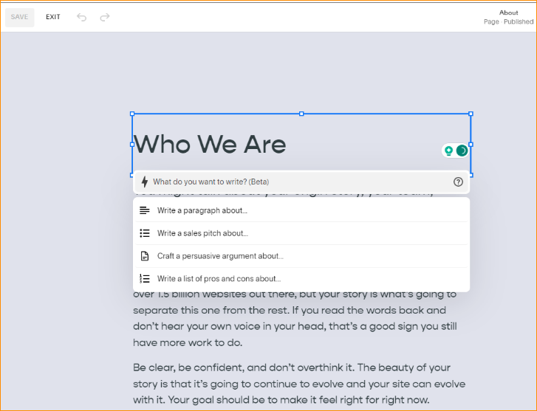

Squarespace AI is Squarespace’s text generator and it’s absolutely the best due to its sheer freedom and creativity.

Instead of operating under a layer of conditions like Wix Text Creator or even Shopify Magic but Squarespace AI has none whatsoever.

When you click the lightning symbol on the text toolbar, you get taken to a text bar where a list of four options for prompts is given:

* Write a paragraph about…
* Write a sales pitch about…
* Craft a persuasive argument about…
* Write a list of pros and cons about…

A downside to this freedom, however, is the lack of guidance. While Wix Text Creator is designed to only use its AI for purposeful text, making it constricting but also easy for newcomers, Squarespace gives you free rein.

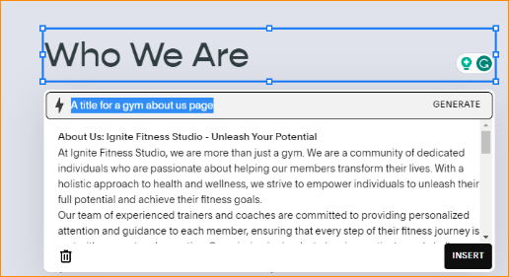

|  |  |  |  |
| --- | --- | --- | --- |
| **Pricing Plans** | **Monthly Plan ($/month)** | **Annual Plan ($/month)** | **Savings (%)** |
| Personal | $23 | $16 | 30% |
| Business | $33 | $23 | 30% |
| Ecommerce Basic | $36 | $27 | 25% |
| Ecommerce Advanced | $65 | $49 | 24% |

* Personal plan ($16/month): Designed for (can guessed it) personal websites, this plan still offers most of Squarespace’s features (that aren’t related to ecommerce). get a wide selection of templates, and receive a free custom domain, SSL security, and 24/7 support.
* Business plan ($23/month): can sell online with this pricing plan, but there is a 3% transaction charge on all sales. It’s more suitable for businesses who just have the odd product to sell, rather than fully-fledged online stores.
* Basic Commerce plan ($27/month): This plan is practical for fully-fledged online stores. get specific tools to help manage your store, like mobile-optimized checkouts, integrated accounting, and customer accounts. can sell directly on Instagram, too.
* Advanced Commerce plan ($49/month): This plan is best for boosting ecommerce sales. Features like abandoned cart recovery, gift cards, and flexible discounts are all designed to encourage more customers to purchase. These features, coupled with advanced tools for shipping, complete Squarespace’s most powerful package.

Pros

* No strict set of categories for text generation
* Can and will generate text for any kind of prompt
* More freedom than Wix

Cons

* No ADI functionality
* All preset functions are included in templates
* No automatic install of useful functions or apps

Web site - <https://www.squarespace.com>