Shopify

Shopify is the go-to ecommerce website builder. If need an online store this is good, since it is well-loved for its amazing scalable commerce and inventory features, perfect for both small and extremely large stores.

Shopify Magic is here to (figuratively) make the problem go away with AI. This AI text-generation tool can write our product descriptions, craft instant email replies, or help write blog posts, saving our time. we can use it in the theme editor, and can even use it on the fly with the Shopify mobile app.

**Shopify Features**

1. Shopify Magic

Shopify has introduced a new AI generation tool called Shopify Magic

Shopify Magic is an LLM (Large Language Model), meaning it’s been pre-loaded with text from various sources beforehand. This gives it a better idea of the intricacies of language before it begins – and from our own testing,

Shopify Magic, a new AI-generation tool for its merchants, is available now.

It can only currently auto-generate product descriptions, but more capabilities are to be rolled out soon according to Shopify.

The company claims its users will save precious time by allowing Shopify Magic to write product descriptions using artificial intelligence.

According to Shopify, users will simply just have to list a few details about the product and Shopify Magic will do the rest, auto-generating a professional description in the admin section of a merchant’s Shopify store. Users are also able to give a list of keywords that they want to rank for across search engines and Shopify Magic will write a description based on that.

In addition to time-saving, Shopify Magic can allegedly also help in creating a consistent tone across many products in a Shopify store. Users will also be able to access Shopify Magic from the Shopify Mobile app, adding an extra layer of convenience to the new tool.

Currently, Shopify Magic can only generate text across its core supported languages, which are:

* English
* German
* Spanish
* French
* Italian
* Japanese
* Portuguese (Brazilian)
* Chinese (Simplified)

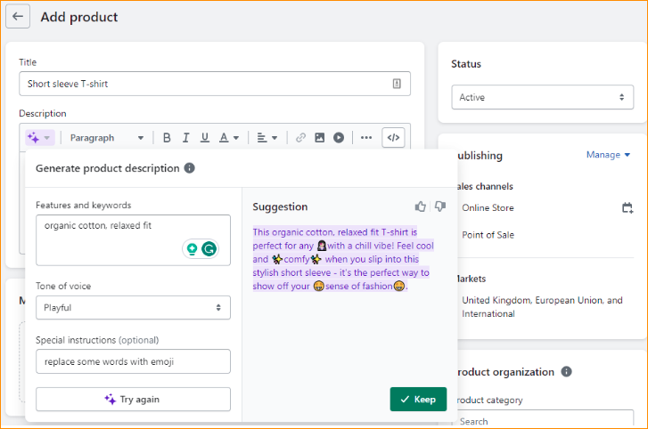

Clicking the purple star symbol in the text toolbar will allow to generate text. Instead of writing a full sentence prompt like Squarespace AI, it asks to list various features and keywords of the product, so “t-shirt, medium, white” for example. A unique feature of Shopify Magic that has tone of voice selector. Here We can select from seven tones of voice for your text:

* Expert
* Custom
* Daring
* Playful
* Sophisticated
* Persuasive
* Supportive

This gives newcomers a good idea of the possibilities of AI text generation, and just below that is an optional “Special Instructions” input you can further tailor our text. If we don’t know what to put, Shopify includes a little example of “Replace some words with emoji.” This is a lovely bridge between the hands-on approach of Wix Text Creator and the hands-off approach of Squarespace AI, giving users freedom but also subtly guiding them into discovering the full capabilities of the AI.

Pros

* AI-generated product descriptions
* Choose between multiple tones of voice
* Can be used across your entire inventory, saving time

Cons

* No ADI functionality
* Shopify Magic only works for product descriptions

**Shopify Pricing**

Shopify offers three pricing plans that range from a basic option ($29 per month) to its most advanced option ($299 per month). You can also take advantage of its $1 a month for 3 months offer.

|  |  |  |  |  |
| --- | --- | --- | --- | --- |
| **Shopify Plan** | **Monthly Cost** | **Paid Annually** | **Saving** | **Best for?** |
| Shopify Starter | $5 | N/A | N/A | Selling on social media – limited features, optimized for mobile |
| Basic Shopify | $39 | $29 | 25% | Small businesses or storefronts for existing ones |
| Shopify | $105 | $79 | 25% | Larger businesses – more robust tools such as gift cards and cart recovery |
| Advanced Shopify | $399 | $299 | 25% | Companies – low transaction rates and priority shipping |
| Shopify Plus | $2000 | N/A | N/A | Enterprise selling for corporations – used by Sony, Unilever etc |

Pros

* AI-generated product descriptions
* Choose between multiple tones of voice
* Can be used across your entire inventory, saving time

Cons

* No ADI functionality
* Shopify Magic only works for product descriptions

Web site - <https://www.shopify.com/>