1. What is IActionResult –

Normal request –

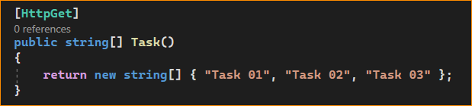

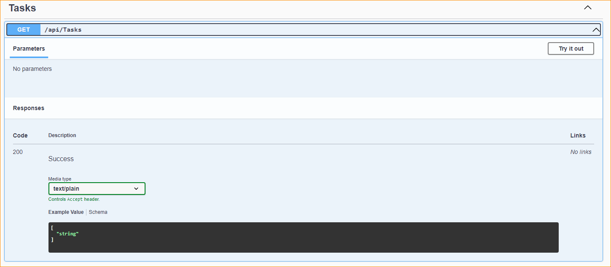

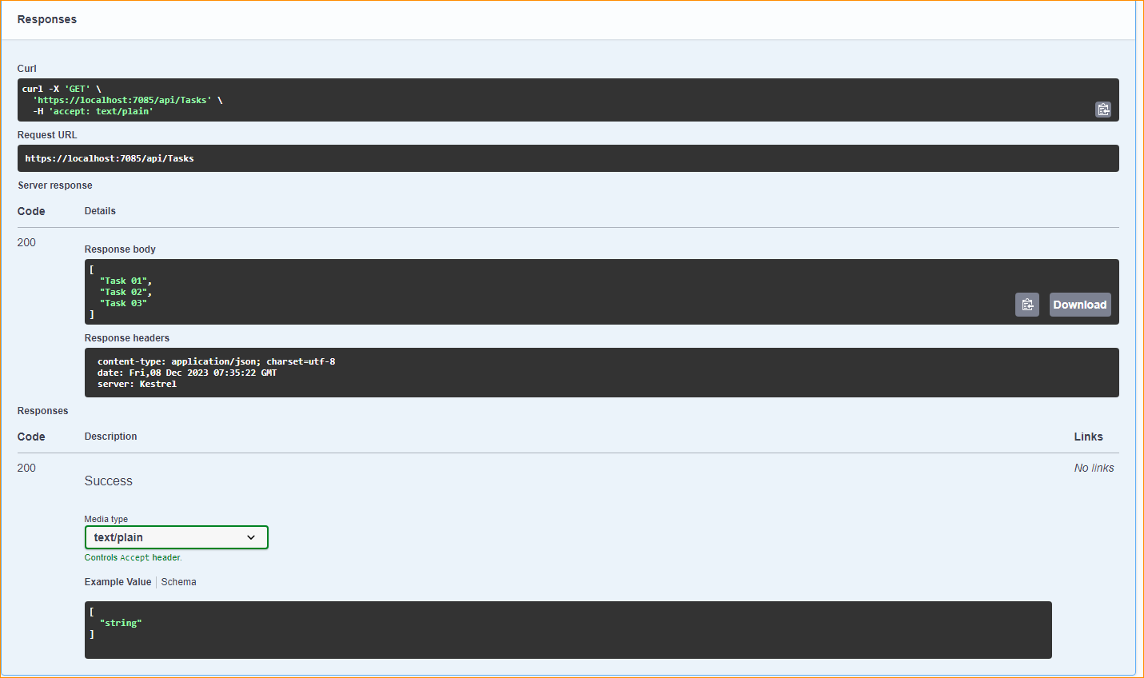

In ASP.NET Core, IActionResult is an interface that represents the result of an action method in a controller, particularly in the context of a REST API. It allows you to return different types of HTTP responses from your API actions. By using IActionResult, you can return various HTTP status codes, as well as different types of data such as JSON, XML, or custom content.

Here are some commonly used implementations of IActionResult in the context of a REST API:

* **ObjectResult:** Represents an HTTP response with an object serialized as JSON. You can return your data objects as JSON using this result type.

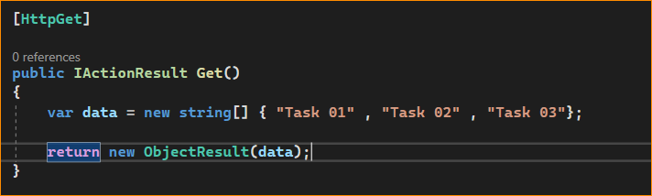

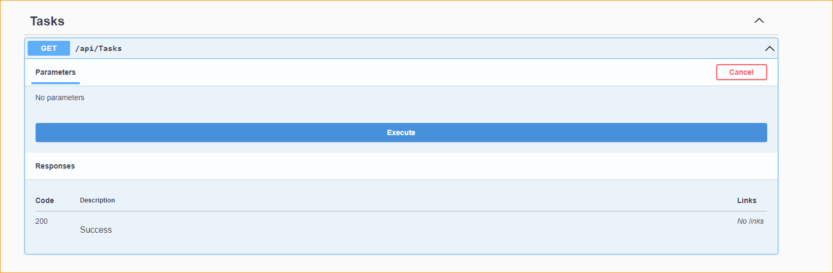

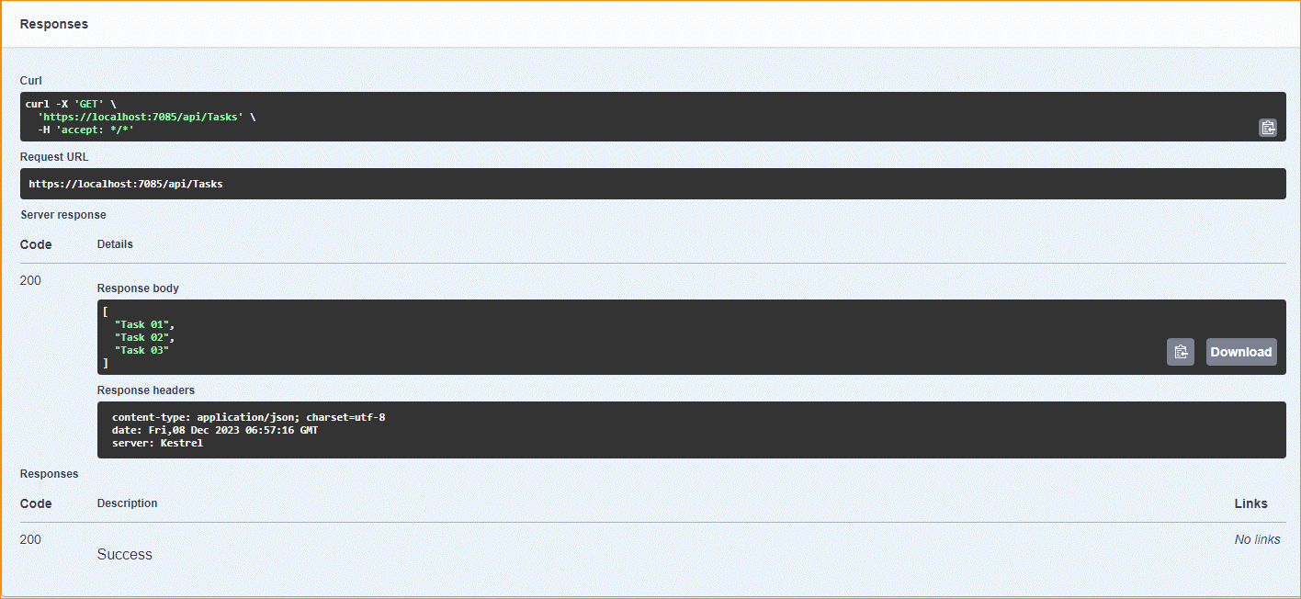

* **OkObjectResult**: Represents a 200 OK response with an object serialized as JSON. It is a specialization of ObjectResult for success cases.

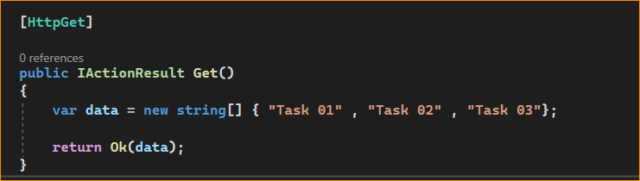

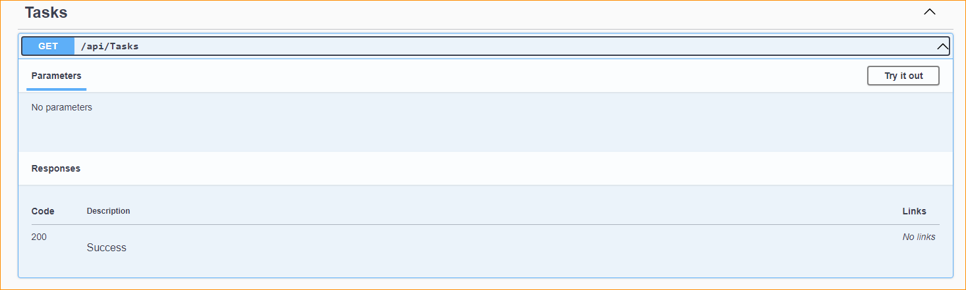

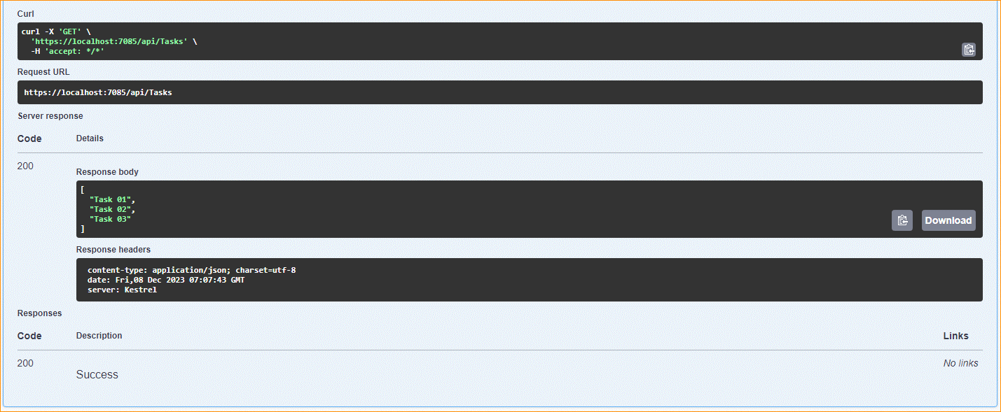

* **NotFoundResult**: Represents a 404 Not Found response.

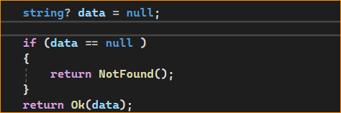

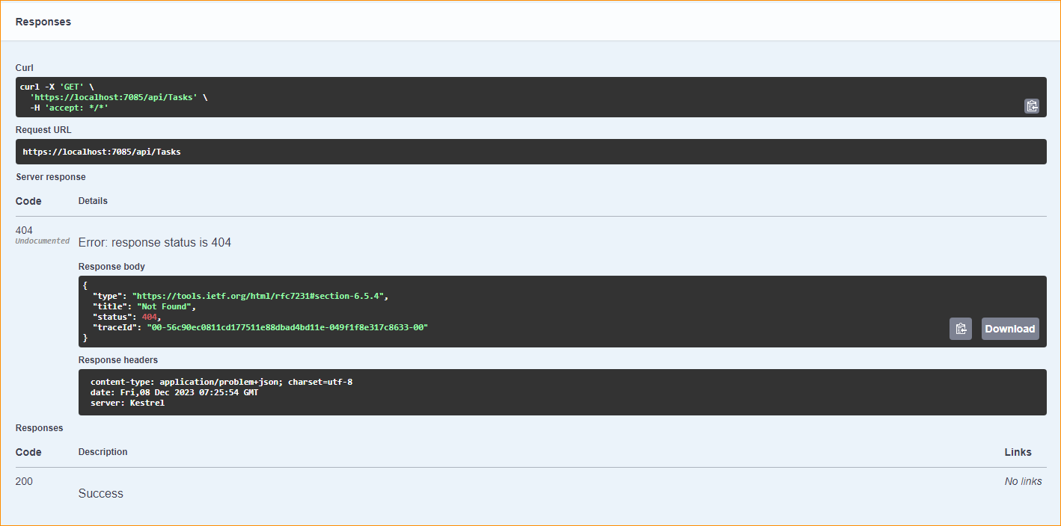

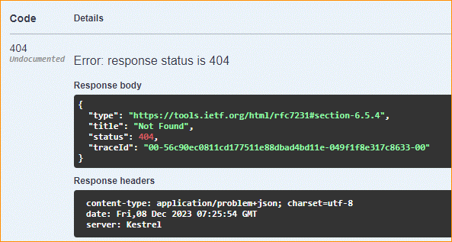

* **CreatedAtActionResult**: Represents a 201 Created response with a location header pointing to the newly created resource.

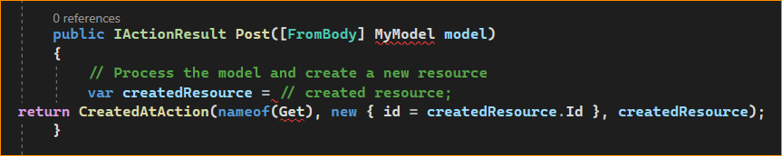

* BadRequestResult: Represents a 400 Bad Request response.

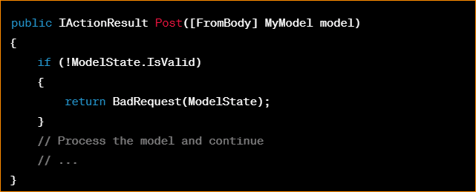

* **NoContentResult**: Represents a 204 No Content response, typically used for successful requests that don't return a body.

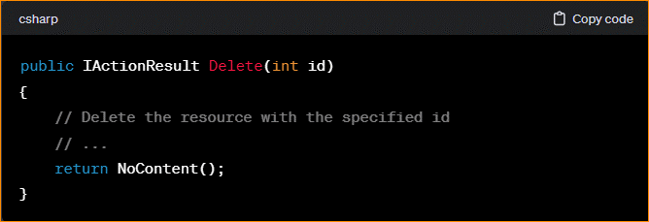

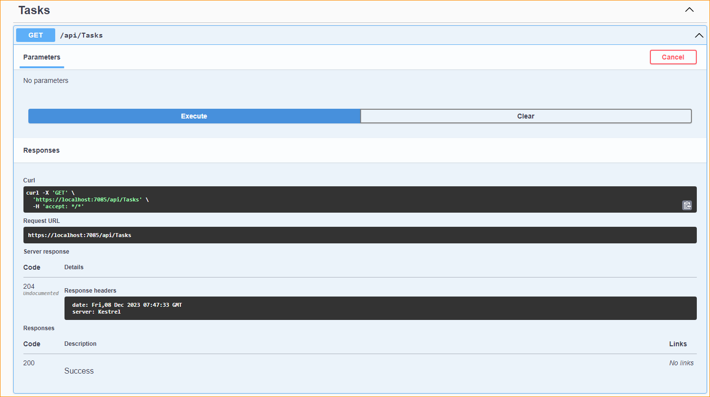

* **UnauthorizedResult**: Represents a 401 Unauthorized response.

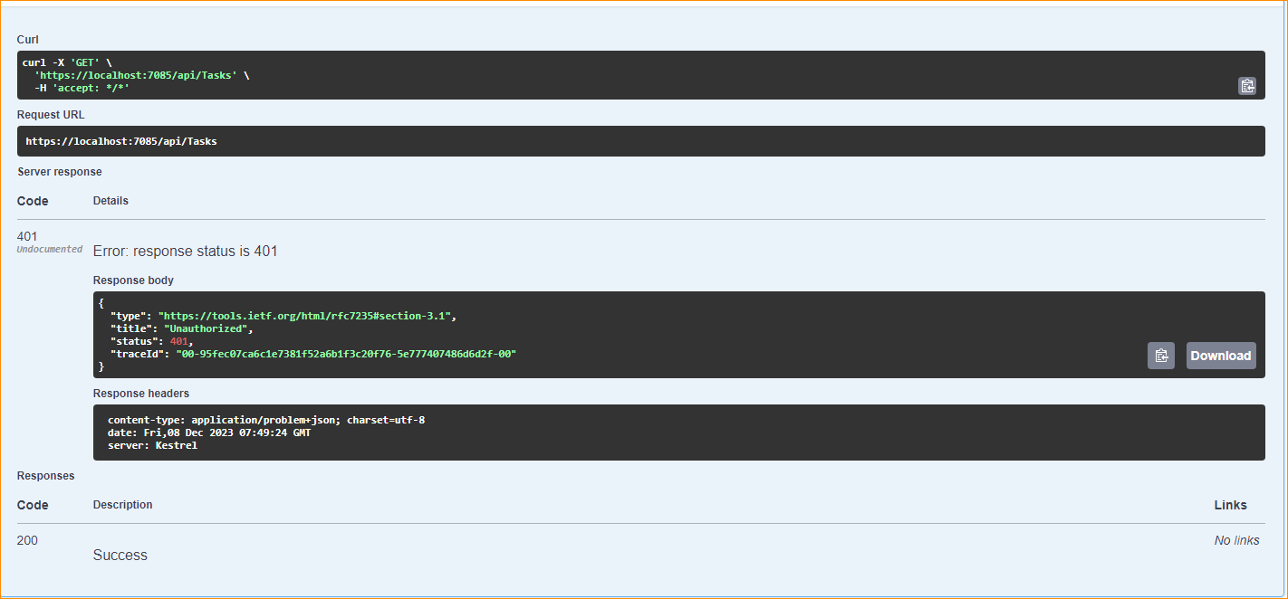

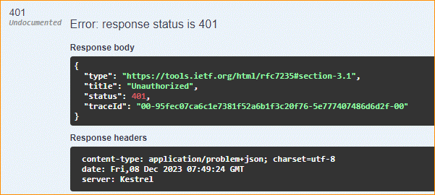

* **StatusCodeResult**: Represents a specific HTTP status code without a response body.

