Logging is about to find what happen in our application.

Example- Razor pages – index.html

Here we use logger to use to send messages to the console. So we can recognize if there are problems.

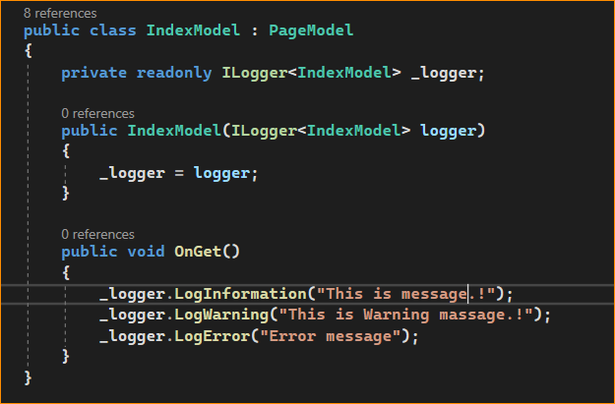

Result-

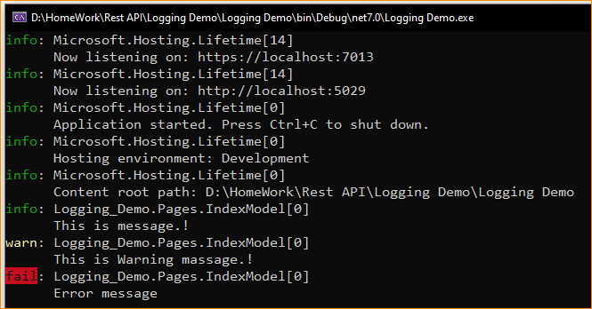

Logging information – appsettings.json

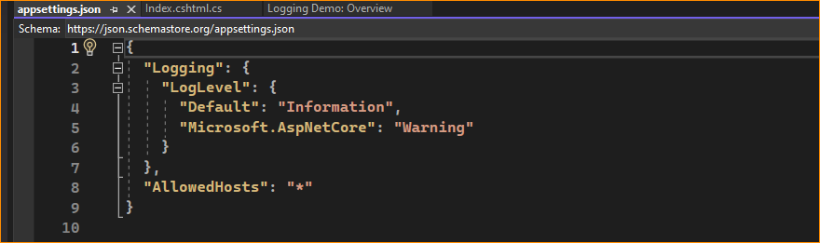

1. *If we have exception, how to show message –*

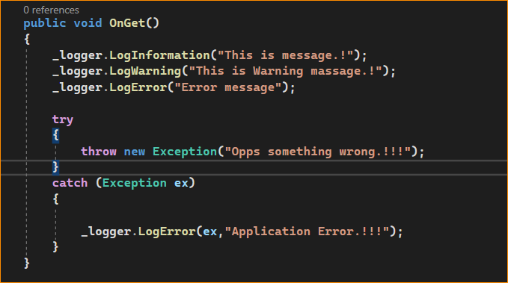

Console –

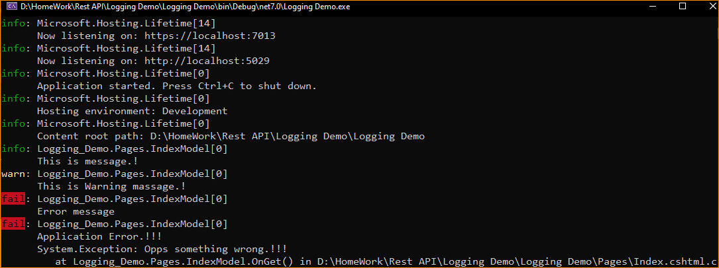

1. Can Sow time

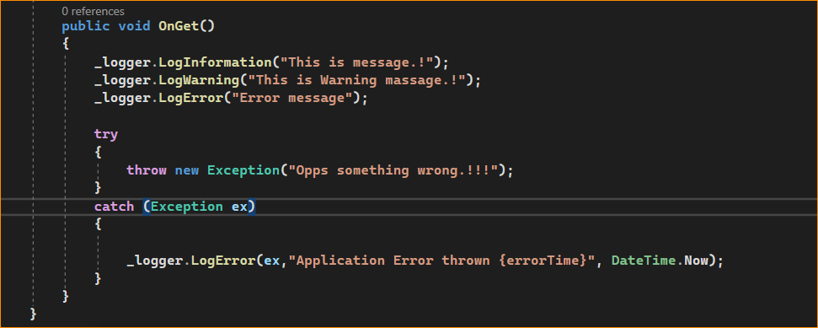

Result –

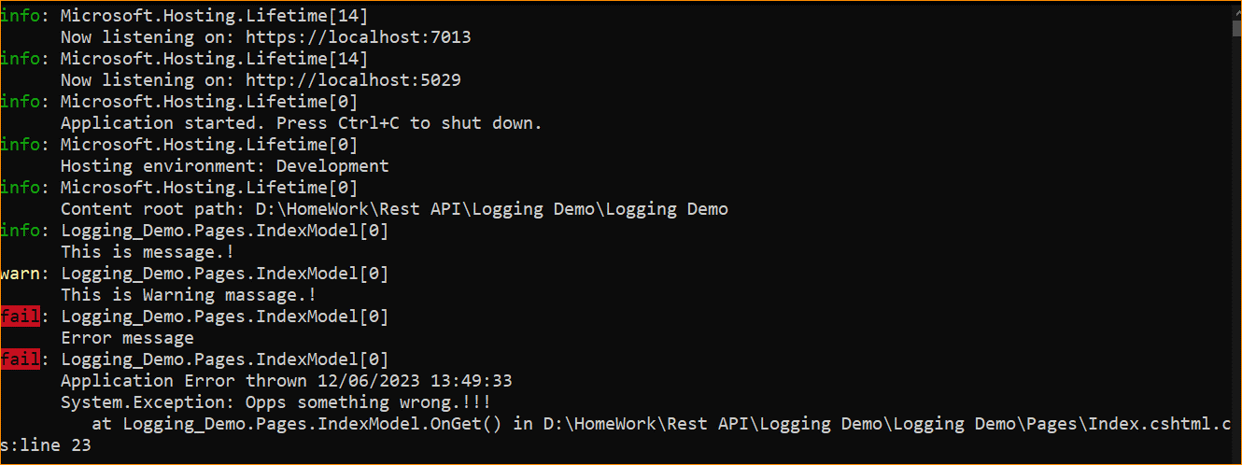

1. Logging using event ID –

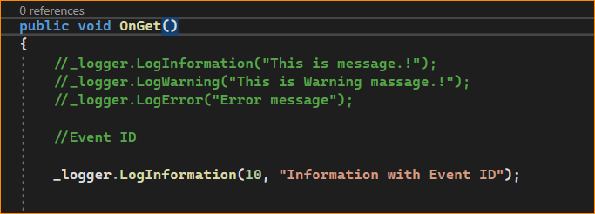

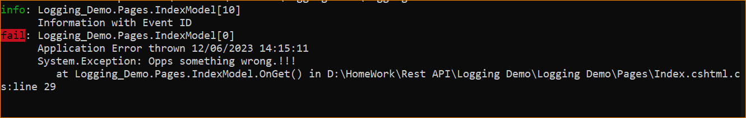

1. Filter and clear logging-

