宠物商店毕业设计

进度汇报

## 系统功能架构图

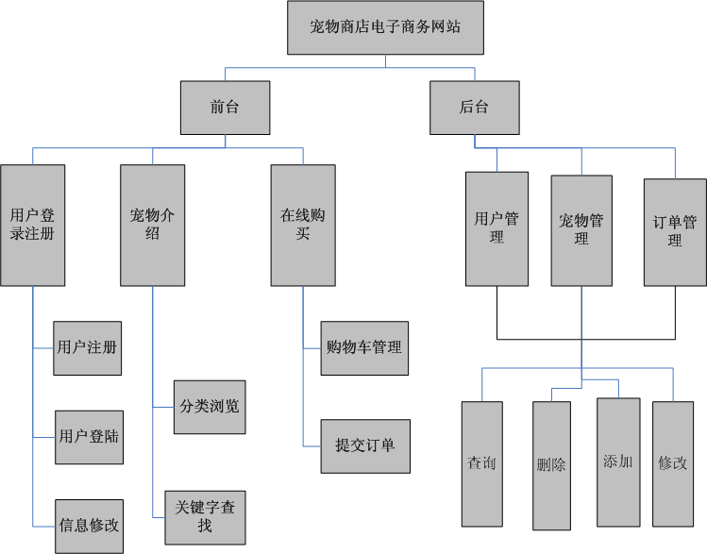

## E-R图

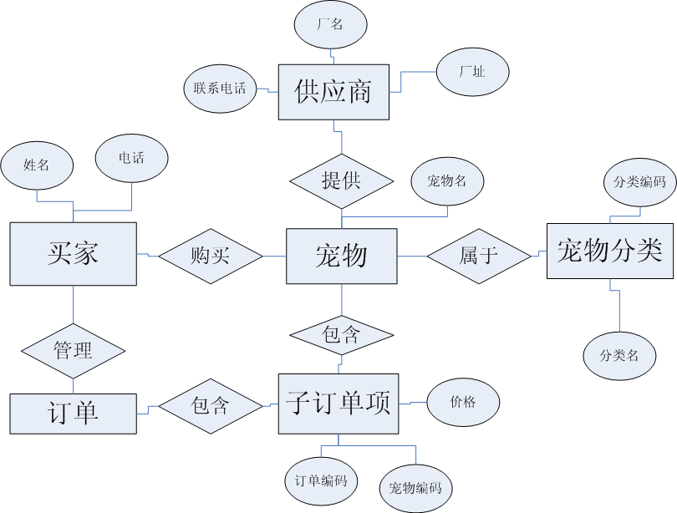

## 数据库模型（还需改进）

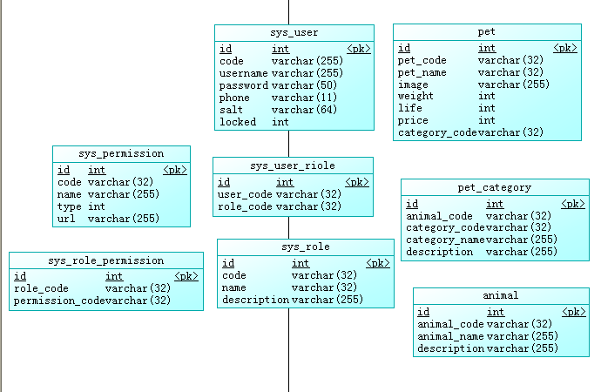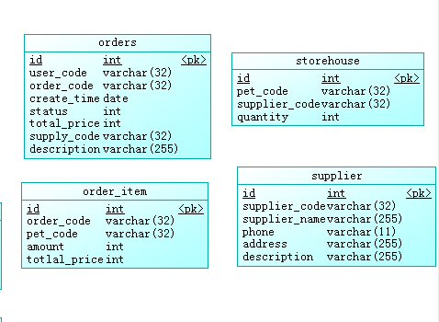

## 表结构（部分）

**表名：order_item**

|  |  |  |  |  |  |  |  |  |  |  |
| --- | --- | --- | --- | --- | --- | --- | --- | --- | --- | --- |
| **序号** | **列名** | **数据类型** | **长度** | **小数位** | **标识** | **主键** | **外键** | **允许空** | **默认值** | **说明** |
| 1 | id | int | 11 |  | 是 | 是 |  | 否 |  | auto_increment |
| 2 | order_code | varchar | 32 |  |  |  |  | 否 |  |  |
| 3 | pet_code | varchar | 32 |  |  |  |  | 否 |  |  |
| 4 | amount | int | 11 |  |  |  |  | 否 |  |  |
| 5 | totlal_price | int | 11 |  |  |  |  | 否 |  |  |

**表名：orders**

|  |  |  |  |  |  |  |  |  |  |  |
| --- | --- | --- | --- | --- | --- | --- | --- | --- | --- | --- |
| **序号** | **列名** | **数据类型** | **长度** | **小数位** | **标识** | **主键** | **外键** | **允许空** | **默认值** | **说明** |
| 1 | id | int | 11 |  | 是 | 是 |  | 否 |  | auto_increment |
| 2 | user_code | varchar | 32 |  |  |  |  | 否 |  |  |
| 3 | order_code | varchar | 32 |  |  |  |  | 否 |  |  |
| 4 | create_time | date |  |  |  |  |  | 否 |  |  |
| 5 | status | int | 11 |  |  |  |  | 否 |  |  |
| 6 | total_price | int | 11 |  |  |  |  | 否 |  |  |
| 7 | supply_code | varchar | 32 |  |  |  |  | 否 |  |  |
| 8 | description | varchar | 255 |  |  |  |  | 是 |  |  |

**表名：pet**

|  |  |  |  |  |  |  |  |  |  |  |
| --- | --- | --- | --- | --- | --- | --- | --- | --- | --- | --- |
| **序号** | **列名** | **数据类型** | **长度** | **小数位** | **标识** | **主键** | **外键** | **允许空** | **默认值** | **说明** |
| 1 | id | int | 11 |  | 是 | 是 |  | 否 |  | auto_increment |
| 2 | pet_code | varchar | 32 |  |  |  |  | 否 |  |  |
| 3 | pet_name | varchar | 32 |  |  |  |  | 否 |  |  |
| 4 | image | varchar | 255 |  |  |  |  | 是 |  |  |
| 5 | weight | int | 11 |  |  |  |  | 否 |  |  |
| 6 | life | int | 11 |  |  |  |  | 否 |  |  |
| 7 | price | int | 11 |  |  |  |  | 否 |  |  |
| 8 | category_code | varchar | 32 |  |  |  |  | 否 |  |  |

**表名：pet_category**

|  |  |  |  |  |  |  |  |  |  |  |
| --- | --- | --- | --- | --- | --- | --- | --- | --- | --- | --- |
| **序号** | **列名** | **数据类型** | **长度** | **小数位** | **标识** | **主键** | **外键** | **允许空** | **默认值** | **说明** |
| 1 | id | int | 11 |  | 是 | 是 |  | 否 |  | auto_increment |
| 2 | animal_code | varchar | 32 |  |  |  |  | 否 |  |  |
| 3 | category_code | varchar | 32 |  |  |  |  | 否 |  |  |
| 4 | category_name | varchar | 255 |  |  |  |  | 否 |  |  |
| 5 | description | varchar | 255 |  |  |  |  | 是 |  |  |

**表名：storehouse**

|  |  |  |  |  |  |  |  |  |  |  |
| --- | --- | --- | --- | --- | --- | --- | --- | --- | --- | --- |
| **序号** | **列名** | **数据类型** | **长度** | **小数位** | **标识** | **主键** | **外键** | **允许空** | **默认值** | **说明** |
| 1 | id | int | 11 |  | 是 | 是 |  | 否 |  | auto_increment |
| 2 | pet_code | varchar | 32 |  |  |  |  | 否 |  |  |
| 3 | supplier_code | varchar | 32 |  |  |  |  | 否 |  |  |
| 4 | quantity | int | 11 |  |  |  |  | 否 |  |  |

**表名：supplier**

|  |  |  |  |  |  |  |  |  |  |  |
| --- | --- | --- | --- | --- | --- | --- | --- | --- | --- | --- |
| **序号** | **列名** | **数据类型** | **长度** | **小数位** | **标识** | **主键** | **外键** | **允许空** | **默认值** | **说明** |
| 1 | id | int | 11 |  | 是 | 是 |  | 否 |  | auto_increment |
| 2 | supplier_code | varchar | 32 |  |  |  |  | 否 |  |  |
| 3 | supplier_name | varchar | 255 |  |  |  |  | 否 |  |  |
| 4 | phone | varchar | 11 |  |  |  |  | 是 |  |  |
| 5 | address | varchar | 255 |  |  |  |  | 是 |  |  |
| 6 | description | varchar | 255 |  |  |  |  | 是 |  |  |

**表名：sys_role**

|  |  |  |  |  |  |  |  |  |  |  |
| --- | --- | --- | --- | --- | --- | --- | --- | --- | --- | --- |
| **序号** | **列名** | **数据类型** | **长度** | **小数位** | **标识** | **主键** | **外键** | **允许空** | **默认值** | **说明** |
| 1 | id | int | 11 |  | 是 | 是 |  | 否 |  | auto_increment |
| 2 | code | varchar | 32 |  |  |  |  | 否 |  |  |
| 3 | name | varchar | 32 |  |  |  |  | 否 |  |  |
| 4 | description | varchar | 255 |  |  |  |  | 是 |  |  |

**表名：sys_role_permission**

|  |  |  |  |  |  |  |  |  |  |  |
| --- | --- | --- | --- | --- | --- | --- | --- | --- | --- | --- |
| **序号** | **列名** | **数据类型** | **长度** | **小数位** | **标识** | **主键** | **外键** | **允许空** | **默认值** | **说明** |
| 1 | id | int | 11 |  | 是 | 是 |  | 否 |  | auto_increment |
| 2 | role_code | varchar | 32 |  |  |  |  | 否 |  |  |
| 3 | permission_code | varchar | 32 |  |  |  |  | 否 |  |  |

**表名：sys_user**

|  |  |  |  |  |  |  |  |  |  |  |
| --- | --- | --- | --- | --- | --- | --- | --- | --- | --- | --- |
| **序号** | **列名** | **数据类型** | **长度** | **小数位** | **标识** | **主键** | **外键** | **允许空** | **默认值** | **说明** |
| 1 | id | int | 11 |  | 是 | 是 |  | 否 |  | auto_increment |
| 2 | code | varchar | 255 |  |  |  |  | 否 |  |  |
| 3 | username | varchar | 255 |  |  |  |  | 否 |  |  |
| 4 | password | varchar | 50 |  |  |  |  | 否 |  |  |
| 5 | phone | varchar | 11 |  |  |  |  | 是 |  |  |
| 6 | salt | varchar | 64 |  |  |  |  | 是 |  |  |
| 7 | locked | int | 11 |  |  |  |  | 否 | 0 |  |

## 框架搭建

登录页面(初步)

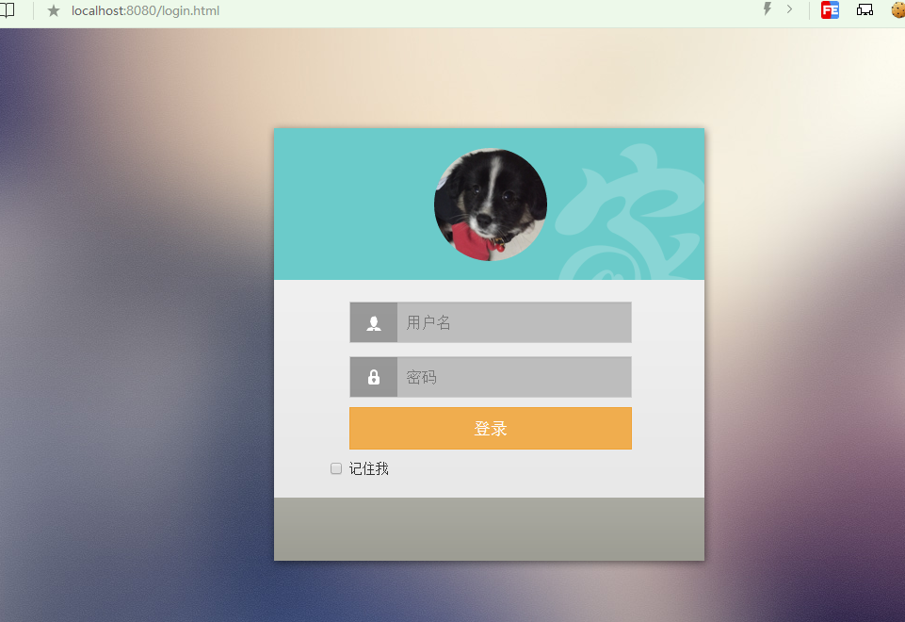

后台管理页面

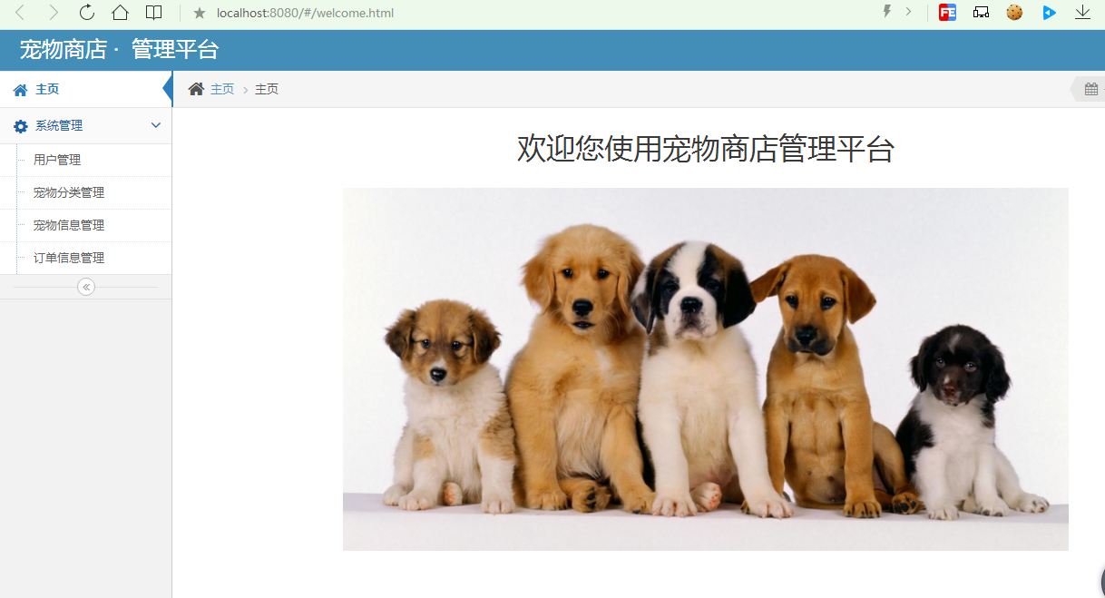

功能尚未完成。