FINDING 1 — login in transit (plain HTTP)
What's exposed: The username and password.
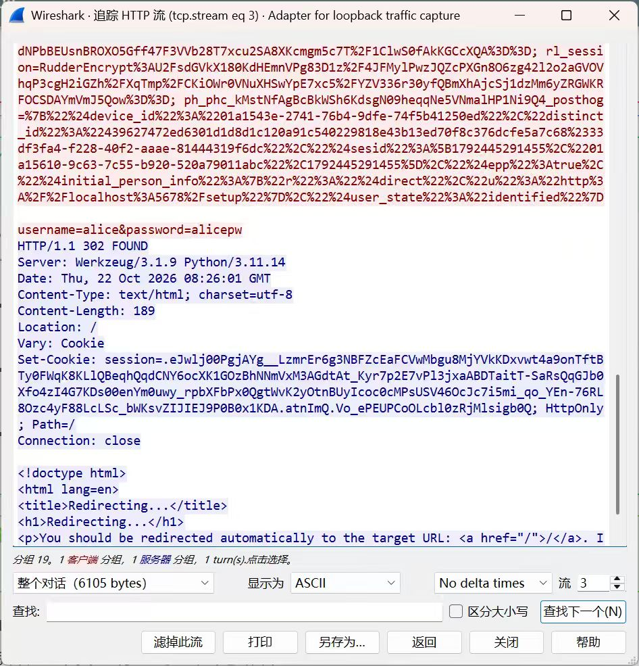
Evidence: the username=alice&password=alicepw line in the HTTP stream
Who can read it:Anyone able to capture the relevant unencrypted network traffic.
Severity: (Low / Med / High) because exposed credentials could allow unauthorized account access.
Fix (1 line):Configure HTTPS using TLS and verify that the server certificate is trusted.

FINDING 2 — certificate trust
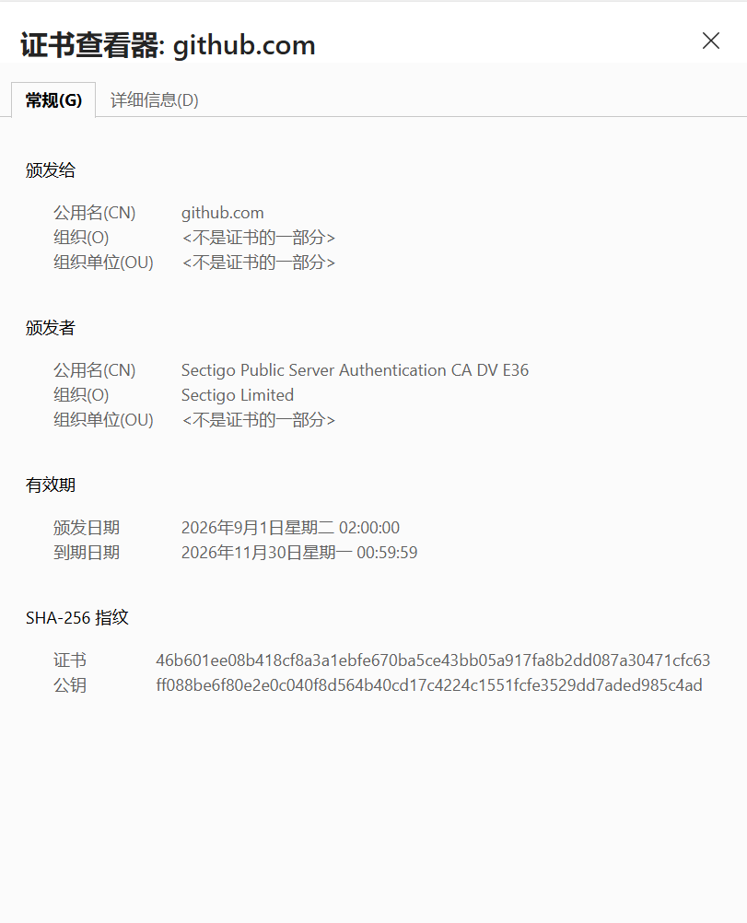
GitHub issued by:Sectigo Limited
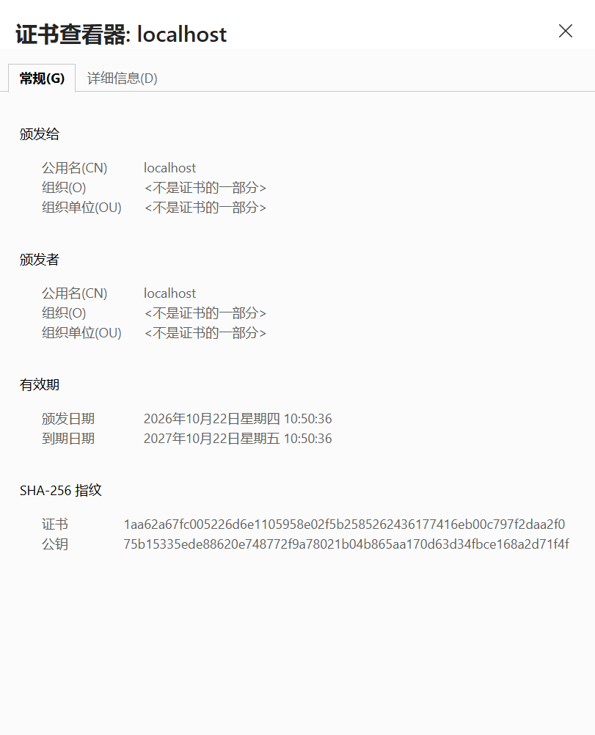
Yours issued by:localhost

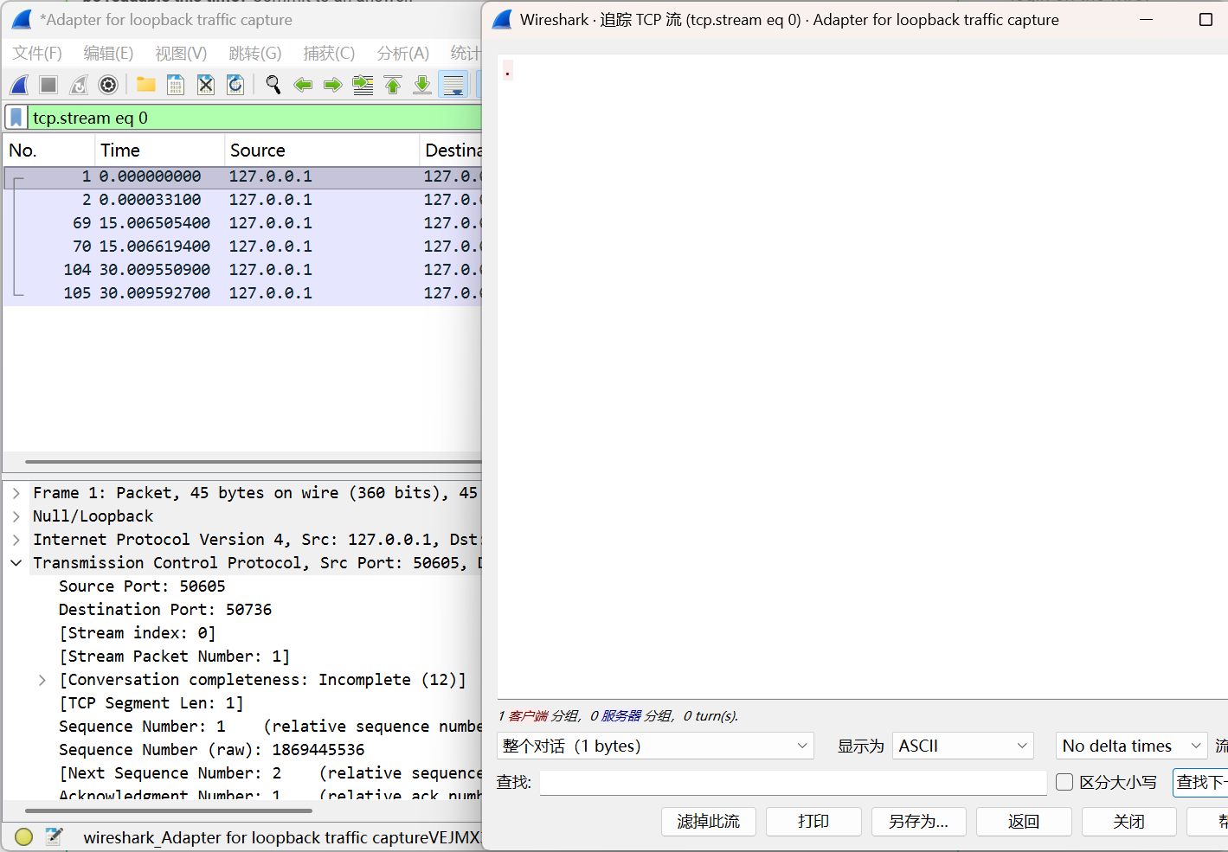
The trust yours lacks:A chain of trust to a trusted Certificate Authority (CA).
Verdict — is "encrypted" the same as "safe to trust"? Why (one sentence):No, encryption protects data in transit, but without a trusted certificate, the server's identity cannot be reliably verified.

