MODBUS MONITOR
User Guide // v3.04

Overview

Modbus Monitor is a desktop application for real-time acquisition and logging of flow meter data over Modbus RTU (RS-485). It combines a live ZMQ subscriber for instantaneous flow rate display with a configurable Modbus register reader, and exports results to Excel for analysis or reporting.

ℹ NOTE: The flow rate display receives data from a Frog monitoring process via ZMQ on 127.0.0.1:5555. Frog must be running before starting this application.

Interface

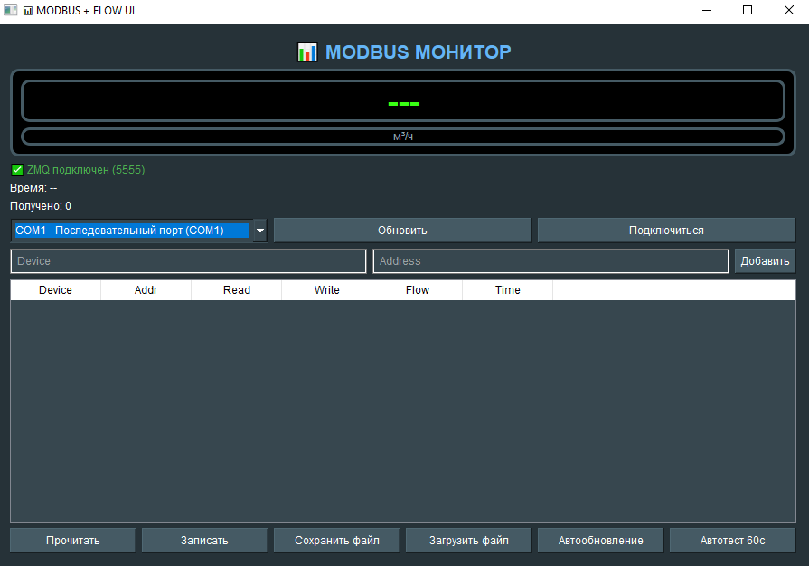

Figure 1 — Main application window

Quick Start

# | ACTION | DESCRIPTION
1 | Select COM Port | Choose the correct serial port from the dropdown list and click Connect. The port corresponds to the RS-485 adapter connected to your flow meter.
2 | Add Device | Enter a device name in the Device field and the Modbus register address in the Address field, then click Add. A new row will appear in the data table.
3 | Read Registers | Click Read to perform a single Modbus read cycle. The Read column will update with the current register value decoded as a 32-bit float.
4 | Auto Update | Enable Auto Update to continuously read all registers every second. The button will highlight green when active. Click again to stop.
5 | Auto Test | Use Auto Test (60 s) to automatically save a snapshot of all readings to the Excel file every 60 seconds — useful for acceptance testing.
6 | Save / Load | Use Save File to export the current table to example.xlsx, or Load File to restore a previously saved session.

Register Encoding

Flow values are stored as IEEE 754 single-precision floats across two consecutive 16-bit Modbus holding registers in Little-Endian Word Order (low word first):

Register | Content | Notes
addr + 0 | Low word (LSW) | Bits 0–15 of the float32
addr + 1 | High word (MSW) | Bits 16–31 of the float32

Requirements

DEPENDENCY | DETAILS
Python | 3.10+
PySide6 | Qt 6 bindings for the GUI layer
pymodbus | Modbus RTU client over serial
pyzmq | ZMQ subscriber for live flow data
pandas / openpyxl | Excel read/write support
Frog Monitor | Must be running and publishing on tcp://127.0.0.1:5555

Modbus Monitor // User Guide // v3.04 // 2026

