SYSTEM DELIVERY AND TECHNICAL DOCUMENTATION

系统交付与技术文档
  - Mixed Reality River Water Quality Visualization System
  - 混合现实河流水质可视化系统
Prepared by: Zhang Xiaoya
Supervisor: Dr. Lam Meng Chun
Organization: FTSM / MYXLab, UKM
Date: 17 April 2026

Table of Contents / 目录
Table of Contents / 目录 2
Mixed Reality River Water Quality Visualization System 4
混合现实河流水质可视化系统 4
1. Project Overview / 1. 项目概述 4
2. System Architecture / 2. 系统架构 5
2.1 Main Components / 2.1 主要组成 5
2.2 Data Flow / 2.2 数据流 6
3. Raspberry Pi and Hardware / 3. 树莓派与硬件 7
3.1 Access Platform and Runtime Software / 3.1 访问平台与运行软件 7
3.2 Main Script / 3.2 主脚本 8
3.3 Main Script Explanation / 3.3 主脚本解析 8
3.3.1 UNITY_IP and UNITY_PORT 8
3.3.2 send() 8
3.3.3 encoder_loop() 9
3.3.4 joystick_loop() 9
3.3.5 slider_loop() 9
3.3.6 Button Callbacks 10
3.4 MCP3008 and SPI / 3.4 MCP3008 与 SPI 12
3.4.1 Why SPI Must Be Enabled / 3.4.1 为什么必须启用 SPI 13
3.4.2 SPI Setup / 3.4.2 SPI 配置 13
3.4.3 SPI Verification / 3.4.3 SPI 验证 14
3.5 Hardware Mapping / 3.5 硬件映射 15
4. Unity Environment and Scripts / 4. Unity 环境与脚本 17
4.1 Unity Environment / 4.1 Unity 环境 17
4.1.1 What This Means for Rebuild / 4.1.1 这对环境重建意味着什么 18
4.2 Key Scripts / 4.2 关键脚本 20
4.3 Unity Script Explanation / 4.3 Unity 脚本解析 20
4.3.1 PiSystemBridge.cs 20
4.3.2 WaterSystemManager.cs 21
4.3.3 mapswitch.cs 21
4.4 PiSystemBridge Inspector / 4.4 PiSystemBridge Inspector 23
5. Setup and Operation / 5. 配置与操作 25
5.1 Raspberry Pi Setup / 5.1 树莓派配置 25
5.2 Unity Setup / 5.2 Unity 配置 27
5.3 Runtime Flow / 5.3 运行流程 27
6. Testing, Limitations, and References / 6. 测试、限制与参考资料 28
6.1 Validation / 6.1 验证 28
6.2 Troubleshooting / 6.2 故障排查 31
6.3 Known Limitations / 6.3 已知限制 32
6.4 GitHub Repository / 6.4 GitHub 仓库 32
6.5 Conclusion / 6.5 结论 33

SYSTEM DELIVERY AND TECHNICAL DOCUMENTATION

系统交付与技术文档

Mixed Reality River Water Quality Visualization System

混合现实河流水质可视化系统

Prepared by: Zhang Xiaoya
Supervisor: Dr. Lam Meng Chun
Organization: FTSM / MYXLab, UKM
Date: 17 April 2026

1. Project Overview / 1. 项目概述

English
This project is a mixed reality river water quality visualization prototype. It runs in Unity on Meta Quest Pro. Joystick, slider, and encoder input is collected on Raspberry Pi, converted when necessary through MCP3008, transmitted to Unity through UDP, and used to drive map selection, filtering, and chart interaction.

The current interaction path is mapstyle -> river -> ri -> data.

中文
本项目是一个混合现实河流水质可视化原型。系统运行在 Meta Quest Pro 的 Unity 环境中。摇杆、滑杆和旋钮输入首先在树莓派端采集，在需要时通过 MCP3008 进行模数转换，再通过 UDP 发送到 Unity，用于驱动地图选择、筛选和图表交互。

当前交互路径为 mapstyle -> river -> ri -> data。

Physical controllers

↓
Raspberry Pi Zero

↓
MCP3008 for analog inputs

↓
pi_input_sender.py

↓
UDP transport

↓
Unity MR application

↓
Map and water-quality interaction

Figure 1. Overall system architecture / 图1.系统总览图
Explanation: This figure summarizes the full delivery path from physical input hardware to Raspberry Pi processing, UDP transport, and Unity-side visual interaction.

2. System Architecture / 2. 系统架构

2.1 Main Components / 2.1 主要组成

English
• Meta Quest Pro: runtime headset
• Unity: mixed reality application
• Raspberry Pi Zero: physical control bridge
• MCP3008: analog-to-digital conversion for joystick and sliders
• CSV data: water quality source data

中文
• Meta Quest Pro：运行头显
• Unity：混合现实应用
• Raspberry Pi Zero：实体控制桥接设备
• MCP3008：摇杆和滑杆的模数转换器
• CSV 数据：水质原始数据

2.2 Data Flow / 2.2 数据流

Joystick, sliders, encoders

↓
GPIO or MCP3008 channel read

↓
Python input loop classifies state

↓
UDP message such as ENC / JOY / SLIDER / BTN

↓
PiSystemBridge receives on port 5005

↓
Unity updates map, river, RI, and data view

Figure 2. Data flow from Raspberry Pi to Unity / 图2.树莓派到 Unity 的数据流图
Explanation: This figure focuses on runtime data movement, showing how controller state is sampled, translated into protocol messages, and consumed by PiSystemBridge in Unity.

3. Raspberry Pi and Hardware / 3. 树莓派与硬件

3.1 Access Platform and Runtime Software / 3.1 访问平台与运行软件

English
The Raspberry Pi workflow has three layers:
• Windows PowerShell: command entry platform on the PC
• SSH: remote access method
• Raspberry Pi OS and Python 3: actual execution environment

Main software and libraries:
• Python 3: runtime language
• gpiozero: reads digital input such as joystick press and encoder signals
• spidev: reads MCP3008 analog values through SPI
• socket: sends UDP messages to Unity
• threading: runs multiple input loops in parallel

中文
树莓派工作流可分为三层：
• Windows PowerShell：电脑端输入命令的平台
• SSH：远程访问方式
• Raspberry Pi OS 和 Python 3：真正执行脚本的环境

主要软件和库：
• Python 3：运行语言
• gpiozero：读取摇杆按下和旋钮等数字输入
• spidev：通过 SPI 读取 MCP3008 的模拟量
• socket：向 Unity 发送 UDP 消息
• threading：并行运行多个输入循环

3.2 Main Script / 3.2 主脚本

English
The final integrated Raspberry Pi script is pi_input_sender.py.

中文
最终整合使用的树莓派主脚本是 pi_input_sender.py。

3.3 Main Script Explanation / 3.3 主脚本解析

3.3.1 UNITY_IP and UNITY_PORT

English
These variables define where the Raspberry Pi sends UDP messages. If the Unity computer changes, UNITY_IP must be updated.

中文
这两个变量定义了树莓派发送 UDP 消息的目标位置。如果运行 Unity 的电脑发生变化，就必须更新 UNITY_IP。

3.3.2 send()

English
This function is the single message output point. It packages the message string and sends it to Unity through UDP.

中文
这个函数是统一的消息发送出口。它将消息字符串打包后，通过 UDP 发送给 Unity。

3.3.3 encoder_loop()

English
This loop monitors encoder phase changes and sends messages such as ENC1:1, ENC2:-1, or ENC3:1.

中文
这个循环持续监测旋钮的相位变化，并发送例如 ENC1:1、ENC2:-1 或 ENC3:1 这样的消息。

3.3.4 joystick_loop()

English
This loop reads joystick analog values from CH5 and CH6, compares them with thresholds, and converts them into directional messages such as JOY:LEFT, JOY:RIGHT, JOY:UP, and JOY:DOWN.

中文
这个循环从 CH5 和 CH6 读取摇杆模拟值，结合阈值判断后，将其转换为 JOY:LEFT、JOY:RIGHT、JOY:UP 和 JOY:DOWN 等方向消息。

3.3.5 slider_loop()

English
This loop reads CH1 and CH3 and sends SLIDER1:<value> and SLIDER2:<value> when the values change enough to pass the threshold.

中文
这个循环读取 CH1 和 CH3，当数值变化超过设定阈值时，就发送 SLIDER1:<value> 和 SLIDER2:<value> 消息。

3.3.6 Button Callbacks

English
Button callbacks send BTN1, BTN2, BTN3, and JOYBTN. In the current system, BTN3 is especially important because it changes encoder 3 between zoom mode and rotate mode.

中文
按钮回调会发送 BTN1、BTN2、BTN3 和 JOYBTN。在当前系统中，BTN3 特别重要，因为它会切换旋钮 3 的缩放模式与旋转模式。

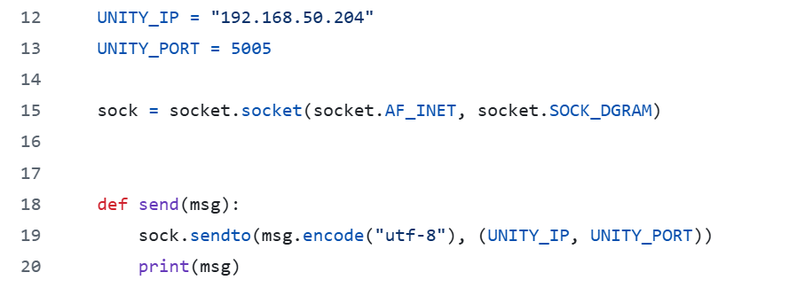
Network configuration and send()
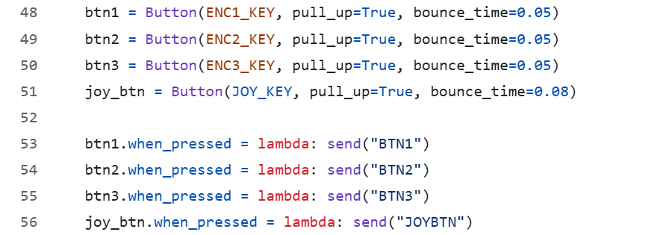
Button callback registration
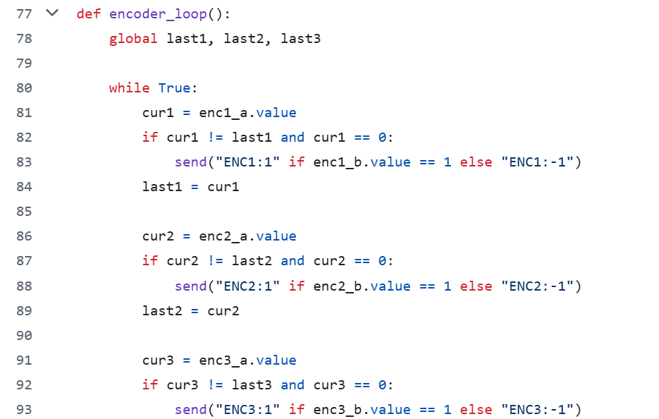
encoder_loop() implementation
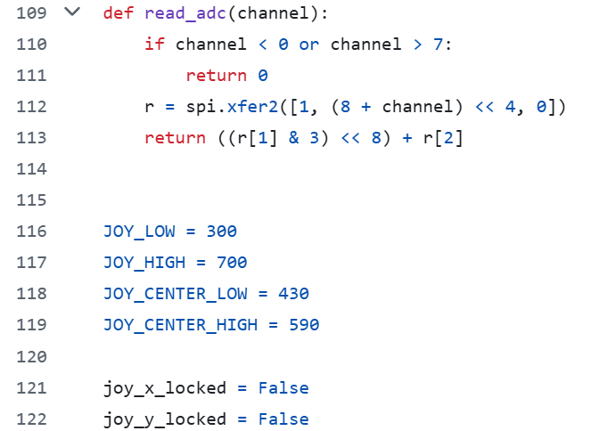
read_adc() and ADC thresholds
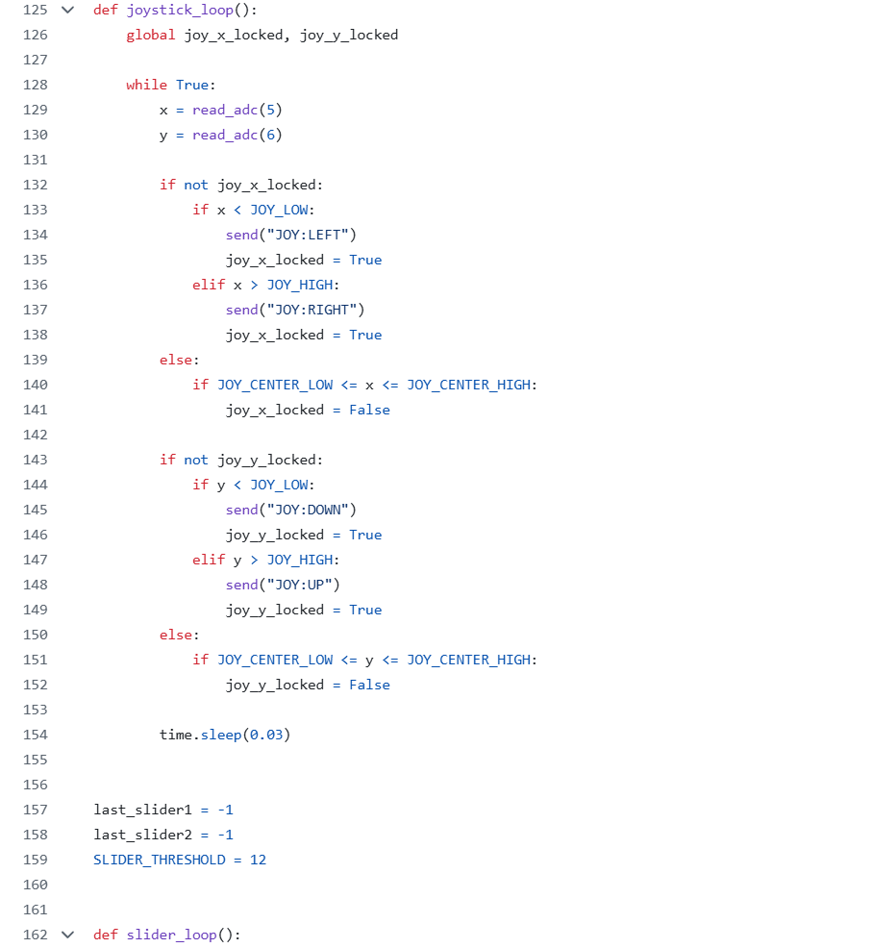
joystick_loop() and slider_loop()
Figure 3. Key sections of pi_input_sender.py / 图3.pi_input_sender.py 关键代码截图
Explanation: These screenshots show the actual Raspberry Pi runtime script sections used in the project, including network configuration, button callbacks, encoder handling, ADC reading, and the joystick and slider loops.

3.4 MCP3008 and SPI / 3.4 MCP3008 与 SPI

English
Raspberry Pi cannot read analog voltage directly. MCP3008 converts analog joystick and slider signals into digital values through SPI.

Channel mapping:
• CH1: horizontal slider
• CH3: vertical slider
• CH5: joystick left-right
• CH6: joystick up-down

中文
树莓派不能直接读取模拟电压，因此需要 MCP3008 通过 SPI 将摇杆和滑杆的模拟信号转换为数字值。

通道映射：
• CH1：横向滑杆
• CH3：纵向滑杆
• CH5：摇杆左右
• CH6：摇杆上下

3.4.1 Why SPI Must Be Enabled / 3.4.1 为什么必须启用 SPI

English
If SPI is not enabled, Raspberry Pi cannot communicate with MCP3008, and analog channels cannot be read correctly.

中文
如果没有启用 SPI，树莓派就无法与 MCP3008 通信，也就无法正确读取模拟通道。

3.4.2 SPI Setup / 3.4.2 SPI 配置

English
1. Connect to Raspberry Pi through SSH.
2. Run sudo raspi-config.
3. Open Interface Options -> SPI -> Enable.
4. Reboot using sudo reboot.
5. Reconnect and check ls /dev/spidev*.
6. If needed, run lsmod | grep spi.
7. If SPI is still unavailable, open sudo nano /boot/config.txt and confirm dtparam=spi=on exists.

中文
1. 先通过 SSH 连接树莓派。
2. 输入 sudo raspi-config。
3. 进入 Interface Options -> SPI -> Enable。
4. 使用 sudo reboot 重启。
5. 重新连接后输入 ls /dev/spidev* 检查。
6. 如有需要，输入 lsmod | grep spi。
7. 如果 SPI 仍不可用，则打开 sudo nano /boot/config.txt，确认存在 dtparam=spi=on。

3.4.3 SPI Verification / 3.4.3 SPI 验证

English
SPI can be treated as available when:
• a device such as /dev/spidev0.0 appears
• lsmod | grep spi shows spi_bcm2835 and spidev
• mcp_read_all.py can read changing values

中文
当满足以下条件时，可以认为 SPI 已可用：
• 出现类似 /dev/spidev0.0 的设备路径
• lsmod | grep spi 显示 spi_bcm2835 和 spidev
• mcp_read_all.py 能读到变化数值

Analog movement on slider or joystick

↓
MCP3008 samples CH1 / CH3 / CH5 / CH6

↓
SPI sends digital values to Raspberry Pi

↓
spidev reads channel values in Python

↓
Threshold logic converts values into events

↓
UDP messages are sent to Unity

Figure 4. MCP3008 analog conversion flow / 图4.MCP3008 模拟量转换流程图
Explanation: This figure explains how MCP3008 converts analog voltage changes from the joystick and sliders into digital channel values that Python can read and forward to Unity.

3.5 Hardware Mapping / 3.5 硬件映射

Joystick / 摇杆
• SW -> GPIO26
• VRx -> MCP3008 CH5
• VRy -> MCP3008 CH6

Sliders / 滑杆
• Horizontal slider -> CH1
• Vertical slider -> CH3

Encoders / 旋钮
• Encoder 1: S1 -> GPIO17, S2 -> GPIO22, KEY -> GPIO27
• Encoder 2: S1 -> GPIO18, S2 -> GPIO23, KEY -> GPIO25
• Encoder 3: S1 -> GPIO24, S2 -> GPIO16, KEY -> GPIO20

Encoder 3 special behavior / 旋钮 3 特殊行为
• BTN3 toggles encoder 3 between zoom mode and rotate mode
• BTN3 用于在旋钮 3 的缩放模式与旋转模式之间切换

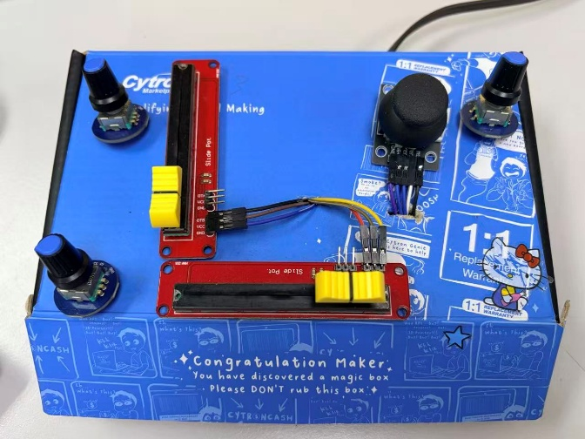  Control box overview | 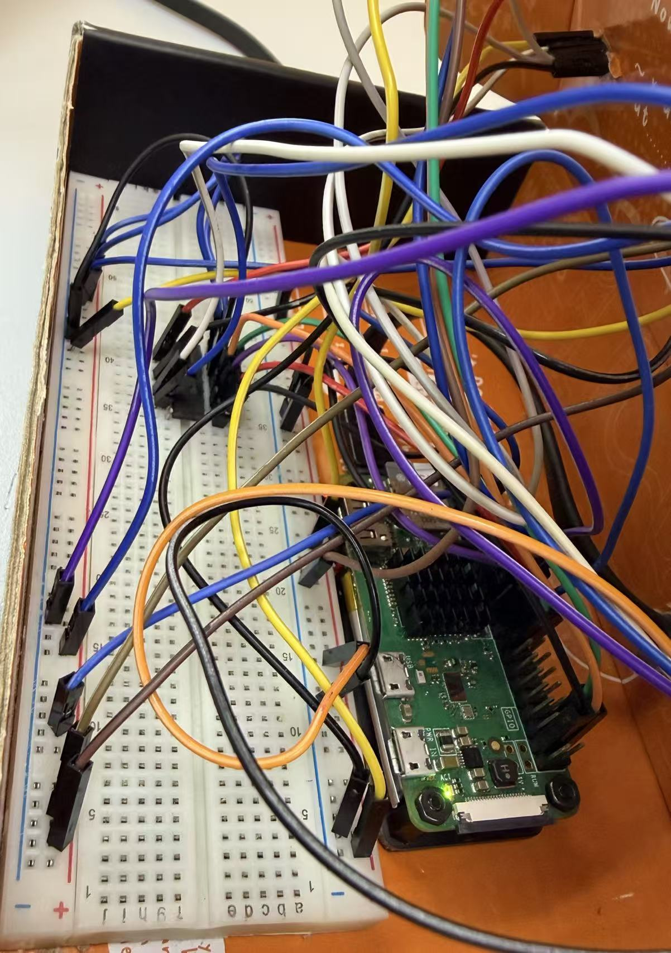  Raspberry Pi and breadboard wiring

Figure 5. Raspberry Pi and breadboard overview / 图5.树莓派与面包板整体图
Explanation: This figure documents the physical prototype, including the control box layout and the Raspberry Pi with breadboard wiring used during integration.

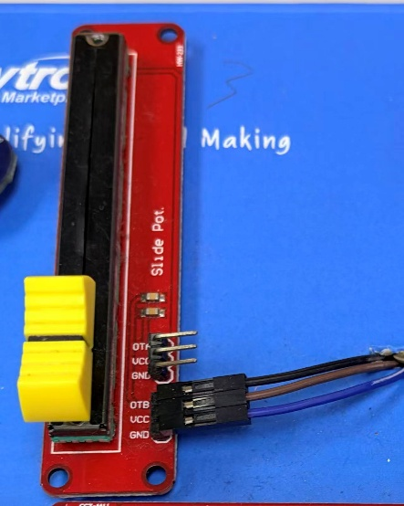  Slider module detail | 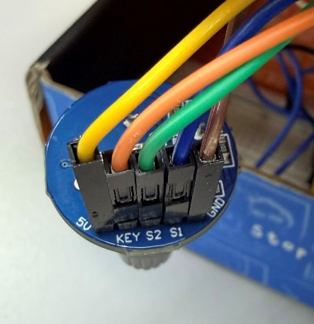  Encoder wiring detail | 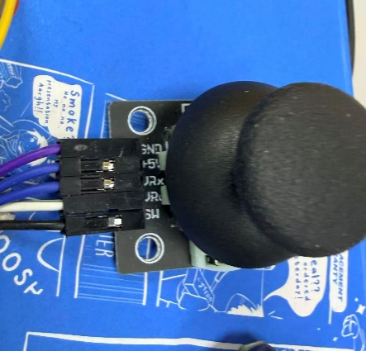  Joystick module detail

Figure 6. Joystick, slider, and encoder mapping / 图6.摇杆、滑杆与旋钮映射图
Explanation: This figure highlights the mapping details of the slider, encoder, and joystick modules so that each physical control can be matched to its corresponding GPIO or ADC channel.

4. Unity Environment and Scripts / 4. Unity 环境与脚本

4.1 Unity Environment / 4.1 Unity 环境

English
The project should be opened with Unity 6000.0.62f1. The environment is configured for Meta Quest Pro mixed reality and depends on Meta XR and Unity XR packages.

Main scene:
• Assets/310.unity

Important package groups:
• Meta XR SDK
• OpenXR
• Android XR OpenXR
• AR Foundation
• XR Hands
• XR Interaction Toolkit

中文
项目应使用 Unity 6000.0.62f1 打开。当前环境面向 Meta Quest Pro 混合现实，并依赖 Meta XR 和 Unity XR 相关包。

主场景：
• Assets/310.unity

重要包组：
• Meta XR SDK
• OpenXR
• Android XR OpenXR
• AR Foundation
• XR Hands
• XR Interaction Toolkit

4.1.1 What This Means for Rebuild / 4.1.1 这对环境重建意味着什么

English
When reconstructing the Unity environment, package compatibility and Android XR support must be checked before editing scripts or scene logic.

中文
在重建 Unity 环境时，应先检查包兼容性和 Android XR 支持，而不是先修改脚本或场景逻辑。

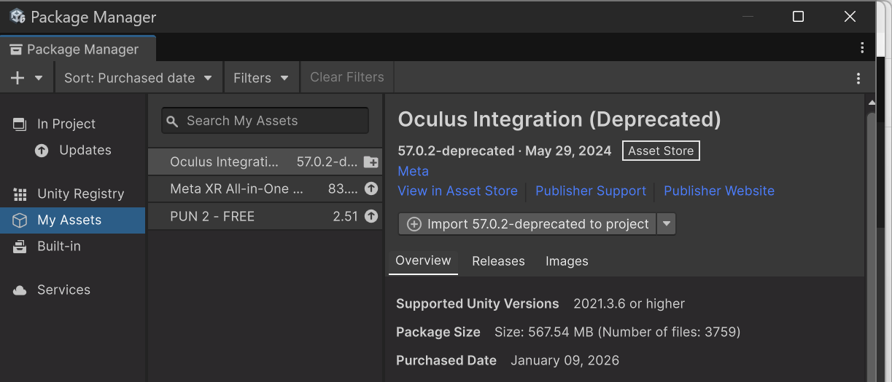
Package Manager assets
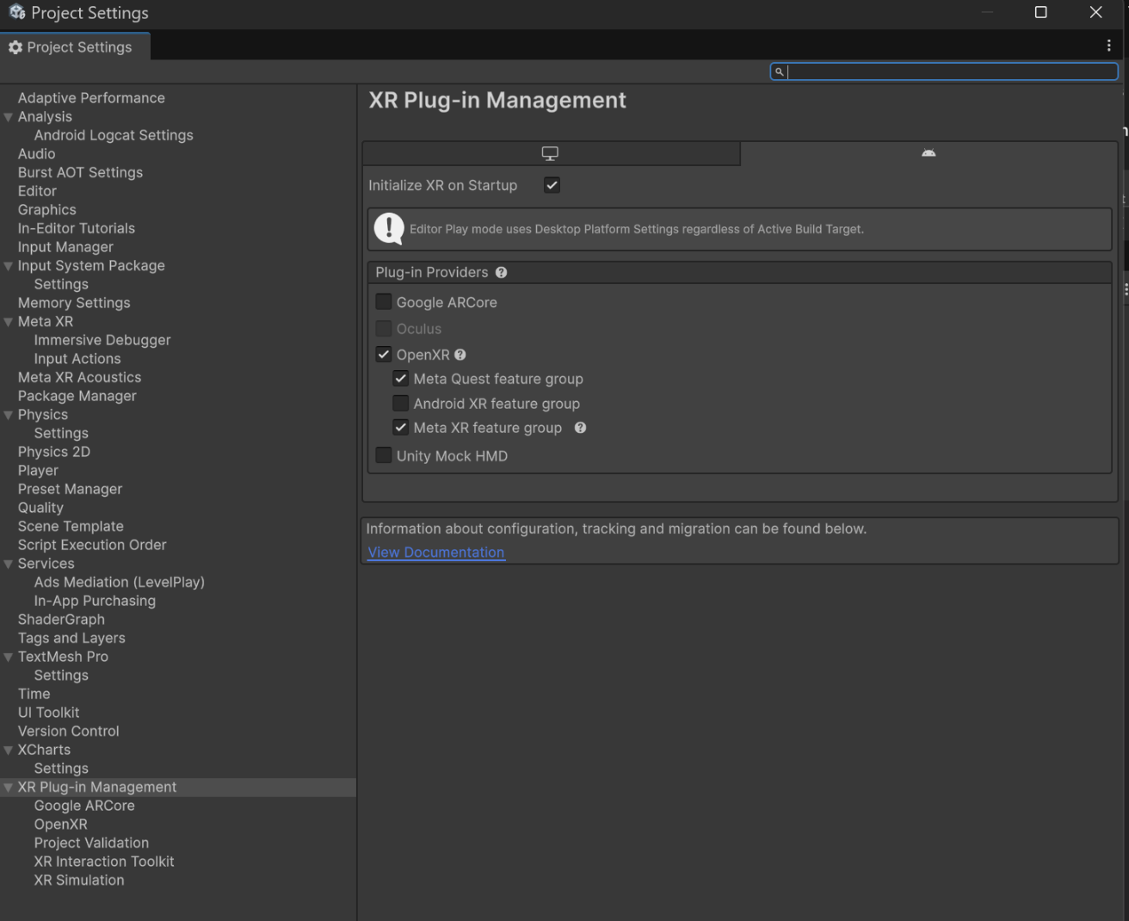
XR Plug-in Management
Figure 7. Unity project and XR package setup / 图7.Unity 项目与 XR 包配置
Explanation: This figure records the Unity-side environment setup, combining package acquisition evidence with XR Plug-in Management settings that enable OpenXR and Meta Quest feature groups for the project.

4.2 Key Scripts / 4.2 关键脚本

Script | Purpose | What to check
PiSystemBridge.cs | receives UDP messages and maps them to Unity actions | port, object references, slider ranges
WaterSystemManager.cs | controls river state, filtering, and charts | toggles, dropdowns, chart references
mapswitch.cs | switches map layers | default, satellite, and terrain map references

脚本 | 用途 | 重点检查
PiSystemBridge.cs | 接收 UDP 消息并映射为 Unity 动作 | 端口、对象引用、滑杆范围
WaterSystemManager.cs | 控制河流状态、筛选和图表 | toggles、dropdowns、图表引用
mapswitch.cs | 切换地图图层 | 默认、卫星和地形地图引用

4.3 Unity Script Explanation / 4.3 Unity 脚本解析

4.3.1 PiSystemBridge.cs

English
This script is the Unity-side bridge. It listens on UDP port 5005, receives Raspberry Pi messages, and converts them into Unity actions.

Main message behavior:
• JOYBTN: confirm action
• JOY:LEFT/RIGHT/UP/DOWN: move selection
• SLIDER1/SLIDER2: update slider state
• BTN3: switch encoder 3 mode
• ENC3:*: zoom or rotate the map depending on current mode

中文
这个脚本是 Unity 侧的通信桥梁。它在 UDP 端口 5005 上监听，接收树莓派消息，并将其转换为 Unity 动作。

主要消息行为：
• JOYBTN：确认动作
• JOY:LEFT/RIGHT/UP/DOWN：移动选择
• SLIDER1/SLIDER2：更新滑杆状态
• BTN3：切换旋钮 3 模式
• ENC3:*：根据当前模式执行地图缩放或旋转

4.3.2 WaterSystemManager.cs

English
This script manages selected river state, filtering logic, and chart refresh. It is the main data-side controller after Unity receives the input.

中文
这个脚本负责管理已选河流状态、筛选逻辑和图表刷新。它是 Unity 收到输入后的主要数据逻辑控制器。

4.3.3 mapswitch.cs

English
This script switches the visible map layer between default, satellite, and terrain.

中文
这个脚本负责在默认、卫星和地形地图之间切换显示图层。

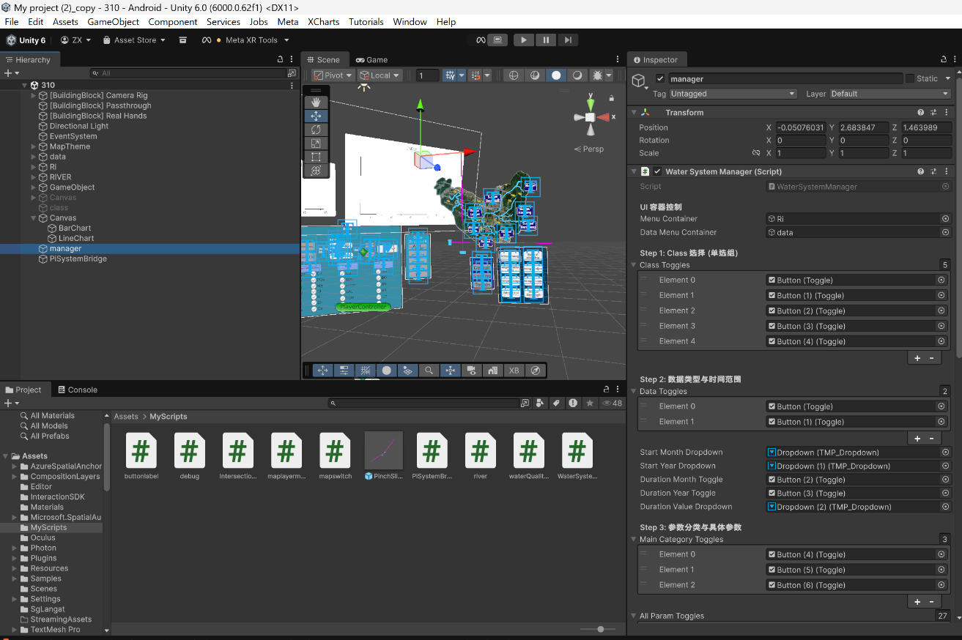
WaterSystemManager references
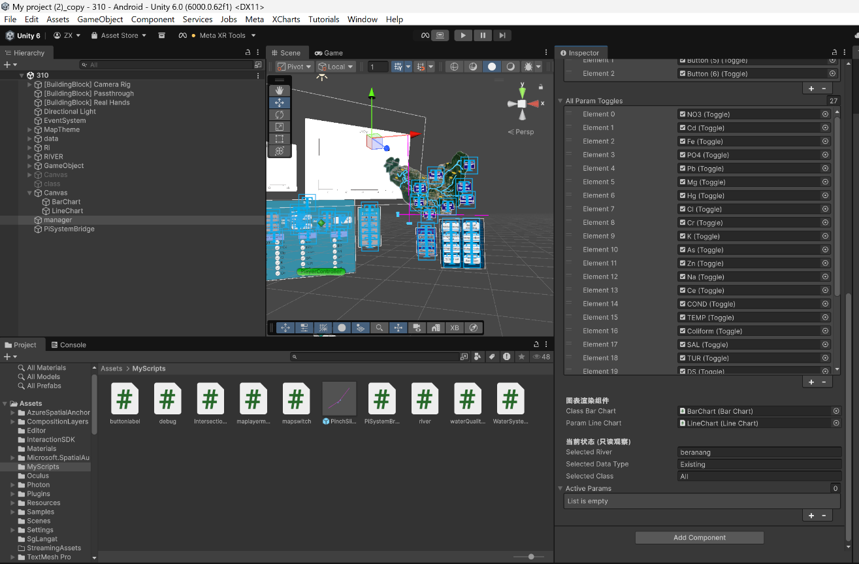
WaterSystemManager data and chart bindings
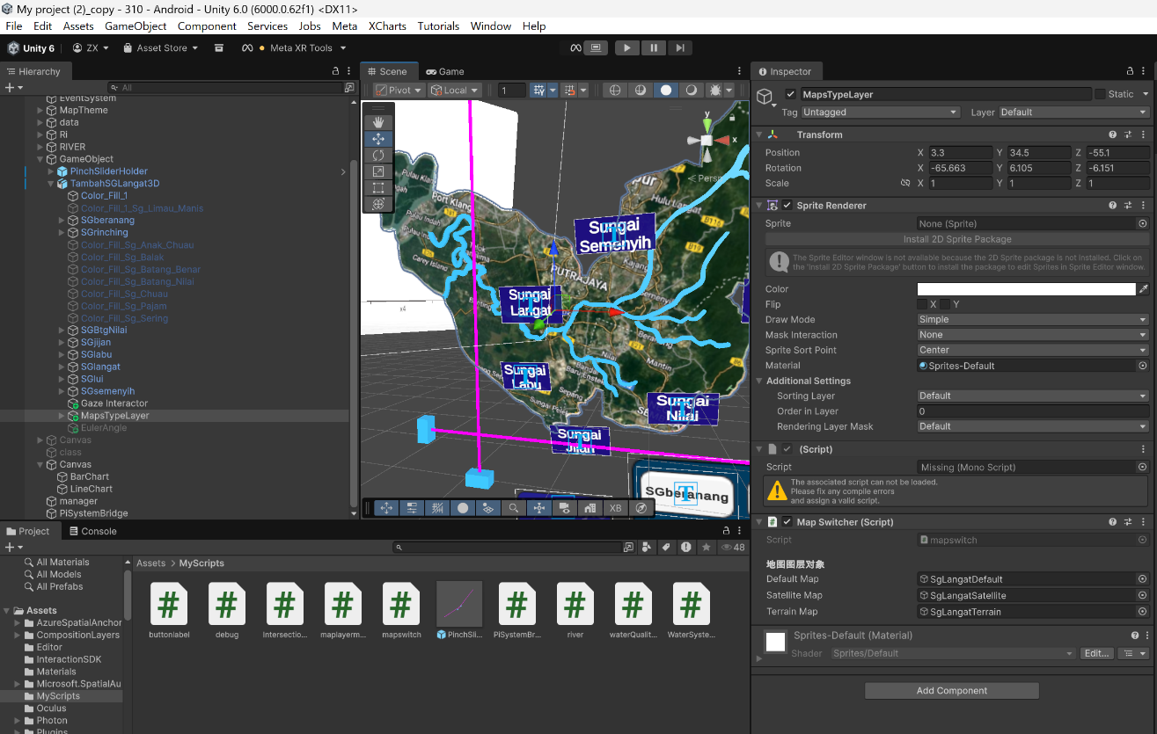
mapswitch and map layer references
Figure 8. Key Unity scripts and scene relationship / 图8.Unity 关键脚本与场景关系图
Explanation: This figure shows the main Unity-side logic relationships by highlighting WaterSystemManager bindings and map switching references used after Raspberry Pi input is received.

4.4 PiSystemBridge Inspector / 4.4 PiSystemBridge Inspector

Must check:
• listenPort = 5005
• mapSwitcher
• waterSystemManager
• mapRoot
• sliderXContainer
• sliderYContainer
• intersectionMarker
• river references
• classPanel
• dataPanel

必须检查：
• listenPort = 5005
• mapSwitcher
• waterSystemManager
• mapRoot
• sliderXContainer
• sliderYContainer
• intersectionMarker
• 河流引用
• classPanel
• dataPanel

If these references are missing, Unity may still enter Play mode, but the Raspberry Pi integration will not behave correctly.

如果这些引用缺失，Unity 虽然可能仍然可以进入 Play 模式，但树莓派集成不会按预期工作。

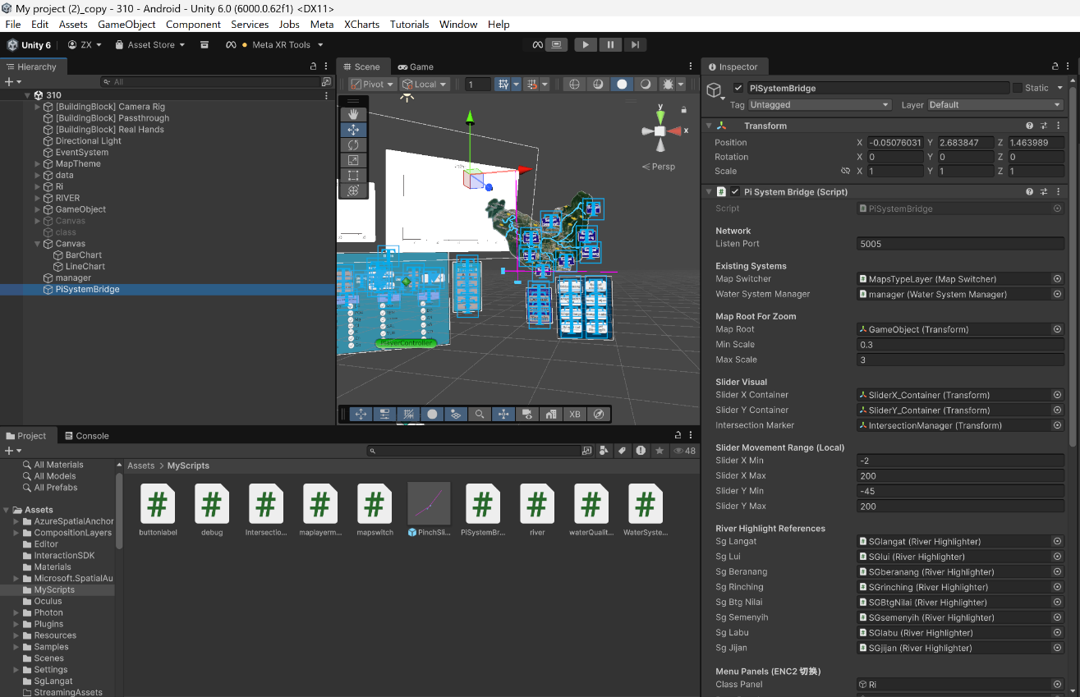
PiSystemBridge inspector - upper section
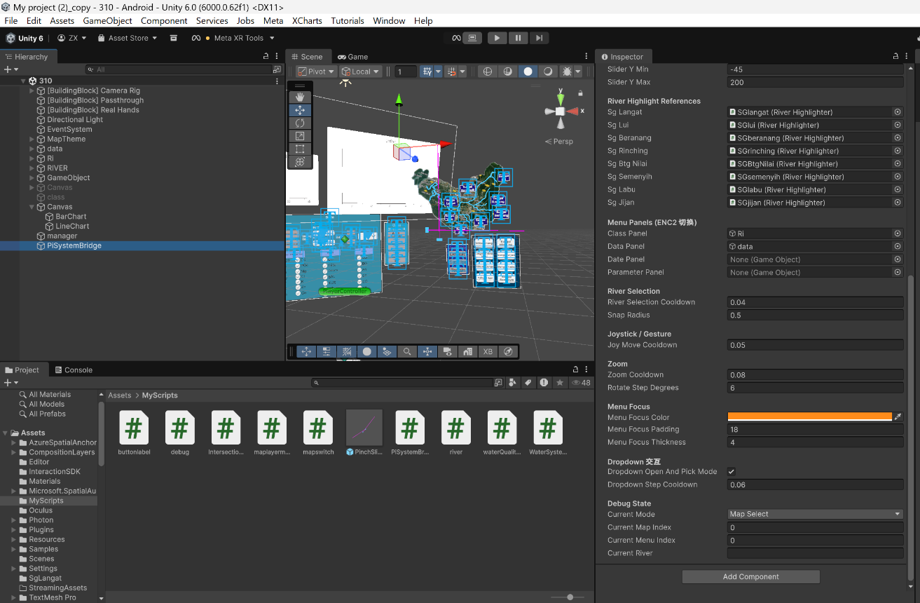
PiSystemBridge inspector - lower section
Figure 9. PiSystemBridge Inspector screenshot / 图9.PiSystemBridge Inspector 截图
Explanation: This figure captures the PiSystemBridge Inspector configuration, including UDP port settings, scene references, slider ranges, menu panels, river selection parameters, and runtime state values.

5. Setup and Operation / 5. 配置与操作

5.1 Raspberry Pi Setup / 5.1 树莓派配置

1. Open Windows PowerShell.
打开 Windows PowerShell。
2. Run arp -a.
输入 arp -a。
3. Connect using ssh xlab@192.168.50.38.
使用 ssh xlab@192.168.50.38 连接树莓派。
4. Confirm pi_input_sender.py is present.
确认 pi_input_sender.py 存在。
5. Edit it if needed using nano pi_input_sender.py.
如有需要，使用 nano pi_input_sender.py 修改。
6. Confirm UNITY_IP and UNITY_PORT.
确认 UNITY_IP 和 UNITY_PORT。
7. Enable SPI using sudo raspi-config.
使用 sudo raspi-config 启用 SPI。
8. Reboot if needed.
如有需要，重启树莓派。
9. Check ls /dev/spidev*.
输入 ls /dev/spidev* 检查。
10. If needed, check lsmod | grep spi.
如有需要，输入 lsmod | grep spi。
11. Run python3 pi_input_sender.py.
输入 python3 pi_input_sender.py 运行脚本。

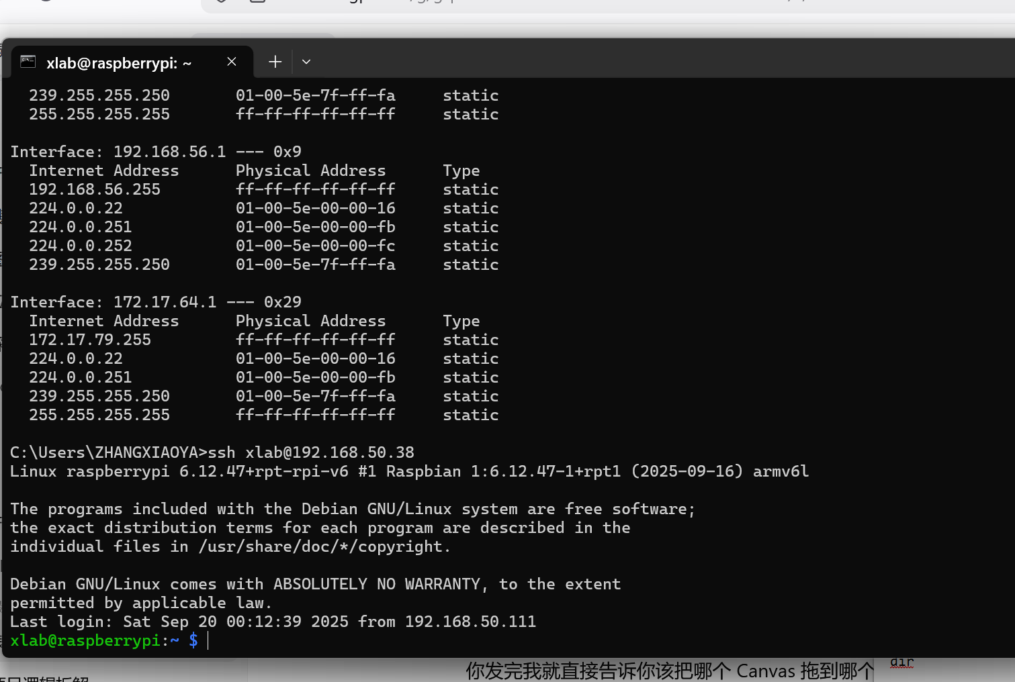
ARP lookup and SSH login
Figure 10. Raspberry Pi setup and SSH access / 图10.树莓派配置与 SSH 访问截图
Explanation: This figure shows the Raspberry Pi access workflow from Windows PowerShell, including address lookup and successful SSH login to the target device before script execution.

5.2 Unity Setup / 5.2 Unity 配置

1. Open Assets/310.unity.
打开 Assets/310.unity。
2. Select the PiSystemBridge GameObject.
选中 PiSystemBridge GameObject。
3. Check Inspector references.
检查 Inspector 引用。
4. Confirm listenPort = 5005.
确认 listenPort = 5005。
5. Press Play.
点击 Play。

5.3 Runtime Flow / 5.3 运行流程

1. ENC1 switches map style.
ENC1 切换地图样式。
2. Sliders position the river-selection intersection.
滑杆控制河流选择交点位置。
3. JOYBTN confirms the hovered river.
JOYBTN 确认当前悬停河流。
4. ENC2 changes menu focus.
ENC2 切换菜单焦点。
5. Joystick directions move inside the active menu.
摇杆方向输入在当前菜单内移动。
6. JOYBTN confirms the current menu selection.
JOYBTN 确认当前菜单选择。
7. BTN3 switches encoder 3 mode if needed.
如有需要，BTN3 切换旋钮 3 模式。
8. ENC3 zooms or rotates the map.
ENC3 执行地图缩放或旋转。

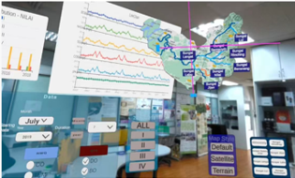
Figure 12. MR runtime interface and data interaction / 图12.混合现实运行界面与数据交付
Explanation: This screenshot shows the MR runtime interface after Unity has received controller input, including river selection, map style controls, data panels, and overlaid water-quality views.

6. Testing, Limitations, and References / 6. 测试、限制与参考资料

6.1 Validation / 6.1 验证

English
The Raspberry Pi to Unity control path was validated in the lab environment. Evidence includes:
• GPIO and ADC mapping checks
• terminal output
• matching Unity-side logic

中文
树莓派到 Unity 的控制路径已在实验室环境中完成验证。证据包括：
• GPIO 与 ADC 映射检查
• 终端输出
• Unity 侧对应逻辑

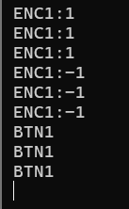  Encoder 1 / 左上旋钮 | 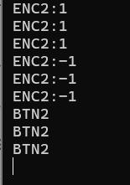  Encoder 2 / 右上旋钮 | 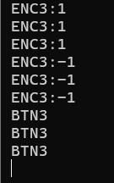  Encoder 3 / 左下旋钮
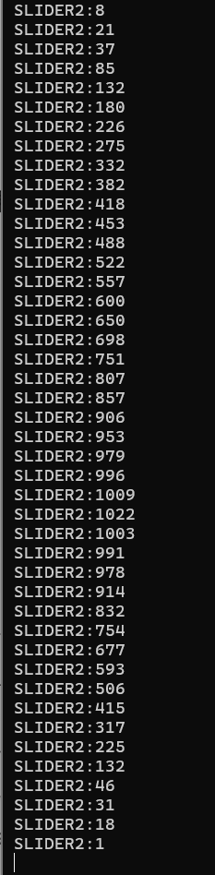  Slider 1 / 左横杆 | 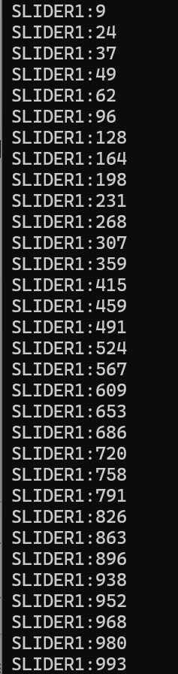  Slider 2 / 下横杆 | 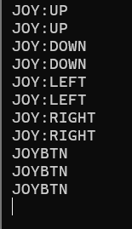  Joystick / 摇杆

Figure 11. Raspberry Pi terminal output for encoders, sliders, and joystick / 图11.树莓派终码出旋钮滑杆及摇杆的终端输出
Explanation: This figure provides terminal-level validation evidence that encoder rotation, joystick movement, slider changes, and button presses were all detected and emitted as runtime messages.

6.2 Troubleshooting / 6.2 故障排查

Main platforms:
• Windows PowerShell before SSH
• Raspberry Pi remote shell after SSH
• Unity Console

主要排查平台：
• SSH 前的 Windows PowerShell
• SSH 后的树莓派远程 Shell
• Unity Console

Key checks:
• arp -a
• ls /dev/spidev*
• lsmod | grep spi
• mcp_read_all.py
• watch_gpio.py
• Unity listenPort = 5005

关键检查项：
• arp -a
• ls /dev/spidev*
• lsmod | grep spi
• mcp_read_all.py
• watch_gpio.py
• Unity listenPort = 5005

6.3 Known Limitations / 6.3 已知限制

English
• dense breadboard wiring reduces visual clarity
• system depends on stable local network communication
• analog input may require threshold tuning
• the current system should be treated as a validated prototype, not a production-hardened deployment

中文
• 面包板接线密集，降低了可视清晰度
• 系统依赖稳定的局域网通信
• 模拟输入可能需要阈值调节
• 当前系统应被视为已验证原型，而不是生产级部署版本

6.4 GitHub Repository / 6.4 GitHub 仓库

Repository:
• https://github.com/77Xiaoya/project-handover

Stored there:
• Raspberry Pi scripts
• wiring notes
• revised bilingual documentation
• Unity bridge script copy

仓库中保存：
• 树莓派脚本
• 接线记录
• 修订版双语文档
• Unity 桥接脚本副本

[Insert Figure 13 here: GitHub repository screenshot / GitHub 仓库截图]

6.5 Conclusion / 6.5 结论

English
The current prototype successfully integrates Raspberry Pi physical input with a Unity mixed reality application on Meta Quest Pro. The system has been documented as a delivery-oriented technical package that supports reconstruction, testing, and future maintenance.

中文
当前原型已成功将树莓派实体输入与运行在 Meta Quest Pro 上的 Unity 混合现实应用集成在一起。该系统现已被整理为一套面向交付的技术文档包，可支持后续重建、测试和维护。

