SYSTEM DELIVERY AND TECHNICAL DOCUMENTATION

  - Mixed Reality River Water Quality Visualization System

Prepared by: Zhang Xiaoya，Ding Fangwei
Supervisor: Dr. Lam Meng Chun
Organization: FTSM / MYXLab, UKM

Table of Contents
Table of Contents 2
1. Project Overview 4
2. System Architecture 5
2.1 Main Components 5
2.2 Data Flow 5
3. Raspberry Pi and Hardware 5
3.1 Access Platform and Runtime Software 5
3.2 Main Script 6
3.3 Main Script Explanation 6
3.3.1 UNITY_IP and UNITY_PORT 6
3.3.2 send() 6
3.3.3 encoder_loop() 6
3.3.4 joystick_loop() 6
3.3.5 slider_loop() 6
3.3.6 Button Callbacks 6
3.4 MCP3008 and SPI 9
3.4.1 Why SPI Must Be Enabled 9
3.4.2 SPI Setup 9
3.4.3 SPI Verification 9
3.5 Hardware Mapping 10
4. Unity Environment and Scripts 12
4.1 Unity Environment 12
4.1.1 What This Means for Rebuild 12
4.2 Key Scripts 13
4.3 Unity Script Explanation 13
4.3.1 PiSystemBridge.cs 13
4.3.2 WaterSystemManager.cs 14
4.3.3 mapswitch.cs 14
4.4 PiSystemBridge Inspector 16
5. Setup and Operation 17
5.1 Raspberry Pi Setup 17
5.2 Unity Setup 18
5.3 Runtime Flow 18
6. Testing, Limitations, and References 19
6.1 Validation 19
6.2 Troubleshooting 20
6.3 Known Limitations 21
6.4 GitHub Repository 21
6.5 Conclusion 21

1. Project Overview
This project is a mixed reality river water quality visualization prototype. It runs in Unity on Meta Quest Pro. Joystick, slider, and encoder input is collected on Raspberry Pi, converted when necessary through MCP3008, transmitted to Unity through UDP, and used to drive map selection, filtering, and chart interaction.

The current interaction path is mapstyle -> river -> ri -> data.
This figure summarizes the full delivery path from physical input hardware to Raspberry Pi processing, UDP transport, and Unity-side visual interaction.

Physical controllers
↓
Raspberry Pi Zero
↓
MCP3008 for analog inputs
↓
pi_input_sender.py
↓
UDP transport
↓
Unity MR application
↓
Map and water-quality interaction

Figure 1. Overall system architecture

2. System Architecture

2.1 Main Components
• Meta Quest Pro: runtime headset
• Unity: mixed reality application
• Raspberry Pi Zero: physical control bridge
• MCP3008: analog-to-digital conversion for joystick and sliders
• CSV data: water quality source data

2.2 Data Flow
This figure focuses on runtime data movement, showing how controller state is sampled, translated into protocol messages, and consumed by PiSystemBridge in Unity.

Joystick, sliders, encoders
↓
GPIO or MCP3008 channel read
↓
Python input loop classifies state
↓
UDP message such as ENC / JOY / SLIDER / BTN
↓
PiSystemBridge receives on port 5005
↓
Unity updates map, river, RI, and data view

Figure 2. Data flow from Raspberry Pi to Unity

3. Raspberry Pi and Hardware

3.1 Access Platform and Runtime Software
The Raspberry Pi workflow has three layers:
• Windows PowerShell: command entry platform on the PC
• SSH: remote access method
• Raspberry Pi OS and Python 3: actual execution environment

Main software and libraries:
• Python 3: runtime language
• gpiozero: reads digital input such as joystick press and encoder signals
• spidev: reads MCP3008 analog values through SPI
• socket: sends UDP messages to Unity
• threading: runs multiple input loops in parallel

3.2 Main Script
The final integrated Raspberry Pi script is pi_input_sender.py.

3.3 Main Script Explanation

3.3.1 UNITY_IP and UNITY_PORT
These variables define where the Raspberry Pi sends UDP messages. If the Unity computer changes, UNITY_IP must be updated.

3.3.2 send()
This function is the single message output point. It packages the message string and sends it to Unity through UDP.

3.3.3 encoder_loop()
This loop monitors encoder phase changes and sends messages such as ENC1:1, ENC2:-1, or ENC3:1.

3.3.4 joystick_loop()
This loop reads joystick analog values from CH5 and CH6, compares them with thresholds, and converts them into directional messages such as JOY:LEFT, JOY:RIGHT, JOY:UP, and JOY:DOWN.

3.3.5 slider_loop()
This loop reads CH1 and CH3 and sends SLIDER1:<value> and SLIDER2:<value> when the values change enough to pass the threshold.

3.3.6 Button Callbacks
Button callbacks send BTN1, BTN2, BTN3, and JOYBTN. In the current system, BTN3 is especially important because it changes encoder 3 between zoom mode and rotate mode.

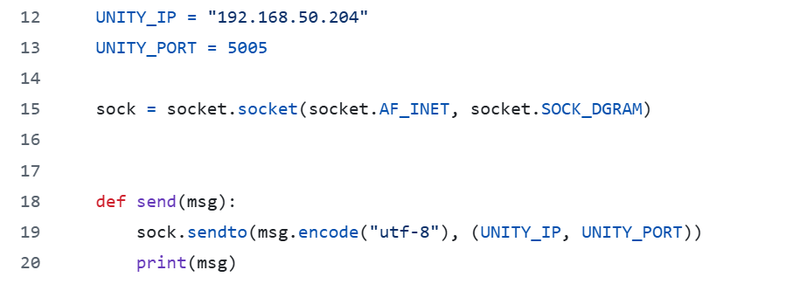
Network configuration and send()
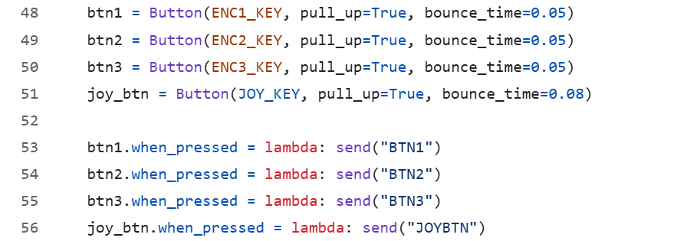
Button callback registration

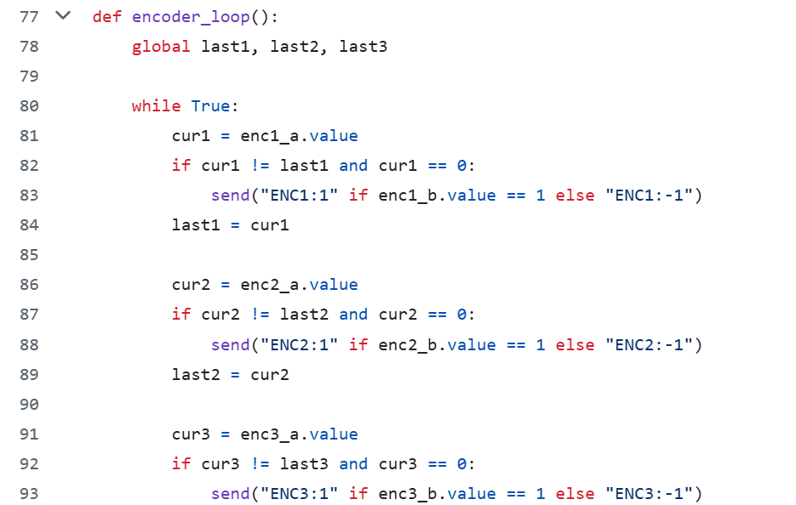
encoder_loop() implementation

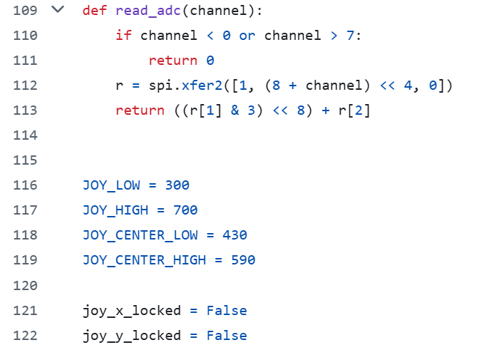
read_adc() and ADC thresholds
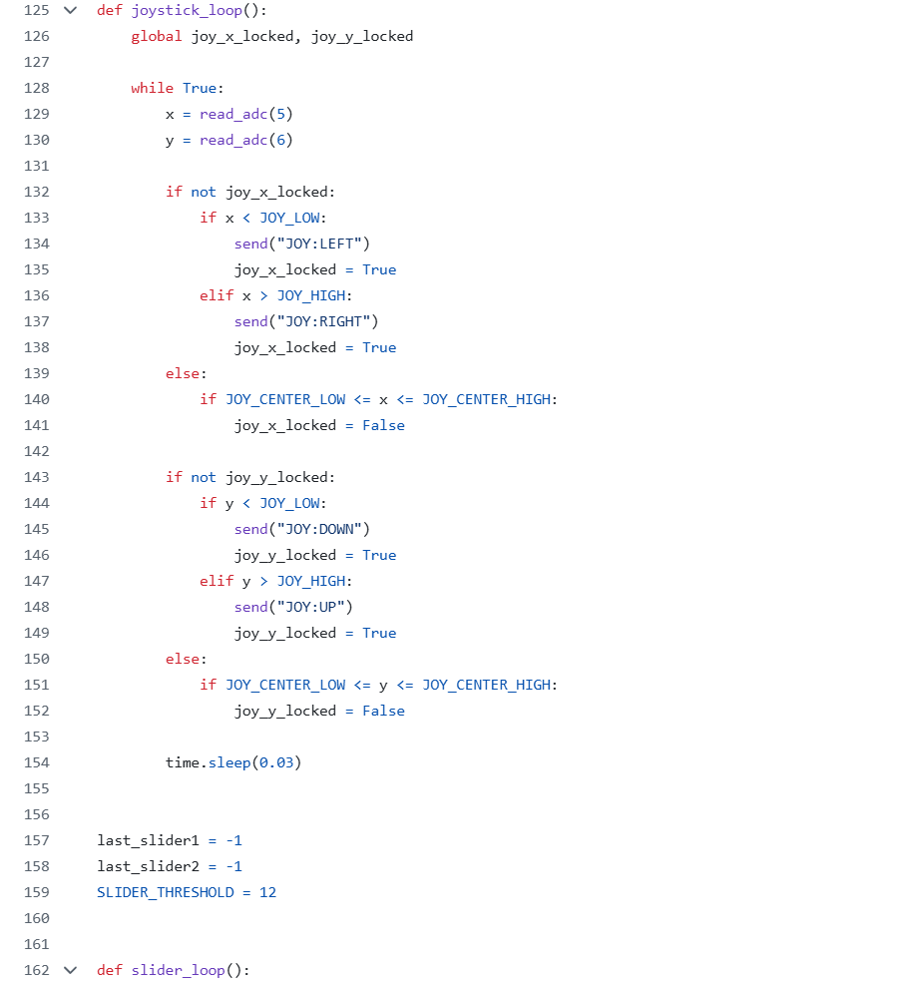
joystick_loop() and slider_loop()
Figure 3. Key sections of pi_input_sender.py
These screenshots show the actual Raspberry Pi runtime script sections used in the project, including network configuration, button callbacks, encoder handling, ADC reading, and the joystick and slider loops.

3.4 MCP3008 and SPI
Raspberry Pi cannot read analog voltage directly. MCP3008 converts analog joystick and slider signals into digital values through SPI.
Channel mapping:
• CH1: horizontal slider
• CH3: vertical slider
• CH5: joystick left-right
• CH6: joystick up-down

3.4.1 Why SPI Must Be Enabled
If SPI is not enabled, Raspberry Pi cannot communicate with MCP3008, and analog channels cannot be read correctly.

3.4.2 SPI Setup
1. Connect to Raspberry Pi through SSH.
2. Run sudo raspi-config.
3. Open Interface Options -> SPI -> Enable.
4. Reboot using sudo reboot.
5. Reconnect and check ls /dev/spidev*.
6. If needed, run lsmod | grep spi.
7. If SPI is still unavailable, open sudo nano /boot/config.txt and confirm dtparam=spi=on exists.

3.4.3 SPI Verification
SPI can be treated as available when:
• a device such as /dev/spidev0.0 appears
• lsmod | grep spi shows spi_bcm2835 and spidev
• mcp_read_all.py can read changing values

Analog movement on slider or joystick
↓
MCP3008 samples CH1 / CH3 / CH5 / CH6
↓
SPI sends digital values to Raspberry Pi
↓
spidev reads channel values in Python
↓
Threshold logic converts values into events
↓
UDP messages are sent to Unity

Figure 4. MCP3008 analog conversion flow
This figure explains how MCP3008 converts analog voltage changes from the joystick and sliders into digital channel values that Python can read and forward to Unity.

3.5 Hardware Mapping
Joystick
• SW -> GPIO26
• VRx -> MCP3008 CH5
• VRy -> MCP3008 CH6

Sliders
• Horizontal slider -> CH1
• Vertical slider -> CH3

Encoders
• Encoder 1: S1 -> GPIO17, S2 -> GPIO22, KEY -> GPIO27
• Encoder 2: S1 -> GPIO18, S2 -> GPIO23, KEY -> GPIO25
• Encoder 3: S1 -> GPIO24, S2 -> GPIO16, KEY -> GPIO20

Encoder 3 special behavior
• BTN3 toggles encoder 3 between zoom mode and rotate mode

This figure documents the physical prototype, including the control box layout and the Raspberry Pi with breadboard wiring used during integration.
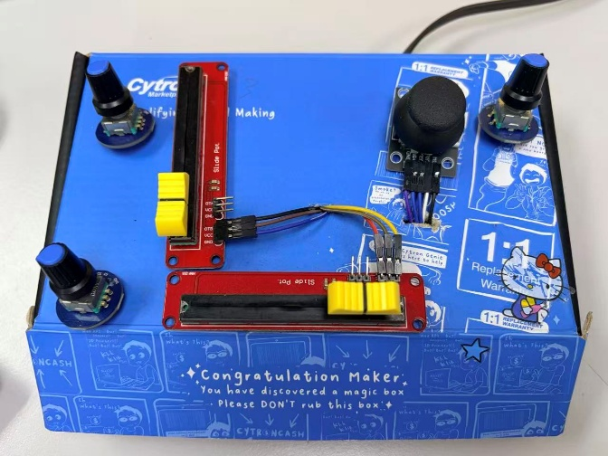  Control box overview | 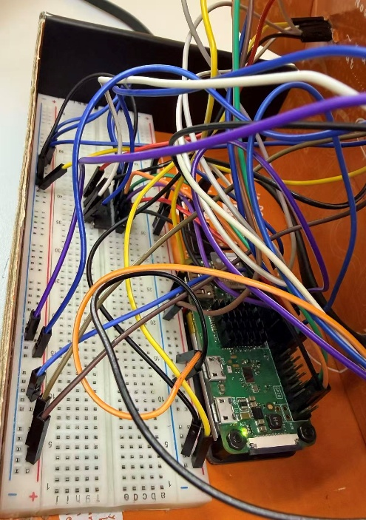  Raspberry Pi and breadboard wiring
Figure 5. Raspberry Pi and breadboard overview
This figure highlights the mapping details of the slider, encoder, and joystick modules so that each physical control can be matched to its corresponding GPIO or ADC channel.

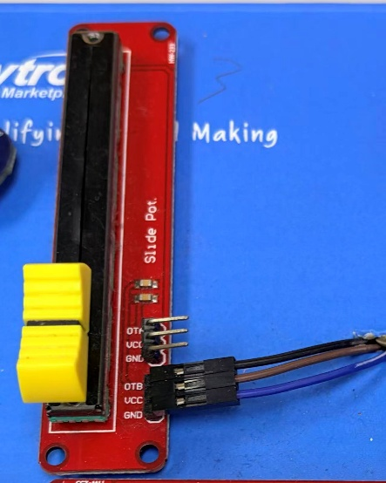  Slider module detail | 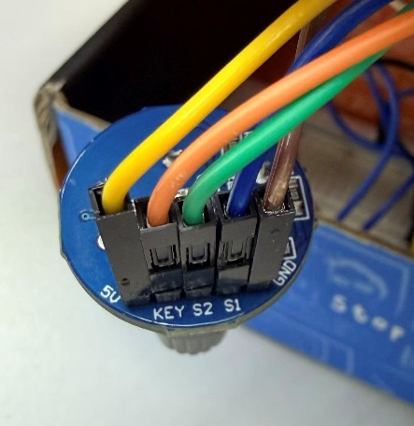  Encoder wiring detail | 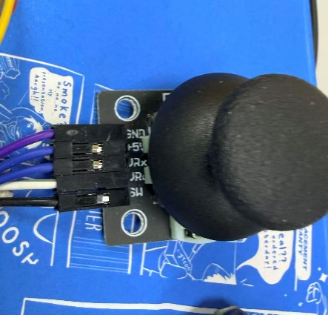  Joystick module detail

Figure 6. Joystick, slider, and encoder mapping

4. Unity Environment and Scripts

4.1 Unity Environment
The project should be opened with Unity 6000.0.62f1. The environment is configured for Meta Quest Pro mixed reality and depends on Meta XR and Unity XR packages.

Main scene:
• Assets/310.unity

Important package groups:
• Meta XR SDK
• OpenXR
• Android XR OpenXR
• AR Foundation
• XR Hands
• XR Interaction Toolkit

4.1.1 What This Means for Rebuild
When reconstructing the Unity environment, package compatibility and Android XR support must be checked before editing scripts or scene logic.
This figure records the Unity-side environment setup, combining package acquisition evidence with XR Plug-in Management settings that enable OpenXR and Meta Quest feature groups for the project.
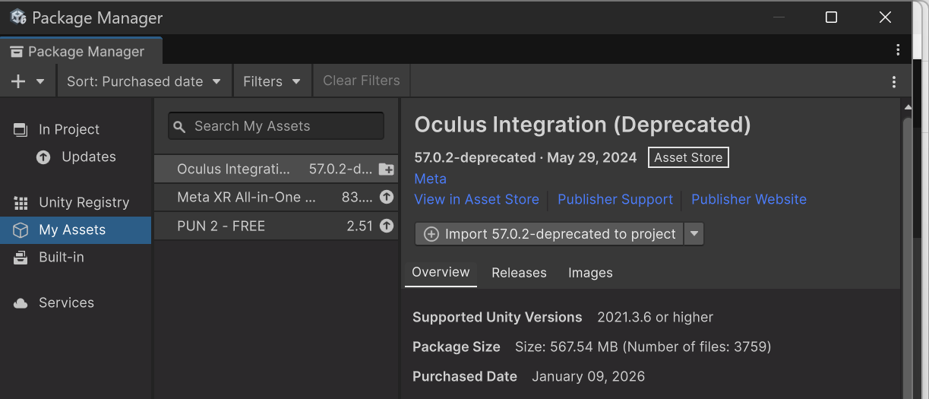
Package Manager assets
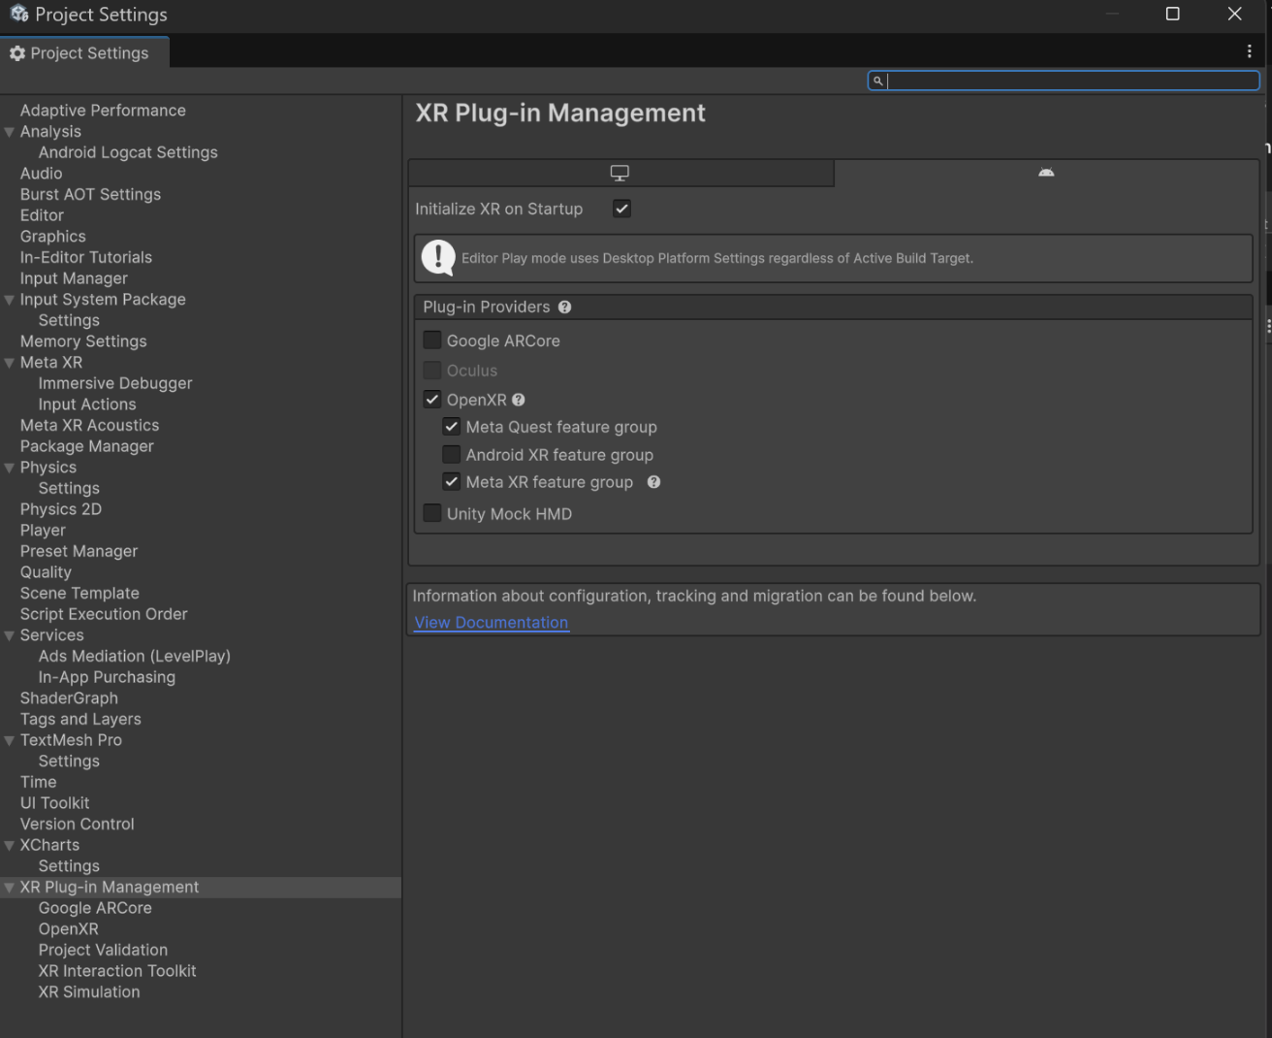
XR Plug-in Management
Figure 7. Unity project and XR package setup

4.2 Key Scripts
Script | Purpose | What to check
PiSystemBridge.cs | receives UDP messages and maps them to Unity actions | port, object references, slider ranges
WaterSystemManager.cs | controls river state, filtering, and charts | toggles, dropdowns, chart references
mapswitch.cs | switches map layers | default, satellite, and terrain map references

4.3 Unity Script Explanation

4.3.1 PiSystemBridge.cs
This script is the Unity-side bridge. It listens on UDP port 5005, receives Raspberry Pi messages, and converts them into Unity actions.

Main message behavior:
• JOYBTN: confirm action
• JOY:LEFT/RIGHT/UP/DOWN: move selection
• SLIDER1/SLIDER2: update slider state
• BTN3: switch encoder 3 mode
• ENC3:*: zoom or rotate the map depending on current mode

4.3.2 WaterSystemManager.cs
This script manages selected river state, filtering logic, and chart refresh. It is the main data-side controller after Unity receives the input.

4.3.3 mapswitch.cs
This script switches the visible map layer between default, satellite, and terrain.

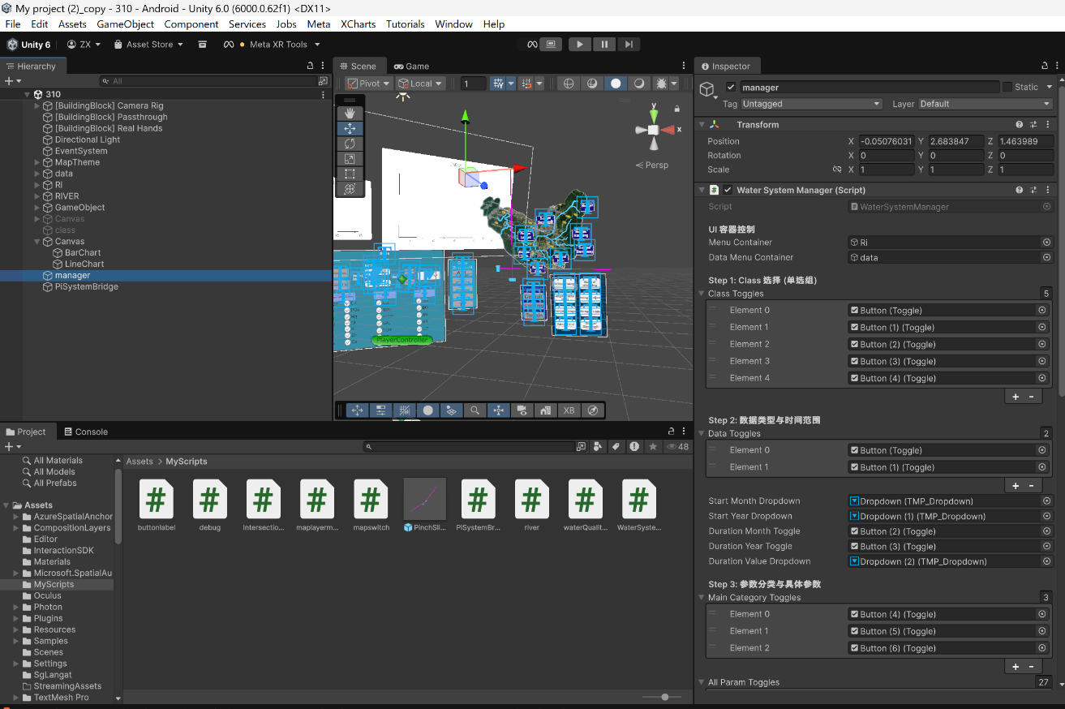
WaterSystemManager references
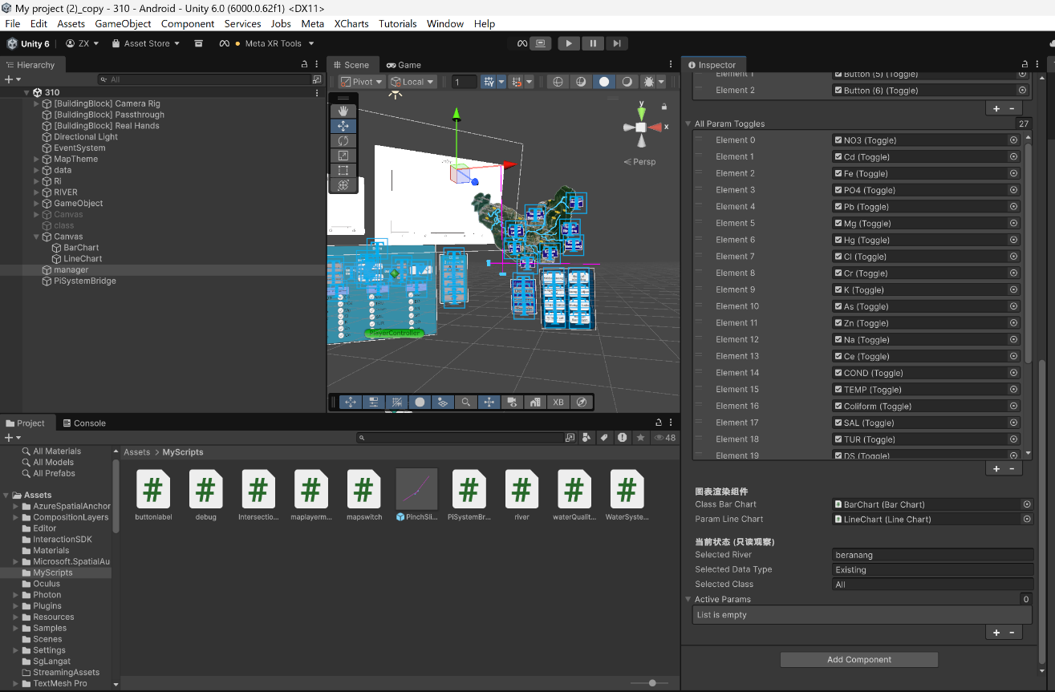
WaterSystemManager data and chart bindings
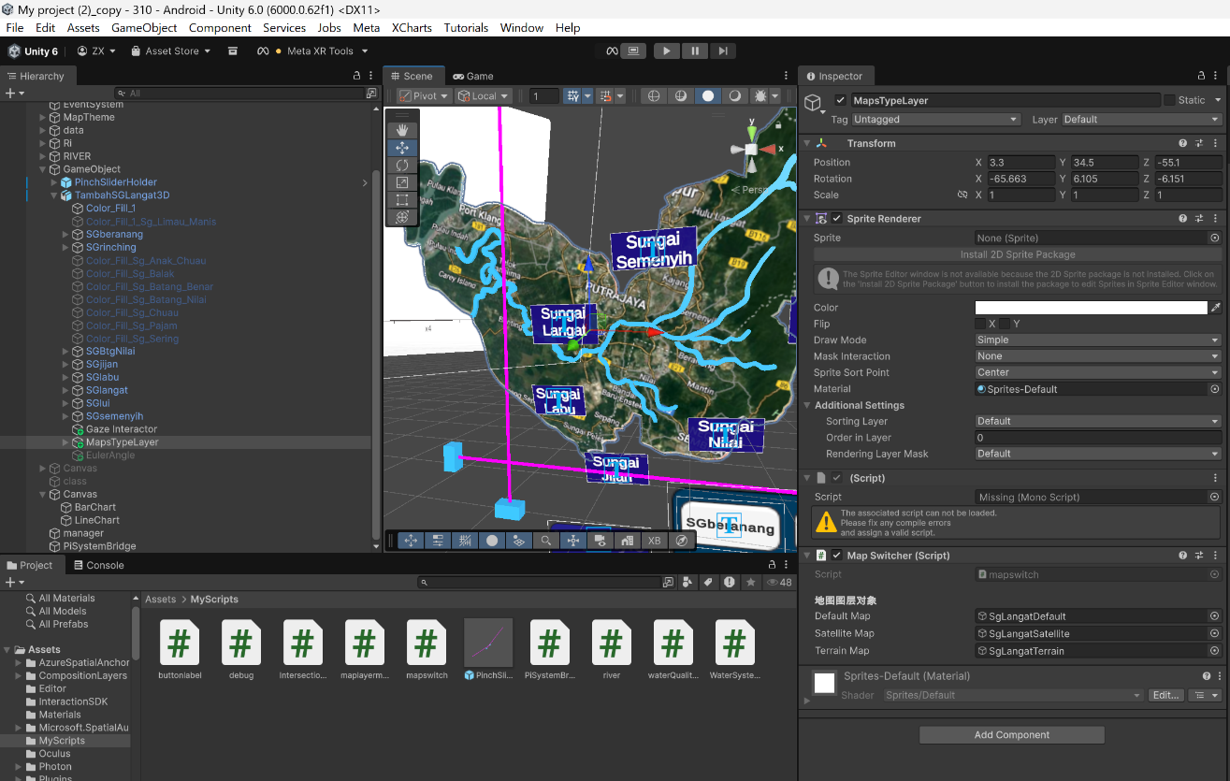
mapswitch and map layer references
Figure 8. Key Unity scripts and scene relationship
This figure shows the main Unity-side logic relationships by highlighting WaterSystemManager bindings and map switching references used after Raspberry Pi input is received.

4.4 PiSystemBridge Inspector
Must check:
• listenPort = 5005
• mapSwitcher
• waterSystemManager
• mapRoot
• sliderXContainer
• sliderYContainer
• intersectionMarker
• river references
• classPanel
• dataPanel

If these references are missing, Unity may still enter Play mode, but the Raspberry Pi integration will not behave correctly.

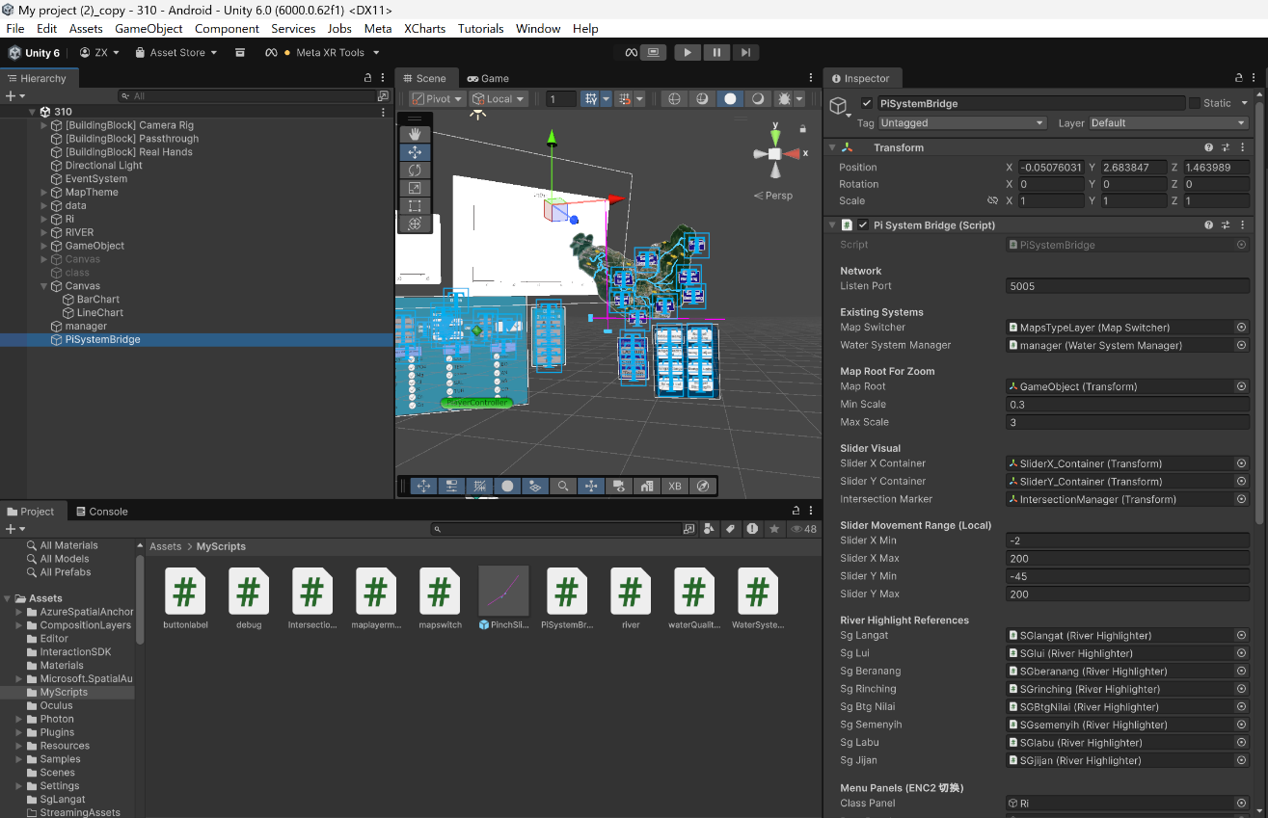
PiSystemBridge inspector - upper section
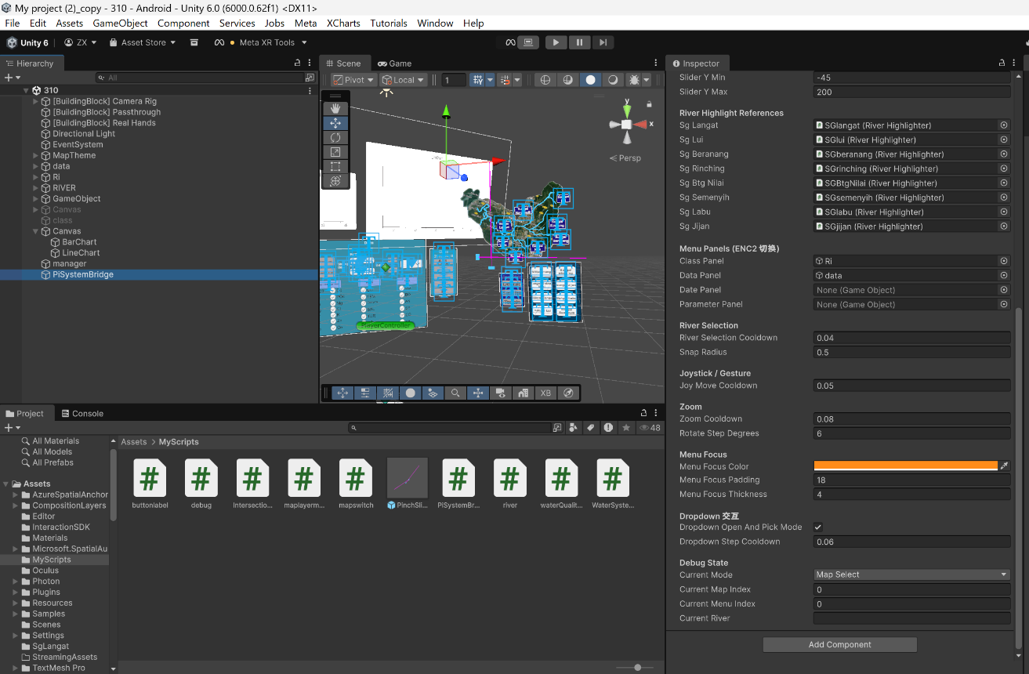
PiSystemBridge inspector - lower section
Figure 9. PiSystemBridge Inspector screenshot
This figure captures the PiSystemBridge Inspector configuration, including UDP port settings, scene references, slider ranges, menu panels, river selection parameters, and runtime state values.

5. Setup and Operation

5.1 Raspberry Pi Setup
1. Open Windows PowerShell.
2. Run arp -a.
3. Connect using ssh xlab@192.168.50.38.
4. Confirm pi_input_sender.py is present.
5. Edit it if needed using nano pi_input_sender.py.
6. Confirm UNITY_IP and UNITY_PORT.
7. Enable SPI using sudo raspi-config.
8. Reboot if needed.
9. Check ls /dev/spidev*.
10. If needed, check lsmod | grep spi.
11. Run python3 pi_input_sender.py.
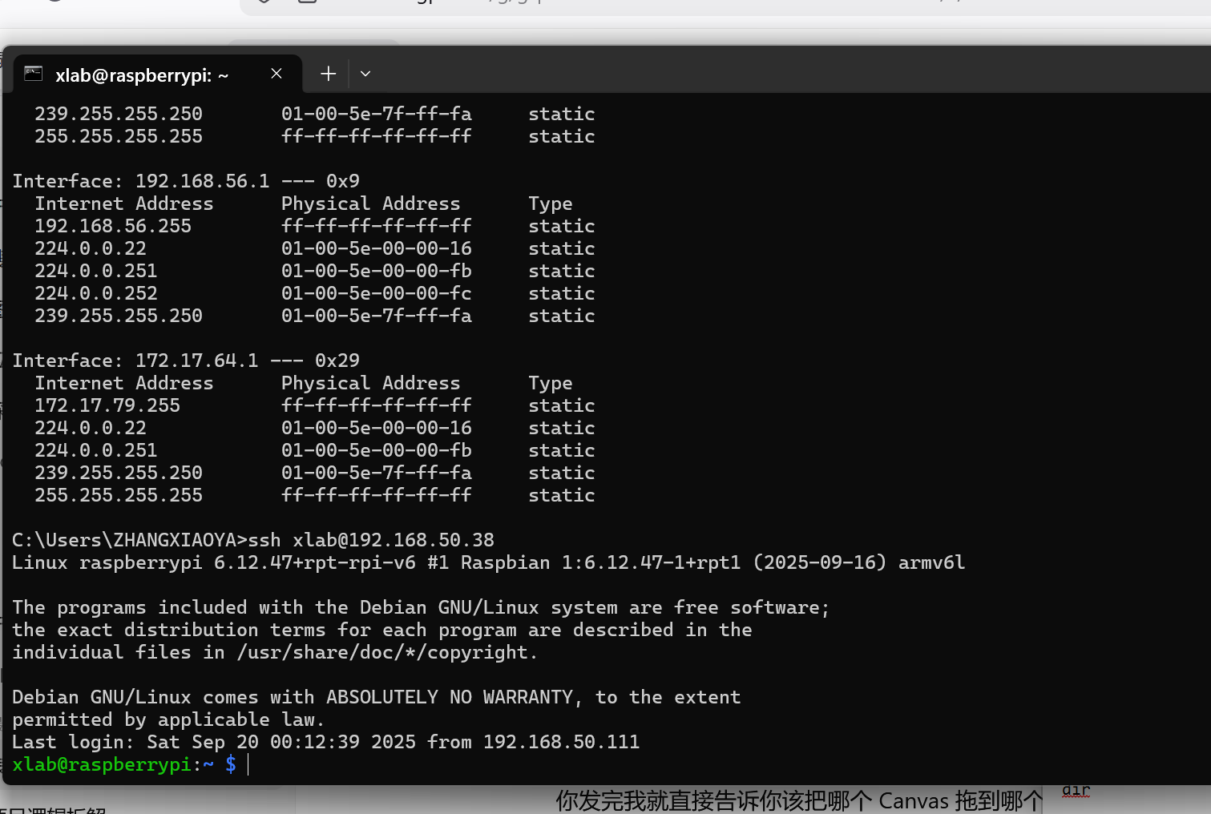
ARP lookup and SSH login
Figure 10. Raspberry Pi setup and SSH access
This figure shows the Raspberry Pi access workflow from Windows PowerShell, including address lookup and successful SSH login to the target device before script execution.

5.2 Unity Setup
1. Open Assets/310.unity.
2. Select the PiSystemBridge GameObject.
3. Check Inspector references.
4. Confirm listenPort = 5005.
5. Press Play.

5.3 Runtime Flow
1. ENC1 switches map style.
2. Sliders position the river-selection intersection.
3. JOYBTN confirms the hovered river.
4. ENC2 changes menu focus.
5. Joystick directions move inside the active menu.
6. JOYBTN confirms the current menu selection.
7. BTN3 switches encoder 3 mode if needed.
8. ENC3 zooms or rotates the map.
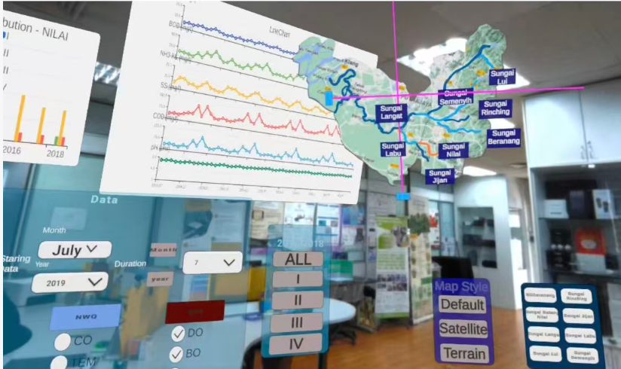
Figure 12. MR runtime interface and data interaction
This screenshot shows the MR runtime interface after Unity has received controller input, including river selection, map style controls, data panels, and overlaid water-quality views.

6. Testing, Limitations, and References

6.1 Validation
The Raspberry Pi to Unity control path was validated in the lab environment. Evidence includes:
• GPIO and ADC mapping checks
• terminal output
• matching Unity-side logic
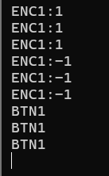  Encoder 1 | 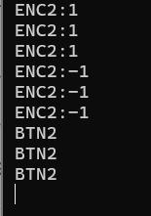  Encoder 2 | 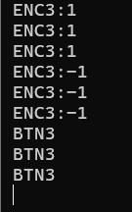  Encoder 3
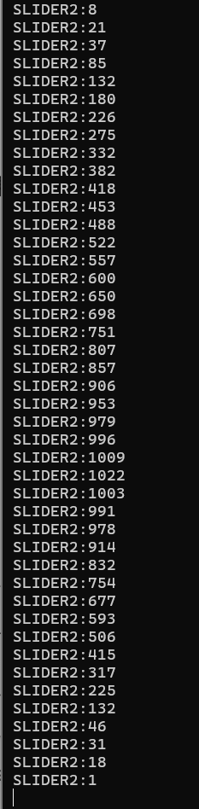  Slider 1 | 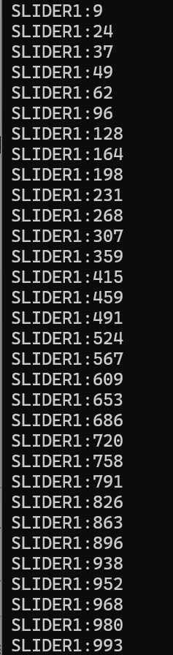  Slider 2 | 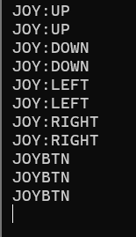  Joystick

Figure 11. Raspberry Pi terminal output for encoders, sliders, and joystick
This figure provides terminal-level validation evidence that encoder rotation, joystick movement, slider changes, and button presses were all detected and emitted as runtime messages.

6.2 Troubleshooting
Main platforms:
• Windows PowerShell before SSH
• Raspberry Pi remote shell after SSH
• Unity Console

Key checks:
• arp -a
• ls /dev/spidev*
• lsmod | grep spi
• mcp_read_all.py
• watch_gpio.py
• Unity listenPort = 5005

6.3 Known Limitations
• dense breadboard wiring reduces visual clarity
• system depends on stable local network communication
• analog input may require threshold tuning
• the current system should be treated as a validated prototype, not a production-hardened deployment

6.4 GitHub Repository
Repository:
https://github.com/77Xiaoya/project-handover
Stored there:
• Raspberry Pi scripts
• wiring notes
• revised bilingual documentation
• Unity bridge script copy 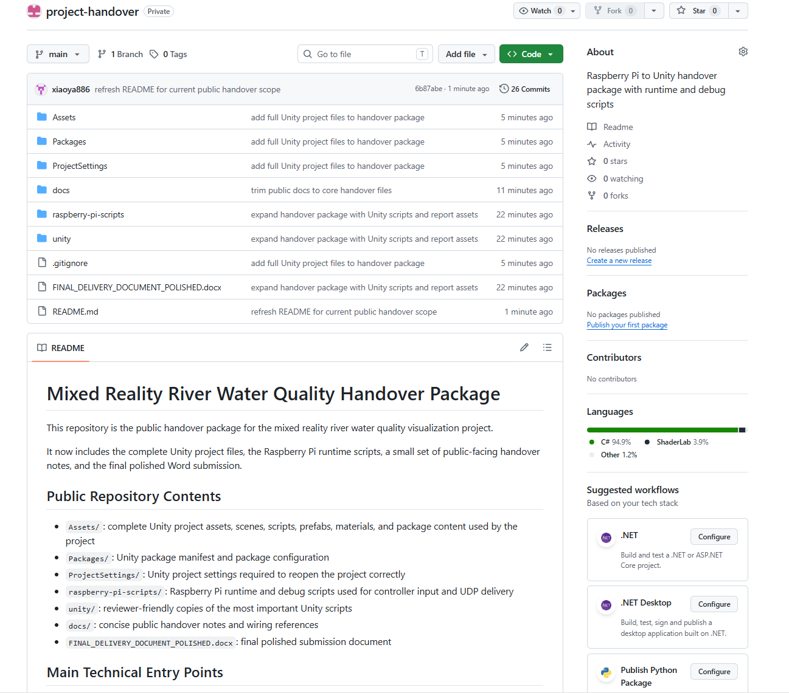
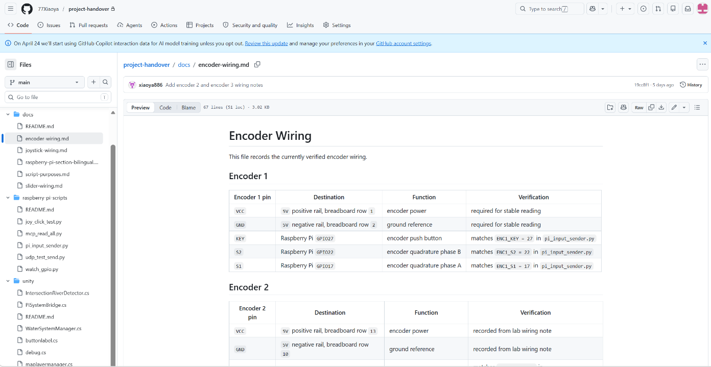
Figure 13 here: GitHub repository screenshot

6.5 Conclusion
The current prototype successfully integrates Raspberry Pi physical input with a Unity mixed reality application on Meta Quest Pro. The system has been documented as a delivery-oriented technical package that supports reconstruction, testing, and future maintenance.

