/src/request.c Line 665-668

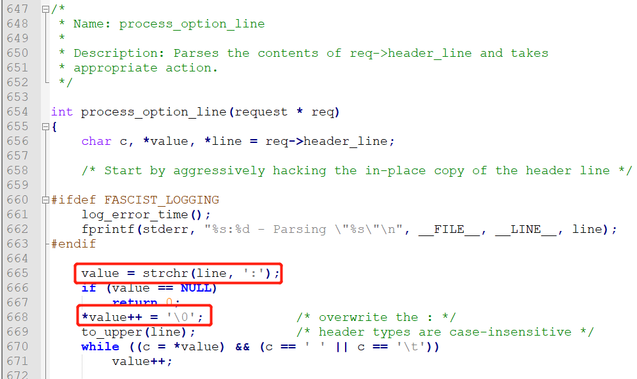

This "process_option_line" function is used to parse the http header. When the attacker passes in a header without parameters, such as "Host:", it will cause value++ to be NULL. The assignment operation on line 668 assigns a null pointer, resulting in denial of service.