Assignment 1
Name: 项 枫 Student ID: 2022211570 Class Number: 2022211801
1 Required Exercises
Exercise 1
The statement has the following tokens: int a3 = a * 3 ;
Total tokens: 7
Exercise 2
1、n+1
2、n
3、1
4、1
5、1
6、$\frac{n(n+1)}{2}+1$
7、2^{n}
Exercise 3
1、The language of all strings over the alphabet {a, b}.
2、The language of all strings over the alphabet {a, b} that end with aaa, aab, aba or abb.
3、The language of all strings over the alphabet {a, b} where character b appears exactly 3 times.
Exercise 4
1、86-0755-[1−9][0−9]⁷
2、a(a|b) * b
3、Let consonant → (b|c|d|f|g|h|j|k|l|m|n|p|q|r|s|t|v|w|x|y|z) *, the regular expression is
consonant a consonant e consonant i consonant o consonant u consonant.
2 Optional Exercises
Exercise 1
DFA：
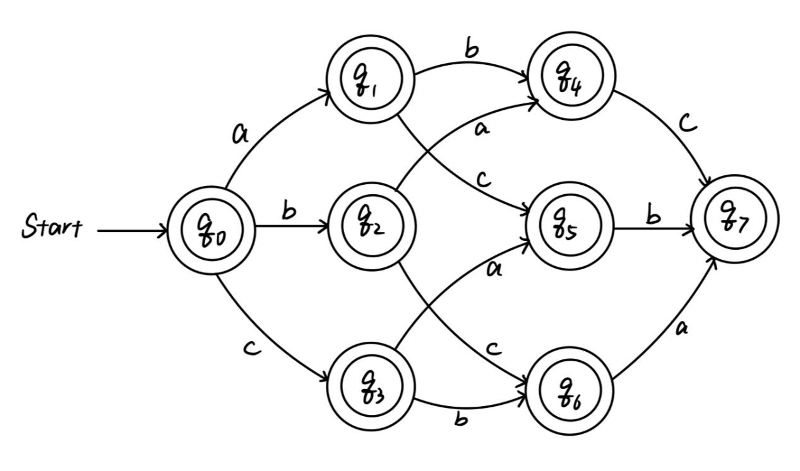
The regular expression：
(ε|a)(ε|b)(ε|c)|
(ε|a)(ε|c)(ε|b)|
(ε|b)(ε|a)(ε|c)|
(ε|b)(ε|c)(ε|a)|
(ε|c)(ε|a)(ε|b)|
(ε|c)(ε|b)(ε|a).

