Assignment 2
Name:项 枫 Student ID:2022211570 Class Number:2022211801
1 Required Exercises
Exercise 1
1.
(1) NFA
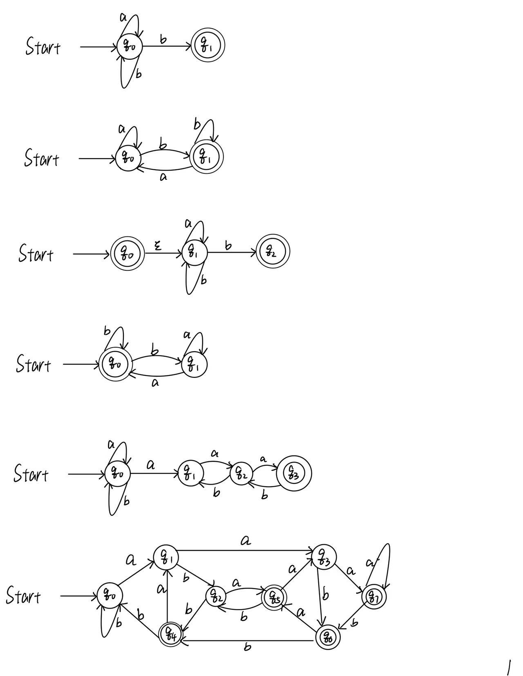
(2) DFA

2.
(1) NFA


(2) DFA

3.
(1) NFA

(2) DFA

4.
(1) NFA
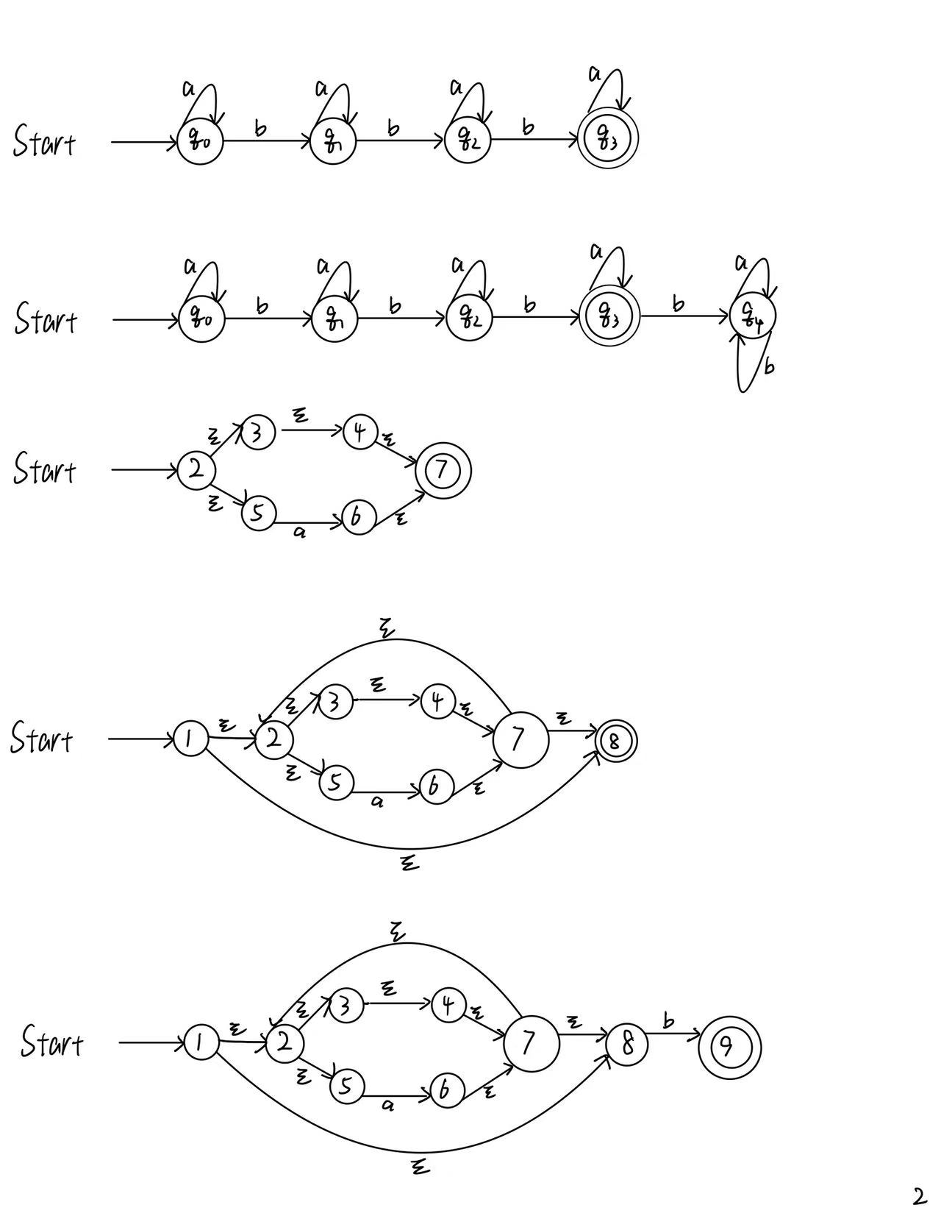
(2) DFA

Exercise 2
1.
(1) Construct the NFA for $R_{1}=ε|a$

(2) Construct the NFA for $R_{2}={(ε|a)}^{*}=R_{1 }^{*}$

(3) Construct the NFA for $R_{3}={(ε|a)}^{*}b=R_{2}b$

(4) Construct the NFA for ${{((ε|a)}^{*}b)}^{*}=R_{3}^{*}$
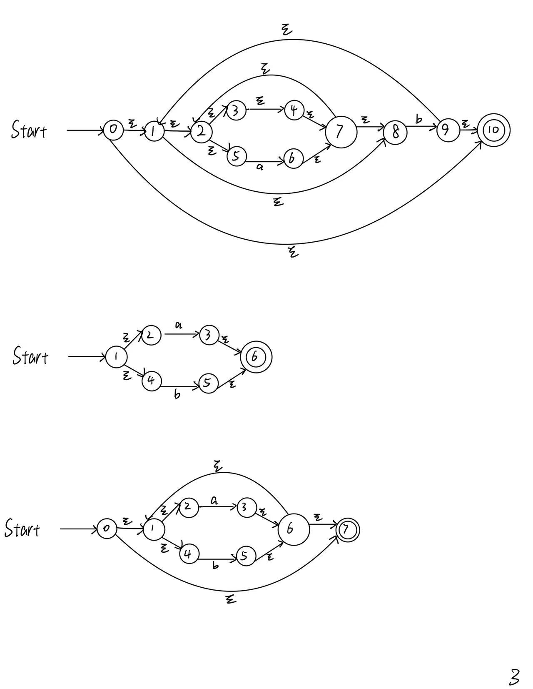
2.
(1) Construct the NFA for $R_{1}=a|b.$

(2) Construct the NFA for $R_{2 }={(a|b)}^{*}=R_{1}^{*}.$

(3) Construct the NFA for $R_{3 }={(a|b)}^{*}a=R_{2}a.$
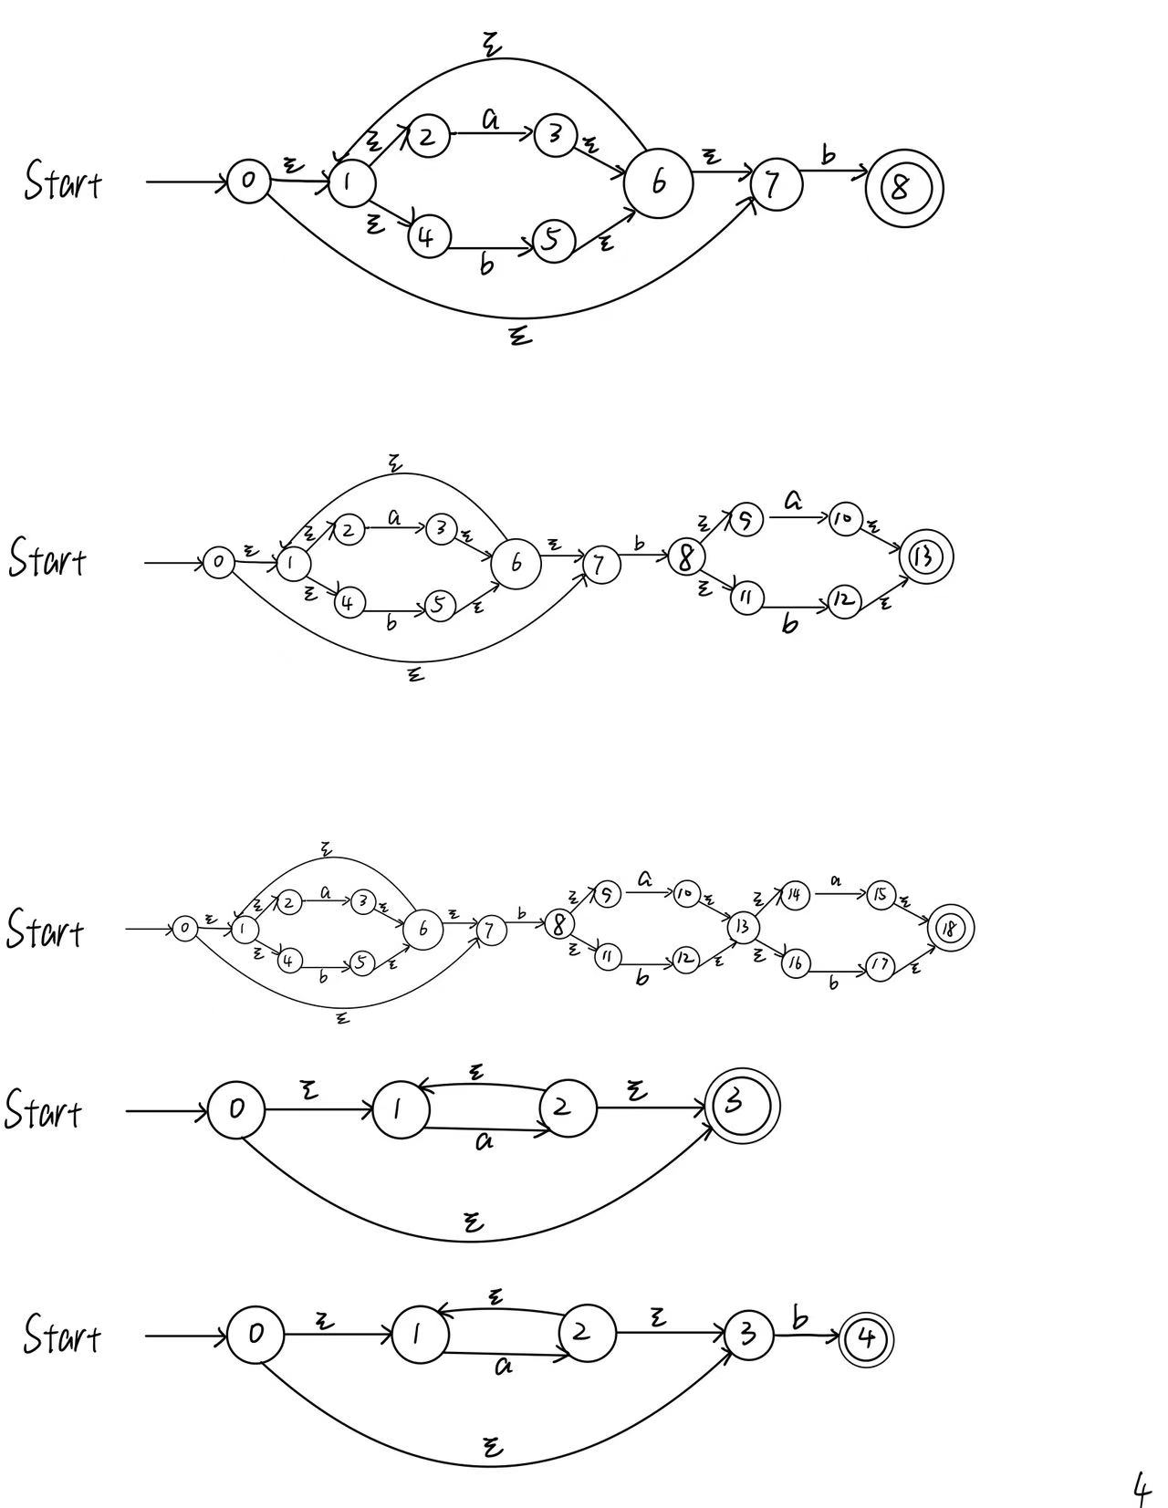
(4) Construct the NFA for $R_{4 }={\left(a | b\right)}^{*}a\left(a | b\right)=R_{3}R_{1}.$

(5) Construct the NFA for ${\left(a | b\right)}^{*}a\left(a | b\right)\left(a | b\right)=R_{4}R_{1}.$

3.
(1) Construct the NFA for $R_{1}=a^{*}.$

(2) Construct the NFA for $R_{2}=a^{*}b=R_{1}b.$

(3) Construct the NFA for $a^{*}ba^{*}ba^{*}ba^{*}=R_{2}R_{2}R_{2}R_{1}$.
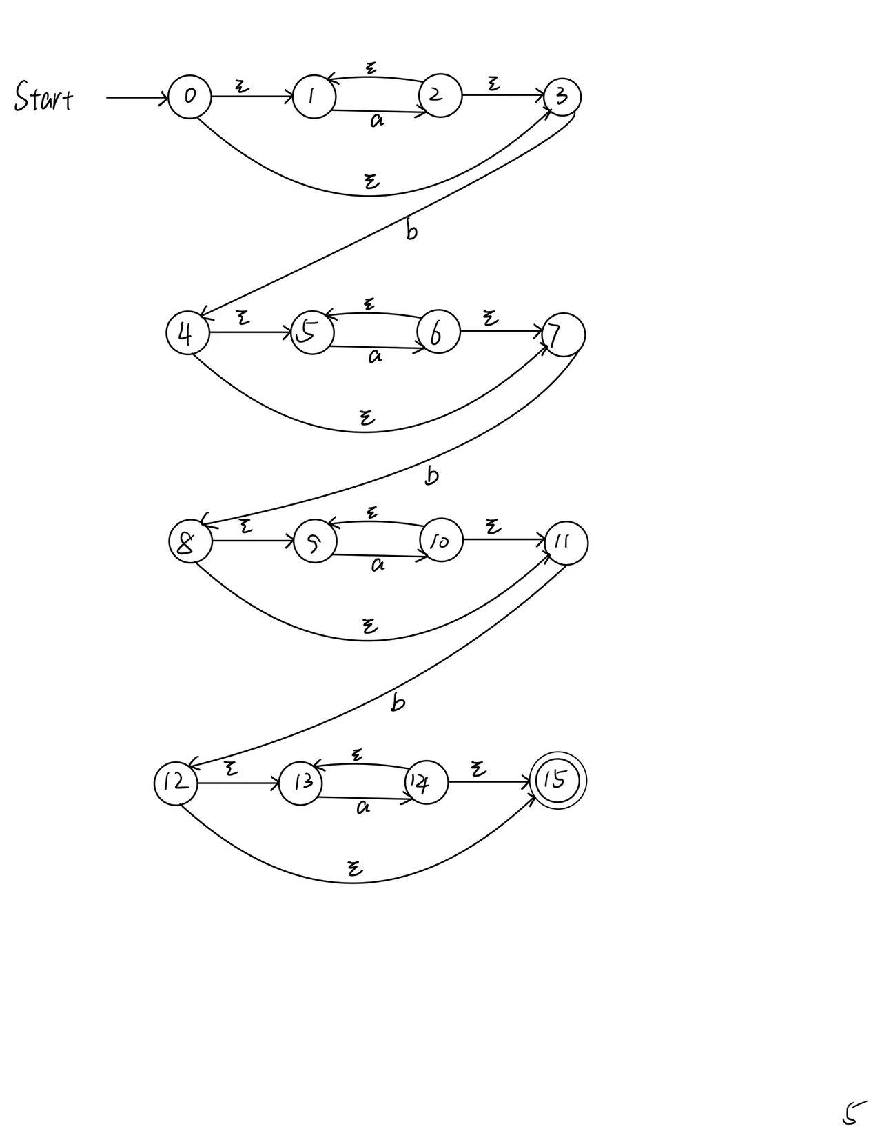
Exercise 3
1.
$$A=ε-closure\left(\left\{0\right\}\right)=\left\{0, 1, 2, 3, 4, 5, 6, 7, 8, 10\right\}.$$
$$B=δ_{D}(A, a)=ε-closure\left(\left\{6\right\}\right)=\left\{2, 3, 4, 5, 6, 7, 8\right\}.$$
$$C=δ_{D}(A, b)=ε-closure\left(\left\{9\right\}\right)=\left\{1, 2, 3, 4, 5, 7, 8, 9, 10\right\}.$$
$$D=δ_{D}(B, a)=ε-closure\left(\left\{6\right\}\right)=B.$$
$$E=δ_{D}(B, b)=ε-closure\left(\left\{9\right\}\right)=C.$$
$$F=δ_{D}(C, a)=ε-closure\left(\left\{6\right\}\right)=B.$$
$$G=δ_{D}(C, b)=ε-closure\left(\left\{9\right\}\right)=C.$$
The transition table of the DFA (Starting state is A and finite states are {A, C}):
NFA STATE | DFA STATE | a | b
$$\left\{0, 1, 2, 3, 4, 5, 6, 7, 8, 10\right\}$$ | A | B | C
$$\left\{2, 3, 4, 5, 6, 7, 8\right\}$$ | B | B | C
$$\left\{1, 2, 3, 4, 5, 7, 8, 9, 10\right\}$$ | C | B | C
The transition diagram:
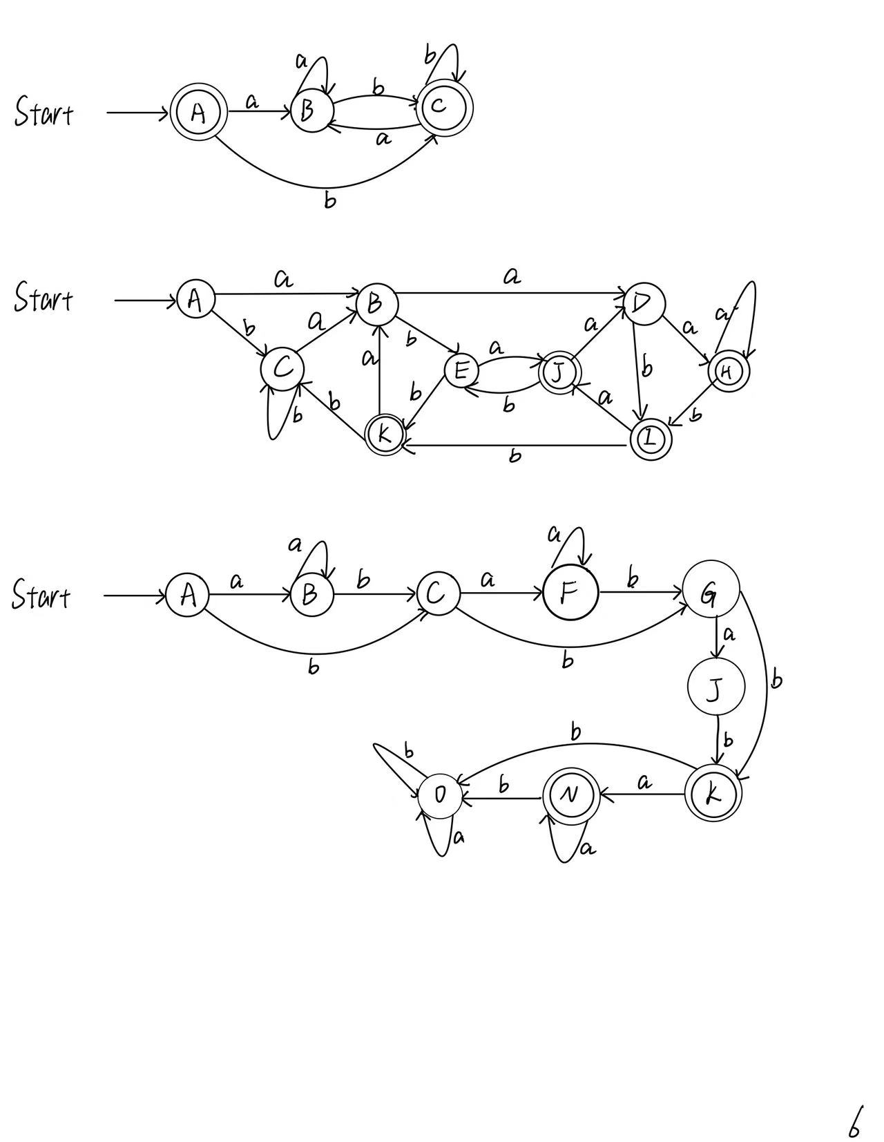
2.
$$A=ε-closure\left(\left\{0\right\}\right)=\left\{0, 1, 2, 4, 7\right\}.$$
$$B=δ_{D}(A, a)=ε-closure\left(\left\{3, 8\right\}\right)=\left\{1, 2, 3, 4, 6, 7, 8, 9, 11\right\}.$$
$$C=δ_{D}(A, b)=ε-closure\left(\left\{5\right\}\right)=\left\{1, 2, 4, 5, 6, 7\right\}.$$
$$D=δ_{D}(B, a)=ε-closure\left(\left\{3, 8, 10\right\}\right)=\left\{1, 2, 3, 4, 6, 7, 8, 9, 11, 13, 14, 16\right\}.$$
$$E=δ_{D}\left(B, b\right)=ε-closure\left(\left\{5, 12\right\}\right)=\{1, 2, 4, 5, 6, 7, 12, 13, 14, 16\}.$$
$$F=δ_{D}(C, a)=ε-closure\left(\left\{3, 8\right\}\right)=B.$$
$$G=δ_{D}(C, b)=ε-closure\left(\left\{5\right\}\right)=C.$$
$$H=δ_{D}(D, a)=ε-closure\left(\left\{3, 8, 10, 15\right\}\right)=\left\{1, 2, 3, 4, 6, 7, 8, 9, 10, 11, 13, 14, 15, 16, 18\right\}.$$
$$I=δ_{D}(D,b)=ε-closure\left(\left\{5, 12, 17\right\}\right)=\left\{1, 2, 4, 5, 6, 7, 12, 13, 14, 16, 17, 18\right\}.$$
$$J=δ_{D}(E, a)=ε-closure\left(\left\{3, 8, 15\right\}\right)=\left\{1, 2, 3, 4, 6, 7, 8, 9, 11, 13, 14, 15, 18\right\}.$$
$$K=δ_{D}(E,b)=ε-closure\left(\left\{5, 17\right\}\right)=\left\{1, 2, 4, 5, 6, 7, 17, 18\right\}.$$
$L=δ_{D}\left(H, a\right)=ε-closure\left(\left\{3, 8, 10, 15\right\}\right)=H$.
$M=δ_{D}\left(H, b\right)=ε-closure\left(\left\{5, 12, 17\right\}\right)=I$.
$N=δ_{D}\left(I, a\right)=ε-closure\left(\left\{3, 8, 15\right\}\right)=J$.
$O=δ_{D}\left(I,b\right)=ε-closure\left(\left\{5, 17\right\}\right)=K$.
$P=δ_{D}\left(J, a\right)=ε-closure\left(\left\{3, 8, 10\right\}\right)=D$.
$Q=δ_{D}\left(J, b\right)=ε-closure\left(\left\{5, 12\right\}\right)=E$.
$R=δ_{D}\left(K, a\right)=ε-closure\left(\left\{3, 8\right\}\right)=B$.
$S=δ_{D}\left(K, b\right)=ε-closure\left(\left\{5\right\}\right)=C$.
The transition table of the DFA (Starting state is A and finite states are {H, I, J, K}):
NFA STATE | DFA STATE | a | b
$$\left\{0, 1, 2, 4, 7\right\}$$ | A | B | C
$$\left\{1, 2, 3, 4, 6, 7, 8, 9, 11\right\}$$ | B | D | E
$$\left\{1, 2, 4, 5, 6, 7\right\}$$ | C | B | C
$$\left\{1, 2, 3, 4, 6, 7, 8, 9, 11, 13, 14, 16\right\}$$ | D | H | I
$$\{1, 2, 4, 5, 6, 7, 12, 13, 14, 16\}$$ | E | J | K
$$\left\{1, 2, 3, 4, 6, 7, 8, 9, 10, 11, 13, 14, 15, 16, 18\right\}$$ | H | H | I
$$\left\{1, 2, 4, 5, 6, 7, 12, 13, 14, 16, 17, 18\right\}$$ | I | J | K
$$\left\{1, 2, 3, 4, 6, 7, 8, 9, 11, 13, 14, 15, 18\right\}$$ | J | D | E
$$\left\{1, 2, 4, 5, 6, 7, 17, 18\right\}$$ | K | B | C
The transition diagram:

3.
$$A=ε-closure\left(\left\{0\right\}\right)=\left\{0, 1, 3\right\}.$$
$$B=δ_{D}(A, a)=ε-closure\left(\left\{2\right\}\right)=\left\{1, 2, 3\right\}.$$
$$C=δ_{D}(A, b)=ε-closure\left(\left\{4\right\}\right)=\left\{4, 5, 7\right\}.$$
$$D=δ_{D}(B, a)=ε-closure\left(\left\{2\right\}\right)=B.$$
$$E=δ_{D}\left(B, b\right)=ε-closure\left(\left\{4\right\}\right)=C.$$
$$F=δ_{D}\left(C, a\right)=ε-closure\left(\left\{6\right\}\right)=\{5, 6, 7\}.$$
$$G=δ_{D}\left(C, b\right)=ε-closure\left(\left\{8\right\}\right)=\{8, 9, 11\}.$$
$$H=δ_{D}(F, a)=ε-closure\left(\left\{6\right\}\right)=F.$$
$$I=δ_{D}(F,b)=ε-closure\left(\left\{8\right\}\right)=G.$$
$$J=δ_{D}(G, a)=ε-closure\left(\left\{10\right\}\right)=\left\{9, 10, 11\right\}.$$
$$K=δ_{D}(G,b)=ε-closure\left(\left\{12\right\}\right)=\left\{12, 13, 15\right\}.$$
$L=δ_{D}\left(J, a\right)=ε-closure\left(\left\{10\right\}\right)=J$.
$M=δ_{D}\left(J, b\right)=ε-closure\left(\left\{12\right\}\right)=K$.
$$N=δ_{D}\left(K, a\right)=ε-closure\left(\left\{14\right\}\right)=\left\{13, 14, 15\right\}.$$
$O=δ_{D}\left(K,b\right)=∅$.
$$P=δ_{D}\left(N, a\right)=ε-closure\left(\left\{14\right\}\right)=N.$$
$Q=δ_{D}\left(N, b\right)=∅=O$.
$R=δ_{D}\left(N, b\right)=∅=O$.
$S=δ_{D}\left(N, b\right)=∅=O$.
The transition table of the DFA (Strating state is A and finite states are {K, N}):
NFA STATE | DFA STATE | a | b
$$\left\{0, 1, 3\right\}$$ | A | B | C
$$\left\{1, 2, 3\right\}$$ | B | B | C
$$\left\{4, 5, 7\right\}$$ | C | F | G
$$\{5, 6, 7\}$$ | F | F | G
$$\{8, 9, 11\}$$ | G | J | K
$$\left\{9, 10, 11\right\}$$ | J | J | K
$$\left\{12, 13, 15\right\}$$ | K | N | O
$$\left\{13, 14, 15\right\}$$ | N | N | O
$$∅$$ | O | O | O
The transition diagram:

2 Optional Exercises
Exercise 1
Regular expression 2:
(1) Initial partition: $G_{1}=\left\{A, B, C, D, E\right\}, G_{2}=\left\{H, I, J, K\right\}.$
(2) $G_{1}:$ b splits it into two groups $G_{3}=\left\{A, B, C, D\right\}, G_{4}=\left\{E\right\}.$
(3) $G_{3}:$ a splits it into two groups $G_{5}=\left\{A, B, C\right\}, G_{6}=\left\{D\right\}.$
(4) $G_{5}:$ b splits it into two groups $G_{7}=\left\{A, C\right\}, G_{8}=\left\{B\right\}.$
(5) $G_{2}:$ a splits it into two groups $G_{9}=\left\{H, I, J\right\} G_{10}=\left\{K\right\}.$
(6) $G_{9}:$ b splits it into two groups $G_{11}=\left\{H, J\right\}, G_{12}=\left\{I\right\}.$
(7) $G_{11}:$ a splits it into two groups $G_{13}=\left\{H\right\}, G_{14}=\left\{J\right\}.$
(8) Picking $A, B, D, E, H, I, J, K$ as the representatives to construct the minimum-state DFA.
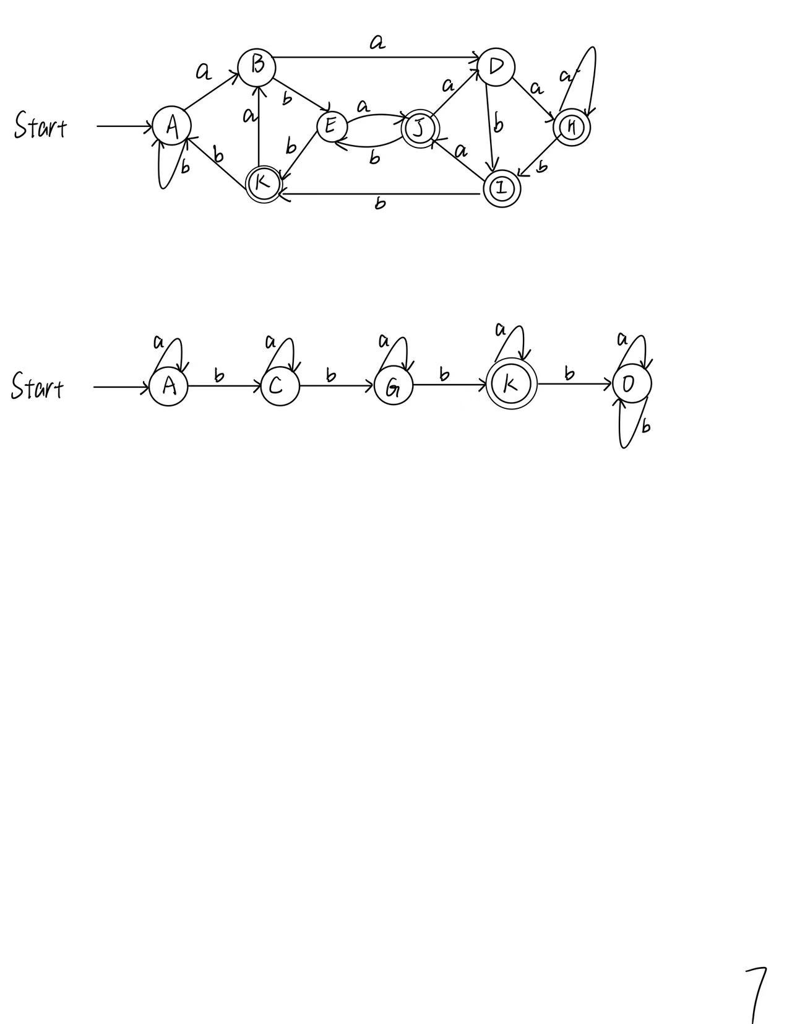
Regular expression 3:
(1) Initial partition: $G_{1}=\left\{A, B, C, F, G, J, O\right\}, G_{2}=\left\{K, N\right\}.$
(2) $G_{1}:$ b splits it into two groups $G_{3}=\left\{A, B, C, F, O\right\}, G_{4}=\left\{G, J\right\}.$
(3) $G_{3}:$ b splits it into two groups $G_{5}=\left\{A, B, O\right\}, G_{6}=\left\{C, F\right\}.$
(4) $G_{5}:$ b splits it into two groups $G_{7}=\left\{A, B\right\}, G_{8}=\left\{O\right\}.$
(5) Picking $A,C, G, K, O$ as the representatives to construct the minimum-state DFA.


