Assignment 5
Name: 项 枫 Student ID: 2022211570 Class Number: 2022211801
1 Required Exercises
Exercise 1
1、$(3 + 4) * (5 + 6)n$
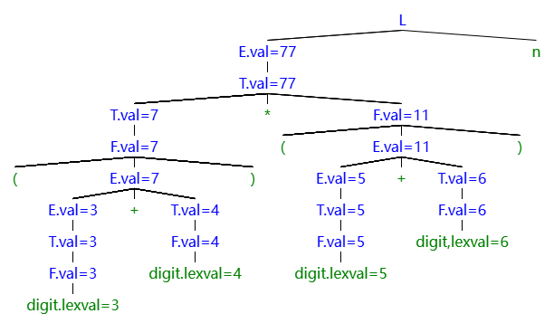
2、$1 * 2 * 3 * (4 + 5)n$
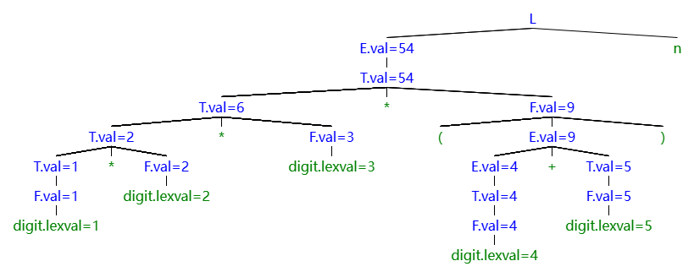
3、$(9 + 8 * (7 + 6) + 5) * 4n$
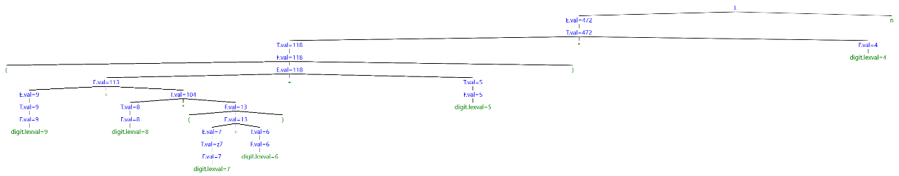
Exercise 2
There all totoally 10 different topological sorts for the dependency graph.
1： | 1, 2, 3, 4, 5, 6, 7, 8, 9;
2： | 1, 2, 3, 5, 4, 6, 7, 8, 9;
3： | 1, 2, 4, 3, 5, 6, 7, 8, 9;
4： | 1, 3, 2, 4, 5, 6, 7, 8, 9;
5： | 1, 3, 2, 5, 4, 6, 7, 8, 9;
6： | 1, 3, 5, 2, 4, 6, 7, 8, 9;
7： | 2, 1, 3, 4, 5, 6, 7, 8, 9;
8： | 2, 1, 3, 5, 4, 6, 7, 8, 9;
9： | 2, 1, 4, 3, 5, 6, 7, 8, 9;
10： | 2, 4, 1, 3, 5, 6, 7, 8, 9.
Exercise 3
PRODUCTIONS | SEMANTIC RULES
1) $E → E1 +T$ | $$E.type := float if E1.type = float else int$$
2) $E → T$ | $$E.type := T.type$$
3) $T → num.num$ | $$T.type := float$$
4) $T → num$ | $$T.type := int$$

