

BUPT Compilers Lab2 2024Fall

Name: 项 枫
Student ID: 2022211570
Class Number: 2022211801
Container Number:
6eca9c2b53e9aaa0c65b6af6613814be05cc0d8ccc63b7df064c4a7230aab09f

1 Running the wc program example
Make the wc target, run it and compare with system's wc.
The commands were used:
make wc
./wc.out inferno3.txt
wc inferno3.txt
1.1 The screenshot of the compilation and execution results.
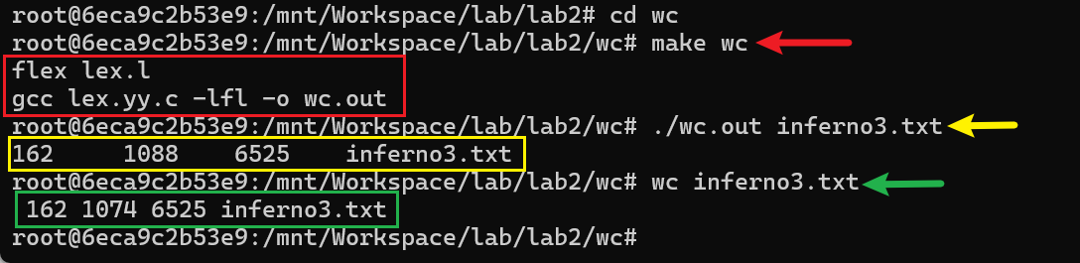
1.2 Explanation of the output of running this wc program is different from the wc command on Linux systems.
Linux's wc treats a sequence of characters separated by spaces, tabs, or newlines as a word; while the example's wc treats a sequence of letters separated by other characters as a word.
2 Flex Exercises-identifiers
Make the identifiers target and run it.
The commands were used:
make idcount
./idcount.out ./test.c
2.1 I found that the line numbers in the output do not match the line numbers of the tokens.
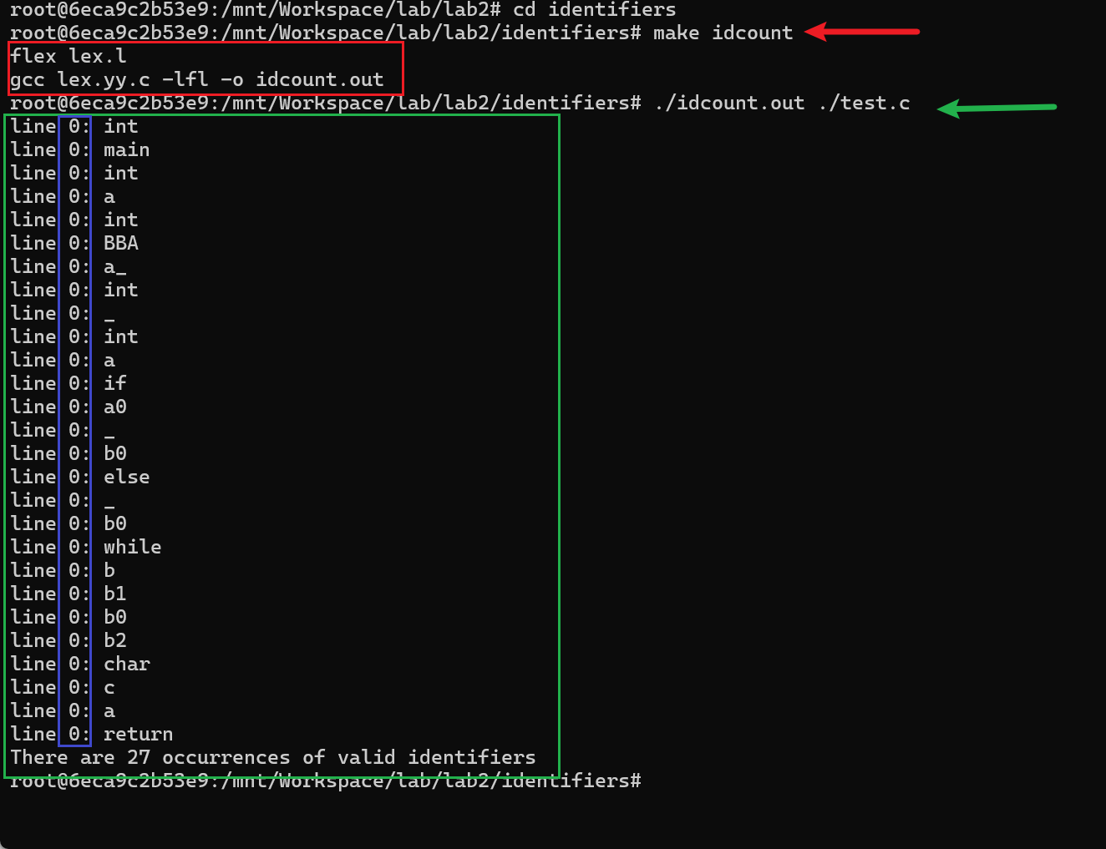
2.2 I solved it with Flex in the lab session.
2.2.1 My code.
Two changes are made to the lex.l file.
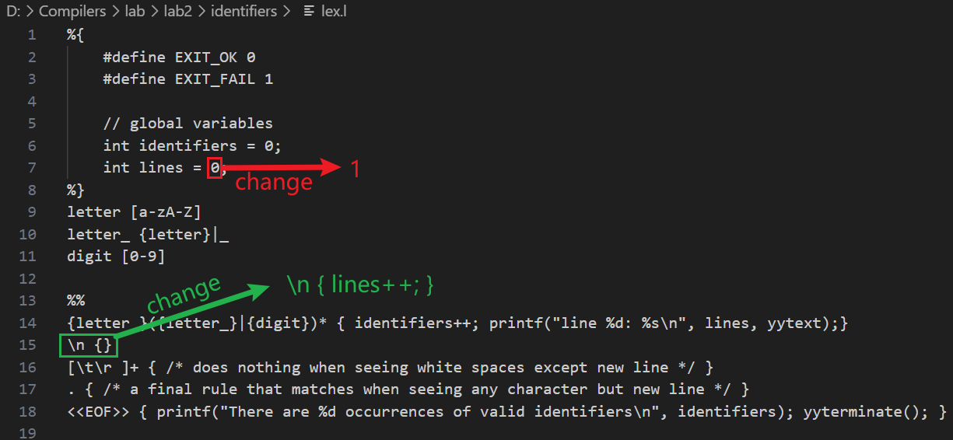
The changed code can be found at lex.l.
2.2.2 The principles of key parts of my code.
The initial value of lines should be 1, and when changing lines, the value of lines should be increased by 1 (self-incrementing).
2.2.3 The screenshot of the compilation and execution results.
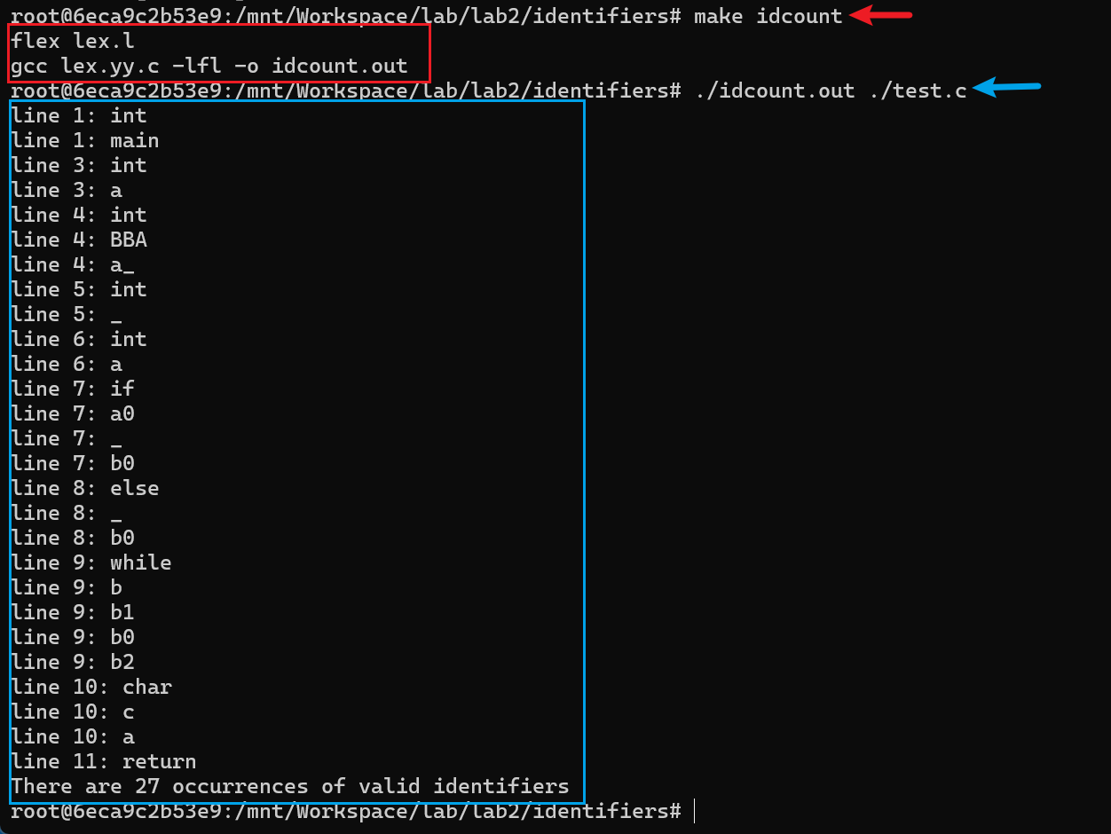
3 Flex Exercise -ipaddr
Validate IP Address.
Solve it with Flex in the lab session and use ip_test.py to verify the results. Try to pass them!
The commands were used:
make ipaddr
python3 ip_test.py
3.1 My code.
Four lines (7~10) of code were added to lex.l file.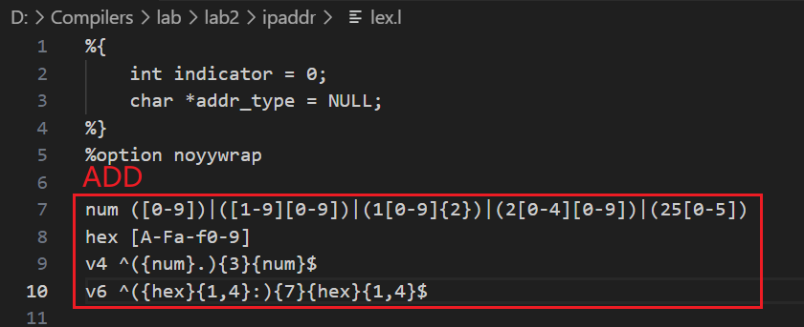
The changed code can be found at lex.l.
3.2 The principles of key parts of my code.
In this part, num defines the pattern of decimal numbers from 0 to 255. hex defines the pattern of hexadecimal numbers from 0 to f. v4 defines the pattern of an IPv4 address. v6 defines the pattern of an IPv6 address.
3.3 The screenshot of the compilation and execution results.
