

BUPT Compilers Lab3 2024Fall

Name: 项 枫
Student ID: 2022211570
Class Number: 2022211801
Container Number:
6eca9c2b53e9aaa0c65b6af6613814be05cc0d8ccc63b7df064c4a7230aab09f

1 Interacting Bison with Flex
The commands were used:
make calc
echo ’1+1=’ | ./calc.out
echo ’2*3=’ | ./calc.out
echo ’5-2*2=’ | ./calc.out
The screenshot of the compilation and execution results.
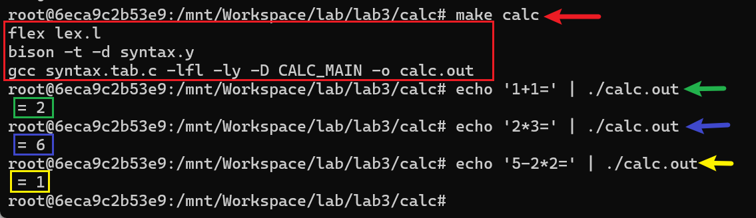
2 Validating parentheses
2.1 Code
The implementation of syntax.y is as follows.
%{
#include"lex.yy.c"
void yyerror(const char *s);
int result;
%}
%token LP RP LB RB LC RC
%%
String: String String
| LP String RP
| LB String RB
| LC String RC
| %empty
;
%%

void yyerror(const char *s){
result = 0;
}

int validParentheses(char *expr){
result = 1;
yy_scan_string(expr);
yyparse();
return result;
}
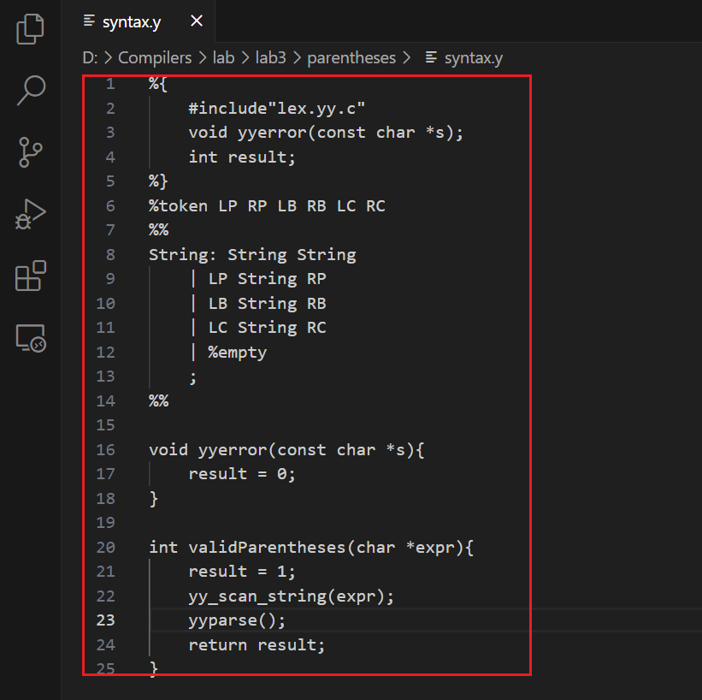
2.2 Run
The commands were used:
make
python3 paren_test.py
The screenshot of the compilation and execution results.
