

BUPT Compilers Project2 2024Fall

Name: 项 枫
Student ID: 2022211570
Class Number: 2022211801
Container Number:
6eca9c2b53e9aaa0c65b6af6613814be05cc0d8ccc63b7df064c4a7230aab09f
Contents
1 Overview 1
2 Abstract Data Types 1
2.1 Linked List 1
2.2 Binary Search Tree 2
2.3 Hash Table 2
3 Scope Checking 3
4 Type Checking 5
4.1 Type System 5
4.2 Type Equivalence 5
4.3 Derived Types Representation 6
5 Semantic Errors 6
6 Run 7
6.1 Make 7
6.2 Test 7
7 Results 9
7.1 BPL Program with Semantic Errors 9
8.2 Correct BPL Program 11

1 Overview
In the previous project, I have completed the tasks of lexical and syntax analysis, which end up with a syntax tree representation for a syntactically-valid bpl program. Informally, semantic analysis ensures that the program has a well-defined meaning, in other words, via semantic analysis, my compiler finally knows whether an input bpl program is legal or not. Unlike my experience in the previous project, to implement the semantic analyzer, I write all the code by myself. Semantic analysis is not the most difficult task for implementing the bpl compiler, however, it is the most laborious one. To realize the semantic analysis effectively and efficiently, I design various data structures, such as symbol table and data type representation, and carefully consider what is their most appropriate implementation. We have defined bpl tokens by regular expressions and bpl syntax by a context-free grammar. In this project, we will not use more expressive formal languages (i.e., contextsensitive grammar) for semantic analysis. Instead, we use attribute grammar, which assigns each symbol in the CFG a set of actions. Actually, we already used attribute grammar for syntax tree generation during parsing in the previous project. Assigning all symbols with solely synthesized attributes allows me to make a one-pass parser, which builds the syntax tree and performs semantic analysis simultaneously. Running in one-pass is definitely more efficient, though it is preferable to separate these two stages (build the tree and then traverse
it to analyze semantics) for better modularity and flexibility. I will start semantic analysis based on the previous project, and will continue the subsequent parts of my bpl compiler on top of this work, hence it is important to keep my code maintainable and extensible.

2 Abstract Data Types

2.1 Linked List
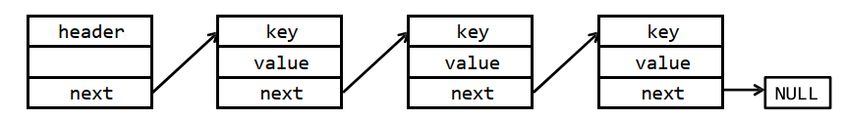
In a linked list symbol table, all symbols are organized in a sequential order. To insert a new symbol, we can simply put it right after the header node, and the time complexity is O(1). However, to lookup a particular symbol, in the worst cases, we need to go through the whole list (O(n) time complexity). Deleting a symbol is the same as lookup, since we should know whether the symbol exists before deleting it.
Clearly, linked list is not efficient for lookup and delete operations. When there are many symbols in the table, these operations can be time-consuming. Nevertheless, the linked list is easy to implement. If you know beforehand that there are only a few symbols during semantic analysis, using a linked list to build the symbol table may be a wise choice.

2.2 Binary Search Tree
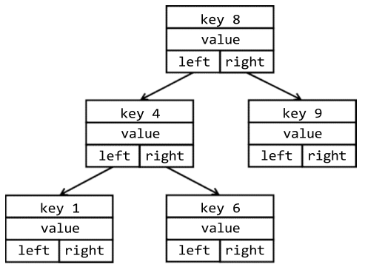
Linked list only supports sequential search, while binary tree supports binary search, of which the time complexity to O(log n). A binary search tree node generally has two pointer fields, one to its left child, another to the right one. The structural property of a binary search tree is that, all keys in the left subtree are strictly less than the root’s key, while all keys in the right subtree are greater than the root’s key. With such a property, a binary search tree is able to lookup/delete in logarithmic time. However, the insert time is also logarithmic, since it should firstly find a suitable position to insert.
However, a binary search tree may degenerate to a linked list, depending on the order of insert and delete. To overcome this limitation, many balance strategies are proposed. Typical variants include AVL tree or red-black tree. These variants propose more strict structural properties to ensure the tree never degenerates, and the operations are in O(log n) time on average. However, implementing a binary search tree with an applicable balance strategy is rather complicated. Binary search tree achieves good trade-off between space and time complexity, hence it is commonly used in some performance-sensitive systems. For example, JDK’s TreeMap collection is implemented using red-black tree.

2.3 Hash Table
The time complexity of lookup in a hash table is O(1). A good hash function may provide constant time for all operations (in average). Comparing to other ADTs, hash table is rather simple to implement: allocate a large consecutive memory space, design a hash function for the given key type (ASCII strings for a symbol table), then insert the key-value at the corresponding position. Note that hash table consumes more space than binary tree, though it is not critical in our project.
A hash function “compresses” the key into a fixed-range index. A good function can produce evenly distributed values with respect to the input string. How to design a good hash function is beyond the scope of our course. You can find many practical examples of hash function in https://github.com/liushoukai/node-hashes. A good candidate is the hash function proposed by P. J. Weinberger.
The hash function inevitably causes collisions, in which multiple keys map to the same index value. To resolve hash collisions, there are generally two approaches: separate chaining and open addressing. The former defines each table element to be the head of a linked list, and appends the collided keys to the same list. The latter is also called rehashing, which re-computes the hash value by alternative hash functions to find next available position. You can also employ other advanced techniques, such as multiplicative hash function or universal hash function, to make your hash table more evenly distributed.

3 Scope Checking
A scope is a section of program text enclosed by basic program delimiters, e . g{}. , in C, or begin-end in Pascal. With scope, variables are only visible within certain sections. Option- ally, our bpl language can provide scoping.
Scope checking refers to the process of determining if an identifier (symbol) is accessible at that location in the program. There are two common approaches to implement a scoping symbol table.
The first approach is imperative-style implementation, in which only one single table is maintained globally. We can implement a hash table with separated chaining, and insert duplicated key to the head of its corresponding linked list. The innermost definition always appears at the head of list. However, when the current scope is enclosed, we should pop out all symbols in the scope. To prevent traversing the whole hash table whenever a scope is closed, you may consider to utilize orthogonal list data structure. In the orthogonal list shown above, three cascading scope is defined. The outermost scope
is at the bottom of the stack, in which two symbols, namely a and i are declared. In the second level, symbols i, j and v are declared, and this symbol i shadows the outer declaration. Similar for the top scope on the stack. When the top scope is popped, we can trace through the list and find that only symbols i and j are defined inside, hence efficiently remove these two keys from the head of their corresponding lists.
Another solution for imperative-style symbol table is assigning each scope with a depth number. Each name in the symbol table is inserted along with the depth number of its containing scope. A name may appear in the symbol table more than once as long as each repetition has a different depth. To lookup a certain name, the symbol table should always return the name with the innermost depth number. Such implementation is similar to an open-addressing hash table.
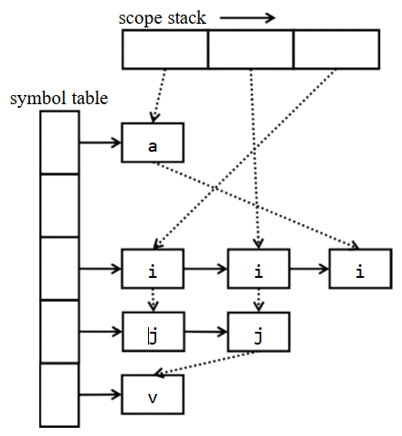
Another implementation style is so called functional-style, which separates individual symbol table for each scope. Under such implementation, we organize all these symbol tables into a scope stack, the innermost scope is stored at the top of the stack, with the next containing scope that is underneath it, etc.. When a new scope is opened, a new symbol table is created and the variables declared in that scope are inserted into the new table. We then push the symbol table on the scope stack. When a scope is closed, the top symbol table is popped. To find a symbol, we start at the top of the stack and work our way down until we find it. If we do not find it, the variable is not accessible and an error should be generated.
In addition to the obvious overhead of creating/removing symbol tables, the functionalstyle has a disadvantage, that is, all global variables will appear at the bottom of the stack, so scope checking of a program that accesses a lot of global variables can run slowly. Nevertheless, this approach has the advantage that each symbol table, once populated, remains immutable for the rest of the compilation process. Often times, immutable data structures lead to more robust code.

4 Type Checking

4.1 Type System
In programming language, a type is a set of values and a set of operations operating on those values. In bpl, there are two categories of data types: 1) Primitive Types are the base types of the language. These types are provided directly by the underlying hardware. They are int, char and float. 2) Derived Types are constructed by aggregating primitive types or derived types. They are arrays, structures in bpl, and pointers, union in C, etc..
Type checking is the process of verifying that each operation executed in a program respects the type system of the language. This generally means that all operands in any expression are of appropriate types and number. Much of what we do in the semantic analysis phase is type checking. Type checking can be done in compilation, during execution, or divided across both.
A type checker typically should identify the language constructs that have types associated
with them, and check them against the predefined semantic rules. In bpl, there are three
language constructs: 1) Variable: All variables declared in a bpl program must have a type, either a primitive type or a derived type. 2) Function: Each function has a return type. Each parameter in the function definition has a type, which is also associated with a corresponding argument in a function call. 3) Expression: Each expression has a type based on the type of the variables in the expression, return types of the called functions, or the operands in the expressions.

4.2 Type Equivalence
How to tell whether two types are equivalent? The question is trivial for primitive types: an int is equivalent only to another int, a float only to another float, etc..
However, things get complicated for derived types. Actually, whether two derived types are equivalent depends on how we define “equivalence”. Typically, there are two kinds of type equivalence: named equivalence and structural equivalence. For languages supporting named equivalence, two types are considered equivalent if and only if they have the same name. For example, struct st {int x; } and struct st {char y;}are equivalent types, regardless of their actual definitions. Structural equivalence is more general. Two types are structurally equivalent if a recursive traversal of the two type definition trees leads to completely the same results.
Clearly, checking types for a language supporting named equivalence is easier and quicker than doing that for a language supporting structural equivalence. But the trade-off is, named equivalence does not always reflect what is really being represented in a derived type.

4.3 Derived Types Representation
At implementation level, it is easy to represent primitive types: using constants is sufficient. As for the derived types, arrays and structures, representing them are rather complicated.
For example, we can define arrays of structures, as well as a structure with an array (what’s more, a multi-dimensional array!) field.
A common technique is to store the basic information, defining the type as multilevel linked list.
Checking type equivalence is much more complicated for real-world compilers. A rigorous and practical type checker should formally infer types from multilevel language constructs, and support more language features, such as pointers, object-oriented classes, explicit or implicit type coercion, etc.. Though you are not required to implement them, you should be aware of the fact that type checking is generally much more difficult than what you are required to do in this project.

5 Semantic Errors
My analyzer can detect the following semantic errors:
Type 1 variable is used without definition
Type 2 function is invoked without definition
Type 3 variable is redefined in the same scope
Type 4 function is redefined (in the global scope, since we don’t have nested function)
Type 5 unmatching types on both sides of assignment operator (=)
Type 6 rvalue on the left side of assignment operator
Type 7 unmatching operands, such as adding an integer to a structure variable
Type 8 the function’s return value type mismatches the declared type
Type 9 the function’s arguments mismatch the declared parameters (either types or
numbers, or both)
Type 10 applying indexing operator ([...]) on non-array type variables
Type 11 applying function invocation operator (foo(...)) on non-function names
Type 12 array indexing with non-integer type expression
Type 13 accessing member of non-structure variable (i.e., misuse the dot operator)
Type 14 accessing an undefined structure member
Type 15 redefine the same structure type

6 Run

6.1 Make
The command was used:
make bplc

6.2 Test
We can test all test cases by running test.py.
The implementation of test.py is as follows.
import subprocess

# Test test_2_o01.bpl
for i in range(1, 2):

name = f"0{i}"

# Define the input file path
input_file = f"test/test_2_o{name}.bpl"
# Define the output file path with the desired naming format
output_file = f"test/test_2_o{name}.out"
# Define the command to run the compiler
command = ["./bin/bplc", input_file]

# Open the output file for writing
with open(output_file, 'w') as f:
# Print a message indicating the input and output files
print(f"{input_file} -> {output_file} OK.")
# Run the command and redirect the output to the output file
subprocess.run(command, stdout=f)

# Test test_2_r01.bpl ~ test_2_r15.bpl
for i in range(1, 16):

if i <= 9:
name = f"0{i}"
else:
name = f"{i}"

# Define the input file path
input_file = f"test/test_2_r{name}.bpl"
# Define the output file path with the desired naming format
output_file = f"test/test_2_r{name}.out"
# Define the command to run the compiler
command = ["./bin/bplc", input_file]

# Open the output file for writing
with open(output_file, 'w') as f:
# Print a message indicating the input and output files
print(f"{input_file} -> {output_file} OK.")
# Run the command and redirect the output to the output file
subprocess.run(command, stdout=f)
The command was used:
python3 test.py
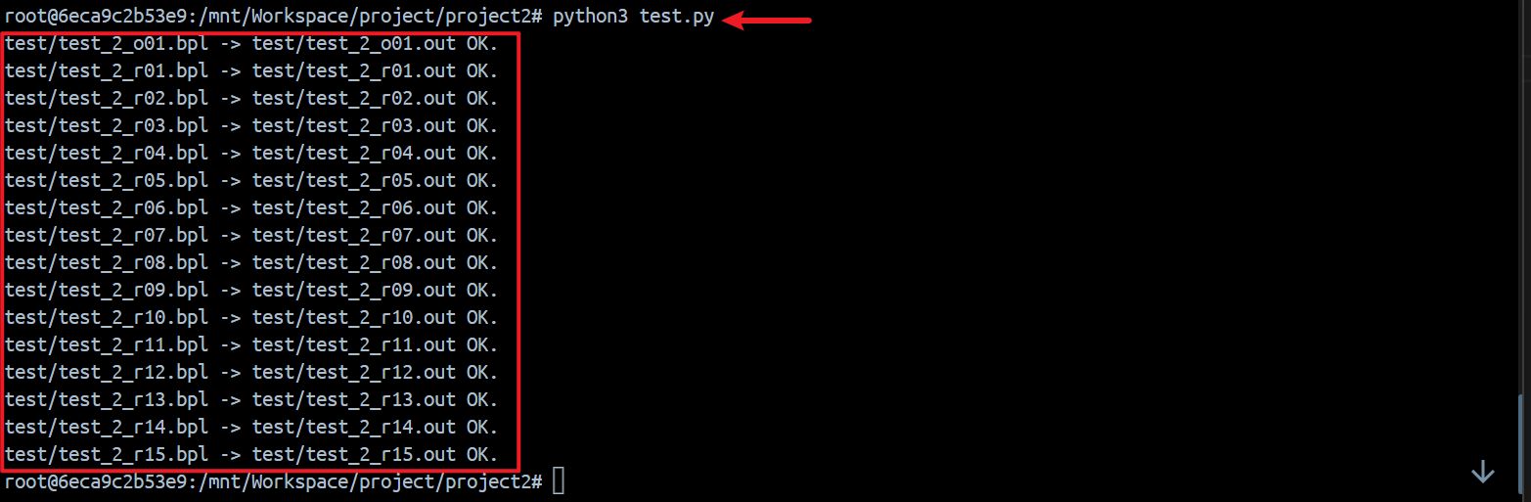
We can find that the all output files have been generated in the test folder.
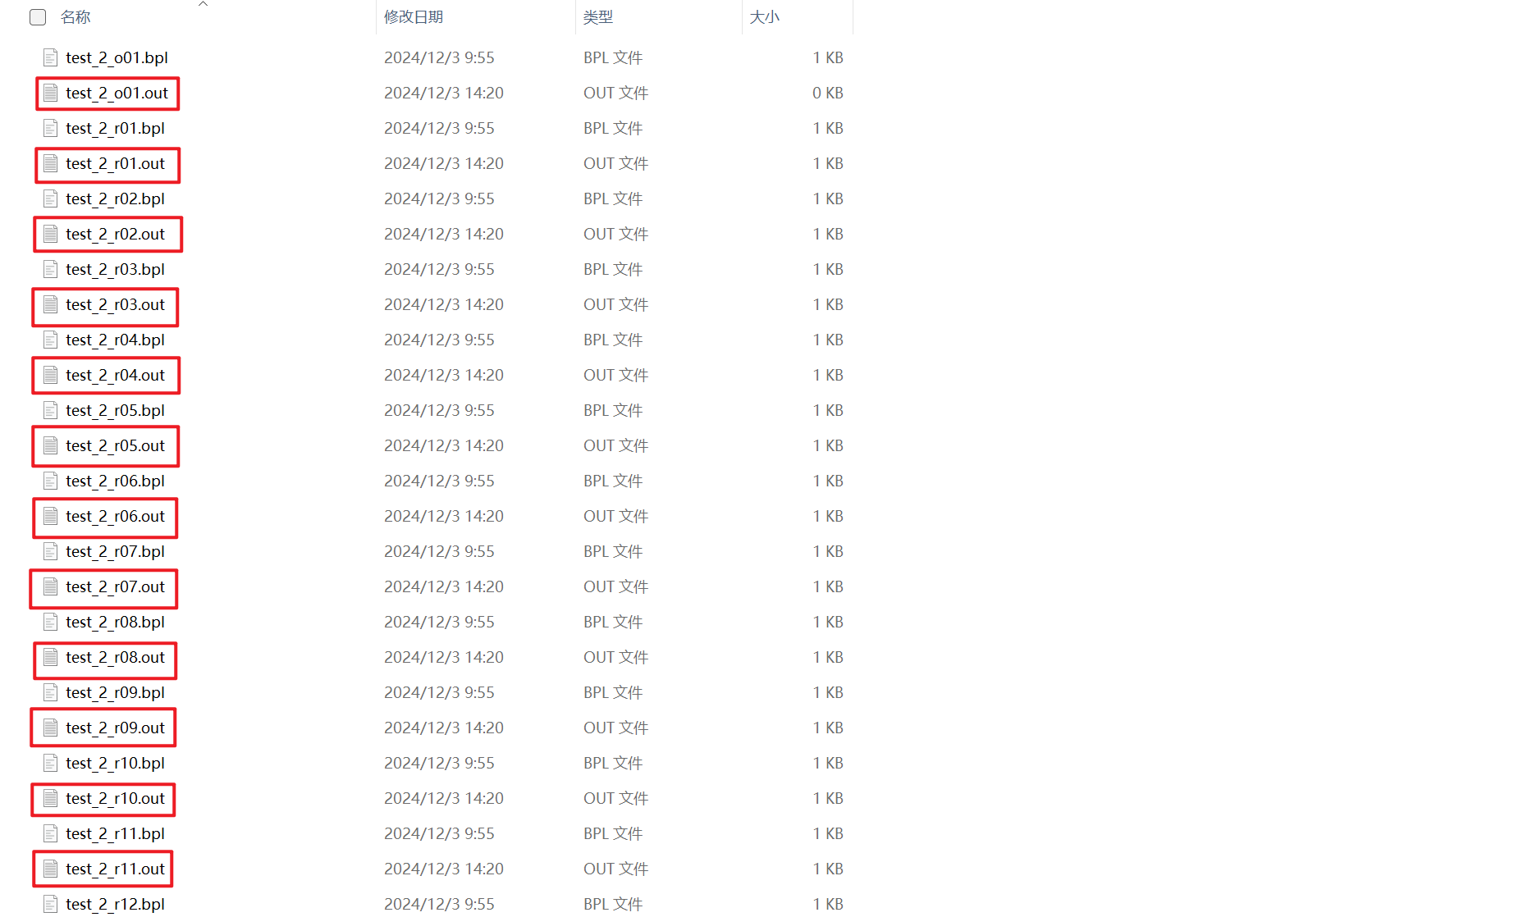
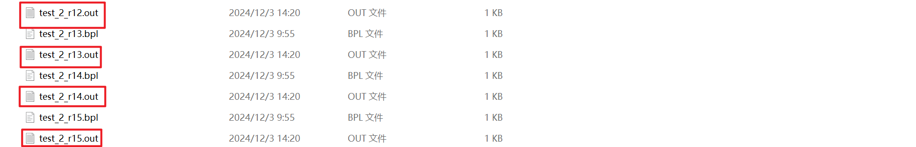

7 Results

7.1 BPL Program with Semantic Errors
My analyzer can output the error message in a text file .out, if any semantic error is presented.
e.g. test_2_r07.bpl
struct Apple
{
int weight;
float round;
};
int test_2_r07()
{
struct Apple aa;
float weight_test = 1.0;
aa.weight = aa + 2;
return 0;
}
In the program, line 10 contains three errors, my analyzer output the error messages in a text file test/ test_2_r07, as follow:
Error type 7 at line 10: Type mismatched for operands, expected int or float
Error type 7 at line 10: Type mismatched for operands, expected same type
Error type 5 at line 10: Type mismatched for assignment
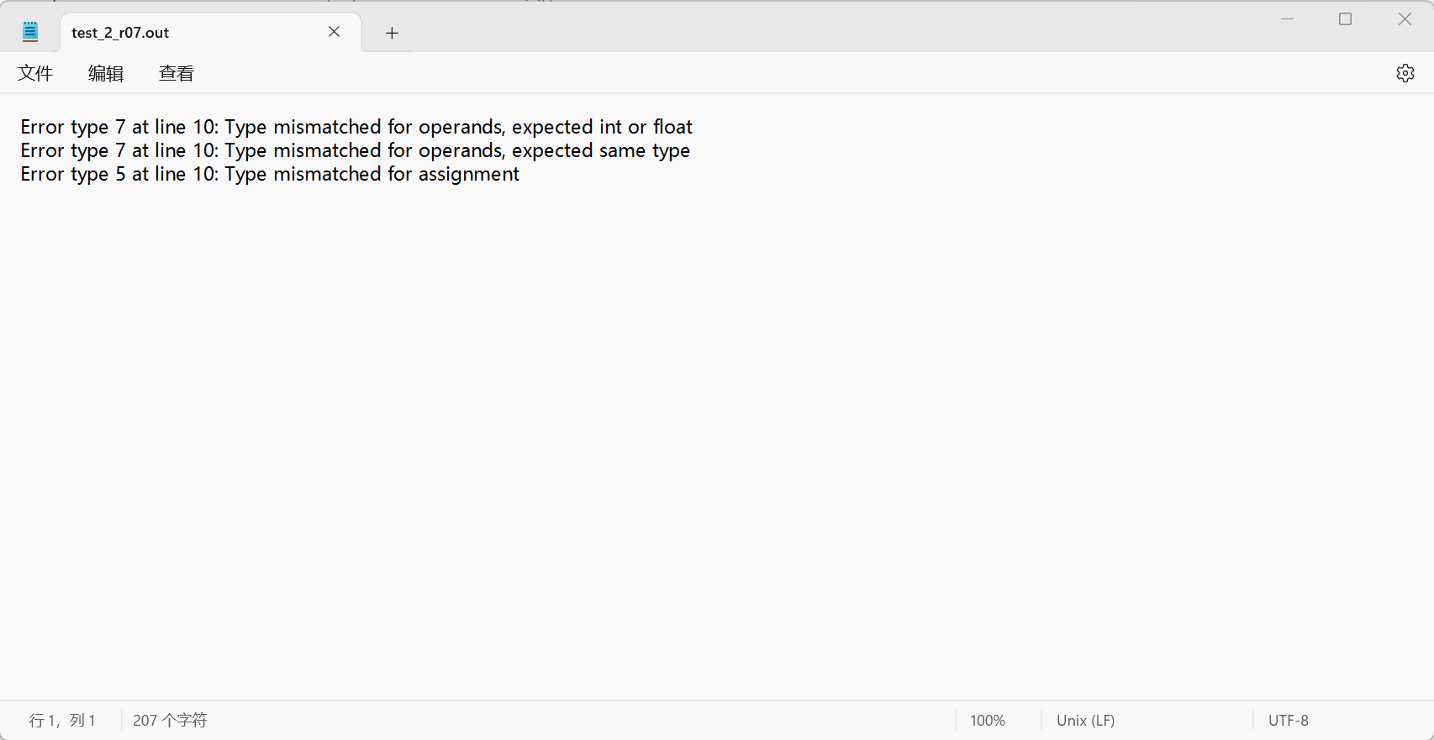
e.g. test_2_r12.bpl
int test_2_r12()
{
float arr1[10];
float arr2[10];
float a = 1.1;
int i = 0;
while (i < 10)
{
arr1[i] = a;
a = a * a;
}
i = 0;
while (i < 10)
{
arr2[arr1[i]] = a;
}
return 0;
}
In the program, line 15 contains two errors, my analyzer output the error messages in a text file test/ test_2_r12, as follow:
Error type 12 at line 15: Array index is not an integer.
Error type 5 at line 15: Type mismatched for assignment
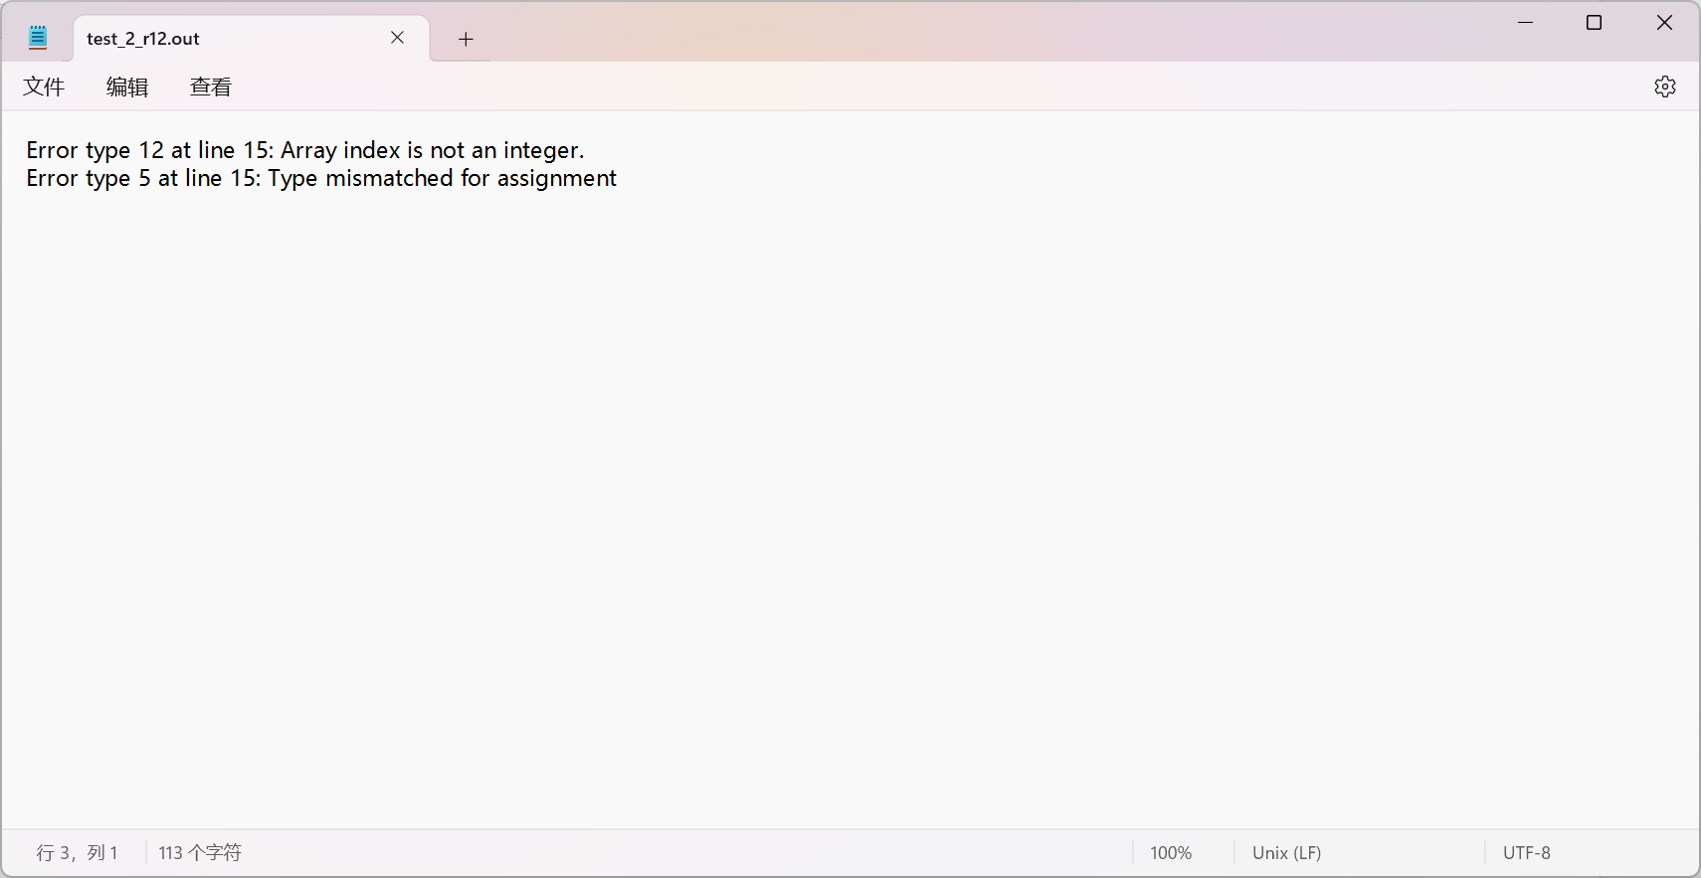
Others can be found in test folder.

8.2 Correct BPL Program
If no error (correct BPL program), touch an empty file.
e.g. test_2_o01.bpl
int foo()
{
int a = 10;
return a;
}
int test_2_o01(int a, int b)
{
int c;
c = foo();
if (b > 0)
{
int a = c + 3;
b = b - a;
}
a = a + b;
return a;
}
In the program, there isn’t any error, my analyzer can touch an empty file, as follow:
