1、新建数据库

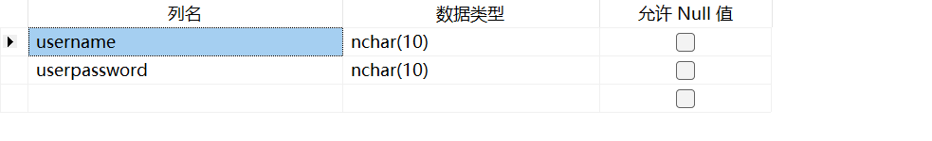

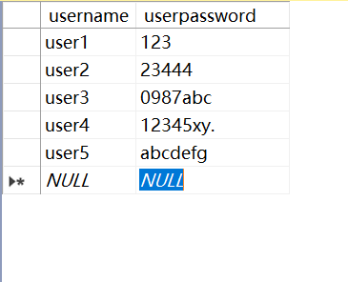

2、python代码如下

import pymssql  
  
# 数据库连接  
conn = pymssql.connect(host='(local)', database='USER_DB', charset="CP936")  
  
if conn:  
 print("数据库连接成功!")  
else:  
 print("数据库连接失败!")  
  
  
# 账号注册  
def Register():  
 cur = conn.cursor()  
 newusername = input("请输入注册账号:")  
 newpassword = input("请输入账号密码:")  
 renewpassword = input("请确认密码:")  
 sql = 'select count(*) from user_1 where username=%s'  
 cur.execute(sql, (newusername,))  
 result1 = cur.fetchone()  
 if newusername == "":  
 print("注册账号不得为空!")  
 elif newpassword == "":  
 print("账号密码不得为空!")  
 elif renewpassword == "":  
 print("请确认密码!")  
 elif newpassword != renewpassword:  
 print("两次密码不一致!请重新确认密码!")  
 elif result1[0] == True:  
 print("该账号已注册!请重新注册!")  
 Register()  
 else:  
 print("新账号注册成功!")  
 sql = "insert into user_1 (username, password,userpwd) values (%s, %s,%s)"  
 cur.execute(sql, (newusername, newpassword, newusername + newpassword))  
 conn.commit()  
 Main()  
 cur.close()  
  
  
# 账号登录  
def Login():  
 cur = conn.cursor()  
 username = input("请输入账号:")  
 password = input("请输入密码:")  
 sql = 'select count(*) from user_1 where userpwd=%s '  
 cur.execute(sql, (username + password,))  
 result1 = cur.fetchone()  
 if username == "":  
 print("账号不得为空!")  
 elif password == "":  
 print("账号密码不得为空!")  
 elif result1[0] == True:  
 print("账号登录成功!")  
 cur.close()  
 Main()  
 else:  
 sql = 'select count(*) from user_1 where username=%s'  
 cur.execute(sql, (username,))  
 result1 = cur.fetchone()  
 if result1[0] == False:  
 num = input("账号不存在,是否选择注册一个新账号?\n1、是；2、否\n")  
 if num == "1":  
 Register()  
 else:  
 Main()  
 else:  
 print("账号密码错误!")  
 Login()  
 cur.close()  
  
  
def Main():  
 num = input("1、账号登录；2、注册账号；3、退出\n请选择:")  
 if num == "1":  
 Login()  
 elif num == "2":  
 Register()  
 elif num == "3":  
 pass  
 else:  
 print("请重新输入!")  
 Main()  
  
  
if __name__ == "__main__":  
 Main()

3、运行结果

