1.
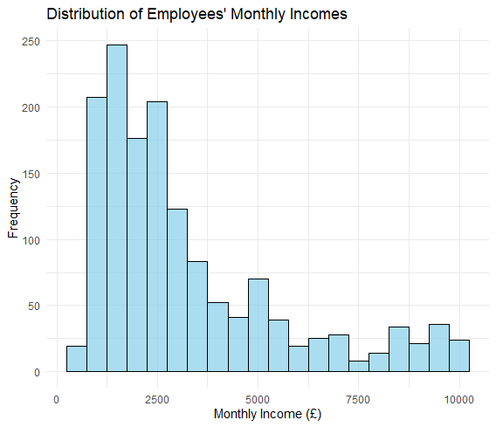
Mean Monthly Income: £ 3251.466
Median Monthly Income: £ 2459.5
Standard Deviation of Monthly Income: £ 2353.978

As the monthly income rises, the frequency of employees decreases.
Mean Monthly Income measure average monthly income of employees.
Median Monthly Income is the middle value of ordered data. Extreme values don’t affect this value much.
Standard Deviation indicates the spread of the income values around the mean. A higher standard deviation means more different in the income data.
The histogram shows how the monthly incomes are distributed, and the summary measures provide description of the distribution. This gives a good understanding of employee’s monthly income.

2.
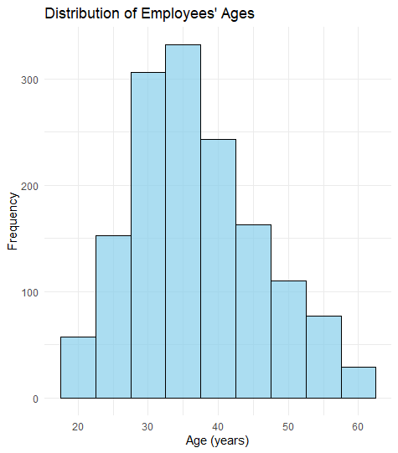
Mean Age: 36.92381
Median Age: 36
Standard Deviation of Age: 9.135373
Mean age give the average age of employees.
Median age gives the middle value of ordered data.
Standard deviation indicates the spread of age values around mean.
This histogram shows how the ages are distributed.
3.
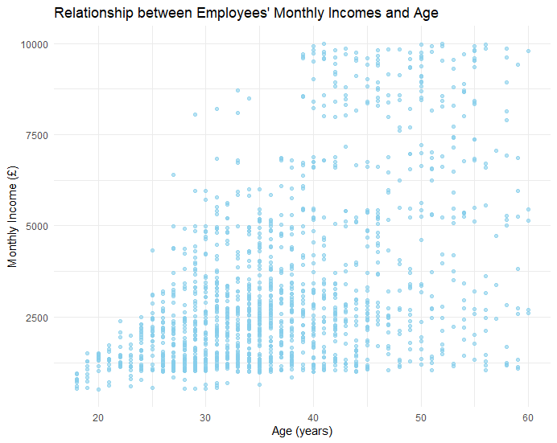
The scatter plot shows data points representing employees ages and their corresponding monthly incomes. There is a positive liner correlation between monthly income and age until about £5000 and age 43.
Correlation Coefficient: 0.4978546
It ranges from -1 to 1.
- 1 indicates a perfect positive linear relationship,
- -1 indicates a perfect negative linear relationship,
- 0 indicates no linear relationship.

Conclusion
By calculating the correlation coefficient, we can quantify the association between age and monthly income.
As correlation coefficient is positive about ~0.5 and close to 1, it suggests that as age increases, monthly income tends to increase as well.
4.
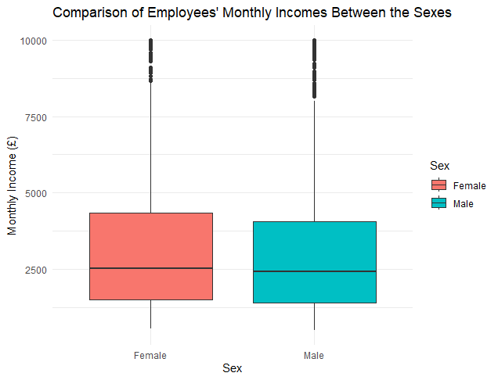

Welch Two Sample t-test

data: incomeGBP by Sex
t = 1.2223, df = 1261.5, p-value = 0.2218
alternative hypothesis: true difference in means between group Female and group Male is not equal to 0
95 percent confidence interval:
-92.59715 398.65554
sample estimates:
mean in group Female mean in group Male
3343.283 3190.254

H0: There is no significant difference in average monthly incomes between male and female employees.
H1: There is a significant difference in average monthly incomes between male and female employees.
Interpreting R output
The t-test result will provide several key pieces of information:
- t-value: This is the calculated test statistic.
- p-value: This indicates the probability of observing the test results under the null hypothesis. A p-value less than 0.05 typically indicates that we can reject the null hypothesis.
- Confidence Interval: This provides a range within which the true difference in means is likely to fall.
Conclusion
As the p-value is greater than 0.05 (0.22 > 0.05), fail to reject the null hypothesis and conclude that there is no significant difference in average monthly incomes between the sexes.

5.
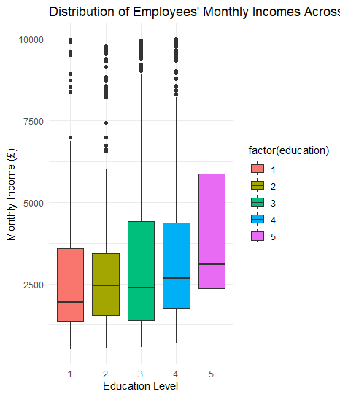
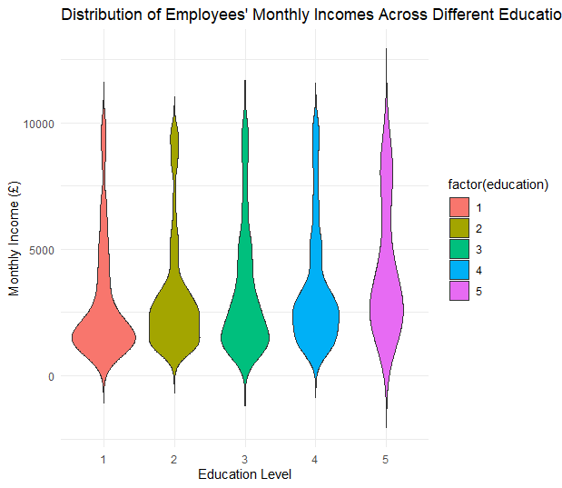
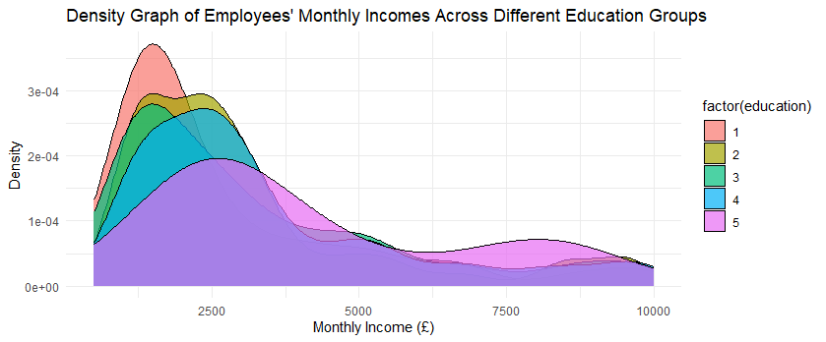

The boxplot shows the median, interquartile range, and any potential outliers for each group. From these 3 graphs and plot we can clearly see that Education Leve 5: Post degree qualification (Academic or professional) tend to earn highest salary between all education level. Education level 3: A level or equivalent and 4: HE degree tend to earn almost similar monthly income. Education level 1 tend to earn the lowest monthly income.
ANOVA Test
H0: There is no significant difference in average monthly incomes between different education groups.
H1: There is a significant difference in average monthly incomes between different education groups.
Interpretation of the ANOVA Output
- F-value: This is the calculated test statistic.
- p-value: This indicates the probability of observing the test results under the null hypothesis. A p-value less than 0.05 typically indicates that we can reject the null hypothesis.

> summary(anova_result)
Df Sum Sq Mean Sq F value
factor(education) 4 8.561e+07 21403220 3.893
Residuals 1465 8.054e+09 5497905
Pr(>F)
factor(education) 0.00377 **
Residuals
---
Signif. codes:
0 ‘***’ 0.001 ‘**’ 0.01 ‘*’ 0.05 ‘.’ 0.1 ‘ ’ 1

Tukey multiple comparisons of means
95% family-wise confidence level

Fit: aov(formula = incomeGBP ~ factor(education), data = emp_sat)

$`factor(education)`
diff lwr upr p adj
2-1 293.0374 -328.788200 914.8630 0.6992686
3-1 438.3467 -121.060271 997.7537 0.2036715
4-1 595.9157 9.161025 1182.6704 0.0444483
5-1 1318.5376 271.815115 2365.2601 0.0053953
3-2 145.3093 -320.657274 611.2759 0.9142013
4-2 302.8783 -195.589091 801.3457 0.4595671
5-2 1025.5002 25.591877 2025.4086 0.0411807
4-3 157.5690 -260.448727 575.5868 0.8417460
5-3 880.1909 -82.142582 1842.5244 0.0915806
5-4 722.6219 -255.861957 1701.1058 0.2582302

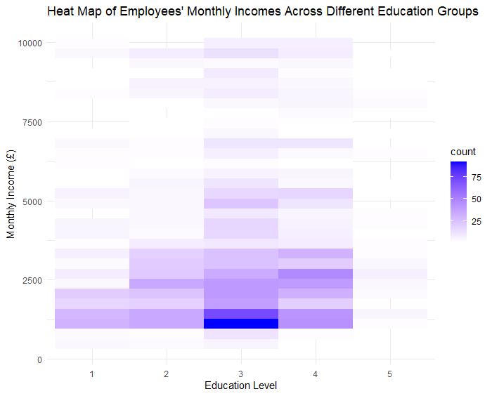
From this heatmap we can see that Education Level 3 (A level or equivalent) has most representation in the dataset.
Conclusion
The ANOVA test results in a p-value less than 0.05, reject the null hypothesis and conclude that there is a significant difference in average monthly incomes between different education groups. The post-hoc test will help us identify which specific education groups differ significantly in terms of average income.

6.i.
Job Satisfaction Across the Sexes
> print(sex_job_sat)

1 2 3 4
Female 119 118 181 170
Male 170 162 261 289

> print(chi_sex)

Pearson's Chi-squared test

data: sex_job_sat
X-squared = 2.5477, df = 3, p-value = 0.4667
Interpretation of Crosstabulation and Chi-Square Test
The crosstabulation shows the frequency of each job satisfaction level for male and female employees. The chi-square test will help to determine if there is a significant difference in job satisfaction between the sexes.
Null Hypothesis (H0): There is no significant difference in job satisfaction between male and female employees.
Alternative Hypothesis (H1): There is a significant difference in job satisfaction between male and female employees.
The p-value from the chi-square test is 0.4667, which is greater than 0.05. This means we fail to reject the null hypothesis and conclude that there is no significant difference in job satisfaction between male and female employees.

6.ii.
Job Satisfaction Across the Education
> print(edu_job_sat)

1 2 3 4
1 32 26 56 56
2 52 54 83 93
3 118 128 161 165
4 74 67 127 130
5 13 5 15 15

> print(chi_edu)

Pearson's Chi-squared test

data: edu_job_sat
X-squared = 13.03, df = 12, p-value = 0.3669
Interpretation of Crosstabulation and Chi-Square Test
H0: There is no significant difference in job satisfaction between different education groups.
H1: There is a significant difference in job satisfaction between different education groups.
The p-value from the chi-square test is 0.3669, which is greater than 0.05. This means we fail to reject the null hypothesis and conclude that there is no significant difference in job satisfaction between different education groups.
Conclusion
By examining the crosstabulations and performing chi-square tests, we can determine that there are significant differences in job satisfaction between the sexes and between different education groups. This analysis will provide valuable insights into the factors influencing job satisfaction among employees.

