 CI5325 Data Modelling
Coursework

Name: Istiak Mohammad
K Number: K2323025

- I declare that the attached work is all my own, and that where I have quoted from, used or referred to the opinions, work or writings of others, these have been fully and clearly acknowledged. No AI tools have been used in any part of the assignment.
- I understand that if there are any suspicions of academic misconduct, I will be required to attend a meeting to explain the contributions and processes undertaken to complete the assignment.
- I am aware of the consequences of late submission.

Signature: Istiak Mohammad

Task 1: Entity Relationship Diagram
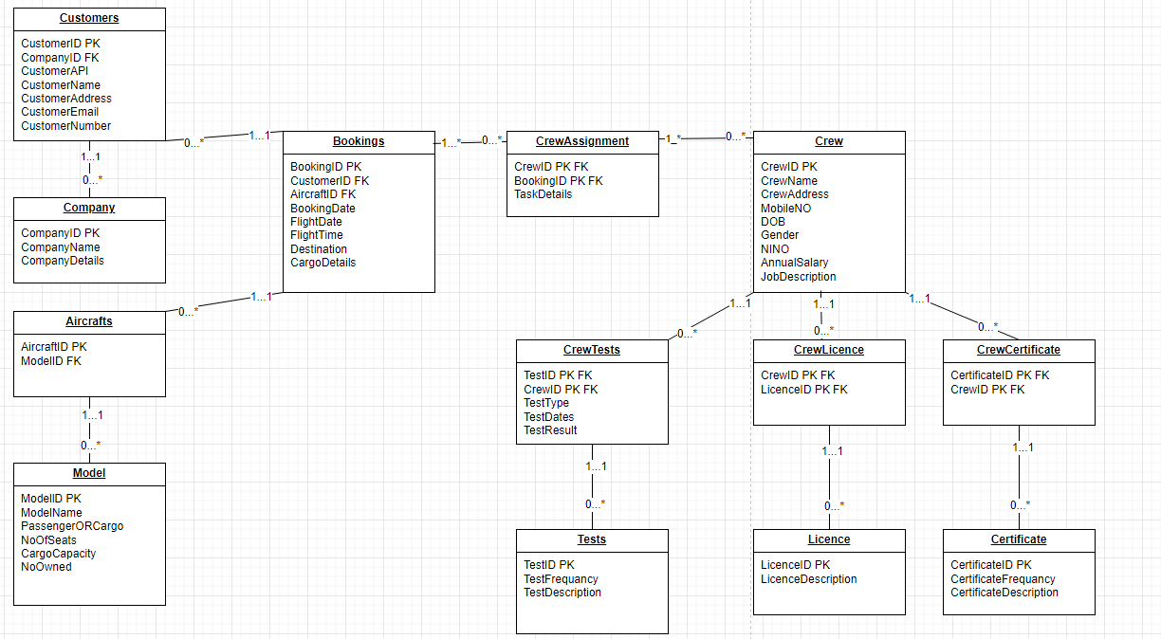
Assumptions
Customers | Passenger details will not need to be recorded on this database.
Aircrafts | Aircrafts can be booked by clients, and a client can book many aircrafts. However, each charter aircraft is booked by one and only one client.
Bookings | A client booking the whole plane and not booking a seat as in a scheduled airline flight.  Each booking is for a single journey and the price of the aircraft hire is agreed in advance
Crew | A crew can consist of more than one person and not all crew members are pilots.

Task 2: Data Dictionary
Company
Column Name | Data Type | Constraints
CompanyID | INT | PRIMARY KEY
CompanyName | VARCHAR2(100) | NOT NULL

Customers
Column Name | Data Type | Constraints
CustomerID | INT | PRIMARY KEY
CompanyID | INT | FOREIGN KEY
CustomerAPI | VARCHAR2(100)
CustomerName | VARCHAR2(100) | NOT NULL
CustomerAddress | VARCHAR2(50) | NOT NULL
CustomerEmail | VARCHAR2(100) | UNIQUE, NOT NULL

Model
Column Name | Data Type | Constraints
ModelID | INT | PRIMARY KEY
ModelName | VARCHAR2(100) | NOT NULL
PassengerORCargo | VARCHAR2(50) | NOT NULL, CHECK (PassengerORCargo IN ('Passenger', 'Cargo')),
NoOfSeats | INT
CargoCapacity | INT
NoOwned | INT

Aircrafts
Column Name | Data Type | Constraints
AircraftID | INT | PRIMARY KEY
ModelID | INT | FOREIGN KEY

Bookings
Column Name | Data Type | Constraints
BookingID | INT | PRIMARY KEY
CustomerID | INT | FOREIGN KEY
AircraftID | INT | FOREIGN KEY
BookingDate | DATE | NOT NULL
FlightDate | DATE | NOT NULL
FlightTime | TIME | NOT NULL
Destination | VARCHAR2(100) | NOT NULL
CargoDetails | VARCHAR2(50)

CrewAssignment
Column Name | Data Type | Constraints
CrewID | INT | PRIMARY KEY, FOREIGN KEY
BookingID | INT | PRIMARY KEY, FOREIGN KEY
TaskDetails | VARCHAR2(50)

Crew
Column Name | Data Type | Constraints
CrewID | INT | PRIMARY KEY
CrewName | VARCHAR2(100) | NOT NULL
CrewAddress | VARCHAR2(50) | NOT NULL
MobileNO | VARCHAR2(15) | UNIQUE, NOT NULL
DOB | DATE | NOT NULL
Gender | VARCHAR2(10) | NOT NULL, CHECK Gende IN ('Male', 'Female')),
NINO | VARCHAR2(20) | UNIQUE, NOT NULL
AnnualSalary | INT | NOT NULL
JobDescription | VARCHAR2(50)

CrewTests
Column Name | Data Type | Constraints
TestID | INT | PRIMARY KEY, FOREIGN KEY
CrewID | INT | PRIMARY KEY, FOREIGN KEY
TestType | VARCHAR2(50) | NOT NULL
TestDates | DATE | NOT NULL
TestResult | VARCHAR2(4) | CHECK (TestResult IN ('Pass', 'Fail'))

Tests
Column Name | Data Type | Constraints
TestID | INT | PRIMARY KEY
TestFrequancy | VARCHAR2(50) | NOT NULL
TestDescription | VARCHAR2(50)

CrewLicence
Column Name | Data Type | Constraints
CrewID | INT | PRIMARY KEY, FOREIGN KEY
LicenceID | INT | PRIMARY KEY, FOREIGN KEY

Licence
Column Name | Data Type | Constraints
LicenceID | INT | PRIMARY KEY
LicenceDescription | VARCHAR2(50)

CrewCertificate
Column Name | Data Type | Constraints
CertificateID | INT | PRIMARY KEY, FOREIGN KEY
CrewID | INT | PRIMARY KEY, FOREIGN KEY

Certificate
Column Name | Data Type | Constraints
CertificateID | INT | PRIMARY KEY
CertificateFrequancy | VARCHAR2(50) | NOT NULL
CertificateDescription | VARCHAR2(50)

Task 3: CREATE TABLE statements
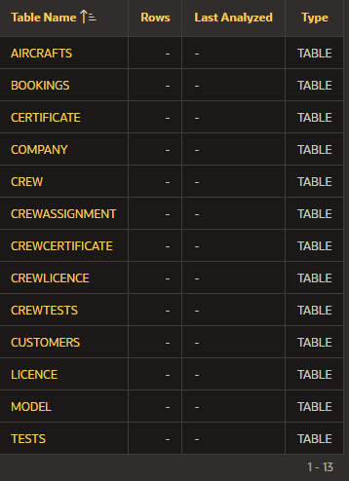
Company | CREATE TABLE Company (  CompanyID INT PRIMARY KEY,  CompanyName VARCHAR2(100) NOT NULL  CompanyDetails VARCHAR2(100)  );
Customers | CREATE TABLE Customers (  CustomerID INT PRIMARY KEY,  CompanyID INT,  CustomerAPI VARCHAR2(100),  CustomerName VARCHAR2(100) NOT NULL,  CustomerAddress VARCHAR2(50) NOT NULL,  CustomerEmail VARCHAR2(100) UNIQUE NOT NULL,  FOREIGN KEY (CompanyID) REFERENCES Company(CompanyID)  );
Model | CREATE TABLE Model (  ModelID INT PRIMARY KEY,  ModelName VARCHAR2(100) NOT NULL,  PassengerORCargo VARCHAR2(50) NOT NULL CHECK (PassengerORCargo IN ('Passenger', 'Cargo')),  NoOfSeats INT,  CargoCapacity INT,  NoOwned INT  );
Aircrafts | CREATE TABLE Aircrafts (  AircraftID INT PRIMARY KEY,  ModelID INT,  FOREIGN KEY (ModelID) REFERENCES Model(ModelID)  );
Bookings | CREATE TABLE Bookings (  BookingID INT PRIMARY KEY,  CustomerID INT,  AircraftID INT,  BookingDate DATE NOT NULL,  FlightDate DATE NOT NULL,  FlightTime TIMESTAMP NOT NULL,  Destination VARCHAR2(100) NOT NULL,  CargoDetails VARCHAR2(50),  FOREIGN KEY (CustomerID) REFERENCES Customers(CustomerID),  FOREIGN KEY (AircraftID) REFERENCES Aircrafts(AircraftID)  );
CrewAssignment | CREATE TABLE CrewAssignment (  CrewID INT,  BookingID INT,  TaskDetails VARCHAR2(50),  PRIMARY KEY (CrewID, BookingID),  FOREIGN KEY (CrewID) REFERENCES Crew(CrewID),  FOREIGN KEY (BookingID) REFERENCES Bookings(BookingID)  );
Crew | CREATE TABLE Crew (  CrewID INT PRIMARY KEY,  CrewName VARCHAR2(100) NOT NULL,  CrewAddress VARCHAR2(50) NOT NULL,  MobileNO VARCHAR2(15) UNIQUE NOT NULL,  DOB DATE NOT NULL,  Gender VARCHAR2(10) NOT NULL, CHECK Gende IN ('Male', 'Female')),  NINO VARCHAR2(20) UNIQUE NOT NULL,  AnnualSalary INT NOT NULL,  JobDescription VARCHAR2(50)  );
CrewTests | CREATE TABLE CrewTests (  TestID INT,  CrewID INT,  TestType VARCHAR2(50) NOT NULL,  TestDates DATE NOT NULL,  TestResult VARCHAR2(4) CHECK (TestResult IN ('Pass', 'Fail')),  PRIMARY KEY (TestID, CrewID),  FOREIGN KEY (TestID) REFERENCES Tests(TestID),  FOREIGN KEY (CrewID) REFERENCES Crew(CrewID)  );
Tests | CREATE TABLE Tests (  TestID INT PRIMARY KEY,  TestFrequancy VARCHAR2(50) NOT NULL,  TestDescription VARCHAR2(50)  );
CrewLicence | CREATE TABLE CrewLicence (  CrewID INT,  LicenceID INT,  PRIMARY KEY (CrewID, LicenceID),  FOREIGN KEY (CrewID) REFERENCES Crew(CrewID),  FOREIGN KEY (LicenceID) REFERENCES Licence(LicenceID)  );
Licence | CREATE TABLE Licence (  LicenceID INT PRIMARY KEY,  LicenceDescription VARCHAR2(50)  );
CrewCertificate | CREATE TABLE CrewCertificate (  CertificateID INT,  CrewID INT,  PRIMARY KEY (CertificateID, CrewID),  FOREIGN KEY (CertificateID) REFERENCES Certificate(CertificateID),  FOREIGN KEY (CrewID) REFERENCES Crew(CrewID)  );
Certificate | CREATE TABLE Certificate (  CertificateID INT PRIMARY KEY,  CertificateFrequancy VARCHAR2(50) NOT NULL,  CertificateDescription VARCHAR2(50)  );

Task 4: Screenshot of populated data
COMPANY
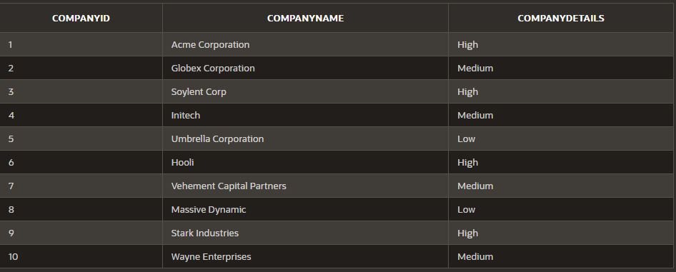
CUSTOMERS
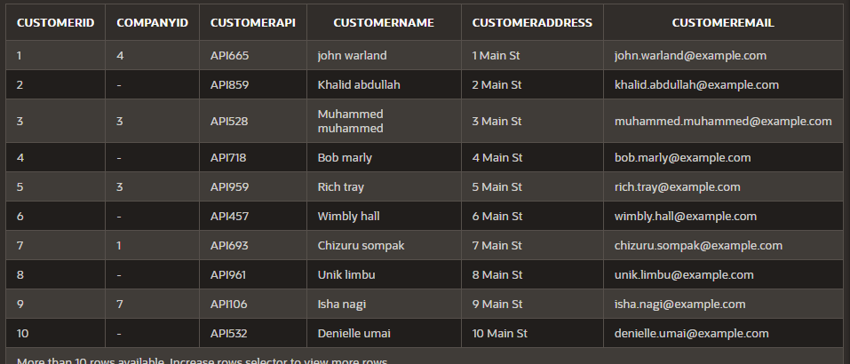
MODEL
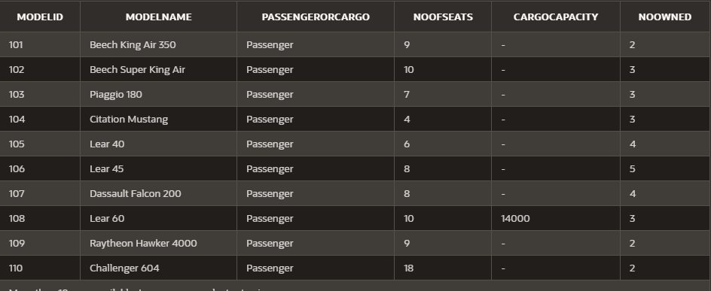
Aircrafts
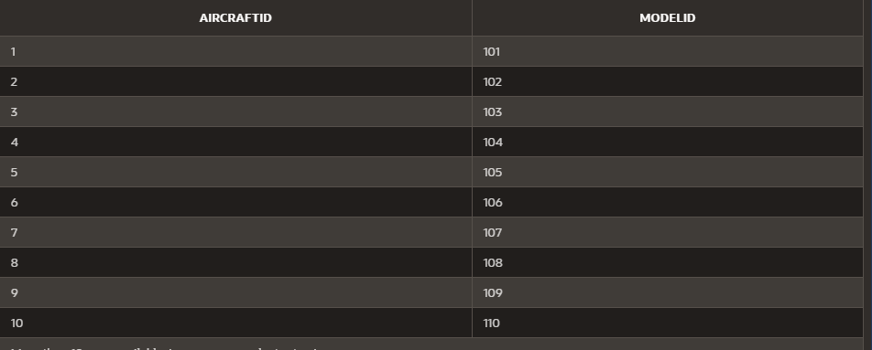
Bookings
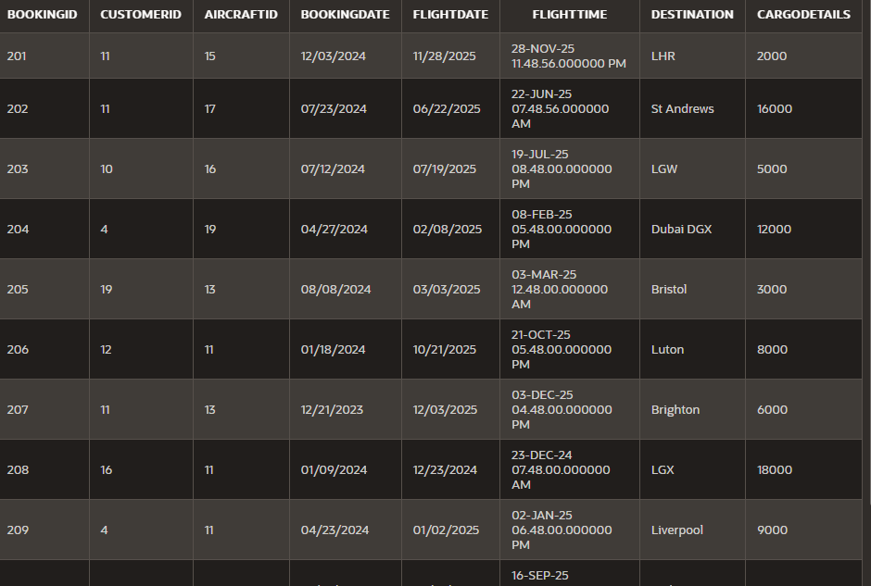
CrewAssignment
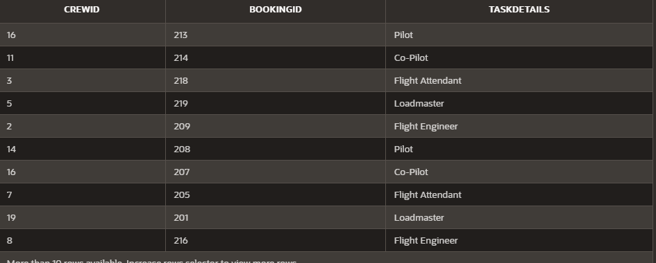
Crew
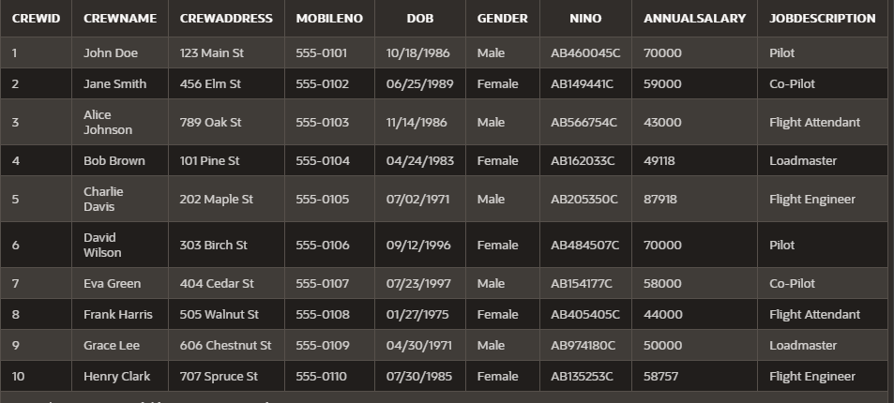
CrewTests
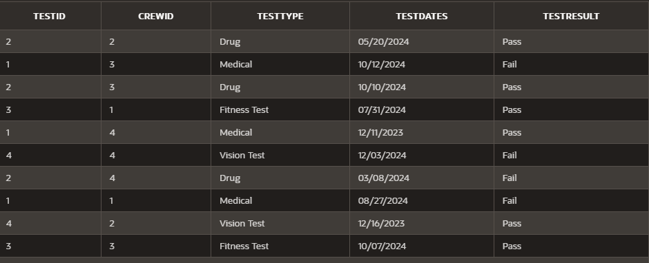
Tests
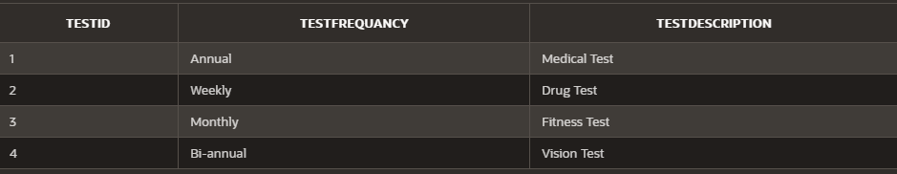
CrewLicence
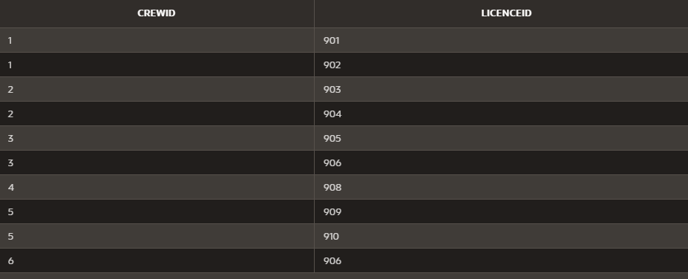
Licence
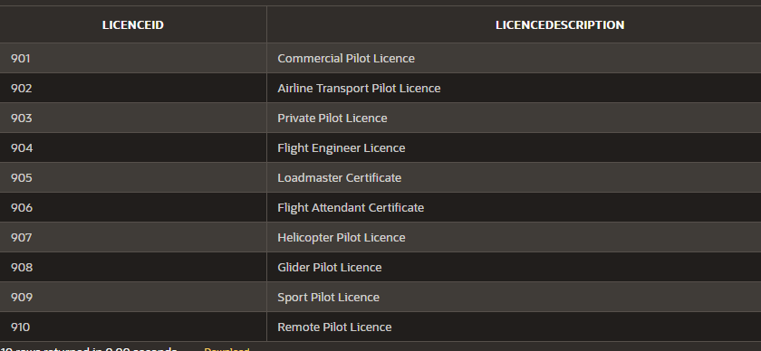
CrewCertificate
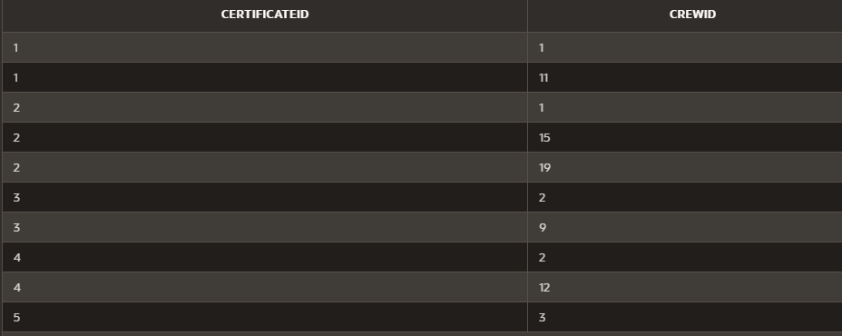
Certificate
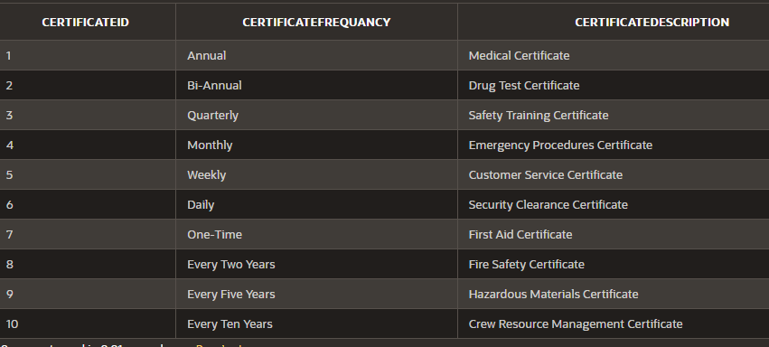

Task 5: Discussion of constraints used
Company | Primary Key: CompanyID uniquely identifies each company.  NOT NULL Constraint: CompanyName ensures that every company has a name provided.
Customers | Primary Key: CustomerID uniquely identifies each customer.  Foreign Key:  CompanyID ensures that the customer belongs to a valid company defined in the Company table.  NOT NULL Constraint: CustomerName, CustomerAddress, and CustomerEmail ensure essential information is always provided.  Unique Constraint: CustomerEmail ensures no duplicate email addresses exist across customers.
Model | Primary Key: ModelID uniquely identifies each aircraft model.  NOT NULL Constraints: ModelName ensure that all models have a defined name and type.  Check constraints: Ensures either 'Passenger' or 'Cargo’ value is entered.
Aircrafts | Primary Key: AircraftID uniquely identifies each aircraft.  Foreign Key:  ModelID ensures that the aircraft is associated with a valid model defined in the Model table.
Bookings | Primary Key: BookingID uniquely identifies each booking.  Foreign Keys:  CustomerID ensures the booking is associated with a valid customer.  AircraftID ensures the booking is associated with a valid aircraft.  NOT NULL Constraints: BookingDate, FlightDate, FlightTime, and Destination ensure essential booking details are provided.
CrewAssignment | Composite Primary Key: (CrewID, BookingID) ensures that each crew member can be uniquely identified for a specific booking.  Foreign Keys:  CrewID ensures the assignment is linked to a valid crew member.  BookingID ensures the assignment is linked to a valid booking.
Crew | Primary Key: CrewID uniquely identifies each crew member.  NOT NULL Constraints: CrewName, CrewAddress, DOB, Gender, NINO, and AnnualSalary ensure that important personal and employment details are provided.  Unique Constraints: MobileNO and NINO ensure uniqueness for contact and national insurance details.
CrewTests | Composite Primary Key: (TestID, CrewID) uniquely identifies each test taken by a specific crew member.  Foreign Keys:  TestID ensures the test is valid and predefined in the Tests table.  CrewID ensures the test result belongs to a valid crew member.  Check Constraint: TestResult restricts values to either 'Pass' or 'Fail'.
Tests | Primary Key: TestID uniquely identifies each test.  NOT NULL Constraints: TestFrequancy, TestDescription ensure that test details are always provided.
CrewLicence | Composite Primary Key: (CrewID, LicenceID) ensures uniqueness for each crew member's licence.  Foreign Keys:  CrewID ensures the licence belongs to a valid crew member.  LicenceID ensures the licence is valid and predefined in the Licence table.
Licence | Primary Key: LicenceID uniquely identifies each licence.
CrewCertificate | Composite Primary Key: (CertificateID, CrewID) ensures uniqueness for each crew member's certificate.  Foreign Keys:  CertificateID ensures the certificate is valid and predefined in the Certificate table.  CrewID ensures the certificate belongs to a valid crew member.
Certificate | Primary Key: CertificateID uniquely identifies each certificate.  NOT NULL Constraints: CertificateFrequancy, CertificateDescription ensure all certificates have specified frequency and details.

Task 6 (i): Query
Q1
SELECT C.CREWID, C.CREWNAME, C.DOB, C.GENDER, C.JOBDESCRIPTION,
COUNT(CT.TESTID) AS TEST_COUNT,
COUNT(CC.CERTIFICATEID) AS CERTIFICATE_COUNT,
COUNT(CL.LICENCEID) AS LICENCE_COUNT
FROM
CREW C
JOIN
CREWTESTS CT ON CT.CREWID = C.CREWID
JOIN
CREWCERTIFICATE CC ON CC.CREWID = C.CREWID
JOIN
CREWLICENCE CL ON CL.CREWID = C.CREWID
GROUP BY
C.CREWID, C.CREWNAME, C.DOB, C.GENDER, C.JOBDESCRIPTION
HAVING
COUNT(CC.CERTIFICATEID) > 1;
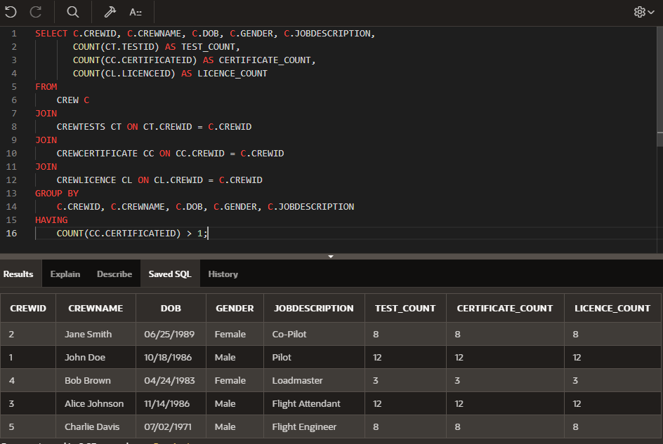
Q2
SELECT
C.COMPANYID, C.COMPANYNAME, C.COMPANYDETAILS,
CU.CUSTOMERNAME, CU.CUSTOMERID, CU.CUSTOMEREMAIL, CU.CUSTOMERADDRESS,
COUNT(B.BOOKINGID) AS BOOKING_AMOUNT
FROM
CUSTOMERS CU
JOIN
BOOKINGS B ON B.CUSTOMERID = CU.CUSTOMERID
JOIN
COMPANY C ON C.COMPANYID = CU.COMPANYID
GROUP BY
C.COMPANYID, C.COMPANYNAME, C.COMPANYDETAILS,
CU.CUSTOMERNAME, CU.CUSTOMERID, CU.CUSTOMEREMAIL, CU.CUSTOMERADDRESS

HAVING
COUNT(B.BOOKINGID) > 1
ORDER BY
BOOKING_AMOUNT ASC;
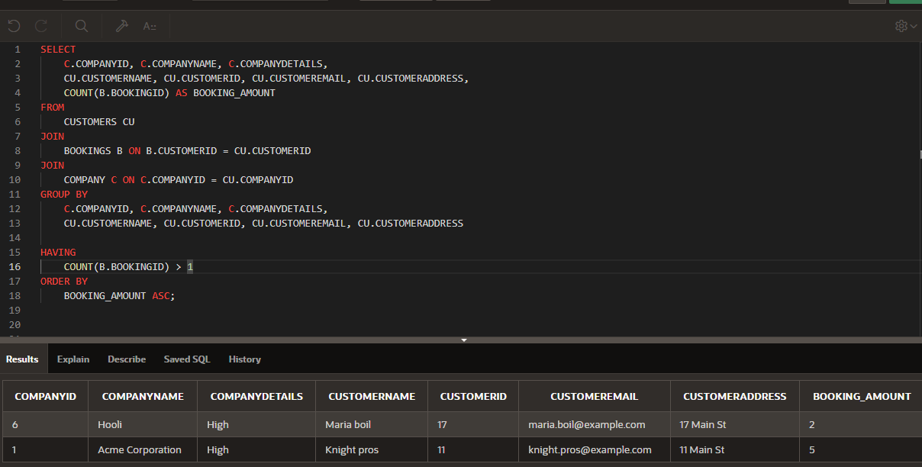
Q3
SELECT CREWID, CREWNAME, CREWADDRESS, MOBILENO, DOB, GENDER, NINO, ANNUALSALARY, JOBDESCRIPTION
FROM
CREW
WHERE
ANNUALSALARY = (SELECT MAX(ANNUALSALARY) FROM CREW)
OR ANNUALSALARY = (SELECT MIN(ANNUALSALARY) FROM CREW);
