**1. Decomposition**  
                    The process of dividing a computation into smaller parts, some or all of which may potentially be executed in parallel, is called decomposition.  
  
**2. Task**  
                    Tasks are programmer-defined units of  
computation into which the main computation is subdivided by means of decomposition.  
                       
**3. Task Dependency Graph**  
                    A task-dependency graph is a directed acyclic graph in which the nodes represent tasks and the directed edges indicate the dependencies amongst them.   
                    The task corresponding to a node can be executed when all tasks connected to this node by incoming edges have completed.   
                    Task-dependency graphs can be disconnected and the edge set of a task-dependency graph can be empty e.g. in Task Dependency Graph of Vector Matrix multiplication, there are no edges as all computations are independent.   
  
e.g. Task Dependency Graph for "Finding minimum element among 23,12,9,30,37,27,8,17":

[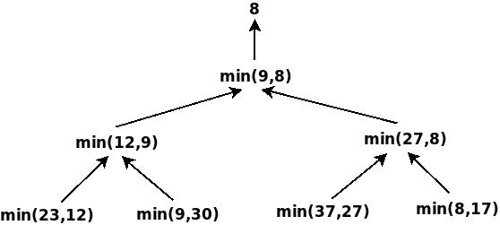](https://blogger.googleusercontent.com/img/b/R29vZ2xl/AVvXsEi4zXOtajaDWU58z5zrWaB8PjMQLP-tg9GWzTqu0RNKzh4jc_rh0LdHgHRQF1HU_xxLAOXyQZ7JlXToBa2YgxT-GFqdgBLy-T-Tib7N_rvjPXe8F6uh40Kmt3p5DwKP_TYLrRwWnrNEGjqf/s1600/Diagram5.jpeg)

**4. Granularity**  
                    The number and size of tasks into which a problem is decomposed determines the granularity  
of the decomposition.   
  
Smaller Granularity:  
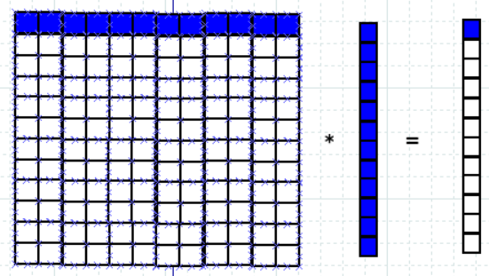

Larger Granularity  
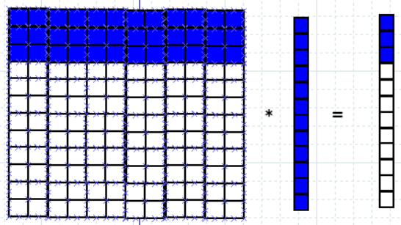

Note: Concurrency usually increase as the granularity of tasks becomes smaller (finer).  
  
  
  
  
**5. Fine Grained Decomposition**  
                     A decomposition into a large number of small tasks is called fine-grained.   
  
  
  
**6. Coarse Grained Decomposition**  
                     A decomposition into a small number of large tasks is called coarse-grained.   
  
  
**7. Concurrency**  
Executing multiple tasks simultaneously, is called concurrency.  
  
  
**8. Maximum Degree of Concurrency**  
                     The maximum number of tasks that can be executed simultaneously in a parallel program at any given time is known as its maximum degree of concurrency.   
                     In most cases, the maximum degree of concurrency is less than the total number of tasks due to dependencies among the tasks.  
                     In general, for task dependency graphs that are trees, the maximum degree of concurrency is always equal to the number of leaves in the tree.  
  
e.g.  
  
[](https://blogger.googleusercontent.com/img/b/R29vZ2xl/AVvXsEi4zXOtajaDWU58z5zrWaB8PjMQLP-tg9GWzTqu0RNKzh4jc_rh0LdHgHRQF1HU_xxLAOXyQZ7JlXToBa2YgxT-GFqdgBLy-T-Tib7N_rvjPXe8F6uh40Kmt3p5DwKP_TYLrRwWnrNEGjqf/s1600/Diagram5.jpeg)  
  
 In above example, Maximum Degree of Concurrency is 4.  
  
**9. Average Degree of Concurrency**  
                     It is the average number of tasks that can run concurrently over the entire duration of execution of the program.   
  
Note: Both the maximum and the average degrees of concurrency usually increase as the granularity of tasks becomes smaller (finer).  
  
**10. Critical Path**  
                     A feature of a task-dependency graph that determines the average degree of concurrency for a given granularity is its critical path.   
                     In a task-dependency graph, let us refer to the nodes with no incoming edges by start nodes and the nodes with no outgoing edges by finish nodes. The longest directed path between any pair of start and finish nodes is known as the **Critical Path**.  
  
**11. Critical Path Length**   
                     The sum of the weights of nodes along critical path is known as the critical path length, where the weight of a node is the size or the amount of work associated with the corresponding task.  
  
**Average Degree of Concurrency = Total Amount of Work / Critical Path Length**  
  
**e.g. 1.**

[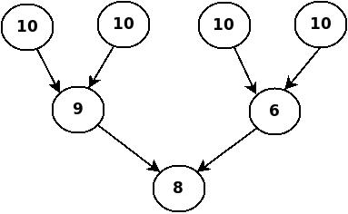](https://blogger.googleusercontent.com/img/b/R29vZ2xl/AVvXsEiWGwv7jTYelwSjGtuEb3-SU7vwDRtAB2JQSc9GFkdqRgQWgSu23OUhdTfa1bzltegSQvldB83kwpVAs4nZ_mNk7VEjUmpIyFGpZ0zJ3c-sp03ZDaGhOpJppJXso_YB-3imQfnXP3Mzl7Ab/s1600/Diagram7.jpeg)

Total Amount of Work=63  
Critical Path Length=27  
Average Degree of Concurrency=63/27=2.33  
  
**e.g. 2.**

[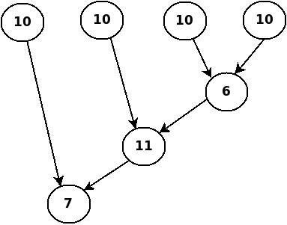](https://blogger.googleusercontent.com/img/b/R29vZ2xl/AVvXsEhSo1ZmwUl-Sq4aMRu8iwWiK4J_-6FQhD65ZPU5G1sWiTvxx4eLlz5J1LJiN4lr37ypNmFTRwh8dUO3me0nmWMomxZNJV6QdVdwBH51SPTEHrA2ELfWxGhrjt37iwdLwczA4KQ1c9JMLwRx/s1600/Diagram8.jpeg)

Total Amount of Work=64  
Critical Path Length=34  
Average Degree of Concurrency=64/34=1.88  
  
  
**12. Speedup**  
  
Speedup = Serial Execution Time / Parallel Execution Time   
  
**13. Task Interaction Graph**  
                     The nodes in a task-interaction graph represent tasks and the edges connect tasks that interact with each other.